H.U. Fall 2009 Name: ---------------------------------
PHY 218
FINAL

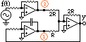1. Assume that all unmarked resistors in the Analogue computation circuit
shown are equal, and that τ =1 . Take f (t) = 2cos3t.
- Write down the voltages at the nodes 1 and 2 ( 5 pts.)
- Write down the differential equation for (y). ( 5 pts.)
------------------------------------------------------------------------------------------------------------
2. The circuit shown is an “azif component”.
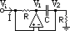 a. Write down the nodal equations for V₁ & V₂ and calculate V_{i}/I ( 12 pts.)
b. V_{i}/I has the form (- jωK ) where (K) is a constant that depends
on R&C. What does that practical meaning mean of K? ( 3 pts.)
-------------------------------------------------------------------------------------------------------------
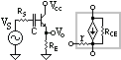3. Take V_{cc} = 12v, V_{E} ~ 6v, R_{E} = 1k, R_{S} = 50Ω, β = 100, F = 10KHz,
and C = 0.47 μF. (1/ωC ~ 34Ω )
- Draw the ac equivalent of the circuit ( 5 pts.)
- 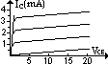Calculate I_{E} and show that r ~ 5Ω ( 2 pts.)
- Use the I-V graph to argue that R_{CE} > 40k ( 2 pts.)
- Simplify the circuit using the answers of parts b&c ( 2 pts.)
- Show that Vo/Vs ~ A/(A+1) where A = βR_{E}/R_{s} ( 4 pts.)
-----------------------------------------------------------------------------------------------------------------------------------
4. Answer 3 of the following 4 problems. ( 3x9 = 27 pts.)
Note: The 4th answer will be ignored.
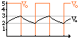
4A. Assume that the two halves of the cycle of the RC oscillator have
equal length. Show that the period is given by T ~ 0.81τ

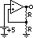
4B. Assume that the opamp shown is ideal except for common mode rejection.
Take CMRR = 104 and show that DVo = 10mv. Show your steps clearly.

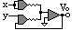
4C. Calculate Vo in terms of x and y.

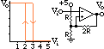
4D. Identify the circuit ( 2 pts.)and show that the reference
voltage(V+) alternates between the does have the values 2v,3v

-----------------------------------------------------------------------------------------------------------------------------------

Note: You may answer the following questions on the sheet itself to save time.
5. Answer 5 of the following 7 questions briefly. The 6th answer will be ignored. ( 5x4=20 pts.)
- How does one write on a CD?
- Draw a CMOS Totem Pole
- Why are voltage followers used as “buffers”?
- Why is the characteristic impedance of a transmission cable weakly dependent on its diameter?
- Why is the input resistance of an FET very large?
- What are the factors that limit the integration time of Analogue computers?
- What would be an educated guess for the resistivity of a semiconductor, if ρ of conductors were ρ_{m} = 10⁻⁹ Ωm and that of insulators ρ_{i} = 10¹³ Ωm? Is the answer you found realistic?
---------------------------------------------------------------------------------------------------------------------------------------------
6. Answer 2 of the following 3 questions briefly. The 3rd answer will be ignored. ( 2x5 = 10 pts.)
- 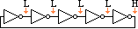The circuit shown is in the (00001) state. What is its next state?
- 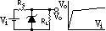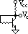Why is the initial steep slope of the regulator shown independent of the Zener diode used, whereas the flatter part is determined by the diode?
- Complete the “nonsense sentence” : ,
which indicates that the operating point tends to be stable.
- 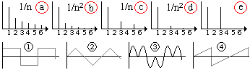Associate each of the the 4 waveforms with one of the spectra. Double penalty for wrong answers.
- ........ 2. ........
- ........ 4. ........
---------------------------------------------------------------------------------------------------------------------------------------------
Good Luck! ......./10 + ......./2x15+ ......./30 +......./20+ ......./10 = ........../100

