CHM. 313

Experiment 7: Alkyl Halides
Name:
Date:
Group #:

Objective:
- To synthesize t-butyl chloride from t-butyl alcohol via SN1 mechanism.
- To practice using a separatory funnel extraction and distillation

Theory:
An alkyl halide is another name for a halogen-substituted alkane. The carbon atom, which is bonded to the halogen atom, has sp³ hybridized bonding orbitals and exhibits a tetrahedral shape. Due to electronegativity differences between the carbon and halogen atoms, the σ covalent bond between these atoms is polarized, with the carbon atom becoming slightly positive and the halogen atom partially negative.
- Reaction of Alcohol with Hydrogen Halide:
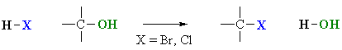

The properties of this substitution reaction are:
- Nucleophilic Substitution:
  - Mononuclear (SN1): Tertiary Alcohols ( t-Butyl Alcohol)
  - Bimolecular (SN2): Primary and Secondary Alcohols. (n-Butyl Alcohol)
- When treated with HBr or HCl, alcohols typically undergo a nucleophilic substitution reaction to generate an alkyl halide and water.

- Reaction usually proceeds via an SN1 mechanism which proceeds via a carbocation intermediate that can also undergo rearrangement.
 | 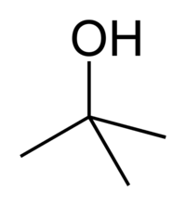 | 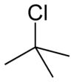
Name | Tert-butyl alcohol | T-butyl chloride
Molecular formula | C₄H₁₀O | C₄H₉Cl
Molar mass | 74.1216 g/mol | 92.57 g/mol
MP | 25.69°C | -25°C
BP | 82.4°C | 51-52°C
Density | 0.78 g/ml | 0.85 g/ml
Physical state | Solid at Room T | Colorless Liquid
We will convert t-Butyl Alcohol (2-methyl-2-propanol) rapidly to t-Butyl Chloride (2-chloro-2-methylpropane) via use of concentrated HCl at room temperature. Since t-Butyl Alcohol is tertiary alcohol the SN1 mech is followed which has the following reactions:
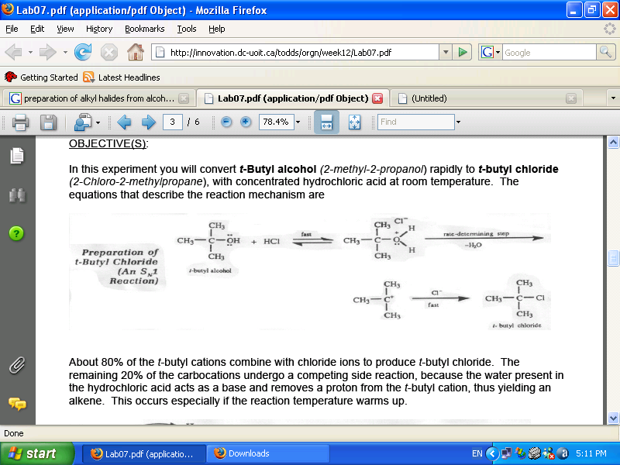

About 80% of the t-Butyl cations combine with chloride ions to produce t-butyl chloride. The remaining 20%of the carbocations undergo a competing side reaction, because the water present in the HCl acts as a base and removes a proton from the t-Butyl cation, thus yielding an alkene via an elimination reaction. This occurs especially if the reaction temperature warms up.
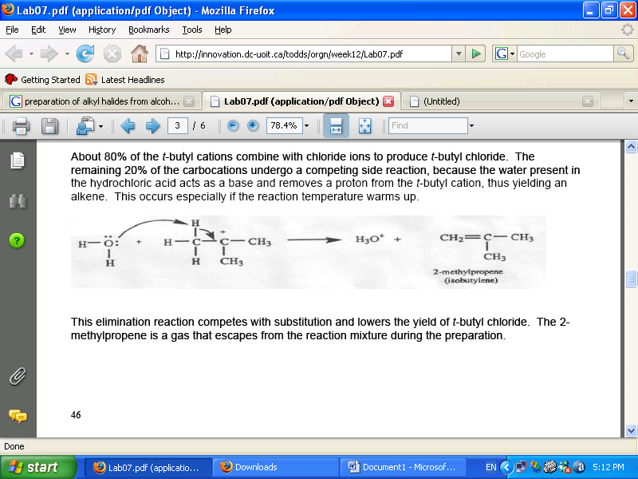
The elimination reaction competes with substitution and lowers the yield of t-Butyl Chloride. The 2-methylpropene is a gas that escapes from the reaction mixture during the preparation.

N.B: The cooler the HCl, the less elimination that will occur.
Procedure:
- Preparation of t-Butyl Chloride SN1:
- Place 5g of t-Butyl Alcohol in a separatory funnel.
- Place 25 ml of cold concentrated HCl (36% weight).
- Shake mixture for 10-15 min releasing pressure occasionally while slowly opening the stopcock.
- Draw off the lower layer which is the aqueous layer, and discard it.
- Add 15 ml of cold water and then discard the aqueous layer.
- Repeat with 15ml of Na₂CO₃ where CO₂ is evolved during neutralization and then discard the aqueous layer.
- Place 15ml of cold water (preferred to be saturated with NaCl) and then discard the aqueous layer.
- Transfer the organic layer (t-Butyl Chloride) to a DRY volumetric flask and add anhydrous CaCl₂ or MgSO₄.
- Perform decantation or filtration into a 50 ml round bottom flask and add boiling stones.
- Perform distillation and collect the volumes from 49-52ºC which is the volume of t-Butyl Chloride.
- Find the percentage yield.

- Preparation of n-Butyl Bromide SN2:
- Prepare HBr solution.
- Add 14ml of concentrated H₂SO₄ in 2-3 ml portions.
- Add 2 boiling stones and reflux (heat to BP) for 30 min.
- Cool the reaction mixture and perform distillation until reaching 110-115ºC temperature obtaining only H₂O solution.
- Transfer distillate to separatory funnel and add 25 ml of water discarding the lower layer.
- Add 25 ml of NaOH (10%) also discarding the lower layer.
- Transfer the organic layer to a DRY volumetric flask and add anhydrous CaCl₂ or MgSO₄.
- Perform decantation or filtration into a 50 ml round bottom flask and add boiling stones.
- Perform distillation and collect the volumes from 98-102ºC which is the volume of n-Butyl Chloride.
- Find the percentage yield.

Results:
- Preparation of t-Butyl Chloride SN1:
Reactant | M.Weight (g/mol) | Volume (ml) | Density (g/ml) | Moles (mol)
t-Butyl Alcohol | 74.12 | 6.6 | 0.78 | 0.07
Hydrochloric Acid | 36.5 | 25 | 1.15 | 0.79

The compound that limits the yield is: t-Butyl Alcohol
The theoretical yield of t-Butyl Chloride:
$$m_{theoretical of t-butyl chloride}=\frac{M_{t-butylchloride}m_{t-butyl alcohol}}{M_{t-butylalcohol}}=\frac{92.57×5.15}{74.12}=6.48g$$

$$n_{theoretical of t-butyl chloride}=\frac{m_{t-butylchloride}}{M_{t-butylchloride}}=0.07 mol$$

Experimental yield of n-Butyl Chloride:
$$m_{ n-butyl chloride}=4.18 g$$
$$\%yeild=\frac{m_{ n-butyl chloride}}{m_{theoretical of n-butyl chloride}}×100=64.52\%$$

- Preparation of n-Butyl Bromide SN1:
Reactant | M.Weight (g/mol) | Grams (g) | Volume (ml) | Density (g/ml) | Moles (mol)
n-Butyl Alcohol | 74.12 | 8 | 10 | 0.8 | 0.06
Sodium Bromide | 102.9 | 13.6 |  |  | 0.13
48% HBr | 80.912 | 4.85 | 3.25 | 1.49 | 0.06
Sulfuric Acid | 98.08 | 26.5 | 14.4 | 1.84 | 0.27

The compound that limits the yield is: n-Butyl Alcohol
The theoretical yield of n-Butyl Chloride:
$$m_{theoretical of n-butyl bromide}=\frac{M_{n-butylbromide}m_{n-butyl alcohol}}{M_{n-butylalcohol}}=\frac{137.02×8}{74.12}=14.79g$$

$$n_{theoretical of n-butylbromide}=\frac{m_{n-butylbromide}}{M_{n-butylbromide}}=0.107 mol$$
Experimental yield of n-Butyl Chloride:
$$m_{ n-butyl bromide}=7.87 g$$
$$\%yeild=\frac{m_{ n-butyl bromide}}{m_{theoretical of n-butyl bromide}}×100=53.24\%$$

