LEBANESE AMERICAN UNIVERSITY
BYBLOS CAMPUS
SCHOOL OF ENGINEERING
DEPARTMENT OF CIVIL ENGINEERING


Fall -2012
CIE 309- CONSTRUCTION MATERIALS LAB
Instructor: Dr. MICHAEL AMMOURY
Lab Report 2
Unit Weight & Voids in Aggregate
ASTM C29

Table of Contents
Objective……………………………………………………. 3
Apparatus…………………………………………………….. 4
Introduction………………………………………………….. 6
Procedure and data collected………………. 7
Data Collected and Calculations………………… 10
➢Formulas:………………………………. 10
➢Measure Volume:……………………………………………………………………………………………………………………….10
Sand 11
➢Loose Sand:………………………… 11
➢Compact Sand:……………………….. 11
Gravel 12
➢Loose Gravel:…………………………. 12
➢Compact Gravel:……………………….. 12
➢Compact Mixture 1: 20% Sand & 80% Gravel:…………………….. 13
Compact Mixture 14
➢Compact Mixture 2: 40% Sand & 60% Gravel:…………………….. 14
➢Compact Mixture 3: 60% Sand & 40% Gravel:…………………….. 14
➢Compact Mixture 4: 80% Sand & 20% Gravel:………………. 15
Results and Graphs…………………………….. 16
Discussion………………………………………………….. 18
Conclusion:………………………………………………….. 20

Figure 1: Scale (or balance , 0,1 lb (0,05 kg)) 4
Figure 2: Tamping Rod 4
Figure 3: Measure 5
Figure 4: Scoop 5

Objective

The purpose of this lab is to determine the unit weight in a compacted or loose condition and calculated voids in fine, coarse , or mixed aggregates based on the same determination.

Apparatus

- Scale (or balance , 0.1 lb(0.05 kg))

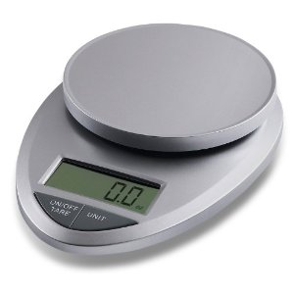
Figure 1: Scale (or balance , 0,1 lb (0,05 kg))

- Tamping Rod

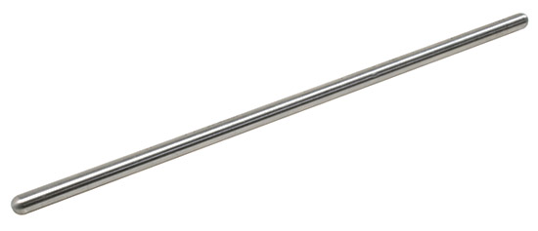
Figure 2: Tamping Rod

- Measure

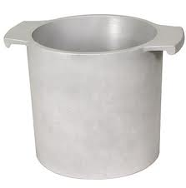
Figure 3: Measure

- Scoop

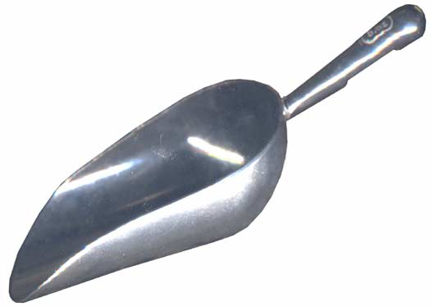
Figure 4: Scoop

Introduction
Concrete is an important element in construction that is composed of coarse and fine aggregates, cement and water. It is extensively used for building foundations. Architectural structures, pavements, bridges, roads and many other different types of construction.
In order to obtain good concrete, it is necessary to take specific properties of gravel and sand. A good concrete is usually one that has a smaller amount of voids between the particles where sand and gravel are joined together with fewer space in between.
The unit weights values of aggregates (which are calculated in ASTM C29) can help determine the quantities of coarse and fine aggregates that are used in concrete mixtures which will define the quality of the resulting concrete. By using an important amount of gravel, a great number of voids in th sample (compared to the sand) will appear since more space Is occupied when gravel is used because of their size and irregular shape. However, a mixture that mostly contains sand will have lesser number of voids, but will be weak moisture.
Therefore, it’s necessary for specific amounts and proportions of sand and gravel to be used in the mixture to get a strong concrete.

Procedure and data collected
I-Calculating the volume of the measure:
- - Determine weight of dry measure.
= 6377 g = 8436g

2) Measure the height, diameter 1 and diameter 2 of the container
3) Calculate the volume of the container
V = W_{w} / γ_{w}
II-Calculating the Loose Unit Weight (Shoveling procedure):
1) Fill the measure to overflowing by means of a scoop, discharging the aggregate from a height not to exceed 2 in. (50 mm) above the top of the measure.
2) Level the surface of the aggregate with a straightedge.
3) Determine the weight of the measure plus content, and the weight of the measure alone, recording values to the nearest 0.1 lb (0.05 kg).
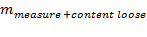= 25423 g
III-Calculating Compact Unit Weight (rodding procedure) :
1) Fill the measure one-third full and level the surface with the fingers.
2) Rod the layer of aggregate with 25 strokes of the tamping rod evenly distributed over the surface.
3) Add additional aggregate to the measure to the two-thirds full level, level with the fingers, and rod again with 25 strokes of the tamping rod.
4) Finally, add additional aggregate to overflowing and rod again using 25 strokes of the tamping rod.
5) Level the surface of the aggregate with a straightedge.
6) Determine the weight of the measure plus content, and the weight of the measure alone, recording values to the nearest 0.1 lb (0.05 kg).
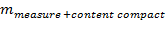= 26988 g

IV-Calculating Compact Unit Weight of the (course/fine aggregate) mixed:
- 80% course & 20 % fine aggregate.
- 60% course & 40 % fine aggregate.
- 40% course & 60 % fine aggregate.
- 20% course & 80 % fine aggregate.

1) Weight every specific combination of Sand-Gravel.
2) Mix each weighted aggregates combination to obtain a mixture of sand & gravel.
3) Fill the measure one-third full and level the surface with the fingers.
4) Rod the layer of aggregate with 25 strokes of the tamping rod evenly distributed over the surface.
5) Add additional aggregate to the measure to the two-thirds full level, level with the fingers, and rod again with 25 strokes of the tamping rod.
6) Finally, add additional aggregate to overflowing and rod again using 25 strokes of the tamping rod.
7) Level the surface of the aggregate with a straightedge.
8) Determine the weight of the measure plus content, and the weight of the measure alone, recording values to the nearest 0.1 lb (0.05 kg).
= 8436 g

Data Collected and Calculations

Formulas:
1) - Unit Weight:
γ_{bulk} = (G - T) / V
Where:
γ_{bulk} = unit weight of the aggregate, Kg/m³
G = mass of the aggregate plus the measure, Kg
T = mass of the measure, Kg
V = volume of the measure, m³
2) - Void Content for compact Fine/ Coarse aggregate:
n (%) = [(G_{s}γ_{w} - γ_{bulk})/ G_{s}γ_{w}](100)
Where:
γ_{bulk} = unit weight of the aggregate, Kg/m³
G_{s} = bulk specific gravity, dry basis (from ASTM C127 or C128)
γ_{w} = unit weight of water (998 kg/m³)

3) - Void Content for compact Fine & Coarse aggregate combinations:
n (%) = [(G_{com}γ_{w} - γ_{bulk})/ G_{com}γ_{w}](100)
Where:
G_{com} = 100/ [(C/G_{c}) + (F/G_{f})]
G_{com} = the specific gravity of the combined sand-gravel mixture
G_{c} = the bulk specific gravity of the coarse aggregate
G_{f} = the bulk specific gravity of the fine aggregate, and

Measure Volume:
Diameter (cm) | Height (cm) | Volume V(m³) | Pan
15.0 cm | 16.0 cm | 0.0030 m³ | Loose
26.3 cm | 25.3 cm | 0.0137 m³ | Gravel
Table 1: Volume Measure

Sand

Loose Sand:

Weight of Measure plus content "G" (g) | Weight of Measure alone "T" (g) | Volume V of the Measure | Unit Weight  γ_{bulk} ( Kg/ m³)
7157 g | 2437 g | 0.0030 m³ | 1573.3 Kg/m³
Table 2: Loose Sand

- Unit weight calculation:

Compact Sand:

Weight of Measure plus content "G" (g) | Weight of Measure alone "T" (g) | Volume V of the Measure | Unit Weight  γ_{bulk} ( Kg/ m³)
7609 g | 2437 g | 0.0030 m³ | 1724 Kg/m³
Table 3: Compact Sand

- Unit weight calculation:

- Void Content calculation:
From Lab report 1, Gs= 1.88

Gravel

Loose Gravel:

Weight of Measure plus content "G" (g) | Weight of Measure alone "T" (g) | Volume V of the Measure | Unit Weight  γ_{bulk} ( Kg/ m³)
25423 g | 6337 g | 0.0137 m³ | Kg/m³
Table 4: Loose Gravel

- Unit weight calculation:

Compact Gravel:

Weight of Measure plus content "G" (g) | Weight of Measure alone "T" (g) | Volume V of the Measure | Unit Weight  γ_{bulk} ( Kg/ m³)
26988 g | 6337 g | 0.0137 m³ | Kg/m³
Table 5: Compact Gravel

- Unit weight calculation:

- Void Content calculation:
From Lab report 1, Gs= 2.18

Compact Mixture 1: 20% Sand & 80% Gravel:

We use the big container: V=0.0137 m³

Weight Without Pan "W" (g) | Volume V Of The Measure | Unit Weight  γ_{bulk} ( Kg/ m³)
5406 g | 0.0030 m³ | Kg/m³
Table 6: Compact Mixture
- Unit weight calculation:
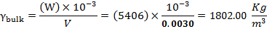

- Void Content calculation:
From Lab report 1, G_{c}= 2.18 & G_{f} = 1.88
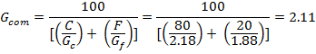
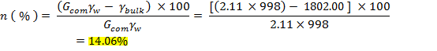

Compact Mixture

Compact Mixture 2: 40% Sand & 60% Gravel:

Weight Without Pan "W" (g) | Volume V of the Measure | Unit Weight  γ_{bulk} ( Kg/ m³)
5999 g | 0.0030 m³ | 1999.67Kg/m³
Table 7: Compact Mixture 2

- Unit weight calculation:
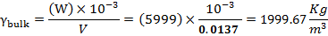
- Void Content calculation:
From Lab report 1, G_{c}= 2.18 & G_{f} = 1.88
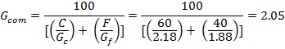

Compact Mixture 3: 60% Sand & 40% Gravel:

Weight Without Pan "W" (g) | Volume V of the Measure | Unit Weight  γ_{bulk} ( Kg/ m³)
5567 g | 0.0030m³ | 1855.67Kg/m³
Table 8: Compact Mixture 3
- Unit weight calculation:
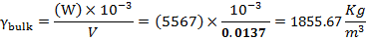

- Void Content calculation:
From Lab report 1, G_{c}= 2.18 & G_{f} = 1.88
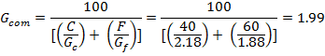

Compact Mixture 4: 80% Sand & 20% Gravel:

Weight Without Pan "W" (g) | Volume V of the Measure | Unit Weight  γ_{bulk} ( Kg/ m³)
5489 g | 0.0030m³ | Kg/m³
Table 9: Compact Mixture 4

- Unit weight calculation:
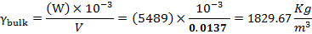

- Void Content calculation:
From Lab report 1, G_{c}= 2.18 & G_{f} = 1.88
Weight of Mix (g) | Sand (%) | Gravel(%) | Gf (%) | Gg | G com | V (m3) | U.W.C (kg/m3) | n%
5406 | 20 | 80 | 1.88 | 2.16 | 2.10 | 0.003 | 1802.00 | 14.06
5999 | 40 | 60 | 1.88 | 2.16 | 2.04 | 0.003 | 1999.67 | 1.73
5567 | 60 | 40 | 1.88 | 2.16 | 1.98 | 0.003 | 1855.67 | 6.29
5489 | 80 | 20 | 1.88 | 2.16 | 1.93 | 0.003 | 1829.67 | 5.06
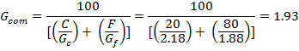

Results and Graphs

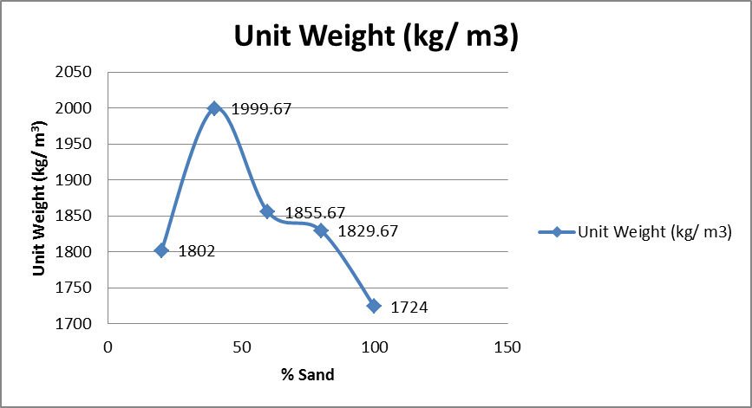
Figure 5: Unit Weight v.s. %Sand

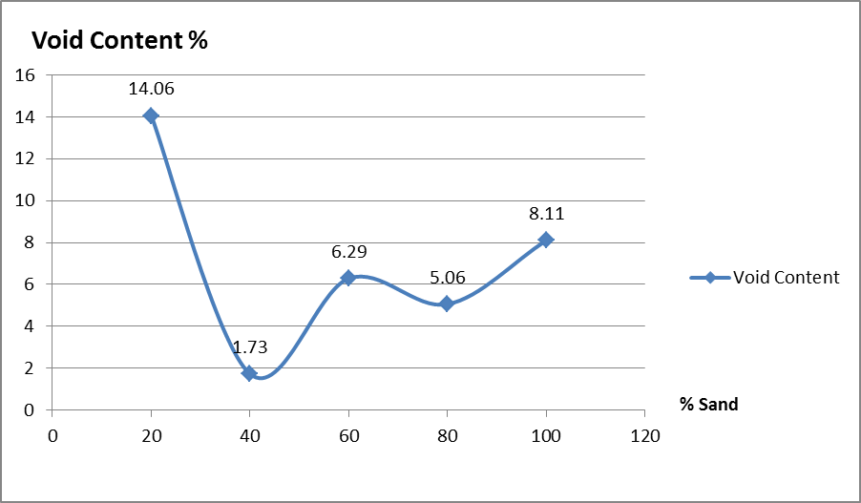
Figure 6: Void Content v.s. %Sand

Discussion

In the previous lab session, the test method ASTM C127 & C128 determines the “specific gravity and absorption of coarse and fine aggregrates” without taking in consideration the voids among the aggregrates.
This consideration is covered in the ASTM C29, which covers the determination of “unit weight & voids in aggregate” (fine and coarse). This knowledge is understood through two methods: the loose unit weight (shoveling procedure) and the compact unit weight (rodding procedure), for fine and coarse aggregates.
It is important to remember that the ASTM C29 isn’t concerned with the absorption of the aggregates, meaning that the bulk specific gravity used is at oven dry condition.
As a matter of fact, the procedures shows that the particles in the rodding process are more compressed to each other than that of the shoveling process. Thus, a bigger quantity of aggregate occupies the same volume, leading to a decrease in the voids. This idea is applicable for both sand and gravel.
 | Loose Unit Weight | Compact Unit Weight
Sand | 1573.3 Kg/m3 | 1724 Kg/m3

 | Loose Unit Weight | Compact Unit Weight
Gravel | 1393.14 Kg/m3 | 1507.37 Kg/m3

However, determining the highest percentage of voids between fine and coarse aggregates is another issue. In fact, there is two ways to think about it.
The first logic claims that at a macro scale, it is evident that voids among coarse aggregates are more evident visually than the voids among sand particles. Thus, the void among coarse aggregates is the highest, according to that logic,.
The second logic claims that at a micro scale, the voids existed among the particles in a gravel is equal to zero, because the gravel is. However, if the same of volume of the pebble is occupied by sand, a certain percentage of voids will be existed among the sand particles. Thus, the void among fine aggregates is the highest, according to that logic.

 | Fine | Coarse
% voids betw. particles | 8.11 | 30.72

However, it’s that the percentage of voids between particles, n, in sand is less than that of gravel. It is affirmed that the voids among coarse is more important than the voids among the fine particles.
Theoretically speaking, mixing coarse and fine should decrease the voids, due to the fact that the sand particles will fill the voids between the coarse aggregates. However, the problem is which ratio of coarse to fine must be provided.
According to the two graphs it seems that a relation between the ratios of sand to gravel, the percentage of voids and the unit weight can be interpolated. For a ratio of 1:4, the unit weight is the lowest of 1802.00 kg/m3, having also the highest percentage of voids 14.06%. For the increase of 40% of sand, lead to the decrease in voids. However, from 60% to above, the percentage of voids decrease with an increase of a unit weight.; This justifies that the sand is filling the voids found between gravel particles and making more space for more amount of the mixture to be filled reaching the maximum at a percentage of 40 % for sand. In Conclusion, a higher number of void and lesser unit weight are obtained.

Conclusion:

The idealistic concrete is to have it filled with coarse aggregates, containing no permeable and impermeable voids, causing a higher strength of the concrete with a less absorption.
However, the idea seems utopic, because the process by itself is expensive. The solution comes by mixing an appropriate ratio of sand to gravel. A low percentage of voids among aggregates are expected for a ratio of 1:4.
In addition, it is important to measure aggregates and their mixtures according to its mass rather than its volume. Different masses of same element can fill the same volume. This is why the syllabus provides us the respective capacity of measure for the respective nominal maximum size of aggregates.

