SPECIFIC GRAVITY & ABSORPTION

OF COARSE & FINE AGGREGATES

ASTM C127 & C128

LAB REPORT #1

Date of submission: 11/10/2010

School of Engineering and Architecture

Lebanese American University

Byblos, Lebanon

Supervised By: Eng. Michael Ammoury

Prepared by:

Table of Contents:

Introduction: 2
Apparatus/Materials: 3
Procedure: 5
Data Collected and Calculations: 8
Discussion: 10
Conclusion: 11

Figures and Tables:

Table 1: Coarse apparatus 3
Table 2: Fine apparatus 4
Figure 1: SSD sample in basket container. 6
Figure 2: Cone test. 7
Figure 3:Pycnometer being filled to calibration mark. 8
Figure 4: Sand being removed from pycnometer using a sieve. 8

Introduction:

Construction in general is a practice performed by humanity throughout history up to our present days and this technique has evolved with time to become a science based on experimental data and statistics done on different types of materials. As much as civil engineering is concerned, some of the materials used in construction, mainly in concrete, are divided according to ASTM (American Standards for testing and materials) into two main categories named coarse and fine aggregates. By definition, coarse aggregates are the particles that are retained on a sieve number four (4.75 mm opening) after performing a sieve analysis test. Furthermore, the fine aggregates are those particles that can bypass the sieve number four upon analysis. The objective of this test is to measure the specific gravity, of both the coarse and fine aggregates, in all its forms (apparent, bulk or bulk SSD) depending on whether we are taking the dried out sample or including both the permeable and the impermeable voids in the particles or taking an SSD sample. As well as determining the absorption of both the coarse and fine aggregates and performing the necessary comparisons in results. For that experiment, ASTM standards C127 and C128 were used to test the coarse and fine aggregates respectively.

Apparatus/Materials:

Coarse aggregate:

Sieve No.4(4.75 mm opening)
Scale (mechanical)
Sample Container (wire basket)
Large circular Tares
Water Tank
scoop
Drying Oven
Dry towels
3 Kg of coarse aggregates (i.e.gravel) soaked for 24 hrs.
Table 1: Coarse apparatus

Fine aggregate:

Scale (mechanical)
Pycnometer
Mold
Tamper
Drying Oven
Latex Gloves
Small opening sieve ( to retain sand from pycnometer)
1 Kg soaked sand for 24 hrs.
Table 2: Fine apparatus

Procedure:

Coarse Aggregate:

- The coarse aggregates are first undergone a number 4 sieve analysis to get rid of the unwanted fine particles.
- An empty large circular tare is weighed alone.
- 3 Kg of the water soaked material is measured, using a mechanical balance in this experiment.
- The material is placed and rolled on dry towel in order to surface dry the particles from any visible water traces. This procedure was done by carefully wiping the particles individually.
- The sample is weighed on the mechanical balance to get the weight of the sample in its SSD condition.
- This SSD sample is then placed in the basket container which is shaken after it is placed in water in order to get rid of any air bubbles and the mass is recorded as being the saturated sample mass in water.
- The sample is placed in a large circular tare of known mass and it is placed in the oven for a 24 hour period at a 110 °C to dry out the sample from water and its mass is taken when it is oven dried.
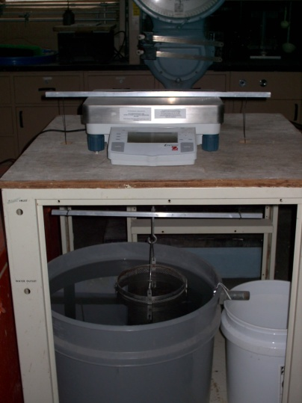
Figure 1: SSD sample in basket container.

Fine Aggregates:

- 1kg of soaked fine sand is measured in an already weighed circular tare.
- The sand is spread on a non-absorbent surface such as plastic surface after it is being freed out of water as much as possible by squeezing it over the pan in which it was weighed.
- The sand is uniformly dried, by exposing it to a warm air while moving the sand around to ensure even drying of the surface of particles.
- While performing the drying process, a cone test is performed by gently pouring some of the sands in it until it overflows.
- The tamper is used by dropping it under free fall, 25 drops evenly over the sand surface by ensuring 5mm spacing between the tamper and the surface of sand on each time the tamper is dropped. When the sand slumps slightly after the vertical removal of the cone, it indicates that the sample is in an SSD state.
- The weight of the SSD sample is recorded.
- The pycnometer is at first weighed with water in it up to the calibration mark.
- 344 g (in our case) of the SSD sample is introduced in the partially water filled pycnometer and their weight is recorded.
- The water is poured again in the pycnometer up to %90 of the total volume and it is inverted and agitated to get rid of the air bubbles (15 to 20 min).
- After bringing the water volume to the calibrated mark, the total weight of the pycnometer filled with sand and water is recorded.
- The sand is removed from the pycnometer by retaining it on a small sieve number (small enough to retain sand) and put in a tray.
- The tray is put in the oven at 110°C for 24 hours to dry out: the dry aggregate is achieved.
- The weight of the dry aggregate sample is recorded.
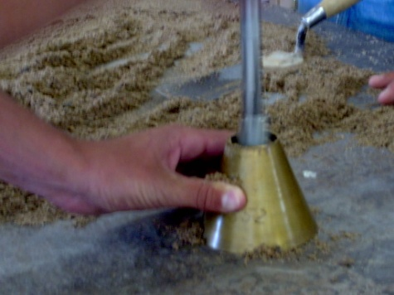
Figure 2: Cone test.

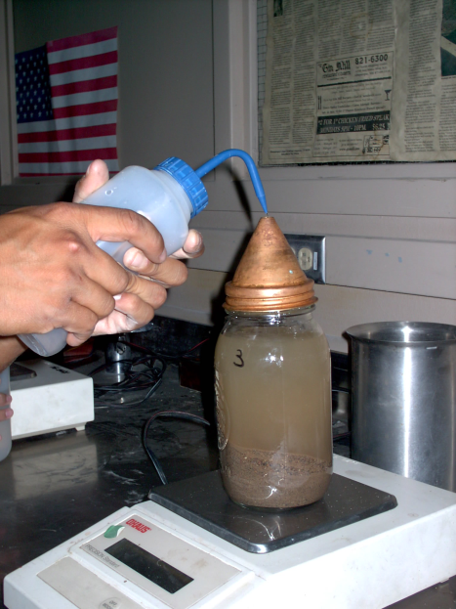
Figure 3: Pycnometer being filled to calibration mark.

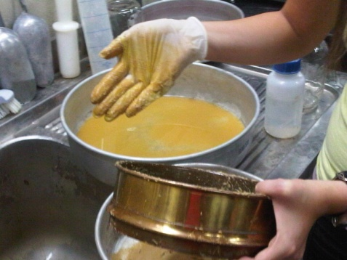
Figure 4: Sand being removed from pycnometer using a sieve.

Data Collected and Calculations:

Coarse Aggregate:

Empty tare weight (tray) = $W_{t}$=389 g
A= weight of oven dried test sample in air = (sand + tare) –$W_{t}$ = 3263-389 =2874 g
B= weight of SSD sample in air = weight after drying –$W_{t}$ = 3298-389 = 2909 g
C= weight of saturated sample in water =1795 g

- Bulk specific Gravity (oven dry) :
The ratio of the weight in air of a unit volume of aggregate of the impermeable (oven dry) portion of aggregate to the weight in air of an equal volume (including voids)of gas-free distilled water at specified temperature:
$\frac{A}{B-C}$ = $\frac{2874}{2909-1795}$ = 2.58

- Bulk specific Gravity (SSD) :
The ratio of the weight in air of a unit volume of aggregate, including the weight of water within the voids filled to the extent(but not including the voids between particles) to the weight in air of an equal volume of gas-free distilled water at specified temperature:
$\frac{B}{B-C}$ = $\frac{2909}{2909-1795}$ = 2.61

- Apparent Specific Gravity :
The ratio of the weight in air of a unit volume of the impermeable (oven dry) portion of aggregate to the weight in air of an equal volume(not including voids) of gas-free distilled water at specified temperature:
$\frac{A}{A-C}$ = $\frac{2874}{2874-1795}$ = 2.66

- Absorption:
The increase in the weight of aggregate due to water in the pores of the material, but not including water adhering to the outside surface of the particles, expressed as a percentage of the dry weight:
% = [ $\frac{(B-A)}{A}]*100$ =[ $\frac{(2909-2874)}{2874}]*100$ = %1.22

In terms of density:

Density of water, 23C=997.5 Kg/$m^{3}$

- ρ (oven dry) = SG (oven dry) * density of water = 2573.44 Kg/$m^{3}$
- ρ (SSD) = SG (SSD) * density of water = = 2604.78 Kg/$m^{3}$
- ρ (apparent) = SG (app) * density of water = = 2656.92 Kg/$m^{3}$

Fine Aggregates:

Empty tare weight (tray) = $W_{t}$ = 394 g
A= weight of oven dried test sample in air = (sand + tare) – $W_{t}$ = 687 – 394 = 293 g
B= weight of pycnometer filled with water to calibration mark =1232 g
S= SSD sample in air (before pycnometer) =weight after drying – $W_{t}$= 732-394= 338 g
C= weight of pycnometer with specimen and water to calibration mark =1441 g

- Bulk specific Gravity (oven dry) = $\frac{A}{(B+S-C)}$ = $\frac{293}{1232+338-1441}$ = 2.27

- Bulk specific Gravity (SSD) = $\frac{S}{(B+S-C)}$ = $\frac{338}{(1232+338-1441)}$ = 2.62

- Apparent Specific Gravity = $\frac{A}{(B+A-C)}$ = $\frac{293}{(1232+293-1441)}$ = 3.49

- Absorption, % = [ $\frac{(S-A)}{A}]*100$ =[ $\frac{(338-293)}{293}]*100$ = %15.36

In terms of density:

Density of water, 23C=997.5 Kg/$m^{3}$

- ρ (oven dry) = SG (oven dry) * density of water ,23C=2265.64Kg/$m^{3}$
- ρ (SSD) = SG (SSD) * density of water ,23 C= 2613.60 Kg/$m^{3}$
- ρ (apparent) = SG (app) * density of water , 23 C= 3479.38 Kg/$m^{3}$

Discussion:

The results obtained for specific gravities in both coarse and fine aggregates do comply with the general expression given in the lab handout which reflects the fact that the specific gravities must conform to:
Bulk specific Gravity ≤ Bulk Specific Gravity (SSD) ≤ Apparent Specific Gravity,
(2.58<=2.61<=2.66 and 2.27<=2.62<=3.49)
It is noticeable that for coarse aggregates the differences in the values for specific gravities is very small and that is the result of the fact that the coarse aggregates (gravel) under investigation have very low absorption rate of %1.22. However, for fine aggregates(sand) the high absorption rate of % 15.36 can explain the large difference in specific gravity values especially between the apparent one ( 3.49) and the two other bulk SG, and bulk SG (SSD) (2.27 and 2.62 respectively). The densities are found to be directly proportional to their specific gravities. The method of testing of sand differs from that of coarse aggregates because it is impossible for example to emerge the sand in water and weigh it, as it will float and get dispersed. The final data cannot be said to be perfectly accurate because many sources of errors are involved in the testing application. For instance, the mechanical balance used cannot assure a weight result within 0.5 g as stated in the lab handout. Also, when doing the slump test, it was not possible to reach the point of slump because the sample needed to be surface dried furthermore but due to limitation of time the test is carried out without the perfect success of the slump test for fine aggregates. In addition, at the removal stage of the sand particles from the pycnometer, some of the sand particles were discarded in the tray below the sieve on which sand is strained ( as shown in Figure:4 above). Air bubbles might have still been present in the samples because we did not allow enough time (15 to 20 min) for shaking the sample. In addition, for coarse aggregates, some of the particles might have been lost as we spread them on towels for surface dry application. Thus, these sources of error can all add up to result in fluctuations and deviations from the realistic data.

Conclusion:

It is evident from the experiment that the fine sand particles used constitutes a material that is more permeable than that of the gravel coarse particles. Thus, the sand is more able to absorb water (%15.36) about thirteen times more than the ability of coarse aggregates (%1.22) as it is the case in this experiment which explains the small difference in weight between the oven dry and SSD sample for gravel (2909-2874=35g) and the large difference for sand (338-293= 45g).Though, the sample used for coarse aggregates is 3 times heavier than that of the sand sample. Also, it is concluded that the sand is denser than gravel as it can be seen from the density values obtained regardless in which state the sand and gravel are (but for the oven dry :density of gravel is slightly larger than that of sand maybe because of an error in the experiment). Recall that “Bulk specific Gravity ≤ Bulk Specific Gravity (SSD) ≤ Apparent Specific Gravity” for both samples.
In terms of classification, the sand is said to pass through a number four sieve of openings 4.75 mm while the coarse gravel particles are retained on that same sieve.

