EECE 210 – Quiz 3

December 10, 2011

4%

1. Determine *Zi* if the susceptance of the inductor is -2 S.



1. *j* Ω
2. -*j* Ω
3. *j*2 Ω
4. *j*0.5 Ω
5. 0

**Solution:** The dependent current source is equivalent to an admittance of *j*2 S. In series with *j*2 S, this becomes *j* S. In parallel with *jB* S, *Yi* = *jB* + *j* = *j*(*B* + 1) S, and the impedance is *Zi* = -*j*/(*B* + 1) Ω.

**Version 1:** *B* = -2 S, *Zi* = -*j*/(*B* + 1) = *j* Ω

**Version 2:** *B* = -3 S, *Zi* = -*j*/(*B* + 1) = *j*0.5 Ω

**Version 3:** *B* = -4 S, *Zi* = -*j*/(*B* + 1) = *j*/3 Ω

**Version 4:** *B* = -5 S, *Zi* = -*j*/(*B* + 1) = *j*0.25 Ω

**Version 5:** *B* = -6 S, *Zi* = -*j*/(*B* + 1) = *j*0.2 Ω.

4%

1. Two coils having *N*1 = 1,000 turns and *N*2 = 510 turns are coupled through a high-permeability core. The inductance of coil 1 is 1 mH and the mutual inductance is 0.5 mH. Determine the ratio of *φ*11*e* to *φ*21, where *φ*11*e* is the effective leakage flux of coil 1 and *φ*21 is the flux in the core due to current in coil 1.
2. 0.02
3. 0.03
4. 0.04
5. 0.01
6. 0.05

**Solution:** , . Dividing, ; ; . Note that the ratio is zero if *N*2 = 500. This is because *L*2 will then be mH, and . The coupling will be perfect, so *φ*11*e* = 0.

**Version 1:** *N2* = 510 turns, 

**Version 2:** *N2* = 520 turns, 

**Version 3:** *N2* = 530 turns, 

**Version 4:** *N2* = 540 turns, 

**Version 5:** *N2* = 550 turns, .

4%

1. Two identical, magnetically coupled coils are connected in series. When the same current is passed though both coils, but with the connections of one coil reversed, the magnetic stored energy is multiplied by a factor of 2. Determine the coefficient of coupling of the coils.
2. 0.33
3. 0.5
4. 0.6
5. 0.67
6. 0.75

**Solution:** The stored energy is  The ratio of the two stored energies is , or, , so 

**Version 1:** *α* = 2, 

**Version 2:** *α* = 3, 

**Version 3:** *α* = 4, 

**Version 4:** *α* = 5, 

**Version 5:** *α* = 7, .

4%



1. In the circuit shown, *iSRC* and *R* are unknown, with *α* = 3. Determine *M* so that *i* = 0.
2. 1 H
3. 1.2 H
4. 1.5 H
5. 1.6 H
6. 1.75 H

**Solution:** The circuit in the frequency domain is as shown. When *i* = 0, **Vbc** = 0, and the connection between these nodes can be removed. To have **Vbc** = 0, , or, . This gives; *α*(2 – *M*) = 4 – *M*, or, .

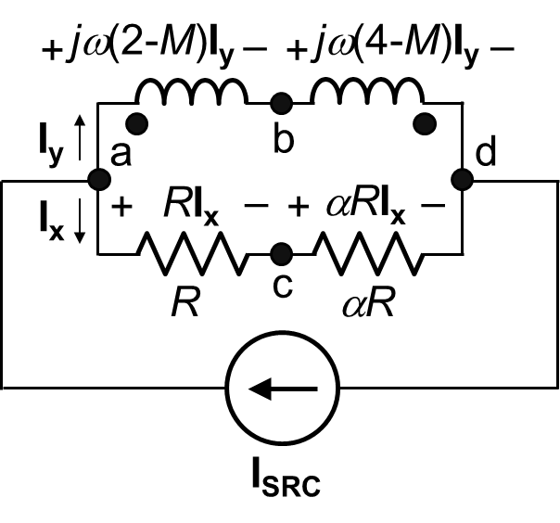

**Version 1:** *α* = 3, H

**Version 2:** *α* = 3.5, H

**Version 3:** *α* = 5, H

**Version 4:** *α* = 6, H

**Version 5:** *α* = 9,  H.

4%

1. In the ideal transformer shown, the phase relation between **V2** and the flux in the core **φc** is that:



1. **V2** lags **φc** by 90°
2. **V2** leads **φc** by 90°
3. **V2** lags **φc** by 45°
4. **V2** leads **φc** by 45°
5. **V2** is in phase with **φc**.

**Solution:** In phasor notation, **V1** = *jωN*1**φc** and  = *jωN*2**φc**. Hence,  leads **φc** by 90°, and **V2** =  lags **φc** by 90°.



4%

1. Given that *vSRC* = 10cos*ωt* V and the ideal transformer has a turns ratio of 1:10. Determine the current to ground *iG*.

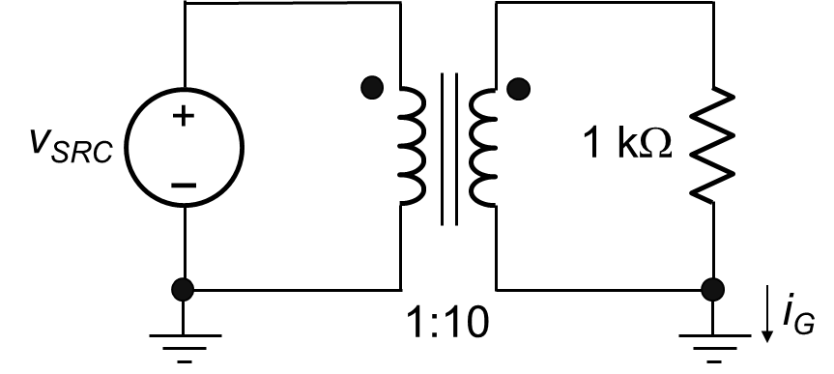

1. 10 mA
2. 100 mA
3. 0
4. 5 mA
5. 50 mA

**Solution:** There is no closed path that involves *iG*. Hence, *iG* = 0.

4%

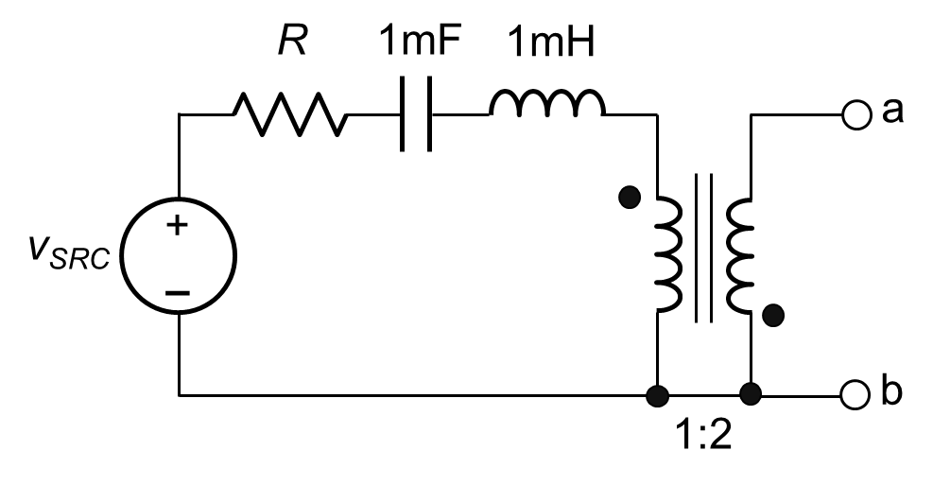

1. Determine the minimum *ZTh* looking into terminals ab and the frequency at which this minimum occurs, assuming *R* = 2 Ω.
2. 8 Ω, 1 krad/s
3. 10 Ω, 2 krad/s
4. 8 + *j*6 Ω, 1 krad/s
5. 8 – *j*6 Ω, 2 krad/s
6. 12 Ω, 0.5 krad/s

**Solution:** When the voltage source is set to zero, the impedance looking into terminals ab is . Minimum *ZTh* is when the imaginary part is zero. This occurs when , or  krad/s, and the minimum *ZTh* is a pure resistance 4*R*.

**Version 1:** *R* = 2 Ω, *ZTh* = 4*R* = 8 Ω

**Version 2:** *R* = 2.5 Ω, *ZTh* = 4*R* = 10 Ω

**Version 3:** *R* = 3 Ω, *ZTh* = 4*R* = 12 Ω

**Version 4:** *R* = 3.5 Ω, *ZTh* = 4*R* = 14 Ω

**Version 5:** *R* = 4 Ω, *ZTh* = 4*R* = 16 Ω.

4%

**8.** Determine *VTh* = *Vab* in the preceding problem at a frequency that is twice the frequency for minimum *ZTh*, assuming *vSRC* = 2cos(*ωt* – 30°) V.

1. 4cos(*ωt* + 150°) V
2. 4cos(*ωt* – 30°) V
3. 8cos(*ωt* + 150°) V
4. 8cos(*ωt* – 30°) V
5. 16cos(*ωt* – 30°) V

**Solution:** Since the secondary is open circuited, the primary current is zero at all frequencies. The primary voltage is *vSRC* and *Vab* = -2*vSRC* = -2*Vm*cos(*ωt* – 30°) = 2*Vm*cos(*ωt* + 150°) V.

**Version 1:** *Vm* = 2 V, *Vab* = 2*Vm*cos(*ωt* + 150°) = 4cos(*ωt* + 150°) V

**Version 2:** *Vm* = 2.5 V, *Vab* = 2*Vm*cos(*ωt* + 150°) = 5cos(*ωt* + 150°) V

**Version 3:** *Vm* = 3 V, *Vab* = 2*Vm*cos(*ωt* + 150°) = 6cos(*ωt* + 150°) V

**Version 4:** *Vm* = 3.5 V, *Vab* = 2*Vm*cos(*ωt* + 150°) = 7cos(*ωt* + 150°) V

**Version 5:** *Vm* = 4 V, *Vab* = 2*Vm*cos(*ωt* + 150°) = 8cos(*ωt* + 150°) V.

4%

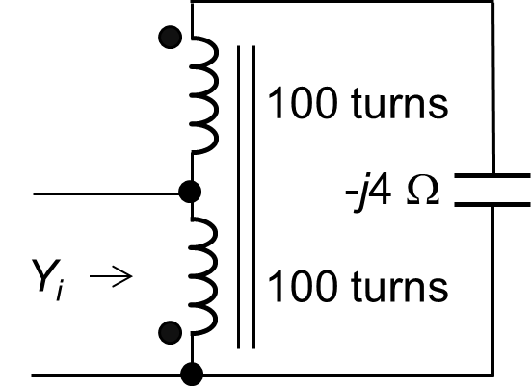

1. Determine *Yi*.
2. -*j* S
3. *j* S
4. 0
5. -*j*2 S

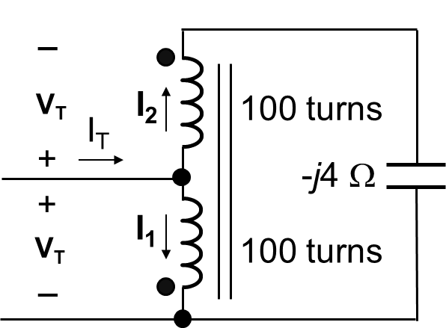

1. Infinite

**Solution:** When a test source is applied, the voltage across the capacitor is zero. Hence all currents are zero, and *Yi* = 0.

4%

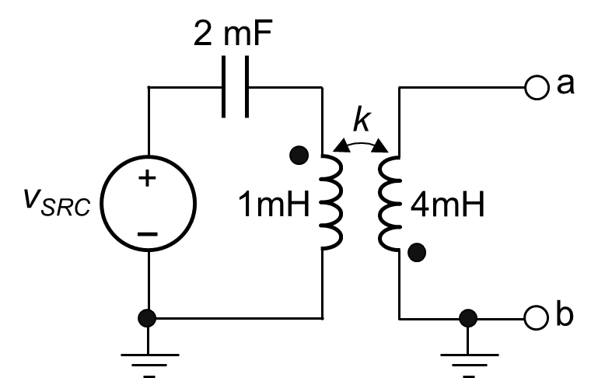

1. Determine Thevenin’s equivalent circuit looking into terminals ab given that *k* = 0.75 and *vSRC* = 2cos(1,000*t* – 60°) V.
2. *VTh* =V, *ZTh* = -*j*0.5 Ω
3. *VTh* =V, *ZTh* = -*j*0.5 Ω
4. *VTh* =V, *ZTh* = *j*0.5 Ω
5. *VTh* =V, *ZTh* = -*j* Ω



1. *VTh* =V, *ZTh* = *j* Ω

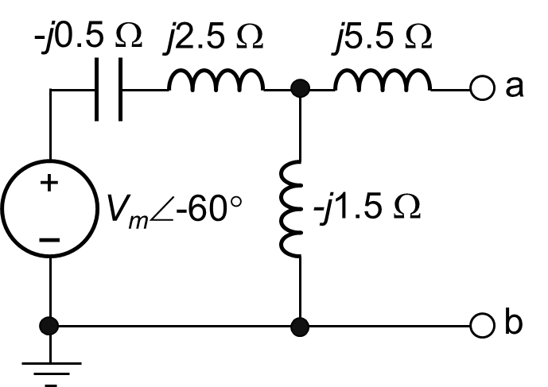

**Solution:** 1/*ωC* = 1/(103×2×10-3) = 0.5 Ω; *ωL*1 = 103×10-3 = 1 Ω; *ωL*2 = 103×4×10-3 = 4 Ω; *ωM* = 103× = 1.5 Ω . Replacing the transformer by its T-equivalent circuit, the circuit becomes as shown, where *jω*(*L*1 + *M*) = *j*2.5 Ω and *jω*(*L*2 + *M*) = *j*5.5 Ω. On open circuit, . If the source is replaced by a short circuit, the impedance looking into terminals ab is *ZTh* = Ω

**Version 1:** *Vm* = 2 V, *VTh* = V

**Version 2:** *Vm* = 3 V, *VTh* = V

**Version 3:** *Vm* = 4 V, *VTh* = V

**Version 4:** *Vm* = 5 V, *VTh* = V

**Version 5:** *Vm* = 6 V, *VTh* = V.

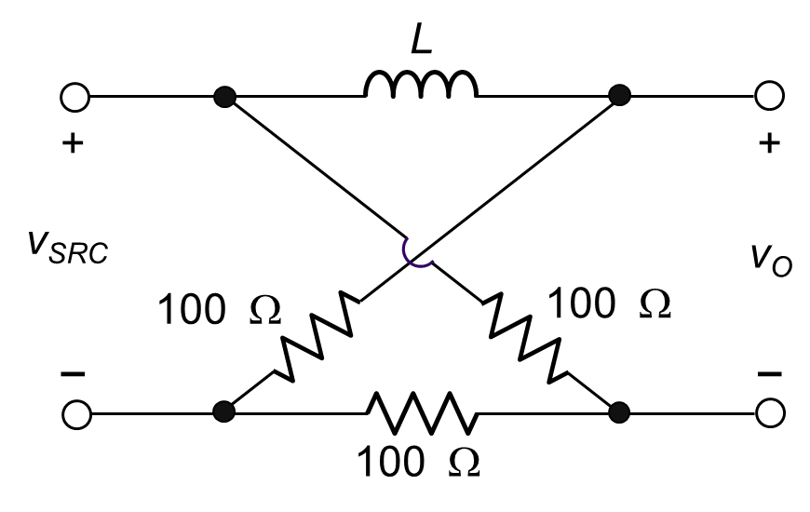

20%

**11.** Given *vSRC* = 10sin*ωt* V and *L* = 0.1 H. Determine the frequency at which *vO* is 90° out of phase with *vSRC* and specify whether *vO* lags or leads *vSRC* at this frequency.

**Solution:** The circuit in the frequency domain is as shown. The voltages **Va** and **Vb** with respect to the reference node are:  and . **VO** = **Va** – **Vb** = . The

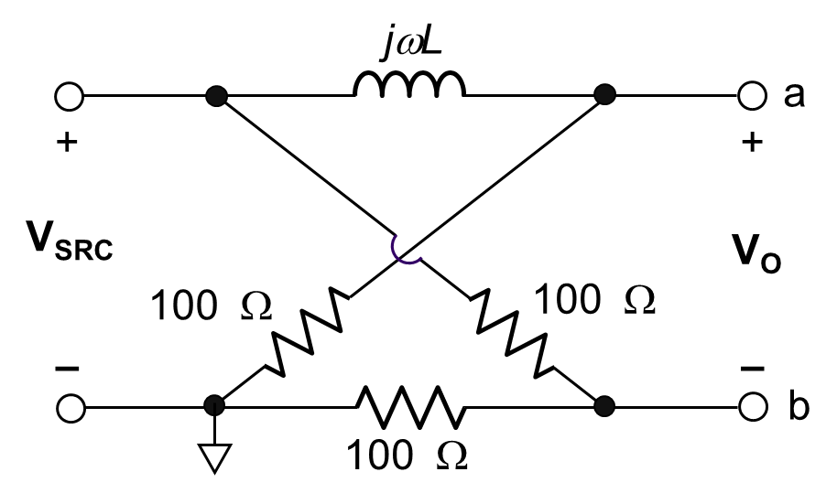

phase angle of **VO** with respect to **VSRC** is , that is lagging. When the magnitude of this angle is 90°,  and . This gives *ω* = *R*/*L* = 100/*L* rad/s.

**Version 1:** *L =* 0.1 H, *ω* = 100/*L* = 1000 rad/s

**Version 2:** *L =* 0.2 H, *ω* = 100/*L* = 500 rad/s

**Version 3:** *L =* 0.4 H, *ω* = 100/*L* = 250 rad/s

**Version 4:** *L =* 0.5 H, *ω* = 100/*L* = 200 rad/s

**Version 5:** *L =* 0.8 H, *ω* = 100/*L* = 125 rad/s.

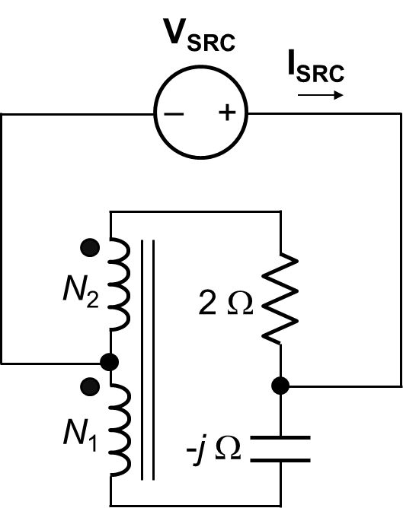

20%

**12.** Determine **ISRC**, in polar coordinates, assuming *N*2/*N*1 = 2 and **VSRC** = 1 V.

**Solution:** The voltages and currents of the ideal autotransformer may be assigned as shown. From KVL in the mesh involving *R*, *C*, and the transformer: 2**I2** + 2**V1** + **V1** – (-*j*2**I2**) = 0, or, 3**V1** = -2(1 + *j*)**I2**. From KVL in the upper mesh, 2**I2 + 2V1** = **VSRC**. Substituting for **V1**: 2**I2** – (4/3)(1 + *j*)**I2** = (2/3)(1 – *j*2)**I2** = **VSRC**, or, . Since **ISRC** = 3**I2**, = 0.9(1 + *j*2)**VSRC** A.

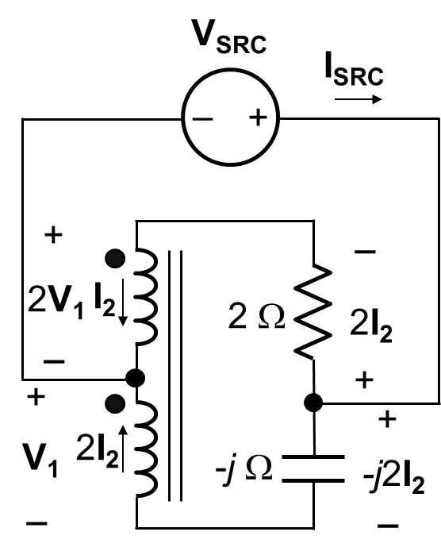

**Version 1: VSRC** = 1 V, **ISRC** = 0.9(1 + *j*2) A = 2.01∠63.4° A

**Version 2: VSRC** = 2 V, **ISR** = 1.8(1 + *j*2) A = 4.02∠63.4° A

**Version 3: VSRC** = 3 V, **ISRC** = 2.7(1 + *j*2) A = 6.03∠63.4° A

**Version 4: VSRC** = 4 V, **ISRC** = 3.6(1 + *j*2) A = 8.05∠63.4° A

**Version 5: VSRC** = 5 V, **ISRC** = 4.5(1 + *j*2) A = 10.1∠63.4° A

20%

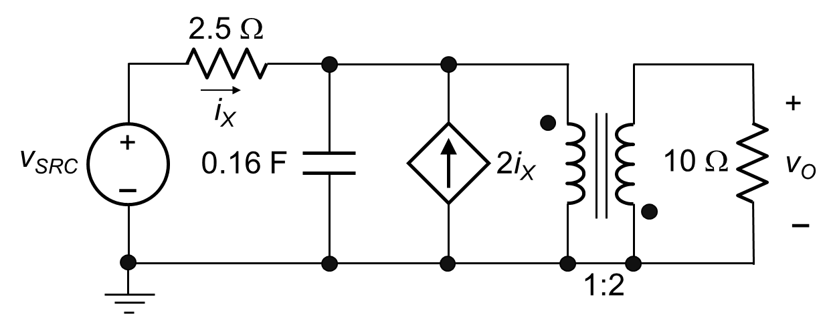

**13.** Determine *vO* in the time domain by reflecting the primary circuit to the secondary side, assuming *vSRC* =cos(10*t* – 10°) V.

**Solution:**   Ω. In reflecting the primary circuit to the secondary side, the 2.5 Ω is multiplied by 4 to become 10 Ω, and *ZC* becomes Ω. **VSRC** is multiplied by 2, with sign reversal. Both the current source 2*iX* and its controlling current *iX* are divided by 2, with sign reversal. They become *iX* and 0.5*iX*, respectively. They could just as well be designated as 2*iY* and *iY*, respectively. The circuit becomes as shown. From KCL at the upper right-hand node, , or . From KVL in the outer loop, , or, . Substituting for **IY**,  = 0, or .

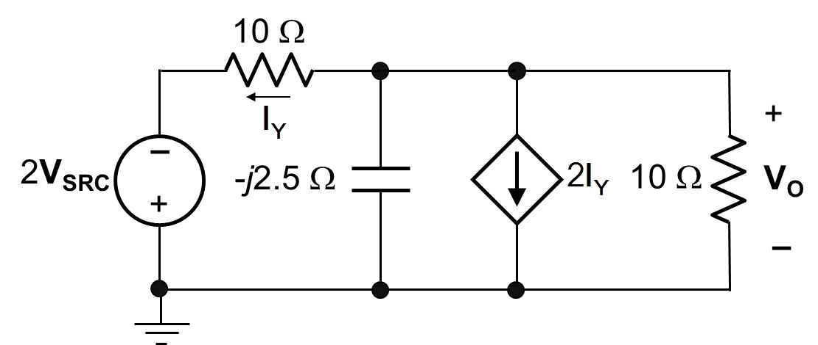

**Version 1:** *vSRC* =cos(10*t* – 10°), **VSRC** = ∠-10°, = 3∠125°, *vO* = 3cos(10*t* + 125°) V

**Version 2:** *vSRC* =cos(10*t* – 10°), **VSRC** = ∠-10°, = 4.5∠125°, *vO* = 4.5cos(10*t* + 125°) V

**Version 3:** *vSRC* =cos(10*t* – 10°), **VSRC** = ∠-10°, = 6∠125°, *vO* = 6cos(10*t* + 125°) V

**Version 4:** *vSRC* =cos(10*t* – 10°), **VSRC** = ∠-10°, = 7.5∠125°, *vO* = 7.5cos(10*t* + 125°) V

**Version 5:** *vSRC* =cos(10*t* – 10°), **VSRC** = ∠-10°, =

9∠125°, *vO* = 9cos(10*t* + 125°) V.