Chapter 11
Stockholders' Equity: Paid-In Capital

True / False Questions
1. When a stockholder sends in a proxy statement to a corporation he or she owns stock in, they relinquish their voting rights to the officers of the corporation.
True False

2. A stockholders' subsidiary ledger will have entries made for each stockholder showing the number of shares held.
True False

3. The number of shares a corporation may issue is specified in the articles of incorporation and approved by the Securities and Exchange Commission.
True False

4. The par value of a stock is the minimum amount of capital of the corporation existing for the protection of creditors.
True False

5. When a state authorizes the sale of stock to stockholders, the corporation will credit Retained Earnings for the par value of the stock.
True False

6. When a corporation fails to pay a dividend one year on its common stock, it is said to be "in arrears."
True False

7. A stock split will normally increase the market price of the stock and decrease the number of shares on the market.
True False

8. Treasury stock is stock that is issued and outstanding but not authorized.
True False

9. The purchase of treasury stock creates an asset for the corporation and is recorded at the cost of the shares purchased, not par value.
True False

10. Contributed capital is equivalent to paid-in capital.
True False

11. Common stock is considered the legal capital of the corporation.
True False

12. Cumulative preferred stock means the stock is entitled to its regular dividend plus an additional share of the total amount of declared dividends.
True False

13. A corporation is a legal entity separate from its owners; it may sue and be sued, but it may not own property in its own name.
True False

14. A corporation continues in existence even if a stockholder dies or withdraws from the organization.
True False

15. Treasury stock is stock of a corporation that has been issued and then reacquired and then cancelled.
True False

16. A stock split will decrease the total par value of the stock.
True False

17. Stockholders of a corporation are personally liable for the debts of the corporation if all shares of stock are owned by the officers of the corporation.
True False

18. It is illegal for the government to double tax corporate earnings.
True False

19. Only preferred stock of a corporation must have a par value.
True False

20. International accounting standards require mandatory redeemable preferred stock to be classified as a liability on the balance sheet and not as equity.
True False

21. To be consistent with international standards, the FASB has changed reporting requirements for redeemable preferred stock to require it to be reported in the equity section.
True False

22. If capital stock is issued by a corporation at a price lower than par value, the difference represents a loss in the period in which the shares of stock are issued.
True False

23. When par value capital stock is issued, capital stock is credited with the par value of the shares issued, regardless of whether the issuance price is equal to par, more than par, or less than par.
True False

24. Preferred stockholders are owners of the corporation and have rights upon liquidation and to receive dividends.
True False

25. Paid-in-capital includes donated capital.
True False

26. In the event of the liquidation of a corporation, treasury stock ordinarily has preference as to liabilities, while preferred stock has preference as to assets.
True False

27. Preferred stockholders generally do not have the same voting rights as do common stockholders in a corporation.
True False

28. By going public a corporation can raise equity capital from many investors.
True False

29. When assets are donated to a corporation, a revenue account should be credited for the fair market value of the assets received.
True False

30. A corporation must always have more than one class of stock.
True False

31. The purchase of treasury stock for cash causes no change in total assets.
True False

32. The sale of treasury stock at a price in excess of its cost results in a realized gain which should be presented as a non-operating item in the income statement.
True False

33. Inside directors of a corporation may be officers of the corporation and therefore are not considered independent.
True False

Multiple Choice Questions
34. The advantages of corporations going public include all of the following except:
A. Professional management.
B. Transferability of ownership.
C. Limited shareholder liability.
D. Ability to remove assets.

35. In a "pump-and-dump" scheme, the owners of the company:
A. Falsely claim the business has high growth potential.
B. Artificially raise the price of the stock.
C. Sell the stock at a high price.
D. Falsely claim the business has high growth potential, artificially raise the price of the stock, and sell the stock at a high price.

36. In order to limit the use of a shell company, the SEC has proposed:
A. Greater financial disclosures.
B. Eliminating this type of company.
C. Arresting promoters of shell companies for fraud.
D. That its stock only be sold in foreign countries.

37. The ownership of common stock in a corporation usually carries the following rights:
A. To vote for directors.
B. To declare dividends.
C. To share in a distribution of assets if the corporation is to be liquidated.
D. Both declare dividends and share in a distribution of assets if the corporation is to be liquidated.

38. The board of directors' primary functions include all of the following except:
A. Hiring corporate officers.
B. Setting officers' salaries.
C. Declaring dividends.
D. Protecting the interests of the officers.

39. Shares that have been sold and are in the hands of stockholders are called:
A. Outstanding.
B. Issued.
C. Treasury.
D. Underwritten.

40. Book value per share of common stock is derived by which of the following:
A. Stockholders equity divided by the number of shares authorized.
B. Stockholders equity divided by the number of shares outstanding.
C. Net income divided by the number of shares outstanding.
D. Net income divided by the number of shares authorized.

41. The net assets of a corporation are equal to:
A. Total assets-total liabilities.
B. Total assets-retained earnings.
C. Total assets + total liabilities.
D. Total assets + retained earnings.

42. When shares of stock are sold from one investor to another, they will trade at:
A. Par value.
B. Book value.
C. Market value.
D. Stated Value.

43. The market price of a preferred stock will be affected by:
A. The dividend rate.
B. The chance that the company will not operate profitably.
C. The level of interest rates.
D. The dividend rate, the chance that the company will not operate profitably, and the level of interest rates.

44. Topper Corporation has 60,000 shares of $1 par value common stock and 16,000 shares of cumulative 7%, $100 par preferred stock outstanding. Topper has not paid a dividend for the prior year. If Topper declares a $1.95 per share dividend this year, what will be the total amount they must pay their shareholders?
A. $117,000.
B. $341,000.
C. $327,000.
D. $177,000.

45. Which of the following is not a characteristic of the corporate form of organization?
A. The owners of a corporation cannot lose more than the amount of their investment.
B. Shares of stock in a corporation are more readily transferable than is an interest in a partnership.
C. Stockholders have authority to decide by majority vote the amount of dividends to be paid.
D. The corporation is a very efficient vehicle for obtaining large amounts of capital required for large-scale production.

46. Most preferred stocks have the following characteristics, except:
A. To receive dividends on a preferred basis.
B. Cumulative dividends.
C. Voting rights.
D. Callable at the option of the corporation.

47. Which of the following is not an addition to total paid-in-capital?
A. Retained earnings.
B. Treasury stock.
C. Neither retained earnings nor treasury stock.
D. Both retained earnings and treasury stock.

48. A primary disadvantage of the corporate form of organization is:
A. Unlimited personal liability for business debts.
B. Ownership is difficult to transfer.
C. Corporate earnings are subject to double taxation.
D. Management is separated from ownership.

49. Public corporations are required by law or regulation to perform all of the following except:
A. Submit much of their financial information to the SEC for review.
B. Make regularly scheduled dividend payments to all stockholders.
C. Have their annual financial statements audited by an independent CPA.
D. Disclose their financial information to the public.

50. Which of the following is not a right of stockholders?
A. To vote for directors and on key issues.
B. To participate in dividends declared.
C. To share in the distribution of assets if the corporation is liquidated.
D. To select the Chief Executive Officer.

51. The rights of a common stockholder do not include the right:
A. To vote for directors.
B. To withdraw a share of corporate net assets proportionate to the person's stockholdings.
C. To receive a proportionate share of corporate assets upon liquidation, after creditors have been paid.
D. To share in profits when the board of directors declares a dividend.

52. The directors of a corporation:
A. Are hired by the officers to run the business on a day-to-day basis.
B. May not own stock in the same corporation or be officers of the same corporation.
C. Are responsible for formulating corporate policy and for hiring corporate officers.
D. Are elected by the shareholders to run day-to-day operations.

53. Which of the following individuals has the most power to influence corporate policy on a long-term basis?
A. A shareholder owning 60% of the outstanding common stock.
B. A shareholder owning 80% of the outstanding preferred stock.
C. The treasurer of the corporation.
D. The controller of the corporation.

54. The term paid-in capital means:
A. All assets other than retained earnings.
B. Legal capital plus retained earnings.
C. Total stockholders' equity minus retained earnings.
D. Legal capital minus retained earnings.

55. If a corporation has issued a single class of stock, it must be:
A. Common Stock.
B. Preferred Stock.
C. Stock issued at Par-value.
D. Cumulative preferred Stock.

56. Which of the following best describes retained earnings?
A. Cash available for dividends.
B. The amount initially invested in the business by stockholders.
C. Cash available for expansion and growth.
D. Income that has been reinvested in the business rather than distributed as dividends to stockholders.

57. A deficit appears in a corporation's financial statements:
A. Among the operating expenses.
B. Among the liabilities.
C. As a deduction from assets.
D. As a deduction from total paid-in capital.

58. Which of the following would usually be the greatest amount?
A. The number of shares authorized.
B. The number of shares issued.
C. The number of shares outstanding.
D. They must all be the same amount.

59. In a corporation's organization chart, which is the highest position?
A. Stockholders.
B. Board of directors.
C. CEO.
D. President.

60. Which of the following best describes the relationship between revenue and retained earnings?
A. Revenue increases net income, which in turn increases retained earnings.
B. Revenue represents a cash receipt; retained earnings is an element of stockholders' equity.
C. Revenue represents the price of goods sold or services rendered; retained earnings represents cash available for paying dividends.
D. Retained earnings is equal to assets minus expenses.

61. If preferred stock is convertible, it is so at the option of the:
A. Board of directors.
B. CEO.
C. CFO.
D. Stockholders.

62. If a corporation has only common stock outstanding, which of the following constitutes legal capital at a particular date?
A. The amount in the Common Stock account.
B. The sum of the Common Stock account and any additional paid-in capital.
C. The total amount of stockholders' equity.
D. The sum of the Common Stock account and retained earnings.

63. The par value of the common stock of a large listed corporation:
A. Tends to establish a ceiling for the market price of the stock.
B. Tends to establish a floor for the market price of the stock.
C. Represents legal capital and is not related to the market price of the stock.
D. Is increased by net income and decreased by dividends.

64. A 2-for-1 stock split will:
A. Increase the total par value of the stock and increase the number of shares outstanding.
B. Decrease the total par value of the stock and increase the number of shares outstanding.
C. Not change the total par value of the stock and increase the number of shares outstanding.
D. Increase total stockholders' equity.

65. The entry to record the issuance of common stock at a price above its par value includes:
A. A credit to Cash.
B. A credit to a liability account for the difference between the price paid by the stockholders and the par value of the stock.
C. A credit to Additional Paid-in Capital: Common Stock.
D. A debit to Common Stock.

66. When a corporation issues capital stock at a price higher than the par value:
A. The amount received over par value increases retained earnings.
B. The entire issue price is credited to the Capital Stock account.
C. The amount received in excess of par value constitutes profit to the issuing corporation.
D. The amount received in excess of par value becomes part of paid-in capital.

67. When no-par stock is issued:
A. The entire amount received is credited to the Additional Paid-in Capital account.
B. The issue price is credited to the Capital Stock account.
C. There is no legal capital created because there is no par or stated value.
D. The transaction usually involves only an exchange for non-cash assets or services, since the stock has no value on the stock exchanges.

68. Which statement is true about a stock split?
A. Total shareholders' equity increases.
B. Total shareholders' equity decreases.
C. Total shareholders' equity remains the same.
D. A change in total stockholders' equity depends upon whether it is a 2-for-1 split or a 1-for-2 split.

69. Which of the following is not a characteristic of most preferred stock?
A. Dividends that vary as income changes.
B. Preference as to dividends.
C. Preference as to assets in the event of liquidation of the company.
D. No voting power.

70. The financial statements of a corporation that failed during the current year to pay any dividends on its cumulative preferred stock should:
A. Include the amount of the omitted dividends among its current liabilities.
B. Include a footnote disclosing the amount of the dividends in arrears.
C. Show the amount of the omitted dividends as a deduction from retained earnings.
D. List the omitted dividends as a long-term liability.

71. If the preferred stock of a corporation is cumulative:
A. Dividends on preferred stock are guaranteed.
B. Dividends cannot be declared in an amount less than that stated on the stock certificate.
C. Preferred stockholders participate in dividends paid in excess of a stated amount on the common shares.
D. Dividends in arrears must be paid on preferred stock before any dividend can be paid on common stock.

72. Treasury stock:
A. Is an asset.
B. Increases total stockholders' equity.
C. Decreases total stockholders' equity.
D. Does not change total stockholders' equity.

73. The purchase of treasury stock for cash will:
A. Increase stockholders' equity.
B. Not increase nor decrease stockholders' equity.
C. Decrease stockholders' equity.
D. Not change total assets.

74. Treasury stock should most often be recorded:
A. At cost.
B. Par value.
C. Fair market value at year end.
D. Face value.

75. Which of the following best describes the book value of a share of stock?
A. Net assets divided by the number of shares outstanding.
B. The amount at which the stock would sell on the market if sold by a willing and informed seller to a willing and informed buyer.
C. Total assets of the company, as reported in the accounting records, divided by the number of shares of stock outstanding.
D. Total stockholders' equity divided by the number of shares authorized.

76. A 2-for-1 stock split:
A. Is accounted for in the same way as a 100% stock dividend.
B. Increases the number of outstanding shares of common stock, but par value per share remains the same as before the split.
C. Is recorded by transferring the par value of additional shares from retained earnings to the common stock account.
D. Should logically cause the market price per share to drop by approximately 50%.

77. Treasury stock represents:
A. Shares of ownership in the United States Treasury Department.
B. A current asset.
C. Authorized shares that have never been issued.
D. Previously outstanding shares that have been repurchased by the issuing company.

78. Stock that had been issued by a corporation, and later reacquired, is classified as:
A. Treasury stock.
B. Non-participating preferred stock.
C. Restricted stock.
D. Issued shares.

79. The purchase of treasury stock for cash will have which effect upon the following items?
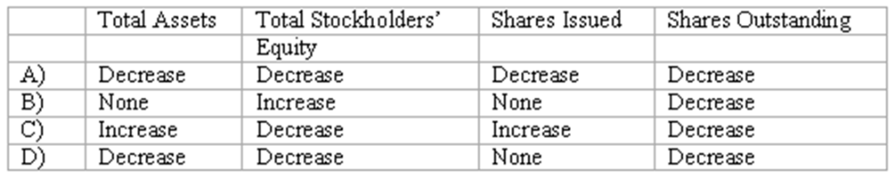
A. Option A
B. Option B
C. Option C
D. Option D

80. Which of the following does not appear in a corporate income statement?
A. Gains and losses from treasury stock transactions.
B. Income tax expense.
C. The income or loss from a segment of the business that has been discontinued during the current year.
D. Gains and losses not expected to recur in the foreseeable future.

81. When treasury stock is reissued at a price above cost:
A. The corporation recognizes a gain to be recorded on the income statement.
B. Total paid-in capital is increased.
C. The re-issuance is treated as an extraordinary item in the corporation's income statement.
D. Retained earnings is increased.

82. A 2-for-1 stock split will have what effect upon the following items?
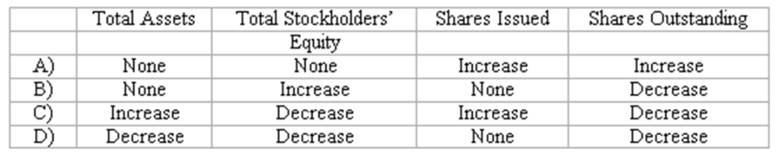
A. Option A
B. Option B
C. Option C
D. Option D

83. Zigma Corporation is authorized to issue 2,000,000 shares of $4 par value capital stock. The corporation issued half the stock for cash at $8 per share, earned $336,000 during the first three months of operation, and declared a cash dividend of $60,000. The total paid-in capital of Zigma Corporation after three months of operation is:
A. $7,940,000.
B. $8,000,000.
C. $8,276,000.
D. $8,336,000.

84. Thurman Corporation issued 450,000 shares of $.50 par value capital stock at its date of incorporation for cash at a price of $4 per share. During the first year of operations, the company earned $100,000 and declared a dividend of $40,000. At the end of this first year of operations, the balance of the Common Stock account is:
A. $1,800,000.
B. $1,860,000.
C. $225,000.
D. $1,820,000.

85. Century Corporation issued 400,000 shares of $4 par value common stock at the time of its incorporation. The stock was issued for cash at a price of $16 per share. During the first year of operations, the company sustained a net loss of $100,000. The year-end balance sheet would show the balance of the Common Stock account to be:
A. $1,600,000.
B. $1,500,000.
C. $6,300,000.
D. $6,400,000.

86. Mayfair Corporation has outstanding 70,000 shares of $1 par value common stock as well as 20,000 shares of 7%, $100 par value cumulative preferred stock. At the beginning of the year, the balance in retained earnings was $800,000, and one year's dividends were in arrears. Net income for the current year is $580,000. Compute the balance in retained earnings at the end of the year if Mayfair Corporation pays a dividend of $3 per share on its common stock this year.
A. $1,080,000.
B. $1,670,000.
C. $890,000.
D. $310,000.

87. Shore and Gardiner each own 10,000 shares of S&G Corporation $12 par value stock which they purchased for $38 per share directly from the corporation. If Shore sells his stock to Gardiner for $475,000:
A. Stockholders' equity of S&G Corporation increases.
B. Assets of S&G Corporation increase.
C. Stockholders' equity of S&G Corporation decreases.
D. No account of S&G Corporation is affected.

88. Coronet Corp. has total stockholders' equity of $7,400,000. The company's outstanding capital stock includes 100,000 shares of $10 par value common stock and 20,000 shares of 6%, $100 par value preferred stock. (No dividends are in arrears.) The book value per share of common stock is:
A. $39.
B. $49.
C. $54.
D. $74.

89. Marks Corporation has total stockholders' equity of $7,400,000. The company has outstanding 300,000 shares of $1 par value common stock and 20,000 shares of 8% preferred stock, $100 par value. (No dividends are in arrears.) The book value per share of common stock is:
A. $9.00.
B. $24.06.
C. $24.66.
D. $18.00.

90. Seville Corporation has net assets of $2,072,000 and paid-in capital of $700,000. The only stock issue consists of 74,000 outstanding shares of common stock. From this information, it can be deduced that the company has:
A. Retained earnings of $2,072,000.
B. A deficit of $2,072,000.
C. A book value of $9.46 per share of common stock.
D. A book value of $28 per share of common stock.

91. Santa Fe Boat Yard has total stockholders' equity of $4,100,000, comprised of the following:
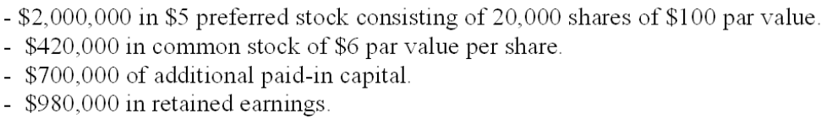
Assuming there are no dividends in arrears, the book value per share of common stock is:
A. $30.00.
B. $58.57.
C. $45.71.
D. $6.00.

On January 1, 2009, Juniper Corporation issued 60,000 shares of its total 200,000 authorized shares of $4 par value common stock for $8 per share. On December 31, 2009, Juniper Corporation's common stock is trading at $12 per share.

92. Refer to the information above. Assuming Juniper Corporation did not issue any more common stock in 2009, how does the increase in value of its outstanding stock affect Juniper?
A. Juniper should recognize additional net income for 2009 of $4 per share, or $240,000.
B. Paid-in capital at December 31, 2009, is $720,000 (i.e., 60,000 shares times $12 per share).
C. This increase in market value of outstanding stock is not recorded in the financial statements of Juniper Corporation.
D. Each shareholder must pay an additional $4 per share to Jupiter.

93. Refer to the information above. Assume Juniper Corporation decides to issue an additional 1,000 shares of its common stock on December 31, 2009. How will the above increase in value affect Juniper?
A. Juniper can issue the 1,000 shares at a higher price than the initial 60,000 shares.
B. Juniper can sell the 1,000 shares for $12 each, as well as collect an additional $4 per share for each of the 60,000 shares sold initially.
C. Juniper reports a gain of $4 per share on all stock sold during the year.
D. Paid-in capital at the end of 2009 will be $732,000 (i.e., 61,000 shares times $12 per share).

Shown below is information relating to the stockholders' equity of Grant Corporation at December 31, 2009:
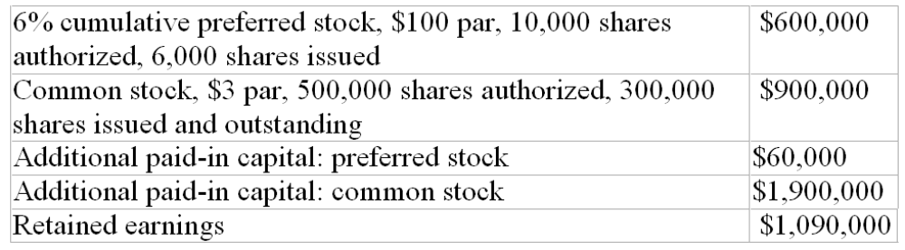
Dividends have been declared and paid for 2009.

94. Grant's total legal capital at December 31, 2009, is:
A. $3,160,000.
B. $3,000,000.
C. $2,590,000.
D. $1,500,000.

95. The total amount of Grant's paid-in capital at December 31, 2009, is:
A. $1,960,000.
B. $1,090,000.
C. $3,460,000.
D. $1,950,000.

96. The average issue price per share of Grant's preferred stock was:
A. $112.
B. $100.
C. $110.
D. $66.

97. The book value per share of common stock is:
A. $7.90.
B. $13.17.
C. $9.10.
D. $15.17.

98. The balance in Retained Earnings at the beginning of the year was $950,000, and there were no dividends in arrears. Net income for 2009 was $980,000. What was the amount of dividend declared on each share of common stock during 2009?
A. $2.50.
B. $2.08.
C. $2.00.
D. $2.68.

99. On September 1, 2009, Maryland Corporation's common stock was selling at a market price of $200 per share. On that date, Maryland announced a 3 for 2 stock split. At what price would you expect the stock to trade immediately after the split goes into effect?
A. $100.
B. $200.
C. $133.33.
D. $225.

Shown below is information relating to the stockholders' equity of Reeve Corporation as of December 31, 2009:
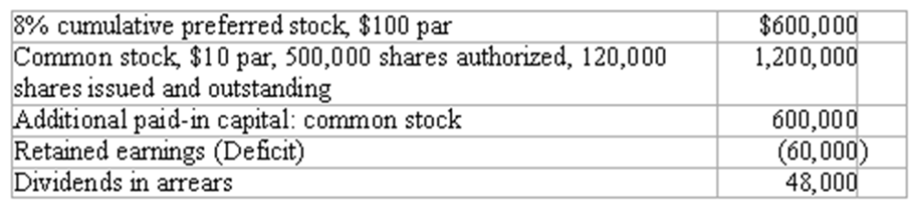

100. Refer to the information above. How many shares of preferred stock are issued and outstanding?
A. 75,000 shares.
B. 6,000 shares.
C. 60,000 shares.
D. 120,000 shares.

101. Refer to the information above. What was the original issue price per share of common stock?
A. $10.00 per share.
B. $2.40 per share.
C. $15.00 per share.
D. $8.00 per share.

102. Refer to the information above. What is total paid-in capital?
A. $2,292,000.
B. $1,800,000.
C. $2,400,000.
D. $2,340,000.

103. Refer to the information above. Total stockholders' equity is:
A. $2,400,000.
B. $2,460,000.
C. $2,340,000.
D. $2,292,000.

104. Refer to the information above. Book value per share of common stock (rounded to the nearest penny) is:
A. $30.20 per share.
B. $28.20 per share.
C. $31.80 per share.
D. $38.20 per share.

105. The following two items are disclosed in the stockholders' equity section of Riverside Corporation's December 31, 2009, balance sheet:
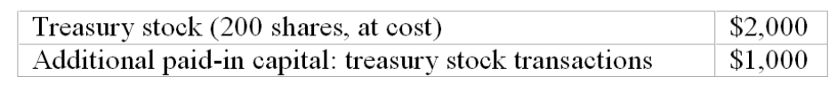
If the company had reacquired 700 shares of treasury stock in February of 2009, then for what amount was the other treasury stock sold for during 2009?
A. $2 per share above its par value.
B. $2 per share.
C. $2 per share above its cost.
D. $22 per share above its cost.

On April 1, 2011, Jetter Corporation reacquired 2,000 shares of its own $10 par stock for $120,000 cash. On October 15, 2011, 600 of the treasury shares were reissued at a price of $65 per share.

106. Refer to the information above. The reacquisition of the 2,000 shares on April 1, 2011, causes:
A. No change in total assets of Jetter Corporation.
B. No change in the number of shares of Jetter Corporation stock outstanding.
C. A reduction in total assets and in total stockholders' equity of Jetter Corporation.
D. Jetter Corporation to show a new asset, "Treasury Stock", for $120,000.

107. Refer to the information above. The journal entry to record the reissuance of the 600 shares of stock on October 15 includes a:
A. Credit to Common Stock of $6,000.
B. Credit to Additional Paid-In Capital: Treasury Stock Transactions of $3,000.
C. Credit to Gain on Treasury Stock Transactions of $3,000.
D. Credit to Treasury Stock Reissued of $39,000.

108. Refer to the information above. Assuming there are no further transactions involving treasury stock in 2011, the financial statements of Jetter Corporation for 2011 will show:
A. Treasury Stock of $81,000 among the assets in the balance sheet.
B. Gain on Sale of Treasury Stock of $3,000 in the income statement for 2011.
C. Treasury Stock of $120,000 as a deduction in the stockholders' equity section of the December 31, 2011, balance sheet.
D. Additional Paid-In Capital: Treasury Stock Transactions of $3,000 in the December 31, 2011 balance sheet.

Shown below is information relating to the stockholders' equity of Brookdale Corporation at December 31, 2010:
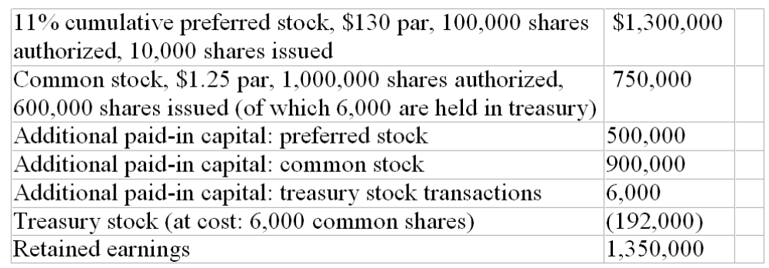

109. Refer to the information above. The average issue price per share of the preferred stock was:
A. $150.
B. $165.
C. $180.
D. $195.

110. Refer to the information above. What was the average issue price per share of common stock?
A. $2.75.
B. $1.25.
C. $1.50.
D. $3.75.

111. Refer to the information above. How many shares of common stock are outstanding?
A. 600,000.
B. 606,000.
C. 594,000.
D. 1,000,000.

112. Refer to the information above. If Brookdale Corporation had reacquired 7,000 shares of treasury stock early in 2010, and this was the company's only treasury stock transaction, then some treasury stock must have been sold during 2010 for:
A. $32 per share.
B. $38 per share.
C. $27 per share.
D. $6 per share.

Vision Corporation has the following information on its financial statement:
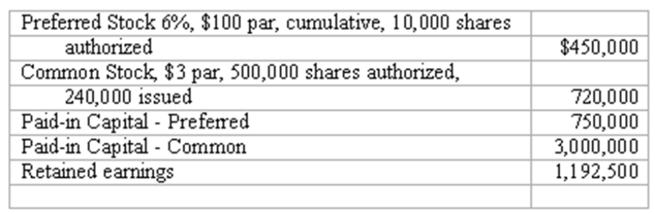

113. Refer to the information above. If Vision paid a total of $55,800 in dividends, how much would each common stockholder receive for each share of stock owned? (Assume there are no dividends in arrears)
A. $0.12.
B. $0.24.
C. $0.06.
D. $0.18.

114. Refer to the information above. If Vision did not pay a dividend for the last two years, but declared a dividend this year, how much will they have to declare in order for the common stockholders to receive $.45 per share?
A. $189,000.
B. $306,000.
C. $108,000.
D. $162,000.

115. Refer to the information above. If Vision decided to purchase 50,000 shares of its common stock to be used for future stock option plans at $9.50 per share, what journal entry would they make?
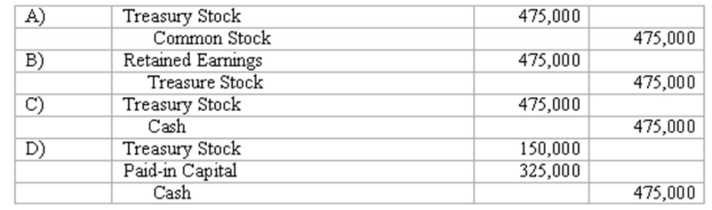
A. Option A
B. Option B
C. Option C
D. Option D

Amelia Corporation has the following information in its financial statement:
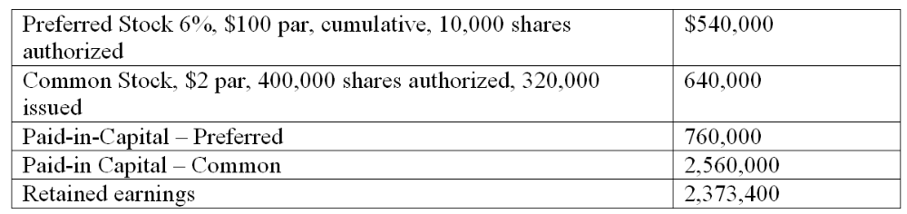

116. Refer to the information above. If Amelia paid a total of $75,000 in dividends, how much would each common stockholder receive for each share of stock owned? (Assume there are no dividends in arrears)
A. $0.23.
B. $0.13.
C. $0.18.
D. $0.08.

117. Refer to the information above. How many shares of preferred stock are outstanding?
A. 32,400 shares.
B. 5,400 shares.
C. 10,000 shares.
D. The number of shares cannot be determined without more information.

118. Refer to the information above. If Amelia did not pay a dividend for the last two years, but declared a $250,000 dividend this year, how much will the common stockholders receive?
A. $152,800.
B. $250,000.
C. $97,200.
D. $217,600.

119. Refer to the information above. If Amelia decided to purchase 20,000 shares of its common stock to be used for future stock option plans at $11.40 per share, what journal entry would they make? 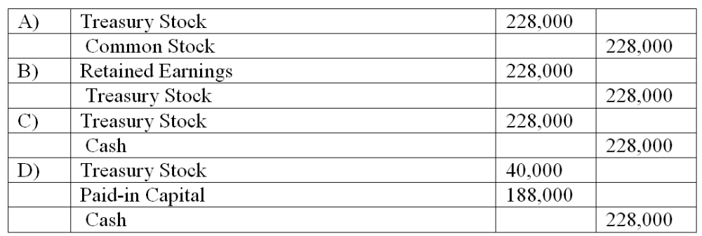
A. Option A
B. Option B
C. Option C
D. Option D

120. On January 1, 2011, Aili Corporation issued 60,000 shares of its total 200,000 authorized shares of $4 par value common stock for $18 per share. On December 31, 2011, Aili Corporation's common stock is trading at $32 per share. Assume Aili Corporation decides to issue an additional 10,000 shares of its common stock on December 31, 2011. How will the above increase in value affect Jupiter?
A. Aili can issue the 10,000 shares at a higher price than the initial 60,000 shares.
B. Aili can sell the 10,000 shares for $32 each, as well as collect an additional $14 per share for each of the 60,000 shares sold initially.
C. Aili reports a gain of $14 per share on all stock sold during the year.
D. Paid-in capital at the end of 2011 will be $2,240,000 (i.e., 70,000 shares times $32 per share).

121. On September 1, 2011, Miami Corporation's common stock was selling at a market price of $300 per share. On that date, Miami announced a 2 for 1 stock split. At what price would you expect the stock to trade immediately after the split goes into effect?
A. $100.
B. $150.
C. $200.
D. $600.

122. On September 1, 2011, Miami Corporation's common stock was selling at a market price of $25 per share. On that date, Miami announced a 1 for 4 stock split. At what price would you expect the stock to trade immediately after the split goes into effect?
A. $100.
B. $25.
C. $6.25.
D. $50.

123. On April 16, 2010, Rodriguez Corporation reacquired 12,000 shares of its own $10 par stock for $660,000 cash. On November 4, 2011, 1,000 of the treasury shares were reissued at a price of $65 per share. The journal entry to record the reissuance of the 1,000 shares of stock on November 4 includes a:
A. Credit to Common Stock of $10,000.
B. Credit to Additional Paid-In Capital: Treasury Stock Transactions of $10,000.
C. Credit to Gain on Treasury Stock Transactions of $10,000.
D. Credit to Treasury Stock Reissued of $65,000.

Shown below is information relating to the stockholders' equity of Clydsdale Corporation at December 31, 2010:
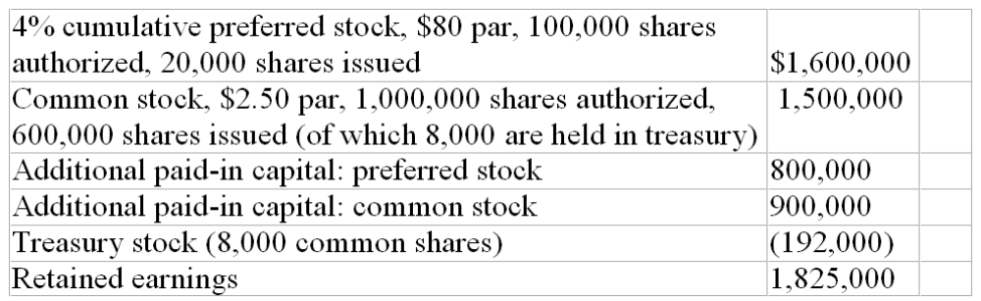

124. Refer to the information above. The average issue price per share of the preferred stock was:
A. $40.
B. $80.
C. $120.
D. $160.

125. Refer to the information above. If Clydesdale Corporation had reacquired the 8,000 shares of treasury stock early in 2010, what was the purchase price per share?
A. $2.50 per share.
B. $4.00 per share.
C. $24 per share.
D. More information is needed to determine the purchase price.

Essay Questions
126. Accounting terminology
Listed below are nine technical accounting terms introduced in this chapter:
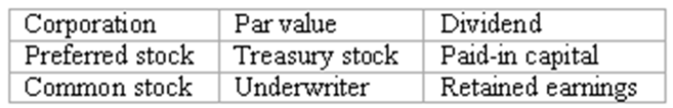
Each of the following statements may (or may not) describe one of these technical terms. In the space provided beside each statement, indicate the accounting term described, or answer "None" if the statement does not correctly describe any of the terms.
____ (a) The type of stock whose owners have little say in management of the corporation and whose annual dividend is limited to a preset amount.
____ (b) Distribution of cash or other company assets to the owners of a corporation.
____ (c) An investment banking firm that guarantees an issuing corporation a specific price for a stock issue and then makes a profit by selling the shares to the investing public at a higher price.
____ (d) Shares of a corporation's stock that have been issued and then reacquired, but not cancelled.
____ (e) An element of stockholders' equity arising from the profitable operations of a business.
____ (f) The type of stock most likely to increase dramatically in value if the issuing corporation is extremely successful.
____ (g) Amounts invested in a corporation by its stockholders.

127. Stockholders' equity section of a balance sheet
Shown below are selected account balances from the accounting records of Hyde Corporation at December 31, 2010:
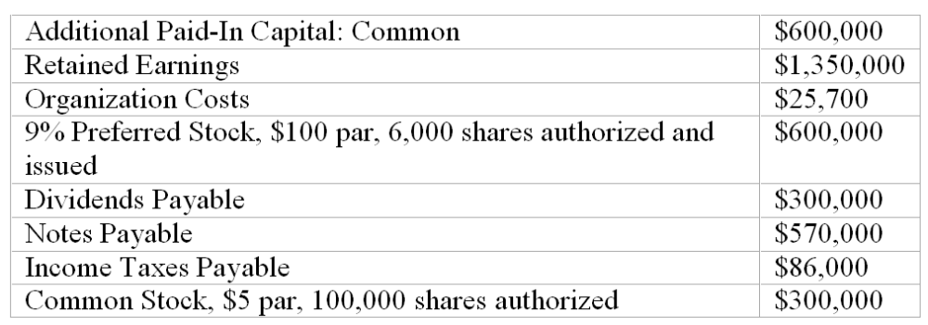
Complete the stockholders' equity section using the data provided above:
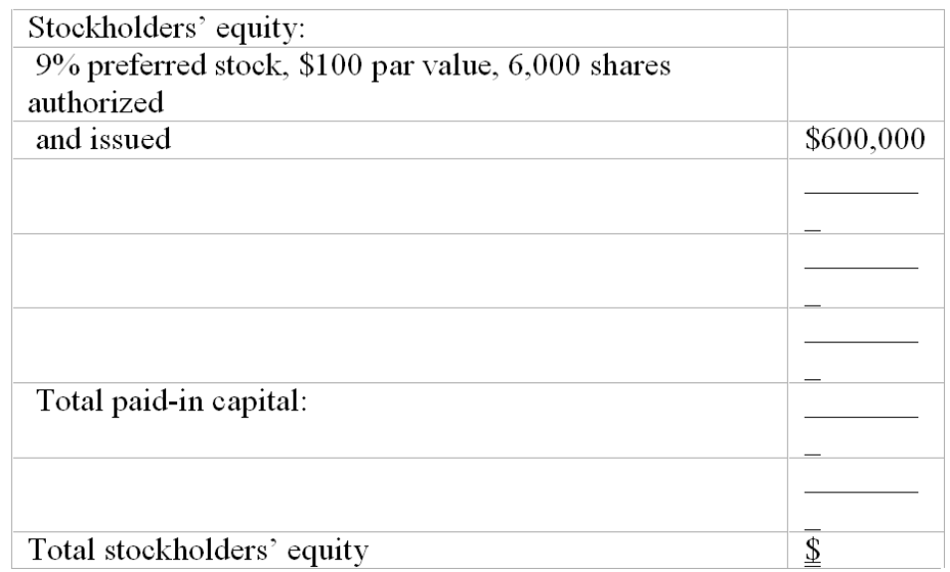

128. Cash dividends and two classes of stock
Raymond Inc., has two classes of capital stock outstanding: 25,000 shares of 5%, $100 par value cumulative preferred and 30,000 shares of $10 par value common. The company had a deficit (negative balance in retained earnings) of $160,000 at the beginning of the current year, and preferred dividends were three years in arrears. During the current year, the company earned net income of $970,000. What will be the balance in the Retained Earnings account at the end of the current year if the company takes all the actions necessary to pay a dividend of $2.50 per share on the common stock? $_______________

129. Interpreting the stockholders' equity section
The stockholders' equity section of the balance sheet of Benson Corporation (with certain details omitted) appears below:
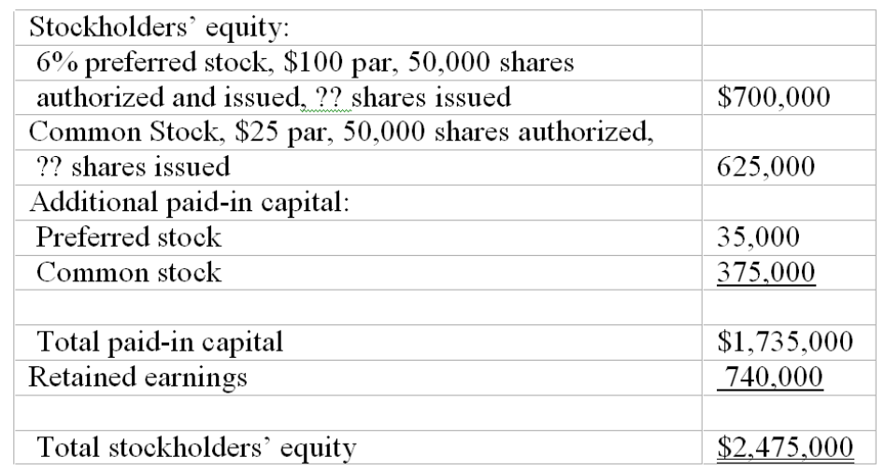
Answer the following questions based on the stockholders' equity section given above.
(a) What is the total amount of legal capital?
(b) What is the total amount of dividends paid annually to the preferred stockholders?
(c) What is the average issue price of a share of common stock?
(d) The balance in retained earnings at the beginning of the current year was $575,000, and there were no dividends in arrears. Net income for the current year was $360,000. What is the amount of the dividends declared on each share of common stock during the current year?

130. Interpreting stockholders' equity section
The stockholders' equity section of the balance sheet of Powell Corporation (with certain details omitted) appears below:
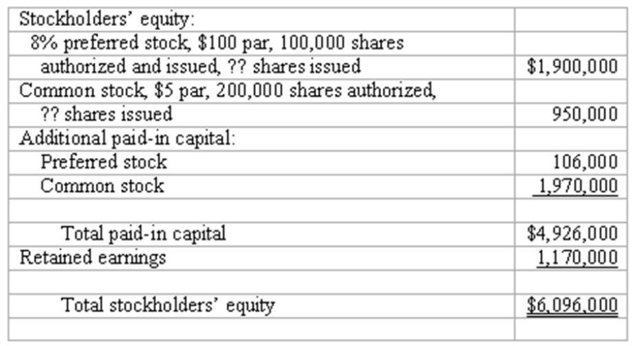
Answer the following questions based on the stockholders' equity section given above:
(a) What is the total amount of legal capital?
(b) What is the total amount of dividends paid annually to the preferred stockholders?
(c) What is the average issue price of a share of common stock?
(d) The balance in retained earnings at the beginning of the current year was $1,351,500, and there were no dividends in arrears. Net income for the current year was $700,000. What is the amount of the dividends declared on each share of common stock during the current year?

131. Prepare a stockholders' equity section
When Haven Corporation was incorporated in 2009, authorization was obtained to issue 200,000 shares of $5 par value common stock and 6,000 shares of 8% cumulative preferred stock. The preferred stock has a par value of $100. All the preferred stock was issued at $107 per share, and 110,000 shares of the common stock were sold for $9 per share. The operations of the company resulted in a net loss of $19,000 in 2009 and net income of $125,000 in 2010. In 2011, net income was $352,000, and the cash position was sufficient to allow the board of directors to declare a cash dividend of $1 per share to the common shareholders, as well as satisfy all preferred stock dividend requirements.
Complete in good form the stockholders' equity section of Haven Corporation's balance sheet at December 31, 2011. (Hint: First determine the total amount of dividends declared in 2011.)
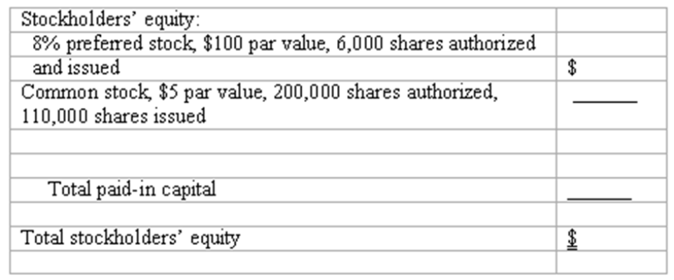

132. Prepare journal entries for stockholders' equity transactions
A partial list of the ledger accounts of Skyway Corporation is shown below, followed by a list of transactions. Indicate the accounts that would be debited and credited in recording each transaction.
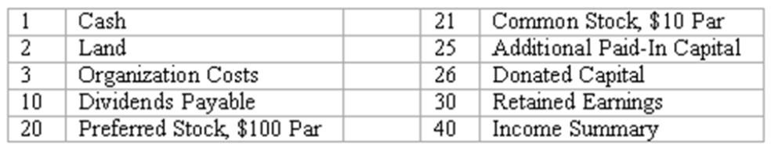
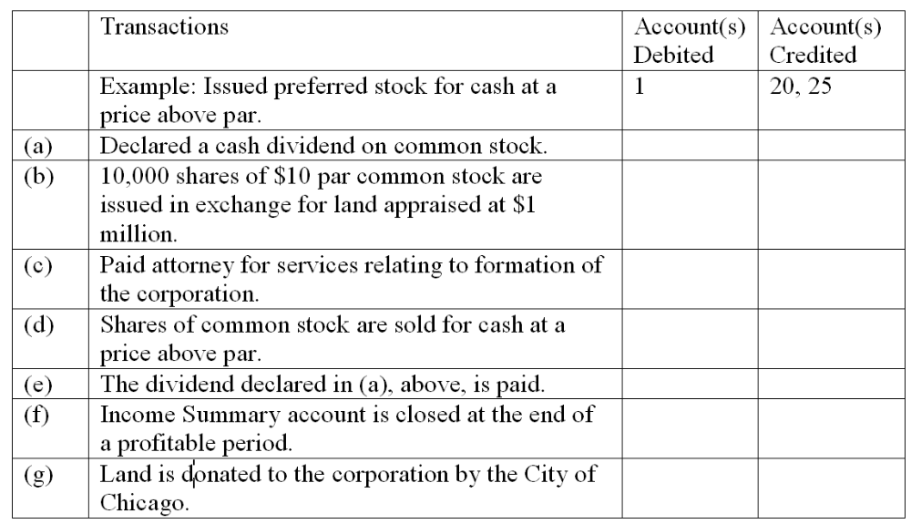

133. Prepare journal entries for stockholders' equity transactions. A partial list of the ledger accounts of Hellman Company is shown below, followed by a list of transactions. Indicate the accounts that would be debited and credited in recording each transaction.
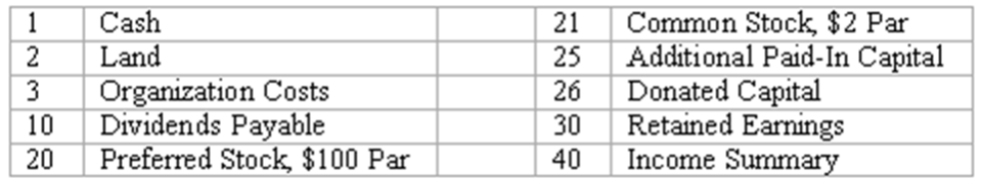
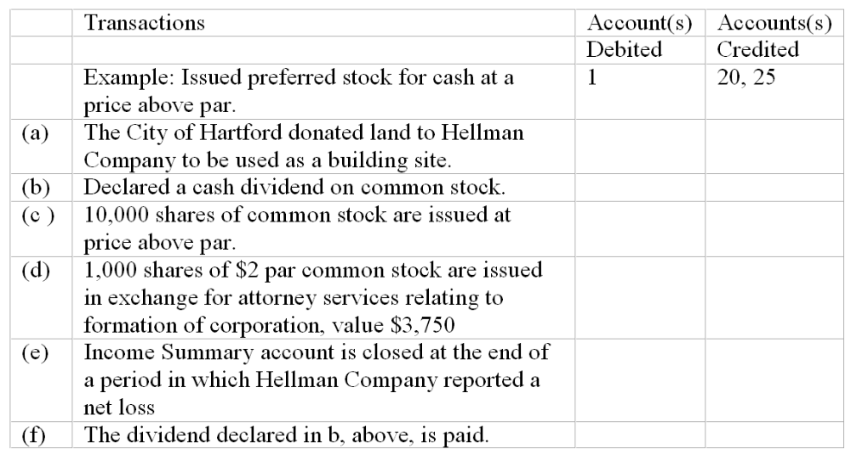

134. Determining book value per share
Shown below is information relating to the stockholders' equity of Churchill, Inc.:
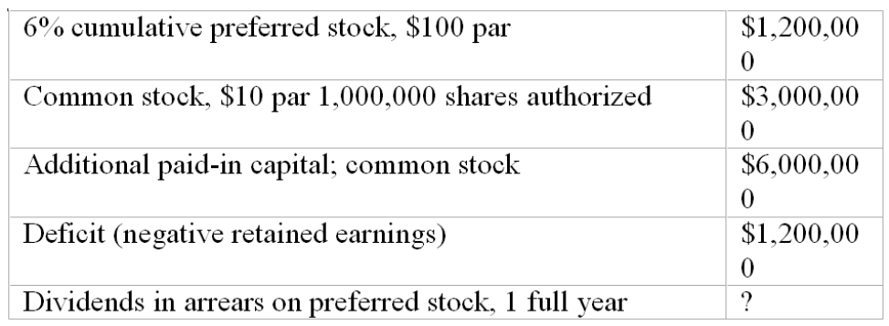
From the above information, compute the following:
(a) Number of shares of preferred stock issued and outstanding
(b) Average issue price per share of common stock
(c) Total paid-in capital
(d) Total stockholders' equity
(e) Book value per share of common stock

135. Stock values
Presented below is an excerpt from the stock listings of a recent issue of the Wall Street Journal.
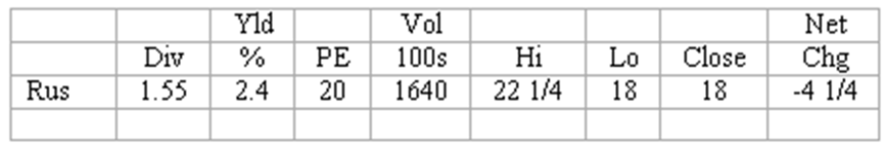
Answer the following questions based on the information about the Russell Corporation given above:
(a) How many shares of Russell Corporation stock were sold on this day?
(b) If you had purchased 10 shares of Russell Corporation stock at the lowest price of the day, what would be the total price that you would have paid for the stock?
(c) What was the closing price of Russell Corporation Stock on the previous day?
(d) If the board of directors of Russell Corporation increased the amount of the annual dividends to $1.00 per share, what would be the amount of the yield percentage on the stock?

136. Book value per share and other computations
Shown below is information relating to the stockholders' equity of Silver Waste Management at December 31, 2009:
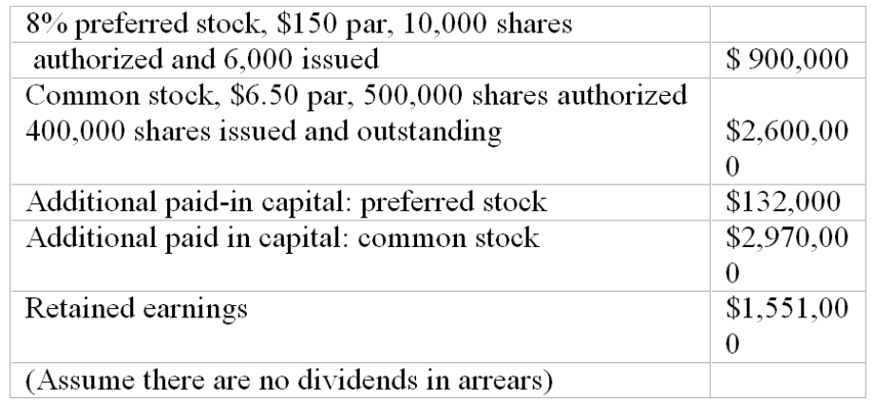
(a) White's total legal capital at December 31, 2009, is $_______________.
(b) The total amount of Silver's paid-in capital at December 31, 2009, is $________________.
(c) The average issue price per share of Silver's preferred stock was $_______.
(d) The book value per share of common stock is $_________ per share.
(e) The balance in Retained Earnings at the beginning of the year was $1,237,500, and net income for 2009 was $1,600,000. What was the amount of dividend declared on each share of common stock during 2007? $______ per share.

137. Prepare the stockholders' equity section from transaction data
Shown below is the stockholders' equity section of Jone's balance sheet at December 31, 2009.
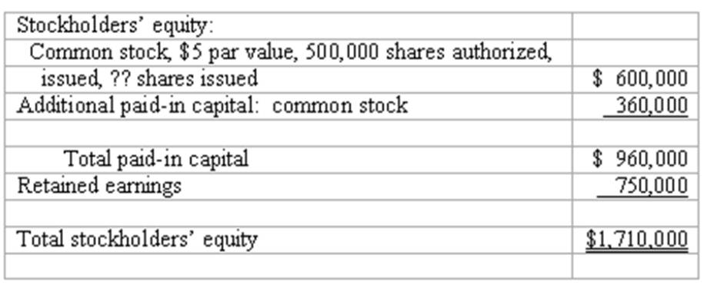
In 2009, the following events occurred:
Jones issued 2,000 shares of $5 par value common stock in exchange for legal services relating to the formation of the corporation; value of these services was set at $19,500.
Jones issued 8,000 of its 10,000 authorized shares of $8 cumulative preferred stock, $100 par value, for $108 per share.
The board of directors declared and paid dividends of $8 per share to preferred stockholders and 50 cents per share to common stockholders.
The company's net income for 2009 is $450,000.
Instructions: Complete in good form the stockholders' equity section of a balance sheet prepared for Jones at December 31, 2009.
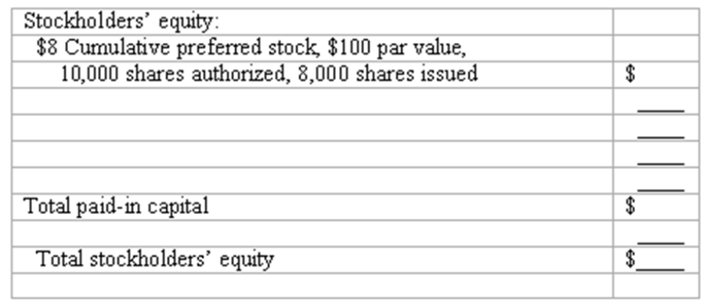

138. Prepare the stockholders' equity section from transaction data.
Shown below is the stockholders' equity section of Farrell Corporation's balance sheet at December 31, 2009:
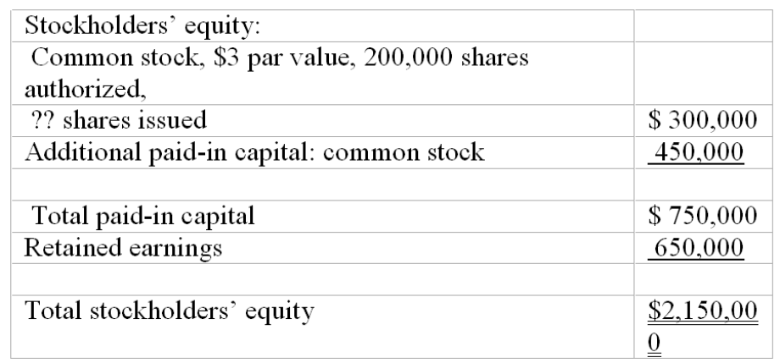
In 2010, the following events occurred:
Farrell Corporation issued 1,000 shares of $3 par common stock in exchange for land. Although several real estate appraisers disagree on the value of the land, Farrell's stock is currently selling on a stock exchange for $32 per share.
Farrell Corporation issued 3,000 shares of 5% cumulative preferred stock, $100 par value, for $108 per share.
The board of directors declared a dividend of $1 per share on the common stock.
Farrell's net income for 2010 is $375,000.
Instructions: Complete in good form the stockholders' equity section of a balance sheet prepared for Farrell Corporation at December 31, 2010:
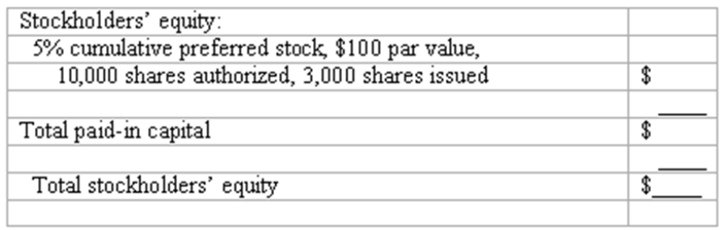

139. Treasury stock transactions.
Jackson Corporation engaged in the following treasury stock transactions during the current year:
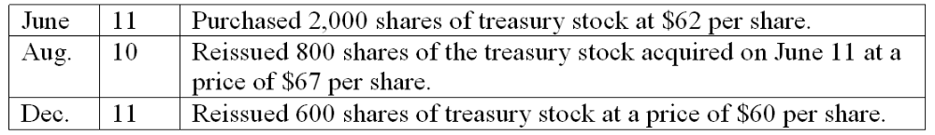
Complete the following three general journal entries to record these treasury stock transactions.
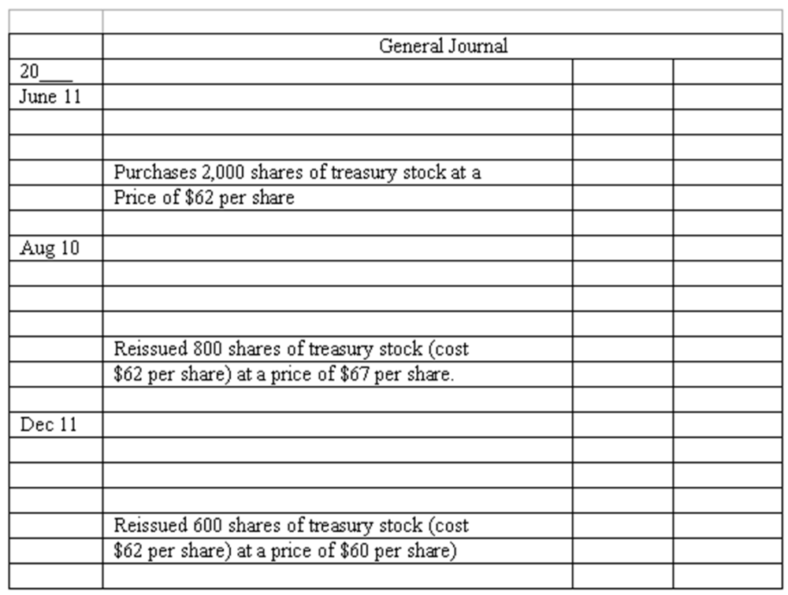

140. Financial reporting of net earnings and retained earnings
The 2012 annual report of Kirtland Products disclosed net earnings of approximately $87 million for the fiscal year ending March 31, 2012, and retained earnings of approximately $485 million as of March 31, 2012.
(a) Which financial statement shows computation of the net earnings?
(b) Which financial statement includes the retained earnings figure of $485 million?
(c) Explain why Kirtland reports $87 million as net earnings, but a much larger amount, $485 million, as retained earnings.

141. Financial reporting of net losses and retained earnings
A recent annual report of Dobbs, Inc., reported a net loss of approximately $63 million and retained earnings of approximately $1.6 billion.
(a) Which financial statement shows computation of the $63 million net loss?
(b) Which financial statement includes the retained earnings figure of $1.6 billion?
(c) Explain how it is possible for Dobbs to report both a net loss of $63 million and retained earnings of $1.6 billion in a single set of financial statements.

142. What's so "preferred" about preferred stocks?
Most preferred stocks do not have voting power, a basic right of common stock. Identify at least two features of most preferred stocks that justify or support use of the term preferred in describing these types of stock issues.

143. Factors affecting the market price of stocks
(a) Murdock Corporation has outstanding several different stock issues. For each of the types of stock listed below, briefly describe a situation or circumstance that would cause the market price of that type of stock to increase.
Preferred stock
Common stock
Convertible preferred stock
(b) How would the increase in market value of any of Murdock's stock be reflected in Murdock's financial statements?

144. Stock splits
Bainbridge Corporation recently patented an extraordinary invention that will allow average homeowners to cheaply generate a large fraction of the electricity consumed in their houses. As a result, the market price of Bainbridge's common stock has soared to $160 per share. Bainbridge is about to announce a 4 for 1 stock split. Explain why the company would take this action?

145. Stockholders' Equity
Blake Corporation has the following accounts on December 31, 2010
Common Stock $.25 par, 1,000,000 authorized, 400,000 issued.
Preferred stock 6%, $100 par, cumulative, 5,000 shares authorized, 3,000 issued.
Treasury stock, 1,500 shares purchased at market value of $6 per share
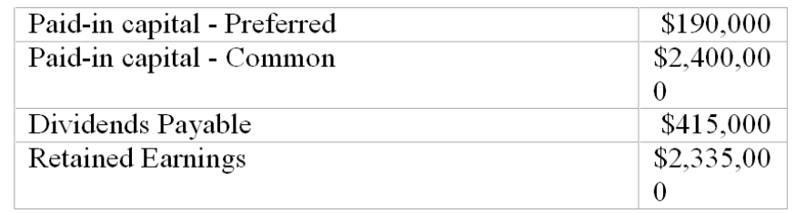
Required:
(1) Prepare the stockholders' equity section of the balance sheet.
(2) Prepare the journal entry for the purchase of the treasury stock.
(3) Blake paid the liability for dividends on March 1. Prepare the journal entry for the payment.

Multiple Choice Questions
146. Lewis Corporation issued 125,000 shares of $5 par value capital stock at date of incorporation for cash at a price of $9 per share. During the first year of operations, the company earned $140,000 and declared a dividend of $100,000. At the end of this first year of operations, the balance of the Capital Stock account is:
A. $765,000.
B. $1,000,000.
C. $625,000.
D. $665,000.

147. Perez Corporation has 100,000 shares of $1 par value common stock and 20,000 shares of 8% cumulative preferred stock, $100 par value, outstanding. The balance in Retained Earnings at the beginning of the year was $1,600,000, and one year's dividends were in arrears. Net income for the current year was $870,000. If Perez Corporation paid a dividend of $2 per share on its common stock, what is the balance in Retained Earnings at the end of the year?
A. $2,150,000.
B. $2,270,000.
C. $2,110,000.
D. $1,950,000.

148. Pike Corporation has total stockholders' equity of $8,690,000 as of December 31, 2009. The company has 300,000 shares of $2 par value common stock and 20,000 shares of 8% cumulative preferred stock, $100 par value, outstanding. Due to lower-than-expected net income, no dividends were declared by Pike's board of directors for 2009. The book value per share of common stock is:
A. $25.00.
B. $21.77.
C. $23.00.
D. $25.60.

149. Which of the following most likely explains why a corporation's stock trades at a very high price-earnings ratio?
A. Investors expect the corporation to have higher earnings in the future.
B. The corporation pays a very low dividend on its stock.
C. The corporation has several classes of stock outstanding.
D. The corporation is large with very low risk.

150. Which of the following is not a characteristic of most preferred stocks?
A. Preference as to dividends.
B. No voting power.
C. Convertible into common stock.
D. Preference as to assets in the event of liquidation of the company.

Shown below is information relating to the stockholders' equity of Revere Corporation at December 31, 2009
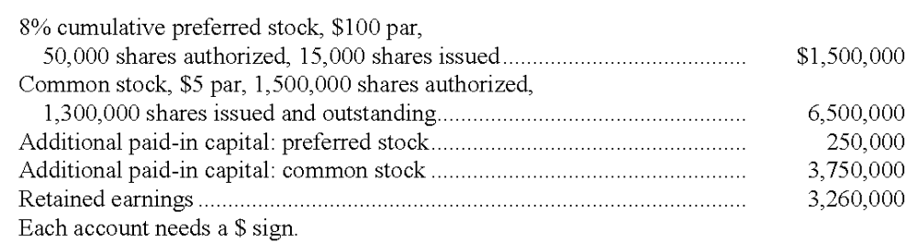

151. The average issue price per share of Revere's preferred stock was:
A. $117.
B. $100.
C. $110.
D. $34.50.

152. The total amount of Revere's paid-in capital at December 31, 2009, is:
A. $8,000,000.
B. $15,260,000.
C. $12,000,000.
D. $4,000,000.

153. Revere's total legal capital at December 31, 2009, is:
A. $12,000,000.
B. $15,260,000.
C. $11,260,000.
D. $8,000,000.

154. The book value per share of common stock, assuming current-year preferred dividends have been paid, is:
A. $9.23.
B. $10.58.
C. $8.66.
D. $6.15.

155. The balance in Retained Earnings at the beginning of the year was $2,710,000, and there were no dividends in arrears. Net income for 2009 was $2,250,000. What was the amount of dividend declared on each share of common stock during 2009?
A. $1.30.
B. $2.40.
C. $1.21.
D. $3.72.

Short Answer Questions
Shown below is information relating to the stockholders' equity of Novake Corporation at December 31, 2010:
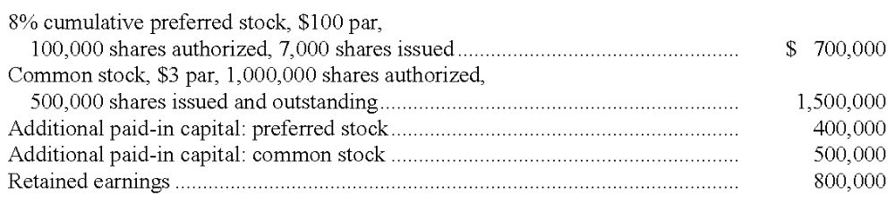
From the above information, compute the following:

156. The total amount of legal capital: $__________

157. The total amount of paid-in capital: $__________

158. The average issue price per share of preferred stock: $_____ per share

159. The book value per share of common stock (assume current-year preferred dividends have been paid) $_____ per share

160. The balance in Retained Earnings at the beginning of the year was $650,000, and there were no dividends in arrears. Net income for 2010 was $475,000. What was the amount of dividend declared on each share of common stock during 2010? $_____ per share

161. Shown below is the stockholders' equity section of Powell's balance sheet at December 31, 2009:
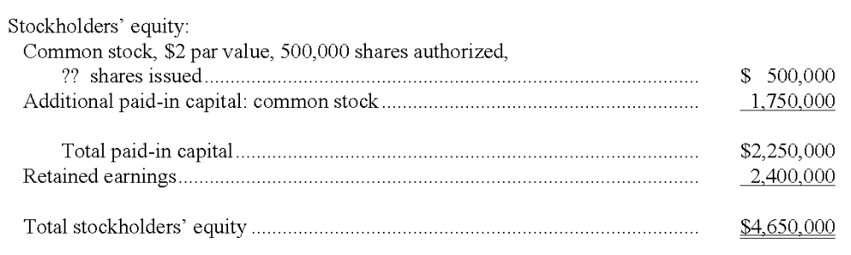
In 2010, the following events occurred:
Powell issued 2,500 shares of $2 par common stock as payment for legal services. Although Powell's stock is not traded on any exchange, the agreed-upon value of the legal services is $80,000.
Powell issued 4,500 shares of 6% cumulative preferred stock, $100 par value, for $106 per share.
The board of directors declared a dividend of $1.25 per share on the common stock.
Powell's net income for 2007 was $675,000.
Instructions
Complete in good form the stockholders' equity section of a balance sheet prepared for Powell at December 31, 2010.
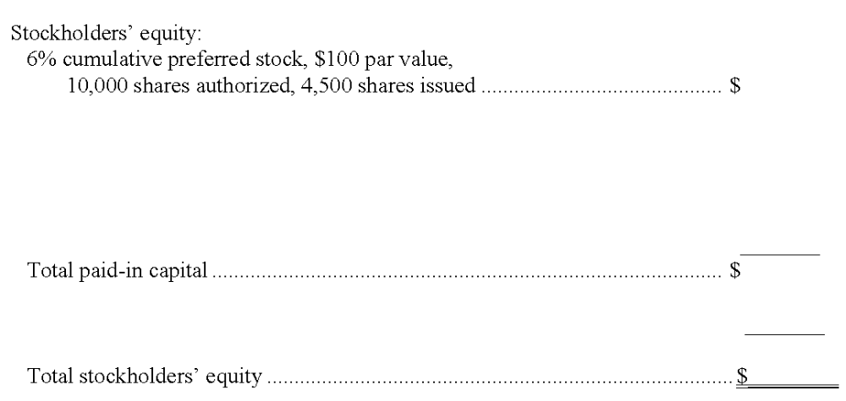

Multiple Choice Questions
162. When a business is organized as a corporation, which of the following statements is true?
A. Stockholders are liable for the debts of the business only in proportion to their percentage ownership of capital stock.
B. Stockholders do not have to pay personal income taxes on dividends received, because the corporation is subject to income taxes on its earnings.
C. Fluctuations in the market value of outstanding shares of capital stock do not affect the amount of stockholders' equity shown in the balance sheet.
D. Each stockholder has the right to bind the corporation to contracts and to make other managerial decisions.

163. Western Moving Corporation was organized with authorization to issue 100,000 shares of $1 par value common stock. Forty thousand shares were issued to Tom Morgan, the company's founder, at a price of $5 per share. No other shares have yet been issued. Which of the following statements is true?
A. Morgan owns 40 percent of the stockholders' equity of the corporation.
B. The corporation should recognize a $160,000 gain on the issuance of these shares.
C. If the balance sheet includes retained earnings of $50,000, total paid-in capital amounts to $250,000.
D. In the balance sheet, the Additional Paid-in Capital account will have a $160,000 balance, regardless of the profits earned or losses incurred since the corporation was organized.

164. Which of the following is not a characteristic of the common stock of a large, publicly owned corporation?
A. The shares may be transferred from one investor to another without disrupting the continuity of business operations.
B. Voting rights in the election of the board of directors.
C. A cumulative right to receive dividends.
D. After issuance, the market value of the stock is unrelated to its par value.

165. Tri-State Electric is a profitable utility company that has increased its dividend to common stockholders every year for 42 consecutive years. Which of the following is least likely to affect the market price of the company's preferred stock by a significant amount?
A. A decrease in long-term interest rates.
B. An increase in long-term interest rates.
C. The board of directors announces its intention to increase common stock dividends in the current year.
D. Whether or not the preferred stock carries a conversion privilege.

166. The following information is taken from the balance sheet and related disclosures of Maxwell, Inc.:
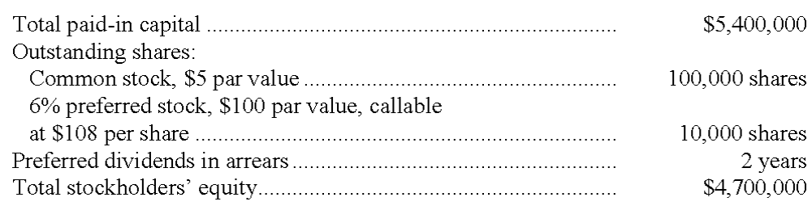
Which of the following statements is (are) true? (Fr this question, more than one answer may be correct.)
A. The preferred dividends in arrears amount to $120,000 and should appear as a liability in the corporate balance sheet.
B. The book value per share of common stock is $35.
C. The stockholders' equity section of the balance sheet should include a deficit (negative amount in retained earnings) of $700,000.
D. The company has paid no dividend on its common stock during the past two years.

167. On December 10, 2010, Smitty Corporation reacquired 2,000 shares of its own $5 par value common stock at a price of $60 per share. In 2011, 500 of the treasury shares are reissued at a price of $70 per share. Which of the following statements is correct?
A. The treasury stock purchased is recorded at cost and is shown in Smitty's December 31, 2010 balance sheet as an asset.
B. The two treasury stock transactions result in an overall net reduction in Smitty's stockholders' equity of $85,000.
C. Smitty recognizes a gain of $10 per share on the reissuance of the 500 treasury shares in 2011.
D. Smitty's stockholders' equity was increased by $110,000 when the treasury stock was acquired.

Chapter 11 Stockholders' Equity: Paid-In Capital Answer Key

True / False Questions
1. When a stockholder sends in a proxy statement to a corporation he or she owns stock in, they relinquish their voting rights to the officers of the corporation.
FALSE

AACSB: Reflective Thinking
AICPA BB: Legal
AICPA FN: Decision Making
Bloom's: Remember
Difficulty: Easy
Learning Objective: 11-03 Explain the rights of stockholders and the roles of corporate directors and officers.
Topic: Formation of a Corporation
2. A stockholders' subsidiary ledger will have entries made for each stockholder showing the number of shares held.
TRUE

AACSB: Reflective Thinking
AICPA BB: Legal
AICPA FN: Measurement
Bloom's: Remember
Difficulty: Easy
Learning Objective: 11-02 Distinguish between publicly owned and closely held corporations.
Topic: Corporations
3. The number of shares a corporation may issue is specified in the articles of incorporation and approved by the Securities and Exchange Commission.
FALSE

AACSB: Reflective Thinking
AICPA BB: Legal
AICPA FN: Measurement
Bloom's: Remember
Difficulty: Easy
Learning Objective: 11-04 Account for paid-in capital and prepare the equity section of a corporate balance sheet.
Topic: Paid-In Capital of a Corporation
4. The par value of a stock is the minimum amount of capital of the corporation existing for the protection of creditors.
TRUE

AACSB: Reflective Thinking
AICPA BB: Legal
AICPA FN: Measurement
Bloom's: Remember
Difficulty: Easy
Learning Objective: 11-04 Account for paid-in capital and prepare the equity section of a corporate balance sheet.
Topic: Paid-In Capital of a Corporation
5. When a state authorizes the sale of stock to stockholders, the corporation will credit Retained Earnings for the par value of the stock.
FALSE

AACSB: Reflective Thinking
AICPA BB: Legal
AICPA FN: Measurement
Bloom's: Remember
Difficulty: Medium
Learning Objective: 11-04 Account for paid-in capital and prepare the equity section of a corporate balance sheet.
Topic: Paid-In Capital of a Corporation
6. When a corporation fails to pay a dividend one year on its common stock, it is said to be "in arrears."
FALSE

AACSB: Reflective Thinking
AICPA BB: Critical Thinking
AICPA FN: Measurement
Bloom's: Remember
Difficulty: Easy
Learning Objective: 11-05 Contrast the features of common stock with those of preferred stock.
Topic: Paid-In Capital of a Corporation
7. A stock split will normally increase the market price of the stock and decrease the number of shares on the market.
FALSE

AACSB: Reflective Thinking
AICPA BB: Legal
AICPA FN: Measurement
Bloom's: Understand
Difficulty: Easy
Learning Objective: 11-08 Explain the purpose and effects of a stock split.
Topic: Market Value
8. Treasury stock is stock that is issued and outstanding but not authorized.
FALSE

AACSB: Reflective Thinking
AICPA BB: Critical Thinking
AICPA FN: Measurement
Bloom's: Remember
Difficulty: Easy
Learning Objective: 11-09 Account for treasury stock transactions.
Topic: Treasury Stock
9. The purchase of treasury stock creates an asset for the corporation and is recorded at the cost of the shares purchased, not par value.
FALSE

AACSB: Reflective Thinking
AICPA BB: Critical Thinking
AICPA FN: Measurement
Bloom's: Remember
Difficulty: Medium
Learning Objective: 11-09 Account for treasury stock transactions.
Topic: Treasury Stock
10. Contributed capital is equivalent to paid-in capital.
TRUE

AACSB: Reflective Thinking
AICPA BB: Critical Thinking
AICPA FN: Measurement
Bloom's: Remember
Difficulty: Easy
Learning Objective: 11-04 Account for paid-in capital and prepare the equity section of a corporate balance sheet.
Topic: Paid-In Capital of a Corporation
11. Common stock is considered the legal capital of the corporation.
FALSE

AACSB: Reflective Thinking
AICPA BB: Legal
AICPA FN: Measurement
Bloom's: Remember
Difficulty: Easy
Learning Objective: 11-04 Account for paid-in capital and prepare the equity section of a corporate balance sheet.
Topic: Paid-In Capital of a Corporation
12. Cumulative preferred stock means the stock is entitled to its regular dividend plus an additional share of the total amount of declared dividends.
FALSE

AACSB: Reflective Thinking
AICPA BB: Legal
AICPA FN: Measurement
Bloom's: Remember
Difficulty: Medium
Learning Objective: 11-05 Contrast the features of common stock with those of preferred stock.
Topic: Paid-In Capital of a Corporation
13. A corporation is a legal entity separate from its owners; it may sue and be sued, but it may not own property in its own name.
FALSE

AACSB: Reflective Thinking
AICPA BB: Legal
AICPA FN: Measurement
Bloom's: Remember
Difficulty: Easy
Learning Objective: 11-01 Discuss the advantages and disadvantages of organizing a business as a corporation.
Topic: Corporations
14. A corporation continues in existence even if a stockholder dies or withdraws from the organization.
TRUE

AACSB: Reflective Thinking
AICPA BB: Legal
AICPA FN: Measurement
Bloom's: Remember
Difficulty: Easy
Learning Objective: 11-01 Discuss the advantages and disadvantages of organizing a business as a corporation.
Topic: Corporations
15. Treasury stock is stock of a corporation that has been issued and then reacquired and then cancelled.
FALSE

AACSB: Reflective Thinking
AICPA BB: Legal
AICPA FN: Measurement
Bloom's: Remember
Difficulty: Easy
Learning Objective: 11-09 Account for treasury stock transactions.
Topic: Treasury Stock
16. A stock split will decrease the total par value of the stock.
FALSE

AACSB: Reflective Thinking
AICPA BB: Critical Thinking
AICPA FN: Measurement
Bloom's: Remember
Difficulty: Easy
Learning Objective: 11-08 Explain the purpose and effects of a stock split.
Topic: Market Value
17. Stockholders of a corporation are personally liable for the debts of the corporation if all shares of stock are owned by the officers of the corporation.
FALSE

AACSB: Reflective Thinking
AICPA BB: Legal
AICPA FN: Measurement
Bloom's: Remember
Difficulty: Easy
Learning Objective: 11-01 Discuss the advantages and disadvantages of organizing a business as a corporation.
Topic: Corporations
18. It is illegal for the government to double tax corporate earnings.
FALSE

AACSB: Reflective Thinking
AICPA BB: Legal
AICPA FN: Measurement
Bloom's: Remember
Difficulty: Easy
Learning Objective: 11-01 Discuss the advantages and disadvantages of organizing a business as a corporation.
Topic: Corporations
19. Only preferred stock of a corporation must have a par value.
FALSE

AACSB: Reflective Thinking
AICPA BB: Legal
AICPA FN: Measurement
Bloom's: Remember
Difficulty: Medium
Learning Objective: 11-05 Contrast the features of common stock with those of preferred stock.
Topic: Paid-In Capital of a Corporation
20. International accounting standards require mandatory redeemable preferred stock to be classified as a liability on the balance sheet and not as equity.
TRUE

AACSB: Reflective Thinking
AICPA BB: Global
AICPA FN: Measurement
Bloom's: Remember
Difficulty: Medium
Learning Objective: 11-05 Contrast the features of common stock with those of preferred stock.
Topic: Paid-In Capital of a Corporation
21. To be consistent with international standards, the FASB has changed reporting requirements for redeemable preferred stock to require it to be reported in the equity section.
FALSE

AACSB: Reflective Thinking
AICPA BB: Global
AICPA FN: Measurement
Bloom's: Remember
Difficulty: Medium
Learning Objective: 11-05 Contrast the features of common stock with those of preferred stock.
Topic: Paid-In Capital of a Corporation
22. If capital stock is issued by a corporation at a price lower than par value, the difference represents a loss in the period in which the shares of stock are issued.
FALSE

AACSB: Reflective Thinking
AICPA BB: Critical Thinking
AICPA FN: Measurement
Bloom's: Understand
Difficulty: Medium
Learning Objective: 11-04 Account for paid-in capital and prepare the equity section of a corporate balance sheet.
Topic: Paid-In Capital of a Corporation
23. When par value capital stock is issued, capital stock is credited with the par value of the shares issued, regardless of whether the issuance price is equal to par, more than par, or less than par.
TRUE

AACSB: Reflective Thinking
AICPA BB: Critical Thinking
AICPA FN: Measurement
Bloom's: Understand
Difficulty: Medium
Learning Objective: 11-04 Account for paid-in capital and prepare the equity section of a corporate balance sheet.
Topic: Paid-In Capital of a Corporation
24. Preferred stockholders are owners of the corporation and have rights upon liquidation and to receive dividends.
TRUE

AACSB: Reflective Thinking
AICPA BB: Legal
AICPA FN: Measurement
Bloom's: Remember
Difficulty: Easy
Learning Objective: 11-05 Contrast the features of common stock with those of preferred stock.
Topic: Paid-In Capital of a Corporation
25. Paid-in-capital includes donated capital.
TRUE

AACSB: Reflective Thinking
AICPA BB: Critical Thinking
AICPA FN: Measurement
Bloom's: Remember
Difficulty: Easy
Learning Objective: 11-04 Account for paid-in capital and prepare the equity section of a corporate balance sheet.
Topic: Paid-In Capital of a Corporation
26. In the event of the liquidation of a corporation, treasury stock ordinarily has preference as to liabilities, while preferred stock has preference as to assets.
FALSE

AACSB: Reflective Thinking
AICPA BB: Legal
AICPA FN: Measurement
Bloom's: Remember
Difficulty: Medium
Learning Objective: 11-03 Explain the rights of stockholders and the roles of corporate directors and officers.
Topic: Formation of a Corporation
27. Preferred stockholders generally do not have the same voting rights as do common stockholders in a corporation.
TRUE

AACSB: Reflective Thinking
AICPA BB: Legal
AICPA FN: Measurement
Bloom's: Remember
Difficulty: Easy
Learning Objective: 11-03 Explain the rights of stockholders and the roles of corporate directors and officers.
Topic: Formation of a Corporation
28. By going public a corporation can raise equity capital from many investors.
TRUE

AACSB: Reflective Thinking
AICPA BB: Resource Management
AICPA FN: Measurement
Bloom's: Remember
Difficulty: Easy
Learning Objective: 11-02 Distinguish between publicly owned and closely held corporations.
Topic: Corporations
29. When assets are donated to a corporation, a revenue account should be credited for the fair market value of the assets received.
FALSE

AACSB: Reflective Thinking
AICPA BB: Critical Thinking
AICPA FN: Measurement
Bloom's: Understand
Difficulty: Medium
Learning Objective: 11-04 Account for paid-in capital and prepare the equity section of a corporate balance sheet.
Topic: Paid-In Capital of a Corporation
30. A corporation must always have more than one class of stock.
FALSE

AACSB: Reflective Thinking
AICPA BB: Legal
AICPA FN: Measurement
Bloom's: Remember
Difficulty: Medium
Learning Objective: 11-05 Contrast the features of common stock with those of preferred stock.
Topic: Paid-In Capital of a Corporation
31. The purchase of treasury stock for cash causes no change in total assets.
FALSE

AACSB: Reflective Thinking
AICPA BB: Critical Thinking
AICPA FN: Measurement
Bloom's: Remember
Difficulty: Medium
Learning Objective: 11-09 Account for treasury stock transactions.
Topic: Treasury Stock
32. The sale of treasury stock at a price in excess of its cost results in a realized gain which should be presented as a non-operating item in the income statement.
FALSE

AACSB: Reflective Thinking
AICPA BB: Critical Thinking
AICPA FN: Measurement
Bloom's: Understand
Difficulty: Medium
Learning Objective: 11-09 Account for treasury stock transactions.
Topic: Treasury Stock
33. Inside directors of a corporation may be officers of the corporation and therefore are not considered independent.
TRUE

AACSB: Reflective Thinking
AICPA BB: Legal
AICPA FN: Risk Analysis
Bloom's: Remember
Difficulty: Medium
Learning Objective: 11-03 Explain the rights of stockholders and the roles of corporate directors and officers.
Topic: Formation of a Corporation

Multiple Choice Questions
34. The advantages of corporations going public include all of the following except:
A. Professional management.
B. Transferability of ownership.
C. Limited shareholder liability.
D. Ability to remove assets.

AACSB: Reflective Thinking
AICPA BB: Resource Management
AICPA FN: Measurement
Bloom's: Understand
Difficulty: Easy
Learning Objective: 11-01 Discuss the advantages and disadvantages of organizing a business as a corporation.
Topic: Corporations
35. In a "pump-and-dump" scheme, the owners of the company:
A. Falsely claim the business has high growth potential.
B. Artificially raise the price of the stock.
C. Sell the stock at a high price.
D. Falsely claim the business has high growth potential, artificially raise the price of the stock, and sell the stock at a high price.

AACSB: Ethics
AICPA BB: Legal
AICPA FN: Measurement
Bloom's: Remember
Difficulty: Medium
Learning Objective: 11-06 Discuss the factors affecting the market price of preferred stock and common stock.
Topic: Market Value
36. In order to limit the use of a shell company, the SEC has proposed:
A. Greater financial disclosures.
B. Eliminating this type of company.
C. Arresting promoters of shell companies for fraud.
D. That its stock only be sold in foreign countries.

AACSB: Ethics
AICPA BB: Legal
AICPA FN: Measurement
Bloom's: Understand
Difficulty: Medium
Learning Objective: 11-06 Discuss the factors affecting the market price of preferred stock and common stock.
Topic: Market Value
37. The ownership of common stock in a corporation usually carries the following rights:
A. To vote for directors.
B. To declare dividends.
C. To share in a distribution of assets if the corporation is to be liquidated.
D. Both declare dividends and share in a distribution of assets if the corporation is to be liquidated.

AACSB: Reflective Thinking
AICPA BB: Legal
AICPA FN: Measurement
Bloom's: Remember
Difficulty: Easy
Learning Objective: 11-03 Explain the rights of stockholders and the roles of corporate directors and officers.
Topic: Formation of a Corporation
38. The board of directors' primary functions include all of the following except:
A. Hiring corporate officers.
B. Setting officers' salaries.
C. Declaring dividends.
D. Protecting the interests of the officers.

AACSB: Reflective Thinking
AICPA BB: Legal
AICPA FN: Measurement
Bloom's: Remember
Difficulty: Easy
Learning Objective: 11-03 Explain the rights of stockholders and the roles of corporate directors and officers.
Topic: Formation of a Corporation
39. Shares that have been sold and are in the hands of stockholders are called:
A. Outstanding.
B. Issued.
C. Treasury.
D. Underwritten.

AACSB: Reflective Thinking
AICPA BB: Critical Thinking
AICPA FN: Measurement
Bloom's: Remember
Difficulty: Easy
Learning Objective: 11-04 Account for paid-in capital and prepare the equity section of a corporate balance sheet.
Topic: Paid-In Capital of a Corporation
40. Book value per share of common stock is derived by which of the following:
A. Stockholders equity divided by the number of shares authorized.
B. Stockholders equity divided by the number of shares outstanding.
C. Net income divided by the number of shares outstanding.
D. Net income divided by the number of shares authorized.

AACSB: Reflective Thinking
AICPA BB: Critical Thinking
AICPA FN: Measurement
Bloom's: Understand
Difficulty: Medium
Learning Objective: 11-04 Account for paid-in capital and prepare the equity section of a corporate balance sheet.
Topic: Paid-In Capital of a Corporation
41. The net assets of a corporation are equal to:
A. Total assets-total liabilities.
B. Total assets-retained earnings.
C. Total assets + total liabilities.
D. Total assets + retained earnings.

AACSB: Reflective Thinking
AICPA BB: Critical Thinking
AICPA FN: Measurement
Bloom's: Understand
Difficulty: Easy
Learning Objective: 11-04 Account for paid-in capital and prepare the equity section of a corporate balance sheet.
Topic: Paid-In Capital of a Corporation
42. When shares of stock are sold from one investor to another, they will trade at:
A. Par value.
B. Book value.
C. Market value.
D. Stated Value.

AACSB: Reflective Thinking
AICPA BB: Critical Thinking
AICPA FN: Measurement
Bloom's: Remember
Difficulty: Easy
Learning Objective: 11-07 Explain the significance of book value and market value of capital stock.
Topic: Market Value
43. The market price of a preferred stock will be affected by:
A. The dividend rate.
B. The chance that the company will not operate profitably.
C. The level of interest rates.
D. The dividend rate, the chance that the company will not operate profitably, and the level of interest rates.

AACSB: Reflective Thinking
AICPA BB: Critical Thinking
AICPA FN: Measurement
Bloom's: Understand
Difficulty: Medium
Learning Objective: 11-06 Discuss the factors affecting the market price of preferred stock and common stock.
Topic: Market Value
44. Topper Corporation has 60,000 shares of $1 par value common stock and 16,000 shares of cumulative 7%, $100 par preferred stock outstanding. Topper has not paid a dividend for the prior year. If Topper declares a $1.95 per share dividend this year, what will be the total amount they must pay their shareholders?
A. $117,000.
B. $341,000.
C. $327,000.
D. $177,000.
2(16,000 x $7) + ($1.95 x 60,000) = $341,000

AACSB: Analytic
AICPA BB: Critical Thinking
AICPA FN: Measurement
Bloom's: Apply
Difficulty: Medium
Learning Objective: 11-05 Contrast the features of common stock with those of preferred stock.
Topic: Paid-In Capital of a Corporation
45. Which of the following is not a characteristic of the corporate form of organization?
A. The owners of a corporation cannot lose more than the amount of their investment.
B. Shares of stock in a corporation are more readily transferable than is an interest in a partnership.
C. Stockholders have authority to decide by majority vote the amount of dividends to be paid.
D. The corporation is a very efficient vehicle for obtaining large amounts of capital required for large-scale production.

AACSB: Reflective Thinking
AICPA BB: Legal
AICPA FN: Measurement
Bloom's: Remember
Difficulty: Medium
Learning Objective: 11-01 Discuss the advantages and disadvantages of organizing a business as a corporation.
Topic: Corporations
46. Most preferred stocks have the following characteristics, except:
A. To receive dividends on a preferred basis.
B. Cumulative dividends.
C. Voting rights.
D. Callable at the option of the corporation.

AACSB: Reflective Thinking
AICPA BB: Legal
AICPA FN: Measurement
Bloom's: Remember
Difficulty: Easy
Learning Objective: 11-05 Contrast the features of common stock with those of preferred stock.
Topic: Paid-In Capital of a Corporation
47. Which of the following is not an addition to total paid-in-capital?
A. Retained earnings.
B. Treasury stock.
C. Neither retained earnings nor treasury stock.
D. Both retained earnings and treasury stock.

AACSB: Reflective Thinking
AICPA BB: Critical Thinking
AICPA FN: Measurement
Bloom's: Remember
Difficulty: Easy
Learning Objective: 11-04 Account for paid-in capital and prepare the equity section of a corporate balance sheet.
Topic: Paid-In Capital of a Corporation
48. A primary disadvantage of the corporate form of organization is:
A. Unlimited personal liability for business debts.
B. Ownership is difficult to transfer.
C. Corporate earnings are subject to double taxation.
D. Management is separated from ownership.

AACSB: Reflective Thinking
AICPA BB: Critical Thinking
AICPA FN: Measurement
Bloom's: Remember
Difficulty: Easy
Learning Objective: 11-01 Discuss the advantages and disadvantages of organizing a business as a corporation.
Topic: Corporations
49. Public corporations are required by law or regulation to perform all of the following except:
A. Submit much of their financial information to the SEC for review.
B. Make regularly scheduled dividend payments to all stockholders.
C. Have their annual financial statements audited by an independent CPA.
D. Disclose their financial information to the public.

AACSB: Ethics
AICPA BB: Legal
AICPA FN: Reporting
Bloom's: Understand
Difficulty: Medium
Learning Objective: 11-02 Distinguish between publicly owned and closely held corporations.
Topic: Corporations
50. Which of the following is not a right of stockholders?
A. To vote for directors and on key issues.
B. To participate in dividends declared.
C. To share in the distribution of assets if the corporation is liquidated.
D. To select the Chief Executive Officer.

AACSB: Reflective Thinking
AICPA BB: Legal
AICPA FN: Measurement
Bloom's: Remember
Difficulty: Medium
Learning Objective: 11-03 Explain the rights of stockholders and the roles of corporate directors and officers.
Topic: Formation of a Corporation
51. The rights of a common stockholder do not include the right:
A. To vote for directors.
B. To withdraw a share of corporate net assets proportionate to the person's stockholdings.
C. To receive a proportionate share of corporate assets upon liquidation, after creditors have been paid.
D. To share in profits when the board of directors declares a dividend.

AACSB: Reflective Thinking
AICPA BB: Legal
AICPA FN: Measurement
Bloom's: Remember
Difficulty: Easy
Learning Objective: 11-03 Explain the rights of stockholders and the roles of corporate directors and officers.
Topic: Formation of a Corporation
52. The directors of a corporation:
A. Are hired by the officers to run the business on a day-to-day basis.
B. May not own stock in the same corporation or be officers of the same corporation.
C. Are responsible for formulating corporate policy and for hiring corporate officers.
D. Are elected by the shareholders to run day-to-day operations.

AACSB: Reflective Thinking
AICPA BB: Legal
AICPA FN: Decision Making
Bloom's: Remember
Difficulty: Medium
Learning Objective: 11-03 Explain the rights of stockholders and the roles of corporate directors and officers.
Topic: Formation of a Corporation
53. Which of the following individuals has the most power to influence corporate policy on a long-term basis?
A. A shareholder owning 60% of the outstanding common stock.
B. A shareholder owning 80% of the outstanding preferred stock.
C. The treasurer of the corporation.
D. The controller of the corporation.

AACSB: Reflective Thinking
AICPA BB: Critical Thinking
AICPA FN: Decision Making
Bloom's: Understand
Difficulty: Medium
Learning Objective: 11-05 Contrast the features of common stock with those of preferred stock.
Topic: Paid-In Capital of a Corporation
54. The term paid-in capital means:
A. All assets other than retained earnings.
B. Legal capital plus retained earnings.
C. Total stockholders' equity minus retained earnings.
D. Legal capital minus retained earnings.

AACSB: Reflective Thinking
AICPA BB: Critical Thinking
AICPA FN: Measurement
Bloom's: Remember
Difficulty: Medium
Learning Objective: 11-04 Account for paid-in capital and prepare the equity section of a corporate balance sheet.
Topic: Paid-In Capital of a Corporation
55. If a corporation has issued a single class of stock, it must be:
A. Common Stock.
B. Preferred Stock.
C. Stock issued at Par-value.
D. Cumulative preferred Stock.

AACSB: Reflective Thinking
AICPA BB: Legal
AICPA FN: Measurement
Bloom's: Remember
Difficulty: Easy
Learning Objective: 11-02 Distinguish between publicly owned and closely held corporations.
Topic: Corporations
56. Which of the following best describes retained earnings?
A. Cash available for dividends.
B. The amount initially invested in the business by stockholders.
C. Cash available for expansion and growth.
D. Income that has been reinvested in the business rather than distributed as dividends to stockholders.

AACSB: Reflective Thinking
AICPA BB: Critical Thinking
AICPA FN: Measurement
Bloom's: Understand
Difficulty: Medium
Learning Objective: 11-04 Account for paid-in capital and prepare the equity section of a corporate balance sheet.
Topic: Paid-In Capital of a Corporation
57. A deficit appears in a corporation's financial statements:
A. Among the operating expenses.
B. Among the liabilities.
C. As a deduction from assets.
D. As a deduction from total paid-in capital.

AACSB: Reflective Thinking
AICPA BB: Critical Thinking
AICPA FN: Measurement
Bloom's: Understand
Difficulty: Medium
Learning Objective: 11-04 Account for paid-in capital and prepare the equity section of a corporate balance sheet.
Topic: Paid-In Capital of a Corporation
58. Which of the following would usually be the greatest amount?
A. The number of shares authorized.
B. The number of shares issued.
C. The number of shares outstanding.
D. They must all be the same amount.

AACSB: Reflective Thinking
AICPA BB: Legal
AICPA FN: Measurement
Bloom's: Understand
Difficulty: Easy
Learning Objective: 11-04 Account for paid-in capital and prepare the equity section of a corporate balance sheet.
Topic: Paid-In Capital of a Corporation
59. In a corporation's organization chart, which is the highest position?
A. Stockholders.
B. Board of directors.
C. CEO.
D. President.

AACSB: Reflective Thinking
AICPA BB: Critical Thinking
AICPA FN: Measurement
Bloom's: Remember
Difficulty: Easy
Learning Objective: 11-01 Discuss the advantages and disadvantages of organizing a business as a corporation.
Topic: Corporations
60. Which of the following best describes the relationship between revenue and retained earnings?
A. Revenue increases net income, which in turn increases retained earnings.
B. Revenue represents a cash receipt; retained earnings is an element of stockholders' equity.
C. Revenue represents the price of goods sold or services rendered; retained earnings represents cash available for paying dividends.
D. Retained earnings is equal to assets minus expenses.

AACSB: Analytic
AICPA BB: Critical Thinking
AICPA FN: Measurement
Bloom's: Understand
Difficulty: Medium
Learning Objective: 11-04 Account for paid-in capital and prepare the equity section of a corporate balance sheet.
Topic: Paid-In Capital of a Corporation
61. If preferred stock is convertible, it is so at the option of the:
A. Board of directors.
B. CEO.
C. CFO.
D. Stockholders.

AACSB: Reflective Thinking
AICPA BB: Legal
AICPA FN: Decision Making
Bloom's: Understand
Difficulty: Medium
Learning Objective: 11-06 Discuss the factors affecting the market price of preferred stock and common stock.
Topic: Market Value
62. If a corporation has only common stock outstanding, which of the following constitutes legal capital at a particular date?
A. The amount in the Common Stock account.
B. The sum of the Common Stock account and any additional paid-in capital.
C. The total amount of stockholders' equity.
D. The sum of the Common Stock account and retained earnings.

AACSB: Reflective Thinking
AICPA BB: Legal
AICPA FN: Measurement
Bloom's: Understand
Difficulty: Medium
Learning Objective: 11-04 Account for paid-in capital and prepare the equity section of a corporate balance sheet.
Topic: Paid-In Capital of a Corporation
63. The par value of the common stock of a large listed corporation:
A. Tends to establish a ceiling for the market price of the stock.
B. Tends to establish a floor for the market price of the stock.
C. Represents legal capital and is not related to the market price of the stock.
D. Is increased by net income and decreased by dividends.

AACSB: Reflective Thinking
AICPA BB: Legal
AICPA FN: Measurement
Bloom's: Remember
Difficulty: Medium
Learning Objective: 11-07 Explain the significance of book value and market value of capital stock.
Topic: Market Value
64. A 2-for-1 stock split will:
A. Increase the total par value of the stock and increase the number of shares outstanding.
B. Decrease the total par value of the stock and increase the number of shares outstanding.
C. Not change the total par value of the stock and increase the number of shares outstanding.
D. Increase total stockholders' equity.

AACSB: Reflective Thinking
AICPA BB: Critical Thinking
AICPA FN: Measurement
Bloom's: Remember
Difficulty: Medium
Learning Objective: 11-08 Explain the purpose and effects of a stock split.
Topic: Market Value
65. The entry to record the issuance of common stock at a price above its par value includes:
A. A credit to Cash.
B. A credit to a liability account for the difference between the price paid by the stockholders and the par value of the stock.
C. A credit to Additional Paid-in Capital: Common Stock.
D. A debit to Common Stock.

AACSB: Reflective Thinking
AICPA BB: Critical Thinking
AICPA FN: Measurement
Bloom's: Understand
Difficulty: Easy
Learning Objective: 11-04 Account for paid-in capital and prepare the equity section of a corporate balance sheet.
Topic: Paid-In Capital of a Corporation
66. When a corporation issues capital stock at a price higher than the par value:
A. The amount received over par value increases retained earnings.
B. The entire issue price is credited to the Capital Stock account.
C. The amount received in excess of par value constitutes profit to the issuing corporation.
D. The amount received in excess of par value becomes part of paid-in capital.

AACSB: Reflective Thinking
AICPA BB: Critical Thinking
AICPA FN: Measurement
Bloom's: Understand
Difficulty: Medium
Learning Objective: 11-04 Account for paid-in capital and prepare the equity section of a corporate balance sheet.
Topic: Paid-In Capital of a Corporation
67. When no-par stock is issued:
A. The entire amount received is credited to the Additional Paid-in Capital account.
B. The issue price is credited to the Capital Stock account.
C. There is no legal capital created because there is no par or stated value.
D. The transaction usually involves only an exchange for non-cash assets or services, since the stock has no value on the stock exchanges.

AACSB: Reflective Thinking
AICPA BB: Critical Thinking
AICPA FN: Measurement
Bloom's: Understand
Difficulty: Medium
Learning Objective: 11-04 Account for paid-in capital and prepare the equity section of a corporate balance sheet.
Topic: Paid-In Capital of a Corporation
68. Which statement is true about a stock split?
A. Total shareholders' equity increases.
B. Total shareholders' equity decreases.
C. Total shareholders' equity remains the same.
D. A change in total stockholders' equity depends upon whether it is a 2-for-1 split or a 1-for-2 split.

AACSB: Reflective Thinking
AICPA BB: Critical Thinking
AICPA FN: Measurement
Bloom's: Understand
Difficulty: Medium
Learning Objective: 11-08 Explain the purpose and effects of a stock split.
Topic: Market Value
69. Which of the following is not a characteristic of most preferred stock?
A. Dividends that vary as income changes.
B. Preference as to dividends.
C. Preference as to assets in the event of liquidation of the company.
D. No voting power.

AACSB: Reflective Thinking
AICPA BB: Legal
AICPA FN: Measurement
Bloom's: Understand
Difficulty: Medium
Learning Objective: 11-05 Contrast the features of common stock with those of preferred stock.
Topic: Paid-In Capital of a Corporation
70. The financial statements of a corporation that failed during the current year to pay any dividends on its cumulative preferred stock should:
A. Include the amount of the omitted dividends among its current liabilities.
B. Include a footnote disclosing the amount of the dividends in arrears.
C. Show the amount of the omitted dividends as a deduction from retained earnings.
D. List the omitted dividends as a long-term liability.

AACSB: Reflective Thinking
AICPA BB: Critical Thinking
AICPA FN: Reporting
Bloom's: Understand
Difficulty: Medium
Learning Objective: 11-05 Contrast the features of common stock with those of preferred stock.
Topic: Paid-In Capital of a Corporation
71. If the preferred stock of a corporation is cumulative:
A. Dividends on preferred stock are guaranteed.
B. Dividends cannot be declared in an amount less than that stated on the stock certificate.
C. Preferred stockholders participate in dividends paid in excess of a stated amount on the common shares.
D. Dividends in arrears must be paid on preferred stock before any dividend can be paid on common stock.

AACSB: Reflective Thinking
AICPA BB: Legal
AICPA FN: Measurement
Bloom's: Understand
Difficulty: Medium
Learning Objective: 11-05 Contrast the features of common stock with those of preferred stock.
Topic: Paid-In Capital of a Corporation
72. Treasury stock:
A. Is an asset.
B. Increases total stockholders' equity.
C. Decreases total stockholders' equity.
D. Does not change total stockholders' equity.

AACSB: Reflective Thinking
AICPA BB: Critical Thinking
AICPA FN: Measurement
Bloom's: Remember
Difficulty: Medium
Learning Objective: 11-09 Account for treasury stock transactions.
Topic: Treasury Stock
73. The purchase of treasury stock for cash will:
A. Increase stockholders' equity.
B. Not increase nor decrease stockholders' equity.
C. Decrease stockholders' equity.
D. Not change total assets.

AACSB: Reflective Thinking
AICPA BB: Critical Thinking
AICPA FN: Measurement
Bloom's: Remember
Difficulty: Medium
Learning Objective: 11-09 Account for treasury stock transactions.
Topic: Treasury Stock
74. Treasury stock should most often be recorded:
A. At cost.
B. Par value.
C. Fair market value at year end.
D. Face value.

AACSB: Reflective Thinking
AICPA BB: Critical Thinking
AICPA FN: Measurement
Bloom's: Remember
Difficulty: Medium
Learning Objective: 11-09 Account for treasury stock transactions.
Topic: Treasury Stock
75. Which of the following best describes the book value of a share of stock?
A. Net assets divided by the number of shares outstanding.
B. The amount at which the stock would sell on the market if sold by a willing and informed seller to a willing and informed buyer.
C. Total assets of the company, as reported in the accounting records, divided by the number of shares of stock outstanding.
D. Total stockholders' equity divided by the number of shares authorized.

AACSB: Reflective Thinking
AICPA BB: Critical Thinking
AICPA FN: Measurement
Bloom's: Understand
Difficulty: Medium
Learning Objective: 11-07 Explain the significance of book value and market value of capital stock.
Topic: Market Value
76. A 2-for-1 stock split:
A. Is accounted for in the same way as a 100% stock dividend.
B. Increases the number of outstanding shares of common stock, but par value per share remains the same as before the split.
C. Is recorded by transferring the par value of additional shares from retained earnings to the common stock account.
D. Should logically cause the market price per share to drop by approximately 50%.

AACSB: Reflective Thinking
AICPA BB: Critical Thinking
AICPA FN: Measurement
Bloom's: Understand
Difficulty: Medium
Learning Objective: 11-08 Explain the purpose and effects of a stock split.
Topic: Market Value
77. Treasury stock represents:
A. Shares of ownership in the United States Treasury Department.
B. A current asset.
C. Authorized shares that have never been issued.
D. Previously outstanding shares that have been repurchased by the issuing company.

AACSB: Reflective Thinking
AICPA BB: Critical Thinking
AICPA FN: Measurement
Bloom's: Remember
Difficulty: Medium
Learning Objective: 11-09 Account for treasury stock transactions.
Topic: Treasury Stock
78. Stock that had been issued by a corporation, and later reacquired, is classified as:
A. Treasury stock.
B. Non-participating preferred stock.
C. Restricted stock.
D. Issued shares.

AACSB: Reflective Thinking
AICPA BB: Critical Thinking
AICPA FN: Reporting
Bloom's: Remember
Difficulty: Easy
Learning Objective: 11-09 Account for treasury stock transactions.
Topic: Treasury Stock
79. The purchase of treasury stock for cash will have which effect upon the following items?
A. Option A
B. Option B
C. Option C
D. Option D

AACSB: Reflective Thinking
AICPA BB: Critical Thinking
AICPA FN: Measurement
Bloom's: Understand
Difficulty: Medium
Learning Objective: 11-09 Account for treasury stock transactions.
Topic: Treasury Stock
80. Which of the following does not appear in a corporate income statement?
A. Gains and losses from treasury stock transactions.
B. Income tax expense.
C. The income or loss from a segment of the business that has been discontinued during the current year.
D. Gains and losses not expected to recur in the foreseeable future.

AACSB: Reflective Thinking
AICPA BB: Critical Thinking
AICPA FN: Measurement
Bloom's: Understand
Difficulty: Easy
Learning Objective: 11-09 Account for treasury stock transactions.
Topic: Treasury Stock
81. When treasury stock is reissued at a price above cost:
A. The corporation recognizes a gain to be recorded on the income statement.
B. Total paid-in capital is increased.
C. The re-issuance is treated as an extraordinary item in the corporation's income statement.
D. Retained earnings is increased.

AACSB: Reflective Thinking
AICPA BB: Critical Thinking
AICPA FN: Measurement
Bloom's: Understand
Difficulty: Medium
Learning Objective: 11-09 Account for treasury stock transactions.
Topic: Treasury Stock
82. A 2-for-1 stock split will have what effect upon the following items?
A. Option A
B. Option B
C. Option C
D. Option D

AACSB: Reflective Thinking
AICPA BB: Critical Thinking
AICPA FN: Measurement
Bloom's: Understand
Difficulty: Medium
Learning Objective: 11-08 Explain the purpose and effects of a stock split.
Topic: Market Value
83. Zigma Corporation is authorized to issue 2,000,000 shares of $4 par value capital stock. The corporation issued half the stock for cash at $8 per share, earned $336,000 during the first three months of operation, and declared a cash dividend of $60,000. The total paid-in capital of Zigma Corporation after three months of operation is:
A. $7,940,000.
B. $8,000,000.
C. $8,276,000.
D. $8,336,000.
$1,000,000 x $8 = $8,000,000

AACSB: Analytic
AICPA BB: Critical Thinking
AICPA FN: Measurement
Bloom's: Analyze
Difficulty: Medium
Learning Objective: 11-04 Account for paid-in capital and prepare the equity section of a corporate balance sheet.
Topic: Paid-In Capital of a Corporation
84. Thurman Corporation issued 450,000 shares of $.50 par value capital stock at its date of incorporation for cash at a price of $4 per share. During the first year of operations, the company earned $100,000 and declared a dividend of $40,000. At the end of this first year of operations, the balance of the Common Stock account is:
A. $1,800,000.
B. $1,860,000.
C. $225,000.
D. $1,820,000.
$450,000 x $0.50 = $225,000

AACSB: Analytic
AICPA BB: Critical Thinking
AICPA FN: Measurement
Bloom's: Analyze
Difficulty: Medium
Learning Objective: 11-04 Account for paid-in capital and prepare the equity section of a corporate balance sheet.
Topic: Paid-In Capital of a Corporation
85. Century Corporation issued 400,000 shares of $4 par value common stock at the time of its incorporation. The stock was issued for cash at a price of $16 per share. During the first year of operations, the company sustained a net loss of $100,000. The year-end balance sheet would show the balance of the Common Stock account to be:
A. $1,600,000.
B. $1,500,000.
C. $6,300,000.
D. $6,400,000.
$400,000 x $4 = $1,600,000

AACSB: Analytic
AICPA BB: Critical Thinking
AICPA FN: Measurement
Bloom's: Analyze
Difficulty: Medium
Learning Objective: 11-04 Account for paid-in capital and prepare the equity section of a corporate balance sheet.
Topic: Paid-In Capital of a Corporation
86. Mayfair Corporation has outstanding 70,000 shares of $1 par value common stock as well as 20,000 shares of 7%, $100 par value cumulative preferred stock. At the beginning of the year, the balance in retained earnings was $800,000, and one year's dividends were in arrears. Net income for the current year is $580,000. Compute the balance in retained earnings at the end of the year if Mayfair Corporation pays a dividend of $3 per share on its common stock this year.
A. $1,080,000.
B. $1,670,000.
C. $890,000.
D. $310,000.
($800,000 + $580,000) - (2($7 x 20,000) + ($3 x 70,000)) = $890,000

AACSB: Analytic
AICPA BB: Critical Thinking
AICPA FN: Measurement
Bloom's: Analyze
Difficulty: Medium
Learning Objective: 11-05 Contrast the features of common stock with those of preferred stock.
Topic: Paid-In Capital of a Corporation
87. Shore and Gardiner each own 10,000 shares of S&G Corporation $12 par value stock which they purchased for $38 per share directly from the corporation. If Shore sells his stock to Gardiner for $475,000:
A. Stockholders' equity of S&G Corporation increases.
B. Assets of S&G Corporation increase.
C. Stockholders' equity of S&G Corporation decreases.
D. No account of S&G Corporation is affected.

AACSB: Analytic
AICPA BB: Critical Thinking
AICPA FN: Measurement
Bloom's: Apply
Difficulty: Medium
Learning Objective: 11-04 Account for paid-in capital and prepare the equity section of a corporate balance sheet.
Topic: Paid-In Capital of a Corporation
88. Coronet Corp. has total stockholders' equity of $7,400,000. The company's outstanding capital stock includes 100,000 shares of $10 par value common stock and 20,000 shares of 6%, $100 par value preferred stock. (No dividends are in arrears.) The book value per share of common stock is:
A. $39.
B. $49.
C. $54.
D. $74.
$7,400,000 - (20,000 x $100) = $5,400,000; $5,400,000/100,000 = $54

AACSB: Analytic
AICPA BB: Critical Thinking
AICPA FN: Measurement
Bloom's: Analyze
Difficulty: Medium
Learning Objective: 11-04 Account for paid-in capital and prepare the equity section of a corporate balance sheet.
Topic: Paid-In Capital of a Corporation
89. Marks Corporation has total stockholders' equity of $7,400,000. The company has outstanding 300,000 shares of $1 par value common stock and 20,000 shares of 8% preferred stock, $100 par value. (No dividends are in arrears.) The book value per share of common stock is:
A. $9.00.
B. $24.06.
C. $24.66.
D. $18.00.
$7,400,000 - (20,000 x $100) = $5,400,000; $5,400,000/300,000 = $18.00

AACSB: Analytic
AICPA BB: Critical Thinking
AICPA FN: Measurement
Bloom's: Analyze
Difficulty: Medium
Learning Objective: 11-04 Account for paid-in capital and prepare the equity section of a corporate balance sheet.
Topic: Paid-In Capital of a Corporation
90. Seville Corporation has net assets of $2,072,000 and paid-in capital of $700,000. The only stock issue consists of 74,000 outstanding shares of common stock. From this information, it can be deduced that the company has:
A. Retained earnings of $2,072,000.
B. A deficit of $2,072,000.
C. A book value of $9.46 per share of common stock.
D. A book value of $28 per share of common stock.
$2,072,000/74,000 = $28

AACSB: Analytic
AICPA BB: Critical Thinking
AICPA FN: Measurement
Bloom's: Analyze
Difficulty: Medium
Learning Objective: 11-04 Account for paid-in capital and prepare the equity section of a corporate balance sheet.
Topic: Paid-In Capital of a Corporation
91. Santa Fe Boat Yard has total stockholders' equity of $4,100,000, comprised of the following:
Assuming there are no dividends in arrears, the book value per share of common stock is:
A. $30.00.
B. $58.57.
C. $45.71.
D. $6.00.
($4,100,000 - $2,000,000)/(420,000/6) = $30.00

AACSB: Analytic
AICPA BB: Critical Thinking
AICPA FN: Measurement
Bloom's: Analyze
Difficulty: Medium
Learning Objective: 11-04 Account for paid-in capital and prepare the equity section of a corporate balance sheet.
Topic: Paid-In Capital of a Corporation
On January 1, 2009, Juniper Corporation issued 60,000 shares of its total 200,000 authorized shares of $4 par value common stock for $8 per share. On December 31, 2009, Juniper Corporation's common stock is trading at $12 per share.

92. Refer to the information above. Assuming Juniper Corporation did not issue any more common stock in 2009, how does the increase in value of its outstanding stock affect Juniper?
A. Juniper should recognize additional net income for 2009 of $4 per share, or $240,000.
B. Paid-in capital at December 31, 2009, is $720,000 (i.e., 60,000 shares times $12 per share).
C. This increase in market value of outstanding stock is not recorded in the financial statements of Juniper Corporation.
D. Each shareholder must pay an additional $4 per share to Jupiter.

AACSB: Analytic
AICPA BB: Critical Thinking
AICPA FN: Measurement
Bloom's: Analyze
Difficulty: Medium
Learning Objective: 11-04 Account for paid-in capital and prepare the equity section of a corporate balance sheet.
Topic: Paid-In Capital of a Corporation
93. Refer to the information above. Assume Juniper Corporation decides to issue an additional 1,000 shares of its common stock on December 31, 2009. How will the above increase in value affect Juniper?
A. Juniper can issue the 1,000 shares at a higher price than the initial 60,000 shares.
B. Juniper can sell the 1,000 shares for $12 each, as well as collect an additional $4 per share for each of the 60,000 shares sold initially.
C. Juniper reports a gain of $4 per share on all stock sold during the year.
D. Paid-in capital at the end of 2009 will be $732,000 (i.e., 61,000 shares times $12 per share).

AACSB: Analytic
AICPA BB: Critical Thinking
AICPA FN: Measurement
Bloom's: Analyze
Difficulty: Medium
Learning Objective: 11-06 Discuss the factors affecting the market price of preferred stock and common stock.
Topic: Market Value
Shown below is information relating to the stockholders' equity of Grant Corporation at December 31, 2009:
Dividends have been declared and paid for 2009.

94. Grant's total legal capital at December 31, 2009, is:
A. $3,160,000.
B. $3,000,000.
C. $2,590,000.
D. $1,500,000.
$900,000 + $600,000 = $1,500,000

AACSB: Analytic
AICPA BB: Critical Thinking
AICPA FN: Measurement
Bloom's: Analyze
Difficulty: Medium
Learning Objective: 11-04 Account for paid-in capital and prepare the equity section of a corporate balance sheet.
Topic: Paid-In Capital of a Corporation
95. The total amount of Grant's paid-in capital at December 31, 2009, is:
A. $1,960,000.
B. $1,090,000.
C. $3,460,000.
D. $1,950,000.
$600,000 + $900,000 + $60,000 + $1,900,000 = $3,460,000

AACSB: Analytic
AICPA BB: Critical Thinking
AICPA FN: Measurement
Bloom's: Analyze
Difficulty: Medium
Learning Objective: 11-04 Account for paid-in capital and prepare the equity section of a corporate balance sheet.
Topic: Paid-In Capital of a Corporation
96. The average issue price per share of Grant's preferred stock was:
A. $112.
B. $100.
C. $110.
D. $66.
($600,000 + $60,000)/6,000 = $110.

AACSB: Analytic
AICPA BB: Critical Thinking
AICPA FN: Measurement
Bloom's: Analyze
Difficulty: Medium
Learning Objective: 11-04 Account for paid-in capital and prepare the equity section of a corporate balance sheet.
Topic: Paid-In Capital of a Corporation
97. The book value per share of common stock is:
A. $7.90.
B. $13.17.
C. $9.10.
D. $15.17.
($900,000 + $60,000 + $1,900,000 + $1,090,000)/300,000 = $13.17

AACSB: Analytic
AICPA BB: Critical Thinking
AICPA FN: Measurement
Bloom's: Analyze
Difficulty: Medium
Learning Objective: 11-04 Account for paid-in capital and prepare the equity section of a corporate balance sheet.
Topic: Paid-In Capital of a Corporation
98. The balance in Retained Earnings at the beginning of the year was $950,000, and there were no dividends in arrears. Net income for 2009 was $980,000. What was the amount of dividend declared on each share of common stock during 2009?
A. $2.50.
B. $2.08.
C. $2.00.
D. $2.68.
$950,000 + $980,000 - $1,090,000 = $840,000
Preferred dividends ($6,000 x $6) = $36,000
Common stock dividends ($840,000 - $36,000)/300,000 = $2.68 per share

AACSB: Analytic
AICPA BB: Critical Thinking
AICPA FN: Measurement
Bloom's: Analyze
Difficulty: Medium
Learning Objective: 11-04 Account for paid-in capital and prepare the equity section of a corporate balance sheet.
Topic: Paid-In Capital of a Corporation
99. On September 1, 2009, Maryland Corporation's common stock was selling at a market price of $200 per share. On that date, Maryland announced a 3 for 2 stock split. At what price would you expect the stock to trade immediately after the split goes into effect?
A. $100.
B. $200.
C. $133.33.
D. $225.
$200 x 2/3 = 133.33

AACSB: Analytic
AICPA BB: Critical Thinking
AICPA FN: Measurement
Bloom's: Analyze
Difficulty: Medium
Learning Objective: 11-08 Explain the purpose and effects of a stock split.
Topic: Market Value
Shown below is information relating to the stockholders' equity of Reeve Corporation as of December 31, 2009:

100. Refer to the information above. How many shares of preferred stock are issued and outstanding?
A. 75,000 shares.
B. 6,000 shares.
C. 60,000 shares.
D. 120,000 shares.
$600,000/$100 = 6,000

AACSB: Analytic
AICPA BB: Critical Thinking
AICPA FN: Measurement
Bloom's: Analyze
Difficulty: Medium
Learning Objective: 11-05 Contrast the features of common stock with those of preferred stock.
Topic: Paid-In Capital of a Corporation
101. Refer to the information above. What was the original issue price per share of common stock?
A. $10.00 per share.
B. $2.40 per share.
C. $15.00 per share.
D. $8.00 per share.
$10 + ($600,000/120,000) = $15

AACSB: Analytic
AICPA BB: Critical Thinking
AICPA FN: Measurement
Bloom's: Analyze
Difficulty: Medium
Learning Objective: 11-04 Account for paid-in capital and prepare the equity section of a corporate balance sheet.
Topic: Paid-In Capital of a Corporation
102. Refer to the information above. What is total paid-in capital?
A. $2,292,000.
B. $1,800,000.
C. $2,400,000.
D. $2,340,000.
$600,000 + $1,200,000 + $600,000 = $2,400,000

AACSB: Analytic
AICPA BB: Critical Thinking
AICPA FN: Measurement
Bloom's: Analyze
Difficulty: Medium
Learning Objective: 11-04 Account for paid-in capital and prepare the equity section of a corporate balance sheet.
Topic: Paid-In Capital of a Corporation
103. Refer to the information above. Total stockholders' equity is:
A. $2,400,000.
B. $2,460,000.
C. $2,340,000.
D. $2,292,000.
$600,000 + $1,200,000 + $600,000 - $60,000 = $2,340,000

AACSB: Analytic
AICPA BB: Critical Thinking
AICPA FN: Measurement
Bloom's: Analyze
Difficulty: Medium
Learning Objective: 11-04 Account for paid-in capital and prepare the equity section of a corporate balance sheet.
Topic: Paid-In Capital of a Corporation
104. Refer to the information above. Book value per share of common stock (rounded to the nearest penny) is:
A. $30.20 per share.
B. $28.20 per share.
C. $31.80 per share.
D. $38.20 per share.
$1,200,000 + $600,000 - $60,000 - $48,000 = $1,692,000/60,000 = $28.20

AACSB: Analytic
AICPA BB: Critical Thinking
AICPA FN: Measurement
Bloom's: Analyze
Difficulty: Medium
Learning Objective: 11-04 Account for paid-in capital and prepare the equity section of a corporate balance sheet.
Topic: Paid-In Capital of a Corporation
105. The following two items are disclosed in the stockholders' equity section of Riverside Corporation's December 31, 2009, balance sheet:
If the company had reacquired 700 shares of treasury stock in February of 2009, then for what amount was the other treasury stock sold for during 2009?
A. $2 per share above its par value.
B. $2 per share.
C. $2 per share above its cost.
D. $22 per share above its cost.
$1,000/(700-200) = $2

AACSB: Analytic
AICPA BB: Critical Thinking
AICPA FN: Measurement
Bloom's: Analyze
Difficulty: Medium
Learning Objective: 11-09 Account for treasury stock transactions.
Topic: Treasury Stock
On April 1, 2011, Jetter Corporation reacquired 2,000 shares of its own $10 par stock for $120,000 cash. On October 15, 2011, 600 of the treasury shares were reissued at a price of $65 per share.

106. Refer to the information above. The reacquisition of the 2,000 shares on April 1, 2011, causes:
A. No change in total assets of Jetter Corporation.
B. No change in the number of shares of Jetter Corporation stock outstanding.
C. A reduction in total assets and in total stockholders' equity of Jetter Corporation.
D. Jetter Corporation to show a new asset, "Treasury Stock", for $120,000.

AACSB: Analytic
AICPA BB: Critical Thinking
AICPA FN: Measurement
Bloom's: Apply
Difficulty: Medium
Learning Objective: 11-09 Account for treasury stock transactions.
Topic: Treasury Stock
107. Refer to the information above. The journal entry to record the reissuance of the 600 shares of stock on October 15 includes a:
A. Credit to Common Stock of $6,000.
B. Credit to Additional Paid-In Capital: Treasury Stock Transactions of $3,000.
C. Credit to Gain on Treasury Stock Transactions of $3,000.
D. Credit to Treasury Stock Reissued of $39,000.
(600 x $65) - (600 x $60) = $3,000

AACSB: Analytic
AICPA BB: Critical Thinking
AICPA FN: Measurement
Bloom's: Apply
Difficulty: Medium
Learning Objective: 11-09 Account for treasury stock transactions.
Topic: Treasury Stock
108. Refer to the information above. Assuming there are no further transactions involving treasury stock in 2011, the financial statements of Jetter Corporation for 2011 will show:
A. Treasury Stock of $81,000 among the assets in the balance sheet.
B. Gain on Sale of Treasury Stock of $3,000 in the income statement for 2011.
C. Treasury Stock of $120,000 as a deduction in the stockholders' equity section of the December 31, 2011, balance sheet.
D. Additional Paid-In Capital: Treasury Stock Transactions of $3,000 in the December 31, 2011 balance sheet.

AACSB: Analytic
AICPA BB: Critical Thinking
AICPA FN: Measurement
Bloom's: Analyze
Difficulty: Medium
Learning Objective: 11-09 Account for treasury stock transactions.
Topic: Treasury Stock
Shown below is information relating to the stockholders' equity of Brookdale Corporation at December 31, 2010:

109. Refer to the information above. The average issue price per share of the preferred stock was:
A. $150.
B. $165.
C. $180.
D. $195.
($1,300,000 + $500,000)/10,000 = $180

AACSB: Analytic
AICPA BB: Critical Thinking
AICPA FN: Measurement
Bloom's: Analyze
Difficulty: Medium
Learning Objective: 11-04 Account for paid-in capital and prepare the equity section of a corporate balance sheet.
Topic: Paid-In Capital of a Corporation
110. Refer to the information above. What was the average issue price per share of common stock?
A. $2.75.
B. $1.25.
C. $1.50.
D. $3.75.
($750,000 + $900,000)/600,000 = $2.75

AACSB: Analytic
AICPA BB: Critical Thinking
AICPA FN: Measurement
Bloom's: Analyze
Difficulty: Medium
Learning Objective: 11-04 Account for paid-in capital and prepare the equity section of a corporate balance sheet.
Topic: Paid-In Capital of a Corporation
111. Refer to the information above. How many shares of common stock are outstanding?
A. 600,000.
B. 606,000.
C. 594,000.
D. 1,000,000.
600,000 - 6,000 = 594,000

AACSB: Analytic
AICPA BB: Critical Thinking
AICPA FN: Measurement
Bloom's: Analyze
Difficulty: Medium
Learning Objective: 11-04 Account for paid-in capital and prepare the equity section of a corporate balance sheet.
Topic: Paid-In Capital of a Corporation
112. Refer to the information above. If Brookdale Corporation had reacquired 7,000 shares of treasury stock early in 2010, and this was the company's only treasury stock transaction, then some treasury stock must have been sold during 2010 for:
A. $32 per share.
B. $38 per share.
C. $27 per share.
D. $6 per share.
($192,000/6,000) + ($6,000/1,000) = $38

AACSB: Analytic
AICPA BB: Critical Thinking
AICPA FN: Measurement
Bloom's: Analyze
Difficulty: Medium
Learning Objective: 11-09 Account for treasury stock transactions.
Topic: Treasury Stock
Vision Corporation has the following information on its financial statement:

113. Refer to the information above. If Vision paid a total of $55,800 in dividends, how much would each common stockholder receive for each share of stock owned? (Assume there are no dividends in arrears)
A. $0.12.
B. $0.24.
C. $0.06.
D. $0.18.
$55,800 - (4,500 x $6) = $28,800/240,000 = $0.12

AACSB: Analytic
AICPA BB: Critical Thinking
AICPA FN: Measurement
Bloom's: Analyze
Difficulty: Medium
Learning Objective: 11-05 Contrast the features of common stock with those of preferred stock.
Topic: Paid-In Capital of a Corporation
114. Refer to the information above. If Vision did not pay a dividend for the last two years, but declared a dividend this year, how much will they have to declare in order for the common stockholders to receive $.45 per share?
A. $189,000.
B. $306,000.
C. $108,000.
D. $162,000.
3(4,500 x $6) + $0.45(240,000) = $189,000

AACSB: Analytic
AICPA BB: Critical Thinking
AICPA FN: Measurement
Bloom's: Analyze
Difficulty: Medium
Learning Objective: 11-05 Contrast the features of common stock with those of preferred stock.
Topic: Paid-In Capital of a Corporation
115. Refer to the information above. If Vision decided to purchase 50,000 shares of its common stock to be used for future stock option plans at $9.50 per share, what journal entry would they make?
A. Option A
B. Option B
C. Option C
D. Option D
50,000 x $9.50 = $475,000

AACSB: Analytic
AICPA BB: Critical Thinking
AICPA FN: Measurement
Bloom's: Apply
Difficulty: Medium
Learning Objective: 11-09 Account for treasury stock transactions.
Topic: Treasury Stock
Amelia Corporation has the following information in its financial statement:

116. Refer to the information above. If Amelia paid a total of $75,000 in dividends, how much would each common stockholder receive for each share of stock owned? (Assume there are no dividends in arrears)
A. $0.23.
B. $0.13.
C. $0.18.
D. $0.08.
$75,000 - (5,400 x $6) = $42,600/320,000 = $0.13 (rounded)

AACSB: Analytic
AICPA BB: Critical Thinking
AICPA FN: Measurement
Bloom's: Analyze
Difficulty: Medium
Learning Objective: 11-05 Contrast the features of common stock with those of preferred stock.
Topic: Paid-In Capital of a Corporation
117. Refer to the information above. How many shares of preferred stock are outstanding?
A. 32,400 shares.
B. 5,400 shares.
C. 10,000 shares.
D. The number of shares cannot be determined without more information.
$540,000/$100 par = 5,400 shares

AACSB: Analytic
AICPA BB: Critical Thinking
AICPA FN: Measurement
Bloom's: Analyze
Difficulty: Medium
Learning Objective: 11-05 Contrast the features of common stock with those of preferred stock.
Topic: Paid-In Capital of a Corporation
118. Refer to the information above. If Amelia did not pay a dividend for the last two years, but declared a $250,000 dividend this year, how much will the common stockholders receive?
A. $152,800.
B. $250,000.
C. $97,200.
D. $217,600.
$250,000-3(5,400 x $6) = $250,000-$97,200 = $152,800

AACSB: Analytic
AICPA BB: Critical Thinking
AICPA FN: Measurement
Bloom's: Analyze
Difficulty: Medium
Learning Objective: 11-05 Contrast the features of common stock with those of preferred stock.
Topic: Paid-In Capital of a Corporation
119. Refer to the information above. If Amelia decided to purchase 20,000 shares of its common stock to be used for future stock option plans at $11.40 per share, what journal entry would they make?
A. Option A
B. Option B
C. Option C
D. Option D
20,000 x $11.40 = $228,000

AACSB: Analytic
AICPA BB: Critical Thinking
AICPA FN: Measurement
Bloom's: Apply
Difficulty: Medium
Learning Objective: 11-09 Account for treasury stock transactions.
Topic: Treasury Stock
120. On January 1, 2011, Aili Corporation issued 60,000 shares of its total 200,000 authorized shares of $4 par value common stock for $18 per share. On December 31, 2011, Aili Corporation's common stock is trading at $32 per share. Assume Aili Corporation decides to issue an additional 10,000 shares of its common stock on December 31, 2011. How will the above increase in value affect Jupiter?
A. Aili can issue the 10,000 shares at a higher price than the initial 60,000 shares.
B. Aili can sell the 10,000 shares for $32 each, as well as collect an additional $14 per share for each of the 60,000 shares sold initially.
C. Aili reports a gain of $14 per share on all stock sold during the year.
D. Paid-in capital at the end of 2011 will be $2,240,000 (i.e., 70,000 shares times $32 per share).

AACSB: Analytic
AICPA BB: Critical Thinking
AICPA FN: Measurement
Bloom's: Analyze
Difficulty: Medium
Learning Objective: 11-06 Discuss the factors affecting the market price of preferred stock and common stock.
Topic: Market Value
121. On September 1, 2011, Miami Corporation's common stock was selling at a market price of $300 per share. On that date, Miami announced a 2 for 1 stock split. At what price would you expect the stock to trade immediately after the split goes into effect?
A. $100.
B. $150.
C. $200.
D. $600.
$300 x 1/2 = 150.00

AACSB: Analytic
AICPA BB: Critical Thinking
AICPA FN: Measurement
Bloom's: Analyze
Difficulty: Medium
Learning Objective: 11-08 Explain the purpose and effects of a stock split.
Topic: Market Value
122. On September 1, 2011, Miami Corporation's common stock was selling at a market price of $25 per share. On that date, Miami announced a 1 for 4 stock split. At what price would you expect the stock to trade immediately after the split goes into effect?
A. $100.
B. $25.
C. $6.25.
D. $50.
$25 x 4/1 = $100

AACSB: Analytic
AICPA BB: Critical Thinking
AICPA FN: Measurement
Bloom's: Analyze
Difficulty: Medium
Learning Objective: 11-08 Explain the purpose and effects of a stock split.
Topic: Market Value
123. On April 16, 2010, Rodriguez Corporation reacquired 12,000 shares of its own $10 par stock for $660,000 cash. On November 4, 2011, 1,000 of the treasury shares were reissued at a price of $65 per share. The journal entry to record the reissuance of the 1,000 shares of stock on November 4 includes a:
A. Credit to Common Stock of $10,000.
B. Credit to Additional Paid-In Capital: Treasury Stock Transactions of $10,000.
C. Credit to Gain on Treasury Stock Transactions of $10,000.
D. Credit to Treasury Stock Reissued of $65,000.
(1,000 x $65) - (1,000 x $55) = $10,000

AACSB: Analytic
AICPA BB: Critical Thinking
AICPA FN: Measurement
Bloom's: Apply
Difficulty: Medium
Learning Objective: 11-09 Account for treasury stock transactions.
Topic: Treasury Stock
Shown below is information relating to the stockholders' equity of Clydsdale Corporation at December 31, 2010:

124. Refer to the information above. The average issue price per share of the preferred stock was:
A. $40.
B. $80.
C. $120.
D. $160.
($1,600,000 + $800,000)/20,000 = $120

AACSB: Analytic
AICPA BB: Critical Thinking
AICPA FN: Measurement
Bloom's: Analyze
Difficulty: Medium
Learning Objective: 11-05 Contrast the features of common stock with those of preferred stock.
Topic: Paid-In Capital of a Corporation
125. Refer to the information above. If Clydesdale Corporation had reacquired the 8,000 shares of treasury stock early in 2010, what was the purchase price per share?
A. $2.50 per share.
B. $4.00 per share.
C. $24 per share.
D. More information is needed to determine the purchase price.
$192,000/8,000 = $24

AACSB: Analytic
AICPA BB: Critical Thinking
AICPA FN: Measurement
Bloom's: Analyze
Difficulty: Medium
Learning Objective: 11-09 Account for treasury stock transactions.
Topic: Treasury Stock

Essay Questions
126. Accounting terminology
Listed below are nine technical accounting terms introduced in this chapter:
Each of the following statements may (or may not) describe one of these technical terms. In the space provided beside each statement, indicate the accounting term described, or answer "None" if the statement does not correctly describe any of the terms.
____ (a) The type of stock whose owners have little say in management of the corporation and whose annual dividend is limited to a preset amount.
____ (b) Distribution of cash or other company assets to the owners of a corporation.
____ (c) An investment banking firm that guarantees an issuing corporation a specific price for a stock issue and then makes a profit by selling the shares to the investing public at a higher price.
____ (d) Shares of a corporation's stock that have been issued and then reacquired, but not cancelled.
____ (e) An element of stockholders' equity arising from the profitable operations of a business.
____ (f) The type of stock most likely to increase dramatically in value if the issuing corporation is extremely successful.
____ (g) Amounts invested in a corporation by its stockholders.
(a) Preferred stock, (b) Dividend, (c) Underwriter, (d) Treasury Stock, (e) Retained earnings, (f) Common stock, (g) Paid-in capital.

AACSB: Reflective Thinking
AICPA BB: Critical Thinking
AICPA FN: Decision Making
Bloom's: Remember
Difficulty: Easy
Learning Objective: 11-01 Discuss the advantages and disadvantages of organizing a business as a corporation.
Learning Objective: 11-09 Account for treasury stock transactions.
Topic: Stockholders' Equity
127. Stockholders' equity section of a balance sheet
Shown below are selected account balances from the accounting records of Hyde Corporation at December 31, 2010:
Complete the stockholders' equity section using the data provided above:
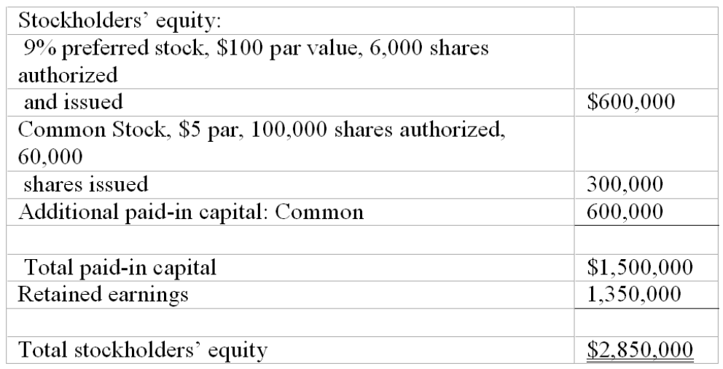

AACSB: Analytic
AICPA BB: Critical Thinking
AICPA FN: Measurement
Bloom's: Apply
Difficulty: Easy
Learning Objective: 11-04 Account for paid-in capital and prepare the equity section of a corporate balance sheet.
Topic: Paid-In Capital of a Corporation
128. Cash dividends and two classes of stock
Raymond Inc., has two classes of capital stock outstanding: 25,000 shares of 5%, $100 par value cumulative preferred and 30,000 shares of $10 par value common. The company had a deficit (negative balance in retained earnings) of $160,000 at the beginning of the current year, and preferred dividends were three years in arrears. During the current year, the company earned net income of $970,000. What will be the balance in the Retained Earnings account at the end of the current year if the company takes all the actions necessary to pay a dividend of $2.50 per share on the common stock? $_______________
235,000
Feedback:
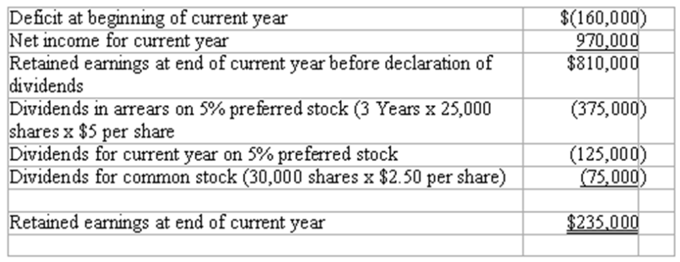

AACSB: Analytic
AICPA BB: Critical Thinking
AICPA FN: Measurement
Bloom's: Analyze
Difficulty: Medium
Learning Objective: 11-05 Contrast the features of common stock with those of preferred stock.
Topic: Paid-In Capital of a Corporation
129. Interpreting the stockholders' equity section
The stockholders' equity section of the balance sheet of Benson Corporation (with certain details omitted) appears below:
Answer the following questions based on the stockholders' equity section given above.
(a) What is the total amount of legal capital?
(b) What is the total amount of dividends paid annually to the preferred stockholders?
(c) What is the average issue price of a share of common stock?
(d) The balance in retained earnings at the beginning of the current year was $575,000, and there were no dividends in arrears. Net income for the current year was $360,000. What is the amount of the dividends declared on each share of common stock during the current year?
(a) $1,325,000
(b) $42,000
(c) $40 per share
(d) $6.12 per share
Feedback:
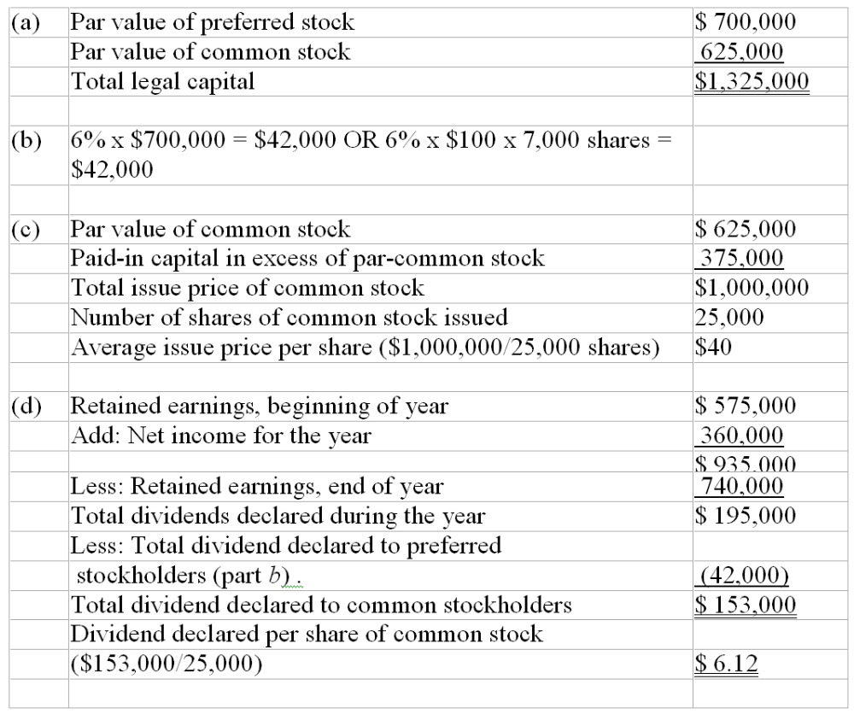

AACSB: Analytic
AICPA BB: Critical Thinking
AICPA FN: Measurement
Bloom's: Analyze
Difficulty: Medium
Learning Objective: 11-04 Account for paid-in capital and prepare the equity section of a corporate balance sheet.
Topic: Paid-In Capital of a Corporation
130. Interpreting stockholders' equity section
The stockholders' equity section of the balance sheet of Powell Corporation (with certain details omitted) appears below:
Answer the following questions based on the stockholders' equity section given above:
(a) What is the total amount of legal capital?
(b) What is the total amount of dividends paid annually to the preferred stockholders?
(c) What is the average issue price of a share of common stock?
(d) The balance in retained earnings at the beginning of the current year was $1,351,500, and there were no dividends in arrears. Net income for the current year was $700,000. What is the amount of the dividends declared on each share of common stock during the current year?
(a) $2,850,000
(b) $152,000
(c) $15.37 per share
(d) $3.84 per share
Feedback: 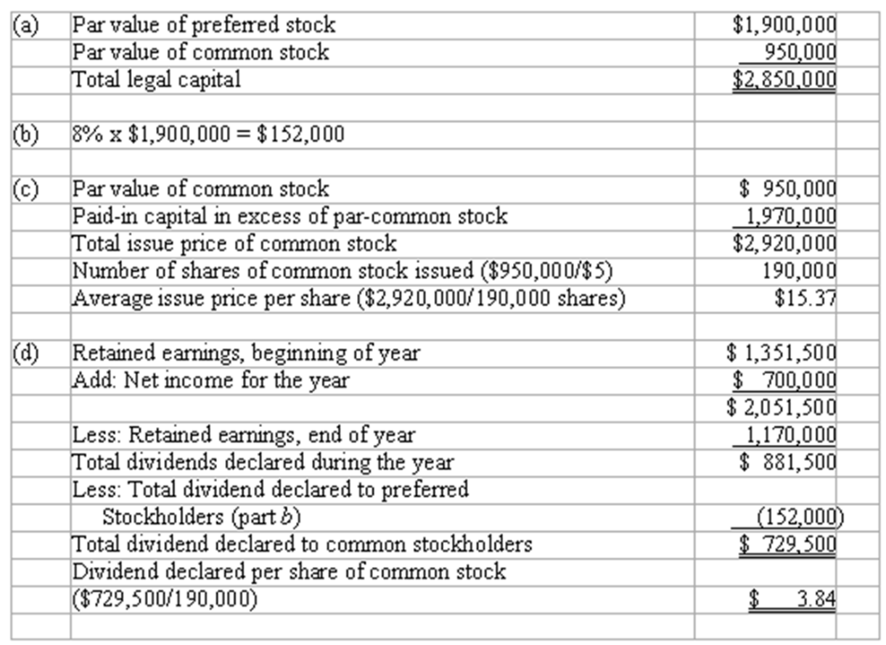

AACSB: Analytic
AICPA BB: Critical Thinking
AICPA FN: Measurement
Bloom's: Analyze
Difficulty: Medium
Learning Objective: 11-04 Account for paid-in capital and prepare the equity section of a corporate balance sheet.
Topic: Paid-In Capital of a Corporation
131. Prepare a stockholders' equity section
When Haven Corporation was incorporated in 2009, authorization was obtained to issue 200,000 shares of $5 par value common stock and 6,000 shares of 8% cumulative preferred stock. The preferred stock has a par value of $100. All the preferred stock was issued at $107 per share, and 110,000 shares of the common stock were sold for $9 per share. The operations of the company resulted in a net loss of $19,000 in 2009 and net income of $125,000 in 2010. In 2011, net income was $352,000, and the cash position was sufficient to allow the board of directors to declare a cash dividend of $1 per share to the common shareholders, as well as satisfy all preferred stock dividend requirements.
Complete in good form the stockholders' equity section of Haven Corporation's balance sheet at December 31, 2011. (Hint: First determine the total amount of dividends declared in 2011.)
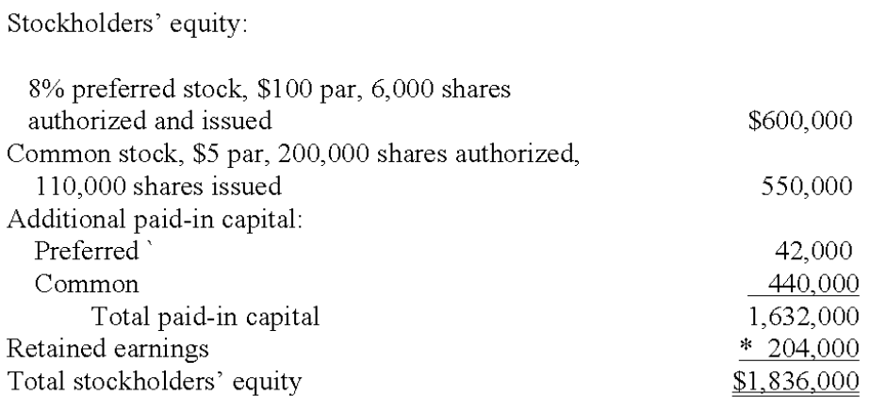
Feedback: $(19,000) + $125,000 + $352,000 = $458,000 retained earnings prior to dividends
$458,000-$144,000 (preferred dividend)-$110,000 (common dividend) = $204,000 *

AACSB: Analytic
AICPA BB: Critical Thinking
AICPA FN: Measurement
Bloom's: Analyze
Difficulty: Medium
Learning Objective: 11-04 Account for paid-in capital and prepare the equity section of a corporate balance sheet.
Topic: Paid-In Capital of a Corporation
132. Prepare journal entries for stockholders' equity transactions
A partial list of the ledger accounts of Skyway Corporation is shown below, followed by a list of transactions. Indicate the accounts that would be debited and credited in recording each transaction.
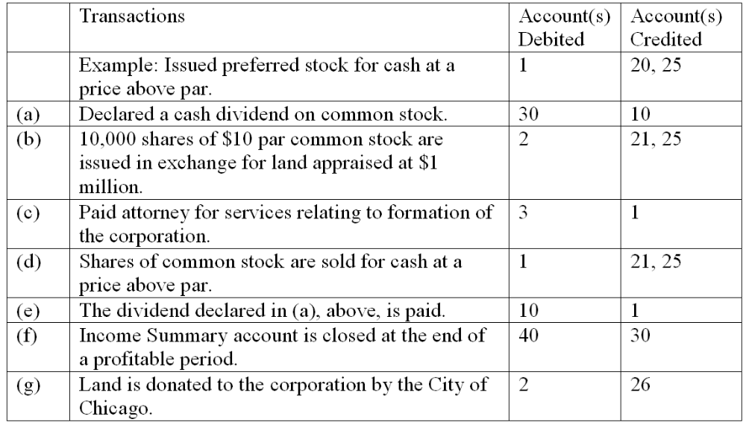

AACSB: Analytic
AICPA BB: Critical Thinking
AICPA FN: Measurement
Bloom's: Apply
Difficulty: Medium
Learning Objective: 11-04 Account for paid-in capital and prepare the equity section of a corporate balance sheet.
Topic: Paid-In Capital of a Corporation
133. Prepare journal entries for stockholders' equity transactions. A partial list of the ledger accounts of Hellman Company is shown below, followed by a list of transactions. Indicate the accounts that would be debited and credited in recording each transaction.
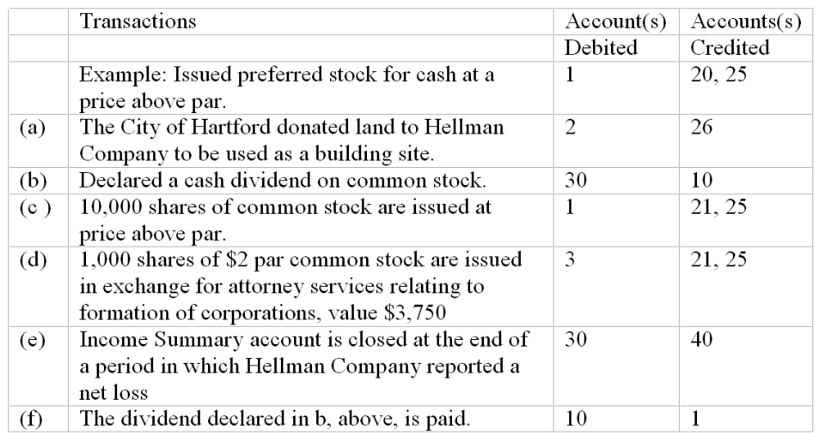

AACSB: Analytic
AICPA BB: Critical Thinking
AICPA FN: Measurement
Bloom's: Apply
Difficulty: Medium
Learning Objective: 11-04 Account for paid-in capital and prepare the equity section of a corporate balance sheet.
Topic: Paid-In Capital of a Corporation
134. Determining book value per share
Shown below is information relating to the stockholders' equity of Churchill, Inc.:
From the above information, compute the following:
(a) Number of shares of preferred stock issued and outstanding
(b) Average issue price per share of common stock
(c) Total paid-in capital
(d) Total stockholders' equity
(e) Book value per share of common stock
(a) 12,000 shares
(b) $30 per share
(c) $10,200,000
(d) $9,000,000
(e) $29.76
Feedback: (a) Number of shares of preferred stock issued and outstanding: $1,200,000/$100 par value = 12,000 shares
(b) Average issue price per share of common stock: ($3,000,000 + $6,000,000)/300,000 shares = $30 per share
(c) Total paid-in capital: $1,200,000 + $3,000,000 + $6,000,000 = $10,200,000
(d) Total stockholders' equity: $10,200,000-$1,200,000 = $9,000,000
(e) Book value per share of common stock: [9,000,000-($1,200,000 x 6%)]/300,000 = $29.76 per share

AACSB: Analytic
AICPA BB: Critical Thinking
AICPA FN: Measurement
Bloom's: Analyze
Difficulty: Medium
Learning Objective: 11-04 Account for paid-in capital and prepare the equity section of a corporate balance sheet.
Topic: Paid-In Capital of a Corporation
135. Stock values
Presented below is an excerpt from the stock listings of a recent issue of the Wall Street Journal.
Answer the following questions based on the information about the Russell Corporation given above:
(a) How many shares of Russell Corporation stock were sold on this day?
(b) If you had purchased 10 shares of Russell Corporation stock at the lowest price of the day, what would be the total price that you would have paid for the stock?
(c) What was the closing price of Russell Corporation Stock on the previous day?
(d) If the board of directors of Russell Corporation increased the amount of the annual dividends to $1.00 per share, what would be the amount of the yield percentage on the stock?
(a) 1,640 x 100 = 164,000
(b) 10 x $18 = $180
(c) $18 + 4 1/4 = $22 ¼
(d) $1.00 ÷ $18.00 = 5.56% (rounded)

AACSB: Analytic
AICPA BB: Critical Thinking
AICPA FN: Measurement
Bloom's: Analyze
Difficulty: Medium
Learning Objective: 11-04 Account for paid-in capital and prepare the equity section of a corporate balance sheet.
Topic: Paid-In Capital of a Corporation
136. Book value per share and other computations
Shown below is information relating to the stockholders' equity of Silver Waste Management at December 31, 2009:
(a) White's total legal capital at December 31, 2009, is $_______________.
(b) The total amount of Silver's paid-in capital at December 31, 2009, is $________________.
(c) The average issue price per share of Silver's preferred stock was $_______.
(d) The book value per share of common stock is $_________ per share.
(e) The balance in Retained Earnings at the beginning of the year was $1,237,500, and net income for 2009 was $1,600,000. What was the amount of dividend declared on each share of common stock during 2007? $______ per share.
(a) $900,000 + $2,600,000 = $3,500,000 total legal capital
(b) $900,000 + $2,600,000 + $132,000 + $2,970,000 = $6,602,000 total paid-in capital
(c) ($900,000 + $132,000)/6,000 shares = $172 per-share issue price (preferred stock)
(d) $14,506 book value per share of common stock
$2,600,000 + $132,000 + $2,970,000 + $1,551,000 = $7,253,000 common stockholders equity $7,253,000 equity allocable to common stock/400,000 shares = $18.13 per share
(e) 3.04 dividend per common share
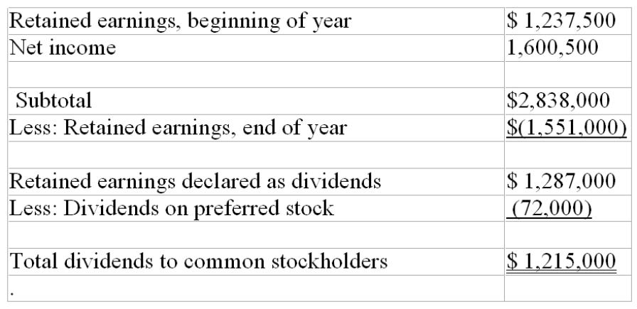
$1,215,000/400,000 shares = $3.04 per share of common stock.

AACSB: Analytic
AICPA BB: Critical Thinking
AICPA FN: Measurement
Bloom's: Analyze
Difficulty: Medium
Learning Objective: 11-07 Explain the significance of book value and market value of capital stock.
Topic: Market Value
137. Prepare the stockholders' equity section from transaction data
Shown below is the stockholders' equity section of Jone's balance sheet at December 31, 2009.
In 2009, the following events occurred:
Jones issued 2,000 shares of $5 par value common stock in exchange for legal services relating to the formation of the corporation; value of these services was set at $19,500.
Jones issued 8,000 of its 10,000 authorized shares of $8 cumulative preferred stock, $100 par value, for $108 per share.
The board of directors declared and paid dividends of $8 per share to preferred stockholders and 50 cents per share to common stockholders.
The company's net income for 2009 is $450,000.
Instructions: Complete in good form the stockholders' equity section of a balance sheet prepared for Jones at December 31, 2009.
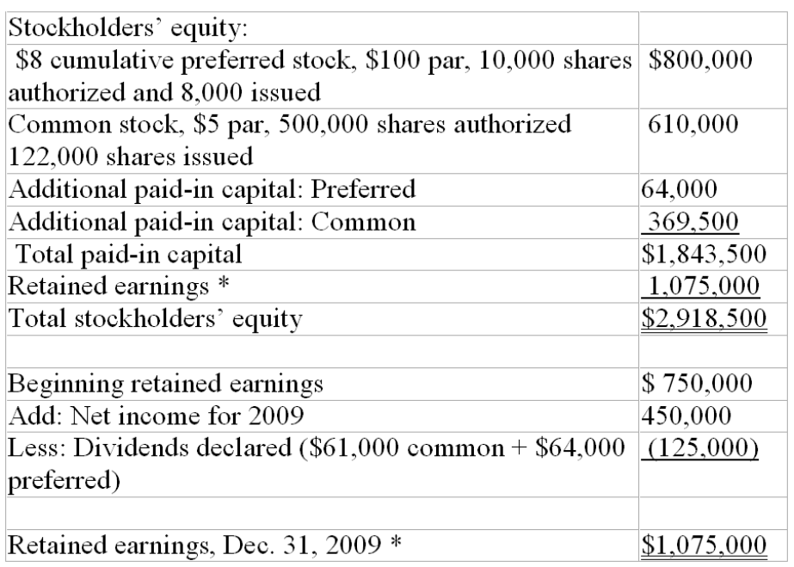

AACSB: Analytic
AICPA BB: Critical Thinking
AICPA FN: Measurement
Bloom's: Analyze
Difficulty: Medium
Learning Objective: 11-04 Account for paid-in capital and prepare the equity section of a corporate balance sheet.
Topic: Paid-In Capital of a Corporation
138. Prepare the stockholders' equity section from transaction data.
Shown below is the stockholders' equity section of Farrell Corporation's balance sheet at December 31, 2009:
In 2010, the following events occurred:
Farrell Corporation issued 1,000 shares of $3 par common stock in exchange for land. Although several real estate appraisers disagree on the value of the land, Farrell's stock is currently selling on a stock exchange for $32 per share.
Farrell Corporation issued 3,000 shares of 5% cumulative preferred stock, $100 par value, for $108 per share.
The board of directors declared a dividend of $1 per share on the common stock.
Farrell's net income for 2010 is $375,000.
Instructions: Complete in good form the stockholders' equity section of a balance sheet prepared for Farrell Corporation at December 31, 2010:
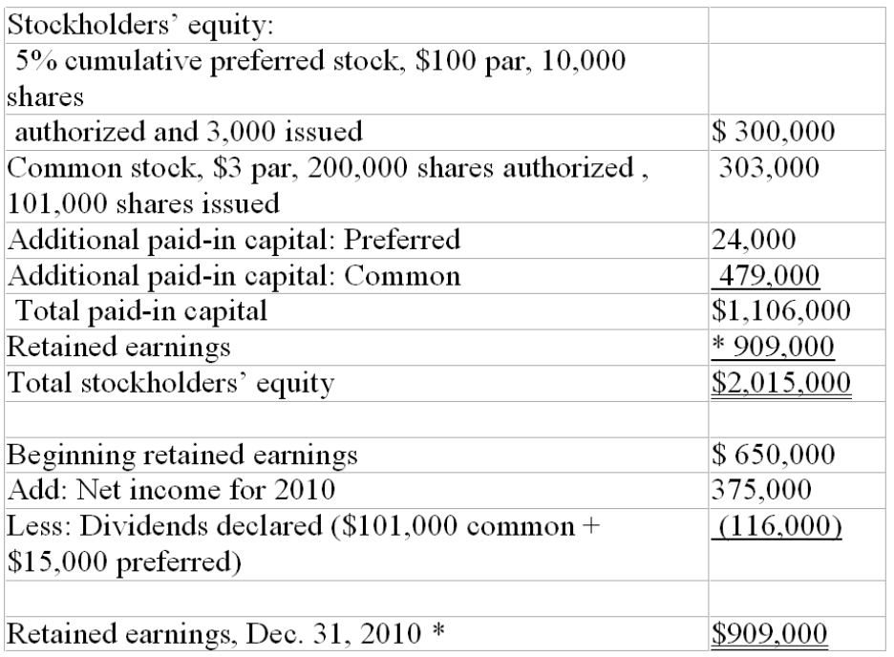

AACSB: Analytic
AICPA BB: Critical Thinking
AICPA FN: Measurement
Bloom's: Analyze
Difficulty: Medium
Learning Objective: 11-04 Account for paid-in capital and prepare the equity section of a corporate balance sheet.
Topic: Paid-In Capital of a Corporation
139. Treasury stock transactions.
Jackson Corporation engaged in the following treasury stock transactions during the current year:
Complete the following three general journal entries to record these treasury stock transactions.
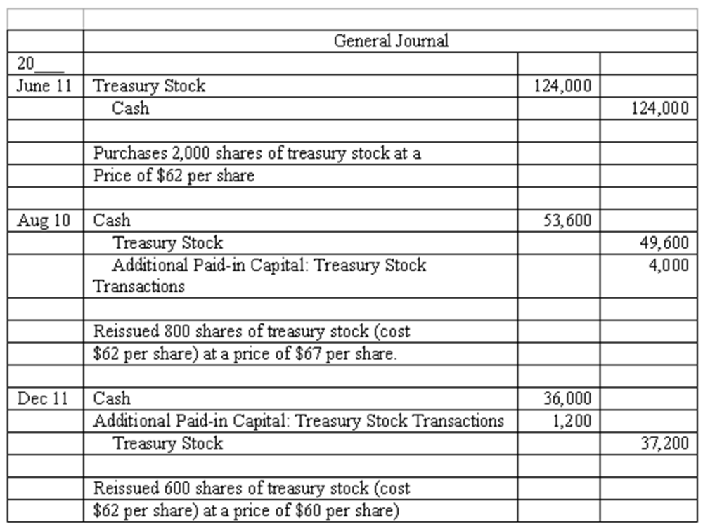

AACSB: Analytic
AICPA BB: Critical Thinking
AICPA FN: Measurement
Bloom's: Apply
Difficulty: Medium
Learning Objective: 11-09 Account for treasury stock transactions.
Topic: Treasury Stock
140. Financial reporting of net earnings and retained earnings
The 2012 annual report of Kirtland Products disclosed net earnings of approximately $87 million for the fiscal year ending March 31, 2012, and retained earnings of approximately $485 million as of March 31, 2012.
(a) Which financial statement shows computation of the net earnings?
(b) Which financial statement includes the retained earnings figure of $485 million?
(c) Explain why Kirtland reports $87 million as net earnings, but a much larger amount, $485 million, as retained earnings.
(a) Income statement (or statement of operations).
(b) Balance sheet (or statement of retained earnings, although this statement is not introduced until the next chapter).
(c) Net earnings (or net income) represents the increase in owners' equity resulting from profitable operations for a single period. Kirtland Products generated net income of $87 million for the fiscal year ending March 31, 2012. Retained earnings represents the cumulative amount of net income and losses over the entire life of the business, less all amounts that have been distributed to owners (stockholders) as dividends. Since Kirtland Products began operations, the cumulative amount of income in excess of amounts paid out as dividends amounts to $485 million as of March 31, 2012.

AACSB: Reflective Thinking
AICPA BB: Critical Thinking
AICPA FN: Reporting
Bloom's: Understand
Difficulty: Easy
Learning Objective: 11-04 Account for paid-in capital and prepare the equity section of a corporate balance sheet.
Topic: Paid-In Capital of a Corporation
141. Financial reporting of net losses and retained earnings
A recent annual report of Dobbs, Inc., reported a net loss of approximately $63 million and retained earnings of approximately $1.6 billion.
(a) Which financial statement shows computation of the $63 million net loss?
(b) Which financial statement includes the retained earnings figure of $1.6 billion?
(c) Explain how it is possible for Dobbs to report both a net loss of $63 million and retained earnings of $1.6 billion in a single set of financial statements.
(a) Income statement (or statement of operations).
(b) Balance sheet (or statement of retained earnings, although this statement is not introduced until the next chapter).
(c) Net loss represents the decrease in owners' equity resulting from unprofitable operations for a single period. Dobbs, Inc.'s operations generated a net loss of $63 million for the current year. Retained earnings represents the cumulative net income and losses over the entire life of the business, less all amounts that have been distributed to owners (stockholders) as dividends. Since Dobbs, Inc., began operations, the cumulative amount of income in excess of amounts paid out as dividends amounts to $1.6 billion.

AACSB: Reflective Thinking
AICPA BB: Critical Thinking
AICPA FN: Reporting
Bloom's: Understand
Difficulty: Medium
Learning Objective: 11-04 Account for paid-in capital and prepare the equity section of a corporate balance sheet.
Topic: Paid-In Capital of a Corporation
142. What's so "preferred" about preferred stocks?
Most preferred stocks do not have voting power, a basic right of common stock. Identify at least two features of most preferred stocks that justify or support use of the term preferred in describing these types of stock issues.
Student's answer should include two of the following features of most preferred stocks that justify the term preferred:
(a) Preferred as to dividends Preferred stock is entitled to receive each year a dividend of specified amount before any dividend is paid on the common stock.
(b) Cumulative as to dividend rights If any or all of the regular dividend on cumulative preferred stock is omitted in a given year, the amount omitted is in arrears and must be paid in a subsequent year before any dividend can be paid on the common stock.
(c) Preferred as to assets in event of liquidation If a business is terminated, the preferred stock is entitled to payment in full of its par value or a higher stated liquidation value before any payment is made to common stockholders.
(Although not as common, student may also list conversion privilege as a "preferred" feature of some preferred stock.)

AACSB: Reflective Thinking
AICPA BB: Legal
AICPA FN: Measurement
Bloom's: Understand
Difficulty: Easy
Learning Objective: 11-05 Contrast the features of common stock with those of preferred stock.
Topic: Paid-In Capital of a Corporation
143. Factors affecting the market price of stocks
(a) Murdock Corporation has outstanding several different stock issues. For each of the types of stock listed below, briefly describe a situation or circumstance that would cause the market price of that type of stock to increase.
Preferred stock
Common stock
Convertible preferred stock
(b) How would the increase in market value of any of Murdock's stock be reflected in Murdock's financial statements?
(a) Preferred stock Since the market price of preferred stock varies inversely with interest rates, a decline in interest rates would cause the market price of preferred stock to increase.
Common stock Investors' increased confidence in future profitability of Murdock 's operations would result in a price increase in Murdock 's common stock. An increase in market value of common stock might also result from expected higher common stock dividends in the future or from a decline in interest rates.
Convertible preferred stock An increase in the market value of common stock would cause a corresponding increase in the market value of convertible preferred stock.
(b) After shares have been issued, they belong to the stockholders, not to the issuing corporation. Increases (and decreases) in the market value of shares after issuance are not recorded in the corporation's accounting records.

AACSB: Reflective Thinking
AICPA BB: Critical Thinking
AICPA FN: Measurement
Bloom's: Understand
Difficulty: Hard
Learning Objective: 11-06 Discuss the factors affecting the market price of preferred stock and common stock.
Topic: Market Value
144. Stock splits
Bainbridge Corporation recently patented an extraordinary invention that will allow average homeowners to cheaply generate a large fraction of the electricity consumed in their houses. As a result, the market price of Bainbridge's common stock has soared to $160 per share. Bainbridge is about to announce a 4 for 1 stock split. Explain why the company would take this action?
The purpose of a stock split is to bring the per-share market price of the company's stock down into a more appropriate "trading range"-that is, a price that is appealing to a greater number of potential investors.

AACSB: Reflective Thinking
AICPA BB: Critical Thinking
AICPA FN: Measurement
Bloom's: Understand
Difficulty: Easy
Learning Objective: 11-08 Explain the purpose and effects of a stock split.
Topic: Market Value
145. Stockholders' Equity
Blake Corporation has the following accounts on December 31, 2010
Common Stock $.25 par, 1,000,000 authorized, 400,000 issued.
Preferred stock 6%, $100 par, cumulative, 5,000 shares authorized, 3,000 issued.
Treasury stock, 1,500 shares purchased at market value of $6 per share
Required:
(1) Prepare the stockholders' equity section of the balance sheet.
(2) Prepare the journal entry for the purchase of the treasury stock.
(3) Blake paid the liability for dividends on March 1. Prepare the journal entry for the payment.
(1)
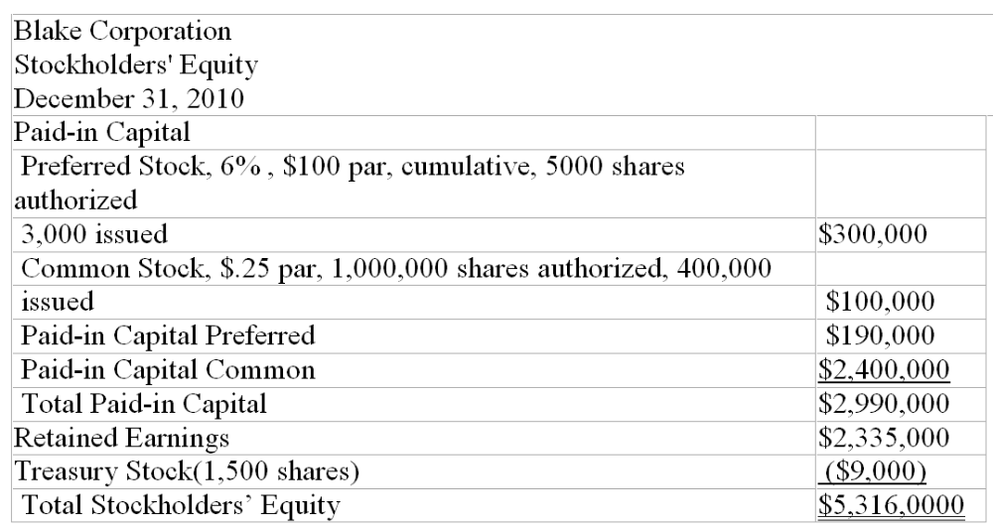
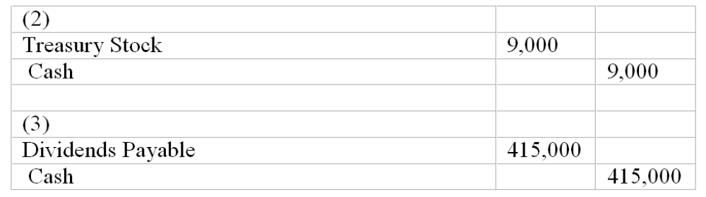

AACSB: Analytic
AICPA BB: Critical Thinking
AICPA FN: Measurement
Bloom's: Apply
Difficulty: Medium
Learning Objective: 11-04 Account for paid-in capital and prepare the equity section of a corporate balance sheet.
Topic: Paid-In Capital of a Corporation

Multiple Choice Questions
146. Lewis Corporation issued 125,000 shares of $5 par value capital stock at date of incorporation for cash at a price of $9 per share. During the first year of operations, the company earned $140,000 and declared a dividend of $100,000. At the end of this first year of operations, the balance of the Capital Stock account is:
A. $765,000.
B. $1,000,000.
C. $625,000.
D. $665,000.

147. Perez Corporation has 100,000 shares of $1 par value common stock and 20,000 shares of 8% cumulative preferred stock, $100 par value, outstanding. The balance in Retained Earnings at the beginning of the year was $1,600,000, and one year's dividends were in arrears. Net income for the current year was $870,000. If Perez Corporation paid a dividend of $2 per share on its common stock, what is the balance in Retained Earnings at the end of the year?
A. $2,150,000.
B. $2,270,000.
C. $2,110,000.
D. $1,950,000.

148. Pike Corporation has total stockholders' equity of $8,690,000 as of December 31, 2009. The company has 300,000 shares of $2 par value common stock and 20,000 shares of 8% cumulative preferred stock, $100 par value, outstanding. Due to lower-than-expected net income, no dividends were declared by Pike's board of directors for 2009. The book value per share of common stock is:
A. $25.00.
B. $21.77.
C. $23.00.
D. $25.60.

149. Which of the following most likely explains why a corporation's stock trades at a very high price-earnings ratio?
A. Investors expect the corporation to have higher earnings in the future.
B. The corporation pays a very low dividend on its stock.
C. The corporation has several classes of stock outstanding.
D. The corporation is large with very low risk.

150. Which of the following is not a characteristic of most preferred stocks?
A. Preference as to dividends.
B. No voting power.
C. Convertible into common stock.
D. Preference as to assets in the event of liquidation of the company.

Shown below is information relating to the stockholders' equity of Revere Corporation at December 31, 2009

151. The average issue price per share of Revere's preferred stock was:
A. $117.
B. $100.
C. $110.
D. $34.50.

152. The total amount of Revere's paid-in capital at December 31, 2009, is:
A. $8,000,000.
B. $15,260,000.
C. $12,000,000.
D. $4,000,000.

153. Revere's total legal capital at December 31, 2009, is:
A. $12,000,000.
B. $15,260,000.
C. $11,260,000.
D. $8,000,000.

154. The book value per share of common stock, assuming current-year preferred dividends have been paid, is:
A. $9.23.
B. $10.58.
C. $8.66.
D. $6.15.

155. The balance in Retained Earnings at the beginning of the year was $2,710,000, and there were no dividends in arrears. Net income for 2009 was $2,250,000. What was the amount of dividend declared on each share of common stock during 2009?
A. $1.30.
B. $2.40.
C. $1.21.
D. $3.72.

Short Answer Questions
Shown below is information relating to the stockholders' equity of Novake Corporation at December 31, 2010:
From the above information, compute the following:

156. The total amount of legal capital: $__________
700,000 + $1,500,000 = $2,200,000 total legal capital

157. The total amount of paid-in capital: $__________
700,000 + $1,500,000 + $400,000 + $500,000 = $3,100,000 total paid-in capital

158. The average issue price per share of preferred stock: $_____ per share
($700,000 + $400,000)/7,000 shares = $157.14 per-share issue price

159. The book value per share of common stock (assume current-year preferred dividends have been paid) $_____ per share
700,000 + 1,500,000 + 400,000 + 500,000 + 800,000 = 3,900,000 total stockholders' equity
$3,900,000 less 700,000 allocable to preferred equals stockholders' equity allocable to common stock/500,000 shares common stock outstanding = $6.40 book value per share of common stock

160. The balance in Retained Earnings at the beginning of the year was $650,000, and there were no dividends in arrears. Net income for 2010 was $475,000. What was the amount of dividend declared on each share of common stock during 2010? $_____ per share
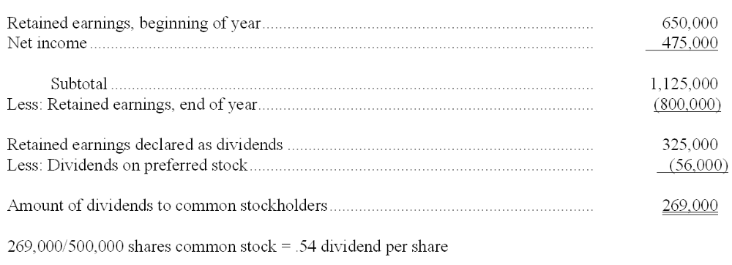

161. Shown below is the stockholders' equity section of Powell's balance sheet at December 31, 2009:
In 2010, the following events occurred:
Powell issued 2,500 shares of $2 par common stock as payment for legal services. Although Powell's stock is not traded on any exchange, the agreed-upon value of the legal services is $80,000.
Powell issued 4,500 shares of 6% cumulative preferred stock, $100 par value, for $106 per share.
The board of directors declared a dividend of $1.25 per share on the common stock.
Powell's net income for 2007 was $675,000.
Instructions
Complete in good form the stockholders' equity section of a balance sheet prepared for Powell at December 31, 2010.
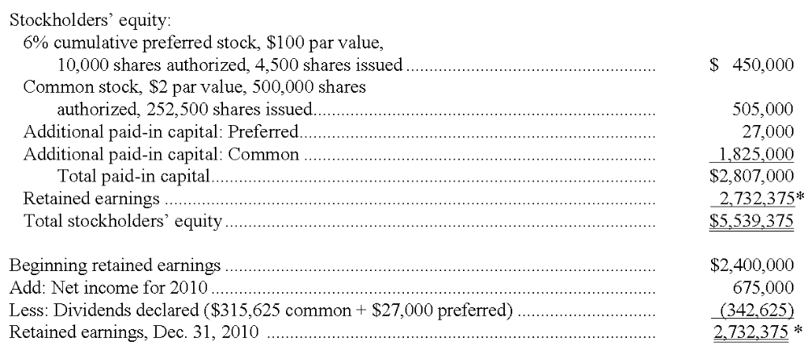

Multiple Choice Questions
162. When a business is organized as a corporation, which of the following statements is true?
A. Stockholders are liable for the debts of the business only in proportion to their percentage ownership of capital stock.
B. Stockholders do not have to pay personal income taxes on dividends received, because the corporation is subject to income taxes on its earnings.
C. Fluctuations in the market value of outstanding shares of capital stock do not affect the amount of stockholders' equity shown in the balance sheet.
D. Each stockholder has the right to bind the corporation to contracts and to make other managerial decisions.

163. Western Moving Corporation was organized with authorization to issue 100,000 shares of $1 par value common stock. Forty thousand shares were issued to Tom Morgan, the company's founder, at a price of $5 per share. No other shares have yet been issued. Which of the following statements is true?
A. Morgan owns 40 percent of the stockholders' equity of the corporation.
B. The corporation should recognize a $160,000 gain on the issuance of these shares.
C. If the balance sheet includes retained earnings of $50,000, total paid-in capital amounts to $250,000.
D. In the balance sheet, the Additional Paid-in Capital account will have a $160,000 balance, regardless of the profits earned or losses incurred since the corporation was organized.

164. Which of the following is not a characteristic of the common stock of a large, publicly owned corporation?
A. The shares may be transferred from one investor to another without disrupting the continuity of business operations.
B. Voting rights in the election of the board of directors.
C. A cumulative right to receive dividends.
D. After issuance, the market value of the stock is unrelated to its par value.

165. Tri-State Electric is a profitable utility company that has increased its dividend to common stockholders every year for 42 consecutive years. Which of the following is least likely to affect the market price of the company's preferred stock by a significant amount?
A. A decrease in long-term interest rates.
B. An increase in long-term interest rates.
C. The board of directors announces its intention to increase common stock dividends in the current year.
D. Whether or not the preferred stock carries a conversion privilege.

166. The following information is taken from the balance sheet and related disclosures of Maxwell, Inc.:
Which of the following statements is (are) true? (Fr this question, more than one answer may be correct.)
A. The preferred dividends in arrears amount to $120,000 and should appear as a liability in the corporate balance sheet.
B. The book value per share of common stock is $35.
C. The stockholders' equity section of the balance sheet should include a deficit (negative amount in retained earnings) of $700,000.
D. The company has paid no dividend on its common stock during the past two years.

167. On December 10, 2010, Smitty Corporation reacquired 2,000 shares of its own $5 par value common stock at a price of $60 per share. In 2011, 500 of the treasury shares are reissued at a price of $70 per share. Which of the following statements is correct?
A. The treasury stock purchased is recorded at cost and is shown in Smitty's December 31, 2010 balance sheet as an asset.
B. The two treasury stock transactions result in an overall net reduction in Smitty's stockholders' equity of $85,000.
C. Smitty recognizes a gain of $10 per share on the reissuance of the 500 treasury shares in 2011.
D. Smitty's stockholders' equity was increased by $110,000 when the treasury stock was acquired.

