Chapter 07
Financial Assets

True / False Questions
1. Showing marketable securities on the balance sheet at current market values violates the consistency principle.
True False

2. A line of credit creates a liability for the borrower when it is granted by the bank.
True False

3. The first step in a bank reconciliation is to update the depositor's accounting records for any deposits-in-transit.
True False

4. To "write-off" an account receivable is to reduce the balance of the customer's account to zero.
True False

5. The Allowance for Doubtful Accounts is a contra-asset account and appears on the balance sheet.
True False

6. The balance shown on a bank statement is always less than the month-end balance of a company's cash account in the general ledger.
True False

7. Deposits-in-transit would not appear on a company's bank reconciliation but would appear on the company's bank statement.
True False

8. Entries made in the general journal after preparing a bank reconciliation are called closing entries.
True False

9. Financial assets may be current or long-term assets.
True False

10. Cash equivalents include money market funds, U.S. Treasury bills, and high-grade commercial paper.
True False

11. The term "financial asset" is synonymous with the term "cash equivalent."
True False

12. Cash equivalents are the most liquid of assets.
True False

13. A credit memoranda from a bank indicates that they have decreased the depositor's cash balance.
True False

14. U.S. Treasury bills that mature within six months are cash equivalents.
True False

15. A company with more than one bank checking account should show more than one account for Cash in its balance sheet.
True False

16. The amount of cash that should appear on the balance sheet is equal to the amount of cash on deposit, plus currency, coin, and customers' checks on hand, minus the balance of the Cash Over and Short account.
True False

17. Financial assets describe not just cash, but all assets that are easily and directly convertible into known amounts of cash, except marketable securities.
True False

18. Restricted cash may be available to meet the normal operating needs of a company.
True False

19. A compensating balance is often required by a bank as a condition for granting a loan.
True False

20. An unrealized gain on available-for-sale securities will increase shareholders' equity.
True False

21. Internal control is strengthened by a policy of making payments by check, or from cash receipts, or from a petty cash fund.
True False

22. Compensating balances are not included in the amount of cash listed on a balance sheet.
True False

23. In order to be classified as available-for-sale securities, the investment cannot be held for a period longer than three months.
True False

24. In order for a company's accounting records to be up-to-date and accurate after a bank reconciliation has been completed, journal entries should be made for any service charges by the bank and for deposits-in-transit.
True False

25. Internal control will aid in achieving accurate accounting for cash.
True False

26. Marketable securities includes investments in bonds and in the capital stocks of publicly traded corporations.
True False

27. The Allowance for Doubtful Accounts should be listed on the balance sheet as a current liability.
True False

28. Short-term investments in marketable securities may not be reported in the balance sheet at values higher than original cost.
True False

29. If the allowance method is used and an account receivable that had been previously written-off is collected, income is currently recorded.
True False

30. The income statement approach used to estimate uncollectible receivables uses a percentage of net sales without considering the current balance in the Allowance account.
True False

31. The Allowance for Doubtful Accounts is called a valuation account, or contra-asset account, and normally has a credit balance.
True False

32. When an Allowance for Doubtful Accounts is used, accounts receivable are valued in the balance sheet at their estimated net realizable value.
True False

33. A major purpose of using an Allowance for Doubtful Accounts is to recognize uncollectible accounts expense in the same accounting period as the related sales which caused the expense.
True False

34. A debit memoranda from a bank indicates that they have decreased your cash balance.
True False

35. When the direct write-off method is used to recognize uncollectible accounts expense, an Allowance for Doubtful Accounts is not required.
True False

36. When doing a bank reconciliation, an NSF check will reduce the bank's balance.
True False

37. The lower the accounts receivable turnover rate, the longer a company must wait to collect from its credit customers.
True False

38. An unrealized loss on available-for-sale securities will reduce net income.
True False

39. The direct write-off method is more conservative than the allowance method for valuation of receivables.
True False

40. Gains (or losses) on sales of marketable securities, as well as any unrealized holding gains (or losses) on investments in available for sale securities, are reported in the income statement.
True False

41. A note receivable which is not collected promptly at the maturity date should be written off the books by a debit to Accounts Receivable and a credit to Notes Receivable.
True False

42. If the time span covered by a note is stated in days, the number of days for which interest accrues is computed by omitting the day on which the note is dated but including the day on which the note falls due.
True False

43. Non U. S. companies can never be compared to U. S. Companies because non U. S. companies use foreign currencies.
True False

44. Many fraudulent financial reporting schemes seek to manipulate accounts payable in order to overstate revenue and income.
True False

45. It has been found that improper revenue recognition was the most common scheme in fraud-related SEC enforcement actions.
True False

46. Management may wish to overstate a company's income because bonus plans and stock options are related to reported earnings.
True False

Multiple Choice Questions
47. In order to overstate income, a company may fraudulently:
A. Capitalize operating expenses.
B. Recognize revenue before it is earned.
C. Both capitalize operating expenses and recognize revenue before it is earned.
D. Neither capitalize operating expenses nor recognize revenue before it is earned.

48. A good system of internal control will include all of the following except:
A. Preparing a pro-forma financial statement on a monthly basis.
B. Separating the handling of cash from the maintenance of accounting records.
C. Making all major payments by check.
D. Reconciling bank statements with accounting records.

49. In order to hold each department manager accountable for monthly cash transactions, a business will often prepare:
A. A bank reconciliation.
B. A bank statement.
C. A cash budget.
D. Petty cash vouchers.

50. Which of the following does not contribute toward achieving internal control over cash payments?
A. The practice of making small cash disbursements directly from the current day's cash receipts.
B. The use of a voucher system.
C. The use of a petty cash fund.
D. The practice of approving every expenditure before the cash disbursement is made.

51. The Allowance for Doubtful Accounts will appear on the:
A. Income statement.
B. Balance sheet.
C. Cash flow statement.
D. Owners' equity statement.

52. "Concentrations of credit risk" occur if:
A. A significant portion of receivables are due from a few major customers.
B. A significant portion of receivables are from customers in the same industry.
C. Both of the above.
D. Neither of the above.

53. The mark-to-market adjustment for investments classified as "available for sale" affects:
A. The balance sheet.
B. The income statement.
C. The cash flow statement.
D. All of the above.

54. Financial assets include all of the following except:
A. Cash.
B. Marketable securities.
C. Inventories.
D. Accounts receivable.

55. The bookkeeper prepared a check for $68 but accidentally recorded it as $86. When preparing the bank reconciliation, this should be corrected by:
A. Adding $18 to the bank balance.
B. Subtracting $18 from the bank balance.
C. Adding $18 to the book balance.
D. Subtracting $18 from the book balance.

56. After preparing a bank reconciliation, a journal entry would be required for which of the following?
A. A deposit in transit.
B. A check for $48 given to a supplier but not yet recorded by the company's bank.
C. Interest earned on the company's checking account.
D. A deposit made by a company with a similar name and credited to your account.

57. All the following are steps included in the preparation of a bank reconciliation except:
A. Comparing deposits listed on the bank statement with the deposits shown in the accounting records.
B. Arranging checks by serial numbers and comparing with those listed in the accounting records.
C. Deducting any debit memoranda from the balance on the bank statement.
D. Preparing journal entries for any adjustments to the depositor's records.

58. Each of these categories of assets is normally shown in the balance sheet at current value, except:
A. Inventories.
B. Accounts receivable.
C. Short-term investments in marketable securities.
D. Cash.

59. Financial assets:
A. Consist of cash and cash equivalents.
B. Are reported at cost in the balance sheet.
C. Include short-term investments in marketable securities and receivables, as well as cash.
D. Are not very productive assets and should be kept to a minimum in a well-managed company.

60. Which of the following is not considered a cash equivalent?
A. US Treasury bills.
B. Money market funds.
C. Accounts receivable.
D. High-grade commercial paper.

61. The term cash equivalent refers to:
A. An item such as a money order, travelers' check, or check from a customer.
B. An account receivable from a reliable customer who has always paid bills within the discount period.
C. A guaranteed line of credit at the company's bank.
D. Very liquid short-term investments such as U.S. Treasury Bills and commercial paper.

62. Under the allowance method, when a receivable that had been previously written off is collected:
A. Net income is increased.
B. Net assets are increased.
C. Net income and net assets are not affected.
D. Net assets and net income are both increased.

63. Which of the following is not an example of internal control over cash?
A. Preparation of a cash budget.
B. Daily deposits of cash receipts at the bank.
C. Combining the functions of signing checks with the approval of expenditures.
D. Preparation of bank reconciliation.

64. Which of the following practices best illustrates efficient management of cash?
A. The accountant records all cash receipts and payments when reconciling the bank account at the end of each month.
B. Management arranges for a loan to cover projected cash shortages during the production phase of the business cycle each year.
C. Cash budgets (forecasts) are prepared only one month in advance in order to avoid the need for constant revision.
D. All cash resources are held in the checking account to maximize liquidity.

65. Efficient management of cash includes which of the following concepts?
A. Pay each bill as soon as the invoice is received.
B. Deposit all cash receipts and make all cash disbursements at the end of each week.
C. Prepare monthly cash budgets (forecasts) up to a year in advance.
D. Pay suppliers in cash out of cash sales receipts before depositing them in the bank.

66. With a line of credit, a liability arises:
A. As soon as the line is created.
B. As soon as any money is borrowed.
C. Upon repayment of the debt.
D. At maturity date.

67. Interest received is shown on which section of the statement of cash flows?
A. Operating.
B. Investing.
C. Financing.
D. Leveraging.

68. Which of the following is not a basic means of achieving internal control over cash receipts?
A. Separate the functions of cash handling and maintenance of accounting records.
B. Prepare a daily listing of cash received through the mail.
C. Deposit all cash receipts daily in the petty cash fund.
D. Use cash registers or pre-numbered sales tickets to record cash sales.

69. In order to achieve internal control over cash receipts:
A. The employee who handles checks received in the mail should not prepare the control listing.
B. The cashier should not deposit cash in the bank.
C. The salesclerk should not count the cash in the register at the end of the day.
D. The checks received in the mail from customers should not be sent to the accounting department to be recorded as cash receipts.

70. Which of the following items on a bank reconciliation may not have been known to the depositor until the bank statement had arrived?
A. Bank service charges.
B. An NSF check.
C. A credit for interest earned.
D. All three of the above.

71. The primary purpose of a petty cash fund is:
A. Accuracy.
B. Convenience.
C. Internal control.
D. Conservatism.

72. Marketable securities are classified into three types; which one is not one of the three types?
A. Available-for-sale.
B. Mark-to-market.
C. Trading.
D. Held-to-maturity.

73. With available-for-sale securities, unrealized holding gains and losses are:
A. Not reported until recognized.
B. Reported on the income statement.
C. Reported as an unearned revenue on the balance sheet.
D. Reported in the stockholders' equity section of the balance sheet.

74. When preparing a bank reconciliation, checks outstanding will:
A. Increase the balance per depositor's records.
B. Decrease the balance per depositor's records.
C. Increase the balance per the bank statement.
D. Decrease the balance per the bank statement.

75. The purpose of establishing a petty cash fund is to:
A. Achieve internal control over small cash disbursements not made by check.
B. Keep track of expenditures paid out of cash receipts from customers prior to deposit.
C. Ensure that the amount of cash in the bank does not become excessive.
D. Keep enough cash on hand in the office to cover all normal operating expenses of the business for a period of time.

76. When preparing a bank reconciliation, an NSF check will:
A. Increase the balance per depositor's records.
B. Decrease the balance per depositor's records.
C. Increase the balance per the bank statement.
D. Decrease the balance per the bank statement.

77. The valuation principle of "mark-to-market" applied to investments classified as available for sale securities:
A. Affects the current period income statement, but not the balance sheet.
B. Enhances usefulness of the balance sheet in evaluating solvency of a business.
C. Applies to marketable securities and inventories.
D. Requires a corporation to adjust its capital stock account to reflect current market value of its outstanding capital stock.

78. A bank reconciliation explains the differences between:
A. Cash receipts and cash disbursements for the period.
B. The balance of cash in the bank and the budgeted expenditures for the upcoming accounting period.
C. The balance per bank statement and the cash balance per the accounting records of the depositor.
D. The balance per bank statement and cash expected to be on hand according to the cash forecast.

79. In reconciling a bank statement, which of the following items could cause the cash per the bank statement to be greater than the balance of cash shown in the depositor's accounting records?
A. An outstanding check.
B. A check returned to the depositor marked NSF.
C. Check 457 written for $643 was recorded by the depositor as $463.
D. A bank service charge.

80. When preparing a bank reconciliation, deposits in transit will:
A. Increase the balance per depositor's records.
B. Decrease the balance per depositor's records.
C. Increase the balance per the bank statement.
D. Decrease the balance per the bank statement.

81. An NSF check returned by the bank should be entered in the depositor's accounting records by a debit to:
A. Accounts Receivable.
B. An expense account.
C. Cash.
D. Cash Over and Short.

82. In preparing a bank reconciliation, a service charge shown on the bank statement should be:
A. Added to the balance per the bank statement.
B. Deducted from the balance per the bank statement.
C. Added to the balance per the depositor's records.
D. Deducted from the balance per the depositor's records.

83. Enclosed with the bank statement received by Sydney Company at October 31 was an NSF check for $300. No entry has yet been made by the company to reflect the bank's action in charging back the NSF check. During preparation of the bank reconciliation, the NSF check should be:
A. Deducted from the balance per the depositor's records.
B. Deducted from the balance per the bank statement.
C. Added to the balance per the bank statement.
D. Added to the balance per the depositor's records.

84. When a bank reconciliation has been satisfactorily completed, the only related entries to be made in the depositor's records are:
A. To correct errors made by the bank in recording the dollar amounts of cash transactions during the period.
B. To reconcile items that explain the difference between the balance per the books and the balance per the bank statement.
C. To record outstanding checks and bank service charges.
D. To record items that explain the difference between the balance per the accounting records and the adjusted cash balance.

85. During preparation of a bank reconciliation, outstanding checks should be:
A. Added to the balance per the bank statement.
B. Deducted from the balance per the bank statement.
C. Added to the balance per the depositor's records.
D. Deducted from the balance per the depositor's records.

86. When the account Allowance for Doubtful Accounts is used, writing-off of an uncollectible accounts receivable will:
A. Reduce income.
B. Reduce an expense.
C. Not change income or total assets.
D. Increase total assets.

87. Which of the following items would cause cash per the bank statement to be smaller than the balance of cash shown in the accounting records?
A. Outstanding checks.
B. Interest earned on the average balance of the checking account.
C. Check no. 824, in the amount of $620.30, is recorded by the bank as $602.30.
D. Deposits in transit.

88. Which of the following items would cause cash per the bank statement to be larger than the balance of cash shown in the accounting records?
A. Bank service charges.
B. Deposits in transit.
C. Outstanding checks.
D. NSF check from one of the depositor's customers.

89. When a petty cash fund is in use:
A. Petty cash is debited only when the fund is replenished.
B. The general bank account is debited only when this fund is established.
C. Small payments are made out of cash receipts before they are deposited.
D. Expenses paid from the fund are recorded when the fund is replenished.

90. When preparing a bank reconciliation, bank service charges will:
A. Increase the balance per depositor's records.
B. Decrease the balance per depositor's records.
C. Increase the balance per the bank statement.
D. Decrease the balance per the bank statement.

91. The financial statements of Baxter Corporation include an Unrealized Holding Gain on Investments. This item:
A. Is included in the income statement.
B. Is shown as a reduction in total stockholders' equity.
C. Indicates that Baxter's marketable securities have a current market value higher than cost.
D. Indicate that Baxter Corporation sold marketable securities during the period at a gain.

92. Accounts receivable are classified as current assets:
A. Only if convertible into cash within 60 days or sooner.
B. Only if the allowance method is used to estimate the uncollectible accounts.
C. Only if convertible into cash within one year.
D. Whenever the accounts receivable arise from "normal" sales of merchandise to customers, regardless of the credit terms.

93. Accounts receivable appear in the balance sheet:
A. As current assets, combined with cash and cash equivalents.
B. As current assets, immediately after cash and cash equivalents.
C. As either current assets or noncurrent assets, depending on whether the allowance method or the direct write-off method is used to account for uncollectible accounts.
D. Only if the balance sheet method of estimating uncollectible accounts is used.

94. Uncollectible accounts expense:
A. Should not occur if the credit department properly investigates prospective customers who wish to purchase merchandise on credit.
B. Is the amount of cash a business must pay each time a credit customer fails to pay his or her account.
C. Is the amount a business must pay to a collection agency to recover amounts on overdue accounts receivable.
D. Represents the loss in value of accounts receivable that are estimated to be uncollectible.

95. When reading a bank statement, which reference indicates an increase in the cash balance?
A. Debit Memorandum.
B. Credit Memorandum.
C. NSF Check.
D. Service Charge.

96. The Allowance for Doubtful Accounts represents:
A. Cash set aside to make up for bad debt losses.
B. The amount of uncollectible accounts written off to date.
C. The difference between total credit sales and collections on credit sales.
D. The difference between the face value of accounts receivable and the net realizable value of accounts receivable.

97. When determining the uncollectible accounts expense in computing taxable income, income tax regulations:
A. Require the allowance method.
B. Require the direct write-off method.
C. Require the income statement approach.
D. Allow any method.

98. The aging of the accounts receivable approach to estimating uncollectible accounts does not:
A. Take into consideration the existing balance in the Allowance for Doubtful Accounts.
B. Utilize a percentage of probable uncollectible accounts for each age group of accounts receivable.
C. Stress the relationship between uncollectible accounts expense and net sales.
D. Tend to give a reliable estimate of uncollectible accounts because of the consideration given to the collectability of specific accounts receivable.

99. If a company uses a percentage of net sales in computing the amount of uncollectible accounts expense:
A. No valuation allowance will be required.
B. The relationship between revenue and expenses is being stressed more than the valuation of receivables at the balance sheet date.
C. The existing balance in the Allowance for Doubtful Accounts will be increased sufficiently to equal the probable loss indicated by the percentage of net sales computation.
D. Any past-due accounts will be listed as a separate item in the balance sheet.

100. Randall, Inc. uses the allowance method supported by an aging of its accounts receivable to recognize uncollectible accounts expense in its financial statements. What method of recognizing this expense does Randall use in its income tax return?
A. It must use the same method.
B. The direct write-off method.
C. Either the balance sheet or income statement approach is acceptable.
D. None, since uncollectible accounts expense is not deductible for income tax purposes.

101. The mark-to-market valuation principle:
A. Adheres to the cost principle.
B. Adheres to conservatism.
C. Does not adhere to the cost principle or conservatism.
D. Adheres to both the cost principle and conservatism.

102. The direct write-off method of recognizing uncollectible accounts expense:
A. Is acceptable only when most of the company's sales are on credit.
B. Records uncollectible accounts expense when individual accounts receivable are determined to be worthless.
C. Records uncollectible accounts expense when customers exceed their credit limits.
D. Uses a valuation account to record specific customer accounts deemed uncollectible.

103. Joe Costello handles cash receipts from customers and also has responsibility for issuing credit memoranda, writing off uncollectible accounts, and maintaining the accounts receivable records. When customers pay their accounts, Costello occasionally issues a credit memorandum and steals the cash received from the customer. This fraud should come to light if an employee other than Costello:
A. Reconciles the bank statement to the accounting records.
B. Reconciles the accounts receivable subsidiary ledger to the accounts receivable controlling account.
C. Investigates weekly all accounts written off as uncollectible.
D. Reconciles credit memoranda for sales returns to returned merchandise accepted by the receiving department.

104. Shrek Cyclery sells a bicycle to W. O'Connor, a customer who uses Empress Charge (a national credit card, but not issued by a bank). In recording this sale, Shrek Cyclery should record:
A. An account receivable from W. O'Connor.
B. A cash receipt.
C. An account receivable from Empress Charge.
D. A small increase in the allowance for doubtful accounts.

105. The Kansas Company makes credit sales to customers who use bank credit cards (such as Visa or MasterCard) as well as to customers who use non-bank credit cards (such as American Express or Diner's Club). In this situation:
A. Sales to customers using bank credit cards are recorded as cash sales.
B. Regardless of the type of credit card used by the customer, Kansas records a receivable from the credit card company when a credit sale is made.
C. Regardless of the type of credit card used by the customer, Kansas estimates uncollectible accounts related to these credit sales using the allowance method.
D. The fees charged by the credit card company reduce the dollar amount of sales recorded.

106. Sales to customers using bank credit cards, such as Visa or MasterCard, are recorded as:
A. Cash sales.
B. An account receivable from the cardholder.
C. An account receivable from the bank.
D. Credit card discount expense.

107. The accounts receivable turnover rate:
A. Indicates how many times the receivables were converted into cash during the year.
B. Is computed by dividing average receivables by sales.
C. Indicates the average number of days a business waits to make collection on a credit sale.
D. Indicates the proportion of a company's accounts receivable that the independent auditors were unable to confirm.

108. The accounts receivable turnover rate for Baldwin Corporation is 8, and for Basinger Company is 10. These statistics indicate that:
A. Basinger collects its accounts receivable within 10 days on average; Baldwin collects its accounts receivable in 8 days on average.
B. Basinger writes off as uncollectible a greater percentage of its accounts receivable than does Baldwin Company.
C. Basinger collects its accounts receivable faster than does Baldwin Company.
D. Basinger makes on average 10 credit sales annually to each of its customers, while Baldwin makes 8 credit sales to each customer.

109. Available-for-sale securities are usually held for:
A. Less than three months.
B. Between six and eighteen months.
C. Greater than one year.
D. Less than one month.

110. Under the allowance method, when a receivable that had been previously written off is collected:
A. Income is recognized.
B. An expense is reduced.
C. Net income is not affected.
D. Net assets are increased.

111. Which of the following activities affects net income, but has no immediate impact upon cash flows?
A. Collection of an account receivable.
B. Making the end-of-period adjustment to record estimated uncollectible accounts.
C. Investing excess cash in marketable securities.
D. Write-off of an uncollectible account receivable against the allowance.

112. Each of the following transactions would be reflected in both the income statement and the statement of cash flows for the current period, except:
A. Purchase of marketable securities for cash.
B. Receipt of dividends earned on investments.
C. Payment of interest on bonds.
D. Sale of merchandise for cash.

113. Investments in available-for-sale marketable securities:
A. Only include investments in the capital stock of publicly traded corporations.
B. May be reported in the balance sheet at market values lower than cost, but never at values in excess of original cost.
C. Are adjusted to current market value at the end of each accounting period.
D. Are carried in the accounting records at current market values, and therefore do not generate gains or losses when sold at market values.

114. The purpose of the mark-to-market adjustment for securities classified as "available-for-sale" is:
A. To adjust the valuation of a company's investment to current market value.
B. To recognize the proper amount of gain or loss on fluctuations in the market value of these securities in the current period income statement.
C. To adjust a corporation's capital stock account to reflect the current market value of the outstanding capital stock.
D. Both a and b are correct.

115. The mark-to-market adjustment:
A. Affects both the balance sheet and the current period income statement.
B. Is not made when the current market value of investments in marketable securities is higher than original cost.
C. May result in either a gain or a loss to be reported in the current period income statement.
D. Represents a departure from the cost principle.

116. An Unrealized Holding Gain (or Loss) on Investments classified as "available-for-sale" securities:
A. Is reported in the asset section of the balance sheet, as an adjustment to the carrying value of the marketable securities.
B. Is reported in the stockholders' equity section of the balance sheet, as either an increase or decrease in total stockholders' equity.
C. Appears in the current period income statement, combined with realized gains and losses from sales of securities.
D. Indicates the amount of cash a company would receive if the marketable securities were sold as of the balance sheet date.

117. J. Lennon borrows a sum of money from Y. Ono. A promissory note is used to document the terms of the transaction. In this situation:
A. J. Lennon is considered the maker of the note.
B. J. Lennon is considered the payee of the note.
C. J. Lennon records the note as an asset in his accounting records.
D. The maker of the note could be either Y. Ono or J. Lennon depending on which party actually draws up the document.

118. Anthony loaned $2,000 to Cleopatra for one year at 10% interest, all due at maturity. He insisted the terms of the transaction be formalized in a promissory note. In this situation:
A. The maturity value of the note is $2,000.
B. Anthony is considered the maker of the note and records the note as an asset in his accounting records.
C. Anthony is considered the maker of the note and records the note as a liability in his accounting records.
D. Cleopatra is considered the maker of the note and records the note as a liability in her [his] accounting records.

119. In regard to the accounts receivable turnover rate:
A. The higher the better.
B. The lower the better.
C. In some industries it is better higher and in some industries it is better to be lower.
D. The auto industry prefers a lower rate.

120. When a promissory note is issued, you would expect to find:
A. Notes payable and interest expense in the financial statements of the maker of the note throughout the life of the note.
B. Notes receivable and interest revenue in the financial statements of the maker of the note throughout the life of the note.
C. Notes receivable in the financial statements of the maker of the note throughout the life of the note, but interest revenue only when interest payments are received.
D. Notes payable in the financial statements of the payee of the note throughout the life of the note, but interest expense only when interest payments are made.

121. When the maker of a note defaults:
A. An account receivable is recorded for the principal amount of the note only.
B. An account receivable is recorded in the amount of the principal plus interest through the maturity date.
C. Any interest earned for the current period is not recorded, since the maker has defaulted.
D. Any interest earned in a previous period that has already been recorded as interest receivable is written off as a loss due to the maker's default.

122. As of December 31, 2009, Valley Company has $16,920 cash in its checking account, as well as several other items listed below:
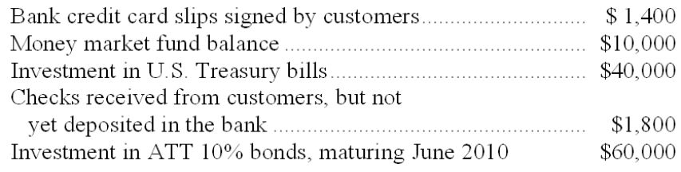
What amount should be shown in Valley's December 31, 2009, balance sheet as "Cash and cash equivalents"?
A. $53,200.
B. $70,120.
C. $130,120.
D. $113,200.

On November 1, 2010, Salem Corporation sold land priced at $900,000 in exchange for a 6%, six-month note receivable.

123. The journal entry made by Salem to record this transaction on November 1, 2010, includes:
A. A debit to Notes Receivable of $927,000.
B. A debit to Interest Receivable of $27,000.
C. A credit to Interest Revenue of $27,000.
D. A debit to Notes Receivable of $900,000.

124. Salem's balance sheet at December 31, 2010 includes which of the following as a result of the sale of land on November 1?
A. Notes Receivable of $900,000 and Interest Receivable of $9,000.
B. Notes Receivable of $927,000 and Interest Receivable of $9,000.
C. Notes Receivable of $900,000 and Interest Receivable of $27,000.
D. Notes Receivable of $900,000 only.

125. On May 1, 2011 (maturity date), the note is collected in full by Salem Corporation. Assuming a fiscal year-end of December 31, Salem recognizes which of the following in its income statement for 2011 with regard to this note?
A. $927,000 sales revenue.
B. $27,000 interest revenue.
C. $18,000 interest revenue.
D. $9,000 interest revenue.

126. Assuming the maker of the note defaults on May 1, 2011, Salem will record on this date:
A. An account receivable of $900,000 from the maker of the note.
B. An account receivable in the amount of $900,000, as well as interest expense of $27,000.
C. An account receivable in the amount of $927,000, as well as interest revenue of $18,000.
D. An account receivable in the amount of $900,000, as well as interest revenue of $18,000.

On June 1, 2009, Jensen Company acquired an 8%, ten-month note receivable from a customer in settlement of an existing account receivable of $130,000. Interest and principal are due at maturity.

127. The proper adjusting entry at December 31, 2009, with regard to this note receivable includes a:
A. Debit to Cash of $6,067.
B. Debit to Notes Receivable of $10,400.
C. Credit to Interest Revenue of $10,400.
D. Debit to Accrued Interest Receivable of $6,067.

128. Jensen's entry to record the collection of this note at maturity includes a:
A. Credit to Accrued Interest Receivable of $6,067.
B. Credit to Interest Revenue of $6,067.
C. Credit to Interest Receivable of $2,600.
D. Credit to Notes Receivable of $140,400.

129. While preparing a bank reconciliation, an accountant discovered that a $426 check returned with the bank statement had been recorded erroneously in the depositor's accounting records as $462. In preparing the bank reconciliation the appropriate action to correct this error would be to:
A. Add $36 to the balance per the depositor's records.
B. Add $36 to the balance per the bank statement.
C. Deduct $36 from the balance per the bank statement.
D. Deduct $36 from the balance per the depositor's records.

130. The accounting records of Golden Company showed cash of $15,250 at June 30. The balance per the bank statement at June 30 was $15,125. The only reconciling items were deposits in transit of $3,200, outstanding checks totaling $4,100, an NSF check for $1,000 returned by the bank which Golden had not yet charged back to the customer, and a bank service charge of $25. The preparation of a bank reconciliation should indicate cash owned by Golden at June 30 in the amount of:
A. $14,475.
B. $15,375.
C. $14,225.
D. $15,525.

131. A bank statement shows a balance of $8,445 at June 30. A bank reconciliation is prepared and includes outstanding checks of $2,790, deposits in transit of $1,350, and a bank service charge of $30. Among the paid checks returned by the bank was check no. 900 in the amount of $600, which the company had erroneously recorded in the accounting records as $60. The "adjusted cash balance" at June 30 is:
A. $6,975.
B. $6,465.
C. $7,005.
D. $7,575.

The Cash account in the ledger of Hensley, Inc. showed a balance of $3,100 at June 30. The bank statement, however, showed a balance of $3,900 at the same date. The only reconciling items consisted of a $700 deposit in transit, a bank service charge of $7, and a large number of outstanding checks.

132. What is the "adjusted cash balance" at June 30?
A. $3,900.
B. $3,093.
C. $7,600.
D. Some other amount.

133. What is the total amount of the outstanding checks at June 30?
A. $1,513.
B. $1,486.
C. $1,507.
D. Some other amount.

134. Upon completion of the bank reconciliation, a journal entry will be required to update the depositor's accounting records. This entry will include a:
A. Credit to Cash for $700.
B. Debit to Cash for $700.
C. Debit to Cash for $7.
D. Debit to Bank Service Charge Expense for $7.

The Cash account in the ledger of Clear Windows shows a balance of $12,596 at September 30. The bank statement, however, shows a balance of $16,253 at the same date. The only reconciling items consist of a bank service charge of $16, a large number of outstanding checks totaling $6,740, and a deposit in transit.

135. What is the adjusted cash balance in the September 30 bank reconciliation?
A. $16,237.
B. $12,580.
C. $9,513.
D. $5,856.

136. What is the amount of the deposit in transit?
A. $5,856.
B. $9,513.
C. $3,067.
D. $3,083.

137. Cardinal Company's bank statement showed a balance at May 31 of $180,974. The only reconciling items consisted of a large number of outstanding checks totaling $51,847. At May 31, what balance should Cardinal's Cash account show?
A. $232,821.
B. $129,127.
C. $77,280.
D. Some other amount.

138. On January 1, Wong Company established a petty cash fund of $300. The journal entry to record the replenishment of the fund for $260 at the end of January includes:
A. A debit to Petty Cash of $260.
B. A credit to Cash of $260.
C. A debit to various expenses of $40.
D. No journal entry; an entry is needed only when the petty cash fund is created or discontinued.

139. Red Pine, Inc. established a $400 petty cash fund several months ago and replenishes it at the end of each month. During the first two weeks of March, $185 was disbursed from the petty cash box for miscellaneous items. If a surprise count of the fund is made on March 15, the petty cash box should contain:
A. $400 cash.
B. $215 cash.
C. $215 cash left for March plus $400 cash for each month since creation of the petty cash fund.
D. $215 cash and receipts for $185 in expenditures.

Kiley Company established a petty cash fund of $750 on January 1. On January 31, receipts for the following items were in the petty cash box:
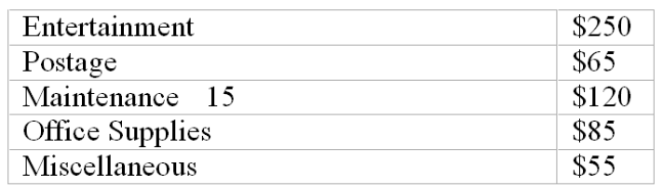

140. The journal entry on January 1 to record establishment of the petty cash fund includes a:
A. Credit to Cash of $750.
B. Credit to Petty Cash of $750.
C. Debit to Petty Cash Expense of $750.
D. No journal entry is necessary, since no cash of the company has been disbursed yet.

141. The journal entry on January 31 to record replenishment of the petty cash fund includes:
A. A credit to Petty Cash for $575.
B. Debits to various expenses totaling $575.
C. A debit to Petty Cash for $575.
D. A debit to Cash for $575.

142. On January 1, Lucas established a petty cash fund of $350, which it replenishes at the end of each month. When a surprise count of the petty cash fund is made on March 5, the petty cash box contains $70 in cash and receipts for the following items:
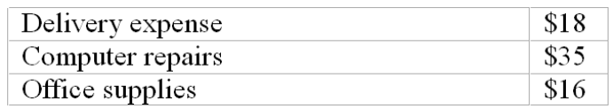
This situation indicates:
A. Approximately $210 of petty cash has been invested in cash equivalents.
B. There were approximately $210 in cash disbursements made from the petty cash fund for the first two months of the year.
C. The petty cash expense recognized for the month of March is approximately $210.
D. There is approximately $210 of petty cash that is missing and unaccounted for at March 5.

143. Taylor, Inc. had accounts receivable of $310,000 and an allowance for doubtful accounts of $19,500 just before writing off as worthless an account receivable from Burton Company of $1,300. The net realizable value of the accounts receivable before and after the write-off were:
A. $290,500 before and $289,200 after.
B. $290,500 before and $290,500 after.
C. $310,000 before and $308,700 after.
D. $329,500 before and $328,200 after.

144. Bert had accounts receivable of $280,000 and an allowance for doubtful accounts of $10,800 just before writing off as worthless an account receivable from Ernie Company of $1,600. After writing off this receivable what would be the balance in Bert's Allowance for Doubtful Accounts?
A. $10,800 credit balance.
B. $12,400 credit balance.
C. $9,200 credit balance.
D. $9,200 debit balance.

145. At December 31, before adjusting and closing the accounts had occurred, the Allowance for Doubtful Accounts of Seaboard Corporation showed a debit balance of $3,200. An aging of the accounts receivable indicated the amount probably uncollectible to be $2,100. Under these circumstances, a year-end adjusting entry for uncollectible accounts expense would include a:
A. Debit to the Allowance for Doubtful Accounts for $1,100.
B. Credit to the Allowance for Doubtful Accounts for $1,100.
C. Debit to Uncollectible Accounts Expense of $2,100.
D. Debit to Uncollectible Accounts Expense of $5,300.

146. Kennedy Company uses the balance sheet approach in estimating uncollectible accounts expense. The company prepares an adjusting entry to recognize this expense at the end of each month. During the month of July, the company wrote-off a $3,500 receivable and made no recoveries of previous write-offs. Following the adjusting entry for July, the credit balance in the Allowance for Doubtful Accounts was $3,000 larger than it was on July 1. What amount of uncollectible account expense was recorded for July?
A. $2,500.
B. $1,000.
C. $1,500.
D. $6,500.

147. Oceanside Company uses the balance sheet approach in estimating uncollectible accounts expense. It has just completed an aging analysis of accounts receivable at December 31, 2009. This analysis disclosed the following information?
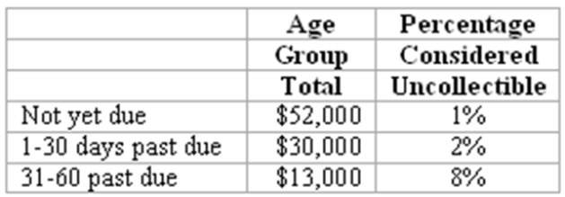
What is the appropriate balance for Oceanside's Allowance for Doubtful Accounts at December 31, 2009
A. $95,000.
B. 2% of credit sales in 2009.
C. $1,560.
D. $2,160.

148. At the start of the current year, Minuteman Corporation had a credit balance in the Allowance for Doubtful Accounts of $1,800. During the year a monthly provision of 2% of sales was made for uncollectible accounts. Sales for the year were $600,000, and $5,600 of accounts receivable were written off as worthless. No recoveries of accounts previously written off were made during the year. The year-end financial statements should show:
A. Uncollectible accounts expense of $13,800.
B. Allowance for Doubtful Accounts with a credit balance of $8,200.
C. Allowance for Doubtful Accounts with a credit balance of $6,400.
D. Uncollectible accounts expense of $5,600.

Dynamic, Inc. had credit sales of $675,000 for March. Accounts receivable of $6,000 were determined to be worthless and were written off during March. Accounts receivable total $575,000 at March 31. Management feels that based on past experience, approximately 2% of net credit sales will prove to be uncollectible.

149. Assuming Dynamic, Inc. uses the direct write-off method of accounting for uncollectible accounts, uncollectible accounts expense for March is:
A. $13,500.
B. $6,000.
C. $11,500.
D. $17,500.

150. Assuming Dynamic, Inc. uses the income statement approach (an allowance method) to account for uncollectible accounts, uncollectible accounts expense for March is:
A. $11,500.
B. $17,500.
C. $19,500.
D. $13,500.

At the end of January, the unadjusted trial balance of Windsor, Inc. included the following accounts:
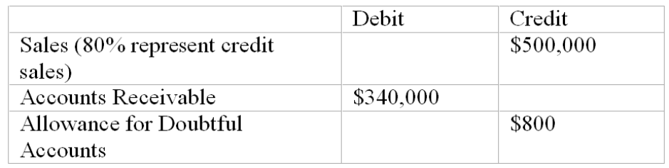

151. Windsor uses the balance sheet approach in estimating uncollectible accounts expense, and aging the accounts receivable indicates the estimated uncollectible portion to be $7,400. What is the amount of uncollectible accounts expense recognized in Windsor's income statement for January?
A. $7,400.
B. $6,600.
C. $8,200.
D. $800.

152. Windsor uses the balance sheet approach in estimating uncollectible accounts expense, and aging the accounts receivable indicates the estimated uncollectible portion to be $7,400. The net realizable value of Windsor's accounts receivable in the January 31 balance sheet is:
A. $321,400.
B. $340,000.
C. $322,600.
D. $347,400.

153. Windsor uses the income statement approach in estimating uncollectible accounts expense, and uncollectible accounts expense is estimated to be 2% of credit sales. What is the amount of uncollectible accounts expense recognized in Windsor's income statement for January?
A. $8,000.
B. $10,000.
C. $8,700.
D. $7,200.

154. Windsor uses the income statement approach in estimating uncollectible accounts expense, and uncollectible accounts expense is estimated to be 2% of credit sales. The net realizable value of Windsor's accounts receivable in the January 31 balance sheet is:
A. $332,800.
B. $332,000.
C. $331,200.
D. $340,000.

155. At the beginning of the year, Robert Company's Allowance for Doubtful Accounts had a $3,200 credit balance. During January, a provision of 2% of sales was made for uncollectible accounts expense. During January, sales totaled $350,000, and $2,900 of accounts receivable were written off as worthless. No recoveries of accounts previously written off were made during the month. Robert's financial statements for January show:
A. Allowance for Doubtful Accounts with a credit balance of $10,200.
B. Allowance for Doubtful Accounts with a credit balance of $7,300.
C. Uncollectible Accounts Expense of $9,900.
D. Uncollectible Accounts Expense of $4,100.

156. Deegan Industries has an accounts receivable turnover rate of 8. Which of the following statements is not true?
A. Deegan's accounts receivable are more liquid than those of a business whose accounts receivable turnover rate is 5.
B. Deegan waits approximately 46 days to make collections of its credit sales. (Use 365 days in a year.)
C. Deegan writes off accounts receivable as uncollectible if they are over 45 days old.
D. Deegan's net credit sales are about eight times the amount of its average accounts receivable.

157. Stanley, Inc.'s 2009 income statement reported net sales of $6,000,000, uncollectible accounts expense of $160,000, and net income of $700,000. Stanley's average accounts receivable during 2009 amounted to $1,200,000. Using 360 days to a year, Stanley's
A. Accounts receivable turnover rate is approximately 4.4 times.
B. Accounts receivable turnover rate is approximately 2.5 times.
C. Average number of days to collect an account receivable is 72 days.
D. Accounts receivable turnover rate is approximately 2 times.

158. Assuming a 365 day year, Gore Industries calculated an average of 53 days to collect its accounts receivable in 2007. During 2007, Gore's accounts receivable turnover rate:
A. Was approximately 6.89.
B. Was equal to 53 times its average accounts receivable.
C. Was approximately 0.15.
D. Can't be determined from this information alone.

159. Varsity Corporation sold available-for-sale marketable securities costing $800,000 for $860,000 cash. This transaction is reported in Varsity's income statement and statement of cash flows, respectively, as:
A. A $60,000 gain and a $60,000 cash receipt.
B. A $860,000 gain and a $60,000 cash receipt.
C. A $60,000 gain and a $860,000 cash receipt.
D. A $860,000 gain and a $860,000 cash receipt.

160. Fisher Corporation invested $320,000 cash in available-for-sale marketable securities in early December. On December 31, the quoted market price for these securities is $337,000. Which of the following statements is correct?
A. Fisher's December income statement includes a $17,000 gain on investments.
B. If Fisher sells these investments on January 2 for $300,000, it will report a loss of $37,000.
C. Fisher's December 31 balance sheet reports marketable securities at $320,000 and an unrealized holding gain on investments of $17,000.
D. Fisher's December 31 balance sheet reports marketable securities at $337,000 and an unrealized holding gain on investments of $17,000.

On October 12, 2010, Neptune Corporation invested $700,000 in short-term available-for-sale marketable securities. The market value of this investment was $730,000 at December 31, 2010, but had slipped to $725,000 by December 31, 2011.

161. In financial statements prepared on December 31, 2010, Neptune Corporation reports:
A. The asset Investments in Marketable Securities at $700,000 with footnote disclosure of the market value of $730,000.
B. The asset Investments in Marketable Securities at $730,000, and a $30,000 Unrealized Holding Gain included in total stockholders' equity.
C. The asset Investments in Marketable Securities at $730,000, and a $30,000 gain recognized in the income statement.
D. The asset Investments in Marketable Securities at $700,000, and a $30,000 Unrealized Holding Gain included in total stockholders' equity.

162. Assuming Neptune does not sell this investment, the mark-to-market adjustment necessary at December 31, 2011, includes:
A. A $5,000 debit to Unrealized Holding Gain on Investments.
B. A $25,000 credit to Unrealized Holding Gain on Investments.
C. A $5,000 debit to Investments in Marketable Securities.
D. A $725,000 debit to Investments in Marketable Securities.

163. Assuming Neptune does not sell this investment, the financial statements prepared at December 31, 2011 will report:
A. Investments in Marketable Securities of $700,000, reduced by a $30,000 Unrealized Holding Gain on Investments, in the asset section of the balance sheet.
B. The asset Investments in Marketable Securities of $700,000 in the balance sheet, and a $25,000 Unrealized Holding Loss on Investments in the income statement.
C. The asset Investments in Marketable Securities of $725,000, and a $5,000 Unrealized Holding Loss deducted from total stockholders' equity.
D. Investment in Marketable Securities of $725,000 in the asset section of the balance sheet, with a $25,000 Unrealized Holding Gain on Investments included in the stockholders' equity section.

164. If a 15%, 60-day note receivable is acquired from a customer in settlement of an existing account receivable of $5,000, the accounting entry for acquisition of the note will:
A. Include a debit to Notes Receivable for $5,750.
B. Include a debit to Notes Receivable for $5,062.50.
C. Include a credit to Interest Revenue for $62.50.
D. Include a debit to Notes Receivable for $5,000 and no entry for interest.

165. Gold Company received a 60-day, 12% note for $8,000 on June 16. Which of the following statements is true?
A. Gold will receive $8,000 plus interest of $960 at maturity.
B. Gold should record a total receivable due of $8,080 on June 16.
C. The principal of the note plus interest is due on August 15.
D. The maturity value of this note is $8,000.

166. On November 1, Willis Corporation sold merchandise in return for a 6%, 90-day note receivable in the amount of $60,000. The proper adjusting entry at December 31 (end of Willis's fiscal year) includes a:
A. Credit to Interest Revenue of $600.
B. Debit to Cash of $600.
C. Debit to Interest Receivable of $300.
D. Credit to Notes Receivable of $900.

167. As of December 31, 2011, Chippewa Company has $26,440 cash in its checking account, as well as several other items listed below:
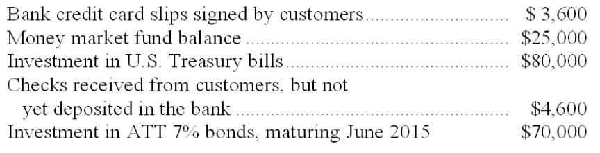
What amount should be shown in Chippewa's December 31, 2011, balance sheet as "Cash and cash equivalents"?
A. $30,040.
B. $139,640.
C. $209,640.
D. $59,640.

168. On January 1, Wilson Company established a petty cash fund of $400. The journal entry to record the replenishment of the fund for $280 at the end of January includes:
A. A debit to Petty Cash of $280.
B. A credit to Cash of $280.
C. A debit to various expenses of $120.
D. No journal entry; an entry is needed only when the petty cash fund is created or discontinued.

At the end of March, the unadjusted trial balance of Tutor, Inc. included the following accounts:
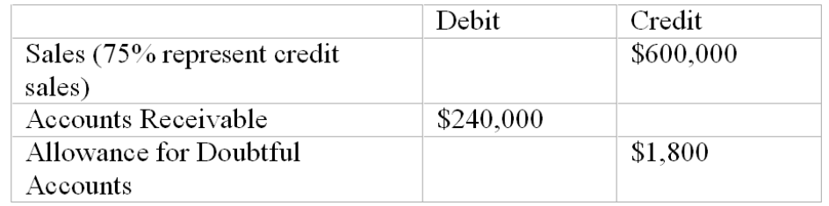

169. Tutor uses the balance sheet approach in estimating uncollectible accounts expense, and aging the accounts receivable indicates the estimated uncollectible portion to be $8,600. What is the amount of uncollectible accounts expense recognized in Tutor's income statement for March?
A. $8,600.
B. $6,800.
C. $10,400.
D. $1,800.

170. Tutor uses the balance sheet approach in estimating uncollectible accounts expense, and aging the accounts receivable indicates the estimated uncollectible portion to be $7,400. The net realizable value of Tutor's accounts receivable in the March 31 balance sheet is:
A. $247,400.
B. $240,000.
C. $232,600.
D. $352,600.

171. Tutor uses the income statement approach in estimating uncollectible accounts expense, and uncollectible accounts expense is estimated to be 3% of credit sales. What is the amount of uncollectible accounts expense recognized in Tutor's income statement for March?
A. $13,500.
B. $18,000.
C. $8,600.
D. $7,200.

172. Tutor uses the income statement approach in estimating uncollectible accounts expense, and uncollectible accounts expense is estimated to be 3% of credit sales. The net realizable value of Tutor's accounts receivable in the March 31 balance sheet is:
A. $251,800.
B. $253,500.
C. $224,700.
D. $255,300.

173. Dorfmann Industries has an accounts receivable turnover rate of 12. Which of the following statements is not true?
A. Dorfmann's accounts receivable are more liquid than those of a business whose accounts receivable turnover rate is 8.
B. Dorfmann waits approximately 30 days to make collections of its credit sales. (Use 365 days in a year.)
C. Dorfmann writes off accounts receivable as uncollectible if they are over 30 days old.
D. Dorfmann's net credit sales are about twelve times the amount of its average accounts receivable.

174. Watins, Inc.'s 2011 income statement reported net sales of $5,000,000. Watin's average accounts receivable during 2011 amounted to $450,000. Using 360 days to a year, Watin's:
A. Accounts receivable turnover rate is approximately 13.8 times.
B. Accounts receivable turnover rate is approximately 1.25 times.
C. Average number of days to collect an account receivable is 32 days.
D. Accounts receivable turnover rate is approximately 2 times.

175. Assuming a 365 day year, Bush Industries calculated an average of 47 days to collect its accounts receivable in 2012. During 2012, Bush's accounts receivable turnover rate:
A. Was approximately 7.77.
B. Was equal to 47 times its average accounts receivable.
C. Was approximately 0.13.
D. Can't be determined from this information alone.

176. If a 5%, 120-day note receivable is acquired from a customer in settlement of an existing account receivable of $50,000, the accounting entry for acquisition of the note will:
A. Include a debit to Notes Receivable for $50,822.
B. Include a debit to Notes Receivable for $50,208.
C. Include a credit to Interest Revenue for $822.
D. Include a debit to Notes Receivable for $50,000 and no entry for interest.

177. Silver Company received a 60-day, 6% note for $16,000 on August 5. Which of the following statements is true?
A. Silver will receive $16,000 plus interest of $960 at maturity.
B. Silver should record a total receivable due of $16,080 on August 5.
C. The principal of the note plus interest is due on October 15.
D. The maturity value of this note is $16,000.

Essay Questions
178. Accounting terminology
Listed below are nine technical accounting terms emphasized in this chapter.
Mark-to-market
Factoring
Direct write-off
Financial asset
Cash equivalent
Bank reconciliation
Allowance for doubtful accounts
Accounts receivable turnover
Uncollectible accounts expense
Each of the following statements may (or may not) describe one of these technical terms. In the space provided below each statement, indicate the accounting term described, or answer "None" if the statement does not correctly describe any of the terms.
____ a. A transaction in which a business sells its accounts receivables to a financial institution.
____ b. An estimate of the portion of year-end accounts receivable that ultimately will turn out to be uncollectible.
____ c. Schedule explaining any differences between cash balances appearing in the accounting records and in the monthly bank statement.
____ d. Balance sheet valuation standard applicable to investments in marketable securities.
____ e. Cash and assets convertible directly into known amounts of cash, such as marketable securities and receivables.
____ f. A ratio, computed by dividing 365 days by average receivables, that indicates the liquidity of the receivables.
____ g. Method of accounting for uncollectible receivables that fails to match revenues and expenses.

179. Internal control over cash transactions
Listed below are seven errors or problems that might occur in the processing of cash transactions. Also shown is a separate list of internal control procedures. Indicate the internal control procedure that should prevent the error or problem from occurring. If none of the control procedures would effectively prevent the error, place an X in the space provided.
Possible Error or Problem
_____ 1. A purchase invoice was paid even though the merchandise was never received.
_____ 2. An employee issued a credit memorandum for a nonexistent sales return in order to conceal his theft of the amount received in payment of an account receivable.
_____ 3. Management is unaware that blank checks are being issued for unauthorized expenditures by the official designated to sign checks.
_____ 4. A salesclerk collects the full selling price from a customer but rings up the sale at less than actual price and pockets the difference.
_____ 5. Several days' cash receipts are lost in a fire.
_____ 6. A new employee often gives customers an incorrect amount of change.
_____ 7. No one has discovered that amounts deposited in the company's bank account by the cashier over the last few years are frequently smaller than amounts forwarded to him from the mailroom or sales department.
Internal Control Procedures
(a). Periodic reconciliation of bank statements to accounting records.
(b). Use of a Cash Over and Short account.
(c). Adequate subdivision of duties.
(d). Use of pre-numbered sales tickets.
(e). Depositing each day's cash receipts intact in the bank.
(f). Use of electronic cash registers equipped with optical scanners to read magnetically coded labels on merchandise.
(g). Immediate preparation of a control listing when cash is received and the comparison of this listing with bank deposits.
(h). Cancellation of paid vouchers.
(i). Requirement that a voucher be prepared as advance authorization of every cash disbursement.

180. Petty cash fund
E-Z Productions established a petty cash fund of $650 on January 1. On January 28, the fund was replenished for the payments made to date as shown by the following petty cash vouchers: postage, $145; telephone expense, $62.80; repairs, $79.20; office supplies, $67.20; and miscellaneous expense, $56. Prepare journal entries in general journal form to record the establishment of the fund on January 1 and its replenishment on January 28.

181. Bank reconciliation-classification
Indicate how the following items would be treated in a bank reconciliation. You may choose from the following answers:
(A) Deducted from the balance per accounting records.
(B) Added to balance per accounting records.
(C) Deducted from balance per bank statement.
(D) Added to balance per bank statement.
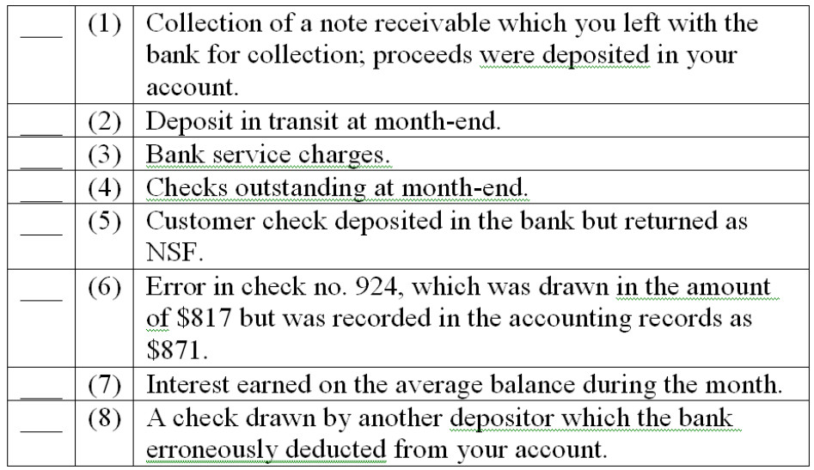

182. Bank reconciliation—classification
Indicate how the following items would be treated in Aladdin's, Inc.'s bank reconciliation. Choose from the following answers:
(a.) Deducted from the balance per accounting records.
(b.) Added to balance per accounting records.
(c.) Deducted from balance per bank statement.
(d.) Added to balance per bank statement.
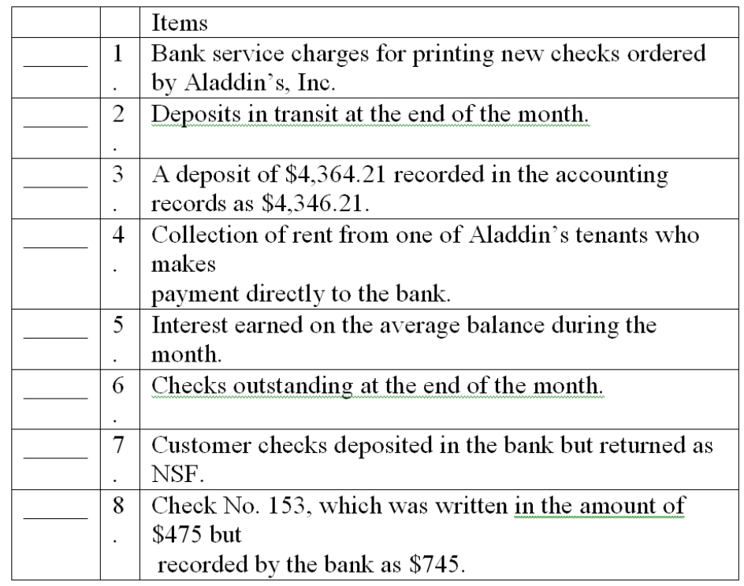

183. Bank reconciliation--computation and journal entry
The Cash account in the ledger of Arnaz Company showed a balance of $13,307 at March 31.
The bank statement, however, showed a balance of $9,936 at the same date. The only reconciling items consisted of a $4,902 deposit in transit, a bank service charge of $36, outstanding checks totaling $2,600, and an NSF check from L. Ball, one of Arnaz' customers.
(a) What is the amount of the adjusted cash balance on March 31?
(b) What is the amount of the NSF check?
(c) Record the journal entry necessary, if any, to adjust Arnaz Company's accounting records at March 31:
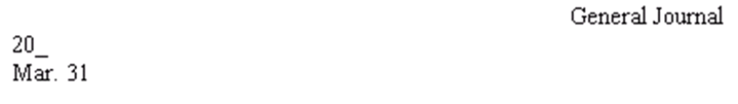

184. Bank reconciliation--computations and journal entry
The Cash account in the ledger of Pine Golf Club shows a balance of $11,925 at December 31, 2009. The December 31 bank statement shows a balance of $10,440. The only reconciling items consist of:
Bank service charges of $32.
Deposit in transit of $1,813.
NSF check from customer L. Diamond in the amount of $126.
Error in recording check no. 970 for utilities: check was written in the amount of $834 but was recorded in Pine's accounting records as $384.
Outstanding checks.
(a) What is the amount of the adjusted cash balance at December 31, 2009?
$_______________
(b) What is the total amount of outstanding checks at December 31, 2009?
$_______________
(c) Record the journal entry necessary, if any, to adjust Pine's Golf Club accounting records at December 31, 2006. (An explanation is not required; a single compound journal entry is acceptable.)
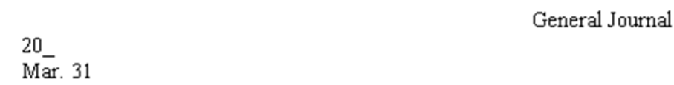

185. Bank reconciliation
At March 31, the balance of the Cash account according to the records of Fisher Company was $7,261. The March 31 bank statement showed a balance of $8,798. You are to prepare the bank reconciliation of Fisher Company at March 31, using the following supplementary information:
(a.) Deposit in transit at March 31, $6,772.
(b.) Outstanding checks: no. 120, $140; no. 121, $932; no. 127, $307; no. 134, $2,200.
(c.) Service charge by bank, $50.
(d.) A note receivable for $5,050 left by Fisher Company with bank for collection that had been collected and credited to company's account. No interest involved.
(e.) A check for $90 drawn by a customer, Stuart Sands, but deducted from Fisher's account by the bank and returned with the notation "NSF."
(f.) Fisher's check no. 480, issued in payment of $970 worth of office equipment, correctly written in the amount of $970 but erroneously recorded in Fisher's accounting records as $790.
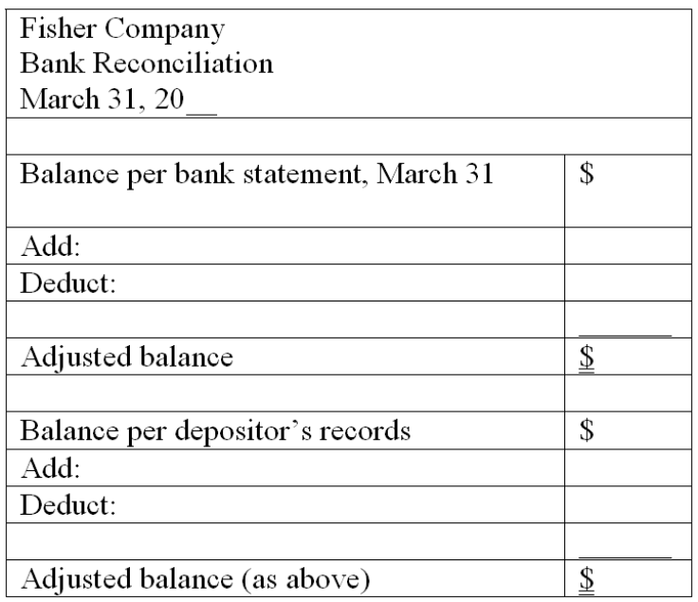

186. Bank reconciliation
(A.) You are to complete the June 30 bank reconciliation for Silver Company using the following information:
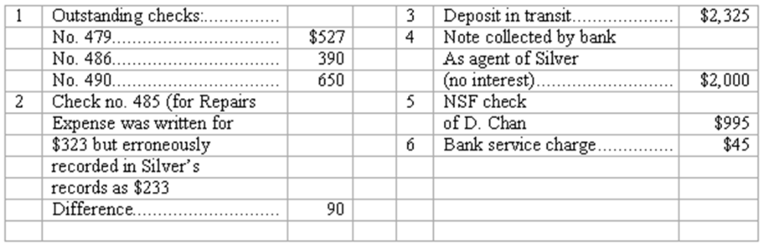
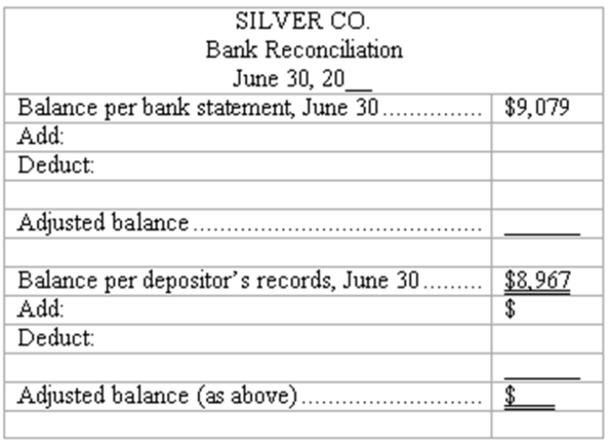
(B.) Give in general journal form the entry or entries necessary to correct Silver's accounting records as of June 30. (Explanations may be omitted; one compound journal entry is acceptable.)
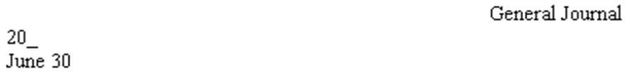

187. Balance sheet method-journal entries
The general ledger controlling account for Accounts Receivable has a balance of $120,500 at year-end before adjustment. The company uses the balance sheet approach to estimate uncollectible accounts. By aging the individual customers' accounts, it was determined that the doubtful accounts amounted to $5,020. Prepare the year-end adjusting entry for uncollectible accounts under each of the following independent assumptions.
(a.) Allowance for Doubtful Accounts has a credit balance of $2,850.
(b.) Allowance for Doubtful Accounts has a debit balance of $925.

188. Balance sheet method-computations
Rainbow Company uses the balance sheet approach to estimate uncollectible accounts. By aging the customers' accounts, it was estimated that $7,325 of the company's month-end accounts receivable would prove to be uncollectible. Determine the amount that should be debited to the Uncollectible Accounts Expense account in the month-end adjusting entry under each of the following independent assumptions:
(a.) Before making any adjustment, the Allowance for Doubtful Accounts has
a $635 credit balance. $_______________
(b.) Before making any adjustment, the Allowance for Doubtful Accounts
has a debit balance of $720. $_______________

189. Uncollectible accounts--two methods
At the end of the year the unadjusted trial balance of Angel Provisions included the following accounts:
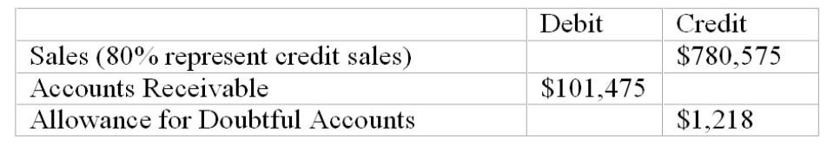
(a.) If Angel uses the balance sheet approach to estimate uncollectible accounts expense, and aging the accounts receivable indicates the estimated uncollectible portion to be $6,075, what will the uncollectible accounts expense for the year be?
(b.) If the income statement approach to estimating uncollectible accounts expense is followed, and uncollectible accounts expense is estimated to be 1% of net credit sales, what is the amount of uncollectible accounts expense for the year?

190. Write-off of uncollectible account receivable
On January 10, Winston, Inc.'s trial balance included the following accounts:
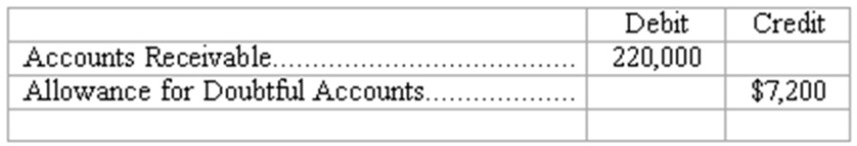
On January 11, Len Palmer, a major customer, declares bankruptcy and thus, Winston determines that a receivable from Palmer in the amount of $3,400 is worthless.
(a) In the space provided, prepare the journal entry that Winston should record to write-off the account receivable from Len Palmer on January 11.
(b) Compute the net realizable value of Winston's accounts receivable at each of the following dates:
January 10 (before write-off of Palmer's account) $_______________
January 11 (immediately after write-off of Palmers' account) $_______________

191. Accounts receivable turnover rate
During 2010, Larsen Company's accounts receivable averaged $750,000. Larsen's 2010 income statement reported net sales of $6,780,000, uncollectible accounts expense of $160,000, and net income of $768,000. (Assume 365 days in a year.)
Using the information, compute the following for Larsen Company:
(a) Accounts receivable turnover: (Round to the nearest two decimals.)
(b) Average number of days to collect accounts receivable (round to nearest day, if necessary): (Round to the nearest %.)

192. Financial assets-effects of transactions
Five events involving financial assets are described below:
(a.) Sold merchandise on account.
(b.) Sold available-for-sale marketable securities at a gain. Cash proceeds from the sale were equal to the current market value of the securities reflected in the last balance sheet.
(c.) Collected an account receivable.
(d.) Adjusted the allowance for doubtful accounts to reflect the portion of accounts receivable estimated to be uncollectible at year-end.
(e.) Made mark-to-market adjustment reducing the balance in the available-for-sale marketable securities account to reflect a decrease in the market value of securities owned.
Indicate the effects of each independent transaction or adjusting entry upon the financial measurements shown in the four column headings below. Use the code letters, I for increase, D for decrease, and NE for no effect.
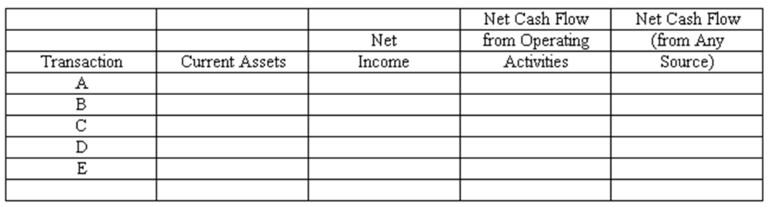

193. Financial assets--effects of transactions
Five events involving financial assets are described below:
(a.) Received dividends earned on investment in marketable securities.
(b.) Invested excess cash in marketable securities.
(c.) Determined that a specific account receivable is worthless and wrote it off against the allowance for doubtful accounts.
(d.) Made sale of merchandise for cash.
(e.) Sold available-for-sale marketable securities at a loss. Cash proceeds from the sale were equal to the current market value reflected in the last balance sheet.
Indicate the effects of each independent transaction or adjusting entry upon the financial measurements shown in the four column headings below. Use the code letters, I for increase, D for decrease, and NE for no effect.
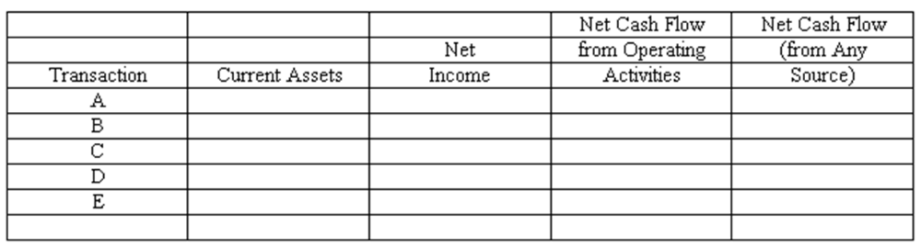

194. At December 31, 2009, Laconia Industries' portfolio of investments in available-for-sale marketable securities consisted of the following:
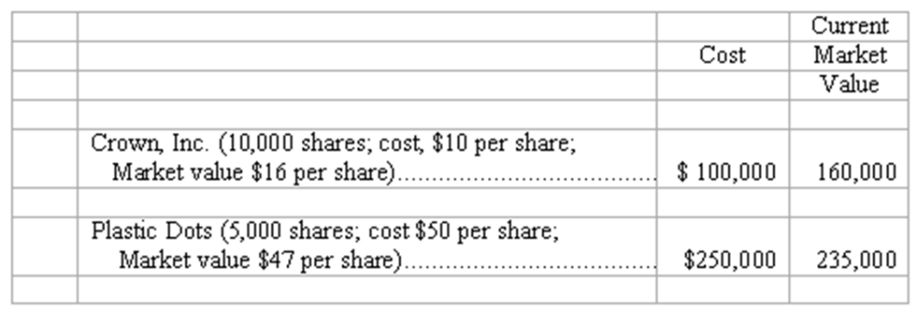
(a.) Illustrate the presentation of marketable securities and unrealized holding gain (or loss) in Laconia's financial statements at December 31, 2009. Indicate the financial statement and section in which each item appears.
(b.) Assume that on March 15, 2010, Laconia made the following sales of securities:
(1) Sold 5,000 shares of its investment in Crown, Inc., at a price of $20 per share.
(2) Sold 1,000 shares of its investment in Plastic Dots at a price of $45 per share.
Compute the gain or loss recognized in Laconia's 2010 income statement for each sale:
(1). Sale of 5,000 shares of Crown: $____________ Gain/Loss
(2). Sale of 1,000 shares of Plastic Dots: $____________ Gain/Loss
(c.) At December 31, 2010, the market values of these stocks are: Crown, $21 per share; Plastic Dots, $42 per share. Complete the following schedule showing cost and current market value of securities owned by Laconia at the end of 2010.
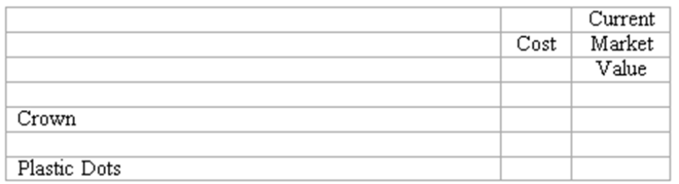
(d.) Illustrate the presentation of marketable securities and unrealized holding gain (or loss) in Laconia's financial statements at December 31, 2010. (Follow same format as in part a.)

195. Notes receivable—computations
Complete the following statements about promissory notes and interest by entering amounts in the spaces provided. (Use 360 days in one year.)
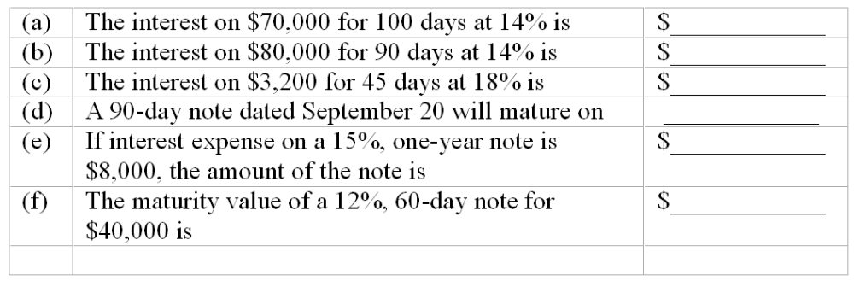

196. Note receivable--journal entries
On September 1, 2010, Dental Equipment Corporation sold equipment priced at $350,000 in exchange for a six-month note receivable with an annual interest rate of 12%, all due at maturity.
(a.) Prepare the December 31, 2010 (fiscal year-end), adjusting entry made by Dental with regard to this note receivable.
(b.) Prepare the entry made by Dental on March 1, 2011(maturity date of note), to record collection of note and interest.
(a) 2010 General Journal
Dec. 31
(b) 2011 March 1
(c.) Assume that on March 1, 2011, the maker of the note defaults and Dental does not collect the note. Prepare the entry to be made to Dental on March 1, 2011, in this situation.
(c) 2011 March 1

197. Financial assets
(a.) Briefly explain what is meant by the term "financial assets."
(b.) List the three major categories of assets comprising a company's financial assets. For each category, indicate the basis for valuation in the balance sheet.

198. Internal control over cash transactions
(a.) Describe three measures contributing to strong internal control over cash receipts.
(b.) Describe three measures contributing to effective internal control over cash disbursements.

199. Cash management
(a.) What is meant by the term "cash management"?
(b.) Identify at least three basic objectives of effective cash management.

200. Reporting cash in the balance sheet
(a.) The first asset shown in the balance sheet of many companies is labeled "cash and cash equivalents." Explain the term "cash equivalent" and give two examples. Why are cash and cash equivalents listed first in the balance sheet?
(b.) The December bank statement for Kowal Publishing Co. reports a balance of $13,847.59 at December 31, 2009. Kowal's accounting records, however, show a balance of $15,245.47 in the same bank account prior to preparation of the bank reconciliation.
Which amount should be included in the amount of cash reported in Kowal's balance sheet at December 31, 2009? Explain your answer.

201. Marketable securities
(a.) Explain how investments in available-for-sale marketable securities are valued in the investor's balance sheet.
(b.) Is valuation of investments in marketable securities consistent with (1) the cost principle, and (2) the objectivity principle?
(c.) What does Unrealized Holding Gain (or Loss) on Investments represent? How is this item reported in the financial statements?

202. Uncollectible accounts
(a.) What is an uncollectible account? Explain how a business suffers losses from uncollectible accounts.
(b.) "A competent credit manager should set credit policies so as to avoid any and all losses from uncollectible accounts." Is this statement accurate? Explain your answer.

203. Evaluating the quality of receivables
(a.) The 2010 annual report of Modern Books, a publicly traded corporation, reports accounts receivable (net of allowance for doubtful accounts), of $190,714 as of February 28, 2010. What assurance do readers of Modern Books' annual report have that these receivables really exist and are not fictitious assets recorded to make the balance sheet "look good"?
(b.) The accounts receivable turnover rate is frequently used in evaluating the liquidity of accounts receivable. How is the accounts receivable turnover rate computed? What type of information does the accounts receivable turnover rate provide?

204. Information for the Hooper Company is as follows:
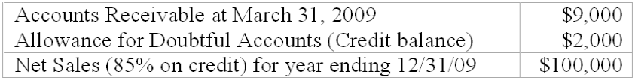
(1) What is the amount of uncollectible account expense for 2009 if the company uses the Percentage of Sales method and 2% of credit sales are deemed uncollectible?
(2) What is the amount of uncollectible expense if the company uses the balance sheet approach and estimates $2,200 as uncollectible in 2009?
(3) What is the net realizable value of accounts receivable if the company uses the balance sheet approach?
(4) If the company writes-off a receivable of $450 what will be the net realizable value of accounts receivable after the write off?

205. Match the following terms with the explanations below. If no term fits the explanation write none
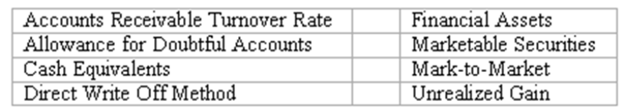
_______ (1) A means of accounting for uncollectibles which does not recognize any expense until specific receivables are determined to be worthless.
_______ (2) An account showing the amount of estimated uncollectible receivables.
_______ (3 ) The process of estimating uncollectible accounts by classifying accounts receivables by age groups.
_______ (4) Dividing net sales by average receivables to create a ratio to measure the liquidity of accounts receivable.
_______ (5) Very short-term liquid investments which must mature within 90 days of acquisition.
_______ (6) Cash and assets convertible directly into known amounts of cash.
_______ (7) An account showing the difference between the cost of an investment in marketable securities and its market value.
_______ (8) The value of a note at its maturity date.
_______ (9) Highly liquid investments that can be sold in organized securities exchanges.

Multiple Choice Questions
At the end of the month the unadjusted trial balance of Four Star Company included the following accounts:
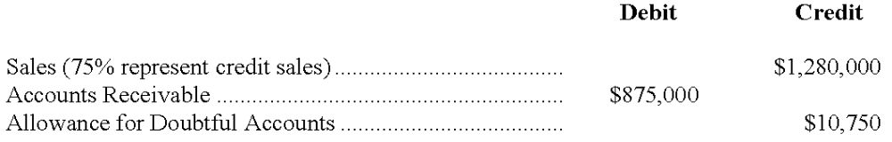

206. If the income statement method of estimating uncollectible accounts expense is followed, and uncollectible accounts expense is estimated to be 2% of net credit sales, the net realizable value of Four Star accounts receivable at the end of the month is:
A. $855,800.
B. $845,050.
C. $19,200.
D. $1,250,050.

207. If Four Star uses the balance sheet approach in estimating uncollectible accounts, and aging the accounts receivable indicates the estimated uncollectible portion to be $24,000, the uncollectible accounts expense for the month is:
A. $24,000.
B. $13,250.
C. $34,750.
D. $10,750.

208. Which of the following items is reported in neither the income statement nor the statement of cash flows?
A. Sale of marketable securities at a loss.
B. Sale of marketable securities at a gain.
C. Adjustment of available-for-sale marketable securities owned to current market value at balance sheet date.
D. Investment of excess cash in marketable securities.

209. Mark-to-market is the balance sheet valuation standard for:
A. Investments in all financial assets.
B. Investments in available-for-sale marketable securities.
C. Investments in capital stock of any corporation.
D. Stockholders' equity of any publicly traded corporation.

210. Cash equivalents:
A. Include amounts of cash available through an unused line of credit.
B. Are investments in the publicly traded stocks and bonds of large corporations.
C. Are usually included in the term "cash" in the balance sheet and the statement of cash flows.
D. Is another term for financial assets.

Shown below is a partially completed bank reconciliation for Hubbard Transport at August 31, as well as additional data necessary to answer the questions that follow.
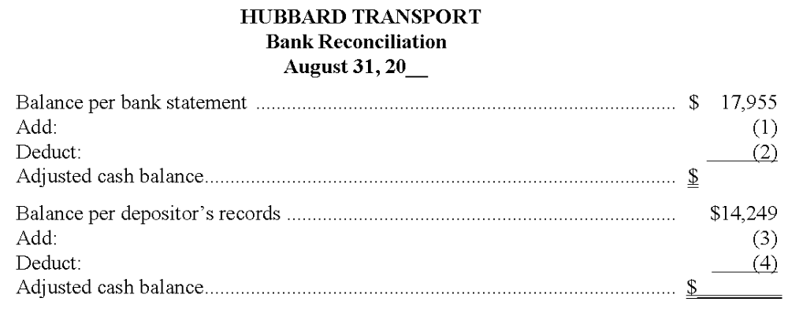
Additional information
a. Outstanding checks: no. 729, $1,253; no. 747, $245; no. 752, $781.
b. Check no. 742 (for repairs) was written for $398 but erroneously recorded in Hubbard's records as $839.
c. Deposits in transit, $2,254.
d. Note collected by the bank and credited to Hubbard's account, $4,800.
e. NSF check of C. Craig, one of Hubbard's customers, $1,525.
f. Bank service charge for August, $35.

211. In Hubbard's completed bank reconciliation at August 31, what dollar amount should be deducted from the balance per bank statement (indicated by 2 above)?
A. $2,254.
B. $2,279.
C. $1,525.
D. $4,800.

212. In Hubbard's completed bank reconciliation at August 31, what dollar amount should be added to the balance per depositor's records (indicated by 3 above)?
A. $4,800.
B. $2,254.
C. $5,241.
D. $6,766.

213. In Hubbard's completed bank reconciliation at August 31, what dollar amount should be deducted from the balance per depositor's records (indicated by 4 above)?
A. $2,254.
B. $2,001.
C. $1,525.
D. $1,560.

214. Hubbard Transport keeps $500 cash on hand in addition to this checking account and has no other bank accounts or cash equivalents. What amount should appear as Cash in Emerald's August 31 balance sheet?
A. $18,430.
B. $14,249.
C. $17,955.
D. Some other amount.

215. The necessary adjustment to Hubbard Transport's accounting records as of August 31 includes a net:
A. Increase to Cash of $5,241.
B. Increase to Cash of $3,240.
C. Increase to Cash of $3,681.
D. Decrease to Cash of $35.

Essay Questions
216. You are to complete the June 30 bank reconciliation for Huang, Inc. using the following information:
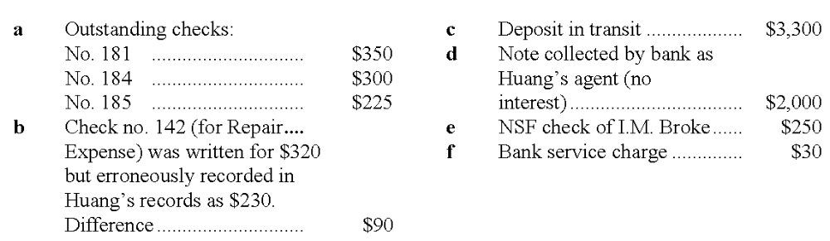

217. Prepare the journal entry to correct Huang's records as of June 30. (Explanations may be omitted; one compound journal entry is acceptable.)
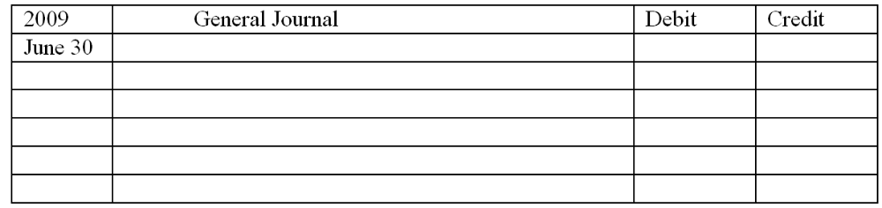

218. After aging its accounts receivable at December 31, Howland Company estimates that $68,000 of the $835,000 outstanding accounts receivable will prove uncollectible. The Allowance for Doubtful Accounts has a debit balance of $6,200 prior to adjustment. In the space provided, prepare the adjusting entry required by Huey in this situation:
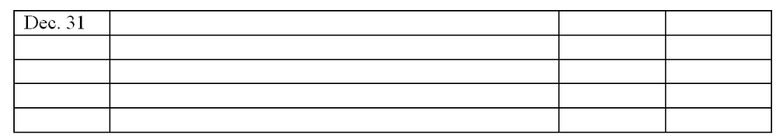

219. At year-end, Atkins Company applies the income statement approach in estimating uncollectible accounts expense and determines such expense to be 2% of net sales. At December 31 of the current year, accounts receivable total $600,000, and Allowance for Doubtful Accounts has a credit balance of $4,200 prior to adjustment. Net sales for the current year were $2,300,000. Compute the net realizable value of accounts receivable to be reported in Dewey's December 31 balance sheet.

220. During the year, Brown Corporation's average accounts receivable were $316,000. The current-year income statement reported net sales of $2,010,000, uncollectible accounts expense of $118,000, and net income of $982,000. Using 365 days to a year, compute the average number of days Brown waits to collect its accounts receivable. (Round answer to the nearest day, if necessary.)

At September 30, the Cash account in the general ledger of Breen Construction shows a balance of $13,221. However, the bank statement shows a balance of $16,720 at the same date. The only reconciling items consist of a bank service charge of $42, outstanding checks totaling $4,744, a deposit in transit, and an error in recording check no. 529. Check no. 529 was written in the amount of $772 but was recorded as $727 in Gentle's accounting records.

221. What is the adjusted cash balance in the September 30 bank reconciliation?

222. What is the amount of the deposit in transit?

Multiple Choice Questions
223. In general terms, financial assets appear in the balance sheet at:
A. Face value.
B. Current value.
C. Cost.
D. Estimated future sales value.

224. Which of the following practices contributes to efficient cash management?
A. Never borrow money—maintain a cash balance sufficient to make all necessary payments.
B. Record all cash receipts and cash payments at the end of the month when reconciling the bank statements.
C. Prepare monthly forecasts of planned cash receipts, payments and anticipated cash balances up to a year in advance.
D. Pay each bill as soon as the invoice arrives.

225. Each of the following measures strengthens internal control over cash receipts except:
A. The use of a voucher system.
B. Preparation of a daily listing of all checks received through the mail.
C. The deposit of cash receipts intact in the bank on a daily basis.
D. The use of cash registers.

Quinn Company's bank statement at January 31 shows a balance of $13,360, while the account for Cash in Quinn's ledger shows a balance of $12,890 at the same date. The only reconciling items are the following:
Deposit in transit, $890.
Bank service charge, $24.
NSF check from customer Greg Denton in the amount of $426.
Error in recording check no. 389 for rent: check was written in
the amount of $1,320, but was recorded improperly in the accounting records as $1,230.
Outstanding checks, $?.

226. What is the total amount of outstanding checks at January 31?
A. $1,048.
B. $868.
C. $1,900.
D. $1,720.

227. Assuming a single journal entry is made to adjust Quinn Company's accounting records at January 31, the journal entry includes:
A. A debit to Rent Expense for $90.
B. A credit to Accounts Receivable, G. Denton, for $426.
C. A credit to Cash for $450.
D. A credit to Cash for $1,720.

228. Which of the following best describes the application of generally accepted accounting principles to the valuation of accounts receivable?
A. Realization principle—Accounts receivable are shown at their net realizable value in the balance sheet.
B. Matching principle—The loss due to an uncollectible account is recognized in the period in which the sale is made, not in the period in which the account receivable is determined to be worthless.
C. Cost principle—Accounts receivable are shown at the initial cost of the merchandise to customers, less the cost the seller must pay to cover uncollectible accounts.
D. Principle of conservatism—Accountants favor using the lowest reasonable estimate for the amount of uncollectible accounts shown in the balance sheet.

229. On January 1, Dillon Company had a $3,100 credit balance in the Allowance for Doubtful Accounts. During the year, sales totaled $780,000 and $6,900 of accounts receivable were written off as uncollectible. A December 31 aging of accounts receivable indicated the amount probably uncollectible to be $5,300. (No recoveries of accounts previously written off were made during the year.) Dillon's financial statements for the current year should include:
A. Uncollectible accounts expense of $9,100.
B. Uncollectible accounts expense of $5,300.
C. Allowance for Doubtful Accounts with a credit balance of $1,500.
D. Allowance for Doubtful Accounts with a credit balance of $8,400.

230. Under the direct write-off method of accounting for uncollectible accounts:
A. The current year uncollectible accounts expense is less than the expense would be under the income statement approach.
B. The relationship between the current period net sales and current period uncollectible accounts expense illustrates the matching principle.
C. The Allowance for Doubtful Accounts is debited when specific accounts receivable are determined to be worthless.
D. Accounts receivable are not stated in the balance sheet at net realizable value, but at the balance of the Accounts Receivable ledger account.

231. Which of the following actions is least likely to increase a company's accounts receivable turnover?
A. Encouraging customers to use bank credit cards, such as Visa and MasterCard, rather than other national credit cards, such as American Express.
B. Offer customers larger cash discounts for making early payments.
C. Borrowing money, pledging accounts receivable as collateral.
D. Sell accounts receivable to a factor.

232. On October 1, 2011, Coast Financial lent Barr Corporation $300,000, receiving in exchange a nine-month, 12% note receivable. Coast ends its fiscal year on December 31, and makes adjusting entries to accrue interest earned on all notes receivable. The interest earned on the note receivable from Barr Corporation during 2012 will amount to:
A. $9,000.
B. $18,000.
C. $27,000.
D. $36,000.

233. Puget Sound Co. sold available-for-sale marketable securities costing $80,000 for $92,000 cash. In the company's income statement and statement of cash flows, respectively, this will appear as:
A. A $12,000 gain and a $92,000 cash receipt.
B. A $92,000 gain and an $8,000 cash receipt.
C. A $12,000 gain and an $80,000 cash receipt.
D. A $92,000 sale and a $92,000 cash receipt.

Chapter 07 Financial Assets Answer Key

True / False Questions
1. Showing marketable securities on the balance sheet at current market values violates the consistency principle.
FALSE

AACSB: Reflective Thinking
AICPA BB: Critical Thinking
AICPA FN: Measurement
Bloom's: Remember
Difficulty: Easy
Learning Objective: 07-04 Describe how short-term investments are reported in the balance sheet and account for transactions involving marketable securities.
Topic: Accounting for Marketable Securities
2. A line of credit creates a liability for the borrower when it is granted by the bank.
FALSE

AACSB: Reflective Thinking
AICPA BB: Critical Thinking
AICPA FN: Measurement
Bloom's: Remember
Difficulty: Easy
Learning Objective: 07-02 Describe the objectives of cash management and internal controls over cash.
Topic: Cash
3. The first step in a bank reconciliation is to update the depositor's accounting records for any deposits-in-transit.
FALSE

AACSB: Reflective Thinking
AICPA BB: Critical Thinking
AICPA FN: Measurement
Bloom's: Remember
Difficulty: Easy
Learning Objective: 07-03 Prepare a bank reconciliation and explain its purpose.
Topic: Cash
4. To "write-off" an account receivable is to reduce the balance of the customer's account to zero.
TRUE

AACSB: Reflective Thinking
AICPA BB: Critical Thinking
AICPA FN: Measurement
Bloom's: Remember
Difficulty: Easy
Learning Objective: 07-05 Account for uncollectible receivables using the allowance and direct write-off methods.
Topic: Accounts Receivable
5. The Allowance for Doubtful Accounts is a contra-asset account and appears on the balance sheet.
TRUE

AACSB: Reflective Thinking
AICPA BB: Critical Thinking
AICPA FN: Reporting
Bloom's: Remember
Difficulty: Easy
Learning Objective: 07-05 Account for uncollectible receivables using the allowance and direct write-off methods.
Topic: Accounts Receivable
6. The balance shown on a bank statement is always less than the month-end balance of a company's cash account in the general ledger.
FALSE

AACSB: Reflective Thinking
AICPA BB: Critical Thinking
AICPA FN: Measurement
Bloom's: Remember
Difficulty: Medium
Learning Objective: 07-03 Prepare a bank reconciliation and explain its purpose.
Topic: Cash
7. Deposits-in-transit would not appear on a company's bank reconciliation but would appear on the company's bank statement.
FALSE

AACSB: Reflective Thinking
AICPA BB: Critical Thinking
AICPA FN: Measurement
Bloom's: Remember
Difficulty: Easy
Learning Objective: 07-03 Prepare a bank reconciliation and explain its purpose.
Topic: Cash
8. Entries made in the general journal after preparing a bank reconciliation are called closing entries.
FALSE

AACSB: Reflective Thinking
AICPA BB: Critical Thinking
AICPA FN: Measurement
Bloom's: Remember
Difficulty: Easy
Learning Objective: 07-03 Prepare a bank reconciliation and explain its purpose.
Topic: Cash
9. Financial assets may be current or long-term assets.
FALSE

AACSB: Reflective Thinking
AICPA BB: Critical Thinking
AICPA FN: Measurement
Bloom's: Remember
Difficulty: Easy
Learning Objective: 07-01 Define financial assets and explain their valuation in the balance sheet.
Topic: Financial Assets
10. Cash equivalents include money market funds, U.S. Treasury bills, and high-grade commercial paper.
TRUE

AACSB: Reflective Thinking
AICPA BB: Critical Thinking
AICPA FN: Measurement
Bloom's: Remember
Difficulty: Easy
Learning Objective: 07-02 Describe the objectives of cash management and internal controls over cash.
Topic: Cash
11. The term "financial asset" is synonymous with the term "cash equivalent."
FALSE

AACSB: Reflective Thinking
AICPA BB: Critical Thinking
AICPA FN: Measurement
Bloom's: Remember
Difficulty: Easy
Learning Objective: 07-01 Define financial assets and explain their valuation in the balance sheet.
Topic: Financial Assets
12. Cash equivalents are the most liquid of assets.
TRUE

AACSB: Reflective Thinking
AICPA BB: Critical Thinking
AICPA FN: Measurement
Bloom's: Remember
Difficulty: Easy
Learning Objective: 07-01 Define financial assets and explain their valuation in the balance sheet.
Topic: Financial Assets
13. A credit memoranda from a bank indicates that they have decreased the depositor's cash balance.
FALSE

AACSB: Reflective Thinking
AICPA BB: Critical Thinking
AICPA FN: Measurement
Bloom's: Remember
Difficulty: Easy
Learning Objective: 07-03 Prepare a bank reconciliation and explain its purpose.
Topic: Cash
14. U.S. Treasury bills that mature within six months are cash equivalents.
FALSE

AACSB: Reflective Thinking
AICPA BB: Critical Thinking
AICPA FN: Measurement
Bloom's: Remember
Difficulty: Easy
Learning Objective: 07-01 Define financial assets and explain their valuation in the balance sheet.
Topic: Financial Assets
15. A company with more than one bank checking account should show more than one account for Cash in its balance sheet.
FALSE

AACSB: Reflective Thinking
AICPA BB: Critical Thinking
AICPA FN: Reporting
Bloom's: Remember
Difficulty: Easy
Learning Objective: 07-02 Describe the objectives of cash management and internal controls over cash.
Topic: Cash
16. The amount of cash that should appear on the balance sheet is equal to the amount of cash on deposit, plus currency, coin, and customers' checks on hand, minus the balance of the Cash Over and Short account.
FALSE

AACSB: Reflective Thinking
AICPA BB: Critical Thinking
AICPA FN: Reporting
Bloom's: Understand
Difficulty: Medium
Learning Objective: 07-03 Prepare a bank reconciliation and explain its purpose.
Topic: Cash
17. Financial assets describe not just cash, but all assets that are easily and directly convertible into known amounts of cash, except marketable securities.
FALSE

AACSB: Reflective Thinking
AICPA BB: Critical Thinking
AICPA FN: Reporting
Bloom's: Remember
Difficulty: Medium
Learning Objective: 07-01 Define financial assets and explain their valuation in the balance sheet.
Topic: Financial Assets
18. Restricted cash may be available to meet the normal operating needs of a company.
FALSE

AACSB: Reflective Thinking
AICPA BB: Critical Thinking
AICPA FN: Measurement
Bloom's: Remember
Difficulty: Easy
Learning Objective: 07-02 Describe the objectives of cash management and internal controls over cash.
Topic: Cash
19. A compensating balance is often required by a bank as a condition for granting a loan.
TRUE

AACSB: Reflective Thinking
AICPA BB: Critical Thinking
AICPA FN: Reporting
Bloom's: Remember
Difficulty: Easy
Learning Objective: 07-02 Describe the objectives of cash management and internal controls over cash.
Topic: Cash
20. An unrealized gain on available-for-sale securities will increase shareholders' equity.
TRUE

AACSB: Reflective Thinking
AICPA BB: Critical Thinking
AICPA FN: Measurement
Bloom's: Understand
Difficulty: Medium
Learning Objective: 07-04 Describe how short-term investments are reported in the balance sheet and account for transactions involving marketable securities.
Topic: Accounting for Marketable Securities
21. Internal control is strengthened by a policy of making payments by check, or from cash receipts, or from a petty cash fund.
FALSE

AACSB: Reflective Thinking
AICPA BB: Critical Thinking
AICPA FN: Measurement
Bloom's: Remember
Difficulty: Medium
Learning Objective: 07-02 Describe the objectives of cash management and internal controls over cash.
Topic: Cash
22. Compensating balances are not included in the amount of cash listed on a balance sheet.
FALSE

AACSB: Reflective Thinking
AICPA BB: Critical Thinking
AICPA FN: Reporting
Bloom's: Remember
Difficulty: Easy
Learning Objective: 07-02 Describe the objectives of cash management and internal controls over cash.
Topic: Cash
23. In order to be classified as available-for-sale securities, the investment cannot be held for a period longer than three months.
FALSE

AACSB: Reflective Thinking
AICPA BB: Critical Thinking
AICPA FN: Reporting
Bloom's: Remember
Difficulty: Medium
Learning Objective: 07-04 Describe how short-term investments are reported in the balance sheet and account for transactions involving marketable securities.
Topic: Accounting for Marketable Securities
24. In order for a company's accounting records to be up-to-date and accurate after a bank reconciliation has been completed, journal entries should be made for any service charges by the bank and for deposits-in-transit.
FALSE

AACSB: Reflective Thinking
AICPA BB: Critical Thinking
AICPA FN: Measurement
Bloom's: Remember
Difficulty: Medium
Learning Objective: 07-03 Prepare a bank reconciliation and explain its purpose.
Topic: Cash
25. Internal control will aid in achieving accurate accounting for cash.
TRUE

AACSB: Reflective Thinking
AICPA BB: Critical Thinking
AICPA FN: Measurement
Bloom's: Remember
Difficulty: Easy
Learning Objective: 07-02 Describe the objectives of cash management and internal controls over cash.
Topic: Cash
26. Marketable securities includes investments in bonds and in the capital stocks of publicly traded corporations.
TRUE

AACSB: Reflective Thinking
AICPA BB: Critical Thinking
AICPA FN: Measurement
Bloom's: Remember
Difficulty: Easy
Learning Objective: 07-04 Describe how short-term investments are reported in the balance sheet and account for transactions involving marketable securities.
Topic: Accounting for Marketable Securities
27. The Allowance for Doubtful Accounts should be listed on the balance sheet as a current liability.
FALSE

AACSB: Reflective Thinking
AICPA BB: Critical Thinking
AICPA FN: Reporting
Bloom's: Remember
Difficulty: Easy
Learning Objective: 07-05 Account for uncollectible receivables using the allowance and direct write-off methods.
Topic: Accounts Receivable
28. Short-term investments in marketable securities may not be reported in the balance sheet at values higher than original cost.
FALSE

AACSB: Reflective Thinking
AICPA BB: Critical Thinking
AICPA FN: Reporting
Bloom's: Remember
Difficulty: Medium
Learning Objective: 07-04 Describe how short-term investments are reported in the balance sheet and account for transactions involving marketable securities.
Topic: Accounting for Marketable Securities
29. If the allowance method is used and an account receivable that had been previously written-off is collected, income is currently recorded.
FALSE

AACSB: Reflective Thinking
AICPA BB: Critical Thinking
AICPA FN: Measurement
Bloom's: Understand
Difficulty: Medium
Learning Objective: 07-05 Account for uncollectible receivables using the allowance and direct write-off methods.
Topic: Accounts Receivable
30. The income statement approach used to estimate uncollectible receivables uses a percentage of net sales without considering the current balance in the Allowance account.
TRUE

AACSB: Reflective Thinking
AICPA BB: Critical Thinking
AICPA FN: Measurement
Bloom's: Remember
Difficulty: Medium
Learning Objective: 07-05 Account for uncollectible receivables using the allowance and direct write-off methods.
Topic: Accounts Receivable
31. The Allowance for Doubtful Accounts is called a valuation account, or contra-asset account, and normally has a credit balance.
TRUE

AACSB: Reflective Thinking
AICPA BB: Critical Thinking
AICPA FN: Measurement
Bloom's: Remember
Difficulty: Medium
Learning Objective: 07-05 Account for uncollectible receivables using the allowance and direct write-off methods.
Topic: Accounts Receivable
32. When an Allowance for Doubtful Accounts is used, accounts receivable are valued in the balance sheet at their estimated net realizable value.
TRUE

AACSB: Reflective Thinking
AICPA BB: Critical Thinking
AICPA FN: Measurement
Bloom's: Understand
Difficulty: Medium
Learning Objective: 07-05 Account for uncollectible receivables using the allowance and direct write-off methods.
Topic: Accounts Receivable
33. A major purpose of using an Allowance for Doubtful Accounts is to recognize uncollectible accounts expense in the same accounting period as the related sales which caused the expense.
TRUE

AACSB: Reflective Thinking
AICPA BB: Critical Thinking
AICPA FN: Measurement
Bloom's: Understand
Difficulty: Medium
Learning Objective: 07-05 Account for uncollectible receivables using the allowance and direct write-off methods.
Topic: Accounts Receivable
34. A debit memoranda from a bank indicates that they have decreased your cash balance.
TRUE

AACSB: Reflective Thinking
AICPA BB: Critical Thinking
AICPA FN: Measurement
Bloom's: Remember
Difficulty: Easy
Learning Objective: 07-03 Prepare a bank reconciliation and explain its purpose.
Topic: Cash
35. When the direct write-off method is used to recognize uncollectible accounts expense, an Allowance for Doubtful Accounts is not required.
TRUE

AACSB: Reflective Thinking
AICPA BB: Critical Thinking
AICPA FN: Measurement
Bloom's: Understand
Difficulty: Medium
Learning Objective: 07-05 Account for uncollectible receivables using the allowance and direct write-off methods.
Topic: Accounts Receivable
36. When doing a bank reconciliation, an NSF check will reduce the bank's balance.
FALSE

AACSB: Reflective Thinking
AICPA BB: Critical Thinking
AICPA FN: Measurement
Bloom's: Understand
Difficulty: Medium
Learning Objective: 07-03 Prepare a bank reconciliation and explain its purpose.
Topic: Cash
37. The lower the accounts receivable turnover rate, the longer a company must wait to collect from its credit customers.
TRUE

AACSB: Reflective Thinking
AICPA BB: Critical Thinking
AICPA FN: Measurement
Bloom's: Understand
Difficulty: Medium
Learning Objective: 07-07 Evaluate the liquidity of a company's accounts receivable.
Topic: Financial Analysis and Decision Making
38. An unrealized loss on available-for-sale securities will reduce net income.
FALSE

AACSB: Reflective Thinking
AICPA BB: Critical Thinking
AICPA FN: Measurement
Bloom's: Understand
Difficulty: Medium
Learning Objective: 07-04 Describe how short-term investments are reported in the balance sheet and account for transactions involving marketable securities.
Topic: Accounting for Marketable Securities
39. The direct write-off method is more conservative than the allowance method for valuation of receivables.
FALSE

AACSB: Reflective Thinking
AICPA BB: Critical Thinking
AICPA FN: Measurement
Bloom's: Understand
Difficulty: Easy
Learning Objective: 07-05 Account for uncollectible receivables using the allowance and direct write-off methods.
Topic: Accounts Receivable
40. Gains (or losses) on sales of marketable securities, as well as any unrealized holding gains (or losses) on investments in available for sale securities, are reported in the income statement.
FALSE

AACSB: Reflective Thinking
AICPA BB: Critical Thinking
AICPA FN: Measurement
Bloom's: Understand
Difficulty: Medium
Learning Objective: 07-04 Describe how short-term investments are reported in the balance sheet and account for transactions involving marketable securities.
Topic: Accounting for Marketable Securities
41. A note receivable which is not collected promptly at the maturity date should be written off the books by a debit to Accounts Receivable and a credit to Notes Receivable.
TRUE

AACSB: Reflective Thinking
AICPA BB: Critical Thinking
AICPA FN: Measurement
Bloom's: Understand
Difficulty: Medium
Learning Objective: 07-06 Explain; compute; and account for notes receivable and interest revenue.
Topic: Notes Receivable and Interest Revenue
42. If the time span covered by a note is stated in days, the number of days for which interest accrues is computed by omitting the day on which the note is dated but including the day on which the note falls due.
TRUE

AACSB: Reflective Thinking
AICPA BB: Critical Thinking
AICPA FN: Measurement
Bloom's: Understand
Difficulty: Medium
Learning Objective: 07-06 Explain; compute; and account for notes receivable and interest revenue.
Topic: Notes Receivable and Interest Revenue
43. Non U. S. companies can never be compared to U. S. Companies because non U. S. companies use foreign currencies.
FALSE

AACSB: Diversity
AICPA BB: Global
AICPA FN: Measurement
Bloom's: Understand
Difficulty: Easy
Learning Objective: 07-02 Describe the objectives of cash management and internal controls over cash.
Topic: Cash
44. Many fraudulent financial reporting schemes seek to manipulate accounts payable in order to overstate revenue and income.
FALSE

AACSB: Ethics
AICPA BB: Critical Thinking
AICPA FN: Measurement
Bloom's: Remember
Difficulty: Easy
Learning Objective: 07-05 Account for uncollectible receivables using the allowance and direct write-off methods.
Topic: Accounts Receivable
45. It has been found that improper revenue recognition was the most common scheme in fraud-related SEC enforcement actions.
TRUE

AACSB: Ethics
AICPA BB: Legal
AICPA FN: Reporting
Bloom's: Remember
Difficulty: Easy
Learning Objective: 07-07 Evaluate the liquidity of a company's accounts receivable.
Topic: Financial Analysis and Decision Making
46. Management may wish to overstate a company's income because bonus plans and stock options are related to reported earnings.
TRUE

AACSB: Ethics
AICPA BB: Critical Thinking
AICPA FN: Measurement
Bloom's: Understand
Difficulty: Medium
Learning Objective: 07-01 Define financial assets and explain their valuation in the balance sheet.
Topic: Financial Assets

Multiple Choice Questions
47. In order to overstate income, a company may fraudulently:
A. Capitalize operating expenses.
B. Recognize revenue before it is earned.
C. Both capitalize operating expenses and recognize revenue before it is earned.
D. Neither capitalize operating expenses nor recognize revenue before it is earned.

AACSB: Ethics
AICPA BB: Critical Thinking
AICPA FN: Measurement
Bloom's: Understand
Difficulty: Medium
Learning Objective: 07-01 Define financial assets and explain their valuation in the balance sheet.
Topic: Financial Assets
48. A good system of internal control will include all of the following except:
A. Preparing a pro-forma financial statement on a monthly basis.
B. Separating the handling of cash from the maintenance of accounting records.
C. Making all major payments by check.
D. Reconciling bank statements with accounting records.

AACSB: Reflective Thinking
AICPA BB: Critical Thinking
AICPA FN: Measurement
Bloom's: Remember
Difficulty: Medium
Learning Objective: 07-02 Describe the objectives of cash management and internal controls over cash.
Topic: Cash
49. In order to hold each department manager accountable for monthly cash transactions, a business will often prepare:
A. A bank reconciliation.
B. A bank statement.
C. A cash budget.
D. Petty cash vouchers.

AACSB: Reflective Thinking
AICPA BB: Critical Thinking
AICPA FN: Measurement
Bloom's: Understand
Difficulty: Easy
Learning Objective: 07-02 Describe the objectives of cash management and internal controls over cash.
Topic: Cash
50. Which of the following does not contribute toward achieving internal control over cash payments?
A. The practice of making small cash disbursements directly from the current day's cash receipts.
B. The use of a voucher system.
C. The use of a petty cash fund.
D. The practice of approving every expenditure before the cash disbursement is made.

AACSB: Reflective Thinking
AICPA BB: Critical Thinking
AICPA FN: Measurement
Bloom's: Understand
Difficulty: Medium
Learning Objective: 07-02 Describe the objectives of cash management and internal controls over cash.
Topic: Cash
51. The Allowance for Doubtful Accounts will appear on the:
A. Income statement.
B. Balance sheet.
C. Cash flow statement.
D. Owners' equity statement.

AACSB: Reflective Thinking
AICPA BB: Critical Thinking
AICPA FN: Reporting
Bloom's: Remember
Difficulty: Easy
Learning Objective: 07-05 Account for uncollectible receivables using the allowance and direct write-off methods.
Topic: Accounts Receivable
52. "Concentrations of credit risk" occur if:
A. A significant portion of receivables are due from a few major customers.
B. A significant portion of receivables are from customers in the same industry.
C. Both of the above.
D. Neither of the above.

AACSB: Reflective Thinking
AICPA BB: Critical Thinking
AICPA FN: Measurement
Bloom's: Understand
Difficulty: Medium
Learning Objective: 07-01 Define financial assets and explain their valuation in the balance sheet.
Topic: Financial Assets
53. The mark-to-market adjustment for investments classified as "available for sale" affects:
A. The balance sheet.
B. The income statement.
C. The cash flow statement.
D. All of the above.

AACSB: Reflective Thinking
AICPA BB: Critical Thinking
AICPA FN: Measurement
Bloom's: Understand
Difficulty: Medium
Learning Objective: 07-04 Describe how short-term investments are reported in the balance sheet and account for transactions involving marketable securities.
Topic: Accounting for Marketable Securities
54. Financial assets include all of the following except:
A. Cash.
B. Marketable securities.
C. Inventories.
D. Accounts receivable.

AACSB: Reflective Thinking
AICPA BB: Critical Thinking
AICPA FN: Measurement
Bloom's: Remember
Difficulty: Easy
Learning Objective: 07-01 Define financial assets and explain their valuation in the balance sheet.
Topic: Financial Assets
55. The bookkeeper prepared a check for $68 but accidentally recorded it as $86. When preparing the bank reconciliation, this should be corrected by:
A. Adding $18 to the bank balance.
B. Subtracting $18 from the bank balance.
C. Adding $18 to the book balance.
D. Subtracting $18 from the book balance.

AACSB: Analytic
AICPA BB: Critical Thinking
AICPA FN: Measurement
Bloom's: Understand
Difficulty: Medium
Learning Objective: 07-03 Prepare a bank reconciliation and explain its purpose.
Topic: Cash
56. After preparing a bank reconciliation, a journal entry would be required for which of the following?
A. A deposit in transit.
B. A check for $48 given to a supplier but not yet recorded by the company's bank.
C. Interest earned on the company's checking account.
D. A deposit made by a company with a similar name and credited to your account.

AACSB: Analytic
AICPA BB: Critical Thinking
AICPA FN: Measurement
Bloom's: Understand
Difficulty: Medium
Learning Objective: 07-03 Prepare a bank reconciliation and explain its purpose.
Topic: Cash
57. All the following are steps included in the preparation of a bank reconciliation except:
A. Comparing deposits listed on the bank statement with the deposits shown in the accounting records.
B. Arranging checks by serial numbers and comparing with those listed in the accounting records.
C. Deducting any debit memoranda from the balance on the bank statement.
D. Preparing journal entries for any adjustments to the depositor's records.

AACSB: Reflective Thinking
AICPA BB: Critical Thinking
AICPA FN: Measurement
Bloom's: Remember
Difficulty: Easy
Learning Objective: 07-03 Prepare a bank reconciliation and explain its purpose.
Topic: Cash
58. Each of these categories of assets is normally shown in the balance sheet at current value, except:
A. Inventories.
B. Accounts receivable.
C. Short-term investments in marketable securities.
D. Cash.

AACSB: Reflective Thinking
AICPA BB: Critical Thinking
AICPA FN: Measurement
Bloom's: Remember
Difficulty: Easy
Learning Objective: 07-01 Define financial assets and explain their valuation in the balance sheet.
Topic: Financial Assets
59. Financial assets:
A. Consist of cash and cash equivalents.
B. Are reported at cost in the balance sheet.
C. Include short-term investments in marketable securities and receivables, as well as cash.
D. Are not very productive assets and should be kept to a minimum in a well-managed company.

AACSB: Reflective Thinking
AICPA BB: Critical Thinking
AICPA FN: Measurement
Bloom's: Remember
Difficulty: Easy
Learning Objective: 07-01 Define financial assets and explain their valuation in the balance sheet.
Topic: Financial Assets
60. Which of the following is not considered a cash equivalent?
A. US Treasury bills.
B. Money market funds.
C. Accounts receivable.
D. High-grade commercial paper.

AACSB: Reflective Thinking
AICPA BB: Critical Thinking
AICPA FN: Measurement
Bloom's: Remember
Difficulty: Easy
Learning Objective: 07-01 Define financial assets and explain their valuation in the balance sheet.
Topic: Financial Assets
61. The term cash equivalent refers to:
A. An item such as a money order, travelers' check, or check from a customer.
B. An account receivable from a reliable customer who has always paid bills within the discount period.
C. A guaranteed line of credit at the company's bank.
D. Very liquid short-term investments such as U.S. Treasury Bills and commercial paper.

AACSB: Reflective Thinking
AICPA BB: Critical Thinking
AICPA FN: Measurement
Bloom's: Remember
Difficulty: Easy
Learning Objective: 07-01 Define financial assets and explain their valuation in the balance sheet.
Topic: Financial Assets
62. Under the allowance method, when a receivable that had been previously written off is collected:
A. Net income is increased.
B. Net assets are increased.
C. Net income and net assets are not affected.
D. Net assets and net income are both increased.

AACSB: Reflective Thinking
AICPA BB: Critical Thinking
AICPA FN: Measurement
Bloom's: Understand
Difficulty: Medium
Learning Objective: 07-05 Account for uncollectible receivables using the allowance and direct write-off methods.
Topic: Accounts Receivable
63. Which of the following is not an example of internal control over cash?
A. Preparation of a cash budget.
B. Daily deposits of cash receipts at the bank.
C. Combining the functions of signing checks with the approval of expenditures.
D. Preparation of bank reconciliation.

AACSB: Reflective Thinking
AICPA BB: Critical Thinking
AICPA FN: Measurement
Bloom's: Understand
Difficulty: Easy
Learning Objective: 07-02 Describe the objectives of cash management and internal controls over cash.
Topic: Cash
64. Which of the following practices best illustrates efficient management of cash?
A. The accountant records all cash receipts and payments when reconciling the bank account at the end of each month.
B. Management arranges for a loan to cover projected cash shortages during the production phase of the business cycle each year.
C. Cash budgets (forecasts) are prepared only one month in advance in order to avoid the need for constant revision.
D. All cash resources are held in the checking account to maximize liquidity.

AACSB: Analytic
AICPA BB: Critical Thinking
AICPA FN: Measurement
Bloom's: Understand
Difficulty: Medium
Learning Objective: 07-02 Describe the objectives of cash management and internal controls over cash.
Topic: Cash
65. Efficient management of cash includes which of the following concepts?
A. Pay each bill as soon as the invoice is received.
B. Deposit all cash receipts and make all cash disbursements at the end of each week.
C. Prepare monthly cash budgets (forecasts) up to a year in advance.
D. Pay suppliers in cash out of cash sales receipts before depositing them in the bank.

AACSB: Analytic
AICPA BB: Critical Thinking
AICPA FN: Measurement
Bloom's: Understand
Difficulty: Medium
Learning Objective: 07-02 Describe the objectives of cash management and internal controls over cash.
Topic: Cash
66. With a line of credit, a liability arises:
A. As soon as the line is created.
B. As soon as any money is borrowed.
C. Upon repayment of the debt.
D. At maturity date.

AACSB: Reflective Thinking
AICPA BB: Critical Thinking
AICPA FN: Measurement
Bloom's: Remember
Difficulty: Easy
Learning Objective: 07-02 Describe the objectives of cash management and internal controls over cash.
Topic: Cash
67. Interest received is shown on which section of the statement of cash flows?
A. Operating.
B. Investing.
C. Financing.
D. Leveraging.

AACSB: Reflective Thinking
AICPA BB: Critical Thinking
AICPA FN: Measurement
Bloom's: Remember
Difficulty: Easy
Learning Objective: 07-06 Explain; compute; and account for notes receivable and interest revenue.
Topic: Notes Receivable and Interest Revenue
68. Which of the following is not a basic means of achieving internal control over cash receipts?
A. Separate the functions of cash handling and maintenance of accounting records.
B. Prepare a daily listing of cash received through the mail.
C. Deposit all cash receipts daily in the petty cash fund.
D. Use cash registers or pre-numbered sales tickets to record cash sales.

AACSB: Reflective Thinking
AICPA BB: Critical Thinking
AICPA FN: Measurement
Bloom's: Understand
Difficulty: Medium
Learning Objective: 07-02 Describe the objectives of cash management and internal controls over cash.
Topic: Cash
69. In order to achieve internal control over cash receipts:
A. The employee who handles checks received in the mail should not prepare the control listing.
B. The cashier should not deposit cash in the bank.
C. The salesclerk should not count the cash in the register at the end of the day.
D. The checks received in the mail from customers should not be sent to the accounting department to be recorded as cash receipts.

AACSB: Reflective Thinking
AICPA BB: Critical Thinking
AICPA FN: Measurement
Bloom's: Understand
Difficulty: Medium
Learning Objective: 07-02 Describe the objectives of cash management and internal controls over cash.
Topic: Cash
70. Which of the following items on a bank reconciliation may not have been known to the depositor until the bank statement had arrived?
A. Bank service charges.
B. An NSF check.
C. A credit for interest earned.
D. All three of the above.

AACSB: Reflective Thinking
AICPA BB: Critical Thinking
AICPA FN: Measurement
Bloom's: Understand
Difficulty: Medium
Learning Objective: 07-03 Prepare a bank reconciliation and explain its purpose.
Topic: Cash
71. The primary purpose of a petty cash fund is:
A. Accuracy.
B. Convenience.
C. Internal control.
D. Conservatism.

AACSB: Reflective Thinking
AICPA BB: Critical Thinking
AICPA FN: Measurement
Bloom's: Remember
Difficulty: Easy
Learning Objective: 07-02 Describe the objectives of cash management and internal controls over cash.
Topic: Cash
72. Marketable securities are classified into three types; which one is not one of the three types?
A. Available-for-sale.
B. Mark-to-market.
C. Trading.
D. Held-to-maturity.

AACSB: Reflective Thinking
AICPA BB: Critical Thinking
AICPA FN: Measurement
Bloom's: Remember
Difficulty: Easy
Learning Objective: 07-04 Describe how short-term investments are reported in the balance sheet and account for transactions involving marketable securities.
Topic: Accounting for Marketable Securities
73. With available-for-sale securities, unrealized holding gains and losses are:
A. Not reported until recognized.
B. Reported on the income statement.
C. Reported as an unearned revenue on the balance sheet.
D. Reported in the stockholders' equity section of the balance sheet.

AACSB: Reflective Thinking
AICPA BB: Critical Thinking
AICPA FN: Measurement
Bloom's: Understand
Difficulty: Medium
Learning Objective: 07-04 Describe how short-term investments are reported in the balance sheet and account for transactions involving marketable securities.
Topic: Accounting for Marketable Securities
74. When preparing a bank reconciliation, checks outstanding will:
A. Increase the balance per depositor's records.
B. Decrease the balance per depositor's records.
C. Increase the balance per the bank statement.
D. Decrease the balance per the bank statement.

AACSB: Reflective Thinking
AICPA BB: Critical Thinking
AICPA FN: Measurement
Bloom's: Apply
Difficulty: Medium
Learning Objective: 07-03 Prepare a bank reconciliation and explain its purpose.
Topic: Cash
75. The purpose of establishing a petty cash fund is to:
A. Achieve internal control over small cash disbursements not made by check.
B. Keep track of expenditures paid out of cash receipts from customers prior to deposit.
C. Ensure that the amount of cash in the bank does not become excessive.
D. Keep enough cash on hand in the office to cover all normal operating expenses of the business for a period of time.

AACSB: Reflective Thinking
AICPA BB: Critical Thinking
AICPA FN: Measurement
Bloom's: Remember
Difficulty: Easy
Learning Objective: 07-02 Describe the objectives of cash management and internal controls over cash.
Topic: Cash
76. When preparing a bank reconciliation, an NSF check will:
A. Increase the balance per depositor's records.
B. Decrease the balance per depositor's records.
C. Increase the balance per the bank statement.
D. Decrease the balance per the bank statement.

AACSB: Reflective Thinking
AICPA BB: Critical Thinking
AICPA FN: Measurement
Bloom's: Apply
Difficulty: Medium
Learning Objective: 07-03 Prepare a bank reconciliation and explain its purpose.
Topic: Cash
77. The valuation principle of "mark-to-market" applied to investments classified as available for sale securities:
A. Affects the current period income statement, but not the balance sheet.
B. Enhances usefulness of the balance sheet in evaluating solvency of a business.
C. Applies to marketable securities and inventories.
D. Requires a corporation to adjust its capital stock account to reflect current market value of its outstanding capital stock.

AACSB: Reflective Thinking
AICPA BB: Critical Thinking
AICPA FN: Measurement
Bloom's: Understand
Difficulty: Medium
Learning Objective: 07-04 Describe how short-term investments are reported in the balance sheet and account for transactions involving marketable securities.
Topic: Accounting for Marketable Securities
78. A bank reconciliation explains the differences between:
A. Cash receipts and cash disbursements for the period.
B. The balance of cash in the bank and the budgeted expenditures for the upcoming accounting period.
C. The balance per bank statement and the cash balance per the accounting records of the depositor.
D. The balance per bank statement and cash expected to be on hand according to the cash forecast.

AACSB: Reflective Thinking
AICPA BB: Critical Thinking
AICPA FN: Measurement
Bloom's: Understand
Difficulty: Medium
Learning Objective: 07-03 Prepare a bank reconciliation and explain its purpose.
Topic: Cash
79. In reconciling a bank statement, which of the following items could cause the cash per the bank statement to be greater than the balance of cash shown in the depositor's accounting records?
A. An outstanding check.
B. A check returned to the depositor marked NSF.
C. Check 457 written for $643 was recorded by the depositor as $463.
D. A bank service charge.

AACSB: Analytic
AICPA BB: Critical Thinking
AICPA FN: Measurement
Bloom's: Apply
Difficulty: Medium
Learning Objective: 07-03 Prepare a bank reconciliation and explain its purpose.
Topic: Cash
80. When preparing a bank reconciliation, deposits in transit will:
A. Increase the balance per depositor's records.
B. Decrease the balance per depositor's records.
C. Increase the balance per the bank statement.
D. Decrease the balance per the bank statement.

AACSB: Reflective Thinking
AICPA BB: Critical Thinking
AICPA FN: Measurement
Bloom's: Apply
Difficulty: Medium
Learning Objective: 07-03 Prepare a bank reconciliation and explain its purpose.
Topic: Cash
81. An NSF check returned by the bank should be entered in the depositor's accounting records by a debit to:
A. Accounts Receivable.
B. An expense account.
C. Cash.
D. Cash Over and Short.

AACSB: Reflective Thinking
AICPA BB: Critical Thinking
AICPA FN: Measurement
Bloom's: Understand
Difficulty: Medium
Learning Objective: 07-03 Prepare a bank reconciliation and explain its purpose.
Topic: Cash
82. In preparing a bank reconciliation, a service charge shown on the bank statement should be:
A. Added to the balance per the bank statement.
B. Deducted from the balance per the bank statement.
C. Added to the balance per the depositor's records.
D. Deducted from the balance per the depositor's records.

AACSB: Reflective Thinking
AICPA BB: Critical Thinking
AICPA FN: Measurement
Bloom's: Apply
Difficulty: Medium
Learning Objective: 07-03 Prepare a bank reconciliation and explain its purpose.
Topic: Cash
83. Enclosed with the bank statement received by Sydney Company at October 31 was an NSF check for $300. No entry has yet been made by the company to reflect the bank's action in charging back the NSF check. During preparation of the bank reconciliation, the NSF check should be:
A. Deducted from the balance per the depositor's records.
B. Deducted from the balance per the bank statement.
C. Added to the balance per the bank statement.
D. Added to the balance per the depositor's records.

AACSB: Reflective Thinking
AICPA BB: Critical Thinking
AICPA FN: Measurement
Bloom's: Apply
Difficulty: Medium
Learning Objective: 07-03 Prepare a bank reconciliation and explain its purpose.
Topic: Cash
84. When a bank reconciliation has been satisfactorily completed, the only related entries to be made in the depositor's records are:
A. To correct errors made by the bank in recording the dollar amounts of cash transactions during the period.
B. To reconcile items that explain the difference between the balance per the books and the balance per the bank statement.
C. To record outstanding checks and bank service charges.
D. To record items that explain the difference between the balance per the accounting records and the adjusted cash balance.

AACSB: Reflective Thinking
AICPA BB: Critical Thinking
AICPA FN: Measurement
Bloom's: Understand
Difficulty: Medium
Learning Objective: 07-03 Prepare a bank reconciliation and explain its purpose.
Topic: Cash
85. During preparation of a bank reconciliation, outstanding checks should be:
A. Added to the balance per the bank statement.
B. Deducted from the balance per the bank statement.
C. Added to the balance per the depositor's records.
D. Deducted from the balance per the depositor's records.

AACSB: Reflective Thinking
AICPA BB: Critical Thinking
AICPA FN: Measurement
Bloom's: Apply
Difficulty: Medium
Learning Objective: 07-03 Prepare a bank reconciliation and explain its purpose.
Topic: Cash
86. When the account Allowance for Doubtful Accounts is used, writing-off of an uncollectible accounts receivable will:
A. Reduce income.
B. Reduce an expense.
C. Not change income or total assets.
D. Increase total assets.

AACSB: Reflective Thinking
AICPA BB: Critical Thinking
AICPA FN: Measurement
Bloom's: Understand
Difficulty: Medium
Learning Objective: 07-05 Account for uncollectible receivables using the allowance and direct write-off methods.
Topic: Accounts Receivable
87. Which of the following items would cause cash per the bank statement to be smaller than the balance of cash shown in the accounting records?
A. Outstanding checks.
B. Interest earned on the average balance of the checking account.
C. Check no. 824, in the amount of $620.30, is recorded by the bank as $602.30.
D. Deposits in transit.

AACSB: Reflective Thinking
AICPA BB: Critical Thinking
AICPA FN: Measurement
Bloom's: Understand
Difficulty: Medium
Learning Objective: 07-03 Prepare a bank reconciliation and explain its purpose.
Topic: Cash
88. Which of the following items would cause cash per the bank statement to be larger than the balance of cash shown in the accounting records?
A. Bank service charges.
B. Deposits in transit.
C. Outstanding checks.
D. NSF check from one of the depositor's customers.

AACSB: Reflective Thinking
AICPA BB: Critical Thinking
AICPA FN: Measurement
Bloom's: Understand
Difficulty: Medium
Learning Objective: 07-03 Prepare a bank reconciliation and explain its purpose.
Topic: Cash
89. When a petty cash fund is in use:
A. Petty cash is debited only when the fund is replenished.
B. The general bank account is debited only when this fund is established.
C. Small payments are made out of cash receipts before they are deposited.
D. Expenses paid from the fund are recorded when the fund is replenished.

AACSB: Reflective Thinking
AICPA BB: Critical Thinking
AICPA FN: Measurement
Bloom's: Remember
Difficulty: Medium
Learning Objective: 07-02 Describe the objectives of cash management and internal controls over cash.
Topic: Cash
90. When preparing a bank reconciliation, bank service charges will:
A. Increase the balance per depositor's records.
B. Decrease the balance per depositor's records.
C. Increase the balance per the bank statement.
D. Decrease the balance per the bank statement.

AACSB: Reflective Thinking
AICPA BB: Critical Thinking
AICPA FN: Measurement
Bloom's: Apply
Difficulty: Medium
Learning Objective: 07-03 Prepare a bank reconciliation and explain its purpose.
Topic: Cash
91. The financial statements of Baxter Corporation include an Unrealized Holding Gain on Investments. This item:
A. Is included in the income statement.
B. Is shown as a reduction in total stockholders' equity.
C. Indicates that Baxter's marketable securities have a current market value higher than cost.
D. Indicate that Baxter Corporation sold marketable securities during the period at a gain.

AACSB: Reflective Thinking
AICPA BB: Critical Thinking
AICPA FN: Measurement
Bloom's: Understand
Difficulty: Medium
Learning Objective: 07-04 Describe how short-term investments are reported in the balance sheet and account for transactions involving marketable securities.
Topic: Accounting for Marketable Securities
92. Accounts receivable are classified as current assets:
A. Only if convertible into cash within 60 days or sooner.
B. Only if the allowance method is used to estimate the uncollectible accounts.
C. Only if convertible into cash within one year.
D. Whenever the accounts receivable arise from "normal" sales of merchandise to customers, regardless of the credit terms.

AACSB: Reflective Thinking
AICPA BB: Critical Thinking
AICPA FN: Measurement
Bloom's: Understand
Difficulty: Medium
Learning Objective: 07-05 Account for uncollectible receivables using the allowance and direct write-off methods.
Topic: Accounts Receivable
93. Accounts receivable appear in the balance sheet:
A. As current assets, combined with cash and cash equivalents.
B. As current assets, immediately after cash and cash equivalents.
C. As either current assets or noncurrent assets, depending on whether the allowance method or the direct write-off method is used to account for uncollectible accounts.
D. Only if the balance sheet method of estimating uncollectible accounts is used.

AACSB: Reflective Thinking
AICPA BB: Critical Thinking
AICPA FN: Measurement
Bloom's: Understand
Difficulty: Medium
Learning Objective: 07-01 Define financial assets and explain their valuation in the balance sheet.
Topic: Financial Assets
94. Uncollectible accounts expense:
A. Should not occur if the credit department properly investigates prospective customers who wish to purchase merchandise on credit.
B. Is the amount of cash a business must pay each time a credit customer fails to pay his or her account.
C. Is the amount a business must pay to a collection agency to recover amounts on overdue accounts receivable.
D. Represents the loss in value of accounts receivable that are estimated to be uncollectible.

AACSB: Reflective Thinking
AICPA BB: Critical Thinking
AICPA FN: Measurement
Bloom's: Understand
Difficulty: Medium
Learning Objective: 07-05 Account for uncollectible receivables using the allowance and direct write-off methods.
Topic: Accounts Receivable
95. When reading a bank statement, which reference indicates an increase in the cash balance?
A. Debit Memorandum.
B. Credit Memorandum.
C. NSF Check.
D. Service Charge.

AACSB: Reflective Thinking
AICPA BB: Critical Thinking
AICPA FN: Measurement
Bloom's: Understand
Difficulty: Medium
Learning Objective: 07-03 Prepare a bank reconciliation and explain its purpose.
Topic: Cash
96. The Allowance for Doubtful Accounts represents:
A. Cash set aside to make up for bad debt losses.
B. The amount of uncollectible accounts written off to date.
C. The difference between total credit sales and collections on credit sales.
D. The difference between the face value of accounts receivable and the net realizable value of accounts receivable.

AACSB: Reflective Thinking
AICPA BB: Critical Thinking
AICPA FN: Measurement
Bloom's: Understand
Difficulty: Medium
Learning Objective: 07-05 Account for uncollectible receivables using the allowance and direct write-off methods.
Topic: Accounts Receivable
97. When determining the uncollectible accounts expense in computing taxable income, income tax regulations:
A. Require the allowance method.
B. Require the direct write-off method.
C. Require the income statement approach.
D. Allow any method.

AACSB: Reflective Thinking
AICPA BB: Critical Thinking
AICPA FN: Measurement
Bloom's: Understand
Difficulty: Medium
Learning Objective: 07-05 Account for uncollectible receivables using the allowance and direct write-off methods.
Topic: Accounts Receivable
98. The aging of the accounts receivable approach to estimating uncollectible accounts does not:
A. Take into consideration the existing balance in the Allowance for Doubtful Accounts.
B. Utilize a percentage of probable uncollectible accounts for each age group of accounts receivable.
C. Stress the relationship between uncollectible accounts expense and net sales.
D. Tend to give a reliable estimate of uncollectible accounts because of the consideration given to the collectability of specific accounts receivable.

AACSB: Reflective Thinking
AICPA BB: Critical Thinking
AICPA FN: Measurement
Bloom's: Understand
Difficulty: Medium
Learning Objective: 07-05 Account for uncollectible receivables using the allowance and direct write-off methods.
Topic: Accounts Receivable
99. If a company uses a percentage of net sales in computing the amount of uncollectible accounts expense:
A. No valuation allowance will be required.
B. The relationship between revenue and expenses is being stressed more than the valuation of receivables at the balance sheet date.
C. The existing balance in the Allowance for Doubtful Accounts will be increased sufficiently to equal the probable loss indicated by the percentage of net sales computation.
D. Any past-due accounts will be listed as a separate item in the balance sheet.

AACSB: Reflective Thinking
AICPA BB: Critical Thinking
AICPA FN: Measurement
Bloom's: Understand
Difficulty: Medium
Learning Objective: 07-05 Account for uncollectible receivables using the allowance and direct write-off methods.
Topic: Accounts Receivable
100. Randall, Inc. uses the allowance method supported by an aging of its accounts receivable to recognize uncollectible accounts expense in its financial statements. What method of recognizing this expense does Randall use in its income tax return?
A. It must use the same method.
B. The direct write-off method.
C. Either the balance sheet or income statement approach is acceptable.
D. None, since uncollectible accounts expense is not deductible for income tax purposes.

AACSB: Reflective Thinking
AICPA BB: Critical Thinking
AICPA FN: Measurement
Bloom's: Understand
Difficulty: Medium
Learning Objective: 07-05 Account for uncollectible receivables using the allowance and direct write-off methods.
Topic: Accounts Receivable
101. The mark-to-market valuation principle:
A. Adheres to the cost principle.
B. Adheres to conservatism.
C. Does not adhere to the cost principle or conservatism.
D. Adheres to both the cost principle and conservatism.

AACSB: Reflective Thinking
AICPA BB: Critical Thinking
AICPA FN: Measurement
Bloom's: Understand
Difficulty: Medium
Learning Objective: 07-04 Describe how short-term investments are reported in the balance sheet and account for transactions involving marketable securities.
Topic: Accounting for Marketable Securities
102. The direct write-off method of recognizing uncollectible accounts expense:
A. Is acceptable only when most of the company's sales are on credit.
B. Records uncollectible accounts expense when individual accounts receivable are determined to be worthless.
C. Records uncollectible accounts expense when customers exceed their credit limits.
D. Uses a valuation account to record specific customer accounts deemed uncollectible.

AACSB: Reflective Thinking
AICPA BB: Critical Thinking
AICPA FN: Measurement
Bloom's: Understand
Difficulty: Medium
Learning Objective: 07-05 Account for uncollectible receivables using the allowance and direct write-off methods.
Topic: Accounts Receivable
103. Joe Costello handles cash receipts from customers and also has responsibility for issuing credit memoranda, writing off uncollectible accounts, and maintaining the accounts receivable records. When customers pay their accounts, Costello occasionally issues a credit memorandum and steals the cash received from the customer. This fraud should come to light if an employee other than Costello:
A. Reconciles the bank statement to the accounting records.
B. Reconciles the accounts receivable subsidiary ledger to the accounts receivable controlling account.
C. Investigates weekly all accounts written off as uncollectible.
D. Reconciles credit memoranda for sales returns to returned merchandise accepted by the receiving department.

AACSB: Reflective Thinking
AICPA BB: Critical Thinking
AICPA FN: Measurement
Bloom's: Understand
Difficulty: Medium
Learning Objective: 07-05 Account for uncollectible receivables using the allowance and direct write-off methods.
Topic: Accounts Receivable
104. Shrek Cyclery sells a bicycle to W. O'Connor, a customer who uses Empress Charge (a national credit card, but not issued by a bank). In recording this sale, Shrek Cyclery should record:
A. An account receivable from W. O'Connor.
B. A cash receipt.
C. An account receivable from Empress Charge.
D. A small increase in the allowance for doubtful accounts.

AACSB: Reflective Thinking
AICPA BB: Critical Thinking
AICPA FN: Measurement
Bloom's: Understand
Difficulty: Medium
Learning Objective: 07-05 Account for uncollectible receivables using the allowance and direct write-off methods.
Topic: Accounts Receivable
105. The Kansas Company makes credit sales to customers who use bank credit cards (such as Visa or MasterCard) as well as to customers who use non-bank credit cards (such as American Express or Diner's Club). In this situation:
A. Sales to customers using bank credit cards are recorded as cash sales.
B. Regardless of the type of credit card used by the customer, Kansas records a receivable from the credit card company when a credit sale is made.
C. Regardless of the type of credit card used by the customer, Kansas estimates uncollectible accounts related to these credit sales using the allowance method.
D. The fees charged by the credit card company reduce the dollar amount of sales recorded.

AACSB: Reflective Thinking
AICPA BB: Critical Thinking
AICPA FN: Measurement
Bloom's: Understand
Difficulty: Medium
Learning Objective: 07-05 Account for uncollectible receivables using the allowance and direct write-off methods.
Topic: Accounts Receivable
106. Sales to customers using bank credit cards, such as Visa or MasterCard, are recorded as:
A. Cash sales.
B. An account receivable from the cardholder.
C. An account receivable from the bank.
D. Credit card discount expense.

AACSB: Reflective Thinking
AICPA BB: Critical Thinking
AICPA FN: Measurement
Bloom's: Remember
Difficulty: Easy
Learning Objective: 07-05 Account for uncollectible receivables using the allowance and direct write-off methods.
Topic: Accounts Receivable
107. The accounts receivable turnover rate:
A. Indicates how many times the receivables were converted into cash during the year.
B. Is computed by dividing average receivables by sales.
C. Indicates the average number of days a business waits to make collection on a credit sale.
D. Indicates the proportion of a company's accounts receivable that the independent auditors were unable to confirm.

AACSB: Reflective Thinking
AICPA BB: Critical Thinking
AICPA FN: Measurement
Bloom's: Understand
Difficulty: Medium
Learning Objective: 07-07 Evaluate the liquidity of a company's accounts receivable.
Topic: Financial Analysis and Decision Making
108. The accounts receivable turnover rate for Baldwin Corporation is 8, and for Basinger Company is 10. These statistics indicate that:
A. Basinger collects its accounts receivable within 10 days on average; Baldwin collects its accounts receivable in 8 days on average.
B. Basinger writes off as uncollectible a greater percentage of its accounts receivable than does Baldwin Company.
C. Basinger collects its accounts receivable faster than does Baldwin Company.
D. Basinger makes on average 10 credit sales annually to each of its customers, while Baldwin makes 8 credit sales to each customer.

AACSB: Analytic
AICPA BB: Critical Thinking
AICPA FN: Measurement
Bloom's: Analyze
Difficulty: Medium
Learning Objective: 07-07 Evaluate the liquidity of a company's accounts receivable.
Topic: Financial Analysis and Decision Making
109. Available-for-sale securities are usually held for:
A. Less than three months.
B. Between six and eighteen months.
C. Greater than one year.
D. Less than one month.

AACSB: Reflective Thinking
AICPA BB: Critical Thinking
AICPA FN: Measurement
Bloom's: Remember
Difficulty: Easy
Learning Objective: 07-04 Describe how short-term investments are reported in the balance sheet and account for transactions involving marketable securities.
Topic: Accounting for Marketable Securities
110. Under the allowance method, when a receivable that had been previously written off is collected:
A. Income is recognized.
B. An expense is reduced.
C. Net income is not affected.
D. Net assets are increased.

AACSB: Reflective Thinking
AICPA BB: Critical Thinking
AICPA FN: Measurement
Bloom's: Understand
Difficulty: Medium
Learning Objective: 07-05 Account for uncollectible receivables using the allowance and direct write-off methods.
Topic: Accounts Receivable
111. Which of the following activities affects net income, but has no immediate impact upon cash flows?
A. Collection of an account receivable.
B. Making the end-of-period adjustment to record estimated uncollectible accounts.
C. Investing excess cash in marketable securities.
D. Write-off of an uncollectible account receivable against the allowance.

AACSB: Analytic
AICPA BB: Critical Thinking
AICPA FN: Measurement
Bloom's: Understand
Difficulty: Medium
Learning Objective: 07-05 Account for uncollectible receivables using the allowance and direct write-off methods.
Topic: Accounts Receivable
112. Each of the following transactions would be reflected in both the income statement and the statement of cash flows for the current period, except:
A. Purchase of marketable securities for cash.
B. Receipt of dividends earned on investments.
C. Payment of interest on bonds.
D. Sale of merchandise for cash.

AACSB: Reflective Thinking
AICPA BB: Critical Thinking
AICPA FN: Measurement
Bloom's: Understand
Difficulty: Medium
Learning Objective: 07-04 Describe how short-term investments are reported in the balance sheet and account for transactions involving marketable securities.
Topic: Accounting for Marketable Securities
113. Investments in available-for-sale marketable securities:
A. Only include investments in the capital stock of publicly traded corporations.
B. May be reported in the balance sheet at market values lower than cost, but never at values in excess of original cost.
C. Are adjusted to current market value at the end of each accounting period.
D. Are carried in the accounting records at current market values, and therefore do not generate gains or losses when sold at market values.

AACSB: Reflective Thinking
AICPA BB: Critical Thinking
AICPA FN: Measurement
Bloom's: Understand
Difficulty: Medium
Learning Objective: 07-04 Describe how short-term investments are reported in the balance sheet and account for transactions involving marketable securities.
Topic: Accounting for Marketable Securities
114. The purpose of the mark-to-market adjustment for securities classified as "available-for-sale" is:
A. To adjust the valuation of a company's investment to current market value.
B. To recognize the proper amount of gain or loss on fluctuations in the market value of these securities in the current period income statement.
C. To adjust a corporation's capital stock account to reflect the current market value of the outstanding capital stock.
D. Both a and b are correct.

AACSB: Reflective Thinking
AICPA BB: Critical Thinking
AICPA FN: Measurement
Bloom's: Understand
Difficulty: Medium
Learning Objective: 07-04 Describe how short-term investments are reported in the balance sheet and account for transactions involving marketable securities.
Topic: Accounting for Marketable Securities
115. The mark-to-market adjustment:
A. Affects both the balance sheet and the current period income statement.
B. Is not made when the current market value of investments in marketable securities is higher than original cost.
C. May result in either a gain or a loss to be reported in the current period income statement.
D. Represents a departure from the cost principle.

AACSB: Reflective Thinking
AICPA BB: Critical Thinking
AICPA FN: Measurement
Bloom's: Understand
Difficulty: Medium
Learning Objective: 07-04 Describe how short-term investments are reported in the balance sheet and account for transactions involving marketable securities.
Topic: Accounting for Marketable Securities
116. An Unrealized Holding Gain (or Loss) on Investments classified as "available-for-sale" securities:
A. Is reported in the asset section of the balance sheet, as an adjustment to the carrying value of the marketable securities.
B. Is reported in the stockholders' equity section of the balance sheet, as either an increase or decrease in total stockholders' equity.
C. Appears in the current period income statement, combined with realized gains and losses from sales of securities.
D. Indicates the amount of cash a company would receive if the marketable securities were sold as of the balance sheet date.

AACSB: Reflective Thinking
AICPA BB: Critical Thinking
AICPA FN: Measurement
Bloom's: Understand
Difficulty: Medium
Learning Objective: 07-04 Describe how short-term investments are reported in the balance sheet and account for transactions involving marketable securities.
Topic: Accounting for Marketable Securities
117. J. Lennon borrows a sum of money from Y. Ono. A promissory note is used to document the terms of the transaction. In this situation:
A. J. Lennon is considered the maker of the note.
B. J. Lennon is considered the payee of the note.
C. J. Lennon records the note as an asset in his accounting records.
D. The maker of the note could be either Y. Ono or J. Lennon depending on which party actually draws up the document.

AACSB: Reflective Thinking
AICPA BB: Critical Thinking
AICPA FN: Measurement
Bloom's: Understand
Difficulty: Medium
Learning Objective: 07-06 Explain; compute; and account for notes receivable and interest revenue.
Topic: Notes Receivable and Interest Revenue
118. Anthony loaned $2,000 to Cleopatra for one year at 10% interest, all due at maturity. He insisted the terms of the transaction be formalized in a promissory note. In this situation:
A. The maturity value of the note is $2,000.
B. Anthony is considered the maker of the note and records the note as an asset in his accounting records.
C. Anthony is considered the maker of the note and records the note as a liability in his accounting records.
D. Cleopatra is considered the maker of the note and records the note as a liability in her [his] accounting records.

AACSB: Analytic
AICPA BB: Critical Thinking
AICPA FN: Measurement
Bloom's: Understand
Difficulty: Medium
Learning Objective: 07-06 Explain; compute; and account for notes receivable and interest revenue.
Topic: Notes Receivable and Interest Revenue
119. In regard to the accounts receivable turnover rate:
A. The higher the better.
B. The lower the better.
C. In some industries it is better higher and in some industries it is better to be lower.
D. The auto industry prefers a lower rate.

AACSB: Analytic
AICPA BB: Critical Thinking
AICPA FN: Measurement
Bloom's: Understand
Difficulty: Medium
Learning Objective: 07-07 Evaluate the liquidity of a company's accounts receivable.
Topic: Financial Analysis and Decision Making
120. When a promissory note is issued, you would expect to find:
A. Notes payable and interest expense in the financial statements of the maker of the note throughout the life of the note.
B. Notes receivable and interest revenue in the financial statements of the maker of the note throughout the life of the note.
C. Notes receivable in the financial statements of the maker of the note throughout the life of the note, but interest revenue only when interest payments are received.
D. Notes payable in the financial statements of the payee of the note throughout the life of the note, but interest expense only when interest payments are made.

AACSB: Analytic
AICPA BB: Critical Thinking
AICPA FN: Measurement
Bloom's: Understand
Difficulty: Medium
Learning Objective: 07-06 Explain; compute; and account for notes receivable and interest revenue.
Topic: Notes Receivable and Interest Revenue
121. When the maker of a note defaults:
A. An account receivable is recorded for the principal amount of the note only.
B. An account receivable is recorded in the amount of the principal plus interest through the maturity date.
C. Any interest earned for the current period is not recorded, since the maker has defaulted.
D. Any interest earned in a previous period that has already been recorded as interest receivable is written off as a loss due to the maker's default.

AACSB: Reflective Thinking
AICPA BB: Critical Thinking
AICPA FN: Measurement
Bloom's: Understand
Difficulty: Medium
Learning Objective: 07-06 Explain; compute; and account for notes receivable and interest revenue.
Topic: Notes Receivable and Interest Revenue
122. As of December 31, 2009, Valley Company has $16,920 cash in its checking account, as well as several other items listed below:
What amount should be shown in Valley's December 31, 2009, balance sheet as "Cash and cash equivalents"?
A. $53,200.
B. $70,120.
C. $130,120.
D. $113,200.
$16,920 + $1,400 + $10,000 + $40,000 + $1,800 = $70,120

AACSB: Reflective Thinking
AICPA BB: Critical Thinking
AICPA FN: Measurement
Bloom's: Analyze
Difficulty: Medium
Learning Objective: 07-02 Describe the objectives of cash management and internal controls over cash.
Topic: Cash
On November 1, 2010, Salem Corporation sold land priced at $900,000 in exchange for a 6%, six-month note receivable.

123. The journal entry made by Salem to record this transaction on November 1, 2010, includes:
A. A debit to Notes Receivable of $927,000.
B. A debit to Interest Receivable of $27,000.
C. A credit to Interest Revenue of $27,000.
D. A debit to Notes Receivable of $900,000.

AACSB: Analytic
AICPA BB: Critical Thinking
AICPA FN: Measurement
Bloom's: Apply
Difficulty: Medium
Learning Objective: 07-06 Explain; compute; and account for notes receivable and interest revenue.
Topic: Notes Receivable and Interest Revenue
124. Salem's balance sheet at December 31, 2010 includes which of the following as a result of the sale of land on November 1?
A. Notes Receivable of $900,000 and Interest Receivable of $9,000.
B. Notes Receivable of $927,000 and Interest Receivable of $9,000.
C. Notes Receivable of $900,000 and Interest Receivable of $27,000.
D. Notes Receivable of $900,000 only.
$900,000 x .06 x 2/12 = $9,000

AACSB: Analytic
AICPA BB: Critical Thinking
AICPA FN: Measurement
Bloom's: Apply
Difficulty: Medium
Learning Objective: 07-06 Explain; compute; and account for notes receivable and interest revenue.
Topic: Notes Receivable and Interest Revenue
125. On May 1, 2011 (maturity date), the note is collected in full by Salem Corporation. Assuming a fiscal year-end of December 31, Salem recognizes which of the following in its income statement for 2011 with regard to this note?
A. $927,000 sales revenue.
B. $27,000 interest revenue.
C. $18,000 interest revenue.
D. $9,000 interest revenue.
$900,000 x .06 x 4/12 = $18,000

AACSB: Analytic
AICPA BB: Critical Thinking
AICPA FN: Measurement
Bloom's: Apply
Difficulty: Medium
Learning Objective: 07-06 Explain; compute; and account for notes receivable and interest revenue.
Topic: Notes Receivable and Interest Revenue
126. Assuming the maker of the note defaults on May 1, 2011, Salem will record on this date:
A. An account receivable of $900,000 from the maker of the note.
B. An account receivable in the amount of $900,000, as well as interest expense of $27,000.
C. An account receivable in the amount of $927,000, as well as interest revenue of $18,000.
D. An account receivable in the amount of $900,000, as well as interest revenue of $18,000.

AACSB: Analytic
AICPA BB: Critical Thinking
AICPA FN: Measurement
Bloom's: Apply
Difficulty: Medium
Learning Objective: 07-06 Explain; compute; and account for notes receivable and interest revenue.
Topic: Notes Receivable and Interest Revenue
On June 1, 2009, Jensen Company acquired an 8%, ten-month note receivable from a customer in settlement of an existing account receivable of $130,000. Interest and principal are due at maturity.

127. The proper adjusting entry at December 31, 2009, with regard to this note receivable includes a:
A. Debit to Cash of $6,067.
B. Debit to Notes Receivable of $10,400.
C. Credit to Interest Revenue of $10,400.
D. Debit to Accrued Interest Receivable of $6,067.
$130,000 x .08 x 7/12 = $6,067

AACSB: Analytic
AICPA BB: Critical Thinking
AICPA FN: Measurement
Bloom's: Analyze
Difficulty: Medium
Learning Objective: 07-06 Explain; compute; and account for notes receivable and interest revenue.
Topic: Notes Receivable and Interest Revenue
128. Jensen's entry to record the collection of this note at maturity includes a:
A. Credit to Accrued Interest Receivable of $6,067.
B. Credit to Interest Revenue of $6,067.
C. Credit to Interest Receivable of $2,600.
D. Credit to Notes Receivable of $140,400.
Correct Journal Entry
Debit, Cash $138,667
Credit, Interest Receivable $6,067
Credit, Interest Revenue $2,600
Credit, Notes Receivable $130,000

AACSB: Analytic
AICPA BB: Critical Thinking
AICPA FN: Measurement
Bloom's: Analyze
Difficulty: Medium
Learning Objective: 07-06 Explain; compute; and account for notes receivable and interest revenue.
Topic: Notes Receivable and Interest Revenue
129. While preparing a bank reconciliation, an accountant discovered that a $426 check returned with the bank statement had been recorded erroneously in the depositor's accounting records as $462. In preparing the bank reconciliation the appropriate action to correct this error would be to:
A. Add $36 to the balance per the depositor's records.
B. Add $36 to the balance per the bank statement.
C. Deduct $36 from the balance per the bank statement.
D. Deduct $36 from the balance per the depositor's records.

AACSB: Analytic
AICPA BB: Critical Thinking
AICPA FN: Measurement
Bloom's: Analyze
Difficulty: Medium
Learning Objective: 07-03 Prepare a bank reconciliation and explain its purpose.
Topic: Cash
130. The accounting records of Golden Company showed cash of $15,250 at June 30. The balance per the bank statement at June 30 was $15,125. The only reconciling items were deposits in transit of $3,200, outstanding checks totaling $4,100, an NSF check for $1,000 returned by the bank which Golden had not yet charged back to the customer, and a bank service charge of $25. The preparation of a bank reconciliation should indicate cash owned by Golden at June 30 in the amount of:
A. $14,475.
B. $15,375.
C. $14,225.
D. $15,525.
$15,250 - $25 - $1,000 = $14,225

AACSB: Analytic
AICPA BB: Critical Thinking
AICPA FN: Measurement
Bloom's: Analyze
Difficulty: Medium
Learning Objective: 07-03 Prepare a bank reconciliation and explain its purpose.
Topic: Cash
131. A bank statement shows a balance of $8,445 at June 30. A bank reconciliation is prepared and includes outstanding checks of $2,790, deposits in transit of $1,350, and a bank service charge of $30. Among the paid checks returned by the bank was check no. 900 in the amount of $600, which the company had erroneously recorded in the accounting records as $60. The "adjusted cash balance" at June 30 is:
A. $6,975.
B. $6,465.
C. $7,005.
D. $7,575.
$8,445 - $2,790 + $1,350 = $7,005

AACSB: Analytic
AICPA BB: Critical Thinking
AICPA FN: Measurement
Bloom's: Analyze
Difficulty: Medium
Learning Objective: 07-03 Prepare a bank reconciliation and explain its purpose.
Topic: Cash
The Cash account in the ledger of Hensley, Inc. showed a balance of $3,100 at June 30. The bank statement, however, showed a balance of $3,900 at the same date. The only reconciling items consisted of a $700 deposit in transit, a bank service charge of $7, and a large number of outstanding checks.

132. What is the "adjusted cash balance" at June 30?
A. $3,900.
B. $3,093.
C. $7,600.
D. Some other amount.
$3,100 - $7 = $3,093

AACSB: Analytic
AICPA BB: Critical Thinking
AICPA FN: Measurement
Bloom's: Analyze
Difficulty: Medium
Learning Objective: 07-03 Prepare a bank reconciliation and explain its purpose.
Topic: Cash
133. What is the total amount of the outstanding checks at June 30?
A. $1,513.
B. $1,486.
C. $1,507.
D. Some other amount.
$3,900 + $700 - $3,093 = $1,507

AACSB: Analytic
AICPA BB: Critical Thinking
AICPA FN: Measurement
Bloom's: Analyze
Difficulty: Medium
Learning Objective: 07-03 Prepare a bank reconciliation and explain its purpose.
Topic: Cash
134. Upon completion of the bank reconciliation, a journal entry will be required to update the depositor's accounting records. This entry will include a:
A. Credit to Cash for $700.
B. Debit to Cash for $700.
C. Debit to Cash for $7.
D. Debit to Bank Service Charge Expense for $7.

AACSB: Analytic
AICPA BB: Critical Thinking
AICPA FN: Measurement
Bloom's: Analyze
Difficulty: Medium
Learning Objective: 07-03 Prepare a bank reconciliation and explain its purpose.
Topic: Cash
The Cash account in the ledger of Clear Windows shows a balance of $12,596 at September 30. The bank statement, however, shows a balance of $16,253 at the same date. The only reconciling items consist of a bank service charge of $16, a large number of outstanding checks totaling $6,740, and a deposit in transit.

135. What is the adjusted cash balance in the September 30 bank reconciliation?
A. $16,237.
B. $12,580.
C. $9,513.
D. $5,856.
$12,596 - $16 = $12,580

AACSB: Analytic
AICPA BB: Critical Thinking
AICPA FN: Measurement
Bloom's: Analyze
Difficulty: Medium
Learning Objective: 07-03 Prepare a bank reconciliation and explain its purpose.
Topic: Cash
136. What is the amount of the deposit in transit?
A. $5,856.
B. $9,513.
C. $3,067.
D. $3,083.
$16,253 - $6,740 + X = $12,580; X = $3,067

AACSB: Analytic
AICPA BB: Critical Thinking
AICPA FN: Measurement
Bloom's: Analyze
Difficulty: Medium
Learning Objective: 07-03 Prepare a bank reconciliation and explain its purpose.
Topic: Cash
137. Cardinal Company's bank statement showed a balance at May 31 of $180,974. The only reconciling items consisted of a large number of outstanding checks totaling $51,847. At May 31, what balance should Cardinal's Cash account show?
A. $232,821.
B. $129,127.
C. $77,280.
D. Some other amount.
$180,974 - $51,847 = $129,127

AACSB: Analytic
AICPA BB: Critical Thinking
AICPA FN: Measurement
Bloom's: Analyze
Difficulty: Medium
Learning Objective: 07-03 Prepare a bank reconciliation and explain its purpose.
Topic: Cash
138. On January 1, Wong Company established a petty cash fund of $300. The journal entry to record the replenishment of the fund for $260 at the end of January includes:
A. A debit to Petty Cash of $260.
B. A credit to Cash of $260.
C. A debit to various expenses of $40.
D. No journal entry; an entry is needed only when the petty cash fund is created or discontinued.

AACSB: Analytic
AICPA BB: Critical Thinking
AICPA FN: Measurement
Bloom's: Apply
Difficulty: Medium
Learning Objective: 07-02 Describe the objectives of cash management and internal controls over cash.
Topic: Cash
139. Red Pine, Inc. established a $400 petty cash fund several months ago and replenishes it at the end of each month. During the first two weeks of March, $185 was disbursed from the petty cash box for miscellaneous items. If a surprise count of the fund is made on March 15, the petty cash box should contain:
A. $400 cash.
B. $215 cash.
C. $215 cash left for March plus $400 cash for each month since creation of the petty cash fund.
D. $215 cash and receipts for $185 in expenditures.
$400 - $185 = $215

AACSB: Analytic
AICPA BB: Critical Thinking
AICPA FN: Measurement
Bloom's: Analyze
Difficulty: Medium
Learning Objective: 07-02 Describe the objectives of cash management and internal controls over cash.
Topic: Cash
Kiley Company established a petty cash fund of $750 on January 1. On January 31, receipts for the following items were in the petty cash box:

140. The journal entry on January 1 to record establishment of the petty cash fund includes a:
A. Credit to Cash of $750.
B. Credit to Petty Cash of $750.
C. Debit to Petty Cash Expense of $750.
D. No journal entry is necessary, since no cash of the company has been disbursed yet.

AACSB: Analytic
AICPA BB: Critical Thinking
AICPA FN: Measurement
Bloom's: Analyze
Difficulty: Medium
Learning Objective: 07-02 Describe the objectives of cash management and internal controls over cash.
Topic: Cash
141. The journal entry on January 31 to record replenishment of the petty cash fund includes:
A. A credit to Petty Cash for $575.
B. Debits to various expenses totaling $575.
C. A debit to Petty Cash for $575.
D. A debit to Cash for $575.

AACSB: Analytic
AICPA BB: Critical Thinking
AICPA FN: Measurement
Bloom's: Analyze
Difficulty: Medium
Learning Objective: 07-02 Describe the objectives of cash management and internal controls over cash.
Topic: Cash
142. On January 1, Lucas established a petty cash fund of $350, which it replenishes at the end of each month. When a surprise count of the petty cash fund is made on March 5, the petty cash box contains $70 in cash and receipts for the following items:
This situation indicates:
A. Approximately $210 of petty cash has been invested in cash equivalents.
B. There were approximately $210 in cash disbursements made from the petty cash fund for the first two months of the year.
C. The petty cash expense recognized for the month of March is approximately $210.
D. There is approximately $210 of petty cash that is missing and unaccounted for at March 5.
$350 - ($70 - $18 - $35 - $16) = $211

AACSB: Analytic
AICPA BB: Critical Thinking
AICPA FN: Measurement
Bloom's: Analyze
Difficulty: Medium
Learning Objective: 07-02 Describe the objectives of cash management and internal controls over cash.
Topic: Cash
143. Taylor, Inc. had accounts receivable of $310,000 and an allowance for doubtful accounts of $19,500 just before writing off as worthless an account receivable from Burton Company of $1,300. The net realizable value of the accounts receivable before and after the write-off were:
A. $290,500 before and $289,200 after.
B. $290,500 before and $290,500 after.
C. $310,000 before and $308,700 after.
D. $329,500 before and $328,200 after.
Before $310,000 - $19,500 = $290,500; After $308,700 - $18,200 = $290,500

AACSB: Analytic
AICPA BB: Critical Thinking
AICPA FN: Measurement
Bloom's: Analyze
Difficulty: Medium
Learning Objective: 07-05 Account for uncollectible receivables using the allowance and direct write-off methods.
Topic: Accounts Receivable
144. Bert had accounts receivable of $280,000 and an allowance for doubtful accounts of $10,800 just before writing off as worthless an account receivable from Ernie Company of $1,600. After writing off this receivable what would be the balance in Bert's Allowance for Doubtful Accounts?
A. $10,800 credit balance.
B. $12,400 credit balance.
C. $9,200 credit balance.
D. $9,200 debit balance.
$10,800 - $1,600 = $9,200 (credit)

AACSB: Analytic
AICPA BB: Critical Thinking
AICPA FN: Measurement
Bloom's: Analyze
Difficulty: Medium
Learning Objective: 07-05 Account for uncollectible receivables using the allowance and direct write-off methods.
Topic: Accounts Receivable
145. At December 31, before adjusting and closing the accounts had occurred, the Allowance for Doubtful Accounts of Seaboard Corporation showed a debit balance of $3,200. An aging of the accounts receivable indicated the amount probably uncollectible to be $2,100. Under these circumstances, a year-end adjusting entry for uncollectible accounts expense would include a:
A. Debit to the Allowance for Doubtful Accounts for $1,100.
B. Credit to the Allowance for Doubtful Accounts for $1,100.
C. Debit to Uncollectible Accounts Expense of $2,100.
D. Debit to Uncollectible Accounts Expense of $5,300.
$3,200 + $2,100 = $5,300

AACSB: Analytic
AICPA BB: Critical Thinking
AICPA FN: Measurement
Bloom's: Apply
Difficulty: Medium
Learning Objective: 07-05 Account for uncollectible receivables using the allowance and direct write-off methods.
Topic: Accounts Receivable
146. Kennedy Company uses the balance sheet approach in estimating uncollectible accounts expense. The company prepares an adjusting entry to recognize this expense at the end of each month. During the month of July, the company wrote-off a $3,500 receivable and made no recoveries of previous write-offs. Following the adjusting entry for July, the credit balance in the Allowance for Doubtful Accounts was $3,000 larger than it was on July 1. What amount of uncollectible account expense was recorded for July?
A. $2,500.
B. $1,000.
C. $1,500.
D. $6,500.
X - $3,500 = $3,000; X = $6,500

AACSB: Analytic
AICPA BB: Critical Thinking
AICPA FN: Measurement
Bloom's: Analyze
Difficulty: Medium
Learning Objective: 07-05 Account for uncollectible receivables using the allowance and direct write-off methods.
Topic: Accounts Receivable
147. Oceanside Company uses the balance sheet approach in estimating uncollectible accounts expense. It has just completed an aging analysis of accounts receivable at December 31, 2009. This analysis disclosed the following information?
What is the appropriate balance for Oceanside's Allowance for Doubtful Accounts at December 31, 2009
A. $95,000.
B. 2% of credit sales in 2009.
C. $1,560.
D. $2,160.
$52,000 x .01 = $520; $30,000 x .02 = $600; $13,000 x .08 = $1,040; total = $2,160

AACSB: Analytic
AICPA BB: Critical Thinking
AICPA FN: Measurement
Bloom's: Analyze
Difficulty: Medium
Learning Objective: 07-05 Account for uncollectible receivables using the allowance and direct write-off methods.
Topic: Accounts Receivable
148. At the start of the current year, Minuteman Corporation had a credit balance in the Allowance for Doubtful Accounts of $1,800. During the year a monthly provision of 2% of sales was made for uncollectible accounts. Sales for the year were $600,000, and $5,600 of accounts receivable were written off as worthless. No recoveries of accounts previously written off were made during the year. The year-end financial statements should show:
A. Uncollectible accounts expense of $13,800.
B. Allowance for Doubtful Accounts with a credit balance of $8,200.
C. Allowance for Doubtful Accounts with a credit balance of $6,400.
D. Uncollectible accounts expense of $5,600.
$1,800 + ($600,000 x .02) - $5,600 = $8,200

AACSB: Analytic
AICPA BB: Critical Thinking
AICPA FN: Measurement
Bloom's: Analyze
Difficulty: Medium
Learning Objective: 07-05 Account for uncollectible receivables using the allowance and direct write-off methods.
Topic: Accounts Receivable
Dynamic, Inc. had credit sales of $675,000 for March. Accounts receivable of $6,000 were determined to be worthless and were written off during March. Accounts receivable total $575,000 at March 31. Management feels that based on past experience, approximately 2% of net credit sales will prove to be uncollectible.

149. Assuming Dynamic, Inc. uses the direct write-off method of accounting for uncollectible accounts, uncollectible accounts expense for March is:
A. $13,500.
B. $6,000.
C. $11,500.
D. $17,500.

AACSB: Analytic
AICPA BB: Critical Thinking
AICPA FN: Measurement
Bloom's: Analyze
Difficulty: Medium
Learning Objective: 07-05 Account for uncollectible receivables using the allowance and direct write-off methods.
Topic: Accounts Receivable
150. Assuming Dynamic, Inc. uses the income statement approach (an allowance method) to account for uncollectible accounts, uncollectible accounts expense for March is:
A. $11,500.
B. $17,500.
C. $19,500.
D. $13,500.
2% x $675,000 = $13,500

AACSB: Analytic
AICPA BB: Critical Thinking
AICPA FN: Measurement
Bloom's: Analyze
Difficulty: Medium
Learning Objective: 07-05 Account for uncollectible receivables using the allowance and direct write-off methods.
Topic: Accounts Receivable
At the end of January, the unadjusted trial balance of Windsor, Inc. included the following accounts:

151. Windsor uses the balance sheet approach in estimating uncollectible accounts expense, and aging the accounts receivable indicates the estimated uncollectible portion to be $7,400. What is the amount of uncollectible accounts expense recognized in Windsor's income statement for January?
A. $7,400.
B. $6,600.
C. $8,200.
D. $800.
$7,400 - $800 = $6,600

AACSB: Analytic
AICPA BB: Critical Thinking
AICPA FN: Measurement
Bloom's: Analyze
Difficulty: Medium
Learning Objective: 07-05 Account for uncollectible receivables using the allowance and direct write-off methods.
Topic: Accounts Receivable
152. Windsor uses the balance sheet approach in estimating uncollectible accounts expense, and aging the accounts receivable indicates the estimated uncollectible portion to be $7,400. The net realizable value of Windsor's accounts receivable in the January 31 balance sheet is:
A. $321,400.
B. $340,000.
C. $322,600.
D. $347,400.
$340,000 - $7,400 = $322,600

AACSB: Analytic
AICPA BB: Critical Thinking
AICPA FN: Measurement
Bloom's: Analyze
Difficulty: Medium
Learning Objective: 07-05 Account for uncollectible receivables using the allowance and direct write-off methods.
Topic: Accounts Receivable
153. Windsor uses the income statement approach in estimating uncollectible accounts expense, and uncollectible accounts expense is estimated to be 2% of credit sales. What is the amount of uncollectible accounts expense recognized in Windsor's income statement for January?
A. $8,000.
B. $10,000.
C. $8,700.
D. $7,200.
2% (.8 x $500,000) = $8,000

AACSB: Analytic
AICPA BB: Critical Thinking
AICPA FN: Measurement
Bloom's: Analyze
Difficulty: Medium
Learning Objective: 07-05 Account for uncollectible receivables using the allowance and direct write-off methods.
Topic: Accounts Receivable
154. Windsor uses the income statement approach in estimating uncollectible accounts expense, and uncollectible accounts expense is estimated to be 2% of credit sales. The net realizable value of Windsor's accounts receivable in the January 31 balance sheet is:
A. $332,800.
B. $332,000.
C. $331,200.
D. $340,000.
$340,000 - ($8,000 + $800) = $331,200

AACSB: Analytic
AICPA BB: Critical Thinking
AICPA FN: Measurement
Bloom's: Analyze
Difficulty: Medium
Learning Objective: 07-05 Account for uncollectible receivables using the allowance and direct write-off methods.
Topic: Accounts Receivable
155. At the beginning of the year, Robert Company's Allowance for Doubtful Accounts had a $3,200 credit balance. During January, a provision of 2% of sales was made for uncollectible accounts expense. During January, sales totaled $350,000, and $2,900 of accounts receivable were written off as worthless. No recoveries of accounts previously written off were made during the month. Robert's financial statements for January show:
A. Allowance for Doubtful Accounts with a credit balance of $10,200.
B. Allowance for Doubtful Accounts with a credit balance of $7,300.
C. Uncollectible Accounts Expense of $9,900.
D. Uncollectible Accounts Expense of $4,100.
$3,200 + (.02 x $350,000) - $2,900 = $7,300

AACSB: Analytic
AICPA BB: Critical Thinking
AICPA FN: Measurement
Bloom's: Analyze
Difficulty: Medium
Learning Objective: 07-05 Account for uncollectible receivables using the allowance and direct write-off methods.
Topic: Accounts Receivable
156. Deegan Industries has an accounts receivable turnover rate of 8. Which of the following statements is not true?
A. Deegan's accounts receivable are more liquid than those of a business whose accounts receivable turnover rate is 5.
B. Deegan waits approximately 46 days to make collections of its credit sales. (Use 365 days in a year.)
C. Deegan writes off accounts receivable as uncollectible if they are over 45 days old.
D. Deegan's net credit sales are about eight times the amount of its average accounts receivable.

AACSB: Analytic
AICPA BB: Critical Thinking
AICPA FN: Measurement
Bloom's: Analyze
Difficulty: Medium
Learning Objective: 07-07 Evaluate the liquidity of a company's accounts receivable.
Topic: Financial Analysis and Decision Making
157. Stanley, Inc.'s 2009 income statement reported net sales of $6,000,000, uncollectible accounts expense of $160,000, and net income of $700,000. Stanley's average accounts receivable during 2009 amounted to $1,200,000. Using 360 days to a year, Stanley's
A. Accounts receivable turnover rate is approximately 4.4 times.
B. Accounts receivable turnover rate is approximately 2.5 times.
C. Average number of days to collect an account receivable is 72 days.
D. Accounts receivable turnover rate is approximately 2 times.
$6,000,000/$1,200,000 = 5; 360/5 = 72

AACSB: Analytic
AICPA BB: Critical Thinking
AICPA FN: Measurement
Bloom's: Analyze
Difficulty: Medium
Learning Objective: 07-07 Evaluate the liquidity of a company's accounts receivable.
Topic: Financial Analysis and Decision Making
158. Assuming a 365 day year, Gore Industries calculated an average of 53 days to collect its accounts receivable in 2007. During 2007, Gore's accounts receivable turnover rate:
A. Was approximately 6.89.
B. Was equal to 53 times its average accounts receivable.
C. Was approximately 0.15.
D. Can't be determined from this information alone.
365/53 = 6.89

AACSB: Analytic
AICPA BB: Critical Thinking
AICPA FN: Measurement
Bloom's: Analyze
Difficulty: Medium
Learning Objective: 07-07 Evaluate the liquidity of a company's accounts receivable.
Topic: Financial Analysis and Decision Making
159. Varsity Corporation sold available-for-sale marketable securities costing $800,000 for $860,000 cash. This transaction is reported in Varsity's income statement and statement of cash flows, respectively, as:
A. A $60,000 gain and a $60,000 cash receipt.
B. A $860,000 gain and a $60,000 cash receipt.
C. A $60,000 gain and a $860,000 cash receipt.
D. A $860,000 gain and a $860,000 cash receipt.

AACSB: Analytic
AICPA BB: Critical Thinking
AICPA FN: Measurement
Bloom's: Analyze
Difficulty: Medium
Learning Objective: 07-04 Describe how short-term investments are reported in the balance sheet and account for transactions involving marketable securities.
Topic: Accounting for Marketable Securities
160. Fisher Corporation invested $320,000 cash in available-for-sale marketable securities in early December. On December 31, the quoted market price for these securities is $337,000. Which of the following statements is correct?
A. Fisher's December income statement includes a $17,000 gain on investments.
B. If Fisher sells these investments on January 2 for $300,000, it will report a loss of $37,000.
C. Fisher's December 31 balance sheet reports marketable securities at $320,000 and an unrealized holding gain on investments of $17,000.
D. Fisher's December 31 balance sheet reports marketable securities at $337,000 and an unrealized holding gain on investments of $17,000.

AACSB: Analytic
AICPA BB: Critical Thinking
AICPA FN: Measurement
Bloom's: Analyze
Difficulty: Medium
Learning Objective: 07-04 Describe how short-term investments are reported in the balance sheet and account for transactions involving marketable securities.
Topic: Accounting for Marketable Securities
On October 12, 2010, Neptune Corporation invested $700,000 in short-term available-for-sale marketable securities. The market value of this investment was $730,000 at December 31, 2010, but had slipped to $725,000 by December 31, 2011.

161. In financial statements prepared on December 31, 2010, Neptune Corporation reports:
A. The asset Investments in Marketable Securities at $700,000 with footnote disclosure of the market value of $730,000.
B. The asset Investments in Marketable Securities at $730,000, and a $30,000 Unrealized Holding Gain included in total stockholders' equity.
C. The asset Investments in Marketable Securities at $730,000, and a $30,000 gain recognized in the income statement.
D. The asset Investments in Marketable Securities at $700,000, and a $30,000 Unrealized Holding Gain included in total stockholders' equity.

AACSB: Reflective Thinking
AICPA BB: Critical Thinking
AICPA FN: Measurement
Bloom's: Analyze
Difficulty: Hard
Learning Objective: 07-04 Describe how short-term investments are reported in the balance sheet and account for transactions involving marketable securities.
Topic: Accounting for Marketable Securities
162. Assuming Neptune does not sell this investment, the mark-to-market adjustment necessary at December 31, 2011, includes:
A. A $5,000 debit to Unrealized Holding Gain on Investments.
B. A $25,000 credit to Unrealized Holding Gain on Investments.
C. A $5,000 debit to Investments in Marketable Securities.
D. A $725,000 debit to Investments in Marketable Securities.

AACSB: Reflective Thinking
AICPA BB: Critical Thinking
AICPA FN: Measurement
Bloom's: Analyze
Difficulty: Hard
Learning Objective: 07-04 Describe how short-term investments are reported in the balance sheet and account for transactions involving marketable securities.
Topic: Accounting for Marketable Securities
163. Assuming Neptune does not sell this investment, the financial statements prepared at December 31, 2011 will report:
A. Investments in Marketable Securities of $700,000, reduced by a $30,000 Unrealized Holding Gain on Investments, in the asset section of the balance sheet.
B. The asset Investments in Marketable Securities of $700,000 in the balance sheet, and a $25,000 Unrealized Holding Loss on Investments in the income statement.
C. The asset Investments in Marketable Securities of $725,000, and a $5,000 Unrealized Holding Loss deducted from total stockholders' equity.
D. Investment in Marketable Securities of $725,000 in the asset section of the balance sheet, with a $25,000 Unrealized Holding Gain on Investments included in the stockholders' equity section.

AACSB: Reflective Thinking
AICPA BB: Critical Thinking
AICPA FN: Measurement
Bloom's: Analyze
Difficulty: Hard
Learning Objective: 07-04 Describe how short-term investments are reported in the balance sheet and account for transactions involving marketable securities.
Topic: Accounting for Marketable Securities
164. If a 15%, 60-day note receivable is acquired from a customer in settlement of an existing account receivable of $5,000, the accounting entry for acquisition of the note will:
A. Include a debit to Notes Receivable for $5,750.
B. Include a debit to Notes Receivable for $5,062.50.
C. Include a credit to Interest Revenue for $62.50.
D. Include a debit to Notes Receivable for $5,000 and no entry for interest.
Correct Journal Entry
Debit, Notes Receivable $5,000
Credit, Accounts Receivable $5,000

AACSB: Reflective Thinking
AICPA BB: Critical Thinking
AICPA FN: Measurement
Bloom's: Analyze
Difficulty: Medium
Learning Objective: 07-06 Explain; compute; and account for notes receivable and interest revenue.
Topic: Notes Receivable and Interest Revenue
165. Gold Company received a 60-day, 12% note for $8,000 on June 16. Which of the following statements is true?
A. Gold will receive $8,000 plus interest of $960 at maturity.
B. Gold should record a total receivable due of $8,080 on June 16.
C. The principal of the note plus interest is due on August 15.
D. The maturity value of this note is $8,000.
$8,000 x 60/360 x .12 = $160 interest due; maturity value = $8,160

AACSB: Analytic
AICPA BB: Critical Thinking
AICPA FN: Measurement
Bloom's: Analyze
Difficulty: Medium
Learning Objective: 07-06 Explain; compute; and account for notes receivable and interest revenue.
Topic: Notes Receivable and Interest Revenue
166. On November 1, Willis Corporation sold merchandise in return for a 6%, 90-day note receivable in the amount of $60,000. The proper adjusting entry at December 31 (end of Willis's fiscal year) includes a:
A. Credit to Interest Revenue of $600.
B. Debit to Cash of $600.
C. Debit to Interest Receivable of $300.
D. Credit to Notes Receivable of $900.
Correct Journal Entry
Debit, Interest Receivable $600
Credit, Interest Revenue $600
($60,000 x .06 x 60/360)

AACSB: Analytic
AICPA BB: Critical Thinking
AICPA FN: Measurement
Bloom's: Analyze
Difficulty: Medium
Learning Objective: 07-06 Explain; compute; and account for notes receivable and interest revenue.
Topic: Notes Receivable and Interest Revenue
167. As of December 31, 2011, Chippewa Company has $26,440 cash in its checking account, as well as several other items listed below:
What amount should be shown in Chippewa's December 31, 2011, balance sheet as "Cash and cash equivalents"?
A. $30,040.
B. $139,640.
C. $209,640.
D. $59,640.
$26,440 + $3,600 + $25,000 + $80,000 + $4,600 = $139,640

AACSB: Reflective Thinking
AICPA BB: Critical Thinking
AICPA FN: Measurement
Bloom's: Analyze
Difficulty: Medium
Learning Objective: 07-02 Describe the objectives of cash management and internal controls over cash.
Topic: Cash
168. On January 1, Wilson Company established a petty cash fund of $400. The journal entry to record the replenishment of the fund for $280 at the end of January includes:
A. A debit to Petty Cash of $280.
B. A credit to Cash of $280.
C. A debit to various expenses of $120.
D. No journal entry; an entry is needed only when the petty cash fund is created or discontinued.

AACSB: Analytic
AICPA BB: Critical Thinking
AICPA FN: Measurement
Bloom's: Apply
Difficulty: Medium
Learning Objective: 07-02 Describe the objectives of cash management and internal controls over cash.
Topic: Cash
At the end of March, the unadjusted trial balance of Tutor, Inc. included the following accounts:

169. Tutor uses the balance sheet approach in estimating uncollectible accounts expense, and aging the accounts receivable indicates the estimated uncollectible portion to be $8,600. What is the amount of uncollectible accounts expense recognized in Tutor's income statement for March?
A. $8,600.
B. $6,800.
C. $10,400.
D. $1,800.
$8,600 - $1,800 = $6,800

AACSB: Analytic
AICPA BB: Critical Thinking
AICPA FN: Measurement
Bloom's: Analyze
Difficulty: Medium
Learning Objective: 07-05 Account for uncollectible receivables using the allowance and direct write-off methods.
Topic: Accounts Receivable
170. Tutor uses the balance sheet approach in estimating uncollectible accounts expense, and aging the accounts receivable indicates the estimated uncollectible portion to be $7,400. The net realizable value of Tutor's accounts receivable in the March 31 balance sheet is:
A. $247,400.
B. $240,000.
C. $232,600.
D. $352,600.
$240,000 - $7,400 = $232,600

AACSB: Analytic
AICPA BB: Critical Thinking
AICPA FN: Measurement
Bloom's: Analyze
Difficulty: Medium
Learning Objective: 07-05 Account for uncollectible receivables using the allowance and direct write-off methods.
Topic: Accounts Receivable
171. Tutor uses the income statement approach in estimating uncollectible accounts expense, and uncollectible accounts expense is estimated to be 3% of credit sales. What is the amount of uncollectible accounts expense recognized in Tutor's income statement for March?
A. $13,500.
B. $18,000.
C. $8,600.
D. $7,200.
3% (.75 x $600,000) = $13,500

AACSB: Analytic
AICPA BB: Critical Thinking
AICPA FN: Measurement
Bloom's: Analyze
Difficulty: Medium
Learning Objective: 07-05 Account for uncollectible receivables using the allowance and direct write-off methods.
Topic: Accounts Receivable
172. Tutor uses the income statement approach in estimating uncollectible accounts expense, and uncollectible accounts expense is estimated to be 3% of credit sales. The net realizable value of Tutor's accounts receivable in the March 31 balance sheet is:
A. $251,800.
B. $253,500.
C. $224,700.
D. $255,300.
$240,000 - ($13,500 + $1,800) = $224,700

AACSB: Analytic
AICPA BB: Critical Thinking
AICPA FN: Measurement
Bloom's: Analyze
Difficulty: Medium
Learning Objective: 07-05 Account for uncollectible receivables using the allowance and direct write-off methods.
Topic: Uncollectible Accounts
173. Dorfmann Industries has an accounts receivable turnover rate of 12. Which of the following statements is not true?
A. Dorfmann's accounts receivable are more liquid than those of a business whose accounts receivable turnover rate is 8.
B. Dorfmann waits approximately 30 days to make collections of its credit sales. (Use 365 days in a year.)
C. Dorfmann writes off accounts receivable as uncollectible if they are over 30 days old.
D. Dorfmann's net credit sales are about twelve times the amount of its average accounts receivable.

AACSB: Analytic
AICPA BB: Critical Thinking
AICPA FN: Measurement
Bloom's: Analyze
Difficulty: Medium
Learning Objective: 07-07 Evaluate the liquidity of a company's accounts receivable.
Topic: Financial Analysis and Decision Making
174. Watins, Inc.'s 2011 income statement reported net sales of $5,000,000. Watin's average accounts receivable during 2011 amounted to $450,000. Using 360 days to a year, Watin's:
A. Accounts receivable turnover rate is approximately 13.8 times.
B. Accounts receivable turnover rate is approximately 1.25 times.
C. Average number of days to collect an account receivable is 32 days.
D. Accounts receivable turnover rate is approximately 2 times.
$5,000,000/$450,000 = 11.1; 360/11.1 = 32

AACSB: Analytic
AICPA BB: Critical Thinking
AICPA FN: Measurement
Bloom's: Analyze
Difficulty: Medium
Learning Objective: 07-07 Evaluate the liquidity of a company's accounts receivable.
Topic: Financial Analysis and Decision Making
175. Assuming a 365 day year, Bush Industries calculated an average of 47 days to collect its accounts receivable in 2012. During 2012, Bush's accounts receivable turnover rate:
A. Was approximately 7.77.
B. Was equal to 47 times its average accounts receivable.
C. Was approximately 0.13.
D. Can't be determined from this information alone.
365/47 = 7.77

AACSB: Analytic
AICPA BB: Critical Thinking
AICPA FN: Measurement
Bloom's: Analyze
Difficulty: Medium
Learning Objective: 07-07 Evaluate the liquidity of a company's accounts receivable.
Topic: Financial Analysis and Decision Making
176. If a 5%, 120-day note receivable is acquired from a customer in settlement of an existing account receivable of $50,000, the accounting entry for acquisition of the note will:
A. Include a debit to Notes Receivable for $50,822.
B. Include a debit to Notes Receivable for $50,208.
C. Include a credit to Interest Revenue for $822.
D. Include a debit to Notes Receivable for $50,000 and no entry for interest.
Correct Journal Entry
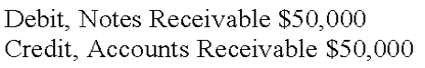

AACSB: Reflective Thinking
AICPA BB: Critical Thinking
AICPA FN: Measurement
Bloom's: Analyze
Difficulty: Medium
Learning Objective: 07-06 Explain; compute; and account for notes receivable and interest revenue.
Topic: Notes Receivable and Interest Revenue
177. Silver Company received a 60-day, 6% note for $16,000 on August 5. Which of the following statements is true?
A. Silver will receive $16,000 plus interest of $960 at maturity.
B. Silver should record a total receivable due of $16,080 on August 5.
C. The principal of the note plus interest is due on October 15.
D. The maturity value of this note is $16,000.
$16,000 x 60/360 x .06 = $160 interest due; maturity value = $16,160

AACSB: Analytic
AICPA BB: Critical Thinking
AICPA FN: Measurement
Bloom's: Analyze
Difficulty: Medium
Learning Objective: 07-06 Explain; compute; and account for notes receivable and interest revenue.
Topic: Notes Receivable and Interest Revenue

Essay Questions
178. Accounting terminology
Listed below are nine technical accounting terms emphasized in this chapter.
Mark-to-market
Factoring
Direct write-off
Financial asset
Cash equivalent
Bank reconciliation
Allowance for doubtful accounts
Accounts receivable turnover
Uncollectible accounts expense
Each of the following statements may (or may not) describe one of these technical terms. In the space provided below each statement, indicate the accounting term described, or answer "None" if the statement does not correctly describe any of the terms.
____ a. A transaction in which a business sells its accounts receivables to a financial institution.
____ b. An estimate of the portion of year-end accounts receivable that ultimately will turn out to be uncollectible.
____ c. Schedule explaining any differences between cash balances appearing in the accounting records and in the monthly bank statement.
____ d. Balance sheet valuation standard applicable to investments in marketable securities.
____ e. Cash and assets convertible directly into known amounts of cash, such as marketable securities and receivables.
____ f. A ratio, computed by dividing 365 days by average receivables, that indicates the liquidity of the receivables.
____ g. Method of accounting for uncollectible receivables that fails to match revenues and expenses.
(a) Factoring, (b) Allowance for doubtful accounts, (c) Bank reconciliation (d) Mark-to-market, (e) Financial asset, (f) None (The accounts receivable turnover is computed by dividing net credit sales by average accounts receivable.), (g) Direct write-off.

AACSB: Reflective Thinking
AICPA BB: Critical Thinking
AICPA FN: Measurement
Bloom's: Remember
Difficulty: Easy
Learning Objective: 07-01 Define financial assets and explain their valuation in the balance sheet.
Learning Objective: 07-07 Evaluate the liquidity of a company's accounts receivable.
Topic: Financial Assets
179. Internal control over cash transactions
Listed below are seven errors or problems that might occur in the processing of cash transactions. Also shown is a separate list of internal control procedures. Indicate the internal control procedure that should prevent the error or problem from occurring. If none of the control procedures would effectively prevent the error, place an X in the space provided.
Possible Error or Problem
_____ 1. A purchase invoice was paid even though the merchandise was never received.
_____ 2. An employee issued a credit memorandum for a nonexistent sales return in order to conceal his theft of the amount received in payment of an account receivable.
_____ 3. Management is unaware that blank checks are being issued for unauthorized expenditures by the official designated to sign checks.
_____ 4. A salesclerk collects the full selling price from a customer but rings up the sale at less than actual price and pockets the difference.
_____ 5. Several days' cash receipts are lost in a fire.
_____ 6. A new employee often gives customers an incorrect amount of change.
_____ 7. No one has discovered that amounts deposited in the company's bank account by the cashier over the last few years are frequently smaller than amounts forwarded to him from the mailroom or sales department.
Internal Control Procedures
(a). Periodic reconciliation of bank statements to accounting records.
(b). Use of a Cash Over and Short account.
(c). Adequate subdivision of duties.
(d). Use of pre-numbered sales tickets.
(e). Depositing each day's cash receipts intact in the bank.
(f). Use of electronic cash registers equipped with optical scanners to read magnetically coded labels on merchandise.
(g). Immediate preparation of a control listing when cash is received and the comparison of this listing with bank deposits.
(h). Cancellation of paid vouchers.
(i). Requirement that a voucher be prepared as advance authorization of every cash disbursement.
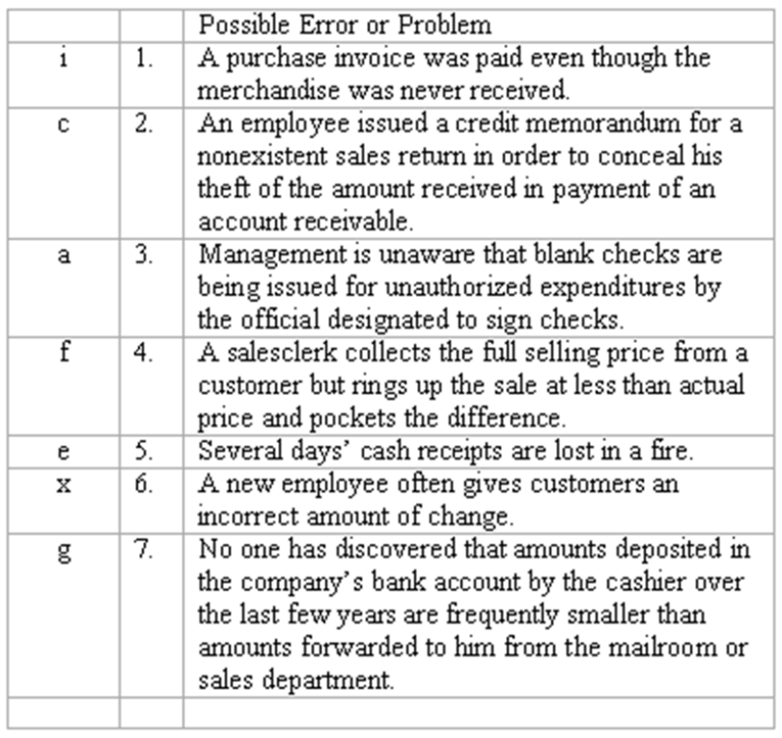

AACSB: Reflective Thinking
AICPA BB: Critical Thinking
AICPA FN: Measurement
Bloom's: Understand
Difficulty: Medium
Learning Objective: 07-02 Describe the objectives of cash management and internal controls over cash.
Topic: Cash
180. Petty cash fund
E-Z Productions established a petty cash fund of $650 on January 1. On January 28, the fund was replenished for the payments made to date as shown by the following petty cash vouchers: postage, $145; telephone expense, $62.80; repairs, $79.20; office supplies, $67.20; and miscellaneous expense, $56. Prepare journal entries in general journal form to record the establishment of the fund on January 1 and its replenishment on January 28.
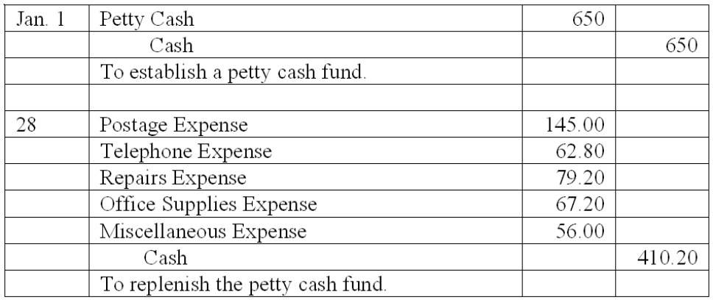

AACSB: Analytic
AICPA BB: Critical Thinking
AICPA FN: Measurement
Bloom's: Apply
Difficulty: Medium
Learning Objective: 07-02 Describe the objectives of cash management and internal controls over cash.
Topic: Cash
181. Bank reconciliation-classification
Indicate how the following items would be treated in a bank reconciliation. You may choose from the following answers:
(A) Deducted from the balance per accounting records.
(B) Added to balance per accounting records.
(C) Deducted from balance per bank statement.
(D) Added to balance per bank statement.
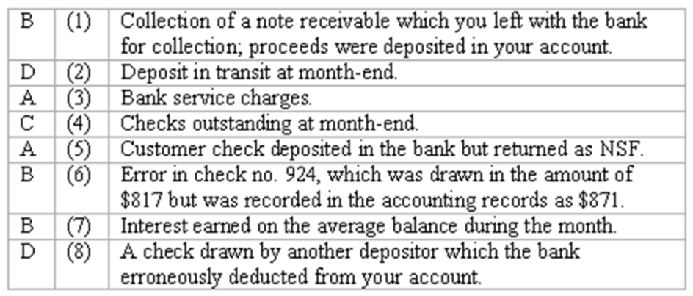

AACSB: Analytic
AICPA BB: Critical Thinking
AICPA FN: Measurement
Bloom's: Apply
Difficulty: Medium
Learning Objective: 07-03 Prepare a bank reconciliation and explain its purpose.
Topic: Cash
182. Bank reconciliation—classification
Indicate how the following items would be treated in Aladdin's, Inc.'s bank reconciliation. Choose from the following answers:
(a.) Deducted from the balance per accounting records.
(b.) Added to balance per accounting records.
(c.) Deducted from balance per bank statement.
(d.) Added to balance per bank statement.
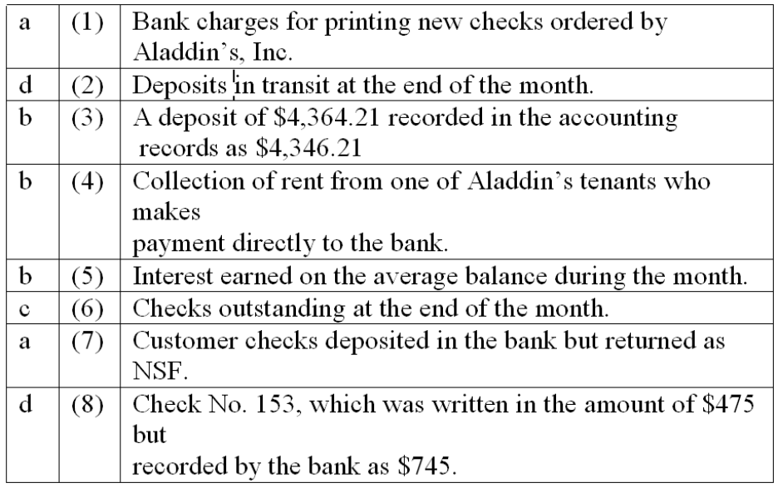

AACSB: Analytic
AICPA BB: Critical Thinking
AICPA FN: Measurement
Bloom's: Apply
Difficulty: Medium
Learning Objective: 07-03 Prepare a bank reconciliation and explain its purpose.
Topic: Cash
183. Bank reconciliation--computation and journal entry
The Cash account in the ledger of Arnaz Company showed a balance of $13,307 at March 31.
The bank statement, however, showed a balance of $9,936 at the same date. The only reconciling items consisted of a $4,902 deposit in transit, a bank service charge of $36, outstanding checks totaling $2,600, and an NSF check from L. Ball, one of Arnaz' customers.
(a) What is the amount of the adjusted cash balance on March 31?
(b) What is the amount of the NSF check?
(c) Record the journal entry necessary, if any, to adjust Arnaz Company's accounting records at March 31:
(a) Adjusted cash balance = $9,936 + $4,902 - $2,600 = $12,238
(b) NSF check = $13,307 - $36 - $12,238 = $1,033
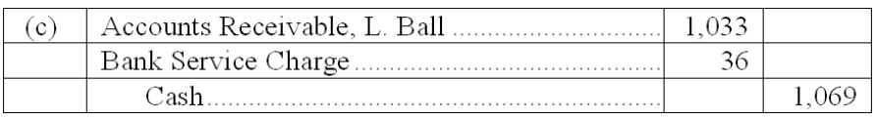

AACSB: Analytic
AICPA BB: Critical Thinking
AICPA FN: Measurement
Bloom's: Analyze
Difficulty: Medium
Learning Objective: 07-03 Prepare a bank reconciliation and explain its purpose.
Topic: Cash
184. Bank reconciliation--computations and journal entry
The Cash account in the ledger of Pine Golf Club shows a balance of $11,925 at December 31, 2009. The December 31 bank statement shows a balance of $10,440. The only reconciling items consist of:
Bank service charges of $32.
Deposit in transit of $1,813.
NSF check from customer L. Diamond in the amount of $126.
Error in recording check no. 970 for utilities: check was written in the amount of $834 but was recorded in Pine's accounting records as $384.
Outstanding checks.
(a) What is the amount of the adjusted cash balance at December 31, 2009?
$_______________
(b) What is the total amount of outstanding checks at December 31, 2009?
$_______________
(c) Record the journal entry necessary, if any, to adjust Pine's Golf Club accounting records at December 31, 2006. (An explanation is not required; a single compound journal entry is acceptable.)
(a) Adjusted cash balance on Dec. 31, 2009: $11,317.
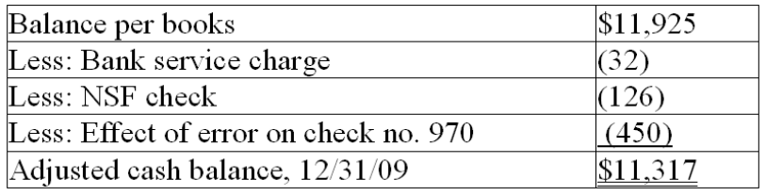
(b) Outstanding checks at December 31, 2009: $936.
$10,440 (balance per bank statement) + $1,813 (deposit in transit) = $12,253.
$12,253 - $11,317 (adjusted cash balance from (a) above) = $936.
(c) 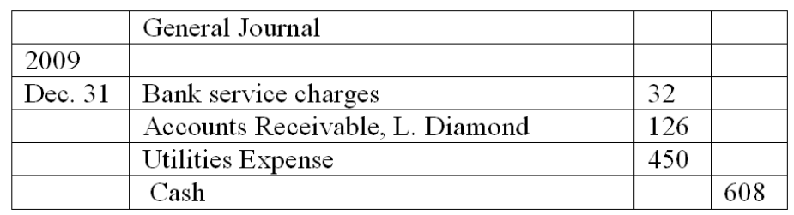

AACSB: Analytic
AICPA BB: Critical Thinking
AICPA FN: Measurement
Bloom's: Analyze
Difficulty: Medium
Learning Objective: 07-03 Prepare a bank reconciliation and explain its purpose.
Topic: Cash
185. Bank reconciliation
At March 31, the balance of the Cash account according to the records of Fisher Company was $7,261. The March 31 bank statement showed a balance of $8,798. You are to prepare the bank reconciliation of Fisher Company at March 31, using the following supplementary information:
(a.) Deposit in transit at March 31, $6,772.
(b.) Outstanding checks: no. 120, $140; no. 121, $932; no. 127, $307; no. 134, $2,200.
(c.) Service charge by bank, $50.
(d.) A note receivable for $5,050 left by Fisher Company with bank for collection that had been collected and credited to company's account. No interest involved.
(e.) A check for $90 drawn by a customer, Stuart Sands, but deducted from Fisher's account by the bank and returned with the notation "NSF."
(f.) Fisher's check no. 480, issued in payment of $970 worth of office equipment, correctly written in the amount of $970 but erroneously recorded in Fisher's accounting records as $790.
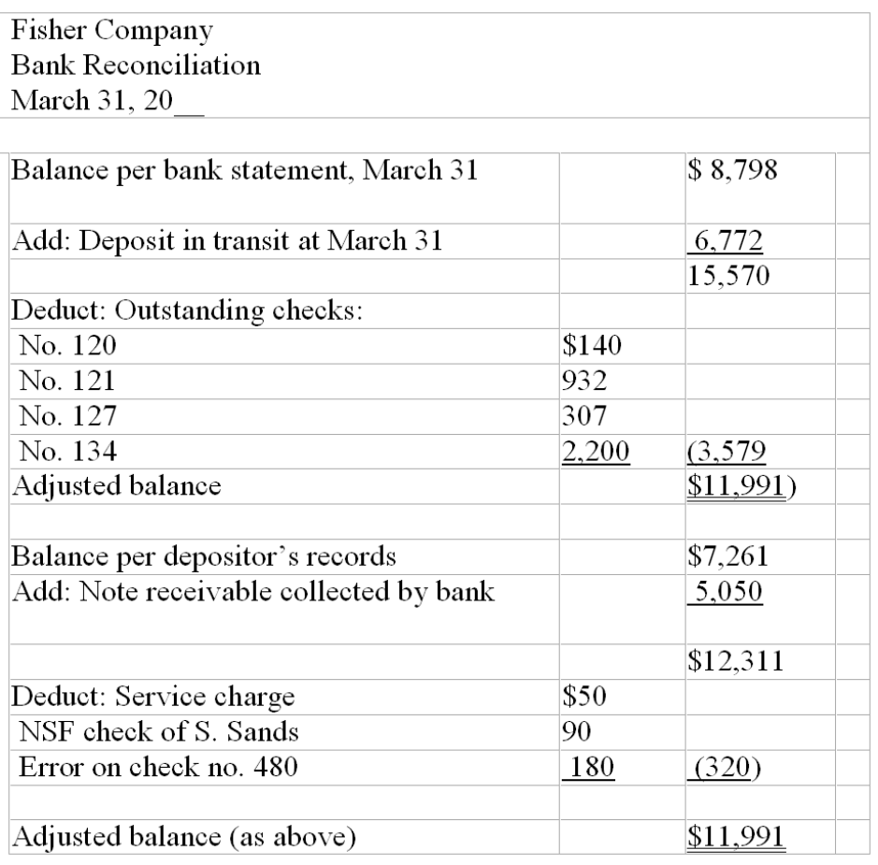

AACSB: Analytic
AICPA BB: Critical Thinking
AICPA FN: Measurement
Bloom's: Analyze
Difficulty: Medium
Learning Objective: 07-03 Prepare a bank reconciliation and explain its purpose.
Topic: Cash
186. Bank reconciliation
(A.) You are to complete the June 30 bank reconciliation for Silver Company using the following information:
(B.) Give in general journal form the entry or entries necessary to correct Silver's accounting records as of June 30. (Explanations may be omitted; one compound journal entry is acceptable.)
(A)
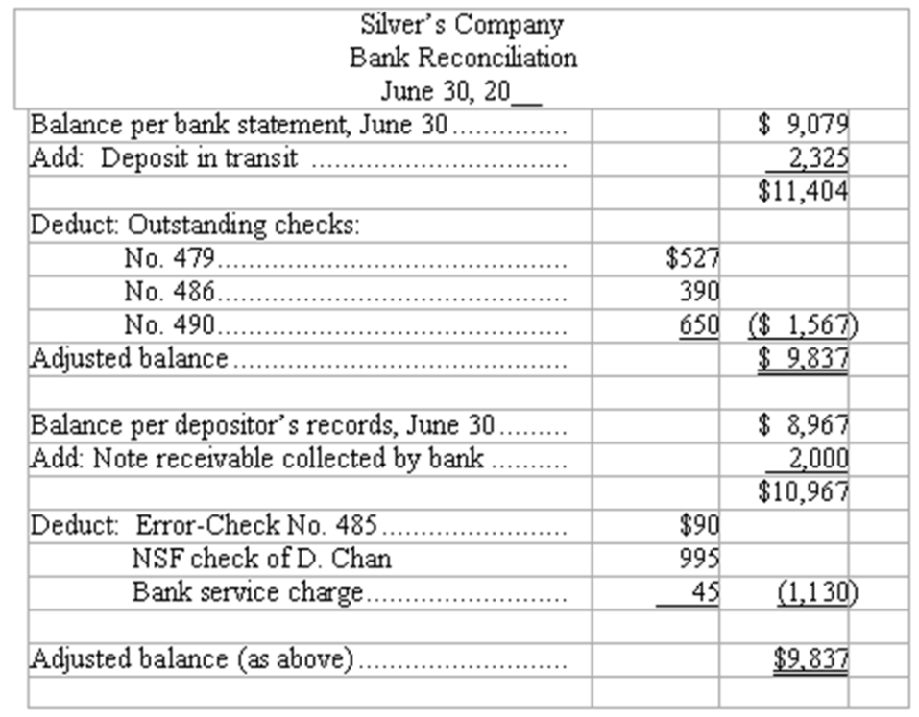
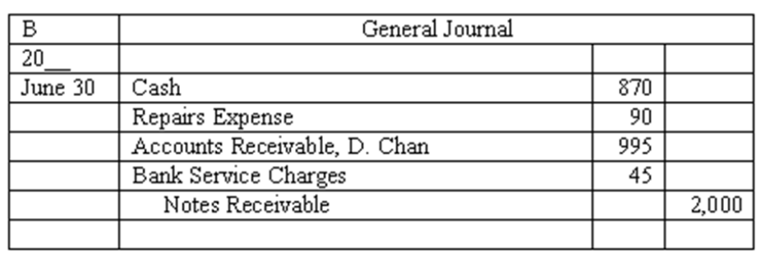

AACSB: Analytic
AICPA BB: Critical Thinking
AICPA FN: Measurement
Bloom's: Analyze
Difficulty: Medium
Learning Objective: 07-03 Prepare a bank reconciliation and explain its purpose.
Topic: Cash
187. Balance sheet method-journal entries
The general ledger controlling account for Accounts Receivable has a balance of $120,500 at year-end before adjustment. The company uses the balance sheet approach to estimate uncollectible accounts. By aging the individual customers' accounts, it was determined that the doubtful accounts amounted to $5,020. Prepare the year-end adjusting entry for uncollectible accounts under each of the following independent assumptions.
(a.) Allowance for Doubtful Accounts has a credit balance of $2,850.
(b.) Allowance for Doubtful Accounts has a debit balance of $925.
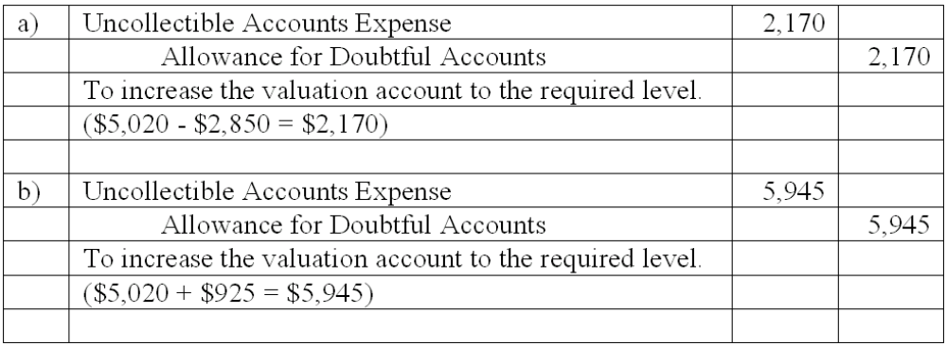

AACSB: Analytic
AICPA BB: Critical Thinking
AICPA FN: Measurement
Bloom's: Apply
Difficulty: Medium
Learning Objective: 07-05 Account for uncollectible receivables using the allowance and direct write-off methods.
Topic: Accounts Receivable
188. Balance sheet method-computations
Rainbow Company uses the balance sheet approach to estimate uncollectible accounts. By aging the customers' accounts, it was estimated that $7,325 of the company's month-end accounts receivable would prove to be uncollectible. Determine the amount that should be debited to the Uncollectible Accounts Expense account in the month-end adjusting entry under each of the following independent assumptions:
(a.) Before making any adjustment, the Allowance for Doubtful Accounts has
a $635 credit balance. $_______________
(b.) Before making any adjustment, the Allowance for Doubtful Accounts
has a debit balance of $720. $_______________
(a) Prior to making any adjustment, the Allowance for Doubtful Accounts account has a $635 credit balance $6,690 ($7,325 - $635) = $6,690)
(b) Prior to making any adjustment, the Allowance for Doubtful Accounts account has a debit balance of $720 $8,045 ($7,325 + $720) = $8,045

AACSB: Analytic
AICPA BB: Critical Thinking
AICPA FN: Measurement
Bloom's: Analyze
Difficulty: Medium
Learning Objective: 07-05 Account for uncollectible receivables using the allowance and direct write-off methods.
Topic: Accounts Receivable
189. Uncollectible accounts--two methods
At the end of the year the unadjusted trial balance of Angel Provisions included the following accounts:
(a.) If Angel uses the balance sheet approach to estimate uncollectible accounts expense, and aging the accounts receivable indicates the estimated uncollectible portion to be $6,075, what will the uncollectible accounts expense for the year be?
(b.) If the income statement approach to estimating uncollectible accounts expense is followed, and uncollectible accounts expense is estimated to be 1% of net credit sales, what is the amount of uncollectible accounts expense for the year?
(a) $6,075 - $1,218 = $4,857
(b) 1% x (80% x $780,575) = $6,244.60

AACSB: Analytic
AICPA BB: Critical Thinking
AICPA FN: Measurement
Bloom's: Analyze
Difficulty: Medium
Learning Objective: 07-05 Account for uncollectible receivables using the allowance and direct write-off methods.
Topic: Accounts Receivable
190. Write-off of uncollectible account receivable
On January 10, Winston, Inc.'s trial balance included the following accounts:
On January 11, Len Palmer, a major customer, declares bankruptcy and thus, Winston determines that a receivable from Palmer in the amount of $3,400 is worthless.
(a) In the space provided, prepare the journal entry that Winston should record to write-off the account receivable from Len Palmer on January 11.
(b) Compute the net realizable value of Winston's accounts receivable at each of the following dates:
January 10 (before write-off of Palmer's account) $_______________
January 11 (immediately after write-off of Palmers' account) $_______________
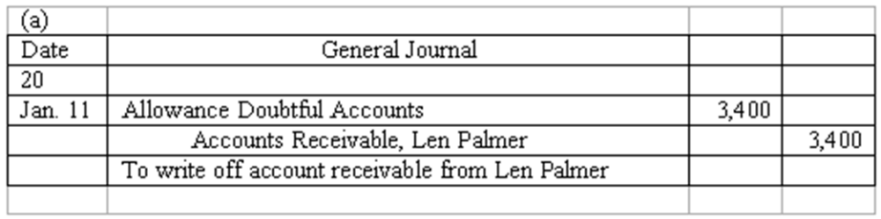
(b) Jan. 10: $220,000 - $7,200 = $212,800.
Jan. 11: $216,600 - $3,800 = $212,800.

AACSB: Analytic
AICPA BB: Critical Thinking
AICPA FN: Measurement
Bloom's: Analyze
Difficulty: Medium
Learning Objective: 07-05 Account for uncollectible receivables using the allowance and direct write-off methods.
Topic: Accounts Receivable
191. Accounts receivable turnover rate
During 2010, Larsen Company's accounts receivable averaged $750,000. Larsen's 2010 income statement reported net sales of $6,780,000, uncollectible accounts expense of $160,000, and net income of $768,000. (Assume 365 days in a year.)
Using the information, compute the following for Larsen Company:
(a) Accounts receivable turnover: (Round to the nearest two decimals.)
(b) Average number of days to collect accounts receivable (round to nearest day, if necessary): (Round to the nearest %.)
(a) 9.04 times ($6,780,000÷750,000).
(b) 365 days ÷ 9.04 (part a) = 40 days.

AACSB: Analytic
AICPA BB: Critical Thinking
AICPA FN: Measurement
Bloom's: Analyze
Difficulty: Medium
Learning Objective: 07-07 Evaluate the liquidity of a company's accounts receivable.
Topic: Financial Analysis and Decision Making
192. Financial assets-effects of transactions
Five events involving financial assets are described below:
(a.) Sold merchandise on account.
(b.) Sold available-for-sale marketable securities at a gain. Cash proceeds from the sale were equal to the current market value of the securities reflected in the last balance sheet.
(c.) Collected an account receivable.
(d.) Adjusted the allowance for doubtful accounts to reflect the portion of accounts receivable estimated to be uncollectible at year-end.
(e.) Made mark-to-market adjustment reducing the balance in the available-for-sale marketable securities account to reflect a decrease in the market value of securities owned.
Indicate the effects of each independent transaction or adjusting entry upon the financial measurements shown in the four column headings below. Use the code letters, I for increase, D for decrease, and NE for no effect.
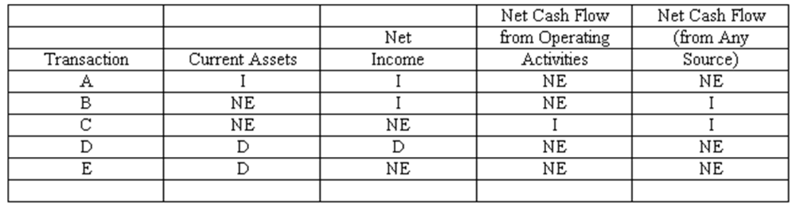
*Note to Instructor: Exchanging marketable securities (adjusted to current market value) for an equal amount of cash has no effect upon current assets. The journal entry to record the sale, however, removes the original cost of the securities in exchange for a greater amount of cash in a gain situation. The overall effect is not evident until the mark-to-market adjustment is made at the end of the period. Therefore, you may wish to accept the answer Increase with respect to those students who analyze only the sale transaction journal entry in determining their answer.

AACSB: Analytic
AICPA BB: Critical Thinking
AICPA FN: Measurement
Bloom's: Evaluate
Difficulty: Hard
Learning Objective: 07-01 Define financial assets and explain their valuation in the balance sheet.
Learning Objective: 07-04 Describe how short-term investments are reported in the balance sheet and account for transactions involving marketable securities.
Learning Objective: 07-05 Account for uncollectible receivables using the allowance and direct write-off methods.
Topic: Financial Assets
193. Financial assets--effects of transactions
Five events involving financial assets are described below:
(a.) Received dividends earned on investment in marketable securities.
(b.) Invested excess cash in marketable securities.
(c.) Determined that a specific account receivable is worthless and wrote it off against the allowance for doubtful accounts.
(d.) Made sale of merchandise for cash.
(e.) Sold available-for-sale marketable securities at a loss. Cash proceeds from the sale were equal to the current market value reflected in the last balance sheet.
Indicate the effects of each independent transaction or adjusting entry upon the financial measurements shown in the four column headings below. Use the code letters, I for increase, D for decrease, and NE for no effect.
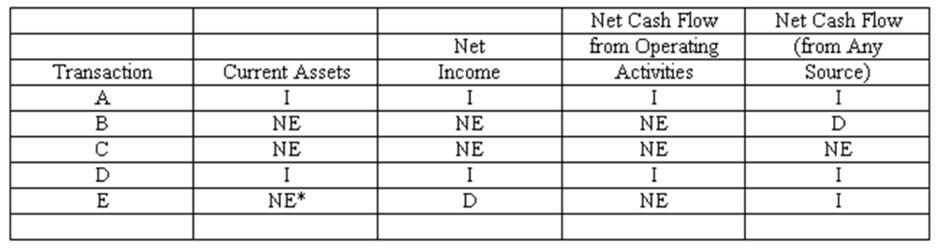
*Note to Instructor: Exchanging marketable securities (adjusted to current market value) for an equal amount of cash has no effect upon current assets. The journal entry to record the sale, however, removes the original cost of the securities in exchange for a smaller amount of cash in a loss situation. The overall effect is not evident until the mark-to-market adjustment is made at the end of the period. Therefore, you may wish to accept the answer Decrease with respect to those students who analyze only the sale transaction journal entry in determining their answer.

AACSB: Analytic
AICPA BB: Critical Thinking
AICPA FN: Measurement
Bloom's: Evaluate
Difficulty: Hard
Learning Objective: 07-01 Define financial assets and explain their valuation in the balance sheet.
Learning Objective: 07-05 Account for uncollectible receivables using the allowance and direct write-off methods.
Topic: Financial Assets
194. At December 31, 2009, Laconia Industries' portfolio of investments in available-for-sale marketable securities consisted of the following:
(a.) Illustrate the presentation of marketable securities and unrealized holding gain (or loss) in Laconia's financial statements at December 31, 2009. Indicate the financial statement and section in which each item appears.
(b.) Assume that on March 15, 2010, Laconia made the following sales of securities:
(1) Sold 5,000 shares of its investment in Crown, Inc., at a price of $20 per share.
(2) Sold 1,000 shares of its investment in Plastic Dots at a price of $45 per share.
Compute the gain or loss recognized in Laconia's 2010 income statement for each sale:
(1). Sale of 5,000 shares of Crown: $____________ Gain/Loss
(2). Sale of 1,000 shares of Plastic Dots: $____________ Gain/Loss
(c.) At December 31, 2010, the market values of these stocks are: Crown, $21 per share; Plastic Dots, $42 per share. Complete the following schedule showing cost and current market value of securities owned by Laconia at the end of 2010.
(d.) Illustrate the presentation of marketable securities and unrealized holding gain (or loss) in Laconia's financial statements at December 31, 2010. (Follow same format as in part a.)
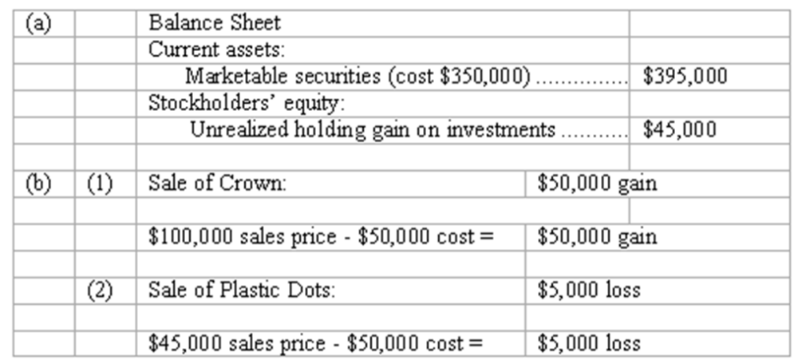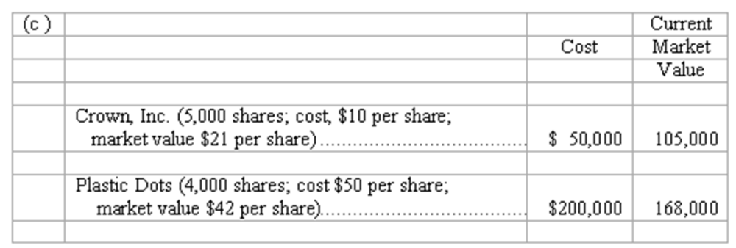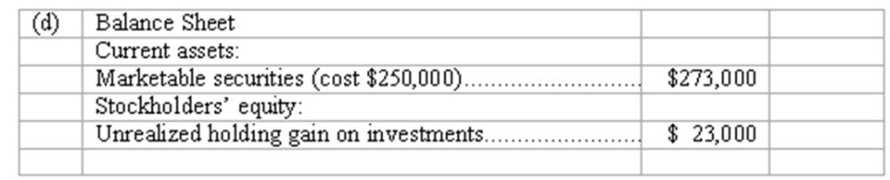

AACSB: Analytic
AICPA BB: Critical Thinking
AICPA FN: Measurement
Bloom's: Analyze
Difficulty: Hard
Learning Objective: 07-04 Describe how short-term investments are reported in the balance sheet and account for transactions involving marketable securities.
Topic: Accounting for Marketable Securities
195. Notes receivable—computations
Complete the following statements about promissory notes and interest by entering amounts in the spaces provided. (Use 360 days in one year.)
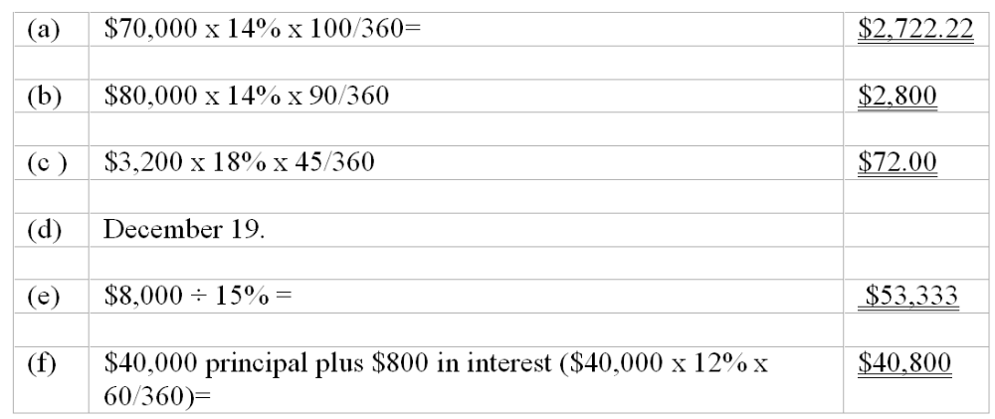

AACSB: Analytic
AICPA BB: Critical Thinking
AICPA FN: Measurement
Bloom's: Analyze
Difficulty: Medium
Learning Objective: 07-06 Explain; compute; and account for notes receivable and interest revenue.
Topic: Notes Receivable and Interest Revenue
196. Note receivable--journal entries
On September 1, 2010, Dental Equipment Corporation sold equipment priced at $350,000 in exchange for a six-month note receivable with an annual interest rate of 12%, all due at maturity.
(a.) Prepare the December 31, 2010 (fiscal year-end), adjusting entry made by Dental with regard to this note receivable.
(b.) Prepare the entry made by Dental on March 1, 2011(maturity date of note), to record collection of note and interest.
(a) 2010 General Journal
Dec. 31
(b) 2011 March 1
(c.) Assume that on March 1, 2011, the maker of the note defaults and Dental does not collect the note. Prepare the entry to be made to Dental on March 1, 2011, in this situation.
(c) 2011 March 1
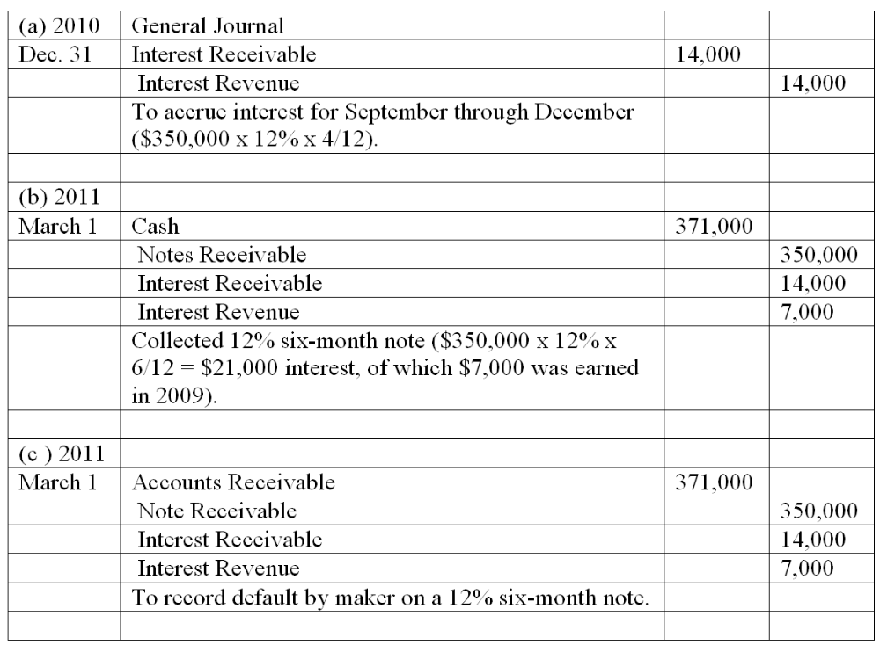

AACSB: Analytic
AICPA BB: Critical Thinking
AICPA FN: Measurement
Bloom's: Apply
Difficulty: Medium
Learning Objective: 07-06 Explain; compute; and account for notes receivable and interest revenue.
Topic: Notes Receivable and Interest Revenue
197. Financial assets
(a.) Briefly explain what is meant by the term "financial assets."
(b.) List the three major categories of assets comprising a company's financial assets. For each category, indicate the basis for valuation in the balance sheet.
(a) The term financial assets refers to cash and also those assets easily and directly convertible into known amounts of cash.
(b) Financial assets are shown in the balance sheet at their current values, meaning the amounts of cash that these assets represent. The three categories of financial assets and the basis of valuation in the balance sheet are summarized below:
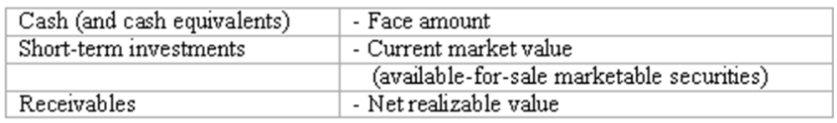

AACSB: Reflective Thinking
AICPA BB: Critical Thinking
AICPA FN: Measurement
Bloom's: Remember
Difficulty: Easy
Learning Objective: 07-01 Define financial assets and explain their valuation in the balance sheet.
Topic: Financial Assets
198. Internal control over cash transactions
(a.) Describe three measures contributing to strong internal control over cash receipts.
(b.) Describe three measures contributing to effective internal control over cash disbursements.
(a) Students may choose three of the following:
Cash received through the mail should be in the form of checks, which are stamped with a restrictive endorsement immediately upon receipt.
A control listing is prepared daily of checks received in the mail. One copy of this list is sent with checks to the cashier, who deposits the checks in the bank. A separate copy is sent to the accounting department, which records the amount in the accounting records. There should be daily comparisons of the amount on the control listing with the amount recorded in the accounting records and with the amount deposited by the cashier.
Cash registers, with a locked in register tape, should be used to ring up cash sales. The register tape serves as a control listing for cash sales, which are recorded by the accounting department after comparison with the amount of cash turned over to the cashier for deposit in the bank.
Point of sale terminals record cash sales automatically in the accounting records for comparison with cash turned over to the cashier for deposit.
Use of pre-numbered sales tickets enables comparison of sales totals (from the intact series) with cash register tapes and with total cash receipts.
Use of a Cash Over and Short account to highlight daily cash shortages and overages.
Subdivision of duties - Employees who handle cash receipts should not have access to the accounting records, nor should they have authority to issue credit memoranda for sales returns.
Departmental cash budgets provide estimates of expected cash receipts. Significant differences from budgeted amounts should be investigated.
(b) Student may choose three of the following:
All payments, except from petty cash, should be made by check.
Every transaction requiring cash payment should be verified, approved, and recorded before a check is issued. Use of a voucher system incorporates these internal control steps.
Prompt reconciliation of bank statements.
Adequate subdivisions of duties. Accounting personnel who verify and approve disbursements are not authorized to sign checks. Finance department personnel, who issue and sign checks, are not authorized to issue checks without supporting documentation.
Use of a petty cash fund for small cash payments.
Departmental cash budgets forecast monthly cash expenditures, which are compared to actual cash disbursements. Significant discrepancies are investigated.

AACSB: Reflective Thinking
AICPA BB: Critical Thinking
AICPA FN: Measurement
Bloom's: Understand
Difficulty: Medium
Learning Objective: 07-02 Describe the objectives of cash management and internal controls over cash.
Topic: Cash
199. Cash management
(a.) What is meant by the term "cash management"?
(b.) Identify at least three basic objectives of effective cash management.
(a) The term cash management refers to planning, controlling, and accounting for cash transactions and cash balances.
(b) Student may choose three of the following objectives of cash management:
Provide accurate accounting for cash receipts, cash disbursements, and cash balances.
Prevent or minimize losses from theft or fraud.
Anticipate the need for borrowing and assure the availability of adequate amounts of cash for conducting business.
Prevent unnecessarily large amounts of cash from sitting idle in bank accounts that produce no revenue.

AACSB: Reflective Thinking
AICPA BB: Critical Thinking
AICPA FN: Measurement
Bloom's: Remember
Difficulty: Easy
Learning Objective: 07-02 Describe the objectives of cash management and internal controls over cash.
Topic: Cash
200. Reporting cash in the balance sheet
(a.) The first asset shown in the balance sheet of many companies is labeled "cash and cash equivalents." Explain the term "cash equivalent" and give two examples. Why are cash and cash equivalents listed first in the balance sheet?
(b.) The December bank statement for Kowal Publishing Co. reports a balance of $13,847.59 at December 31, 2009. Kowal's accounting records, however, show a balance of $15,245.47 in the same bank account prior to preparation of the bank reconciliation.
Which amount should be included in the amount of cash reported in Kowal's balance sheet at December 31, 2009? Explain your answer.
(a) Cash equivalents are very short term investments that are so liquid that they are considered equivalent to cash. Examples include money market funds, U.S. Treasury bills, certificates of deposit, and commercial paper. These investments must mature within three months of acquisition.
In the current asset section of the balance sheet, assets are listed in the order of their liquidity. Cash (and cash equivalents) is listed first because it is the most liquid asset owned by a business.
(b) Neither the amount on the bank statement nor the balance in the accounting records is the appropriate amount to include in the balance sheet with respect to this bank account. The amount to be included in cash reported in the balance sheet is the adjusted cash balance determined in the bank reconciliation, and which usually is different from both the balance per bank statement and the balance per depositor's records.

AACSB: Reflective Thinking
AICPA BB: Critical Thinking
AICPA FN: Measurement
Bloom's: Analyze
Difficulty: Medium
Learning Objective: 07-02 Describe the objectives of cash management and internal controls over cash.
Topic: Cash
201. Marketable securities
(a.) Explain how investments in available-for-sale marketable securities are valued in the investor's balance sheet.
(b.) Is valuation of investments in marketable securities consistent with (1) the cost principle, and (2) the objectivity principle?
(c.) What does Unrealized Holding Gain (or Loss) on Investments represent? How is this item reported in the financial statements?
(a) Short-term investments in marketable securities appear in the balance sheet at their current market values as of the balance sheet date. The balance sheet valuation is adjusted to market value at the balance sheet date; this adjustment is termed mark-to-market.
(b) (1) Mark-to-market valuation represents a departure from the cost principle, since the investment in marketable securities is reported at current market value.
(2) The mark-to-market valuation is consistent with the objectivity principle. Marketable securities are traded daily on organized securities exchanges and they can be purchased or sold immediately at quoted market prices. These market prices are the basis for the mark-to-market valuation adjustments and are both objective and readily verifiable.
(c) Unrealized Holding Gain (or Loss) on Investments represents the difference (as of the balance sheet date) between the cost and the current market value of the portfolio of marketable securities owned.* This item is reported in the balance sheet as an element of stockholders' equity. If the current market value of the marketable securities is higher than cost, an Unrealized Holding Gain is added to other components of equity in determining total stockholders' equity. If current market value of the portfolio is below cost, an Unrealized Holding Loss is shown as a reduction in total stockholders' equity. Unrealized Holding Gains (or Losses) are not reported in the income statement; mark-to-market adjustments have no effect on net income.
*Note to instructor: As mentioned in the text, Unrealized Holding Gains and Losses technically are to be shown in the balance sheet net of expected future income tax effects. In this introductory course, however, the above concept is used in discussions and assignment materials.

AACSB: Reflective Thinking
AICPA BB: Critical Thinking
AICPA FN: Measurement
Bloom's: Evaluate
Difficulty: Medium
Learning Objective: 07-04 Describe how short-term investments are reported in the balance sheet and account for transactions involving marketable securities.
Topic: Accounting for Marketable Securities
202. Uncollectible accounts
(a.) What is an uncollectible account? Explain how a business suffers losses from uncollectible accounts.
(b.) "A competent credit manager should set credit policies so as to avoid any and all losses from uncollectible accounts." Is this statement accurate? Explain your answer.
(a) An uncollectible account is an account receivable that a business is unable to collect. An account receivable that has been determined to be uncollectible is no longer an asset. A business suffers a loss from an uncollectible account because it has provided services or exchanged merchandise for an asset (the account receivable) that now is worthless. The loss is in terms of cash flow but uncollectible accounts do not appear as a loss on the income statement.
(b) This statement is false. If the credit manager becomes overly cautious and conservative in extending credit in order to avoid all credit losses, he or she might lose a greater amount of profitable business by rejecting many acceptable customers.

AACSB: Reflective Thinking
AICPA BB: Critical Thinking
AICPA FN: Measurement
Bloom's: Understand
Difficulty: Easy
Learning Objective: 07-05 Account for uncollectible receivables using the allowance and direct write-off methods.
Topic: Accounts Receivable
203. Evaluating the quality of receivables
(a.) The 2010 annual report of Modern Books, a publicly traded corporation, reports accounts receivable (net of allowance for doubtful accounts), of $190,714 as of February 28, 2010. What assurance do readers of Modern Books' annual report have that these receivables really exist and are not fictitious assets recorded to make the balance sheet "look good"?
(b.) The accounts receivable turnover rate is frequently used in evaluating the liquidity of accounts receivable. How is the accounts receivable turnover rate computed? What type of information does the accounts receivable turnover rate provide?
(a) The financial statements of publicly traded corporations, such as Modern Books, are audited by CPA firms. In the annual audit of a company by a CPA firm, the independent auditors will verify, or confirm, receivables by communicating directly with the customers of the company. This confirmation process is designed to provide evidence that the customers actually exist, and that they acknowledge owing the amount of the receivable to Modern Books. The CPA firms frequently verify the credit ratings of those customers owing significant amounts.
(b) The accounts receivable turnover rate is computed by dividing annual net sales (ideally net credit sales) by average accounts receivable. This accounts receivable turnover rate indicates how many times the receivables were converted into cash during the year, i.e., how many times they were collected.

AACSB: Analytic
AICPA BB: Critical Thinking
AICPA FN: Measurement
Bloom's: Understand
Difficulty: Medium
Learning Objective: 07-07 Evaluate the liquidity of a company's accounts receivable.
Topic: Financial Analysis and Decision Making
204. Information for the Hooper Company is as follows:
(1) What is the amount of uncollectible account expense for 2009 if the company uses the Percentage of Sales method and 2% of credit sales are deemed uncollectible?
(2) What is the amount of uncollectible expense if the company uses the balance sheet approach and estimates $2,200 as uncollectible in 2009?
(3) What is the net realizable value of accounts receivable if the company uses the balance sheet approach?
(4) If the company writes-off a receivable of $450 what will be the net realizable value of accounts receivable after the write off?
(1) $1,700 ($100,000 x 85%) x 2%
(2) $200 ($2,200 - $2000)
(3) $6,800 ($9,000-$2,200)
(4) $6,800 ($9,000 - $450) - ($2,200 - $450)

AACSB: Analytic
AICPA BB: Critical Thinking
AICPA FN: Measurement
Bloom's: Analyze
Difficulty: Medium
Learning Objective: 07-05 Account for uncollectible receivables using the allowance and direct write-off methods.
Topic: Accounts Receivable
205. Match the following terms with the explanations below. If no term fits the explanation write none
_______ (1) A means of accounting for uncollectibles which does not recognize any expense until specific receivables are determined to be worthless.
_______ (2) An account showing the amount of estimated uncollectible receivables.
_______ (3 ) The process of estimating uncollectible accounts by classifying accounts receivables by age groups.
_______ (4) Dividing net sales by average receivables to create a ratio to measure the liquidity of accounts receivable.
_______ (5) Very short-term liquid investments which must mature within 90 days of acquisition.
_______ (6) Cash and assets convertible directly into known amounts of cash.
_______ (7) An account showing the difference between the cost of an investment in marketable securities and its market value.
_______ (8) The value of a note at its maturity date.
_______ (9) Highly liquid investments that can be sold in organized securities exchanges.
(1.) Direct Write Off Method
(2.) Allowance for Doubtful Accounts
(3.) None
(4.) Accounts Receivable Turnover Rate
(5.) Cash Equivalents
(6.) Financial Assets
(7.) Unrealized Gain
(8.) None
(9.) Marketable Securities

AACSB: Reflective Thinking
AICPA BB: Critical Thinking
AICPA FN: Measurement
Bloom's: Remember
Difficulty: Easy
Learning Objective: 07-01 Define financial assets and explain their valuation in the balance sheet.
Learning Objective: 07-04 Describe how short-term investments are reported in the balance sheet and account for transactions involving marketable securities.
Learning Objective: 07-05 Account for uncollectible receivables using the allowance and direct write-off methods.
Topic: Financial Assets

Multiple Choice Questions
At the end of the month the unadjusted trial balance of Four Star Company included the following accounts:

206. If the income statement method of estimating uncollectible accounts expense is followed, and uncollectible accounts expense is estimated to be 2% of net credit sales, the net realizable value of Four Star accounts receivable at the end of the month is:
A. $855,800.
B. $845,050.
C. $19,200.
D. $1,250,050.

Learning Objective: 07-01 Define financial assets and explain their valuation in the balance sheet.
Learning Objective: 07-04 Describe how short-term investments are reported in the balance sheet and account for transactions involving marketable securities.
Learning Objective: 07-05 Account for uncollectible receivables using the allowance and direct write-off methods.
207. If Four Star uses the balance sheet approach in estimating uncollectible accounts, and aging the accounts receivable indicates the estimated uncollectible portion to be $24,000, the uncollectible accounts expense for the month is:
A. $24,000.
B. $13,250.
C. $34,750.
D. $10,750.

Learning Objective: 07-01 Define financial assets and explain their valuation in the balance sheet.
Learning Objective: 07-04 Describe how short-term investments are reported in the balance sheet and account for transactions involving marketable securities.
Learning Objective: 07-05 Account for uncollectible receivables using the allowance and direct write-off methods.
208. Which of the following items is reported in neither the income statement nor the statement of cash flows?
A. Sale of marketable securities at a loss.
B. Sale of marketable securities at a gain.
C. Adjustment of available-for-sale marketable securities owned to current market value at balance sheet date.
D. Investment of excess cash in marketable securities.

Learning Objective: 07-01 Define financial assets and explain their valuation in the balance sheet.
Learning Objective: 07-04 Describe how short-term investments are reported in the balance sheet and account for transactions involving marketable securities.
Learning Objective: 07-05 Account for uncollectible receivables using the allowance and direct write-off methods.
209. Mark-to-market is the balance sheet valuation standard for:
A. Investments in all financial assets.
B. Investments in available-for-sale marketable securities.
C. Investments in capital stock of any corporation.
D. Stockholders' equity of any publicly traded corporation.

Learning Objective: 07-01 Define financial assets and explain their valuation in the balance sheet.
Learning Objective: 07-04 Describe how short-term investments are reported in the balance sheet and account for transactions involving marketable securities.
Learning Objective: 07-05 Account for uncollectible receivables using the allowance and direct write-off methods.
210. Cash equivalents:
A. Include amounts of cash available through an unused line of credit.
B. Are investments in the publicly traded stocks and bonds of large corporations.
C. Are usually included in the term "cash" in the balance sheet and the statement of cash flows.
D. Is another term for financial assets.

Learning Objective: 07-01 Define financial assets and explain their valuation in the balance sheet.
Learning Objective: 07-04 Describe how short-term investments are reported in the balance sheet and account for transactions involving marketable securities.
Learning Objective: 07-05 Account for uncollectible receivables using the allowance and direct write-off methods.
Shown below is a partially completed bank reconciliation for Hubbard Transport at August 31, as well as additional data necessary to answer the questions that follow.
Additional information
a. Outstanding checks: no. 729, $1,253; no. 747, $245; no. 752, $781.
b. Check no. 742 (for repairs) was written for $398 but erroneously recorded in Hubbard's records as $839.
c. Deposits in transit, $2,254.
d. Note collected by the bank and credited to Hubbard's account, $4,800.
e. NSF check of C. Craig, one of Hubbard's customers, $1,525.
f. Bank service charge for August, $35.

211. In Hubbard's completed bank reconciliation at August 31, what dollar amount should be deducted from the balance per bank statement (indicated by 2 above)?
A. $2,254.
B. $2,279.
C. $1,525.
D. $4,800.

Learning Objective: 07-01 Define financial assets and explain their valuation in the balance sheet.
Learning Objective: 07-03 Prepare a bank reconciliation and explain its purpose.
212. In Hubbard's completed bank reconciliation at August 31, what dollar amount should be added to the balance per depositor's records (indicated by 3 above)?
A. $4,800.
B. $2,254.
C. $5,241.
D. $6,766.

Learning Objective: 07-01 Define financial assets and explain their valuation in the balance sheet.
Learning Objective: 07-03 Prepare a bank reconciliation and explain its purpose.
213. In Hubbard's completed bank reconciliation at August 31, what dollar amount should be deducted from the balance per depositor's records (indicated by 4 above)?
A. $2,254.
B. $2,001.
C. $1,525.
D. $1,560.

Learning Objective: 07-01 Define financial assets and explain their valuation in the balance sheet.
Learning Objective: 07-03 Prepare a bank reconciliation and explain its purpose.
214. Hubbard Transport keeps $500 cash on hand in addition to this checking account and has no other bank accounts or cash equivalents. What amount should appear as Cash in Emerald's August 31 balance sheet?
A. $18,430.
B. $14,249.
C. $17,955.
D. Some other amount.

Learning Objective: 07-01 Define financial assets and explain their valuation in the balance sheet.
Learning Objective: 07-03 Prepare a bank reconciliation and explain its purpose.
215. The necessary adjustment to Hubbard Transport's accounting records as of August 31 includes a net:
A. Increase to Cash of $5,241.
B. Increase to Cash of $3,240.
C. Increase to Cash of $3,681.
D. Decrease to Cash of $35.

Learning Objective: 07-01 Define financial assets and explain their valuation in the balance sheet.
Learning Objective: 07-03 Prepare a bank reconciliation and explain its purpose.

Essay Questions
216. You are to complete the June 30 bank reconciliation for Huang, Inc. using the following information:
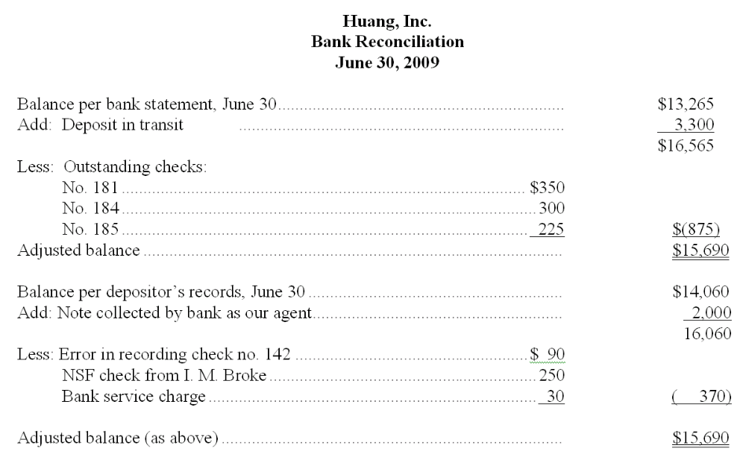

Learning Objective: 07-03 Prepare a bank reconciliation and explain its purpose.
217. Prepare the journal entry to correct Huang's records as of June 30. (Explanations may be omitted; one compound journal entry is acceptable.)
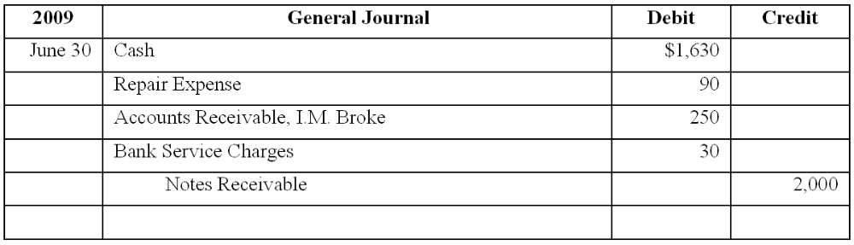

Learning Objective: 07-03 Prepare a bank reconciliation and explain its purpose.
218. After aging its accounts receivable at December 31, Howland Company estimates that $68,000 of the $835,000 outstanding accounts receivable will prove uncollectible. The Allowance for Doubtful Accounts has a debit balance of $6,200 prior to adjustment. In the space provided, prepare the adjusting entry required by Huey in this situation:
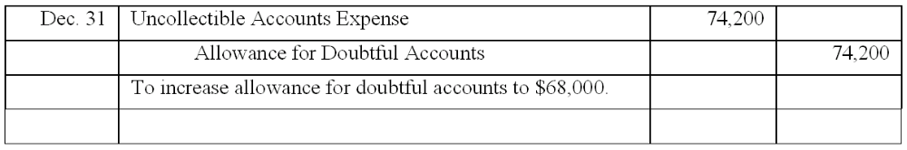

Learning Objective: 07-03 Prepare a bank reconciliation and explain its purpose.
Learning Objective: 07-05 Account for uncollectible receivables using the allowance and direct write-off methods.
Learning Objective: 07-07 Evaluate the liquidity of a company's accounts receivable.
219. At year-end, Atkins Company applies the income statement approach in estimating uncollectible accounts expense and determines such expense to be 2% of net sales. At December 31 of the current year, accounts receivable total $600,000, and Allowance for Doubtful Accounts has a credit balance of $4,200 prior to adjustment. Net sales for the current year were $2,300,000. Compute the net realizable value of accounts receivable to be reported in Dewey's December 31 balance sheet.
$600,000 - $50,200 [($2,300,000 x .02) + $4,200] = $549,800

Learning Objective: 07-03 Prepare a bank reconciliation and explain its purpose.
Learning Objective: 07-05 Account for uncollectible receivables using the allowance and direct write-off methods.
Learning Objective: 07-07 Evaluate the liquidity of a company's accounts receivable.
220. During the year, Brown Corporation's average accounts receivable were $316,000. The current-year income statement reported net sales of $2,010,000, uncollectible accounts expense of $118,000, and net income of $982,000. Using 365 days to a year, compute the average number of days Brown waits to collect its accounts receivable. (Round answer to the nearest day, if necessary.)
Accounts receivable turnover: $2,010,000/$316,000 = 6.36 times
Average Days to Collect 365/6.36 = 57 days

Learning Objective: 07-03 Prepare a bank reconciliation and explain its purpose.
Learning Objective: 07-05 Account for uncollectible receivables using the allowance and direct write-off methods.
Learning Objective: 07-07 Evaluate the liquidity of a company's accounts receivable.
At September 30, the Cash account in the general ledger of Breen Construction shows a balance of $13,221. However, the bank statement shows a balance of $16,720 at the same date. The only reconciling items consist of a bank service charge of $42, outstanding checks totaling $4,744, a deposit in transit, and an error in recording check no. 529. Check no. 529 was written in the amount of $772 but was recorded as $727 in Gentle's accounting records.

221. What is the adjusted cash balance in the September 30 bank reconciliation?
Adjusted cash balance $13,134.
Balance per books $13,221 - $42 service charge - $45 error = $13,134 adjusted cash balance.

Learning Objective: 07-03 Prepare a bank reconciliation and explain its purpose.
Learning Objective: 07-05 Account for uncollectible receivables using the allowance and direct write-off methods.
Learning Objective: 07-07 Evaluate the liquidity of a company's accounts receivable.
222. What is the amount of the deposit in transit?
Deposit in transit: $1,158
Balance per bank statement $16,720 - $4,744 outstanding checks = $11,976.
Adjusted cash balance $13,134 (from 4 above) - $11,976 = $1,158 deposit in transit.

Learning Objective: 07-03 Prepare a bank reconciliation and explain its purpose.
Learning Objective: 07-05 Account for uncollectible receivables using the allowance and direct write-off methods.
Learning Objective: 07-07 Evaluate the liquidity of a company's accounts receivable.

Multiple Choice Questions
223. In general terms, financial assets appear in the balance sheet at:
A. Face value.
B. Current value.
C. Cost.
D. Estimated future sales value.

224. Which of the following practices contributes to efficient cash management?
A. Never borrow money—maintain a cash balance sufficient to make all necessary payments.
B. Record all cash receipts and cash payments at the end of the month when reconciling the bank statements.
C. Prepare monthly forecasts of planned cash receipts, payments and anticipated cash balances up to a year in advance.
D. Pay each bill as soon as the invoice arrives.

225. Each of the following measures strengthens internal control over cash receipts except:
A. The use of a voucher system.
B. Preparation of a daily listing of all checks received through the mail.
C. The deposit of cash receipts intact in the bank on a daily basis.
D. The use of cash registers.

Quinn Company's bank statement at January 31 shows a balance of $13,360, while the account for Cash in Quinn's ledger shows a balance of $12,890 at the same date. The only reconciling items are the following:
Deposit in transit, $890.
Bank service charge, $24.
NSF check from customer Greg Denton in the amount of $426.
Error in recording check no. 389 for rent: check was written in
the amount of $1,320, but was recorded improperly in the accounting records as $1,230.
Outstanding checks, $?.

226. What is the total amount of outstanding checks at January 31?
A. $1,048.
B. $868.
C. $1,900.
D. $1,720.

227. Assuming a single journal entry is made to adjust Quinn Company's accounting records at January 31, the journal entry includes:
A. A debit to Rent Expense for $90.
B. A credit to Accounts Receivable, G. Denton, for $426.
C. A credit to Cash for $450.
D. A credit to Cash for $1,720.

228. Which of the following best describes the application of generally accepted accounting principles to the valuation of accounts receivable?
A. Realization principle—Accounts receivable are shown at their net realizable value in the balance sheet.
B. Matching principle—The loss due to an uncollectible account is recognized in the period in which the sale is made, not in the period in which the account receivable is determined to be worthless.
C. Cost principle—Accounts receivable are shown at the initial cost of the merchandise to customers, less the cost the seller must pay to cover uncollectible accounts.
D. Principle of conservatism—Accountants favor using the lowest reasonable estimate for the amount of uncollectible accounts shown in the balance sheet.

229. On January 1, Dillon Company had a $3,100 credit balance in the Allowance for Doubtful Accounts. During the year, sales totaled $780,000 and $6,900 of accounts receivable were written off as uncollectible. A December 31 aging of accounts receivable indicated the amount probably uncollectible to be $5,300. (No recoveries of accounts previously written off were made during the year.) Dillon's financial statements for the current year should include:
A. Uncollectible accounts expense of $9,100.
B. Uncollectible accounts expense of $5,300.
C. Allowance for Doubtful Accounts with a credit balance of $1,500.
D. Allowance for Doubtful Accounts with a credit balance of $8,400.

230. Under the direct write-off method of accounting for uncollectible accounts:
A. The current year uncollectible accounts expense is less than the expense would be under the income statement approach.
B. The relationship between the current period net sales and current period uncollectible accounts expense illustrates the matching principle.
C. The Allowance for Doubtful Accounts is debited when specific accounts receivable are determined to be worthless.
D. Accounts receivable are not stated in the balance sheet at net realizable value, but at the balance of the Accounts Receivable ledger account.

231. Which of the following actions is least likely to increase a company's accounts receivable turnover?
A. Encouraging customers to use bank credit cards, such as Visa and MasterCard, rather than other national credit cards, such as American Express.
B. Offer customers larger cash discounts for making early payments.
C. Borrowing money, pledging accounts receivable as collateral.
D. Sell accounts receivable to a factor.

232. On October 1, 2011, Coast Financial lent Barr Corporation $300,000, receiving in exchange a nine-month, 12% note receivable. Coast ends its fiscal year on December 31, and makes adjusting entries to accrue interest earned on all notes receivable. The interest earned on the note receivable from Barr Corporation during 2012 will amount to:
A. $9,000.
B. $18,000.
C. $27,000.
D. $36,000.

233. Puget Sound Co. sold available-for-sale marketable securities costing $80,000 for $92,000 cash. In the company's income statement and statement of cash flows, respectively, this will appear as:
A. A $12,000 gain and a $92,000 cash receipt.
B. A $92,000 gain and an $8,000 cash receipt.
C. A $12,000 gain and an $80,000 cash receipt.
D. A $92,000 sale and a $92,000 cash receipt.
Question 10 b ($300,000 x 12% x 6/12)

