Chapter 06
Merchandising Activities

True / False Questions
1. Inventory is a relatively liquid asset and usually appears above Accounts Receivable on the balance sheet.
True False

2. The operating cycle of a merchandising company consists of (1) purchases of merchandise; (2) sales of the merchandise; and (3) collection of accounts receivable.
True False

3. Inventory shrinkage refers to unrecorded decreases in inventory resulting from breakage, theft, and sales of inventory.
True False

4. In a perpetual inventory system, when merchandise is purchased, it is debited to an account called Purchases.
True False

5. In a periodic inventory system, the Cost of Goods Sold account may be created during the closing process by debiting Cost of Goods Sold and crediting the Beginning Inventory and the Purchases account.
True False

6. Purchase Discounts Lost is shown as a reduction of cost of goods sold in the income statement.
True False

7. Net Sales is computed as total sales revenue less sales returns and allowances less sales discounts.
True False

8. The contra-revenue accounts, Sales Returns and Allowances and Sales Discounts, should be closed by crediting these accounts and debiting Income Summary for each account.
True False

9. Gross profit margin is the dollar amount of gross profit expressed as a percentage of gross sales.
True False

10. The accounting cycle of a merchandising business is the length of time covered by the company's income statement.
True False

11. Today, most large merchandising companies use a perpetual inventory system.
True False

12. Inventories are assets that a company holds for sale in the ordinary course of business.
True False

13. In preparing monthly bills to be sent to individual credit customers, the billing department will use the accounts payable subsidiary ledger, rather than the general ledger.
True False

14. In a periodic inventory system, the Inventory and Cost of Goods Sold accounts are kept up-to-date throughout the accounting period.
True False

15. A perpetual inventory system requires the capability of recording the cost of the goods sold in individual sales transactions.
True False

16. Wholesalers buy from retailers and sell to the general public.
True False

17. Under the periodic inventory system, no effort is made to keep up-to-date records of either Inventory or Cost of Goods Sold as transactions occur.
True False

18. The manager of National Software wants to know how many Microsoft Excel programs the store sold in June. This information is contained in the Inventory controlling account.
True False

19. In a retail department store with an efficient perpetual inventory system, the quantities of goods actually on hand are probably somewhat more than the quantities indicated in the accounting records.
True False

20. When using a perpetual inventory system, the Purchases account is debited when merchandise is acquired.
True False

21. In a perpetual inventory system, the Inventory and Cost of Goods Sold accounts are kept up-to-date throughout the accounting period.
True False

22. In a periodic inventory system, the ending inventory can be determined from the accounting records, and a physical count of the merchandise on hand will confirm the amount.
True False

23. In a periodic inventory system, the cost of goods sold is determined by the following end-of-period computation: Beginning Inventory + Purchases - Ending inventory = Cost of Goods Sold.
True False

24. Under the perpetual inventory system, two entries are required when goods are sold.
True False

25. If ending inventory and cost of goods sold are added together, they should equal gross profit.
True False

26. Instead of paying for merchandise purchased on account, Olympic Corp. returned this merchandise to the supplier. Olympic should record this transaction by debiting Accounts Payable and crediting Sales Returns and Allowances.
True False

27. When using a perpetual inventory system, the Purchases account is debited when merchandise is acquired.
True False

28. A large company with many different kinds of low-cost items would tend to use a perpetual inventory system.
True False

29. The average gross profit margin is a measure of relative profitability.
True False

30. If ending inventory and cost of goods sold are added together, they should equal cost of goods available for sale.
True False

Multiple Choice Questions
31. Operating income is:
A. A measure of profitability after deducting cost of sales from net sales.
B. A measure of profitability after deducting cost of sales and all expenses incurred in operating the business from net sales.
C. A measure of liquidity after deducting cost of sales from net sales.
D. The equivalent of net sales.

32. Sales discounts and allowances:
A. When properly recorded will reduce net profit.
B. When properly recorded will increase net profit.
C. Will not affect net profit.
D. Are always immaterial and need not be recorded.

33. Which account listed below is classified as a contra-revenue account?
A. Cost of Goods Sold.
B. Gross profit.
C. Sales Discounts.
D. Purchases.

34. The Cost of Goods Sold account is closed by:
A. Debiting Cost of Goods Sold and crediting Income Summary.
B. Debiting Cost of Goods Sold and crediting Retained Earnings.
C. Debiting Income Summary and crediting Cost of Goods Sold.
D. Debiting Retained Earnings and crediting Cost of Goods Sold.

35. Merchandising companies that are small and do not use a perpetual inventory system may elect to use:
A. A physical inventory system.
B. A periodic inventory system.
C. An inventory shrinkage method.
D. An inventory subsidiary ledger system.

36. Which of the following would not tend to make a manufacturer choose a perpetual inventory system?
A. Management wants information about quantities of specific products.
B. A low volume of sales transactions and a computerized accounting system.
C. A high volume of sales transactions and a manual accounting system.
D. Items in inventory with high per unit costs.

37. Which of the following should not be classified as inventory in the balance sheet of a large automobile dealership?
A. Pickup trucks offered for sale.
B. Used cars taken in trade and offered for sale on the company's used-car lot.
C. Spark plugs, oil filters, and other parts which are intended for use by the service department in repairing and servicing customers' cars.
D. "Company cars" provided to specific company executives for their personal use.

38. Which of the following factors would suggest the use of a perpetual inventory system?
A. A small company.
B. A high volume of many different, low-cost items.
C. A desire to minimize record-keeping requirements.
D. Only annual reporting is required.

39. Which of the following businesses is likely to have the shortest operating cycle?
A. A food store.
B. A department store.
C. An art store.
D. A car store.

40. Which of the following companies would be more likely to use a periodic inventory system?
A. IBM.
B. 1st Bank of New York.
C. Sears.
D. A newspaper stand.

41. Sales revenue is recognized in the period in which:
A. Merchandise is delivered to the customer.
B. The customer orders the merchandise.
C. Cash payment is received by the seller.
D. Purchases are made to replace the merchandise sold.

42. Which of the following companies would be more likely to use a perpetual inventory system?
A. Corner deli.
B. Home Depot.
C. James Dean, CPA.
D. A manufacturer of custom sailboats.

43. Which of the following appears in the income statement of a merchandising business, but not in the income statement of a business that renders only services?
A. Interest revenue.
B. Gross profit.
C. Advertising expense.
D. Income tax expense.

44. Which of the following factors would suggest the use of a periodic inventory system?
A. A small company.
B. A high volume of sales and a manual accounting system.
C. Neither a small company or a high volume of sales and a manual accounting system.
D. Both a small company and a high volume of sales and a manual accounting system.

45. Gross profit is the difference between:
A. Net sales and the cost of goods sold.
B. The cost of merchandise purchased and the cost of merchandise sold.
C. Net sales and net income.
D. Net sales and all expenses.

46. The credit term 2/10, n/30 means:
A. That after 10 days 2% interest is charged.
B. That there is a 10% discount if payment is received within 30 days.
C. That there is a 2% discount if payment is received within 10 days, otherwise, full payment is due within 30 days.
D. There is a 10% discount if paid immediately and 2% if paid within 30 days.

47. The basic purpose of a subsidiary ledger is to:
A. Provide a chronological record of all business transactions.
B. Provide details about the individual items comprising the balance of a general ledger account.
C. Enable accountants to prepare financial statements.
D. Provide persons outside of the organization with detailed information about the company's operations.

48. Under the perpetual inventory system which journal entry would indicate a purchase of merchandise?
A. Debit, Inventory and credit, Cash.
B. Debit, Purchases and credit, Cash.
C. Debit, Costs of Goods Sold and credit, Inventory.
D. Debit, Inventory and credit, Cost of Goods Sold.

49. The purchasing agent of Superb Service Co. wants to know the dollar amount of inventory purchased on account during the year from a particular supplier. This information can be found most easily in Superb Service's:
A. Inventory subsidiary ledger.
B. Accounts payable controlling account.
C. Inventory controlling account.
D. Accounts payable subsidiary ledger.

50. Which of the following credit terms is the most advantageous to the purchaser of merchandise?
A. 1/10, n/30.
B. 5/10, n/60.
C. 2/10, n/30.
D. 5/10, n/20.

51. Cumberland, Inc. has applied to its bank for a loan. The bank asks Cumberland's controller about the total amount of the company's accounts receivable. Assuming that all accounting records are up-to-date, the controller can best answer this question by referring to:
A. The Income Statement.
B. The Accounts Receivable controlling account.
C. The Accounts Receivable subsidiary ledger.
D. Last year's Balance Sheet.

52. In a perpetual inventory system:
A. Merchandising transactions are recorded as they occur.
B. No effort is made to record the Cost of Goods Sold until year-end.
C. Entries are made in the Cost of Goods Sold account whenever merchandise is purchased or sold.
D. The need for ever taking physical inventory is eliminated.

53. Net sales is calculated by:
A. Subtracting cost of sales from sales.
B. Subtracting sales returns and sales discounts from sales.
C. Subtracting sales returns, cost of sales, and sales discounts from sales.
D. Subtracting gross profit from sales.

54. In a perpetual inventory system, two entries usually are made to record each sales transaction. The purposes of these entries are best described as follows:
A. One entry recognizes the sales revenue, and the other recognizes the cost of goods sold.
B. One entry records the purchase of the merchandise, and the other records the sale.
C. One entry records the cost of goods sold, and the other reduces the balance in the Inventory account.
D. One entry updates the general ledger, and the other updates the subsidiary ledgers.

55. In a periodic inventory system, which of the following accounts may be closed by debiting Cost of Goods Sold?
A. Sales, Inventory (beginning), and Gross Profit.
B. Inventory (beginning) and Purchases.
C. Purchases and Inventory (ending).
D. Sales, Inventory (beginning), and Cost of Goods Available for Sale.

56. In comparing a perpetual inventory system with a periodic inventory system, which of the following statements is not correct?
A. Most large companies use perpetual inventory systems.
B. A periodic system does not include an inventory subsidiary ledger.
C. The perpetual method is easier to apply in a manual accounting system.
D. Regardless of the system in use, most businesses take a physical inventory at least once a year.

57. Hicksville's Department Store uses a perpetual inventory system. At year-end, the balance in the Inventory controlling account is $1,200,000. Assuming that the inventory records have been maintained properly, a year-end physical inventory:
A. Is unnecessary.
B. Is needed to establish the ending inventory, as the $1,200,000 balance in the Inventory controlling account represents the beginning inventory.
C. Probably will indicate more than $1,200,000 in merchandise on hand.
D. Probably will indicate less than $1,200,000 in merchandise on hand.

58. Jayson Products uses a perpetual inventory system. At year-end, the Inventory account had a balance of $280,000, but a complete year-end physical inventory indicated goods on hand costing only $273,000. Jayson should:
A. Reduce its cost of goods sold by $7,000.
B. Record a $7,000 current liability.
C. Reduce the balance in its Inventory controlling account and inventory subsidiary ledger by $7,000.
D. Reduce the balance in the Inventory controlling account and record a current liability, both in the amount of $7,000.

59. The cost of delivering merchandise to the customer is:
A. Part of cost of goods sold.
B. Used in the calculation of net sales.
C. An operating expense.
D. A reduction of gross profit.

60. In a periodic inventory system, the cost of goods sold is:
A. Recorded as sales transactions occur.
B. Determined by a computation which is performed at year-end, after the taking of a complete physical inventory.
C. Equal to the beginning inventory, plus purchases made during the period, less sales revenue for the period.
D. Determined by subtracting the balance in the Gross Profit account from the amount of net sales.

61. In a periodic inventory system, the formula used in computing the cost of goods sold may be summarized as follows:
A. Beginning inventory + purchases - ending inventory.
B. Beginning inventory + purchases - net sales.
C. Ending inventory + purchases - net sales.
D. Balance in the Cost of Goods Sold account, less the balance in the Inventory Shrinkage account.

62. Periodic inventory systems are used primarily by:
A. Small businesses with manual accounting systems.
B. Large manufacturing companies.
C. Small businesses that sell a low volume of high-priced items.
D. Companies that sell a high volume of low-priced items and record sales transactions on point-of-sale terminals.

63. Inventory shrinkage is not caused by:
A. Shoplifting.
B. Breakage.
C. Price reductions by competitors.
D. Spoilage.

64. Which of the following statements about a periodic inventory system is not correct?
A. These systems are used primarily by small businesses with manual accounting systems.
B. The system does not include an up-to-date inventory ledger.
C. The balance in the Inventory account remains unchanged until the end of the period.
D. The Cost of Goods Sold account is updated as sales transactions occur.

65. The cost of the transportation of inventory purchased:
A. Are expensed in the current period.
B. Increases income.
C. Becomes part of the cost of inventory.
D. Reduces the sales price.

66. A company's gross profit rate is computed by dividing:
A. Net sales by gross profit.
B. Cost of goods sold by gross profit.
C. Gross profit by the cost of goods sold.
D. Gross profit by net sales.

67. Regal Artworks Co. records purchases net of all available purchase discounts. If the company makes payment after the discount has expired, the entry to record the payment should include a:
A. Debit to Purchase Discounts Lost.
B. Credit to Purchase Discounts Lost.
C. Debit to Sales Discounts.
D. Credit to Sales Discounts.

68. To arrive at net sales:
A. Add sales discounts to sales.
B. Subtract the cost of goods sold from the sales price.
C. Subtract sales returns and sales discounts from sales.
D. Subtract accounts receivable from sales.

69. As a retailer, which of the following percentages is the least attractive to you?
A. Gross profit of 30%.
B. Cost of goods sold as a percentage of net sales equal to 70%.
C. Gross margin of 30%.
D. Sales markup of 30% over cost.

70. Bernice Beverages is not satisfied with the quality of merchandise purchased from Reade Supplies. If American Supplies agrees to settle this matter by granting Bernice Beverages a sales allowance, Bernice Beverages will:
A. Return the entire shipment to Reade Supplies and receive a full refund.
B. Return only that portion of the merchandise that it is unable to sell within the discount period.
C. Keep the merchandise, but pay a reduced purchase price.
D. Keep the merchandise and sell it at a reduced sales price.

71. The Sales Returns and Allowances account is debited when:
A. Merchandise is returned to a supplier.
B. Merchandise is returned by a customer.
C. Payment is made to a supplier within the discount period.
D. An account receivable is collected within the discount period.

72. If sales discounts are shown as a separate item in financial statements, they should be shown as a (n):
A. Deduction from accounts receivable.
B. Deduction from gross sales revenue.
C. Operating expense.
D. Current liability.

73. All of the following accounts normally have debit balances except:
A. Transportation-in.
B. Cost of Goods Sold.
C. Sales Returns & Allowances.
D. Purchase Returns & Allowances.

74. The gross profit margin:
A. Is the dollar amount of gross profit expressed as a percentage of cost of sales.
B. May indicate popular products and successful marketing strategies.
C. Must be computed for the business as a whole rather than for specific sales departments.
D. Is equal to cost of goods sold plus gross operating expenses.

75. The basic purpose of offering customers cash discounts such as 2/10, n/30 is to:
A. Increase sales.
B. Reduce net sales.
C. Speed up the collection of accounts receivable.
D. Focus management's attention upon customers that fail to take advantage of all available cash discounts.

76. When making sales, the sales taxes received are:
A. Revenue.
B. A liability.
C. An expense if incurred.
D. A reduction in inventory value.

77. Emerald Co. uses a perpetual inventory system and records purchases of merchandise at net cost. The company recently purchased 200 compact discs at an invoice price of $6,000 and terms of 2/10, n/30. Half of these discs had been mislabeled and were returned immediately to the supplier. The journal entry to record payment of this invoice after the discount period has expired will include a:
A. Debit to Inventory for $3,000.
B. Credit to Cash for $3,000.
C. Debit to an expense account for $60.
D. Credit to Cash for $2,940.

78. Parkside Pool reports net sales of $625,000, gross profit of $275,000, and net income of $15,000. The company's cost of goods sold is:
A. $335,000.
B. $350,000.
C. $340,000.
D. $325,000.

79. The following information is available:
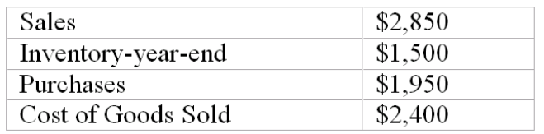
Calculate the gross profit:
A. $0.
B. $1,500.
C. $450.
D. $900.

80. During the year 2010, the inventory of Debra's Gift Shop decreased by $50,000. If the income statement for the year 2010 reported cost of goods sold of $350,000, purchases during the year must have amounted to:
A. $400,000.
B. $310,000.
C. $300,000.
D. $350,000.

81. At the beginning of 2011, Midway Hardware has an inventory of $400,000. Because sales growth was strong during 2011, the owner wants to increase inventory on hand to $450,000 at December 31, 2011. If net sales for 2011 are expected to be $1,600,000, and the gross profit rate is expected to be 35%, compute the cost of the merchandise the owner should expect to purchase during 2011.
A. $1,490,000.
B. $1,040,000.
C. $1,090,000.
D. $1,600,000.

82. If cost of goods sold is $480,000 and the gross profit rate is 40%, what is the gross profit?
A. $320,000.
B. $288,000.
C. $480,000.
D. $1,200,000.

83. Sutton Supplies reports net sales of $3,750,000, net income of $375,000, and gross profit of $900,000. The company's cost of goods sold is:
A. $1,700,000.
B. $1,900,000.
C. $3,375,000.
D. $2,850,000.

84. At the beginning of the year, Saratoga Dress Co. had an inventory of $300,000. During the year, the company purchased merchandise costing $850,000. Net sales for the year totaled $1,200,000, and the gross profit rate was 45%. The cost of goods sold and the ending inventory, respectively, were:
A. $1,150,000 and $660,000.
B. $540,000 and $610,000.
C. $660,000 and $490,000.
D. $1,150,000 and $490,000.

85. At the beginning of 2010, England Dresses has an inventory of $140,000. However, management wants to reduce the amount of inventory on hand to $80,000 at December 31. If net sales for 2010 are forecast at $400,000 and the gross profit rate is expected to be 40%, compute the cost of the merchandise which management should expect to purchase during 2010. (Hint: First compute the expected cost of goods sold.)
A. $240,000.
B. $180,000.
C. $320,000.
D. $220,000.

86. On July 1, the inventory of at Barnett Shoes was $60,000. Because of anticipated back-to-school sales, the owner wants to have an inventory of $105,000 on hand at the beginning of August. Net sales during July are expected to total $70,000, with a gross profit rate of 45%. During July, the company should purchase merchandise costing:
A. $38,500.
B. $143,500.
C. $83,500.
D. $105,000.

Michael uses its periodic inventory system and the following information is available:
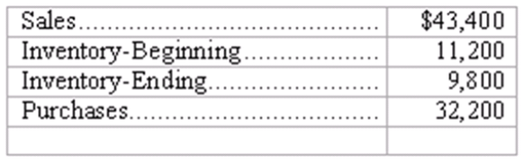

87. What is the cost of goods sold?
A. $9,800.
B. $33,600.
C. $32,200.
D. $43,400.

88. What is the gross profit?
A. $9,800
B. $33,600
C. $32,200
D. $43,400

89. If Bartner Furniture, Inc. purchased inventory at $1,200 list price and the terms were 3/10 n/30, what would be the value associated with the inventory if payment was made after 20 days?
A. $1,176.
B. $1,236.
C. $1,164.
D. $1,200.

90. If costs of goods sold is $560,000 and its gross profit rate is 20%, what is the gross profit?
A. $140,000.
B. $70,000.
C. $120,000.
D. $112,000.

Washington Warehouse is a small retail business that specializes in the sale of top-of-the-line televisions. This year, the store has begun to carry the Flat TV manufactured by Bass Co. Thus far, Washington has recorded the following transactions involving the Flat TV:
Jan. 5 Purchased 8 Flat TVs at a unit cost of $1,400
Jan. 18 Purchased 5 additional Flat TVs at $1,400 each
Feb. 12 Sold 9 Flat TVs to the Duke Hotel for $15,300

91. Refer to the information above. If Washington uses a perpetual inventory system, the journal entry to record the purchase on January 18th would include which of the following?
A. A debit to the Purchases account for $7,000.
B. A debit to the Cost of Goods Sold for $7,000.
C. A credit to Inventory for $7,000.
D. A debit to Inventory for $7,000.

92. Refer to the information above. The gross profit on the Flat TVs as of February 12th is:
A. $11,200.
B. $2,700.
C. $4,100.
D. $15,300.

93. Refer to the information above. If Washington uses a perpetual inventory system, the journal entry to record the sale on February 12th would include all of the following except:
A. A debit to the Cost of Goods Sold for $15,300.
B. A credit to Sales Revenue for $18,200.
C. A credit to Purchases for $15,300.
D. A credit to Inventory for $15,300.

94. Refer to the information above. Washington maintains a subsidiary ledger account for each type of TV carried in the store. An examination of the account for the Flat TV model at the end of February would show:
A. 4 units on hand with a total value of $1,400.
B. 4 units on hand with a total value of $5,600.
C. 13 units on hand with a total value of $18,200.
D. The amount that Washington owes to Bass.

95. Beacon Food Stores purchased canned goods at an invoice price of $4,000 and terms of 2/10, n/30. Half of the goods had been mislabeled and were returned immediately to the supplier. If Harvest Food pays the remaining amount of the invoice within the discount period, the amount paid should be:
A. $1,920.
B. $1,960.
C. $3,920.
D. $4,000.

96. Berg Tooling reports net sales of $325,000, gross profit of $175,000, and net income of $15,000. The company's cost of goods sold is:
A. $135,000.
B. $150,000.
C. $140,000.
D. $125,000.

97. VanRoy Supplies reports net sales of $1,750,000, net income of $175,000, and gross profit of $300,000. The company's cost of goods sold is:
A. $1,400,000.
B. $475,000.
C. $1,575,000.
D. $1,450,000.

World of Sound is a small retail business that specializes in the sale of top-of-the-line sound systems. This year, the store has begun to carry the Surround Sound manufactured by Carp Co. Thus far, World of Sound has recorded the following transactions involving the Surround Sound
May 5 Purchased 18 units at a unit cost of $2,400
May 18 Purchased 15 additional units at $2,550 each
June 12 Sold 19 units to the Davies Theater

98. If World of Sound uses a perpetual inventory system, the journal entry to record the purchase on May 18th would include which of the following?
A. A debit to the Purchases account for $38,250.
B. A debit to the Cost of Goods Sold for $38,250.
C. A credit to Inventory for $38,250.
D. A debit to Inventory for $38,250.

99. If World of Sound uses a perpetual inventory system, the journal entry to record the sale on February 12th would include which of the following?
A. A debit to the Cost of Goods Sold for $45,750.
B. A credit to the Cost of Goods Sold for $45,750.
C. A credit to Purchases for $45,750.
D. A debit to Inventory for $45,750

Bremmer uses a periodic inventory system and the following information is available:
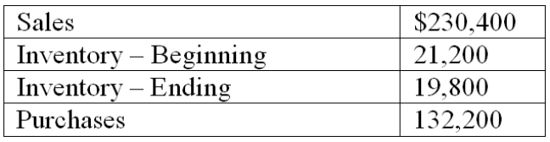

100. What is the cost of goods sold?
A. $96,800.
B. $133,600.
C. $132,200.
D. $230,400.

101. What is the gross profit?
A. $96,800.
B. $133,600.
C. $132,200.
D. $230,400.

102. If Bounder Dog Supplies, Inc purchased inventory at $2,200 list price and the terms were 3/10 n/30, what would be the value associated with the inventory if payment was made within 10 days?
A. $2,268.
B. $2,334.
C. $2,200.
D. $2,134.

103. Pet Foods Plus purchased bagged dog food at an invoice price of $6,000 and terms of 2/10, n/30. Half of the bags had been damaged in shipment and delivery was refused. If Pet Foods Plus pays the remaining amount of the invoice within the discount period, the amount paid should be:
A. $2,940.
B. $3,000.
C. $5,880.
D. $6,000.

104. At the beginning of 2012, Wilson Stores has an inventory of $300,000. Because sales growth was strong during 2012, the owner wants to increase inventory on hand to $450,000 at December 31, 2012. If net sales for 2012 are expected to be $2,600,000, and the gross profit rate is expected to be 35%, compute the cost of the merchandise the owner should expect to purchase during 2012.
A. $750,000.
B. $1,240,000.
C. $1,690,000.
D. $1,840,000.

105. If cost of goods sold is $360,000 and the gross profit rate is 40%, what is the gross profit?
A. $240,000.
B. $360,000.
C. $600,000.
D. $900,000.

Essay Questions
106. Accounting terminology Listed below are nine technical accounting terms introduced in this chapter:
Gross profit
Gross profit rate
General ledger
Cost of goods sold
Physical inventory
Subsidiary ledger
Perpetual inventory system
Periodic inventory system Inventory shrinkage
Each of the following statements may (or may not) describe one of these technical terms. In the space provided below each statement, indicate the accounting term described, or answer "None" if the statement does not correctly describe any of the terms.
____ a. An approach to accounting for inventories and the cost of goods sold used primarily in small businesses with manual accounting systems.
____ b. A reason why perpetual inventory records may not be entirely accurate.
____ c. The difference between the revenue earned by selling merchandise and the cost of goods sold.
____ d. Gross profit divided by average total stockholders' equity.
____ e. An accounting procedure used in both perpetual and periodic inventory systems. In a perpetual system, this procedure brings to light the amount of inventory shrinkage. In a periodic system, it is the basis for computing the cost of goods sold.
____ f. An accounting record showing the individual items comprising the balance of a general ledger account.
____ g. The accounting record in which transactions initially are recorded.

107. Effects of transactions upon the accounting equation Listed below are selected transactions of Simon's, a retail store which uses a perpetual inventory system:
(a) Purchased merchandise on account.
(b) Made an entry to recognize the revenue from a sale of merchandise on account. (Ignore the cost of goods sold.)
(c) Recognized the cost of goods sold relating to the sale in Transaction b.
(d) Collected in cash the account receivable from the customer in Transaction b.
(e) Following the taking of a physical inventory at year-end, made an adjusting entry to record a normal amount of inventory shrinkage.
Indicate the effects of each of these transactions upon the elements of the company's financial statements. Organize your answer in tabular form, using the column headings shown below. (Notice that the cost of goods sold is shown separately from all other expenses.) Use the code letters I for increase, D for decrease, and NE for no effect. The answer for Transaction a is provided as an example.
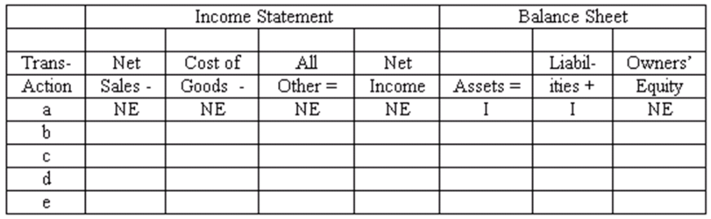

108. Subsidiary ledgers Listed below are several merchandising transactions of Siegel's Garden Center, a garden supply store.
(a) Purchased merchandise from Bayview Wholesale on account.
(b) Sold merchandise for cash.
(c) Sold merchandise on account to Dom's Landscaping Co.
(d) Paid the account payable to Bayview Wholesale.
(e) Collected the account receivable from Dom's Landscaping Co.
Among the accounting records maintained by Siegel's are subsidiary ledgers for inventory, accounts receivable, and accounts payable.
For each of the five transactions, you are to indicate any subsidiary ledger (or ledgers) to which the transaction would be posted. Use the code:
Inv = Inventory subsidiary ledger
AR = Accounts receivable subsidiary ledger
AP = Accounts payable subsidiary ledger
Also indicate whether each posting causes the balance in the subsidiary ledger account to increase or decrease. Organize your answer in tabular form as illustrated below. The answer for transaction a is provided as an example.
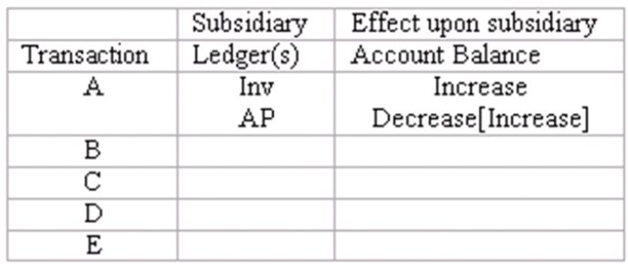

109. Perpetual inventory system: basic entries Renato Company uses a perpetual inventory system. A partial chart of accounts is shown below, followed by a series of merchandising transactions. Indicate the accounts that should be debited and credited in recording each transaction. (Ignore sales taxes.)
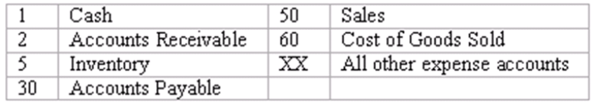
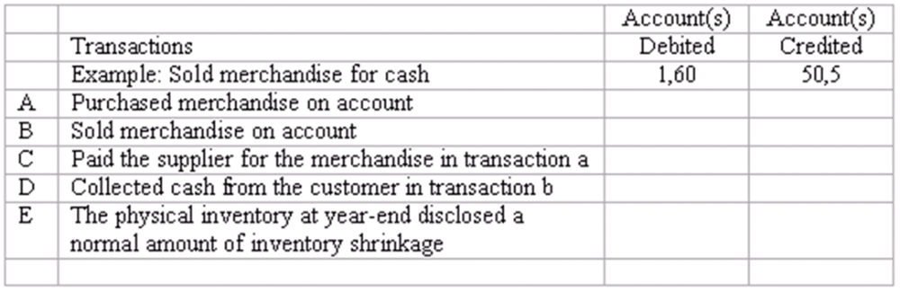

110. Perpetual inventory system: transactions and closing entries Danny's Wholesale Company uses a perpetual inventory system. A partial chart of accounts is shown below, followed by a series of merchandising transactions. Indicate the accounts that should be debited and credited in recording each transaction. (Ignore sales taxes.)
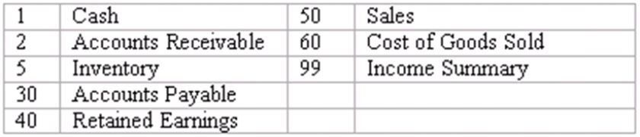
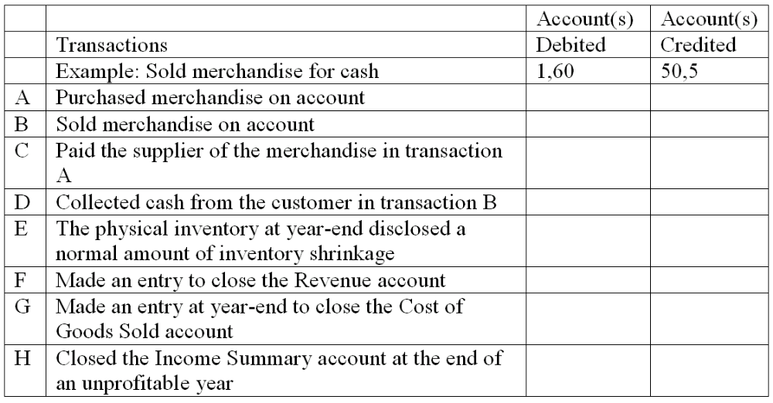

111. Periodic inventory system Soundview Centre uses a periodic inventory system. At the end of 2010, the accounting records include the following information:
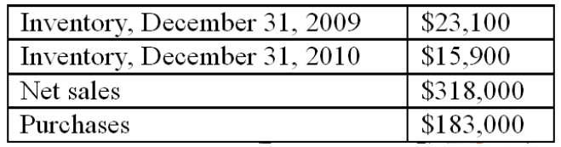
Compute the following for 2010:

112. Periodic inventory system Armstrong Creation uses a periodic inventory system. During the current year, the company purchased merchandise at a cost of $245,000. You are to compute the cost of goods sold under each of the following alternative assumptions:
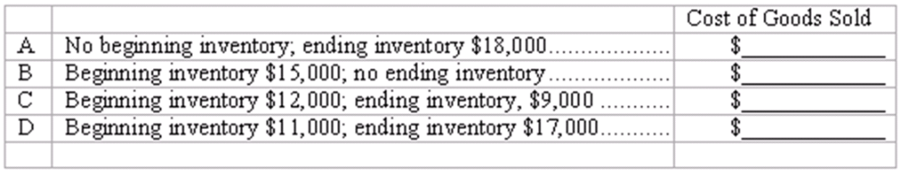

113. Gross profit The table below contains information from a recent annual report of Molloy, Inc. (Dollar amounts are stated in millions.) Fill in the missing amounts.
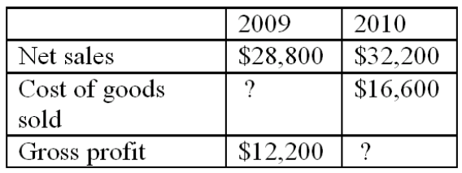

114. Gross profit rates a practical application
Note to instructor: The following exercise requires students to use gross profit rates in a manner not specifically illustrated in the chapter. We view this as an exercise in critical thinking and, as such, it is more challenging than the typical exercise. Part d requires an expository answer. Some instructors may choose to omit part d.
Your store sells computers and software. The average computer sells for $1,350, but the customer buying a computer also buys an average of $750 in software. You earn only 10% gross profit rate on sales of computers, but you make a 40% gross profit rate on software. You currently are selling 150 computers per month.
(a) What is the total amount of your monthly gross profit? $________________
(b) To increase sales, you are thinking about selling computers at cost ($1,215.) This would be the "cheapest price in town," and should attract more customers. You expect each customer who buys a computer to also buy $750 worth of software. Under these assumptions, how many computers must you sell each month in order to earn the same amount of gross profit as you are earning now?
(c) Assume that as a result of reducing the sales price of computers to cost ($1,215), you are able to sell 250 computers each month, and that each customer now buys $850 worth of software. What will be the total amount of your monthly gross profit?
(d) Assume that you achieve the results specified in part c (250 sales transactions per month, including an average of $850 in software). Would you consider the policy of selling computers at cost successful or unsuccessful? Explain specifically why this strategy is working out favorably or unfavorably.

115. Net sales and gross profit
Mayflower Supply House had gross sales revenue of $1,700,000, cost of goods sold of $950,000, sales returns and allowances of $52,500, and allowed sales discounts of $30,000.
Compute for the year:
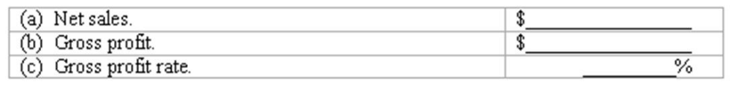

116. Journal entries for merchandising transactions Shown below is a partial chart of accounts for Main Street Markets, followed by a series of merchandising transactions. The company uses a perpetual inventory system, records purchases at net cost, and records sales at the full invoice price. Sales taxes are collected on all sales, and the sales tax liability is recorded immediately. Freight charges on inbound shipments are recorded in the Transportation-in account.
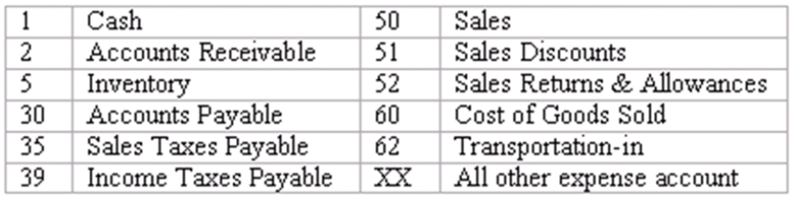
Indicate the accounts that should be credited in recording each transaction by placing the appropriate account number(s) in the space provided.
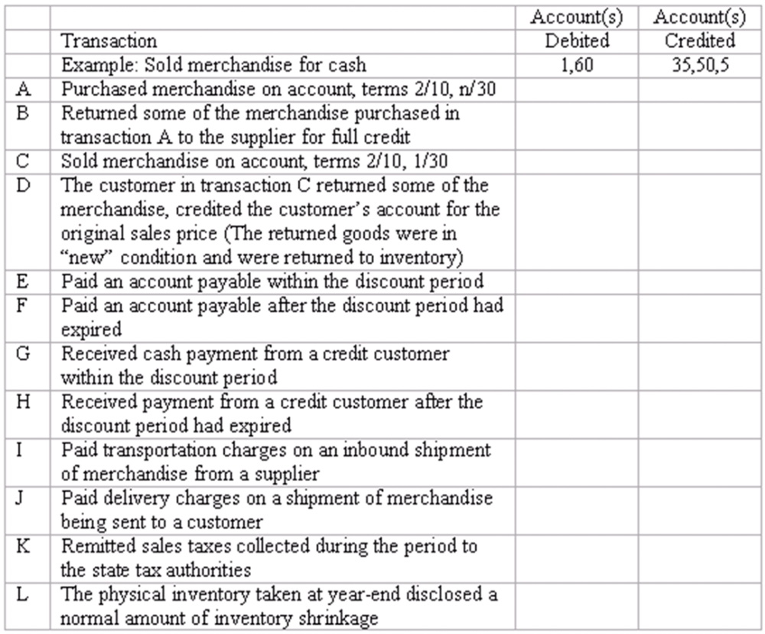

117. Inventory systems
Briefly distinguish between a perpetual inventory system and a periodic inventory system.

118. Inventory systems
Indicate whether you would expect each of the following businesses to maintain a perpetual or a periodic inventory system. Explain the reasoning behind your answers:
(a) A jewelry store.
(b) A roadside vegetable stand.

119. Inventory systems
Bookmarks, Inc. sells used books at its store in the resort community of Lake Bryn Mawr. The owner maintains a large inventory of used books purchased from estate sales, flea markets, and customers. During the tourist seasons of summer and winter, the store is exceptionally busy with customers. Each customer usually makes small purchases ranging in amount from one to twenty dollars. What type of inventory system would you recommend to the owner of Bookmarks, Inc.? Explain the reasoning behind your advice.

120. Subsidiary ledgers Explain the nature of subsidiary ledgers, and give two specific examples. For each of these examples, explain (1) the unit of organization within this ledger, and (2) the usefulness of this ledger in business operations.

121. Using gross profit rates Explain how the gross profit rate for a particular product is determined. How would you expect the manager of a large department store to use these gross profit rates in deciding which products to feature in the store's window displays and in determining the location of various types of merchandise within the store? Explain.

122. A customer purchased merchandise for $450 which cost the seller $200. The customer was dissatisfied with some of the goods and thus returned $100 worth and received a cash refund.
(a) What journal entries should the seller make when the merchandise is sold and at the time of the return? Assume that the seller uses a perpetual inventory system.
(b) If the seller uses a periodic inventory system, what entries would be made?

123. Prepare journals entries for the following, assuming the company uses a perpetual inventory method and records purchases at their net amounts.
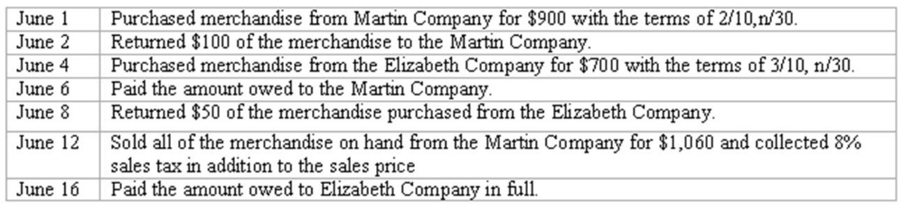

Multiple Choice Questions
124. Which of the following businesses is most likely to use a periodic inventory system?
A. An aircraft manufacturer.
B. A supermarket that is part of a national chain.
C. An independently owned art gallery with a manual accounting system.
D. A beer bar.

125. A periodic inventory system eliminates the need for:
A. Taking an annual physical inventory.
B. Recording the revenue from sales transactions.
C. Recording the cost of merchandise sold as sales occur.
D. None of the above.

126. If management wants to know the cost and quantity of merchandise on hand at all times, the business will probably:
A. Use a periodic inventory system.
B. Maintain an inventory subsidiary ledger.
C. Take a complete physical inventory each day.
D. Debit all purchases of merchandise directly to the Cost of Goods Sold account.

127. In a perpetual inventory system, the entry to record the cost of goods sold always includes an entry of equal amount to the:
A. Inventory account.
B. Sales account.
C. Purchases account.
D. None of the above.

128. Prior to taking a physical inventory at year-end, the perpetual inventory records of Athena Designs showed an inventory of $26,000, sales of $358,000, and a cost of goods sold of $215,000. The year-end physical inventory indicated merchandise on hand costing $24,000. The company's gross profit for the year was:
A. $334,000.
B. $145,000.
C. $141,000.
D. Some other amount.

At the end of last year, Helen's, Inc. had merchandise costing $115,000 in inventory. During January of the current year, the company purchased merchandise costing $35,000, and sold merchandise which it had purchased at a total cost of $55,000.
Based upon the above information, place the best answer in the space provided. In questions 1 through 3, assume that Helen's uses a perpetual inventory system.

129. The total debited to the Inventory account during January was:
A. $0.
B. $35,000.
C. $55,000.
D. Some other answer.

130. The balance in the Inventory account at January 31 was:
A. $35,000.
B. $205,000.
C. $95,000.
D. Some other answer.

131. The amount of costs transferred from the Inventory account to the Cost of Goods Sold account during January was:
A. $0.
B. $35,000.
C. $55,000.
D. Some other answer.

Assume that Jerome's, Inc. uses a periodic inventory system and takes a physical inventory only at year-end.

132. The total debited to the Inventory account during January was:
A. $0.
B. $35,000.
C. $55,000.
D. Some other answer.

133. The balance in the Inventory account at January 31 was:
A. $0.
B. $105,000.
C. $115,000.
D. Some other answer.

134. The amount of costs transferred from the Inventory account to the Cost of Goods Sold account during January was:
A. $0.
B. $35,000.
C. $55,000.
D. Some other answer.

Essay Questions
135. At the end of last year, Baron's Bazaar had merchandise costing $381,000 in inventory.
During January of the current year, the company purchased merchandise costing $133,500, and sold merchandise which it had purchased at a total cost of $109,300.
a. Assume that Baron's Bazaar uses a perpetual inventory system.
(1) The total amount debited to the Inventory account during January was:
$________________
(2) The balance in the Inventory account at January 31 was:
$________________
(3) The amount of costs transferred from the Inventory account to the Cost of Goods Sold account during January was:
$________________
b. Assume that Baron's Bazaar uses a periodic inventory system and takes a physical inventory only at year-end (December 31). (Note: $0 may be an appropriate answer to one or more of the following questions.)
(1) The total amount debited to the Inventory account during January was:
$________________
(2) The balance in the Inventory account at January 31 was:
$________________
(3) The amount of costs transferred from the Inventory account to the Cost of Goods Sold account during January was:
$________________

136. Phillips Co. is an office supply store. The company uses a perpetual inventory system, records purchases at net cost, and records sales revenue at full invoice price.
Record the following transactions in the company's general journal. To conserve space, you may omit the written explanations which normally should accompany the entries.
July 1 Purchased four Lorac copying machines on account from Lorac Corp. Total invoice price was $2,500 per machine ($10,000 total); terms of 2/10, n/30. These machines are intended for resale.
3 Found one of the Lorac copiers to be defective and returned it to Lorac, thus reducing the amount owed.
9 Sold one of the Lorac copiers to Morris Realty. The sales price was $3,500, terms 5/10, n/60.
10 Paid the remaining amount owned to Lorac Corp., less the allowable discount.
19 Received full payment from Morris, less the allowable discount.
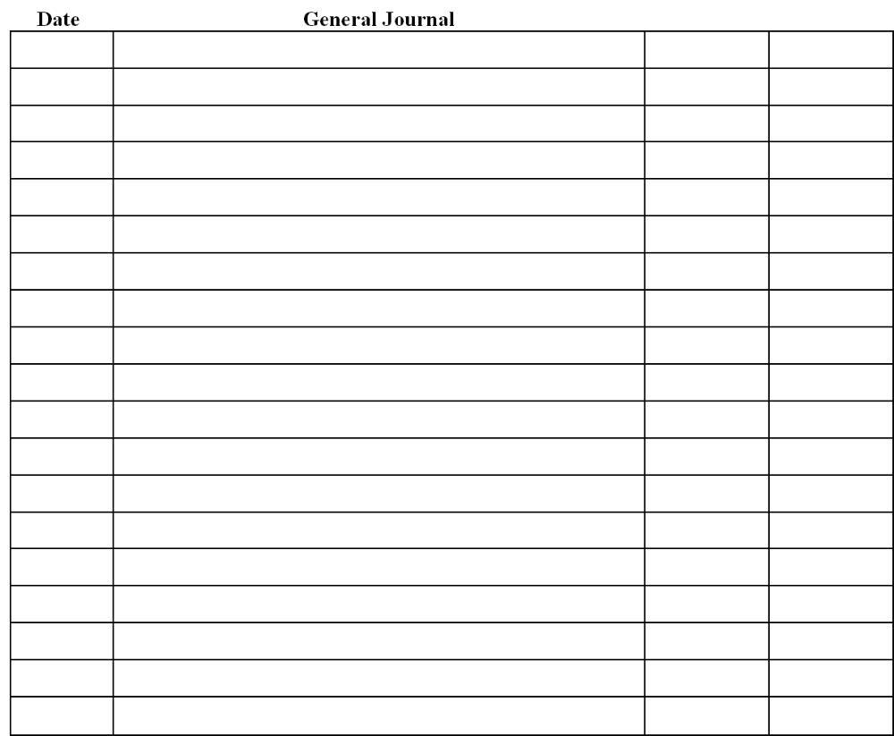

Multiple Choice Questions
137. Mark and Amanda Carter own an appliance store and a restaurant. The appliance store sells merchandise on a 12-month installment plan; the restaurant sells only for cash. (More than one of the following answers may be correct.)
A. The appliance store has a longer operating cycle than the restaurant.
B. The appliance store probably uses a perpetual inventory system, whereas the restaurant probably uses a periodic system.
C. Both businesses require subsidiary ledgers for accounts receivable and inventory.
D. Both businesses probably have subsidiary ledgers for accounts payable.

138. Which of the following statements about merchandising activities is true? (More than one answer may be correct)
A. As inventory is purchased, the Inventory Expense account is debited and Cash (or Accounts Payable) is credited.
B. Inventory is recorded as an asset when it is first purchased.
C. As inventory is sold, its cost is transferred from the balance sheet to the income statement.
D. As inventory is sold, its cost is transferred from the income statement to the balance sheet.

139. Marietta Corporation uses a perpetual inventory system. All of its sales are made on account. The company sells merchandise costing $3,000 at a sales price of $4,300. In recording this transaction, Marietta will make all of the following entries except:
A. Credit Sales, $4,300.
B. Credit Inventory, $3,000.
C. Debit Cost of Goods Sold, $3,000.
D. Debit one or more accounts in the inventory subsidiary ledger for amounts totaling $3,000.

140. Fashion House uses a perpetual inventory system. At the beginning of the year, inventory amounted to $50,000. During the year, the company purchased merchandise for $230,000, and sold merchandise costing $245,000. A physical inventory taken at year-end indicated shrinkage losses of $4,000. Prior to recording these shrinkage losses, the year-end balance in the company's Inventory account was:
A. $31,000.
B. $35,000.
C. $50,000.
D. Some other amount.

141. Best Hardware uses a periodic inventory system. Its inventory was $38,000 at the beginning of the year, and $40,000 at the end. During the year, Best made purchases of merchandise totaling $107,000. Identify all of the correct answers:
A. To use this system, Best must take a complete physical inventory twice each year.
B. Prior to making adjusting and closing entries at year-end, the balance in Best's Inventory account is $38,000.
C. The cost of goods sold for the year is $109,000.
D. As sales transactions occur, Best makes no entries to update its inventory records or record the cost of goods sold.

142. The two basic approaches to accounting for inventory and the cost of goods sold are the perpetual inventory system and the periodic inventory system. (More than one of the following statements may be correct.)
A. Most large merchandising companies and manufacturing businesses use periodic inventory systems.
B. As a practical matter, a grocery store or a large department store could not maintain a perpetual inventory system without the use of point-of-sale terminals.
C. In a periodic inventory system the cost of goods sold cannot be determined until a complete physical inventory is taken.
D. In a perpetual inventory system, the Cost of Goods Sold account is debited promptly for the cost of merchandise sold.

143. Big Brother, a retail store, purchased 100 television sets from Krueger Electronics on account at a cost of $200 each. Kruger offers credit terms of 2/10, n/30; Big Brother uses a perpetual inventory system and records purchases at net cost. Big Brother determines that 10 of these television sets are defective and returns them to Krueger for full credit. In recording this return, Big Brother will:
A. Debit Sales Returns and Allowances, $1,960.
B. Debit Accounts Payable, $1,960.
C. Debit Cost of Goods Sold, $1,960.
D. Credit Inventory, $2,000.

144. Two of the lawn mowers sold by Garden Products Co. are the Lawn Master and the Mark 5. Lawn Masters sell for $250 apiece, which results in a 35% profit margin. Each Mark 5 costs Garden Products $300 and sells for $400. Indicate all correct answers.
A. The dollar amount of gross profit is greater on the sale of a Mark 5 than a LawnMaster.
B. The gross profit margin is higher on Mark 5s than on LawnMasters.
C. Garden profits relatively more by selling one Mark 5 than one LawnMaster.
D. Garden profits more by selling $2,000 worth of Mark 5s than $2,000 worth of LawnMasters.

Chapter 06 Merchandising Activities Answer Key

True / False Questions
1. Inventory is a relatively liquid asset and usually appears above Accounts Receivable on the balance sheet.
FALSE

AACSB: Reflective Thinking
AICPA BB: Critical Thinking
AICPA FN: Measurement
Bloom's: Remember
Difficulty: Easy
Learning Objective: 06-01 Describe the operating cycle of a merchandising company.
Topic: Merchandising Companies
2. The operating cycle of a merchandising company consists of (1) purchases of merchandise; (2) sales of the merchandise; and (3) collection of accounts receivable.
TRUE

AACSB: Reflective Thinking
AICPA BB: Resource Management
AICPA FN: Measurement
Bloom's: Remember
Difficulty: Easy
Learning Objective: 06-01 Describe the operating cycle of a merchandising company.
Topic: Merchandising Companies
3. Inventory shrinkage refers to unrecorded decreases in inventory resulting from breakage, theft, and sales of inventory.
FALSE

AACSB: Reflective Thinking
AICPA BB: Critical Thinking
AICPA FN: Measurement
Bloom's: Remember
Difficulty: Easy
Learning Objective: 06-03 Account for purchases and sales of merchandise in a perpetual inventory system.
Topic: Perpetual Inventory Systems
4. In a perpetual inventory system, when merchandise is purchased, it is debited to an account called Purchases.
FALSE

AACSB: Reflective Thinking
AICPA BB: Critical Thinking
AICPA FN: Measurement
Bloom's: Remember
Difficulty: Easy
Learning Objective: 06-03 Account for purchases and sales of merchandise in a perpetual inventory system.
Topic: Perpetual Inventory Systems
5. In a periodic inventory system, the Cost of Goods Sold account may be created during the closing process by debiting Cost of Goods Sold and crediting the Beginning Inventory and the Purchases account.
TRUE

AACSB: Reflective Thinking
AICPA BB: Critical Thinking
AICPA FN: Measurement
Bloom's: Understand
Difficulty: Medium
Learning Objective: 06-04 Explain how a periodic inventory system operates.
Topic: Periodic Inventory Systems
6. Purchase Discounts Lost is shown as a reduction of cost of goods sold in the income statement.
FALSE

AACSB: Reflective Thinking
AICPA BB: Critical Thinking
AICPA FN: Measurement
Bloom's: Remember
Difficulty: Medium
Learning Objective: 06-06 Account for additional merchandising transactions related to purchases and sales.
Topic: Transactions Relating to Purchases
7. Net Sales is computed as total sales revenue less sales returns and allowances less sales discounts.
TRUE

AACSB: Reflective Thinking
AICPA BB: Critical Thinking
AICPA FN: Measurement
Bloom's: Remember
Difficulty: Easy
Learning Objective: 06-06 Account for additional merchandising transactions related to purchases and sales.
Topic: Transactions Relating to Sales
8. The contra-revenue accounts, Sales Returns and Allowances and Sales Discounts, should be closed by crediting these accounts and debiting Income Summary for each account.
TRUE

AACSB: Reflective Thinking
AICPA BB: Critical Thinking
AICPA FN: Measurement
Bloom's: Understand
Difficulty: Medium
Learning Objective: 06-06 Account for additional merchandising transactions related to purchases and sales.
Topic: Transactions Relating to Sales
9. Gross profit margin is the dollar amount of gross profit expressed as a percentage of gross sales.
FALSE

AACSB: Reflective Thinking
AICPA BB: Industry
AICPA FN: Measurement
Bloom's: Remember
Difficulty: Easy
Learning Objective: 06-08 Measure the performance of a merchandising business.
Topic: Financial Analysis and Decision Making
10. The accounting cycle of a merchandising business is the length of time covered by the company's income statement.
TRUE

AACSB: Reflective Thinking
AICPA BB: Critical Thinking
AICPA FN: Measurement
Bloom's: Remember
Difficulty: Easy
Learning Objective: 06-01 Describe the operating cycle of a merchandising company.
Topic: Merchandising Companies
11. Today, most large merchandising companies use a perpetual inventory system.
TRUE

AACSB: Reflective Thinking
AICPA BB: Critical Thinking
AICPA FN: Measurement
Bloom's: Remember
Difficulty: Easy
Learning Objective: 06-05 Discuss the factors to be considered in selecting an inventory system.
Topic: Periodic Inventory Systems
12. Inventories are assets that a company holds for sale in the ordinary course of business.
TRUE

AACSB: Reflective Thinking
AICPA BB: Critical Thinking
AICPA FN: Measurement
Bloom's: Remember
Difficulty: Easy
Learning Objective: 06-02 Understand the components of a merchandising company's income statement.
Topic: Merchandising Companies
13. In preparing monthly bills to be sent to individual credit customers, the billing department will use the accounts payable subsidiary ledger, rather than the general ledger.
FALSE

AACSB: Reflective Thinking
AICPA BB: Critical Thinking
AICPA FN: Measurement
Bloom's: Understand
Difficulty: Easy
Learning Objective: 06-07 Define special journals and explain their usefulness.
Topic: Modifying an Accounting System
14. In a periodic inventory system, the Inventory and Cost of Goods Sold accounts are kept up-to-date throughout the accounting period.
FALSE

AACSB: Reflective Thinking
AICPA BB: Critical Thinking
AICPA FN: Measurement
Bloom's: Understand
Difficulty: Easy
Learning Objective: 06-04 Explain how a periodic inventory system operates.
Topic: Periodic Inventory Systems
15. A perpetual inventory system requires the capability of recording the cost of the goods sold in individual sales transactions.
TRUE

AACSB: Reflective Thinking
AICPA BB: Critical Thinking
AICPA FN: Measurement
Bloom's: Understand
Difficulty: Easy
Learning Objective: 06-03 Account for purchases and sales of merchandise in a perpetual inventory system.
Topic: Perpetual Inventory Systems
16. Wholesalers buy from retailers and sell to the general public.
FALSE

AACSB: Reflective Thinking
AICPA BB: Critical Thinking
AICPA FN: Measurement
Bloom's: Remember
Difficulty: Easy
Learning Objective: 06-02 Understand the components of a merchandising company's income statement.
Topic: Merchandising Companies
17. Under the periodic inventory system, no effort is made to keep up-to-date records of either Inventory or Cost of Goods Sold as transactions occur.
TRUE

AACSB: Reflective Thinking
AICPA BB: Critical Thinking
AICPA FN: Measurement
Bloom's: Understand
Difficulty: Medium
Learning Objective: 06-04 Explain how a periodic inventory system operates.
Topic: Periodic Inventory Systems
18. The manager of National Software wants to know how many Microsoft Excel programs the store sold in June. This information is contained in the Inventory controlling account.
FALSE

AACSB: Reflective Thinking
AICPA BB: Critical Thinking
AICPA FN: Measurement
Bloom's: Understand
Difficulty: Medium
Learning Objective: 06-07 Define special journals and explain their usefulness.
Topic: Modifying an Accounting System
19. In a retail department store with an efficient perpetual inventory system, the quantities of goods actually on hand are probably somewhat more than the quantities indicated in the accounting records.
FALSE

AACSB: Analytic
AICPA BB: Critical Thinking
AICPA FN: Measurement
Bloom's: Understand
Difficulty: Medium
Learning Objective: 06-06 Account for additional merchandising transactions related to purchases and sales.
Topic: Transactions Relating to Purchases
20. When using a perpetual inventory system, the Purchases account is debited when merchandise is acquired.
FALSE

AACSB: Reflective Thinking
AICPA BB: Critical Thinking
AICPA FN: Measurement
Bloom's: Remember
Difficulty: Easy
Learning Objective: 06-03 Account for purchases and sales of merchandise in a perpetual inventory system.
Topic: Perpetual Inventory Systems
21. In a perpetual inventory system, the Inventory and Cost of Goods Sold accounts are kept up-to-date throughout the accounting period.
TRUE

AACSB: Reflective Thinking
AICPA BB: Critical Thinking
AICPA FN: Measurement
Bloom's: Understand
Difficulty: Easy
Learning Objective: 06-03 Account for purchases and sales of merchandise in a perpetual inventory system.
Topic: Perpetual Inventory Systems
22. In a periodic inventory system, the ending inventory can be determined from the accounting records, and a physical count of the merchandise on hand will confirm the amount.
FALSE

AACSB: Reflective Thinking
AICPA BB: Critical Thinking
AICPA FN: Measurement
Bloom's: Understand
Difficulty: Medium
Learning Objective: 06-04 Explain how a periodic inventory system operates.
Topic: Periodic Inventory Systems
23. In a periodic inventory system, the cost of goods sold is determined by the following end-of-period computation: Beginning Inventory + Purchases - Ending inventory = Cost of Goods Sold.
TRUE

AACSB: Reflective Thinking
AICPA BB: Critical Thinking
AICPA FN: Measurement
Bloom's: Understand
Difficulty: Medium
Learning Objective: 06-04 Explain how a periodic inventory system operates.
Topic: Periodic Inventory Systems
24. Under the perpetual inventory system, two entries are required when goods are sold.
TRUE

AACSB: Reflective Thinking
AICPA BB: Critical Thinking
AICPA FN: Measurement
Bloom's: Understand
Difficulty: Medium
Learning Objective: 06-03 Account for purchases and sales of merchandise in a perpetual inventory system.
Topic: Perpetual Inventory Systems
25. If ending inventory and cost of goods sold are added together, they should equal gross profit.
FALSE

AACSB: Reflective Thinking
AICPA BB: Critical Thinking
AICPA FN: Measurement
Bloom's: Remember
Difficulty: Easy
Learning Objective: 06-02 Understand the components of a merchandising company's income statement.
Topic: Merchandising Companies
26. Instead of paying for merchandise purchased on account, Olympic Corp. returned this merchandise to the supplier. Olympic should record this transaction by debiting Accounts Payable and crediting Sales Returns and Allowances.
FALSE

AACSB: Reflective Thinking
AICPA BB: Critical Thinking
AICPA FN: Measurement
Bloom's: Understand
Difficulty: Medium
Learning Objective: 06-06 Account for additional merchandising transactions related to purchases and sales.
Topic: Transactions Relating to Purchases
27. When using a perpetual inventory system, the Purchases account is debited when merchandise is acquired.
FALSE

AACSB: Reflective Thinking
AICPA BB: Critical Thinking
AICPA FN: Measurement
Bloom's: Remember
Difficulty: Easy
Learning Objective: 06-03 Account for purchases and sales of merchandise in a perpetual inventory system.
Topic: Perpetual Inventory Systems
28. A large company with many different kinds of low-cost items would tend to use a perpetual inventory system.
TRUE

AACSB: Analytic
AICPA BB: Critical Thinking
AICPA FN: Measurement
Bloom's: Understand
Difficulty: Medium
Learning Objective: 06-05 Discuss the factors to be considered in selecting an inventory system.
Topic: Periodic Inventory Systems
29. The average gross profit margin is a measure of relative profitability.
TRUE

AACSB: Reflective Thinking
AICPA BB: Critical Thinking
AICPA FN: Measurement
Bloom's: Remember
Difficulty: Easy
Learning Objective: 06-08 Measure the performance of a merchandising business.
Topic: Financial Analysis and Decision Making
30. If ending inventory and cost of goods sold are added together, they should equal cost of goods available for sale.
TRUE

AACSB: Reflective Thinking
AICPA BB: Critical Thinking
AICPA FN: Measurement
Bloom's: Remember
Difficulty: Easy
Learning Objective: 06-02 Understand the components of a merchandising company's income statement.
Topic: Merchandising Companies

Multiple Choice Questions
31. Operating income is:
A. A measure of profitability after deducting cost of sales from net sales.
B. A measure of profitability after deducting cost of sales and all expenses incurred in operating the business from net sales.
C. A measure of liquidity after deducting cost of sales from net sales.
D. The equivalent of net sales.

AACSB: Reflective Thinking
AICPA BB: Critical Thinking
AICPA FN: Measurement
Bloom's: Remember
Difficulty: Easy
Learning Objective: 06-01 Describe the operating cycle of a merchandising company.
Topic: Merchandising Companies
32. Sales discounts and allowances:
A. When properly recorded will reduce net profit.
B. When properly recorded will increase net profit.
C. Will not affect net profit.
D. Are always immaterial and need not be recorded.

AACSB: Analytic
AICPA BB: Critical Thinking
AICPA FN: Measurement
Bloom's: Understand
Difficulty: Medium
Learning Objective: 06-06 Account for additional merchandising transactions related to purchases and sales.
Topic: Transactions Relating to Sales
33. Which account listed below is classified as a contra-revenue account?
A. Cost of Goods Sold.
B. Gross profit.
C. Sales Discounts.
D. Purchases.

AACSB: Reflective Thinking
AICPA BB: Critical Thinking
AICPA FN: Measurement
Bloom's: Remember
Difficulty: Medium
Learning Objective: 06-02 Understand the components of a merchandising company's income statement.
Topic: Merchandising Companies
34. The Cost of Goods Sold account is closed by:
A. Debiting Cost of Goods Sold and crediting Income Summary.
B. Debiting Cost of Goods Sold and crediting Retained Earnings.
C. Debiting Income Summary and crediting Cost of Goods Sold.
D. Debiting Retained Earnings and crediting Cost of Goods Sold.

AACSB: Analytic
AICPA BB: Critical Thinking
AICPA FN: Measurement
Bloom's: Understand
Difficulty: Easy
Learning Objective: 06-02 Understand the components of a merchandising company's income statement.
Topic: Merchandising Companies
35. Merchandising companies that are small and do not use a perpetual inventory system may elect to use:
A. A physical inventory system.
B. A periodic inventory system.
C. An inventory shrinkage method.
D. An inventory subsidiary ledger system.

AACSB: Reflective Thinking
AICPA BB: Critical Thinking
AICPA FN: Measurement
Bloom's: Understand
Difficulty: Medium
Learning Objective: 06-05 Discuss the factors to be considered in selecting an inventory system.
Topic: Periodic Inventory Systems
36. Which of the following would not tend to make a manufacturer choose a perpetual inventory system?
A. Management wants information about quantities of specific products.
B. A low volume of sales transactions and a computerized accounting system.
C. A high volume of sales transactions and a manual accounting system.
D. Items in inventory with high per unit costs.

AACSB: Reflective Thinking
AICPA BB: Critical Thinking
AICPA FN: Measurement
Bloom's: Understand
Difficulty: Medium
Learning Objective: 06-05 Discuss the factors to be considered in selecting an inventory system.
Topic: Periodic Inventory Systems
37. Which of the following should not be classified as inventory in the balance sheet of a large automobile dealership?
A. Pickup trucks offered for sale.
B. Used cars taken in trade and offered for sale on the company's used-car lot.
C. Spark plugs, oil filters, and other parts which are intended for use by the service department in repairing and servicing customers' cars.
D. "Company cars" provided to specific company executives for their personal use.

AACSB: Analytic
AICPA BB: Critical Thinking
AICPA FN: Measurement
Bloom's: Understand
Difficulty: Medium
Learning Objective: 06-02 Understand the components of a merchandising company's income statement.
Topic: Merchandising Companies
38. Which of the following factors would suggest the use of a perpetual inventory system?
A. A small company.
B. A high volume of many different, low-cost items.
C. A desire to minimize record-keeping requirements.
D. Only annual reporting is required.

AACSB: Reflective Thinking
AICPA BB: Critical Thinking
AICPA FN: Measurement
Bloom's: Understand
Difficulty: Medium
Learning Objective: 06-05 Discuss the factors to be considered in selecting an inventory system.
Topic: Periodic Inventory Systems
39. Which of the following businesses is likely to have the shortest operating cycle?
A. A food store.
B. A department store.
C. An art store.
D. A car store.

AACSB: Reflective Thinking
AICPA BB: Critical Thinking
AICPA FN: Measurement
Bloom's: Understand
Difficulty: Medium
Learning Objective: 06-01 Describe the operating cycle of a merchandising company.
Topic: Merchandising Companies
40. Which of the following companies would be more likely to use a periodic inventory system?
A. IBM.
B. 1st Bank of New York.
C. Sears.
D. A newspaper stand.

AACSB: Reflective Thinking
AICPA BB: Critical Thinking
AICPA FN: Measurement
Bloom's: Understand
Difficulty: Medium
Learning Objective: 06-05 Discuss the factors to be considered in selecting an inventory system.
Topic: Periodic Inventory Systems
41. Sales revenue is recognized in the period in which:
A. Merchandise is delivered to the customer.
B. The customer orders the merchandise.
C. Cash payment is received by the seller.
D. Purchases are made to replace the merchandise sold.

AACSB: Reflective Thinking
AICPA BB: Critical Thinking
AICPA FN: Measurement
Bloom's: Understand
Difficulty: Easy
Learning Objective: 06-02 Understand the components of a merchandising company's income statement.
Topic: Merchandising Companies
42. Which of the following companies would be more likely to use a perpetual inventory system?
A. Corner deli.
B. Home Depot.
C. James Dean, CPA.
D. A manufacturer of custom sailboats.

AACSB: Reflective Thinking
AICPA BB: Critical Thinking
AICPA FN: Measurement
Bloom's: Understand
Difficulty: Medium
Learning Objective: 06-05 Discuss the factors to be considered in selecting an inventory system.
Topic: Periodic Inventory Systems
43. Which of the following appears in the income statement of a merchandising business, but not in the income statement of a business that renders only services?
A. Interest revenue.
B. Gross profit.
C. Advertising expense.
D. Income tax expense.

AACSB: Reflective Thinking
AICPA BB: Critical Thinking
AICPA FN: Reporting
Bloom's: Understand
Difficulty: Medium
Learning Objective: 06-02 Understand the components of a merchandising company's income statement.
Topic: Merchandising Companies
44. Which of the following factors would suggest the use of a periodic inventory system?
A. A small company.
B. A high volume of sales and a manual accounting system.
C. Neither a small company or a high volume of sales and a manual accounting system.
D. Both a small company and a high volume of sales and a manual accounting system.

AACSB: Reflective Thinking
AICPA BB: Critical Thinking
AICPA FN: Measurement
Bloom's: Understand
Difficulty: Medium
Learning Objective: 06-05 Discuss the factors to be considered in selecting an inventory system.
Topic: Periodic Inventory Systems
45. Gross profit is the difference between:
A. Net sales and the cost of goods sold.
B. The cost of merchandise purchased and the cost of merchandise sold.
C. Net sales and net income.
D. Net sales and all expenses.

AACSB: Reflective Thinking
AICPA BB: Critical Thinking
AICPA FN: Measurement
Bloom's: Remember
Difficulty: Easy
Learning Objective: 06-02 Understand the components of a merchandising company's income statement.
Topic: Merchandising Companies
46. The credit term 2/10, n/30 means:
A. That after 10 days 2% interest is charged.
B. That there is a 10% discount if payment is received within 30 days.
C. That there is a 2% discount if payment is received within 10 days, otherwise, full payment is due within 30 days.
D. There is a 10% discount if paid immediately and 2% if paid within 30 days.

AACSB: Reflective Thinking
AICPA BB: Critical Thinking
AICPA FN: Measurement
Bloom's: Remember
Difficulty: Medium
Learning Objective: 06-06 Account for additional merchandising transactions related to purchases and sales.
Topic: Transactions Relating to Purchases
47. The basic purpose of a subsidiary ledger is to:
A. Provide a chronological record of all business transactions.
B. Provide details about the individual items comprising the balance of a general ledger account.
C. Enable accountants to prepare financial statements.
D. Provide persons outside of the organization with detailed information about the company's operations.

AACSB: Reflective Thinking
AICPA BB: Critical Thinking
AICPA FN: Measurement
Bloom's: Understand
Difficulty: Easy
Learning Objective: 06-02 Understand the components of a merchandising company's income statement.
Topic: Merchandising Companies
48. Under the perpetual inventory system which journal entry would indicate a purchase of merchandise?
A. Debit, Inventory and credit, Cash.
B. Debit, Purchases and credit, Cash.
C. Debit, Costs of Goods Sold and credit, Inventory.
D. Debit, Inventory and credit, Cost of Goods Sold.

AACSB: Reflective Thinking
AICPA BB: Critical Thinking
AICPA FN: Measurement
Bloom's: Understand
Difficulty: Easy
Learning Objective: 06-03 Account for purchases and sales of merchandise in a perpetual inventory system.
Topic: Perpetual Inventory Systems
49. The purchasing agent of Superb Service Co. wants to know the dollar amount of inventory purchased on account during the year from a particular supplier. This information can be found most easily in Superb Service's:
A. Inventory subsidiary ledger.
B. Accounts payable controlling account.
C. Inventory controlling account.
D. Accounts payable subsidiary ledger.

AACSB: Reflective Thinking
AICPA BB: Critical Thinking
AICPA FN: Measurement
Bloom's: Understand
Difficulty: Medium
Learning Objective: 06-02 Understand the components of a merchandising company's income statement.
Topic: Merchandising Companies
50. Which of the following credit terms is the most advantageous to the purchaser of merchandise?
A. 1/10, n/30.
B. 5/10, n/60.
C. 2/10, n/30.
D. 5/10, n/20.

AACSB: Reflective Thinking
AICPA BB: Critical Thinking
AICPA FN: Measurement
Bloom's: Understand
Difficulty: Medium
Learning Objective: 06-06 Account for additional merchandising transactions related to purchases and sales.
Topic: Transactions Relating to Purchases
51. Cumberland, Inc. has applied to its bank for a loan. The bank asks Cumberland's controller about the total amount of the company's accounts receivable. Assuming that all accounting records are up-to-date, the controller can best answer this question by referring to:
A. The Income Statement.
B. The Accounts Receivable controlling account.
C. The Accounts Receivable subsidiary ledger.
D. Last year's Balance Sheet.

AACSB: Reflective Thinking
AICPA BB: Critical Thinking
AICPA FN: Reporting
Bloom's: Understand
Difficulty: Medium
Learning Objective: 06-02 Understand the components of a merchandising company's income statement.
Topic: Merchandising Companies
52. In a perpetual inventory system:
A. Merchandising transactions are recorded as they occur.
B. No effort is made to record the Cost of Goods Sold until year-end.
C. Entries are made in the Cost of Goods Sold account whenever merchandise is purchased or sold.
D. The need for ever taking physical inventory is eliminated.

AACSB: Reflective Thinking
AICPA BB: Critical Thinking
AICPA FN: Measurement
Bloom's: Understand
Difficulty: Medium
Learning Objective: 06-03 Account for purchases and sales of merchandise in a perpetual inventory system.
Topic: Perpetual Inventory Systems
53. Net sales is calculated by:
A. Subtracting cost of sales from sales.
B. Subtracting sales returns and sales discounts from sales.
C. Subtracting sales returns, cost of sales, and sales discounts from sales.
D. Subtracting gross profit from sales.

AACSB: Reflective Thinking
AICPA BB: Critical Thinking
AICPA FN: Measurement
Bloom's: Remember
Difficulty: Easy
Learning Objective: 06-02 Understand the components of a merchandising company's income statement.
Topic: Merchandising Companies
54. In a perpetual inventory system, two entries usually are made to record each sales transaction. The purposes of these entries are best described as follows:
A. One entry recognizes the sales revenue, and the other recognizes the cost of goods sold.
B. One entry records the purchase of the merchandise, and the other records the sale.
C. One entry records the cost of goods sold, and the other reduces the balance in the Inventory account.
D. One entry updates the general ledger, and the other updates the subsidiary ledgers.

AACSB: Reflective Thinking
AICPA BB: Critical Thinking
AICPA FN: Measurement
Bloom's: Understand
Difficulty: Medium
Learning Objective: 06-03 Account for purchases and sales of merchandise in a perpetual inventory system.
Topic: Perpetual Inventory Systems
55. In a periodic inventory system, which of the following accounts may be closed by debiting Cost of Goods Sold?
A. Sales, Inventory (beginning), and Gross Profit.
B. Inventory (beginning) and Purchases.
C. Purchases and Inventory (ending).
D. Sales, Inventory (beginning), and Cost of Goods Available for Sale.

AACSB: Analytic
AICPA BB: Critical Thinking
AICPA FN: Measurement
Bloom's: Understand
Difficulty: Medium
Learning Objective: 06-04 Explain how a periodic inventory system operates.
Topic: Periodic Inventory Systems
56. In comparing a perpetual inventory system with a periodic inventory system, which of the following statements is not correct?
A. Most large companies use perpetual inventory systems.
B. A periodic system does not include an inventory subsidiary ledger.
C. The perpetual method is easier to apply in a manual accounting system.
D. Regardless of the system in use, most businesses take a physical inventory at least once a year.

AACSB: Analytic
AICPA BB: Critical Thinking
AICPA FN: Measurement
Bloom's: Understand
Difficulty: Medium
Learning Objective: 06-05 Discuss the factors to be considered in selecting an inventory system.
Topic: Periodic Inventory Systems
57. Hicksville's Department Store uses a perpetual inventory system. At year-end, the balance in the Inventory controlling account is $1,200,000. Assuming that the inventory records have been maintained properly, a year-end physical inventory:
A. Is unnecessary.
B. Is needed to establish the ending inventory, as the $1,200,000 balance in the Inventory controlling account represents the beginning inventory.
C. Probably will indicate more than $1,200,000 in merchandise on hand.
D. Probably will indicate less than $1,200,000 in merchandise on hand.

AACSB: Analytic
AICPA BB: Critical Thinking
AICPA FN: Measurement
Bloom's: Understand
Difficulty: Medium
Learning Objective: 06-03 Account for purchases and sales of merchandise in a perpetual inventory system.
Topic: Perpetual Inventory Systems
58. Jayson Products uses a perpetual inventory system. At year-end, the Inventory account had a balance of $280,000, but a complete year-end physical inventory indicated goods on hand costing only $273,000. Jayson should:
A. Reduce its cost of goods sold by $7,000.
B. Record a $7,000 current liability.
C. Reduce the balance in its Inventory controlling account and inventory subsidiary ledger by $7,000.
D. Reduce the balance in the Inventory controlling account and record a current liability, both in the amount of $7,000.

AACSB: Analytic
AICPA BB: Critical Thinking
AICPA FN: Measurement
Bloom's: Apply
Difficulty: Medium
Learning Objective: 06-03 Account for purchases and sales of merchandise in a perpetual inventory system.
Topic: Perpetual Inventory Systems
59. The cost of delivering merchandise to the customer is:
A. Part of cost of goods sold.
B. Used in the calculation of net sales.
C. An operating expense.
D. A reduction of gross profit.

AACSB: Reflective Thinking
AICPA BB: Critical Thinking
AICPA FN: Measurement
Bloom's: Understand
Difficulty: Medium
Learning Objective: 06-06 Account for additional merchandising transactions related to purchases and sales.
Topic: Transactions Relating to Sales
60. In a periodic inventory system, the cost of goods sold is:
A. Recorded as sales transactions occur.
B. Determined by a computation which is performed at year-end, after the taking of a complete physical inventory.
C. Equal to the beginning inventory, plus purchases made during the period, less sales revenue for the period.
D. Determined by subtracting the balance in the Gross Profit account from the amount of net sales.

AACSB: Reflective Thinking
AICPA BB: Critical Thinking
AICPA FN: Measurement
Bloom's: Understand
Difficulty: Medium
Learning Objective: 06-04 Explain how a periodic inventory system operates.
Topic: Periodic Inventory Systems
61. In a periodic inventory system, the formula used in computing the cost of goods sold may be summarized as follows:
A. Beginning inventory + purchases - ending inventory.
B. Beginning inventory + purchases - net sales.
C. Ending inventory + purchases - net sales.
D. Balance in the Cost of Goods Sold account, less the balance in the Inventory Shrinkage account.

AACSB: Reflective Thinking
AICPA BB: Critical Thinking
AICPA FN: Measurement
Bloom's: Understand
Difficulty: Easy
Learning Objective: 06-04 Explain how a periodic inventory system operates.
Topic: Periodic Inventory Systems
62. Periodic inventory systems are used primarily by:
A. Small businesses with manual accounting systems.
B. Large manufacturing companies.
C. Small businesses that sell a low volume of high-priced items.
D. Companies that sell a high volume of low-priced items and record sales transactions on point-of-sale terminals.

AACSB: Reflective Thinking
AICPA BB: Critical Thinking
AICPA FN: Measurement
Bloom's: Understand
Difficulty: Medium
Learning Objective: 06-05 Discuss the factors to be considered in selecting an inventory system.
Topic: Periodic Inventory Systems
63. Inventory shrinkage is not caused by:
A. Shoplifting.
B. Breakage.
C. Price reductions by competitors.
D. Spoilage.

AACSB: Reflective Thinking
AICPA BB: Critical Thinking
AICPA FN: Measurement
Bloom's: Understand
Difficulty: Easy
Learning Objective: 06-06 Account for additional merchandising transactions related to purchases and sales.
Topic: Transactions Relating to Purchases
64. Which of the following statements about a periodic inventory system is not correct?
A. These systems are used primarily by small businesses with manual accounting systems.
B. The system does not include an up-to-date inventory ledger.
C. The balance in the Inventory account remains unchanged until the end of the period.
D. The Cost of Goods Sold account is updated as sales transactions occur.

AACSB: Reflective Thinking
AICPA BB: Critical Thinking
AICPA FN: Measurement
Bloom's: Understand
Difficulty: Medium
Learning Objective: 06-04 Explain how a periodic inventory system operates.
Topic: Periodic Inventory Systems
65. The cost of the transportation of inventory purchased:
A. Are expensed in the current period.
B. Increases income.
C. Becomes part of the cost of inventory.
D. Reduces the sales price.

AACSB: Reflective Thinking
AICPA BB: Critical Thinking
AICPA FN: Measurement
Bloom's: Understand
Difficulty: Easy
Learning Objective: 06-06 Account for additional merchandising transactions related to purchases and sales.
Topic: Transactions Relating to Purchases
66. A company's gross profit rate is computed by dividing:
A. Net sales by gross profit.
B. Cost of goods sold by gross profit.
C. Gross profit by the cost of goods sold.
D. Gross profit by net sales.

AACSB: Reflective Thinking
AICPA BB: Critical Thinking
AICPA FN: Measurement
Bloom's: Remember
Difficulty: Easy
Learning Objective: 06-08 Measure the performance of a merchandising business.
Topic: Financial Analysis and Decision Making
67. Regal Artworks Co. records purchases net of all available purchase discounts. If the company makes payment after the discount has expired, the entry to record the payment should include a:
A. Debit to Purchase Discounts Lost.
B. Credit to Purchase Discounts Lost.
C. Debit to Sales Discounts.
D. Credit to Sales Discounts.

AACSB: Reflective Thinking
AICPA BB: Critical Thinking
AICPA FN: Measurement
Bloom's: Understand
Difficulty: Medium
Learning Objective: 06-06 Account for additional merchandising transactions related to purchases and sales.
Topic: Transactions Relating to Purchases
68. To arrive at net sales:
A. Add sales discounts to sales.
B. Subtract the cost of goods sold from the sales price.
C. Subtract sales returns and sales discounts from sales.
D. Subtract accounts receivable from sales.

AACSB: Reflective Thinking
AICPA BB: Critical Thinking
AICPA FN: Measurement
Bloom's: Understand
Difficulty: Easy
Learning Objective: 06-06 Account for additional merchandising transactions related to purchases and sales.
Topic: Transactions Relating to Sales
69. As a retailer, which of the following percentages is the least attractive to you?
A. Gross profit of 30%.
B. Cost of goods sold as a percentage of net sales equal to 70%.
C. Gross margin of 30%.
D. Sales markup of 30% over cost.
A sales markup of 30% over cost would be the same as a gross profit of 30%/130% = 23%.

AACSB: Reflective Thinking
AICPA BB: Critical Thinking
AICPA FN: Measurement
Bloom's: Analyze
Difficulty: Hard
Learning Objective: 06-08 Measure the performance of a merchandising business.
Topic: Financial Analysis and Decision Making
70. Bernice Beverages is not satisfied with the quality of merchandise purchased from Reade Supplies. If American Supplies agrees to settle this matter by granting Bernice Beverages a sales allowance, Bernice Beverages will:
A. Return the entire shipment to Reade Supplies and receive a full refund.
B. Return only that portion of the merchandise that it is unable to sell within the discount period.
C. Keep the merchandise, but pay a reduced purchase price.
D. Keep the merchandise and sell it at a reduced sales price.

AACSB: Reflective Thinking
AICPA BB: Critical Thinking
AICPA FN: Measurement
Bloom's: Apply
Difficulty: Medium
Learning Objective: 06-06 Account for additional merchandising transactions related to purchases and sales.
Topic: Transactions Relating to Purchases
71. The Sales Returns and Allowances account is debited when:
A. Merchandise is returned to a supplier.
B. Merchandise is returned by a customer.
C. Payment is made to a supplier within the discount period.
D. An account receivable is collected within the discount period.

AACSB: Reflective Thinking
AICPA BB: Critical Thinking
AICPA FN: Measurement
Bloom's: Understand
Difficulty: Easy
Learning Objective: 06-06 Account for additional merchandising transactions related to purchases and sales.
Topic: Transactions Relating to Sales
72. If sales discounts are shown as a separate item in financial statements, they should be shown as a (n):
A. Deduction from accounts receivable.
B. Deduction from gross sales revenue.
C. Operating expense.
D. Current liability.

AACSB: Reflective Thinking
AICPA BB: Critical Thinking
AICPA FN: Reporting
Bloom's: Understand
Difficulty: Easy
Learning Objective: 06-06 Account for additional merchandising transactions related to purchases and sales.
Topic: Transactions Relating to Sales
73. All of the following accounts normally have debit balances except:
A. Transportation-in.
B. Cost of Goods Sold.
C. Sales Returns & Allowances.
D. Purchase Returns & Allowances.

AACSB: Reflective Thinking
AICPA BB: Critical Thinking
AICPA FN: Measurement
Bloom's: Understand
Difficulty: Easy
Learning Objective: 06-06 Account for additional merchandising transactions related to purchases and sales.
Topic: Transactions Relating to Purchases
74. The gross profit margin:
A. Is the dollar amount of gross profit expressed as a percentage of cost of sales.
B. May indicate popular products and successful marketing strategies.
C. Must be computed for the business as a whole rather than for specific sales departments.
D. Is equal to cost of goods sold plus gross operating expenses.

AACSB: Analytic
AICPA BB: Critical Thinking
AICPA FN: Measurement
Bloom's: Remember
Difficulty: Medium
Learning Objective: 06-08 Measure the performance of a merchandising business.
Topic: Financial Analysis and Decision Making
75. The basic purpose of offering customers cash discounts such as 2/10, n/30 is to:
A. Increase sales.
B. Reduce net sales.
C. Speed up the collection of accounts receivable.
D. Focus management's attention upon customers that fail to take advantage of all available cash discounts.

AACSB: Reflective Thinking
AICPA BB: Resource Management
AICPA FN: Measurement
Bloom's: Understand
Difficulty: Medium
Learning Objective: 06-06 Account for additional merchandising transactions related to purchases and sales.
Topic: Transactions Relating to Sales
76. When making sales, the sales taxes received are:
A. Revenue.
B. A liability.
C. An expense if incurred.
D. A reduction in inventory value.

AACSB: Reflective Thinking
AICPA BB: Critical Thinking
AICPA FN: Measurement
Bloom's: Understand
Difficulty: Medium
Learning Objective: 06-06 Account for additional merchandising transactions related to purchases and sales.
Topic: Transactions Relating to Sales
77. Emerald Co. uses a perpetual inventory system and records purchases of merchandise at net cost. The company recently purchased 200 compact discs at an invoice price of $6,000 and terms of 2/10, n/30. Half of these discs had been mislabeled and were returned immediately to the supplier. The journal entry to record payment of this invoice after the discount period has expired will include a:
A. Debit to Inventory for $3,000.
B. Credit to Cash for $3,000.
C. Debit to an expense account for $60.
D. Credit to Cash for $2,940.
(1/2 x $6000) = $3,000

AACSB: Analytic
AICPA BB: Critical Thinking
AICPA FN: Measurement
Bloom's: Apply
Difficulty: Medium
Learning Objective: 06-06 Account for additional merchandising transactions related to purchases and sales.
Topic: Transactions Relating to Purchases
78. Parkside Pool reports net sales of $625,000, gross profit of $275,000, and net income of $15,000. The company's cost of goods sold is:
A. $335,000.
B. $350,000.
C. $340,000.
D. $325,000.
$625,000 - $275,000 = $350,000

AACSB: Analytic
AICPA BB: Critical Thinking
AICPA FN: Measurement
Bloom's: Apply
Difficulty: Easy
Learning Objective: 06-02 Understand the components of a merchandising company's income statement.
Topic: Merchandising Companies
79. The following information is available:
Calculate the gross profit:
A. $0.
B. $1,500.
C. $450.
D. $900.
$2,850 - $2,400 = $450

AACSB: Analytic
AICPA BB: Critical Thinking
AICPA FN: Measurement
Bloom's: Apply
Difficulty: Medium
Learning Objective: 06-04 Explain how a periodic inventory system operates.
Topic: Periodic Inventory Systems
80. During the year 2010, the inventory of Debra's Gift Shop decreased by $50,000. If the income statement for the year 2010 reported cost of goods sold of $350,000, purchases during the year must have amounted to:
A. $400,000.
B. $310,000.
C. $300,000.
D. $350,000.
Beginning inventory + Purchases - Ending inventory = Cost of Goods Sold
Purchases = Cost of goods sold - (Beginning inventory - Ending inventory)
Purchases = $350,000 - 50,000 = $300,000

AACSB: Analytic
AICPA BB: Critical Thinking
AICPA FN: Measurement
Bloom's: Apply
Difficulty: Medium
Learning Objective: 06-04 Explain how a periodic inventory system operates.
Topic: Periodic Inventory Systems
81. At the beginning of 2011, Midway Hardware has an inventory of $400,000. Because sales growth was strong during 2011, the owner wants to increase inventory on hand to $450,000 at December 31, 2011. If net sales for 2011 are expected to be $1,600,000, and the gross profit rate is expected to be 35%, compute the cost of the merchandise the owner should expect to purchase during 2011.
A. $1,490,000.
B. $1,040,000.
C. $1,090,000.
D. $1,600,000.
$1,600,000 x (1 - .35) = $1,040,000 Cost of Goods Sold
$1,040,000 + $450,000 EI - $400,000 BI = $1,090,000 Purchases

AACSB: Analytic
AICPA BB: Critical Thinking
AICPA FN: Measurement
Bloom's: Apply
Difficulty: Medium
Learning Objective: 06-08 Measure the performance of a merchandising business.
Topic: Financial Analysis and Decision Making
82. If cost of goods sold is $480,000 and the gross profit rate is 40%, what is the gross profit?
A. $320,000.
B. $288,000.
C. $480,000.
D. $1,200,000.
$480,000/.60 = $800,000 (Sales); $800,000 x .4 = $320,000

AACSB: Analytic
AICPA BB: Critical Thinking
AICPA FN: Measurement
Bloom's: Apply
Difficulty: Medium
Learning Objective: 06-08 Measure the performance of a merchandising business.
Topic: Financial Analysis and Decision Making
83. Sutton Supplies reports net sales of $3,750,000, net income of $375,000, and gross profit of $900,000. The company's cost of goods sold is:
A. $1,700,000.
B. $1,900,000.
C. $3,375,000.
D. $2,850,000.
$3,750,000 - $900,000 = $2,850,000

AACSB: Analytic
AICPA BB: Critical Thinking
AICPA FN: Measurement
Bloom's: Apply
Difficulty: Medium
Learning Objective: 06-02 Understand the components of a merchandising company's income statement.
Topic: Merchandising Companies
84. At the beginning of the year, Saratoga Dress Co. had an inventory of $300,000. During the year, the company purchased merchandise costing $850,000. Net sales for the year totaled $1,200,000, and the gross profit rate was 45%. The cost of goods sold and the ending inventory, respectively, were:
A. $1,150,000 and $660,000.
B. $540,000 and $610,000.
C. $660,000 and $490,000.
D. $1,150,000 and $490,000.
Cost of Goods Sold = (100% - 45%) = 55% x $1,200,000 = $660,000
Goods Available = $300,000 + $850,000 = $1,150,000
Ending Inventory = $1,150,000 - $660,000 = $490,000

AACSB: Analytic
AICPA BB: Critical Thinking
AICPA FN: Measurement
Bloom's: Apply
Difficulty: Medium
Learning Objective: 06-08 Measure the performance of a merchandising business.
Topic: Financial Analysis and Decision Making
85. At the beginning of 2010, England Dresses has an inventory of $140,000. However, management wants to reduce the amount of inventory on hand to $80,000 at December 31. If net sales for 2010 are forecast at $400,000 and the gross profit rate is expected to be 40%, compute the cost of the merchandise which management should expect to purchase during 2010. (Hint: First compute the expected cost of goods sold.)
A. $240,000.
B. $180,000.
C. $320,000.
D. $220,000.
Cost of goods sold = 60% x $400,000 = $240,000
Goods available = $80,000 + $240,000 = $320,000
Purchases = $320,000 - $140,000 = $180,000

AACSB: Analytic
AICPA BB: Critical Thinking
AICPA FN: Measurement
Bloom's: Apply
Difficulty: Medium
Learning Objective: 06-08 Measure the performance of a merchandising business.
Topic: Financial Analysis and Decision Making
86. On July 1, the inventory of at Barnett Shoes was $60,000. Because of anticipated back-to-school sales, the owner wants to have an inventory of $105,000 on hand at the beginning of August. Net sales during July are expected to total $70,000, with a gross profit rate of 45%. During July, the company should purchase merchandise costing:
A. $38,500.
B. $143,500.
C. $83,500.
D. $105,000.
Cost of goods sold = 55% x $70,000 = $38,500
Goods available = $38,500 + $105,000 = $143,500
Purchases = $143,500 - $60,000 = $83,500

AACSB: Analytic
AICPA BB: Critical Thinking
AICPA FN: Measurement
Bloom's: Apply
Difficulty: Medium
Learning Objective: 06-08 Measure the performance of a merchandising business.
Topic: Financial Analysis and Decision Making
Michael uses its periodic inventory system and the following information is available:

87. What is the cost of goods sold?
A. $9,800.
B. $33,600.
C. $32,200.
D. $43,400.
Beginning Inventory ($11,200) + Purchases ($32,200) = Goods Available ($43,400) - Ending Inventory ($9,800) = Cost of Goods Sold ($33,600)

AACSB: Analytic
AICPA BB: Critical Thinking
AICPA FN: Measurement
Bloom's: Apply
Difficulty: Medium
Learning Objective: 06-04 Explain how a periodic inventory system operates.
Topic: Periodic Inventory Systems
88. What is the gross profit?
A. $9,800
B. $33,600
C. $32,200
D. $43,400
Sales ($43,400) - Cost of Goods Sold ($33,600) = $9,800

AACSB: Analytic
AICPA BB: Critical Thinking
AICPA FN: Measurement
Bloom's: Apply
Difficulty: Medium
Learning Objective: 06-04 Explain how a periodic inventory system operates.
Topic: Periodic Inventory Systems
89. If Bartner Furniture, Inc. purchased inventory at $1,200 list price and the terms were 3/10 n/30, what would be the value associated with the inventory if payment was made after 20 days?
A. $1,176.
B. $1,236.
C. $1,164.
D. $1,200.
$1,200 x 100% = $1,200

AACSB: Analytic
AICPA BB: Critical Thinking
AICPA FN: Measurement
Bloom's: Apply
Difficulty: Medium
Learning Objective: 06-06 Account for additional merchandising transactions related to purchases and sales.
Topic: Transactions Relating to Purchases
90. If costs of goods sold is $560,000 and its gross profit rate is 20%, what is the gross profit?
A. $140,000.
B. $70,000.
C. $120,000.
D. $112,000.
Cost of goods sold = 80%
Sales = $560,000/.8 = $700,000
Gross Profit = .2 x $700,000 = $140,000

AACSB: Analytic
AICPA BB: Critical Thinking
AICPA FN: Measurement
Bloom's: Apply
Difficulty: Medium
Learning Objective: 06-08 Measure the performance of a merchandising business.
Topic: Financial Analysis and Decision Making
Washington Warehouse is a small retail business that specializes in the sale of top-of-the-line televisions. This year, the store has begun to carry the Flat TV manufactured by Bass Co. Thus far, Washington has recorded the following transactions involving the Flat TV:
Jan. 5 Purchased 8 Flat TVs at a unit cost of $1,400
Jan. 18 Purchased 5 additional Flat TVs at $1,400 each
Feb. 12 Sold 9 Flat TVs to the Duke Hotel for $15,300

91. Refer to the information above. If Washington uses a perpetual inventory system, the journal entry to record the purchase on January 18th would include which of the following?
A. A debit to the Purchases account for $7,000.
B. A debit to the Cost of Goods Sold for $7,000.
C. A credit to Inventory for $7,000.
D. A debit to Inventory for $7,000.
5 x $1,400 = $7,000

AACSB: Analytic
AICPA BB: Critical Thinking
AICPA FN: Measurement
Bloom's: Apply
Difficulty: Medium
Learning Objective: 06-03 Account for purchases and sales of merchandise in a perpetual inventory system.
Topic: Perpetual Inventory Systems
92. Refer to the information above. The gross profit on the Flat TVs as of February 12th is:
A. $11,200.
B. $2,700.
C. $4,100.
D. $15,300.
$15,300 - (9 x $1,400) = $2,700

AACSB: Analytic
AICPA BB: Critical Thinking
AICPA FN: Measurement
Bloom's: Apply
Difficulty: Medium
Learning Objective: 06-03 Account for purchases and sales of merchandise in a perpetual inventory system.
Topic: Perpetual Inventory Systems
93. Refer to the information above. If Washington uses a perpetual inventory system, the journal entry to record the sale on February 12th would include all of the following except:
A. A debit to the Cost of Goods Sold for $15,300.
B. A credit to Sales Revenue for $18,200.
C. A credit to Purchases for $15,300.
D. A credit to Inventory for $15,300.

AACSB: Analytic
AICPA BB: Critical Thinking
AICPA FN: Measurement
Bloom's: Apply
Difficulty: Medium
Learning Objective: 06-03 Account for purchases and sales of merchandise in a perpetual inventory system.
Topic: Perpetual Inventory Systems
94. Refer to the information above. Washington maintains a subsidiary ledger account for each type of TV carried in the store. An examination of the account for the Flat TV model at the end of February would show:
A. 4 units on hand with a total value of $1,400.
B. 4 units on hand with a total value of $5,600.
C. 13 units on hand with a total value of $18,200.
D. The amount that Washington owes to Bass.

AACSB: Analytic
AICPA BB: Critical Thinking
AICPA FN: Measurement
Bloom's: Apply
Difficulty: Medium
Learning Objective: 06-03 Account for purchases and sales of merchandise in a perpetual inventory system.
Topic: Perpetual Inventory Systems
95. Beacon Food Stores purchased canned goods at an invoice price of $4,000 and terms of 2/10, n/30. Half of the goods had been mislabeled and were returned immediately to the supplier. If Harvest Food pays the remaining amount of the invoice within the discount period, the amount paid should be:
A. $1,920.
B. $1,960.
C. $3,920.
D. $4,000.
.98 (1/2 x $4,000) = $1,960

AACSB: Analytic
AICPA BB: Critical Thinking
AICPA FN: Measurement
Bloom's: Apply
Difficulty: Medium
Learning Objective: 06-06 Account for additional merchandising transactions related to purchases and sales.
Topic: Transactions Relating to Purchases
96. Berg Tooling reports net sales of $325,000, gross profit of $175,000, and net income of $15,000. The company's cost of goods sold is:
A. $135,000.
B. $150,000.
C. $140,000.
D. $125,000.
$325,000 - $175,000 = $150,000

AACSB: Analytic
AICPA BB: Critical Thinking
AICPA FN: Measurement
Bloom's: Apply
Difficulty: Easy
Learning Objective: 06-02 Understand the components of a merchandising company's income statement.
Topic: Merchandising Companies
97. VanRoy Supplies reports net sales of $1,750,000, net income of $175,000, and gross profit of $300,000. The company's cost of goods sold is:
A. $1,400,000.
B. $475,000.
C. $1,575,000.
D. $1,450,000.
$1,750,000 - $300,000 = $1,450,000

AACSB: Analytic
AICPA BB: Critical Thinking
AICPA FN: Measurement
Bloom's: Apply
Difficulty: Medium
Learning Objective: 06-02 Understand the components of a merchandising company's income statement.
Topic: Merchandising Companies
World of Sound is a small retail business that specializes in the sale of top-of-the-line sound systems. This year, the store has begun to carry the Surround Sound manufactured by Carp Co. Thus far, World of Sound has recorded the following transactions involving the Surround Sound
May 5 Purchased 18 units at a unit cost of $2,400
May 18 Purchased 15 additional units at $2,550 each
June 12 Sold 19 units to the Davies Theater

98. If World of Sound uses a perpetual inventory system, the journal entry to record the purchase on May 18th would include which of the following?
A. A debit to the Purchases account for $38,250.
B. A debit to the Cost of Goods Sold for $38,250.
C. A credit to Inventory for $38,250.
D. A debit to Inventory for $38,250.
15 x $2,550 = $38,250

AACSB: Analytic
AICPA BB: Critical Thinking
AICPA FN: Measurement
Bloom's: Apply
Difficulty: Medium
Learning Objective: 06-03 Account for purchases and sales of merchandise in a perpetual inventory system.
Topic: Perpetual Inventory Systems
99. If World of Sound uses a perpetual inventory system, the journal entry to record the sale on February 12th would include which of the following?
A. A debit to the Cost of Goods Sold for $45,750.
B. A credit to the Cost of Goods Sold for $45,750.
C. A credit to Purchases for $45,750.
D. A debit to Inventory for $45,750
18 x $2,400 + 1 x $2,550 = $45,750

AACSB: Analytic
AICPA BB: Critical Thinking
AICPA FN: Measurement
Bloom's: Apply
Difficulty: Medium
Learning Objective: 06-03 Account for purchases and sales of merchandise in a perpetual inventory system.
Topic: Perpetual Inventory Systems
Bremmer uses a periodic inventory system and the following information is available:

100. What is the cost of goods sold?
A. $96,800.
B. $133,600.
C. $132,200.
D. $230,400.
Beginning Inventory ($21,200) + Purchases ($132,200) = Goods Available ($153,400) - Ending Inventory ($19,800) = Cost of Goods Sold ($133,600)

AACSB: Analytic
AICPA BB: Critical Thinking
AICPA FN: Measurement
Bloom's: Apply
Difficulty: Medium
Learning Objective: 06-04 Explain how a periodic inventory system operates.
Topic: Periodic Inventory Systems
101. What is the gross profit?
A. $96,800.
B. $133,600.
C. $132,200.
D. $230,400.
Sales ($230,400) - Cost of Goods Sold ($133,600) = $96,800

AACSB: Analytic
AICPA BB: Critical Thinking
AICPA FN: Measurement
Bloom's: Apply
Difficulty: Medium
Learning Objective: 06-04 Explain how a periodic inventory system operates.
Topic: Periodic Inventory Systems
102. If Bounder Dog Supplies, Inc purchased inventory at $2,200 list price and the terms were 3/10 n/30, what would be the value associated with the inventory if payment was made within 10 days?
A. $2,268.
B. $2,334.
C. $2,200.
D. $2,134.
$2,200 x 97% = $2,134

AACSB: Analytic
AICPA BB: Critical Thinking
AICPA FN: Measurement
Bloom's: Apply
Difficulty: Medium
Learning Objective: 06-06 Account for additional merchandising transactions related to purchases and sales.
Topic: Transactions Relating to Purchases
103. Pet Foods Plus purchased bagged dog food at an invoice price of $6,000 and terms of 2/10, n/30. Half of the bags had been damaged in shipment and delivery was refused. If Pet Foods Plus pays the remaining amount of the invoice within the discount period, the amount paid should be:
A. $2,940.
B. $3,000.
C. $5,880.
D. $6,000.
98 (1/2 x $6,000) = $2,940

AACSB: Analytic
AICPA BB: Critical Thinking
AICPA FN: Measurement
Bloom's: Apply
Difficulty: Medium
Learning Objective: 06-06 Account for additional merchandising transactions related to purchases and sales.
Topic: Transactions Relating to Purchases
104. At the beginning of 2012, Wilson Stores has an inventory of $300,000. Because sales growth was strong during 2012, the owner wants to increase inventory on hand to $450,000 at December 31, 2012. If net sales for 2012 are expected to be $2,600,000, and the gross profit rate is expected to be 35%, compute the cost of the merchandise the owner should expect to purchase during 2012.
A. $750,000.
B. $1,240,000.
C. $1,690,000.
D. $1,840,000.
$2,600,000 x (1 - .35) = $1,690,000 Cost of Goods Sold
$1,690,000 + $450,000 EI - $300,000 BI = $1,840,000 Purchases

AACSB: Analytic
AICPA BB: Critical Thinking
AICPA FN: Measurement
Bloom's: Apply
Difficulty: Medium
Learning Objective: 06-08 Measure the performance of a merchandising business.
Topic: Financial Analysis and Decision Making
105. If cost of goods sold is $360,000 and the gross profit rate is 40%, what is the gross profit?
A. $240,000.
B. $360,000.
C. $600,000.
D. $900,000.
$360,000/.60 = $600,000 (Sales); $600,000 x .4 = $240,000

AACSB: Analytic
AICPA BB: Critical Thinking
AICPA FN: Measurement
Bloom's: Apply
Difficulty: Medium
Learning Objective: 06-08 Measure the performance of a merchandising business.
Topic: Financial Analysis and Decision Making

Essay Questions
106. Accounting terminology Listed below are nine technical accounting terms introduced in this chapter:
Gross profit
Gross profit rate
General ledger
Cost of goods sold
Physical inventory
Subsidiary ledger
Perpetual inventory system
Periodic inventory system Inventory shrinkage
Each of the following statements may (or may not) describe one of these technical terms. In the space provided below each statement, indicate the accounting term described, or answer "None" if the statement does not correctly describe any of the terms.
____ a. An approach to accounting for inventories and the cost of goods sold used primarily in small businesses with manual accounting systems.
____ b. A reason why perpetual inventory records may not be entirely accurate.
____ c. The difference between the revenue earned by selling merchandise and the cost of goods sold.
____ d. Gross profit divided by average total stockholders' equity.
____ e. An accounting procedure used in both perpetual and periodic inventory systems. In a perpetual system, this procedure brings to light the amount of inventory shrinkage. In a periodic system, it is the basis for computing the cost of goods sold.
____ f. An accounting record showing the individual items comprising the balance of a general ledger account.
____ g. The accounting record in which transactions initially are recorded.
(a) Periodic inventory system; (b) Inventory shrinkage; (c) Gross profit; (d) None (Gross profit rate is gross profit divided by net sales); (e) Physical inventory; (f) Subsidiary ledger; (g) None (The statement describes a journal)

AACSB: Reflective Thinking
AICPA BB: Critical Thinking
AICPA FN: Measurement
Bloom's: Remember
Difficulty: Easy
Learning Objective: 06-01 Describe the operating cycle of a merchandising company.
Learning Objective: 06-08 Measure the performance of a merchandising business.
Topic: Merchandising Activities
107. Effects of transactions upon the accounting equation Listed below are selected transactions of Simon's, a retail store which uses a perpetual inventory system:
(a) Purchased merchandise on account.
(b) Made an entry to recognize the revenue from a sale of merchandise on account. (Ignore the cost of goods sold.)
(c) Recognized the cost of goods sold relating to the sale in Transaction b.
(d) Collected in cash the account receivable from the customer in Transaction b.
(e) Following the taking of a physical inventory at year-end, made an adjusting entry to record a normal amount of inventory shrinkage.
Indicate the effects of each of these transactions upon the elements of the company's financial statements. Organize your answer in tabular form, using the column headings shown below. (Notice that the cost of goods sold is shown separately from all other expenses.) Use the code letters I for increase, D for decrease, and NE for no effect. The answer for Transaction a is provided as an example.
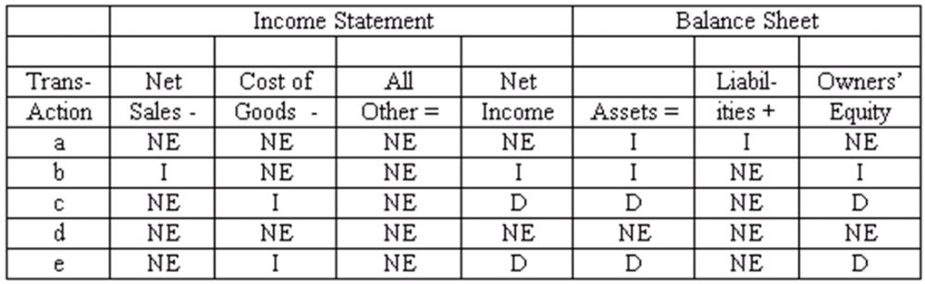

AACSB: Analytic
AICPA BB: Critical Thinking
AICPA FN: Measurement
Bloom's: Understand
Difficulty: Medium
Learning Objective: 06-03 Account for purchases and sales of merchandise in a perpetual inventory system.
Topic: Perpetual Inventory Systems
108. Subsidiary ledgers Listed below are several merchandising transactions of Siegel's Garden Center, a garden supply store.
(a) Purchased merchandise from Bayview Wholesale on account.
(b) Sold merchandise for cash.
(c) Sold merchandise on account to Dom's Landscaping Co.
(d) Paid the account payable to Bayview Wholesale.
(e) Collected the account receivable from Dom's Landscaping Co.
Among the accounting records maintained by Siegel's are subsidiary ledgers for inventory, accounts receivable, and accounts payable.
For each of the five transactions, you are to indicate any subsidiary ledger (or ledgers) to which the transaction would be posted. Use the code:
Inv = Inventory subsidiary ledger
AR = Accounts receivable subsidiary ledger
AP = Accounts payable subsidiary ledger
Also indicate whether each posting causes the balance in the subsidiary ledger account to increase or decrease. Organize your answer in tabular form as illustrated below. The answer for transaction a is provided as an example.
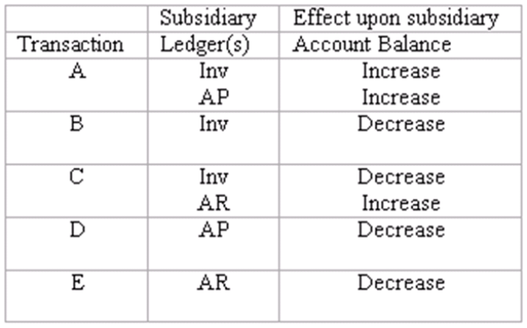

AACSB: Reflective Thinking
AICPA BB: Critical Thinking
AICPA FN: Measurement
Bloom's: Understand
Difficulty: Medium
Learning Objective: 06-02 Understand the components of a merchandising company's income statement.
Topic: Merchandising Companies
109. Perpetual inventory system: basic entries Renato Company uses a perpetual inventory system. A partial chart of accounts is shown below, followed by a series of merchandising transactions. Indicate the accounts that should be debited and credited in recording each transaction. (Ignore sales taxes.)
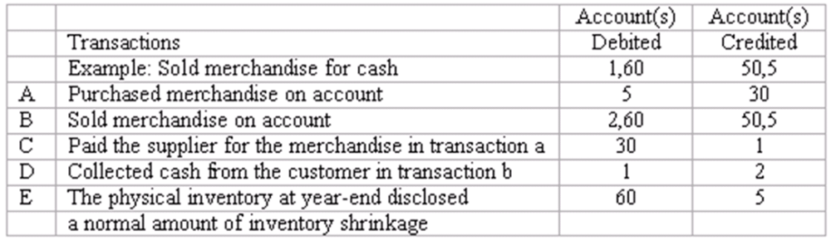

AACSB: Analytic
AICPA BB: Critical Thinking
AICPA FN: Measurement
Bloom's: Apply
Difficulty: Medium
Learning Objective: 06-03 Account for purchases and sales of merchandise in a perpetual inventory system.
Topic: Perpetual Inventory Systems
110. Perpetual inventory system: transactions and closing entries Danny's Wholesale Company uses a perpetual inventory system. A partial chart of accounts is shown below, followed by a series of merchandising transactions. Indicate the accounts that should be debited and credited in recording each transaction. (Ignore sales taxes.)
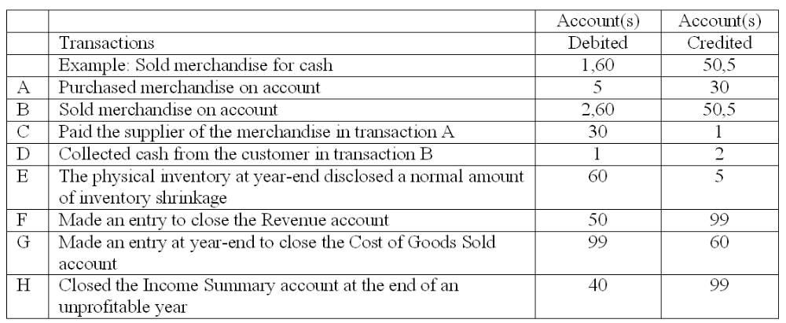

AACSB: Analytic
AICPA BB: Critical Thinking
AICPA FN: Measurement
Bloom's: Apply
Difficulty: Medium
Learning Objective: 06-03 Account for purchases and sales of merchandise in a perpetual inventory system.
Topic: Perpetual Inventory Systems
111. Periodic inventory system Soundview Centre uses a periodic inventory system. At the end of 2010, the accounting records include the following information:
Compute the following for 2010:
(a) Cost of goods sold: $190,200
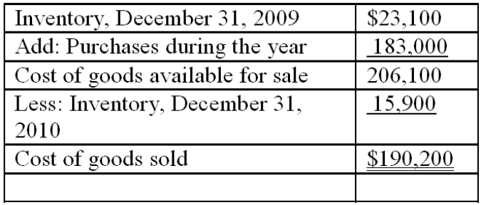
(b) Gross Profit: $127,800
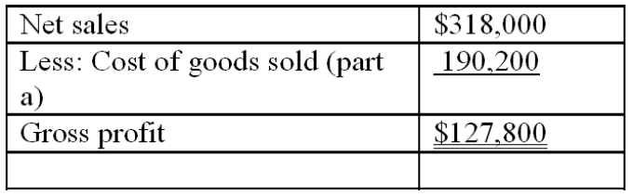

AACSB: Analytic
AICPA BB: Critical Thinking
AICPA FN: Measurement
Bloom's: Apply
Difficulty: Medium
Learning Objective: 06-04 Explain how a periodic inventory system operates.
Topic: Periodic Inventory Systems
112. Periodic inventory system Armstrong Creation uses a periodic inventory system. During the current year, the company purchased merchandise at a cost of $245,000. You are to compute the cost of goods sold under each of the following alternative assumptions:
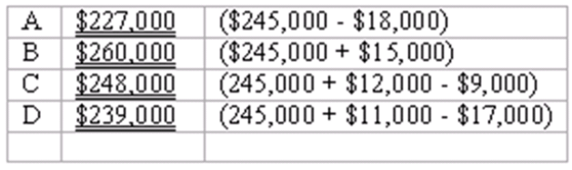

AACSB: Analytic
AICPA BB: Critical Thinking
AICPA FN: Measurement
Bloom's: Apply
Difficulty: Medium
Learning Objective: 06-04 Explain how a periodic inventory system operates.
Topic: Periodic Inventory Systems
113. Gross profit The table below contains information from a recent annual report of Molloy, Inc. (Dollar amounts are stated in millions.) Fill in the missing amounts.
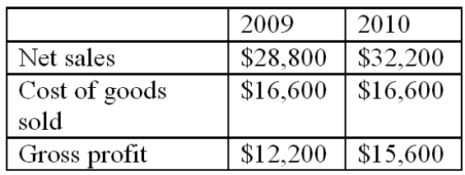

AACSB: Analytic
AICPA BB: Critical Thinking
AICPA FN: Measurement
Bloom's: Analyze
Difficulty: Medium
Learning Objective: 06-02 Understand the components of a merchandising company's income statement.
Topic: Merchandising Companies
114. Gross profit rates a practical application
Note to instructor: The following exercise requires students to use gross profit rates in a manner not specifically illustrated in the chapter. We view this as an exercise in critical thinking and, as such, it is more challenging than the typical exercise. Part d requires an expository answer. Some instructors may choose to omit part d.
Your store sells computers and software. The average computer sells for $1,350, but the customer buying a computer also buys an average of $750 in software. You earn only 10% gross profit rate on sales of computers, but you make a 40% gross profit rate on software. You currently are selling 150 computers per month.
(a) What is the total amount of your monthly gross profit? $________________
(b) To increase sales, you are thinking about selling computers at cost ($1,215.) This would be the "cheapest price in town," and should attract more customers. You expect each customer who buys a computer to also buy $750 worth of software. Under these assumptions, how many computers must you sell each month in order to earn the same amount of gross profit as you are earning now?
(c) Assume that as a result of reducing the sales price of computers to cost ($1,215), you are able to sell 250 computers each month, and that each customer now buys $850 worth of software. What will be the total amount of your monthly gross profit?
(d) Assume that you achieve the results specified in part c (250 sales transactions per month, including an average of $850 in software). Would you consider the policy of selling computers at cost successful or unsuccessful? Explain specifically why this strategy is working out favorably or unfavorably.
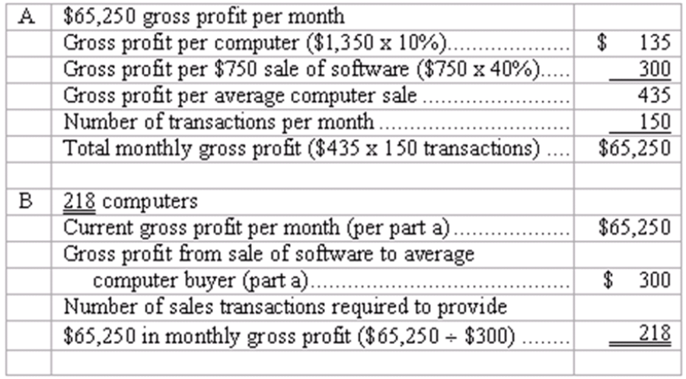
Note to instructor: You may wish to point out that this computation represents an introduction to cost-volume-profit analysis (or break-even analysis). This type of analysis is useful in assessing the potential impact of many proposed marketing strategies. The topic is addressed in depth in the management accounting course.
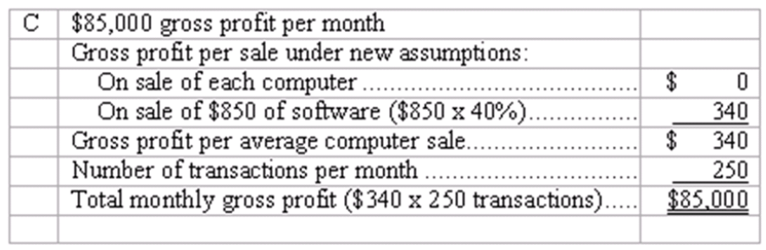
(d) The policy of selling computers at cost appears modestly successful, increasing the monthly gross profit from $65,250 to $85,000. There are two factors leading to the success of this strategy. The first is an increase in sales transactions to 218 computer sales per month instead of 150. But as shown in part b, an increase to 218 sales per month would not in itself make this strategy successful. The reason that total monthly profit margin increased is that the average customer is now buying more software.

AACSB: Analytic
AICPA BB: Critical Thinking
AICPA FN: Decision Making
Bloom's: Analyze
Difficulty: Hard
Learning Objective: 06-08 Measure the performance of a merchandising business.
Topic: Financial Analysis and Decision Making
115. Net sales and gross profit
Mayflower Supply House had gross sales revenue of $1,700,000, cost of goods sold of $950,000, sales returns and allowances of $52,500, and allowed sales discounts of $30,000.
Compute for the year:
(a) Net sales: $1,617,500 = ($1,700,000 - $52,500 - $30,000)
(b) Gross profit: $667,500 = ($1617,500 - $950,000)
(c) Gross profit rate: 41.3% = [$667,500 (part b) ÷ $1,617,500 (part a)]

AACSB: Analytic
AICPA BB: Critical Thinking
AICPA FN: Measurement
Bloom's: Analyze
Difficulty: Medium
Learning Objective: 06-08 Measure the performance of a merchandising business.
Topic: Financial Analysis and Decision Making
116. Journal entries for merchandising transactions Shown below is a partial chart of accounts for Main Street Markets, followed by a series of merchandising transactions. The company uses a perpetual inventory system, records purchases at net cost, and records sales at the full invoice price. Sales taxes are collected on all sales, and the sales tax liability is recorded immediately. Freight charges on inbound shipments are recorded in the Transportation-in account.
Indicate the accounts that should be credited in recording each transaction by placing the appropriate account number(s) in the space provided.
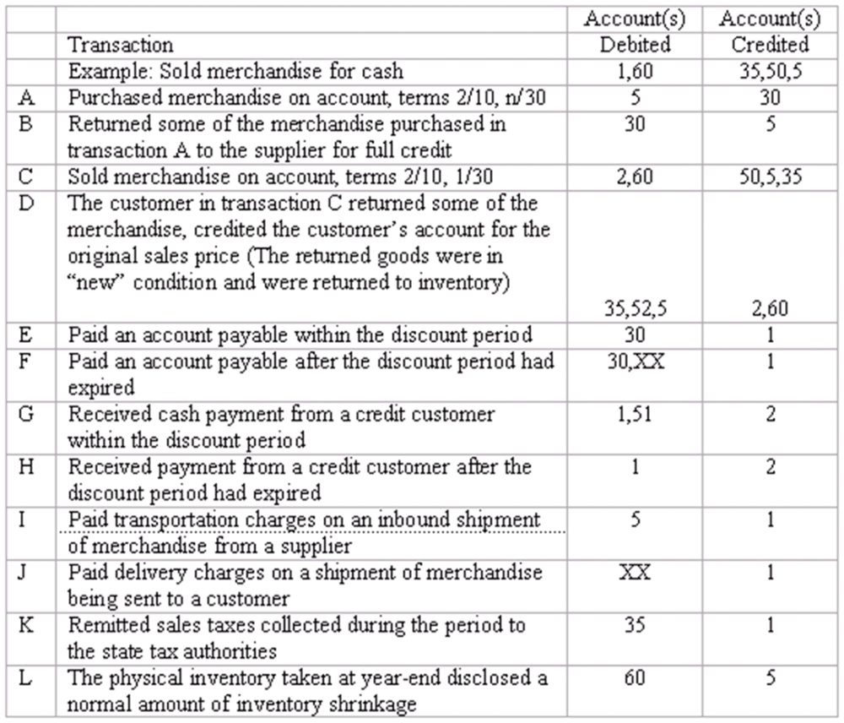

AACSB: Analytic
AICPA BB: Critical Thinking
AICPA FN: Measurement
Bloom's: Apply
Difficulty: Medium
Learning Objective: 06-06 Account for additional merchandising transactions related to purchases and sales.
Topic: Transactions Relating to Purchases and Sales
117. Inventory systems
Briefly distinguish between a perpetual inventory system and a periodic inventory system.
Students' answers should address most of the following points:
In a perpetual inventory system:
Inventory and Cost of Goods Sold accounts are kept continuously up-to-date, reflecting the effects of the merchandising transactions as they occur.
The system requires recording the cost of sales transactions on a timely basis. Often, this is practicable only with a computer-based accounting system.
This method is used by virtually all businesses with extensive interim reporting requirements (publicly owned companies), or which must continuously know the quantities of various types of merchandise on hand.
In a periodic inventory system:
No effort is made to keep the Inventory account up-to-date, or to record the cost of goods sold as sales take place.
The amounts of inventory on hand and the cost of goods sold are not determined until a complete physical inventory is taken, usually only at year-end.
The method is used primarily by small businesses with manual accounting systems, and with few external reporting requirements.

AACSB: Communications
AICPA BB: Critical Thinking
AICPA FN: Decision Making
Bloom's: Understand
Difficulty: Medium
Learning Objective: 06-05 Discuss the factors to be considered in selecting an inventory system.
Topic: Periodic Inventory Systems
118. Inventory systems
Indicate whether you would expect each of the following businesses to maintain a perpetual or a periodic inventory system. Explain the reasoning behind your answers:
(a) A jewelry store.
(b) A roadside vegetable stand.
Students' answers should address most of the following points:
(a) A jewelry store probably would maintain a perpetual inventory system, for the following reasons:
Items have different per-unit costs. Therefore, management needs detailed information about the cost of specific units sold in order to properly measure income.
Because the items are expensive and subject to theft, management needs detailed records of the items in inventory and their cost, to recognize when shrinkage losses occur, to measure such losses, and to support theft-insurance claims.
Because the volume of sales transactions is relatively low, it would not be difficult or costly to maintain a perpetual inventory system.
(b) A roadside vegetable stand probably would maintain a periodic inventory system, for the following reasons:
Management has no need of perpetual inventory records to see what is in stock.
It would be difficult to determine the per unit cost of vegetables, as they probably are purchased in bulk. Also, it would be impractical to record the cost of each sales transaction.
The company does not need an elaborate accounting system; it probably has no external reporting requirements other than income tax returns.

AACSB: Reflective Thinking
AICPA BB: Industry
AICPA FN: Decision Making
Bloom's: Understand
Difficulty: Medium
Learning Objective: 06-05 Discuss the factors to be considered in selecting an inventory system.
Topic: Periodic Inventory Systems
119. Inventory systems
Bookmarks, Inc. sells used books at its store in the resort community of Lake Bryn Mawr. The owner maintains a large inventory of used books purchased from estate sales, flea markets, and customers. During the tourist seasons of summer and winter, the store is exceptionally busy with customers. Each customer usually makes small purchases ranging in amount from one to twenty dollars. What type of inventory system would you recommend to the owner of Bookmarks, Inc.? Explain the reasoning behind your advice.
The owner would be well advised to use a periodic inventory system. Sales during the store's busy seasons are occurring in high volume and are individually of low value. Up-to-date information regarding the cost of goods sold and the value of the existing inventory would not seem to be worth the cost of installing point of sale terminals. A manual perpetual system would impose time costs that would likewise be difficult to justify in terms of the value of the information obtained.

AACSB: Analytic
AICPA BB: Industry
AICPA FN: Decision Making
Bloom's: Understand
Difficulty: Medium
Learning Objective: 06-05 Discuss the factors to be considered in selecting an inventory system.
Topic: Periodic Inventory Systems
120. Subsidiary ledgers Explain the nature of subsidiary ledgers, and give two specific examples. For each of these examples, explain (1) the unit of organization within this ledger, and (2) the usefulness of this ledger in business operations.
Subsidiary ledgers provide detailed information about the individual items that comprise the balance of a general ledger account.
Students are asked to provide two examples of subsidiary ledgers, stating the unit of organization and usefulness of the ledger in business operations. Usually, students select two of the following:
Inventory subsidiary ledger. Organized by type of product. Used to determine quantities of the product currently on hand, quantities sold recently, and recent purchase costs relating to the product.
Accounts receivable subsidiary ledger. Organized by customer (name or account number). Used in billing customers, evaluating the customers' credit history with the business, and in enforcing credit limits.
Accounts payable subsidiary ledger. Organized by creditor. Used in paying creditors and in monitoring the volume of business done with a specific supplier. Of course, students may identify other subsidiary ledgers. Several are described in the text.

AACSB: Communications
AICPA BB: Resource Management
AICPA FN: Measurement
Bloom's: Understand
Difficulty: Medium
Learning Objective: 06-02 Understand the components of a merchandising company's income statement.
Topic: Merchandising Companies
121. Using gross profit rates Explain how the gross profit rate for a particular product is determined. How would you expect the manager of a large department store to use these gross profit rates in deciding which products to feature in the store's window displays and in determining the location of various types of merchandise within the store? Explain.
The gross profit rate of a particular product is determined as follows:
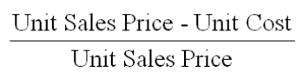
Most businesses seek to maximize sales of those products with the highest gross profit rates (profit margins). Therefore, the store manager wants customers to be aware of these products, and to see them in an appealing setting. The manager logically would feature high-margin products in the window displays. Also, the manager will locate high-margin products where they will be seen by all customers such as on the main floor, near the main entrance. Low-margin items usually are displayed in space off of the main traffic areas, such as the top floor, corners of the store, and the "bargain basement."

AACSB: Communications
AICPA BB: Critical Thinking
AICPA FN: Decision Making
Bloom's: Understand
Difficulty: Medium
Learning Objective: 06-08 Measure the performance of a merchandising business.
Topic: Financial Analysis and Decision Making
122. A customer purchased merchandise for $450 which cost the seller $200. The customer was dissatisfied with some of the goods and thus returned $100 worth and received a cash refund.
(a) What journal entries should the seller make when the merchandise is sold and at the time of the return? Assume that the seller uses a perpetual inventory system.
(b) If the seller uses a periodic inventory system, what entries would be made?
(a.)
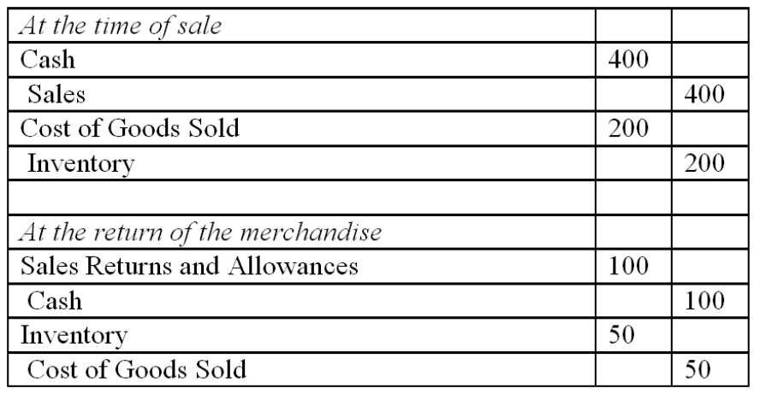
(b.)
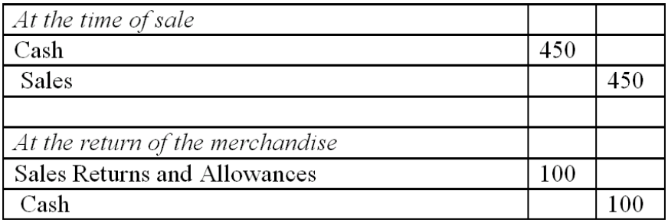

AACSB: Analytic
AICPA BB: Critical Thinking
AICPA FN: Measurement
Bloom's: Apply
Difficulty: Medium
Learning Objective: 06-03 Account for purchases and sales of merchandise in a perpetual inventory system.
Learning Objective: 06-04 Explain how a periodic inventory system operates.
Topic: Periodic Inventory Systems
Topic: Perpetual Inventory Systems
123. Prepare journals entries for the following, assuming the company uses a perpetual inventory method and records purchases at their net amounts.
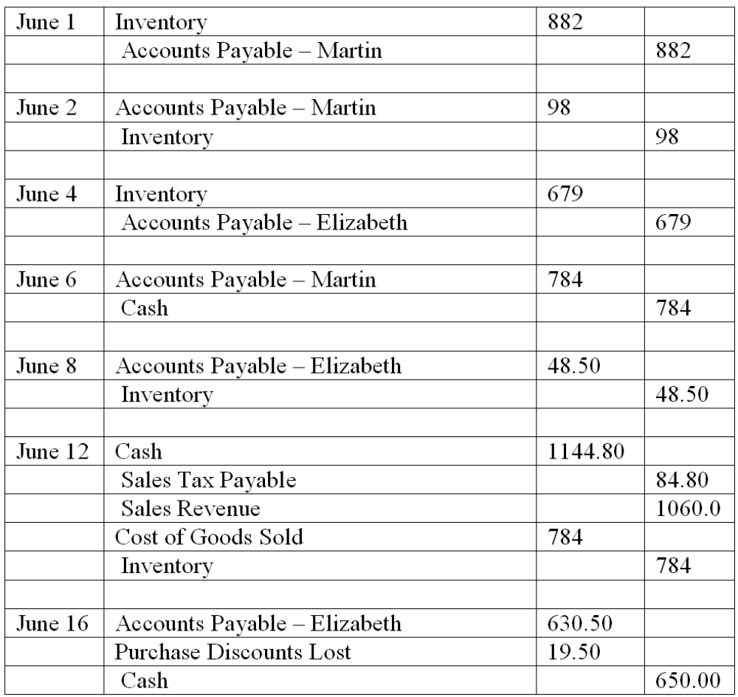

AACSB: Analytic
AICPA BB: Critical Thinking
AICPA FN: Measurement
Bloom's: Apply
Difficulty: Medium
Learning Objective: 06-06 Account for additional merchandising transactions related to purchases and sales.
Topic: Transactions Relating to Purchases and Sales

Multiple Choice Questions
124. Which of the following businesses is most likely to use a periodic inventory system?
A. An aircraft manufacturer.
B. A supermarket that is part of a national chain.
C. An independently owned art gallery with a manual accounting system.
D. A beer bar.

125. A periodic inventory system eliminates the need for:
A. Taking an annual physical inventory.
B. Recording the revenue from sales transactions.
C. Recording the cost of merchandise sold as sales occur.
D. None of the above.

126. If management wants to know the cost and quantity of merchandise on hand at all times, the business will probably:
A. Use a periodic inventory system.
B. Maintain an inventory subsidiary ledger.
C. Take a complete physical inventory each day.
D. Debit all purchases of merchandise directly to the Cost of Goods Sold account.

127. In a perpetual inventory system, the entry to record the cost of goods sold always includes an entry of equal amount to the:
A. Inventory account.
B. Sales account.
C. Purchases account.
D. None of the above.

128. Prior to taking a physical inventory at year-end, the perpetual inventory records of Athena Designs showed an inventory of $26,000, sales of $358,000, and a cost of goods sold of $215,000. The year-end physical inventory indicated merchandise on hand costing $24,000. The company's gross profit for the year was:
A. $334,000.
B. $145,000.
C. $141,000.
D. Some other amount.

At the end of last year, Helen's, Inc. had merchandise costing $115,000 in inventory. During January of the current year, the company purchased merchandise costing $35,000, and sold merchandise which it had purchased at a total cost of $55,000.
Based upon the above information, place the best answer in the space provided. In questions 1 through 3, assume that Helen's uses a perpetual inventory system.

129. The total debited to the Inventory account during January was:
A. $0.
B. $35,000.
C. $55,000.
D. Some other answer.

130. The balance in the Inventory account at January 31 was:
A. $35,000.
B. $205,000.
C. $95,000.
D. Some other answer.

131. The amount of costs transferred from the Inventory account to the Cost of Goods Sold account during January was:
A. $0.
B. $35,000.
C. $55,000.
D. Some other answer.

Assume that Jerome's, Inc. uses a periodic inventory system and takes a physical inventory only at year-end.

132. The total debited to the Inventory account during January was:
A. $0.
B. $35,000.
C. $55,000.
D. Some other answer.

133. The balance in the Inventory account at January 31 was:
A. $0.
B. $105,000.
C. $115,000.
D. Some other answer.

134. The amount of costs transferred from the Inventory account to the Cost of Goods Sold account during January was:
A. $0.
B. $35,000.
C. $55,000.
D. Some other answer.

Essay Questions
135. At the end of last year, Baron's Bazaar had merchandise costing $381,000 in inventory.
During January of the current year, the company purchased merchandise costing $133,500, and sold merchandise which it had purchased at a total cost of $109,300.
a. Assume that Baron's Bazaar uses a perpetual inventory system.
(1) The total amount debited to the Inventory account during January was:
$________________
(2) The balance in the Inventory account at January 31 was:
$________________
(3) The amount of costs transferred from the Inventory account to the Cost of Goods Sold account during January was:
$________________
b. Assume that Baron's Bazaar uses a periodic inventory system and takes a physical inventory only at year-end (December 31). (Note: $0 may be an appropriate answer to one or more of the following questions.)
(1) The total amount debited to the Inventory account during January was:
$________________
(2) The balance in the Inventory account at January 31 was:
$________________
(3) The amount of costs transferred from the Inventory account to the Cost of Goods Sold account during January was:
$________________
a. (1) $133,500 (The merchandise purchases)
(2) $405,200 ($381,000 + $133,500 - $109,300)
(3) $109,300 (The cost of merchandise sold)
b. (1) $-0- (In a periodic system, merchandise purchases are debited to the
Purchases account, not the Inventory account)
(2) $381,000 (The balance at the beginning of the month)
(3) $-0- (In a periodic system, no entries are made to transfer costs as sales occur from the Inventory account to the Cost of Goods Sold account)

Learning Objective: 06-03 Account for purchases and sales of merchandise in a perpetual inventory system.
Learning Objective: 06-04 Explain how a periodic inventory system operates.
136. Phillips Co. is an office supply store. The company uses a perpetual inventory system, records purchases at net cost, and records sales revenue at full invoice price.
Record the following transactions in the company's general journal. To conserve space, you may omit the written explanations which normally should accompany the entries.
July 1 Purchased four Lorac copying machines on account from Lorac Corp. Total invoice price was $2,500 per machine ($10,000 total); terms of 2/10, n/30. These machines are intended for resale.
3 Found one of the Lorac copiers to be defective and returned it to Lorac, thus reducing the amount owed.
9 Sold one of the Lorac copiers to Morris Realty. The sales price was $3,500, terms 5/10, n/60.
10 Paid the remaining amount owned to Lorac Corp., less the allowable discount.
19 Received full payment from Morris, less the allowable discount.
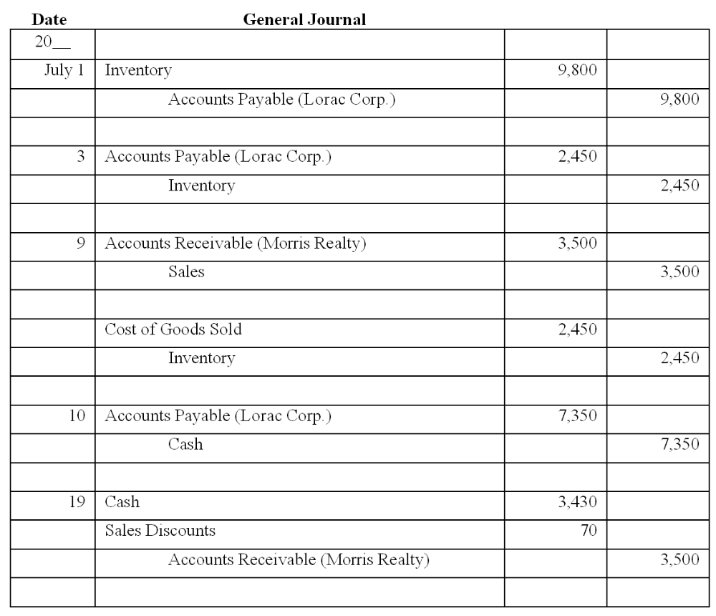

Learning Objective: 06-06 Account for additional merchandising transactions related to purchases and sales.

Multiple Choice Questions
137. Mark and Amanda Carter own an appliance store and a restaurant. The appliance store sells merchandise on a 12-month installment plan; the restaurant sells only for cash. (More than one of the following answers may be correct.)
A. The appliance store has a longer operating cycle than the restaurant.
B. The appliance store probably uses a perpetual inventory system, whereas the restaurant probably uses a periodic system.
C. Both businesses require subsidiary ledgers for accounts receivable and inventory.
D. Both businesses probably have subsidiary ledgers for accounts payable.

138. Which of the following statements about merchandising activities is true? (More than one answer may be correct)
A. As inventory is purchased, the Inventory Expense account is debited and Cash (or Accounts Payable) is credited.
B. Inventory is recorded as an asset when it is first purchased.
C. As inventory is sold, its cost is transferred from the balance sheet to the income statement.
D. As inventory is sold, its cost is transferred from the income statement to the balance sheet.

139. Marietta Corporation uses a perpetual inventory system. All of its sales are made on account. The company sells merchandise costing $3,000 at a sales price of $4,300. In recording this transaction, Marietta will make all of the following entries except:
A. Credit Sales, $4,300.
B. Credit Inventory, $3,000.
C. Debit Cost of Goods Sold, $3,000.
D. Debit one or more accounts in the inventory subsidiary ledger for amounts totaling $3,000.

140. Fashion House uses a perpetual inventory system. At the beginning of the year, inventory amounted to $50,000. During the year, the company purchased merchandise for $230,000, and sold merchandise costing $245,000. A physical inventory taken at year-end indicated shrinkage losses of $4,000. Prior to recording these shrinkage losses, the year-end balance in the company's Inventory account was:
A. $31,000.
B. $35,000.
C. $50,000.
D. Some other amount.

141. Best Hardware uses a periodic inventory system. Its inventory was $38,000 at the beginning of the year, and $40,000 at the end. During the year, Best made purchases of merchandise totaling $107,000. Identify all of the correct answers:
A. To use this system, Best must take a complete physical inventory twice each year.
B. Prior to making adjusting and closing entries at year-end, the balance in Best's Inventory account is $38,000.
C. The cost of goods sold for the year is $109,000.
D. As sales transactions occur, Best makes no entries to update its inventory records or record the cost of goods sold.

142. The two basic approaches to accounting for inventory and the cost of goods sold are the perpetual inventory system and the periodic inventory system. (More than one of the following statements may be correct.)
A. Most large merchandising companies and manufacturing businesses use periodic inventory systems.
B. As a practical matter, a grocery store or a large department store could not maintain a perpetual inventory system without the use of point-of-sale terminals.
C. In a periodic inventory system the cost of goods sold cannot be determined until a complete physical inventory is taken.
D. In a perpetual inventory system, the Cost of Goods Sold account is debited promptly for the cost of merchandise sold.

143. Big Brother, a retail store, purchased 100 television sets from Krueger Electronics on account at a cost of $200 each. Kruger offers credit terms of 2/10, n/30; Big Brother uses a perpetual inventory system and records purchases at net cost. Big Brother determines that 10 of these television sets are defective and returns them to Krueger for full credit. In recording this return, Big Brother will:
A. Debit Sales Returns and Allowances, $1,960.
B. Debit Accounts Payable, $1,960.
C. Debit Cost of Goods Sold, $1,960.
D. Credit Inventory, $2,000.

144. Two of the lawn mowers sold by Garden Products Co. are the Lawn Master and the Mark 5. Lawn Masters sell for $250 apiece, which results in a 35% profit margin. Each Mark 5 costs Garden Products $300 and sells for $400. Indicate all correct answers.
A. The dollar amount of gross profit is greater on the sale of a Mark 5 than a LawnMaster.
B. The gross profit margin is higher on Mark 5s than on LawnMasters.
C. Garden profits relatively more by selling one Mark 5 than one LawnMaster.
D. Garden profits more by selling $2,000 worth of Mark 5s than $2,000 worth of LawnMasters.

