Chapter 05
The Accounting Cycle: Reporting Financial Results

True / False Questions
1. The report form of the balance sheet lists liabilities and owners' equity below assets.
True False

2. A current asset may be cash or must be capable of being converted into cash within a relatively short period of time, usually less than five years.
True False

3. Real accounts can only be closed at the end of the year with a single compound entry.
True False

4. The adjusted trial balance contains income statement accounts and balance sheet accounts, while the after-closing trial balance will only have balance sheet accounts.
True False

5. Measures of profitability tell us how quickly current assets can be converted into profits.
True False

6. The current ratio is a measure of liquidity.
True False

7. The purpose of the after-closing trial balance is to give assurance that the accounts are in balance and ready for the new accounting period.
True False

8. The account, Accumulated Depreciation, is considered a permanent account.
True False

9. The net income percentage can be measured by dividing net income by total revenue.
True False

10. Working capital equals current assets divided by current liabilities.
True False

11. In regard to disclosures that are required to be contained in annual reports, the FASB has no well-defined list of items that must be included.
True False

12. At year-end, all equity accounts must be closed.
True False

13. The income summary account appears, as stated, on the statement of retained earnings.
True False

14. Dividends are closed out directly to retained earnings at year-end.
True False

15. Income summary does not appear on the income statement.
True False

16. Dividends declared are an expense and reduce net income.
True False

17. The current ratio equals current assets plus current liabilities.
True False

18. The return on equity ratio equals net income divided by common stock.
True False

19. Interim financial statements usually report on a period of time greater than one year.
True False

20. Publicly owned companies are typically managed by their stockholders.
True False

21. Financial statements are usually prepared before the closing entries are made.
True False

22. Closing entries do not affect the cash account.
True False

23. Return on equity is a commonly used measure of a company's solvency.
True False

24. The current ratio is a measure of short-term debt paying ability.
True False

25. An after-closing trial balance consists only of asset, liability, and owners' equity accounts.
True False

26. IFRS 1 requires that management and auditors should depart from compliance with GAAP if it is necessary to achieve a fair presentation when reporting financial results.
True False

27. An annual report filed with the Securities and Exchange Commission must include a section called "Management's Predictions of Future Earnings."
True False

Multiple Choice Questions
28. Of the following, which is not an alternative title for the income statement?
A. Earnings statement.
B. Statement of Operations.
C. Profit and Loss Statement.
D. Statement of Financial Position.

29. The Retained Earnings statement is based upon which of the following relationships?
A. Retained Earnings - Net Income - Dividends.
B. Retained Earnings - Net Income + Dividends.
C. Retained Earnings + Net Income + Dividends.
D. Retained Earnings + Net Income - Dividends.

30. In the notes to financial statements, adequate disclosure would typically not include:
A. The accounting methods in use.
B. Lawsuits pending against the business.
C. Due dates of major liabilities.
D. The optimism of the CFO regarding future profits.

31. A worksheet consists of all of the following except:
A. A trial balance.
B. Adjusting entries.
C. An adjusted trial balance.
D. Transaction entries.

32. Closing entries would be prepared before:
A. Financial statements are prepared.
B. A post-closing trial balance.
C. An adjusted trial balance.
D. Adjusting entries.

33. When a worksheet is prepared, which account would not be entered into the income statement columns?
A. Depreciation Expense.
B. Unearned Revenue.
C. Service Revenue.
D. Prepaid Insurance.

34. The closing entry for an expense account would consist of a:
A. Debit to Income Summary and a credit to the expense account.
B. Debit to the expense account and a credit to Income Summary.
C. Credit to Retained Earnings and a debit to the expense account.
D. Credit to Revenue and a debit to the expense account.

35. The income summary account has debits of $85,000 and credits of $75,000. The company had which of the following:
A. Net income of $10,000.
B. Net income of $160,000.
C. Net loss of $10,000.
D. Net loss of $160,000.

36. What types of information must be disclosed in the financial statements?
A. The comprehensive list issued by the FASB.
B. Only information that is determined by management.
C. Non-financial information that is not included in the basic financial statements.
D. Ratio analysis.

37. Dividends declared:
A. Reduce retained earnings.
B. Increase retained earnings.
C. Reduce net income.
D. Increase net income.

38. During the closing process:
A. All income statement accounts are credited to income summary.
B. All income statement accounts are debited to income summary.
C. All revenue accounts are credited and expense accounts are debited.
D. All revenue accounts are debited and expense accounts are credited.

39. A debit balance in the income summary account indicates:
A. An error was made.
B. A Net Profit.
C. A Net Loss.
D. That revenues were greater than expenses.

40. The dividends account should be:
A. Closed to income summary.
B. Closed to retained earnings.
C. Closed only if there is a profit.
D. Not closed at all.

41. Which account will appear on an after-closing trial balance?
A. Dividends.
B. Prepaid Expenses.
C. Retained Earnings, at the beginning of the period.
D. Sales.

42. Which account will not appear on an after-closing trial balance?
A. Dividends.
B. Prepaid Expenses.
C. Unearned Revenue.
D. Retained Earnings, at the end of the period.

43. The section of the annual report titled "Management Discussion and Analysis" is:
A. Required by the SEC.
B. Not required but may be included by management.
C. Required by GAAP.
D. Reported to the SEC but not included in the annual report.

44. Return on equity measures:
A. Solvency.
B. Profitability.
C. Leverage.
D. All three of the above.

45. Publicly owned companies are:
A. Managed and owned by the government.
B. Must be not-for-profit companies.
C. Usually listed on a stock exchange.
D. Not permitted to be owned by individuals.

46. The worksheet:
A. Is one of the basic financial statements.
B. Is prepared throughout the year.
C. Is not a formal step in the accounting cycle.
D. Starts with the first column being the adjusted trial balance.

47. If Income Summary has a net credit balance, it signifies:
A. A net loss.
B. Net income.
C. A reduction of net worth.
D. Dividends have been declared.

48. The balance in Income Summary:
A. Should equal retained earnings.
B. Will always be equal to the increase in retained earnings.
C. Will equal net income less dividends.
D. Will equal net income or net loss.

49. After preparing the financial statements for the current year, the accountant for Exquisite Gems closed the Dividends account at year-end by debiting Income Summary and crediting the Dividends account. What is the effect of this entry on current-year net income and the balance in the Retained Earnings account at year-end?
A. Net income is overstated and the balance in the Retained Earnings account is correct.
B. Net income is correct and the balance in the Retained Earnings account is overstated.
C. Net income is understated and the balance in the Retained Earnings account is understated.
D. Net income is understated and the balance in the Retained Earnings account is overstated.

50. The concept of adequate disclosure:
A. Does not apply to information which is immaterial.
B. Grants users of the financial statements access to a company's accounting records.
C. Does not apply to events occurring after the balance sheet date.
D. Specifies which accounting methods must be used in a company's financial statements.

51. The concept of adequate disclosure requires a company to inform financial statement users of each of the following, except:
A. The accounting methods in use.
B. The due dates of major liabilities.
C. Destruction of a large portion of the company's inventory on January 20, three weeks after the balance sheet date, but prior to issuance of the financial statements.
D. Income projections for the next five years based upon anticipated market share of a new product; the new product was introduced a few days before the balance sheet date.

52. Income Summary appears on which financial statement:
A. Income statement.
B. Balance sheet.
C. Retained Earnings statement.
D. Income summary does not appear on any financial statement.

53. Retained Earnings at the end of a period:
A. Is equal to the balance in the Retained Earnings account in the adjusted trial balance at the end of a period.
B. Is determined in the statement of Retained Earnings.
C. Is equal to Retained Earnings at the beginning of the period, minus net income (or plus net loss) for the period.
D. Appears in the income statement for the period.

54. A statement of retained earnings shows:
A. The changes in the Cash account occurring during the accounting period.
B. The revenue, expense, and dividends of the period.
C. The types of assets which have been purchased with the earnings retained during the accounting period.
D. The changes in the Retained Earnings account occurring during the accounting period.

55. The normal order in which the financial statements are prepared is:
A. Balance sheet, income statement, statement of retained earnings.
B. Income statement, statement of retained earnings, balance sheet.
C. Income tax return, income statement, balance sheet.
D. Income statement, statement of cash flows, balance sheet.

56. The purpose of making closing entries is to:
A. Prepare revenue and expense accounts for the recording of the next period's revenue and expenses.
B. Enable the accountant to prepare financial statements at the end of the accounting period.
C. Establish new balances in the balance sheet accounts.
D. Reduce the number of expense accounts.

57. When closing the accounts at the end of the period, which of the following is closed directly into the Retained Earnings account?
A. Depreciation Expense.
B. Accumulated Depreciation.
C. Revenue and liability accounts.
D. The Income Summary account.

58. Publicly traded companies must file audited financial statements with the:
A. AICPA.
B. IRS.
C. SEC.
D. AAA.

59. Closing entries never involve posting a credit to the:
A. Income Summary account.
B. Accumulated Depreciation account.
C. Dividends.
D. Depreciation Expense account.

60. Which of the following account titles would not be debited in the process of preparing closing entries for Andrew's Auto Shop?
A. Income Summary.
B. Fees Earned.
C. Dividends.
D. Retained Earnings.

61. If a business closes its accounts only at year-end:
A. Financial statements are prepared only at year-end.
B. Adjusting entries are made only at year-end.
C. Revenue and expense accounts reflect year-to-date amounts throughout the year.
D. Monthly and quarterly financial statements cannot be prepared.

62. Assets are considered current assets if they are cash or will usually be converted into cash:
A. Within a month or less.
B. Within 3 months.
C. Within a year or less.
D. Within 6 months or less.

63. Which of the following amounts appears in both the Income Statement debit column and the Balance Sheet credit column of a worksheet?
A. Net income.
B. Net loss.
C. Dividends.
D. Retained earnings.

64. A worksheet should be viewed as:
A. A financial statement to be distributed to investors.
B. A financial statement to assist managers in making managerial decisions.
C. A tool to assist accountants in making end-of-period adjustments and in preparing financial statements.
D. A tool to assist auditors in determining that all transactions have been properly recorded throughout the period.

65. The amount of net income (or loss) will appear on the debit side of the Income Statement columns in a worksheet if:
A. Revenue exceeds total expenses for the period.
B. The trial balance is out of balance.
C. Dividends are more than the income or loss for the period.
D. There is a net loss for the period.

66. Return on equity is calculated by:
A. Dividing net income by total revenue.
B. Dividing net income by average stockholders' equity.
C. Dividing net income by working capital.
D. Dividing dividends by stockholders' equity.

67. Which of the following is true regarding a worksheet prepared at year-end?
A. The number of account titles applicable to the Adjusted Trial Balance columns is usually greater than the number of account titles applicable to the Trial Balance columns.
B. The worksheet can be issued instead of financial statements.
C. The worksheet eliminates the need to make adjusting and closing entries.
D. An equal number of account titles are applicable to the Income Statement columns and the Balance Sheet columns.

68. Interim financial statements:
A. Cover a period less than one year.
B. Cover only periods of a quarter of a year.
C. Cover periods greater than a year.
D. Cannot cover a period of one month or less.

69. When a worksheet is used:
A. Adjusting entries are not prepared, since adjustments are shown on the worksheet.
B. Revenue and expense accounts do not have to be closed to the Income Summary account, because the income statement is prepared from the worksheet and net income is already computed.
C. Financial statements may be prepared before recording adjusting and closing entries in the accounting records.
D. The Income Statement column and Balance Sheet column of the worksheet eliminate the need to prepare formal financial statements for a business.

70. Preparation of interim financial statements:
A. Makes the preparation of year-end financial statements unnecessary.
B. Requires the journalizing and posting of adjusting entries.
C. Requires the journalizing and posting of closing entries.
D. Is done monthly or quarterly, in-between the year-end financial statements.

71. If monthly financial statements are desired by management:
A. Journalizing and posting adjusting entries must be done each month.
B. Journalizing and posting closing entries must be done each month.
C. Monthly financial statements can be prepared from worksheets; adjustments and closing entries need not be entered in the accounting records.
D. Adjusting and closing entries must be entered in the accounting records before preparation of interim financial statements.

72. Declaring a dividend will:
A. Increase net income.
B. Decrease net income.
C. Not change net income.
D. Increase the net worth of a company.

73. Dividends will have what effect upon retained earnings?
A. Increase.
B. Decrease.
C. No effect.
D. Depends upon if there is income or loss.

74. Which of the following accounts will be closed to Income Summary?
A. Prepaid Expenses.
B. Unearned Revenue.
C. Dividends.
D. Earned Revenue.

75. Net income from the Income Statement appears on:
A. The Balance Sheet.
B. The Retained Earnings Statement.
C. Neither the Balance Sheet nor the Retained Earnings Statement.
D. Both the Balance Sheet and the Retained Earnings Statement.

76. Which statement is true regarding the Income Statement?
A. Losses do not appear on income statements.
B. Dividends reduce net income.
C. Dividends declared increase net income.
D. Both losses and gains appear on an income statement.

77. Under the Sarbanes-Oxley Act, CFOs and high-ranking corporate officers are now:
A. Personally responsible for the integrity of annual reports.
B. Subject of fines of up to $5 million for knowingly making false statements.
C. Facing prison sentences of up to 20 years for knowingly making false statements.
D. All of the above.

78. Closing entries should be made:
A. Every year.
B. Only when an entity goes out of business.
C. Only if there is a profit.
D. Only if there is a loss.

79. Which accounts should not be closed?
A. Expenses and revenues.
B. Dividends.
C. Income summary.
D. Accumulated depreciation.

80. Which account appears on the After-Closing Trial Balance?
A. Service Revenue.
B. Unearned Revenue.
C. Dividends.
D. Retained Earnings, Beginning of Year.

81. If sales are $270,000, expenses are $220,000 and dividends are $30,000, Income Summary:
A. Will have a credit balance of $50,000.
B. Will have a debit balance of $50,000.
C. Will have a debit balance of $20,000.
D. Will have a credit balance of $20,000.

82. If current assets are $90,000 and current liabilities are $70,000, the current ratio will be:
A. 77%.
B. $20,000.
C. 1.3.
D. $160,000.

83. If current assets are $110,000 and current liabilities are $50,000, working capital will be:
A. 45.5%.
B. 2:2.
C. $60,000.
D. $160,000.

84. The following information is available:
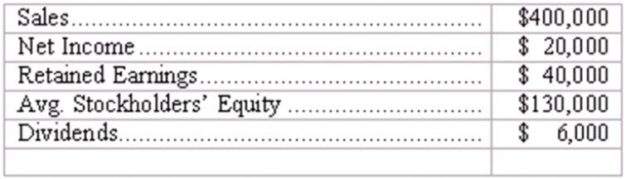
What is the return on equity? (round to the nearest number)
A. 5%.
B. 20%.
C. 25%.
D. 15%.

85. Only two adjustments appear in the adjustments column of a worksheet for Wycliff Publications: one to record $800 depreciation of office equipment and the other to record the use of $560 of office supplies. If the Trial Balance column totals are $15,380, what are the totals of the Adjusted Trial Balance columns?
A. $16,740.
B. $15,140.
C. $16,180.
D. $15,860.

86. The December 31, 2010 worksheet for Fran's Fine Dining showed the following amounts related to the Supplies Expense account:
(a). In the Trial Balance debit column: $745
(b). In the Adjustments debit column: $125
(c). In the Adjusted Trial Balance debit column: $870
What is the proper balance in the Supplies Expense account on January 1, 2011, after all closing entries for 2010 have been posted, but before any 2011 transactions are recorded?
A. $870.
B. $745.
C. $0.
D. $125.

Shown below is a trial balance for Novelty Toys, Inc., on December 31, after adjusting entries:
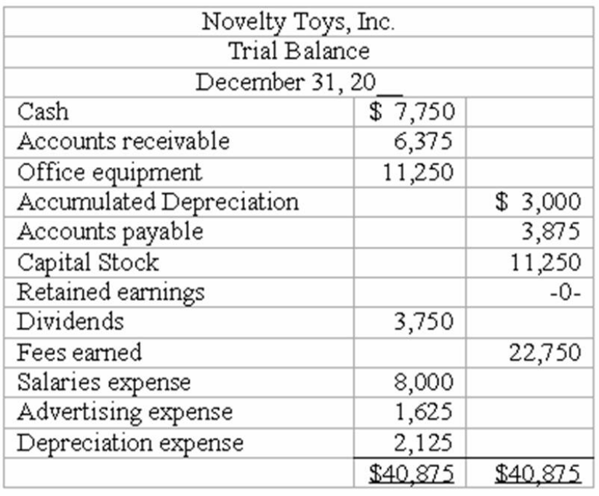

87. Refer to the information above. The entry to close the Fees earned account will:
A. Produce a zero balance in that account when posted.
B. Include a debit to Income Summary.
C. Include a credit to Fees Earned.
D. Include a debit to Capital Stock.

88. Refer to the information above. The entry to close Salaries expense account will:
A. Produce a zero balance in that account when posted.
B. Include a credit to Income Summary.
C. Include a debit to Salaries Expense.
D. Include a credit to Capital Stock.

89. Refer to the information above. Net income for the period equals:
A. $18,375.
B. $11,000.
C. $5,800.
D. $11,250.

90. Refer to the information above. After closing the accounts, Retained earnings at December 31 equals:
A. $11,000.
B. $7,250.
C. Zero.
D. $22,250.

91. Refer to the information above. The total debits in the After-Closing Trial Balance will equal:
A. $25,375.
B. $29,125.
C. $40,875.
D. $18,125.

92. Refer to the information above. Income Summary will have what balance before it is closed?
A. Zero.
B. $11,750.
C. $7,250.
D. $11,000.

Shown below is the adjusted Trial Balance for Simon Inc., on December 31, after the first year of operations, after adjusting entries:
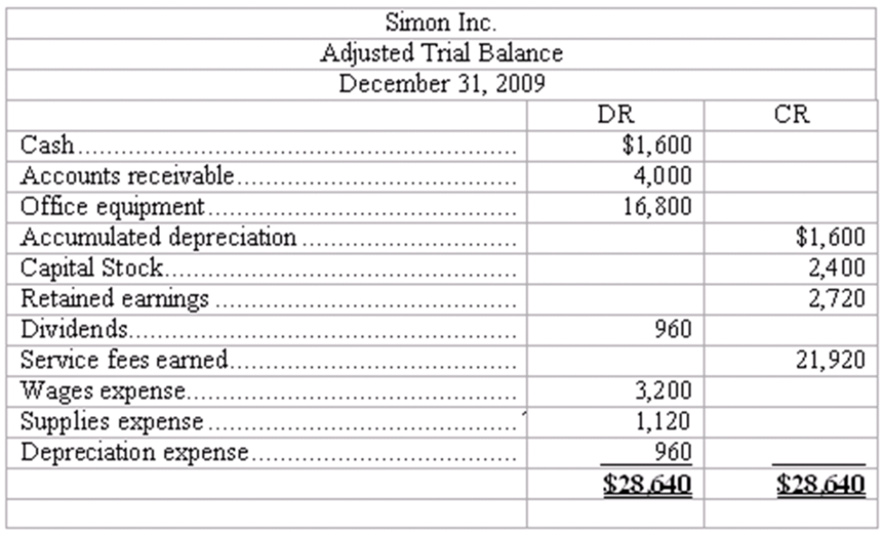

93. Refer to the information above. The entry to close the Service fees earned account will:
A. Produce a zero balance in that account when posted.
B. Include a debit to Income Summary.
C. Include a credit to Service Fees Earned.
D. Include a debit to Capital Stock.

94. Refer to the information above. The entry to close Depreciation expense account will:
A. Produce a zero balance in that account when posted.
B. Include a credit to Income Summary.
C. Include a debit to Depreciation Expense.
D. Include a credit to Capital Stock.

95. Refer to the information above. Net income for the period equals:
A. $20,960.
B. $16,640.
C. $21,920.
D. $23,360.

96. Refer to the information above. After closing the accounts, Retained earnings at December 31 equals:
A. Zero.
B. $18,400.
C. $19,360.
D. $16,640.

97. Refer to the information above. The total debits in the After Closing-Trial Balance will equal:
A. $23,360.
B. $28,640.
C. $22,400.
D. $6,720.

98. Refer to the information above. Income Summary will have what balance before it is closed?
A. $28,640.
B. $15,600.
C. $21,920.
D. $16,640.

99. If sales are $540,000, expenses are $440,000 and dividends are $50,000, Income Summary:
A. Will have a credit balance of $50,000.
B. Will have a debit balance of $50,000.
C. Will have a debit balance of $100,000.
D. Will have a credit balance of $100,000.

100. If current assets are $180,000 and current liabilities are $130,000, the current ratio will be:
A. 72%.
B. $50,000.
C. 1.4.
D. $310,000.

101. If current assets are $180,000 and current liabilities are $130,000, working capital will be:
A. 72%.
B. $50,000.
C. 1.4.
D. $310,000.

102. The following information is available:
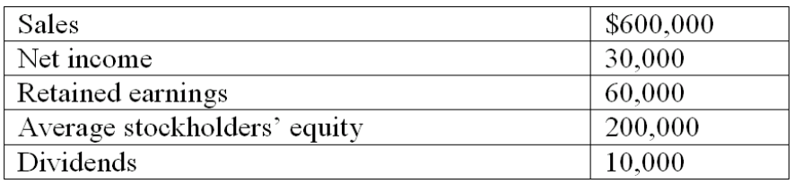
What is the return on equity? (round to the nearest number)
A. 5%.
B. 15%.
C. 20%.
D. 25%.

103. The following information is available:
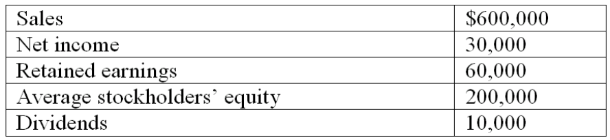
What is the net income percentage? (round to the nearest number)
A. 5%.
B. 15%.
C. 20%.
D. 25%.

104. Only two adjustments appear in the adjustments column of a worksheet for Winona Mfg: one to record $8,000 depreciation of factory equipment, and the other to record the use of $1,500 of prepaid insurance. If the Trial Balance column totals are $145,380, what are the totals of the Adjusted Trial Balance columns?
A. $145,380.
B. $153,380.
C. $152,880.
D. $154,880.

105. The December 31, 2011 worksheet for Albertville Grill showed the following amounts related to the Depreciation Expense account:
(a). In the Trial Balance debit column: $1,745
(b). In the Adjustments debit column: $1,125
(c). In the Adjusted Trial Balance debit column: $1,870
What is the proper balance in the Depreciation Expense account on January 1, 2012, after all closing entries for 2011 have been posted, but before any 2012 transactions are recorded?
A. $1,870.
B. $1,745.
C. $0.
D. $1,125.

Shown below is a trial balance for Cornell Products, Inc., on December 31, after adjusting entries:
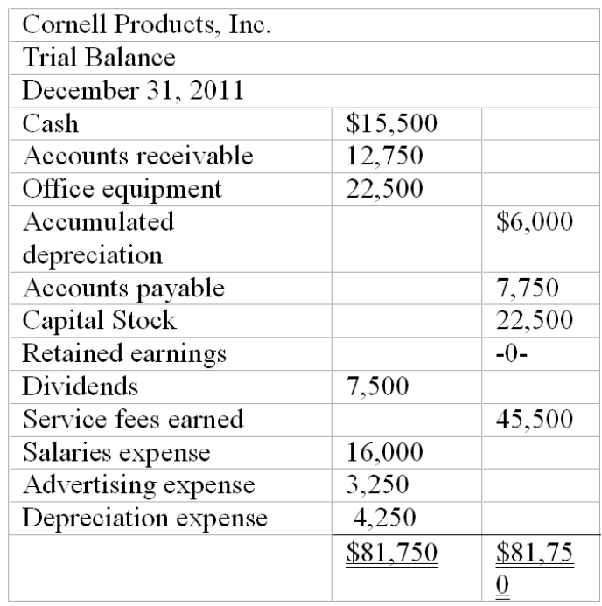

106. Refer to the information above. Net income for the period equals:
A. $11,600.
B. $22,000.
C. $22,500.
D. $36,750.

107. Refer to the information above. After closing the accounts, Retained earnings at December 31 equals:
A. zero.
B. $14,500.
C. $22,000.
D. $22,500.

108. Refer to the information above. The total debits in the After-Closing Trial Balance will equal:
A. $23,500.
B. $31,000.
C. $50,750.
D. $58,250.

Essay Questions
109. Accounting terminology
Listed below are eight technical accounting terms emphasized in this chapter:
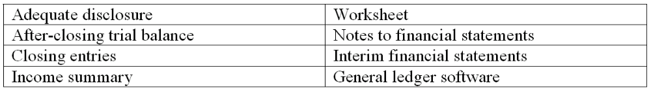
In the space provided for each statement, indicate the accounting term described.
____ a. The generally accepted accounting principle of providing with financial statements any information that users need to interpret those statements properly.
____ b. A trial balance prepared after all closing entries have been posted. This trial balance consists only of accounts for assets, liabilities, and owners' equity.
____ c. Journal entries made at the end of the period for the purpose of closing temporary accounts (revenue, expense, and dividend accounts) and transferring balances to the Retained Earnings account.
____ d. Computer software used for recording transactions, maintaining journals and ledgers, and preparing financial statements. Also includes spreadsheet capabilities for showing the effects of proposed adjusting entries or transactions on the financial statements without actually recording these entries in the accounting records.
____ e. The summary account in the ledger to which revenue and expense accounts are closed at the end of the period. The balance (credit balance for a net income, debit balance for a net loss) is transferred to the Retained Earnings account.
____ f. Financial statements prepared for periods of less than one year (includes monthly and quarterly statements).
____ g Supplemental disclosures that accompany financial statements. These notes provide users with various types of information considered necessary for the proper interpretation of the statements.
____ h. A multicolumn schedule showing the relationships among the current account balances (a trial balance), proposed or actual adjusting entries or transactions, and the financial statements that would result if these adjusting entries or transactions were recorded. Used both at the end of the accounting period as an aid to preparing financial statements and for planning purposes.

110. Inserting missing data into a worksheet
Certain data are given on the worksheet below, and certain missing data are indicated by the blank lines. Sufficient information is included to fill in the missing data. Each account has a debit or credit balance characteristically normal for that kind of account. Note that the dollar amounts have been reduced to figures of not more than three digits to simplify the arithmetic. Insert the figures necessary to complete the worksheet in the blanks indicated by an underline. The lines cover both debit and credit columns; be sure to insert the missing figures in the correct column of the blank line. If no figure should appear in a column within a line, indicate this by placing a "0" in one or more columns with a blank line (see sample box opposite Cash).
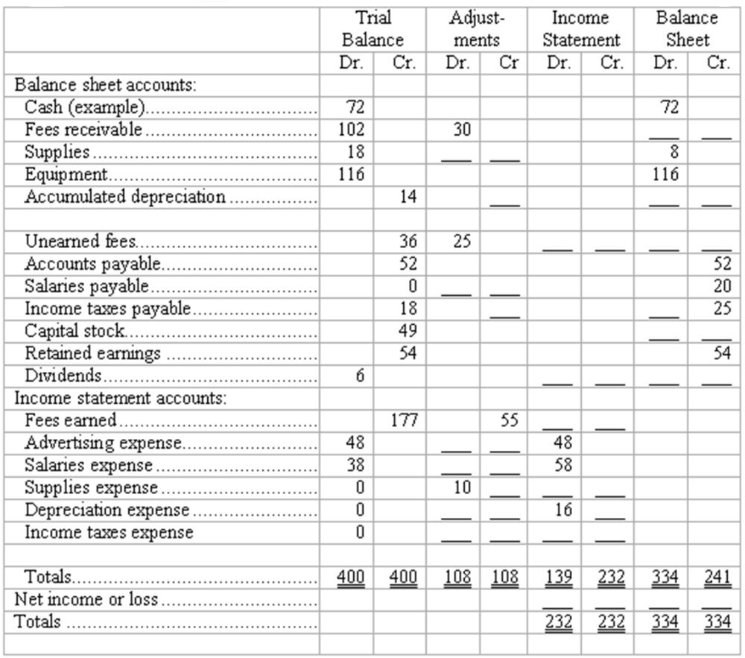

111. Preparation of financial statements
Using the Adjusted Trial Balance shown below, prepare (a) an Income Statement and (b) a Statement of Retained Earnings for All Star Repairs.
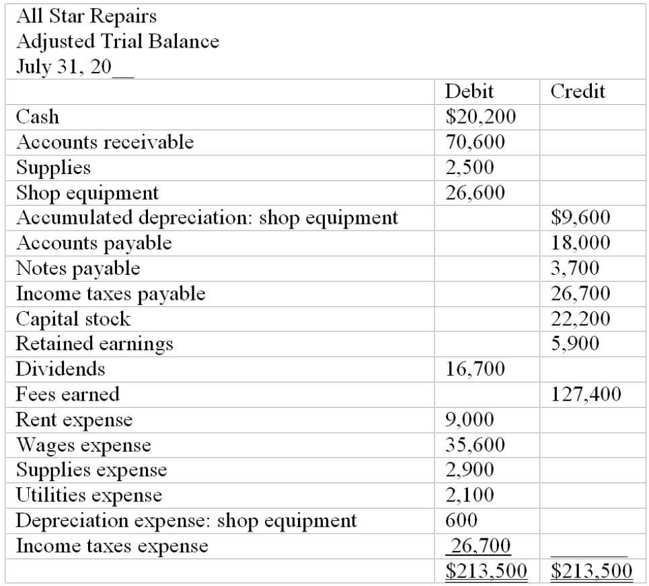
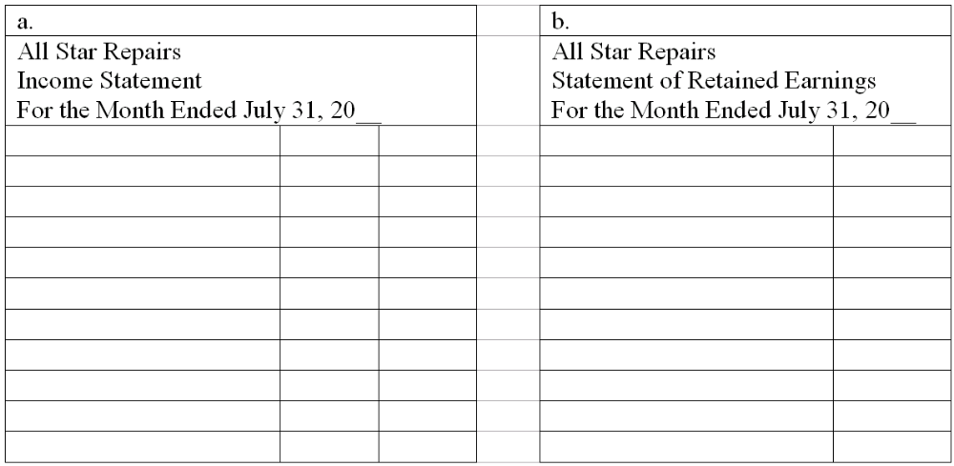
112. Completion of worksheet--missing data
Certain data are given on the worksheet below, and certain missing data are indicated by the blank boxes. Sufficient information is included to fill in the missing data. Each account has a debit or credit balance characteristically normal for that kind of account. Note that the dollar amounts have been reduced to figures of not more than three digits to simplify the arithmetic.
Insert the figures necessary to complete the worksheet in the blanks indicated by an underline. The boxes cover both debit and credit columns; be sure to insert the missing figures in the correct column of the box. If no figure should appear in a column within a box, indicate this by placing a "0" in one or more columns of the box (see sample box opposite Cash).
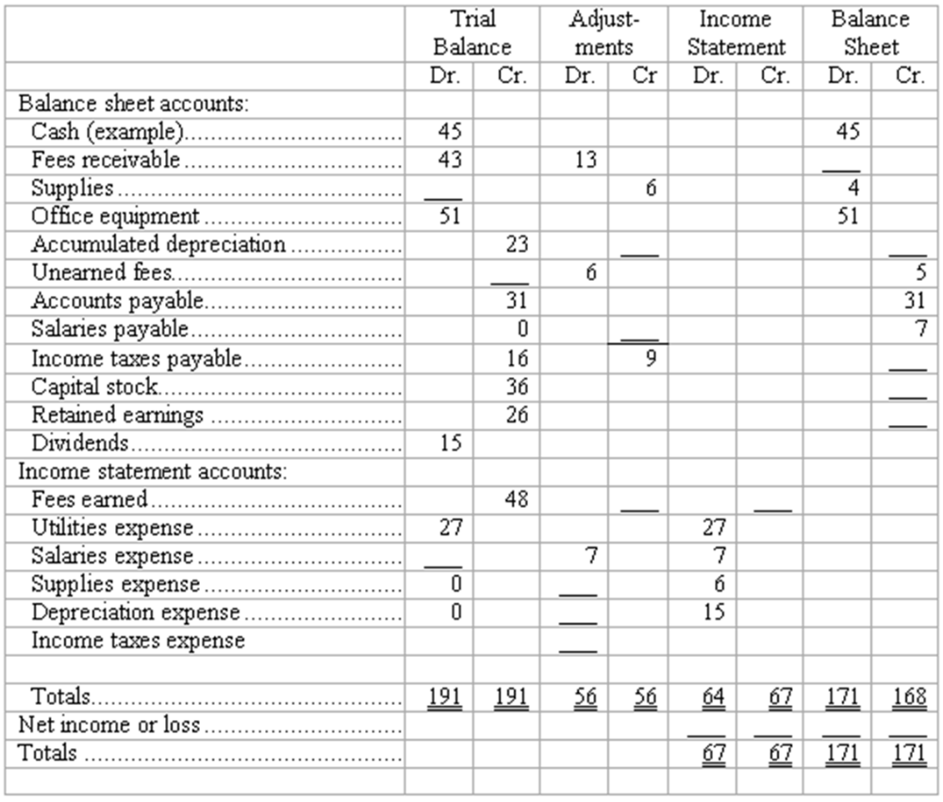

113. Closing entries
An Adjusted Trial Balance for Tiger, Inc., at December 31 appears below.
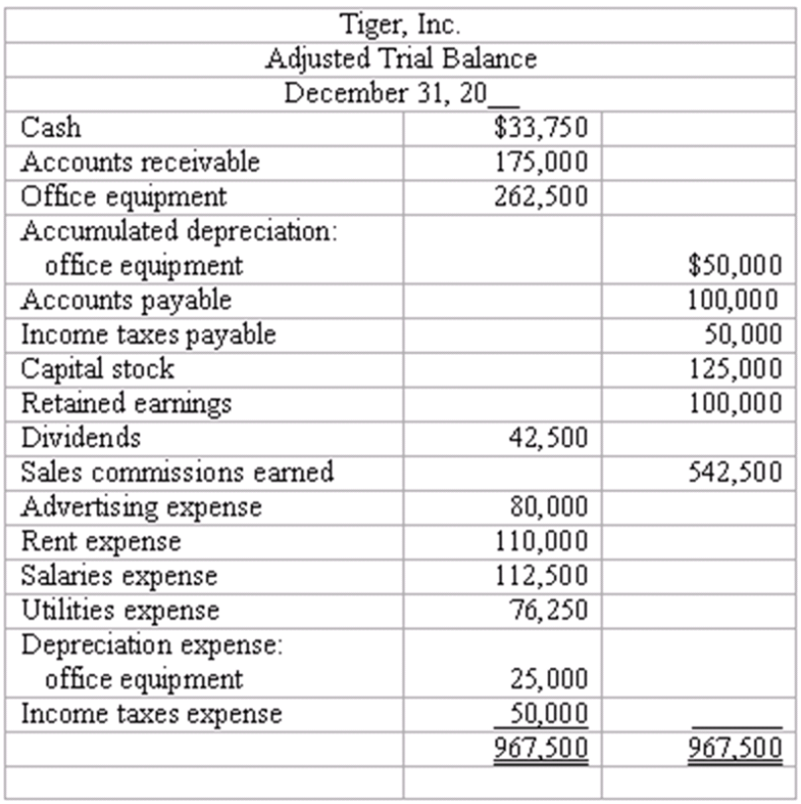
Prepare journal entries to close the accounts. Use four entries to: (1) close the revenue account, (2) close the expense accounts, (3) close the Income Summary account, and (4) close the Dividends account.
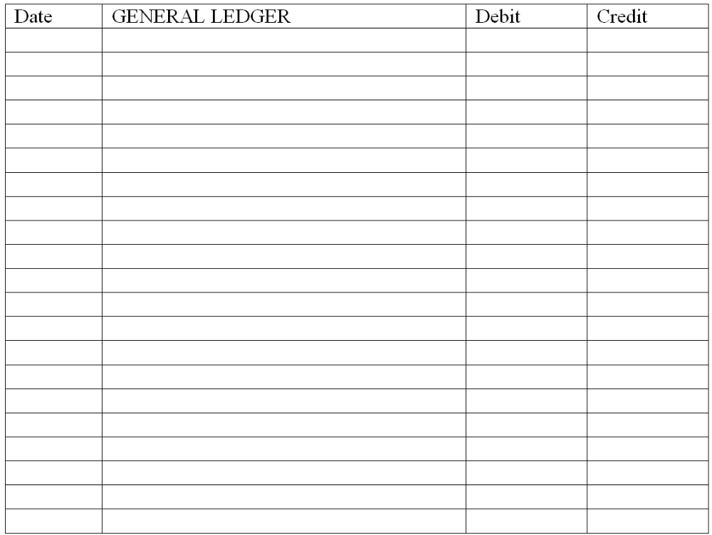

114. Adjustments and closing process--basic entries
Selected ledger accounts used by Goldstone Advertising, Inc., are listed along with identifying numbers. Following this list of account numbers and titles is a series of transactions. For each transaction, you are to indicate the proper accounts to be debited and credited.
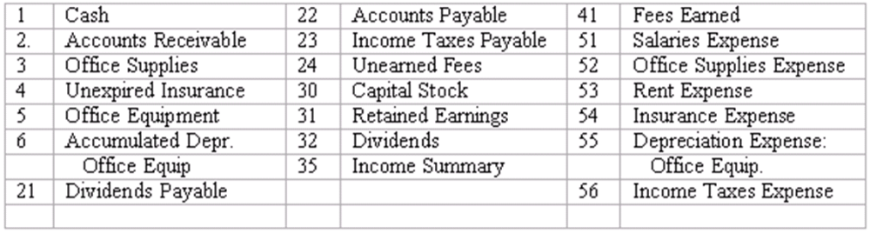
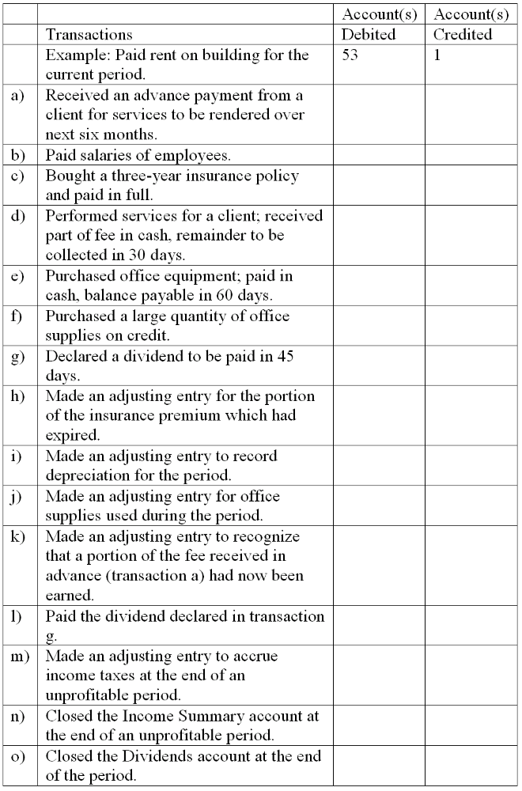

115. Adjustments and closing process-basic entries
Selected ledger accounts used by Speedy Truck Rentals, Inc., are listed along with identifying numbers. Following this list of account numbers and titles is a series of transactions. For each transaction, you are to indicate the proper accounts to be debited and credited.
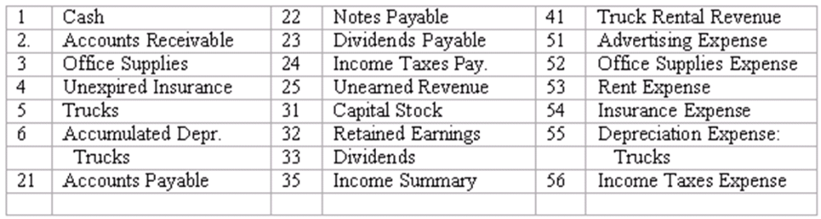
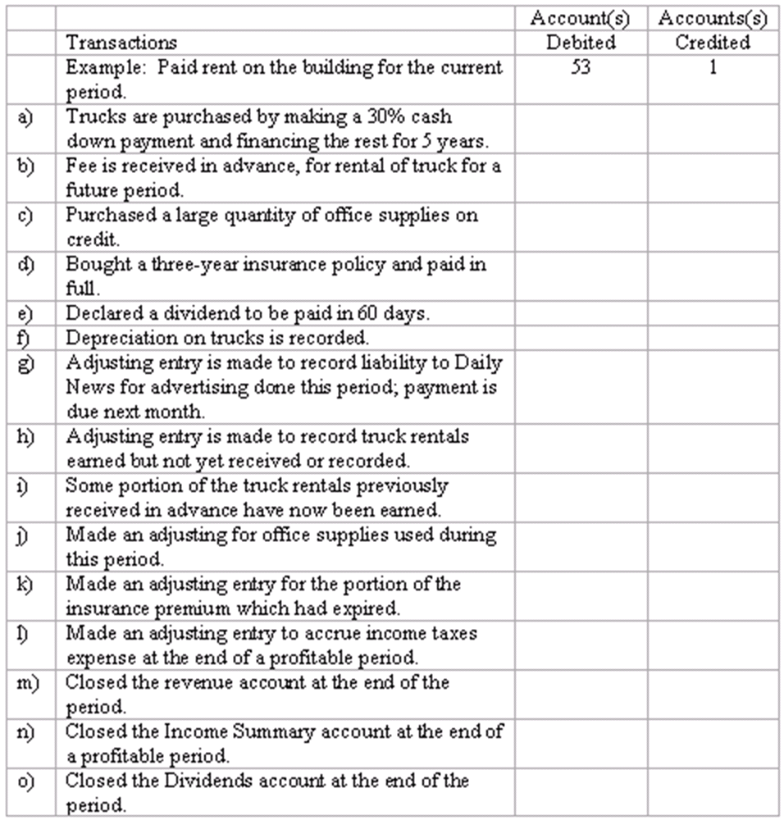

116. Materiality
(a) Identify several factors considered by an accountant in deciding whether an item is "material."
(b) Does the concept of materiality complicate or simplify the process of making adjusting entries? Give an illustration to support your answer.

117. Adequate disclosure
(a) Briefly explain what is meant by the principle of adequate disclosure.
(b) How does professional judgment enter into the application of the principle of adequate disclosure?
(c) List 5 types of information that a publicly-held corporation generally would be required to provide according to the concept of adequate disclosure.

118. Indicate which of the following accounts will be closed to Income Summary at year-end.
(a) Cash
(b) Office Supplies Expense
(c) Unexpired Insurance
(d) Unearned Revenue
(e) Dividends
(f) Depreciation Expense
(g) Income Taxes Payable
(h) Accumulated Depreciation

119. Given the following information for the Maple Tree Co. for the year ended December 31, 2009, prepare a Statement of Retained Earnings.
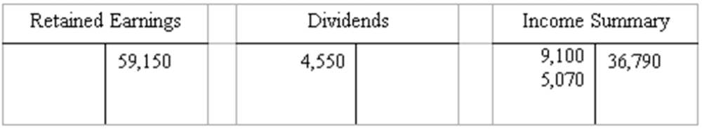

120. The accounts and their amounts for Belgrave Co. at December 31, 20__ are listed below. Prepare closing entries and an After-Closing Trial Balance.
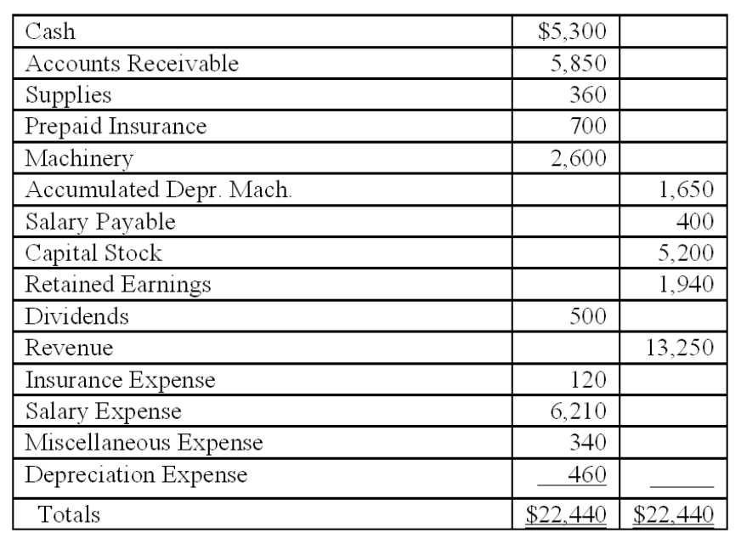

Short Answer Questions
121. The accountant for Sheldrake Consulting prepared the following "Adjusted" Trial Balance at December 31, 2011, after one year of operations:
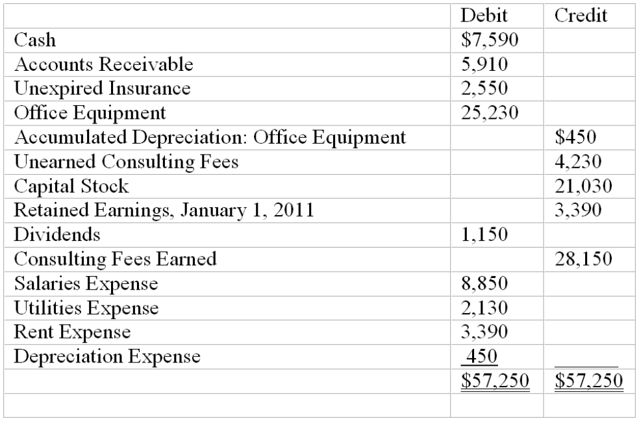
Prepare closing entries for Sheldrake Consulting.

Multiple Choice Questions
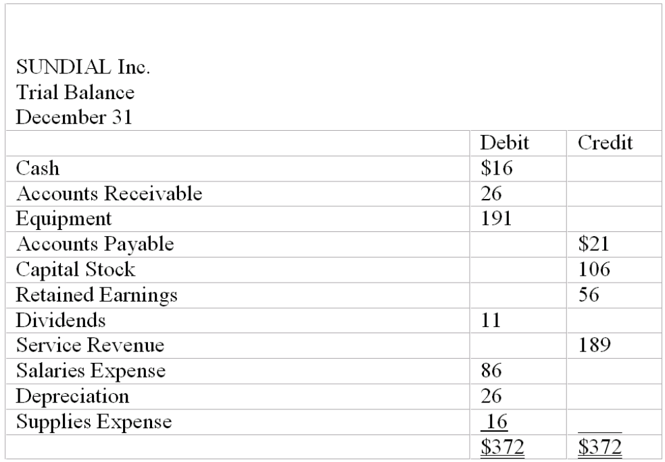

122. What is the balance in Income Summary before it is closed to Retained Earnings?
A. $61.
B. $50.
C. $73.
D. $145.

123. What is the balance in Retained Earnings after posting closing entries at December 31?
A. $117.
B. $106.
C. $61.
D. $45.

124. What is the total debits on the after-closing trial balance?
A. $222.
B. $372.
C. $233.
D. $161.

125. Which accounts are closed to Income Summary?
A. All accounts.
B. Revenue and expenses.
C. Revenue, expenses, and dividends.
D. All accounts that are not nominal.

126. Which accounts will appear on the balance sheet?
A. Retained earnings of $56.
B. Dividends of $11.
C. Net income of $60.
D. None of the above.

Short Answer Questions
127. The accountant for Successful Consulting prepared the following "Adjusted" Trial Balance at December 31, 20 __ after one year of operations:
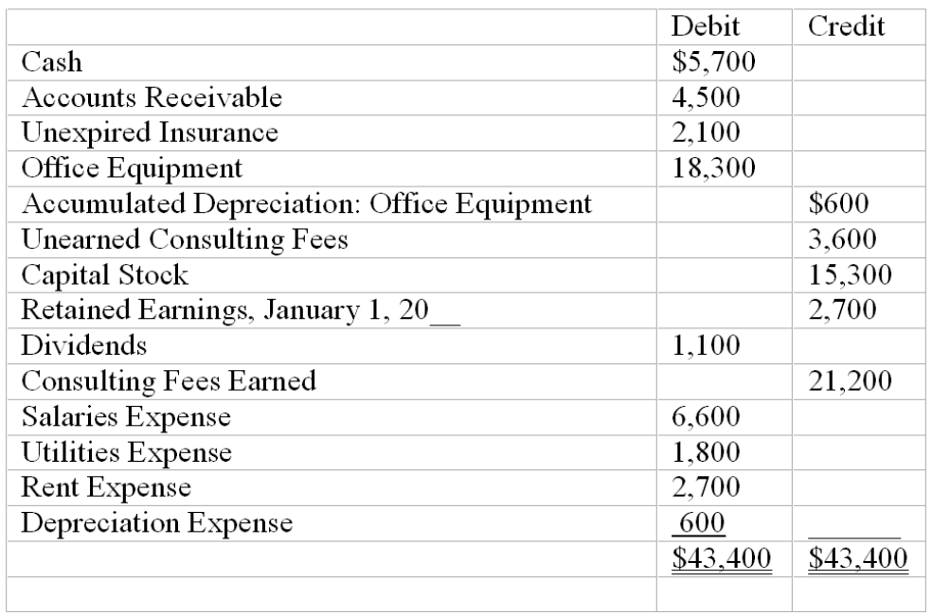
Prepare an After-Closing Trial Balance.

128. 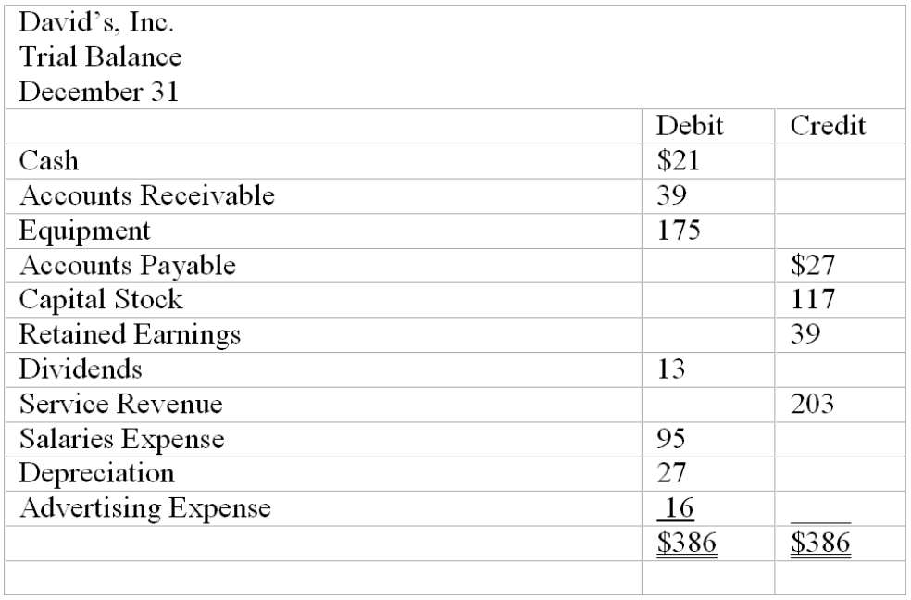
Prepare the closing entries.

Multiple Choice Questions
129. For a publicly held company, indicate which of the following activities are likely to occur at or shortly after year-end. (More than one answer may be correct.)
A. Preparing of income tax returns.
B. Adjusting and closing the accounts.
C. Drafting disclosures that accompany financial statements.
D. An audit of the financial statements by a firm of CPAs.

130. Which of the following financial statements is generally prepared first?
A. Income statement.
B. Balance sheet.
C. Statement of retained earnings.
D. Statement of cash flows.

131. Which of the following accounts would never be reported in the income statement as an expense?
A. Depreciation expense.
B. Income taxes expense.
C. Interest expense.
D. Dividends expense.

132. Which of the following accounts would never appear in the after-closing trial balance? (More than one answer may be correct)
A. Unearned revenue.
B. Dividends.
C. Accumulated depreciation.
D. Income taxes expense.

133. Which of the following journal entries is required to close the Income Summary account of a profitable company?
A. Debit Income Summary, credit Retained earnings.
B. Credit Income Summary, debit Retained earnings.
C. Debit Income Summary, credit Capital Stock.
D. Credit Income Summary, debit Capital Stock.

134. Indicate those items for which generally accepted accounting principles require disclosure in notes accompanying the financial statements. (More than one answer may be correct.)
A. A large lawsuit was filed against the company two days after the balance sheet date.
B. The depreciation method in use, given that several different methods are acceptable under generally accepted accounting principles.
C. Whether small but long-lived items-such as electric pencil sharpeners and handheld calculators-are charged to asset accounts or to expense accounts.
D. As of year-end, the chief executive officer had been hospitalized because of chest pains.

135. Ski West adjusts its accounts at the end of each month, but closes them only at the end of the calendar year (December 31). The ending balances in the Equipment Rental Revenue account and the Cash account in February and March appear below.
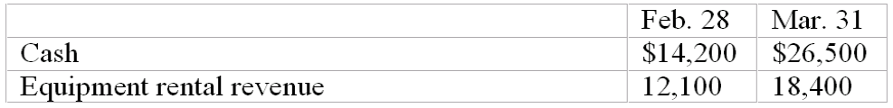
Ski West prepares financial statements showing separately the operating results of each month. In the financial statements prepared for the month ended March 31, Equipment Rental Revenue and Cash should appear as follows:
A. Equipment Rental Revenue, $18,400; Cash, $26,500.
B. Equipment Rental Revenue, $18,400; Cash, $12,300.
C. Equipment Rental Revenue, $6,300; Cash, $26,500.
D. Equipment Rental Revenue, $6,300; Cash, $12,300.

136. Which of the following accounts is not closed to the Income Summary at the end of the accounting period? (More than one answer may be correct).
A. Rent expense.
B. Accumulated Depreciation.
C. Unearned Revenue.
D. Supplies Expense.

Chapter 05 The Accounting Cycle: Reporting Financial Results Answer Key

True / False Questions
1. The report form of the balance sheet lists liabilities and owners' equity below assets.
TRUE

AACSB: Communications
AICPA BB: Critical Thinking
AICPA FN: Reporting
Bloom's: Remember
Difficulty: Easy
Learning Objective: 05-01 Prepare an income statement; a statement of retained earnings; and a balance sheet.
Topic: Preparing Financial Statements
2. A current asset may be cash or must be capable of being converted into cash within a relatively short period of time, usually less than five years.
FALSE

AACSB: Reflective Thinking
AICPA BB: Critical Thinking
AICPA FN: Measurement
Bloom's: Remember
Difficulty: Easy
Learning Objective: 05-01 Prepare an income statement; a statement of retained earnings; and a balance sheet.
Topic: Preparing Financial Statements
3. Real accounts can only be closed at the end of the year with a single compound entry.
FALSE

AACSB: Reflective Thinking
AICPA BB: Critical Thinking
AICPA FN: Measurement
Bloom's: Understand
Difficulty: Easy
Learning Objective: 05-04 Explain the purposes of closing entries; prepare these entries.
Topic: Closing the Temporary Accounts
4. The adjusted trial balance contains income statement accounts and balance sheet accounts, while the after-closing trial balance will only have balance sheet accounts.
TRUE

AACSB: Reflective Thinking
AICPA BB: Critical Thinking
AICPA FN: Measurement
Bloom's: Understand
Difficulty: Medium
Learning Objective: 05-05 Prepare an after-closing trial balance.
Topic: After-Closing Trial Balance
5. Measures of profitability tell us how quickly current assets can be converted into profits.
FALSE

AACSB: Reflective Thinking
AICPA BB: Critical Thinking
AICPA FN: Measurement
Bloom's: Remember
Difficulty: Medium
Learning Objective: 05-06 Use financial statement information to evaluate profitability and liquidity.
Topic: After-Closing Trial Balance
6. The current ratio is a measure of liquidity.
TRUE

AACSB: Reflective Thinking
AICPA BB: Resource Management
AICPA FN: Decision Making
Bloom's: Remember
Difficulty: Easy
Learning Objective: 05-06 Use financial statement information to evaluate profitability and liquidity.
Topic: After-Closing Trial Balance
7. The purpose of the after-closing trial balance is to give assurance that the accounts are in balance and ready for the new accounting period.
TRUE

AACSB: Reflective Thinking
AICPA BB: Critical Thinking
AICPA FN: Measurement
Bloom's: Understand
Difficulty: Medium
Learning Objective: 05-05 Prepare an after-closing trial balance.
Topic: After-Closing Trial Balance
8. The account, Accumulated Depreciation, is considered a permanent account.
TRUE

AACSB: Reflective Thinking
AICPA BB: Critical Thinking
AICPA FN: Measurement
Bloom's: Remember
Difficulty: Easy
Learning Objective: 05-04 Explain the purposes of closing entries; prepare these entries.
Topic: Closing the Temporary Accounts
9. The net income percentage can be measured by dividing net income by total revenue.
TRUE

AACSB: Reflective Thinking
AICPA BB: Resource Management
AICPA FN: Measurement
Bloom's: Remember
Difficulty: Easy
Learning Objective: 05-06 Use financial statement information to evaluate profitability and liquidity.
Topic: After-Closing Trial Balance
10. Working capital equals current assets divided by current liabilities.
FALSE

AACSB: Reflective Thinking
AICPA BB: Resource Management
AICPA FN: Measurement
Bloom's: Remember
Difficulty: Easy
Learning Objective: 05-06 Use financial statement information to evaluate profitability and liquidity.
Topic: After-Closing Trial Balance
11. In regard to disclosures that are required to be contained in annual reports, the FASB has no well-defined list of items that must be included.
TRUE

AACSB: Reflective Thinking
AICPA BB: Legal
AICPA FN: Reporting
Bloom's: Understand
Difficulty: Medium
Learning Objective: 05-03 Explain the concept of adequate disclosure.
Topic: Relationships among the Financial Statements
12. At year-end, all equity accounts must be closed.
FALSE

AACSB: Reflective Thinking
AICPA BB: Critical Thinking
AICPA FN: Measurement
Bloom's: Understand
Difficulty: Easy
Learning Objective: 05-04 Explain the purposes of closing entries; prepare these entries.
Topic: Closing the Temporary Accounts
13. The income summary account appears, as stated, on the statement of retained earnings.
FALSE

AACSB: Reflective Thinking
AICPA BB: Critical Thinking
AICPA FN: Reporting
Bloom's: Understand
Difficulty: Medium
Learning Objective: 05-04 Explain the purposes of closing entries; prepare these entries.
Topic: Closing the Temporary Accounts
14. Dividends are closed out directly to retained earnings at year-end.
TRUE

AACSB: Reflective Thinking
AICPA BB: Critical Thinking
AICPA FN: Measurement
Bloom's: Understand
Difficulty: Easy
Learning Objective: 05-04 Explain the purposes of closing entries; prepare these entries.
Topic: Closing the Temporary Accounts
15. Income summary does not appear on the income statement.
TRUE

AACSB: Reflective Thinking
AICPA BB: Critical Thinking
AICPA FN: Reporting
Bloom's: Remember
Difficulty: Easy
Learning Objective: 05-01 Prepare an income statement; a statement of retained earnings; and a balance sheet.
Topic: Preparing Financial Statements
16. Dividends declared are an expense and reduce net income.
FALSE

AACSB: Reflective Thinking
AICPA BB: Critical Thinking
AICPA FN: Measurement
Bloom's: Remember
Difficulty: Easy
Learning Objective: 05-02 Explain how the income statement and the statement of retained earnings relate to the balance sheet
Topic: Preparing Financial Statements
17. The current ratio equals current assets plus current liabilities.
FALSE

AACSB: Reflective Thinking
AICPA BB: Resource Management
AICPA FN: Measurement
Bloom's: Remember
Difficulty: Easy
Learning Objective: 05-06 Use financial statement information to evaluate profitability and liquidity.
Topic: After-Closing Trial Balance
18. The return on equity ratio equals net income divided by common stock.
FALSE

AACSB: Reflective Thinking
AICPA BB: Resource Management
AICPA FN: Measurement
Bloom's: Remember
Difficulty: Easy
Learning Objective: 05-06 Use financial statement information to evaluate profitability and liquidity.
Topic: After-Closing Trial Balance
19. Interim financial statements usually report on a period of time greater than one year.
FALSE

AACSB: Reflective Thinking
AICPA BB: Critical Thinking
AICPA FN: Reporting
Bloom's: Remember
Difficulty: Easy
Learning Objective: 05-07 Explain how interim financial statements are prepared in a business that closes its accounts only at year-end.
Topic: After-Closing Trial Balance
20. Publicly owned companies are typically managed by their stockholders.
FALSE

AACSB: Reflective Thinking
AICPA BB: Legal
AICPA FN: Measurement
Bloom's: Remember
Difficulty: Medium
Learning Objective: 05-01 Prepare an income statement; a statement of retained earnings; and a balance sheet.
Topic: Preparing Financial Statements
21. Financial statements are usually prepared before the closing entries are made.
TRUE

AACSB: Reflective Thinking
AICPA BB: Critical Thinking
AICPA FN: Measurement
Bloom's: Remember
Difficulty: Easy
Learning Objective: 05-04 Explain the purposes of closing entries; prepare these entries.
Topic: Closing the Temporary Accounts
22. Closing entries do not affect the cash account.
TRUE

AACSB: Reflective Thinking
AICPA BB: Critical Thinking
AICPA FN: Measurement
Bloom's: Understand
Difficulty: Easy
Learning Objective: 05-04 Explain the purposes of closing entries; prepare these entries.
Topic: Closing the Temporary Accounts
23. Return on equity is a commonly used measure of a company's solvency.
FALSE

AACSB: Reflective Thinking
AICPA BB: Resource Management
AICPA FN: Measurement
Bloom's: Understand
Difficulty: Medium
Learning Objective: 05-06 Use financial statement information to evaluate profitability and liquidity.
Topic: After-Closing Trial Balance
24. The current ratio is a measure of short-term debt paying ability.
TRUE

AACSB: Reflective Thinking
AICPA BB: Resource Management
AICPA FN: Measurement
Bloom's: Understand
Difficulty: Medium
Learning Objective: 05-06 Use financial statement information to evaluate profitability and liquidity.
Topic: After-Closing Trial Balance
25. An after-closing trial balance consists only of asset, liability, and owners' equity accounts.
TRUE

AACSB: Reflective Thinking
AICPA BB: Critical Thinking
AICPA FN: Measurement
Bloom's: Understand
Difficulty: Easy
Learning Objective: 05-05 Prepare an after-closing trial balance.
Topic: After-Closing Trial Balance
26. IFRS 1 requires that management and auditors should depart from compliance with GAAP if it is necessary to achieve a fair presentation when reporting financial results.
TRUE

AACSB: Diversity
AICPA BB: Global
AICPA FN: Measurement
Bloom's: Understand
Difficulty: Medium
Learning Objective: 05-01 Prepare an income statement; a statement of retained earnings; and a balance sheet.
Topic: Preparing Financial Statements
27. An annual report filed with the Securities and Exchange Commission must include a section called "Management's Predictions of Future Earnings."
FALSE

AACSB: Reflective Thinking
AICPA BB: Legal
AICPA FN: Reporting
Bloom's: Understand
Difficulty: Medium
Learning Objective: 05-01 Prepare an income statement; a statement of retained earnings; and a balance sheet.
Topic: Preparing Financial Statements

Multiple Choice Questions
28. Of the following, which is not an alternative title for the income statement?
A. Earnings statement.
B. Statement of Operations.
C. Profit and Loss Statement.
D. Statement of Financial Position.

AACSB: Communications
AICPA BB: Critical Thinking
AICPA FN: Reporting
Bloom's: Understand
Difficulty: Easy
Learning Objective: 05-01 Prepare an income statement; a statement of retained earnings; and a balance sheet.
Topic: Preparing Financial Statements
29. The Retained Earnings statement is based upon which of the following relationships?
A. Retained Earnings - Net Income - Dividends.
B. Retained Earnings - Net Income + Dividends.
C. Retained Earnings + Net Income + Dividends.
D. Retained Earnings + Net Income - Dividends.

AACSB: Analytic
AICPA BB: Critical Thinking
AICPA FN: Measurement
Bloom's: Remember
Difficulty: Easy
Learning Objective: 05-02 Explain how the income statement and the statement of retained earnings relate to the balance sheet
Topic: Preparing Financial Statements
30. In the notes to financial statements, adequate disclosure would typically not include:
A. The accounting methods in use.
B. Lawsuits pending against the business.
C. Due dates of major liabilities.
D. The optimism of the CFO regarding future profits.

AACSB: Reflective Thinking
AICPA BB: Critical Thinking
AICPA FN: Reporting
Bloom's: Understand
Difficulty: Medium
Learning Objective: 05-03 Explain the concept of adequate disclosure.
Topic: Relationships among the Financial Statements
31. A worksheet consists of all of the following except:
A. A trial balance.
B. Adjusting entries.
C. An adjusted trial balance.
D. Transaction entries.

AACSB: Reflective Thinking
AICPA BB: Critical Thinking
AICPA FN: Measurement
Bloom's: Understand
Difficulty: Medium
Learning Objective: 05-08 Prepare a worksheet and explain its uses.
Topic: Supplemental Topic: The Worksheet
32. Closing entries would be prepared before:
A. Financial statements are prepared.
B. A post-closing trial balance.
C. An adjusted trial balance.
D. Adjusting entries.

AACSB: Reflective Thinking
AICPA BB: Critical Thinking
AICPA FN: Measurement
Bloom's: Understand
Difficulty: Medium
Learning Objective: 05-04 Explain the purposes of closing entries; prepare these entries.
Topic: Closing the Temporary Accounts
33. When a worksheet is prepared, which account would not be entered into the income statement columns?
A. Depreciation Expense.
B. Unearned Revenue.
C. Service Revenue.
D. Prepaid Insurance.

AACSB: Reflective Thinking
AICPA BB: Critical Thinking
AICPA FN: Measurement
Bloom's: Understand
Difficulty: Medium
Learning Objective: 05-08 Prepare a worksheet and explain its uses.
Topic: Supplemental Topic: The Worksheet
34. The closing entry for an expense account would consist of a:
A. Debit to Income Summary and a credit to the expense account.
B. Debit to the expense account and a credit to Income Summary.
C. Credit to Retained Earnings and a debit to the expense account.
D. Credit to Revenue and a debit to the expense account.

AACSB: Reflective Thinking
AICPA BB: Critical Thinking
AICPA FN: Measurement
Bloom's: Understand
Difficulty: Medium
Learning Objective: 05-04 Explain the purposes of closing entries; prepare these entries.
Topic: Closing the Temporary Accounts
35. The income summary account has debits of $85,000 and credits of $75,000. The company had which of the following:
A. Net income of $10,000.
B. Net income of $160,000.
C. Net loss of $10,000.
D. Net loss of $160,000.

AACSB: Analytic
AICPA BB: Critical Thinking
AICPA FN: Measurement
Bloom's: Apply
Difficulty: Medium
Learning Objective: 05-04 Explain the purposes of closing entries; prepare these entries.
Topic: Closing the Temporary Accounts
36. What types of information must be disclosed in the financial statements?
A. The comprehensive list issued by the FASB.
B. Only information that is determined by management.
C. Non-financial information that is not included in the basic financial statements.
D. Ratio analysis.

AACSB: Reflective Thinking
AICPA BB: Critical Thinking
AICPA FN: Reporting
Bloom's: Understand
Difficulty: Medium
Learning Objective: 05-03 Explain the concept of adequate disclosure.
Topic: Relationships among the Financial Statements
37. Dividends declared:
A. Reduce retained earnings.
B. Increase retained earnings.
C. Reduce net income.
D. Increase net income.

AACSB: Reflective Thinking
AICPA BB: Critical Thinking
AICPA FN: Measurement
Bloom's: Remember
Difficulty: Easy
Learning Objective: 05-02 Explain how the income statement and the statement of retained earnings relate to the balance sheet
Topic: Preparing Financial Statements
38. During the closing process:
A. All income statement accounts are credited to income summary.
B. All income statement accounts are debited to income summary.
C. All revenue accounts are credited and expense accounts are debited.
D. All revenue accounts are debited and expense accounts are credited.

AACSB: Reflective Thinking
AICPA BB: Critical Thinking
AICPA FN: Measurement
Bloom's: Understand
Difficulty: Medium
Learning Objective: 05-04 Explain the purposes of closing entries; prepare these entries.
Topic: Closing the Temporary Accounts
39. A debit balance in the income summary account indicates:
A. An error was made.
B. A Net Profit.
C. A Net Loss.
D. That revenues were greater than expenses.

AACSB: Reflective Thinking
AICPA BB: Critical Thinking
AICPA FN: Measurement
Bloom's: Understand
Difficulty: Medium
Learning Objective: 05-04 Explain the purposes of closing entries; prepare these entries.
Topic: Closing the Temporary Accounts
40. The dividends account should be:
A. Closed to income summary.
B. Closed to retained earnings.
C. Closed only if there is a profit.
D. Not closed at all.

AACSB: Reflective Thinking
AICPA BB: Critical Thinking
AICPA FN: Measurement
Bloom's: Understand
Difficulty: Medium
Learning Objective: 05-02 Explain how the income statement and the statement of retained earnings relate to the balance sheet
Topic: Preparing Financial Statements
41. Which account will appear on an after-closing trial balance?
A. Dividends.
B. Prepaid Expenses.
C. Retained Earnings, at the beginning of the period.
D. Sales.

AACSB: Reflective Thinking
AICPA BB: Critical Thinking
AICPA FN: Measurement
Bloom's: Understand
Difficulty: Medium
Learning Objective: 05-05 Prepare an after-closing trial balance.
Topic: After-Closing Trial Balance
42. Which account will not appear on an after-closing trial balance?
A. Dividends.
B. Prepaid Expenses.
C. Unearned Revenue.
D. Retained Earnings, at the end of the period.

AACSB: Reflective Thinking
AICPA BB: Critical Thinking
AICPA FN: Measurement
Bloom's: Understand
Difficulty: Medium
Learning Objective: 05-05 Prepare an after-closing trial balance.
Topic: After-Closing Trial Balance
43. The section of the annual report titled "Management Discussion and Analysis" is:
A. Required by the SEC.
B. Not required but may be included by management.
C. Required by GAAP.
D. Reported to the SEC but not included in the annual report.

AACSB: Reflective Thinking
AICPA BB: Legal
AICPA FN: Reporting
Bloom's: Understand
Difficulty: Medium
Learning Objective: 05-03 Explain the concept of adequate disclosure.
Topic: Relationships among the Financial Statements
44. Return on equity measures:
A. Solvency.
B. Profitability.
C. Leverage.
D. All three of the above.

AACSB: Reflective Thinking
AICPA BB: Resource Management
AICPA FN: Measurement
Bloom's: Remember
Difficulty: Medium
Learning Objective: 05-06 Use financial statement information to evaluate profitability and liquidity.
Topic: After-Closing Trial Balance
45. Publicly owned companies are:
A. Managed and owned by the government.
B. Must be not-for-profit companies.
C. Usually listed on a stock exchange.
D. Not permitted to be owned by individuals.

AACSB: Reflective Thinking
AICPA BB: Legal
AICPA FN: Reporting
Bloom's: Understand
Difficulty: Medium
Learning Objective: 05-01 Prepare an income statement; a statement of retained earnings; and a balance sheet.
Topic: Preparing Financial Statements
46. The worksheet:
A. Is one of the basic financial statements.
B. Is prepared throughout the year.
C. Is not a formal step in the accounting cycle.
D. Starts with the first column being the adjusted trial balance.

AACSB: Reflective Thinking
AICPA BB: Critical Thinking
AICPA FN: Measurement
Bloom's: Understand
Difficulty: Medium
Learning Objective: 05-08 Prepare a worksheet and explain its uses.
Topic: Supplemental Topic: The Worksheet
47. If Income Summary has a net credit balance, it signifies:
A. A net loss.
B. Net income.
C. A reduction of net worth.
D. Dividends have been declared.

AACSB: Reflective Thinking
AICPA BB: Critical Thinking
AICPA FN: Measurement
Bloom's: Understand
Difficulty: Medium
Learning Objective: 05-04 Explain the purposes of closing entries; prepare these entries.
Topic: Closing the Temporary Accounts
48. The balance in Income Summary:
A. Should equal retained earnings.
B. Will always be equal to the increase in retained earnings.
C. Will equal net income less dividends.
D. Will equal net income or net loss.

AACSB: Reflective Thinking
AICPA BB: Critical Thinking
AICPA FN: Measurement
Bloom's: Understand
Difficulty: Medium
Learning Objective: 05-04 Explain the purposes of closing entries; prepare these entries.
Topic: Closing the Temporary Accounts
49. After preparing the financial statements for the current year, the accountant for Exquisite Gems closed the Dividends account at year-end by debiting Income Summary and crediting the Dividends account. What is the effect of this entry on current-year net income and the balance in the Retained Earnings account at year-end?
A. Net income is overstated and the balance in the Retained Earnings account is correct.
B. Net income is correct and the balance in the Retained Earnings account is overstated.
C. Net income is understated and the balance in the Retained Earnings account is understated.
D. Net income is understated and the balance in the Retained Earnings account is overstated.

AACSB: Reflective Thinking
AICPA BB: Critical Thinking
AICPA FN: Measurement
Bloom's: Understand
Difficulty: Medium
Learning Objective: 05-04 Explain the purposes of closing entries; prepare these entries.
Topic: Closing the Temporary Accounts
50. The concept of adequate disclosure:
A. Does not apply to information which is immaterial.
B. Grants users of the financial statements access to a company's accounting records.
C. Does not apply to events occurring after the balance sheet date.
D. Specifies which accounting methods must be used in a company's financial statements.

AACSB: Reflective Thinking
AICPA BB: Critical Thinking
AICPA FN: Measurement
Bloom's: Understand
Difficulty: Medium
Learning Objective: 05-03 Explain the concept of adequate disclosure.
Topic: Relationships among the Financial Statements
51. The concept of adequate disclosure requires a company to inform financial statement users of each of the following, except:
A. The accounting methods in use.
B. The due dates of major liabilities.
C. Destruction of a large portion of the company's inventory on January 20, three weeks after the balance sheet date, but prior to issuance of the financial statements.
D. Income projections for the next five years based upon anticipated market share of a new product; the new product was introduced a few days before the balance sheet date.

AACSB: Reflective Thinking
AICPA BB: Critical Thinking
AICPA FN: Measurement
Bloom's: Understand
Difficulty: Medium
Learning Objective: 05-03 Explain the concept of adequate disclosure.
Topic: Relationships among the Financial Statements
52. Income Summary appears on which financial statement:
A. Income statement.
B. Balance sheet.
C. Retained Earnings statement.
D. Income summary does not appear on any financial statement.

AACSB: Reflective Thinking
AICPA BB: Critical Thinking
AICPA FN: Measurement
Bloom's: Understand
Difficulty: Medium
Learning Objective: 05-04 Explain the purposes of closing entries; prepare these entries.
Topic: Closing the Temporary Accounts
53. Retained Earnings at the end of a period:
A. Is equal to the balance in the Retained Earnings account in the adjusted trial balance at the end of a period.
B. Is determined in the statement of Retained Earnings.
C. Is equal to Retained Earnings at the beginning of the period, minus net income (or plus net loss) for the period.
D. Appears in the income statement for the period.

AACSB: Reflective Thinking
AICPA BB: Critical Thinking
AICPA FN: Measurement
Bloom's: Understand
Difficulty: Medium
Learning Objective: 05-02 Explain how the income statement and the statement of retained earnings relate to the balance sheet
Topic: Preparing Financial Statements
54. A statement of retained earnings shows:
A. The changes in the Cash account occurring during the accounting period.
B. The revenue, expense, and dividends of the period.
C. The types of assets which have been purchased with the earnings retained during the accounting period.
D. The changes in the Retained Earnings account occurring during the accounting period.

AACSB: Reflective Thinking
AICPA BB: Critical Thinking
AICPA FN: Measurement
Bloom's: Understand
Difficulty: Medium
Learning Objective: 05-02 Explain how the income statement and the statement of retained earnings relate to the balance sheet
Topic: Preparing Financial Statements
55. The normal order in which the financial statements are prepared is:
A. Balance sheet, income statement, statement of retained earnings.
B. Income statement, statement of retained earnings, balance sheet.
C. Income tax return, income statement, balance sheet.
D. Income statement, statement of cash flows, balance sheet.

AACSB: Reflective Thinking
AICPA BB: Critical Thinking
AICPA FN: Measurement
Bloom's: Understand
Difficulty: Medium
Learning Objective: 05-01 Prepare an income statement; a statement of retained earnings; and a balance sheet.
Topic: Preparing Financial Statements
56. The purpose of making closing entries is to:
A. Prepare revenue and expense accounts for the recording of the next period's revenue and expenses.
B. Enable the accountant to prepare financial statements at the end of the accounting period.
C. Establish new balances in the balance sheet accounts.
D. Reduce the number of expense accounts.

AACSB: Reflective Thinking
AICPA BB: Critical Thinking
AICPA FN: Measurement
Bloom's: Understand
Difficulty: Medium
Learning Objective: 05-04 Explain the purposes of closing entries; prepare these entries.
Topic: Closing the Temporary Accounts
57. When closing the accounts at the end of the period, which of the following is closed directly into the Retained Earnings account?
A. Depreciation Expense.
B. Accumulated Depreciation.
C. Revenue and liability accounts.
D. The Income Summary account.

AACSB: Reflective Thinking
AICPA BB: Critical Thinking
AICPA FN: Measurement
Bloom's: Understand
Difficulty: Medium
Learning Objective: 05-04 Explain the purposes of closing entries; prepare these entries.
Topic: Closing the Temporary Accounts
58. Publicly traded companies must file audited financial statements with the:
A. AICPA.
B. IRS.
C. SEC.
D. AAA.

AACSB: Reflective Thinking
AICPA BB: Legal
AICPA FN: Reporting
Bloom's: Remember
Difficulty: Easy
Learning Objective: 05-01 Prepare an income statement; a statement of retained earnings; and a balance sheet.
Topic: Preparing Financial Statements
59. Closing entries never involve posting a credit to the:
A. Income Summary account.
B. Accumulated Depreciation account.
C. Dividends.
D. Depreciation Expense account.

AACSB: Reflective Thinking
AICPA BB: Critical Thinking
AICPA FN: Measurement
Bloom's: Understand
Difficulty: Medium
Learning Objective: 05-04 Explain the purposes of closing entries; prepare these entries.
Topic: Closing the Temporary Accounts
60. Which of the following account titles would not be debited in the process of preparing closing entries for Andrew's Auto Shop?
A. Income Summary.
B. Fees Earned.
C. Dividends.
D. Retained Earnings.

AACSB: Reflective Thinking
AICPA BB: Critical Thinking
AICPA FN: Measurement
Bloom's: Understand
Difficulty: Medium
Learning Objective: 05-04 Explain the purposes of closing entries; prepare these entries.
Topic: Closing the Temporary Accounts
61. If a business closes its accounts only at year-end:
A. Financial statements are prepared only at year-end.
B. Adjusting entries are made only at year-end.
C. Revenue and expense accounts reflect year-to-date amounts throughout the year.
D. Monthly and quarterly financial statements cannot be prepared.

AACSB: Reflective Thinking
AICPA BB: Critical Thinking
AICPA FN: Measurement
Bloom's: Understand
Difficulty: Medium
Learning Objective: 05-04 Explain the purposes of closing entries; prepare these entries.
Topic: Closing the Temporary Accounts
62. Assets are considered current assets if they are cash or will usually be converted into cash:
A. Within a month or less.
B. Within 3 months.
C. Within a year or less.
D. Within 6 months or less.

AACSB: Reflective Thinking
AICPA BB: Critical Thinking
AICPA FN: Measurement
Bloom's: Remember
Difficulty: Medium
Learning Objective: 05-03 Explain the concept of adequate disclosure.
Topic: Relationships among the Financial Statements
63. Which of the following amounts appears in both the Income Statement debit column and the Balance Sheet credit column of a worksheet?
A. Net income.
B. Net loss.
C. Dividends.
D. Retained earnings.

AACSB: Reflective Thinking
AICPA BB: Critical Thinking
AICPA FN: Measurement
Bloom's: Understand
Difficulty: Medium
Learning Objective: 05-08 Prepare a worksheet and explain its uses.
Topic: Supplemental Topic: The Worksheet
64. A worksheet should be viewed as:
A. A financial statement to be distributed to investors.
B. A financial statement to assist managers in making managerial decisions.
C. A tool to assist accountants in making end-of-period adjustments and in preparing financial statements.
D. A tool to assist auditors in determining that all transactions have been properly recorded throughout the period.

AACSB: Reflective Thinking
AICPA BB: Critical Thinking
AICPA FN: Measurement
Bloom's: Understand
Difficulty: Medium
Learning Objective: 05-08 Prepare a worksheet and explain its uses.
Topic: Supplemental Topic: The Worksheet
65. The amount of net income (or loss) will appear on the debit side of the Income Statement columns in a worksheet if:
A. Revenue exceeds total expenses for the period.
B. The trial balance is out of balance.
C. Dividends are more than the income or loss for the period.
D. There is a net loss for the period.

AACSB: Reflective Thinking
AICPA BB: Critical Thinking
AICPA FN: Measurement
Bloom's: Understand
Difficulty: Medium
Learning Objective: 05-08 Prepare a worksheet and explain its uses.
Topic: Supplemental Topic: The Worksheet
66. Return on equity is calculated by:
A. Dividing net income by total revenue.
B. Dividing net income by average stockholders' equity.
C. Dividing net income by working capital.
D. Dividing dividends by stockholders' equity.

AACSB: Reflective Thinking
AICPA BB: Resource Management
AICPA FN: Measurement
Bloom's: Remember
Difficulty: Easy
Learning Objective: 05-06 Use financial statement information to evaluate profitability and liquidity.
Topic: After-Closing Trial Balance
67. Which of the following is true regarding a worksheet prepared at year-end?
A. The number of account titles applicable to the Adjusted Trial Balance columns is usually greater than the number of account titles applicable to the Trial Balance columns.
B. The worksheet can be issued instead of financial statements.
C. The worksheet eliminates the need to make adjusting and closing entries.
D. An equal number of account titles are applicable to the Income Statement columns and the Balance Sheet columns.

AACSB: Reflective Thinking
AICPA BB: Critical Thinking
AICPA FN: Measurement
Bloom's: Understand
Difficulty: Medium
Learning Objective: 05-08 Prepare a worksheet and explain its uses.
Topic: Supplemental Topic: The Worksheet
68. Interim financial statements:
A. Cover a period less than one year.
B. Cover only periods of a quarter of a year.
C. Cover periods greater than a year.
D. Cannot cover a period of one month or less.

AACSB: Reflective Thinking
AICPA BB: Critical Thinking
AICPA FN: Measurement
Bloom's: Remember
Difficulty: Easy
Learning Objective: 05-07 Explain how interim financial statements are prepared in a business that closes its accounts only at year-end.
Topic: After-Closing Trial Balance
69. When a worksheet is used:
A. Adjusting entries are not prepared, since adjustments are shown on the worksheet.
B. Revenue and expense accounts do not have to be closed to the Income Summary account, because the income statement is prepared from the worksheet and net income is already computed.
C. Financial statements may be prepared before recording adjusting and closing entries in the accounting records.
D. The Income Statement column and Balance Sheet column of the worksheet eliminate the need to prepare formal financial statements for a business.

AACSB: Reflective Thinking
AICPA BB: Critical Thinking
AICPA FN: Measurement
Bloom's: Understand
Difficulty: Medium
Learning Objective: 05-08 Prepare a worksheet and explain its uses.
Topic: Supplemental Topic: The Worksheet
70. Preparation of interim financial statements:
A. Makes the preparation of year-end financial statements unnecessary.
B. Requires the journalizing and posting of adjusting entries.
C. Requires the journalizing and posting of closing entries.
D. Is done monthly or quarterly, in-between the year-end financial statements.

AACSB: Reflective Thinking
AICPA BB: Critical Thinking
AICPA FN: Measurement
Bloom's: Understand
Difficulty: Medium
Learning Objective: 05-07 Explain how interim financial statements are prepared in a business that closes its accounts only at year-end.
Topic: After-Closing Trial Balance
71. If monthly financial statements are desired by management:
A. Journalizing and posting adjusting entries must be done each month.
B. Journalizing and posting closing entries must be done each month.
C. Monthly financial statements can be prepared from worksheets; adjustments and closing entries need not be entered in the accounting records.
D. Adjusting and closing entries must be entered in the accounting records before preparation of interim financial statements.

AACSB: Reflective Thinking
AICPA BB: Critical Thinking
AICPA FN: Measurement
Bloom's: Understand
Difficulty: Medium
Learning Objective: 05-07 Explain how interim financial statements are prepared in a business that closes its accounts only at year-end.
Topic: After-Closing Trial Balance
72. Declaring a dividend will:
A. Increase net income.
B. Decrease net income.
C. Not change net income.
D. Increase the net worth of a company.

AACSB: Reflective Thinking
AICPA BB: Critical Thinking
AICPA FN: Measurement
Bloom's: Understand
Difficulty: Medium
Learning Objective: 05-02 Explain how the income statement and the statement of retained earnings relate to the balance sheet
Topic: Preparing Financial Statements
73. Dividends will have what effect upon retained earnings?
A. Increase.
B. Decrease.
C. No effect.
D. Depends upon if there is income or loss.

AACSB: Reflective Thinking
AICPA BB: Critical Thinking
AICPA FN: Measurement
Bloom's: Understand
Difficulty: Easy
Learning Objective: 05-02 Explain how the income statement and the statement of retained earnings relate to the balance sheet
Topic: Preparing Financial Statements
74. Which of the following accounts will be closed to Income Summary?
A. Prepaid Expenses.
B. Unearned Revenue.
C. Dividends.
D. Earned Revenue.

AACSB: Reflective Thinking
AICPA BB: Critical Thinking
AICPA FN: Measurement
Bloom's: Understand
Difficulty: Easy
Learning Objective: 05-04 Explain the purposes of closing entries; prepare these entries.
Topic: Closing the Temporary Accounts
75. Net income from the Income Statement appears on:
A. The Balance Sheet.
B. The Retained Earnings Statement.
C. Neither the Balance Sheet nor the Retained Earnings Statement.
D. Both the Balance Sheet and the Retained Earnings Statement.

AACSB: Reflective Thinking
AICPA BB: Critical Thinking
AICPA FN: Measurement
Bloom's: Understand
Difficulty: Easy
Learning Objective: 05-02 Explain how the income statement and the statement of retained earnings relate to the balance sheet
Topic: Preparing Financial Statements
76. Which statement is true regarding the Income Statement?
A. Losses do not appear on income statements.
B. Dividends reduce net income.
C. Dividends declared increase net income.
D. Both losses and gains appear on an income statement.

AACSB: Reflective Thinking
AICPA BB: Critical Thinking
AICPA FN: Measurement
Bloom's: Understand
Difficulty: Medium
Learning Objective: 05-02 Explain how the income statement and the statement of retained earnings relate to the balance sheet
Topic: Preparing Financial Statements
77. Under the Sarbanes-Oxley Act, CFOs and high-ranking corporate officers are now:
A. Personally responsible for the integrity of annual reports.
B. Subject of fines of up to $5 million for knowingly making false statements.
C. Facing prison sentences of up to 20 years for knowingly making false statements.
D. All of the above.

AACSB: Ethics
AICPA BB: Legal
AICPA FN: Risk Analysis
Bloom's: Understand
Difficulty: Medium
Learning Objective: 05-03 Explain the concept of adequate disclosure.
Topic: Relationships among the Financial Statements
78. Closing entries should be made:
A. Every year.
B. Only when an entity goes out of business.
C. Only if there is a profit.
D. Only if there is a loss.

AACSB: Reflective Thinking
AICPA BB: Critical Thinking
AICPA FN: Measurement
Bloom's: Understand
Difficulty: Easy
Learning Objective: 05-04 Explain the purposes of closing entries; prepare these entries.
Topic: Closing the Temporary Accounts
79. Which accounts should not be closed?
A. Expenses and revenues.
B. Dividends.
C. Income summary.
D. Accumulated depreciation.

AACSB: Reflective Thinking
AICPA BB: Critical Thinking
AICPA FN: Measurement
Bloom's: Understand
Difficulty: Easy
Learning Objective: 05-04 Explain the purposes of closing entries; prepare these entries.
Topic: Closing the Temporary Accounts
80. Which account appears on the After-Closing Trial Balance?
A. Service Revenue.
B. Unearned Revenue.
C. Dividends.
D. Retained Earnings, Beginning of Year.

AACSB: Reflective Thinking
AICPA BB: Critical Thinking
AICPA FN: Measurement
Bloom's: Understand
Difficulty: Medium
Learning Objective: 05-05 Prepare an after-closing trial balance.
Topic: After-Closing Trial Balance
81. If sales are $270,000, expenses are $220,000 and dividends are $30,000, Income Summary:
A. Will have a credit balance of $50,000.
B. Will have a debit balance of $50,000.
C. Will have a debit balance of $20,000.
D. Will have a credit balance of $20,000.
$270,000 - $220,000 = $50,000

AACSB: Analytic
AICPA BB: Critical Thinking
AICPA FN: Measurement
Bloom's: Apply
Difficulty: Medium
Learning Objective: 05-04 Explain the purposes of closing entries; prepare these entries.
Topic: Closing the Temporary Accounts
82. If current assets are $90,000 and current liabilities are $70,000, the current ratio will be:
A. 77%.
B. $20,000.
C. 1.3.
D. $160,000.
$90,000/$70,000 = 1.3

AACSB: Analytic
AICPA BB: Resource Management
AICPA FN: Measurement
Bloom's: Apply
Difficulty: Medium
Learning Objective: 05-06 Use financial statement information to evaluate profitability and liquidity.
Topic: After-Closing Trial Balance
83. If current assets are $110,000 and current liabilities are $50,000, working capital will be:
A. 45.5%.
B. 2:2.
C. $60,000.
D. $160,000.
$110,000 - $50,000 = $60,000

AACSB: Analytic
AICPA BB: Resource Management
AICPA FN: Measurement
Bloom's: Apply
Difficulty: Medium
Learning Objective: 05-06 Use financial statement information to evaluate profitability and liquidity.
Topic: After-Closing Trial Balance
84. The following information is available:
What is the return on equity? (round to the nearest number)
A. 5%.
B. 20%.
C. 25%.
D. 15%.
$20,000/$130,000 = 15%

AACSB: Analytic
AICPA BB: Resource Management
AICPA FN: Measurement
Bloom's: Apply
Difficulty: Medium
Learning Objective: 05-06 Use financial statement information to evaluate profitability and liquidity.
Topic: After-Closing Trial Balance
85. Only two adjustments appear in the adjustments column of a worksheet for Wycliff Publications: one to record $800 depreciation of office equipment and the other to record the use of $560 of office supplies. If the Trial Balance column totals are $15,380, what are the totals of the Adjusted Trial Balance columns?
A. $16,740.
B. $15,140.
C. $16,180.
D. $15,860.
$15,380 + $800 = $16,180. The decrease in office supplies cancels the increase in supplies expense.

AACSB: Analytic
AICPA BB: Critical Thinking
AICPA FN: Measurement
Bloom's: Apply
Difficulty: Medium
Learning Objective: 05-08 Prepare a worksheet and explain its uses.
Topic: Supplemental Topic: The Worksheet
86. The December 31, 2010 worksheet for Fran's Fine Dining showed the following amounts related to the Supplies Expense account:
(a). In the Trial Balance debit column: $745
(b). In the Adjustments debit column: $125
(c). In the Adjusted Trial Balance debit column: $870
What is the proper balance in the Supplies Expense account on January 1, 2011, after all closing entries for 2010 have been posted, but before any 2011 transactions are recorded?
A. $870.
B. $745.
C. $0.
D. $125.

AACSB: Analytic
AICPA BB: Critical Thinking
AICPA FN: Measurement
Bloom's: Analyze
Difficulty: Medium
Learning Objective: 05-08 Prepare a worksheet and explain its uses.
Topic: Supplemental Topic: The Worksheet
Shown below is a trial balance for Novelty Toys, Inc., on December 31, after adjusting entries:

87. Refer to the information above. The entry to close the Fees earned account will:
A. Produce a zero balance in that account when posted.
B. Include a debit to Income Summary.
C. Include a credit to Fees Earned.
D. Include a debit to Capital Stock.

AACSB: Analytic
AICPA BB: Critical Thinking
AICPA FN: Measurement
Bloom's: Apply
Difficulty: Medium
Learning Objective: 05-04 Explain the purposes of closing entries; prepare these entries.
Topic: Closing the Temporary Accounts
88. Refer to the information above. The entry to close Salaries expense account will:
A. Produce a zero balance in that account when posted.
B. Include a credit to Income Summary.
C. Include a debit to Salaries Expense.
D. Include a credit to Capital Stock.

AACSB: Analytic
AICPA BB: Critical Thinking
AICPA FN: Measurement
Bloom's: Apply
Difficulty: Medium
Learning Objective: 05-04 Explain the purposes of closing entries; prepare these entries.
Topic: Closing the Temporary Accounts
89. Refer to the information above. Net income for the period equals:
A. $18,375.
B. $11,000.
C. $5,800.
D. $11,250.
$22,750 - $8,000 - $1,625 -$2,125 = $11,000

AACSB: Analytic
AICPA BB: Critical Thinking
AICPA FN: Measurement
Bloom's: Apply
Difficulty: Medium
Learning Objective: 05-04 Explain the purposes of closing entries; prepare these entries.
Topic: Closing the Temporary Accounts
90. Refer to the information above. After closing the accounts, Retained earnings at December 31 equals:
A. $11,000.
B. $7,250.
C. Zero.
D. $22,250.
$11,000 - $3,750 = $7,250

AACSB: Analytic
AICPA BB: Critical Thinking
AICPA FN: Measurement
Bloom's: Apply
Difficulty: Medium
Learning Objective: 05-04 Explain the purposes of closing entries; prepare these entries.
Topic: Closing the Temporary Accounts
91. Refer to the information above. The total debits in the After-Closing Trial Balance will equal:
A. $25,375.
B. $29,125.
C. $40,875.
D. $18,125.
$7,750 + $6,375 + $11,250 = $25,375

AACSB: Analytic
AICPA BB: Critical Thinking
AICPA FN: Measurement
Bloom's: Apply
Difficulty: Medium
Learning Objective: 05-05 Prepare an after-closing trial balance.
Topic: After-Closing Trial Balance
92. Refer to the information above. Income Summary will have what balance before it is closed?
A. Zero.
B. $11,750.
C. $7,250.
D. $11,000.
$22,750 - $8,000 - $1,625 - $2,125 = $11,000

AACSB: Analytic
AICPA BB: Critical Thinking
AICPA FN: Measurement
Bloom's: Apply
Difficulty: Medium
Learning Objective: 05-04 Explain the purposes of closing entries; prepare these entries.
Topic: Closing the Temporary Accounts
Shown below is the adjusted Trial Balance for Simon Inc., on December 31, after the first year of operations, after adjusting entries:

93. Refer to the information above. The entry to close the Service fees earned account will:
A. Produce a zero balance in that account when posted.
B. Include a debit to Income Summary.
C. Include a credit to Service Fees Earned.
D. Include a debit to Capital Stock.

AACSB: Analytic
AICPA BB: Critical Thinking
AICPA FN: Measurement
Bloom's: Apply
Difficulty: Medium
Learning Objective: 05-04 Explain the purposes of closing entries; prepare these entries.
Topic: Closing the Temporary Accounts
94. Refer to the information above. The entry to close Depreciation expense account will:
A. Produce a zero balance in that account when posted.
B. Include a credit to Income Summary.
C. Include a debit to Depreciation Expense.
D. Include a credit to Capital Stock.

AACSB: Analytic
AICPA BB: Critical Thinking
AICPA FN: Measurement
Bloom's: Apply
Difficulty: Medium
Learning Objective: 05-04 Explain the purposes of closing entries; prepare these entries.
Topic: Closing the Temporary Accounts
95. Refer to the information above. Net income for the period equals:
A. $20,960.
B. $16,640.
C. $21,920.
D. $23,360.
$21,920 - $3,200 - $1,120 - $960 = $16,640

AACSB: Analytic
AICPA BB: Critical Thinking
AICPA FN: Measurement
Bloom's: Apply
Difficulty: Medium
Learning Objective: 05-04 Explain the purposes of closing entries; prepare these entries.
Topic: Closing the Temporary Accounts
96. Refer to the information above. After closing the accounts, Retained earnings at December 31 equals:
A. Zero.
B. $18,400.
C. $19,360.
D. $16,640.
$2,720 + $16,640 - $960 = $18,400

AACSB: Analytic
AICPA BB: Critical Thinking
AICPA FN: Measurement
Bloom's: Apply
Difficulty: Medium
Learning Objective: 05-04 Explain the purposes of closing entries; prepare these entries.
Topic: Closing the Temporary Accounts
97. Refer to the information above. The total debits in the After Closing-Trial Balance will equal:
A. $23,360.
B. $28,640.
C. $22,400.
D. $6,720.
$1,600 + $4,000 + $16,800 = $22,400

AACSB: Analytic
AICPA BB: Critical Thinking
AICPA FN: Measurement
Bloom's: Apply
Difficulty: Medium
Learning Objective: 05-05 Prepare an after-closing trial balance.
Topic: After-Closing Trial Balance
98. Refer to the information above. Income Summary will have what balance before it is closed?
A. $28,640.
B. $15,600.
C. $21,920.
D. $16,640.
$21,920 - $3,200 - $1,120 - $960 = $16,640

AACSB: Analytic
AICPA BB: Critical Thinking
AICPA FN: Measurement
Bloom's: Apply
Difficulty: Medium
Learning Objective: 05-04 Explain the purposes of closing entries; prepare these entries.
Topic: Closing the Temporary Accounts
99. If sales are $540,000, expenses are $440,000 and dividends are $50,000, Income Summary:
A. Will have a credit balance of $50,000.
B. Will have a debit balance of $50,000.
C. Will have a debit balance of $100,000.
D. Will have a credit balance of $100,000.
$540,000 - $440,000 = $100,000

AACSB: Analytic
AICPA BB: Critical Thinking
AICPA FN: Measurement
Bloom's: Apply
Difficulty: Medium
Learning Objective: 05-04 Explain the purposes of closing entries; prepare these entries.
Topic: Closing the Temporary Accounts
100. If current assets are $180,000 and current liabilities are $130,000, the current ratio will be:
A. 72%.
B. $50,000.
C. 1.4.
D. $310,000.
$180,000/$130,000 = 1.4

AACSB: Analytic
AICPA BB: Resource Management
AICPA FN: Measurement
Bloom's: Apply
Difficulty: Medium
Learning Objective: 05-06 Use financial statement information to evaluate profitability and liquidity.
Topic: After-Closing Trial Balance
101. If current assets are $180,000 and current liabilities are $130,000, working capital will be:
A. 72%.
B. $50,000.
C. 1.4.
D. $310,000.
$180,000 - $130,000 = $50,000

AACSB: Analytic
AICPA BB: Resource Management
AICPA FN: Measurement
Bloom's: Apply
Difficulty: Medium
Learning Objective: 05-06 Use financial statement information to evaluate profitability and liquidity.
Topic: After-Closing Trial Balance
102. The following information is available:
What is the return on equity? (round to the nearest number)
A. 5%.
B. 15%.
C. 20%.
D. 25%.
$30,000/$200,000 = 15%

AACSB: Analytic
AICPA BB: Resource Management
AICPA FN: Measurement
Bloom's: Apply
Difficulty: Medium
Learning Objective: 05-06 Use financial statement information to evaluate profitability and liquidity.
Topic: After-Closing Trial Balance
103. The following information is available:
What is the net income percentage? (round to the nearest number)
A. 5%.
B. 15%.
C. 20%.
D. 25%.
$30,000/$600,000 = 5%

AACSB: Analytic
AICPA BB: Resource Management
AICPA FN: Measurement
Bloom's: Apply
Difficulty: Medium
Learning Objective: 05-06 Use financial statement information to evaluate profitability and liquidity.
Topic: After-Closing Trial Balance
104. Only two adjustments appear in the adjustments column of a worksheet for Winona Mfg: one to record $8,000 depreciation of factory equipment, and the other to record the use of $1,500 of prepaid insurance. If the Trial Balance column totals are $145,380, what are the totals of the Adjusted Trial Balance columns?
A. $145,380.
B. $153,380.
C. $152,880.
D. $154,880.
$145,380 + $8,000 = $153,380. The decrease in prepaid insurance cancels the increase in insurance expense.

AACSB: Analytic
AICPA BB: Critical Thinking
AICPA FN: Measurement
Bloom's: Apply
Difficulty: Medium
Learning Objective: 05-08 Prepare a worksheet and explain its uses.
Topic: Supplemental Topic: The Worksheet
105. The December 31, 2011 worksheet for Albertville Grill showed the following amounts related to the Depreciation Expense account:
(a). In the Trial Balance debit column: $1,745
(b). In the Adjustments debit column: $1,125
(c). In the Adjusted Trial Balance debit column: $1,870
What is the proper balance in the Depreciation Expense account on January 1, 2012, after all closing entries for 2011 have been posted, but before any 2012 transactions are recorded?
A. $1,870.
B. $1,745.
C. $0.
D. $1,125.
The expense account would have been closed out for 2011; the beginning balance for 2012 would be $0.

AACSB: Analytic
AICPA BB: Critical Thinking
AICPA FN: Measurement
Bloom's: Analyze
Difficulty: Medium
Learning Objective: 05-08 Prepare a worksheet and explain its uses.
Topic: Supplemental Topic: The Worksheet
Shown below is a trial balance for Cornell Products, Inc., on December 31, after adjusting entries:

106. Refer to the information above. Net income for the period equals:
A. $11,600.
B. $22,000.
C. $22,500.
D. $36,750.
$45,500 - $16,000 - $3,250 - $4,250 = $22,000

AACSB: Analytic
AICPA BB: Critical Thinking
AICPA FN: Measurement
Bloom's: Apply
Difficulty: Medium
Learning Objective: 05-04 Explain the purposes of closing entries; prepare these entries.
Topic: Closing the Temporary Accounts
107. Refer to the information above. After closing the accounts, Retained earnings at December 31 equals:
A. zero.
B. $14,500.
C. $22,000.
D. $22,500.
$22,000 - $7,500 = $14,500

AACSB: Analytic
AICPA BB: Critical Thinking
AICPA FN: Measurement
Bloom's: Apply
Difficulty: Medium
Learning Objective: 05-04 Explain the purposes of closing entries; prepare these entries.
Topic: Closing the Temporary Accounts
108. Refer to the information above. The total debits in the After-Closing Trial Balance will equal:
A. $23,500.
B. $31,000.
C. $50,750.
D. $58,250.
$15,500 + $12,750 + $22,500 = $50,750

AACSB: Analytic
AICPA BB: Critical Thinking
AICPA FN: Measurement
Bloom's: Apply
Difficulty: Medium
Learning Objective: 05-05 Prepare an after-closing trial balance.
Topic: After-Closing Trial Balance

Essay Questions
109. Accounting terminology
Listed below are eight technical accounting terms emphasized in this chapter:
In the space provided for each statement, indicate the accounting term described.
____ a. The generally accepted accounting principle of providing with financial statements any information that users need to interpret those statements properly.
____ b. A trial balance prepared after all closing entries have been posted. This trial balance consists only of accounts for assets, liabilities, and owners' equity.
____ c. Journal entries made at the end of the period for the purpose of closing temporary accounts (revenue, expense, and dividend accounts) and transferring balances to the Retained Earnings account.
____ d. Computer software used for recording transactions, maintaining journals and ledgers, and preparing financial statements. Also includes spreadsheet capabilities for showing the effects of proposed adjusting entries or transactions on the financial statements without actually recording these entries in the accounting records.
____ e. The summary account in the ledger to which revenue and expense accounts are closed at the end of the period. The balance (credit balance for a net income, debit balance for a net loss) is transferred to the Retained Earnings account.
____ f. Financial statements prepared for periods of less than one year (includes monthly and quarterly statements).
____ g Supplemental disclosures that accompany financial statements. These notes provide users with various types of information considered necessary for the proper interpretation of the statements.
____ h. A multicolumn schedule showing the relationships among the current account balances (a trial balance), proposed or actual adjusting entries or transactions, and the financial statements that would result if these adjusting entries or transactions were recorded. Used both at the end of the accounting period as an aid to preparing financial statements and for planning purposes.
(a) Adequate disclosure (b) After-closing trial balance (c) Closing entries (d) General ledger software (e) Income summary (f) Interim financial statements (g) Notes to financial statements (h) Worksheet

AACSB: Reflective Thinking
AICPA BB: Critical Thinking
AICPA FN: Decision Making
Bloom's: Remember
Difficulty: Easy
Learning Objective: 05-01 Prepare an income statement; a statement of retained earnings; and a balance sheet.
Topic: Preparing Financial Statements
110. Inserting missing data into a worksheet
Certain data are given on the worksheet below, and certain missing data are indicated by the blank lines. Sufficient information is included to fill in the missing data. Each account has a debit or credit balance characteristically normal for that kind of account. Note that the dollar amounts have been reduced to figures of not more than three digits to simplify the arithmetic. Insert the figures necessary to complete the worksheet in the blanks indicated by an underline. The lines cover both debit and credit columns; be sure to insert the missing figures in the correct column of the blank line. If no figure should appear in a column within a line, indicate this by placing a "0" in one or more columns with a blank line (see sample box opposite Cash).
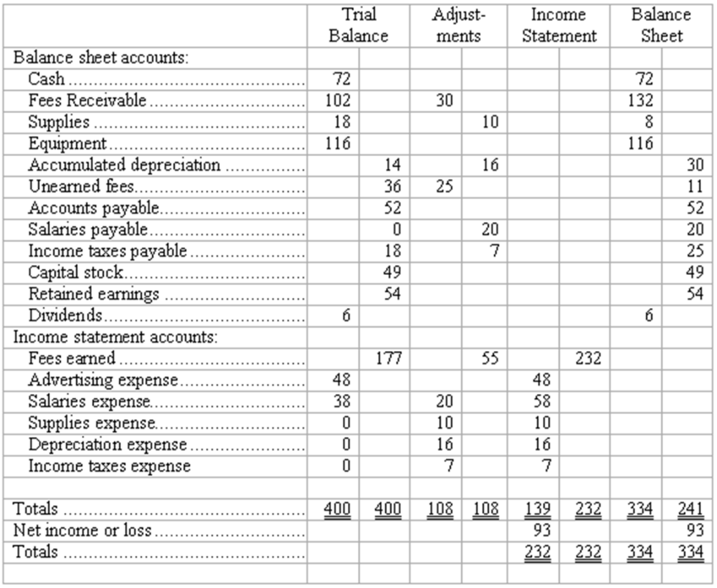

AACSB: Analytic
AICPA BB: Critical Thinking
AICPA FN: Measurement
Bloom's: Analyze
Difficulty: Medium
Learning Objective: 05-08 Prepare a worksheet and explain its uses.
Topic: Supplemental Topic: The Worksheet
111. Preparation of financial statements
Using the Adjusted Trial Balance shown below, prepare (a) an Income Statement and (b) a Statement of Retained Earnings for All Star Repairs.

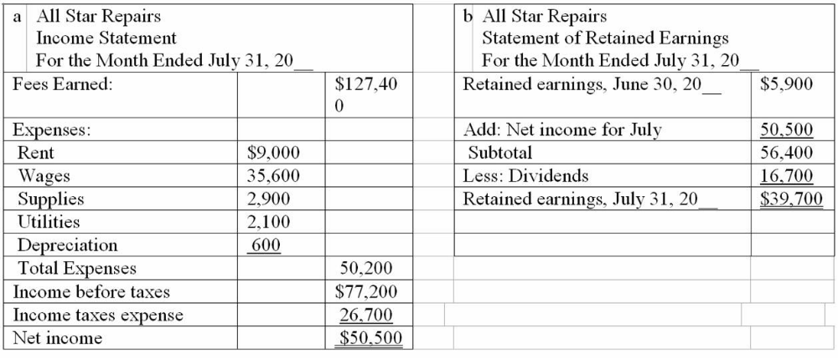

AACSB: Analytic
AICPA BB: Critical Thinking
AICPA FN: Measurement
Bloom's: Analyze
Difficulty: Medium
Learning Objective: 05-01 Prepare an income statement; a statement of retained earnings; and a balance sheet.
Topic: Preparing Financial Statements
112. Completion of worksheet--missing data
Certain data are given on the worksheet below, and certain missing data are indicated by the blank boxes. Sufficient information is included to fill in the missing data. Each account has a debit or credit balance characteristically normal for that kind of account. Note that the dollar amounts have been reduced to figures of not more than three digits to simplify the arithmetic.
Insert the figures necessary to complete the worksheet in the blanks indicated by an underline. The boxes cover both debit and credit columns; be sure to insert the missing figures in the correct column of the box. If no figure should appear in a column within a box, indicate this by placing a "0" in one or more columns of the box (see sample box opposite Cash).
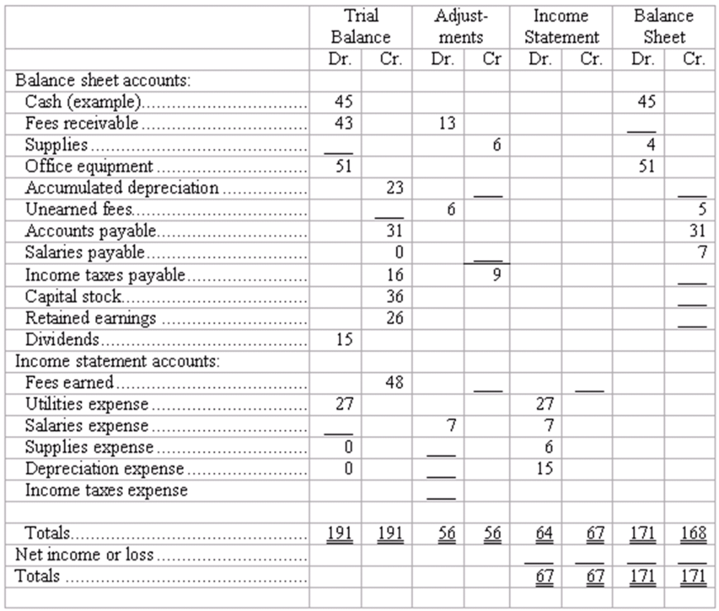

AACSB: Analytic
AICPA BB: Critical Thinking
AICPA FN: Measurement
Bloom's: Analyze
Difficulty: Medium
Learning Objective: 05-08 Prepare a worksheet and explain its uses.
Topic: Supplemental Topic: The Worksheet
113. Closing entries
An Adjusted Trial Balance for Tiger, Inc., at December 31 appears below.
Prepare journal entries to close the accounts. Use four entries to: (1) close the revenue account, (2) close the expense accounts, (3) close the Income Summary account, and (4) close the Dividends account.
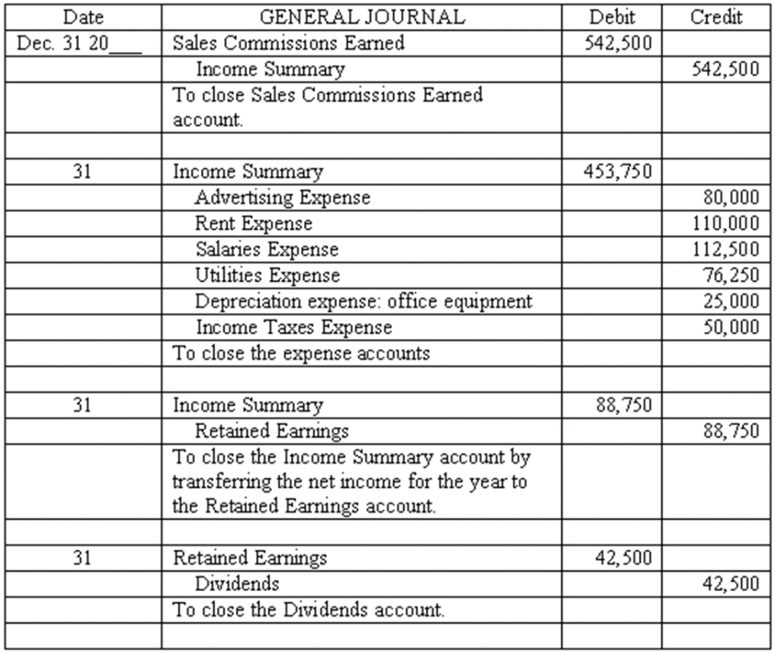

AACSB: Analytic
AICPA BB: Critical Thinking
AICPA FN: Measurement
Bloom's: Analyze
Difficulty: Medium
Learning Objective: 05-04 Explain the purposes of closing entries; prepare these entries.
Topic: Closing the Temporary Accounts
114. Adjustments and closing process--basic entries
Selected ledger accounts used by Goldstone Advertising, Inc., are listed along with identifying numbers. Following this list of account numbers and titles is a series of transactions. For each transaction, you are to indicate the proper accounts to be debited and credited.
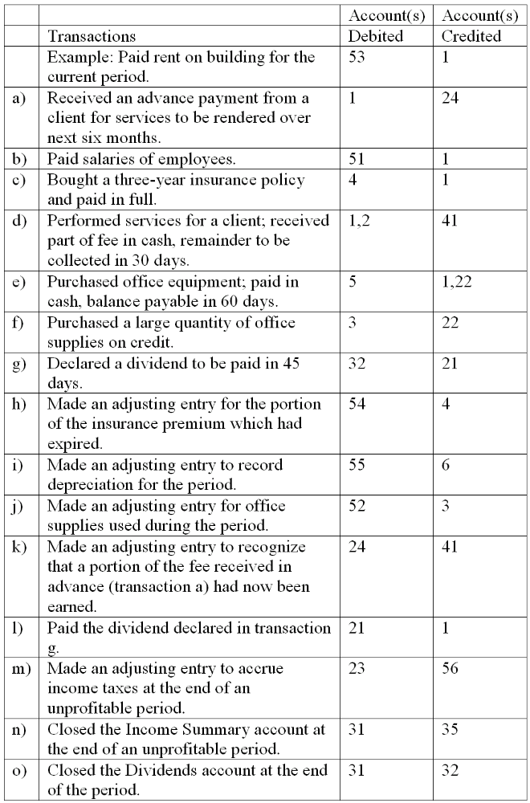

AACSB: Analytic
AICPA BB: Critical Thinking
AICPA FN: Measurement
Bloom's: Apply
Difficulty: Medium
Learning Objective: 05-04 Explain the purposes of closing entries; prepare these entries.
Topic: Closing the Temporary Accounts
115. Adjustments and closing process-basic entries
Selected ledger accounts used by Speedy Truck Rentals, Inc., are listed along with identifying numbers. Following this list of account numbers and titles is a series of transactions. For each transaction, you are to indicate the proper accounts to be debited and credited.
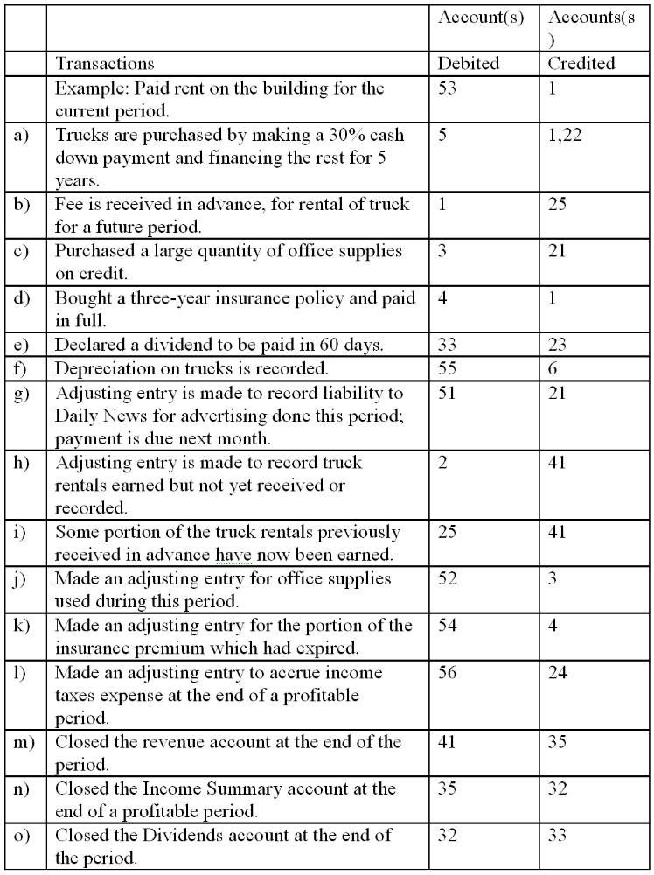

AACSB: Analytic
AICPA BB: Critical Thinking
AICPA FN: Measurement
Bloom's: Apply
Difficulty: Medium
Learning Objective: 05-04 Explain the purposes of closing entries; prepare these entries.
Topic: Closing the Temporary Accounts
116. Materiality
(a) Identify several factors considered by an accountant in deciding whether an item is "material."
(b) Does the concept of materiality complicate or simplify the process of making adjusting entries? Give an illustration to support your answer.
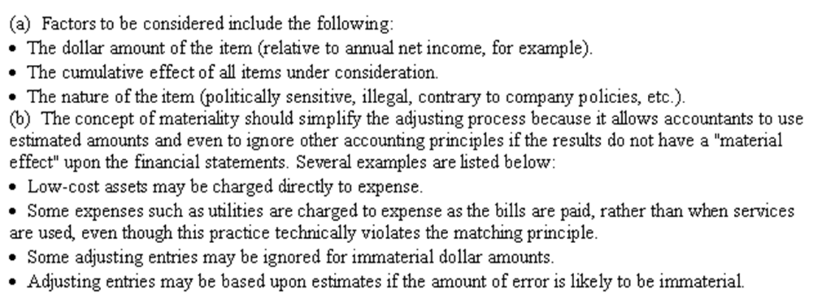

AACSB: Communications
AICPA BB: Critical Thinking
AICPA FN: Measurement
Bloom's: Understand
Difficulty: Medium
Learning Objective: 05-03 Explain the concept of adequate disclosure.
Topic: Relationships among the Financial Statements
117. Adequate disclosure
(a) Briefly explain what is meant by the principle of adequate disclosure.
(b) How does professional judgment enter into the application of the principle of adequate disclosure?
(c) List 5 types of information that a publicly-held corporation generally would be required to provide according to the concept of adequate disclosure.
(a) The principle of adequate disclosure means that financial statements should be accompanied by any information necessary for the statements to be interpreted properly. Most disclosures appear within several pages of notes (or footnotes) that accompany the financial statements.
(b) Drafting footnotes requires an in-depth understanding of the company and its operations. As there is no comprehensive list of information that must be disclosed and the content of the notes often is not drawn directly from the accounting records, the adequacy of disclosure is dependent upon the accountants' professional judgment. This professional judgment is used in selecting those items for disclosure that an intelligent person would consider necessary to properly interpret the financial statements.
(c) A publicly held corporation is generally required to disclose the following types of information (students are required to list five):
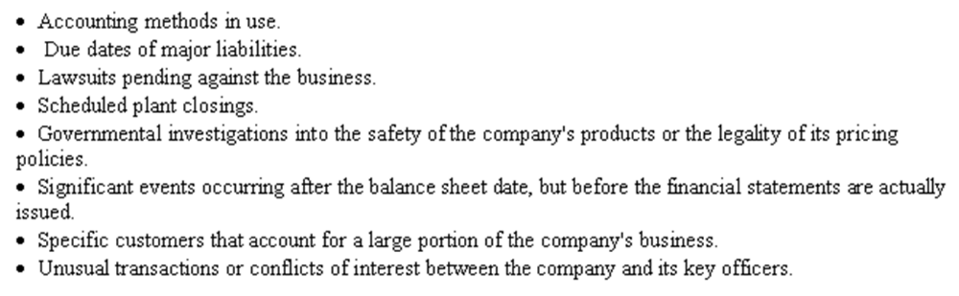

AACSB: Communications
AICPA BB: Legal
AICPA FN: Reporting
Bloom's: Understand
Difficulty: Medium
Learning Objective: 05-03 Explain the concept of adequate disclosure.
Topic: Relationships among the Financial Statements
118. Indicate which of the following accounts will be closed to Income Summary at year-end.
(a) Cash
(b) Office Supplies Expense
(c) Unexpired Insurance
(d) Unearned Revenue
(e) Dividends
(f) Depreciation Expense
(g) Income Taxes Payable
(h) Accumulated Depreciation
(b) Office Supplies Expense and (f) Depreciation Expense are the only accounts shown that will be closed to Income Summary.

AACSB: Reflective Thinking
AICPA BB: Critical Thinking
AICPA FN: Measurement
Bloom's: Understand
Difficulty: Medium
Learning Objective: 05-04 Explain the purposes of closing entries; prepare these entries.
Topic: Closing the Temporary Accounts
119. Given the following information for the Maple Tree Co. for the year ended December 31, 2009, prepare a Statement of Retained Earnings.
The Statement of Retained Earnings is as follows:
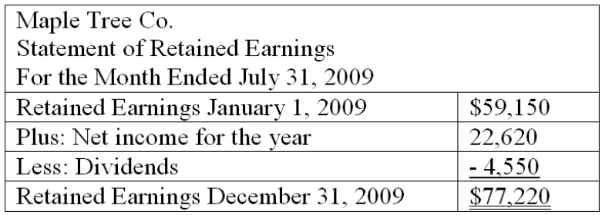

AACSB: Communications
AICPA BB: Legal
AICPA FN: Reporting
Bloom's: Analyze
Difficulty: Medium
Learning Objective: 05-02 Explain how the income statement and the statement of retained earnings relate to the balance sheet
Topic: Preparing Financial Statements
120. The accounts and their amounts for Belgrave Co. at December 31, 20__ are listed below. Prepare closing entries and an After-Closing Trial Balance.
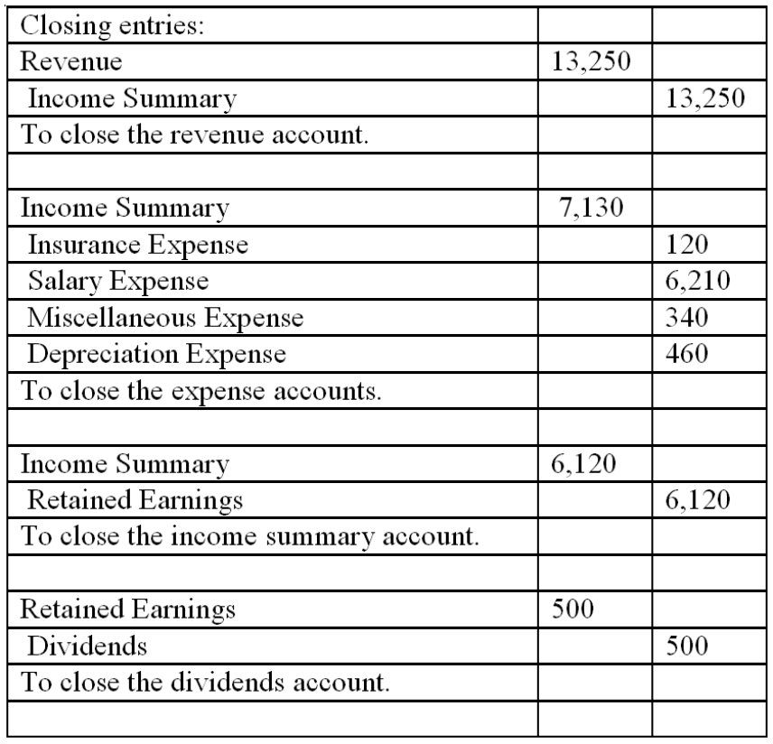
After-Closing Trial Balance
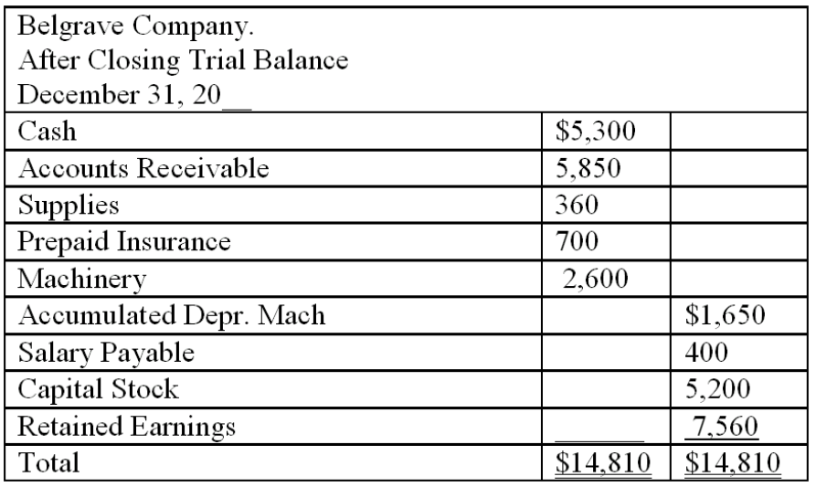

AACSB: Analytic
AICPA BB: Critical Thinking
AICPA FN: Measurement
Bloom's: Analyze
Difficulty: Medium
Learning Objective: 05-05 Prepare an after-closing trial balance.
Topic: After-Closing Trial Balance

Short Answer Questions
121. The accountant for Sheldrake Consulting prepared the following "Adjusted" Trial Balance at December 31, 2011, after one year of operations:
Prepare closing entries for Sheldrake Consulting.
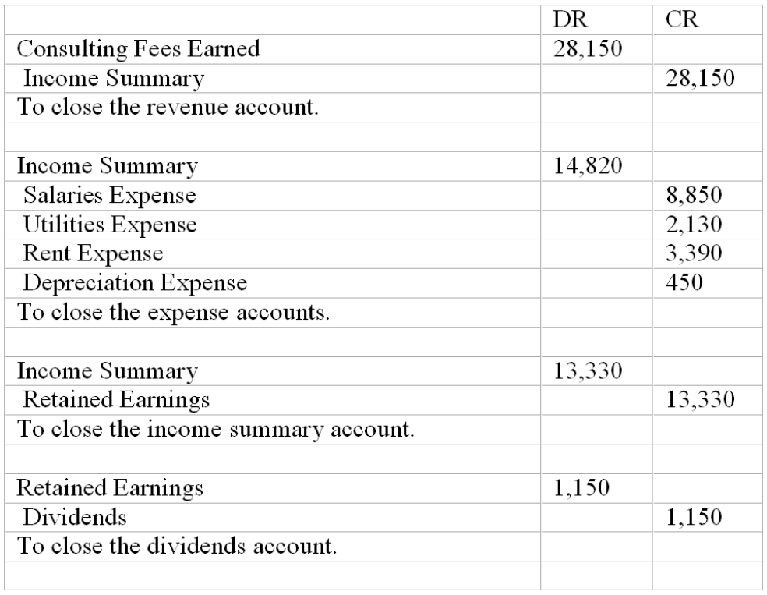

Learning Objective: 05-04 Explain the purposes of closing entries; prepare these entries.

Multiple Choice Questions

122. What is the balance in Income Summary before it is closed to Retained Earnings?
A. $61.
B. $50.
C. $73.
D. $145.

Learning Objective: 05-04 Explain the purposes of closing entries; prepare these entries.
Learning Objective: 05-05 Prepare an after-closing trial balance.
123. What is the balance in Retained Earnings after posting closing entries at December 31?
A. $117.
B. $106.
C. $61.
D. $45.

Learning Objective: 05-04 Explain the purposes of closing entries; prepare these entries.
Learning Objective: 05-05 Prepare an after-closing trial balance.
124. What is the total debits on the after-closing trial balance?
A. $222.
B. $372.
C. $233.
D. $161.

Learning Objective: 05-04 Explain the purposes of closing entries; prepare these entries.
Learning Objective: 05-05 Prepare an after-closing trial balance.
125. Which accounts are closed to Income Summary?
A. All accounts.
B. Revenue and expenses.
C. Revenue, expenses, and dividends.
D. All accounts that are not nominal.

Learning Objective: 05-04 Explain the purposes of closing entries; prepare these entries.
Learning Objective: 05-05 Prepare an after-closing trial balance.
126. Which accounts will appear on the balance sheet?
A. Retained earnings of $56.
B. Dividends of $11.
C. Net income of $60.
D. None of the above.

Learning Objective: 05-04 Explain the purposes of closing entries; prepare these entries.
Learning Objective: 05-05 Prepare an after-closing trial balance.

Short Answer Questions
127. The accountant for Successful Consulting prepared the following "Adjusted" Trial Balance at December 31, 20 __ after one year of operations:
Prepare an After-Closing Trial Balance.
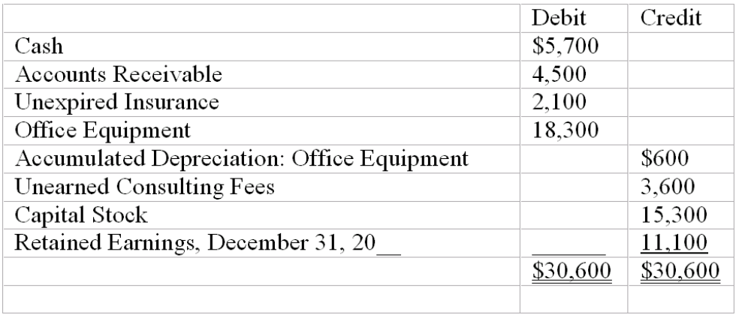

Learning Objective: 05-05 Prepare an after-closing trial balance.
128.
Prepare the closing entries.
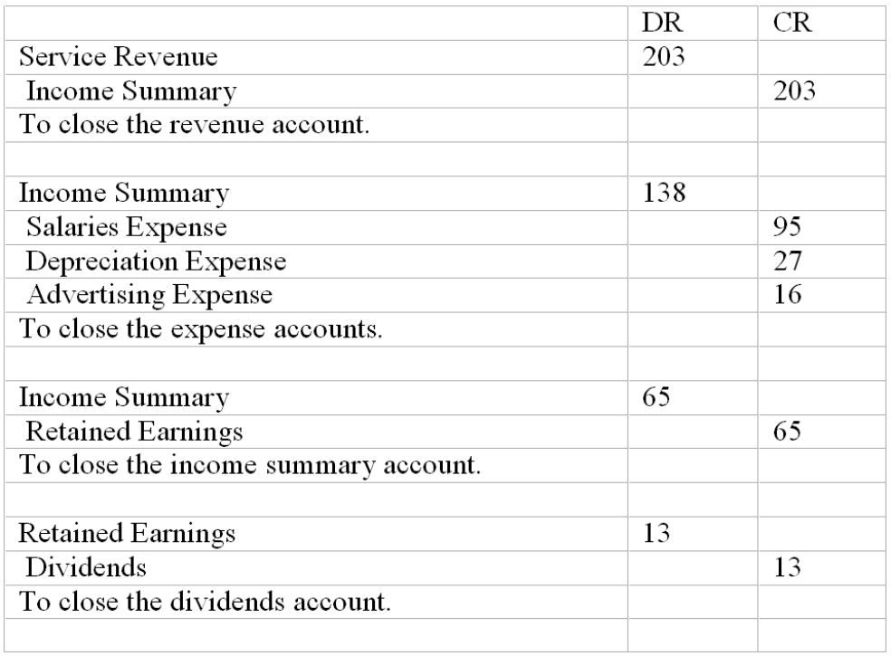

Learning Objective: 05-04 Explain the purposes of closing entries; prepare these entries.

Multiple Choice Questions
129. For a publicly held company, indicate which of the following activities are likely to occur at or shortly after year-end. (More than one answer may be correct.)
A. Preparing of income tax returns.
B. Adjusting and closing the accounts.
C. Drafting disclosures that accompany financial statements.
D. An audit of the financial statements by a firm of CPAs.

130. Which of the following financial statements is generally prepared first?
A. Income statement.
B. Balance sheet.
C. Statement of retained earnings.
D. Statement of cash flows.

131. Which of the following accounts would never be reported in the income statement as an expense?
A. Depreciation expense.
B. Income taxes expense.
C. Interest expense.
D. Dividends expense.

132. Which of the following accounts would never appear in the after-closing trial balance? (More than one answer may be correct)
A. Unearned revenue.
B. Dividends.
C. Accumulated depreciation.
D. Income taxes expense.

133. Which of the following journal entries is required to close the Income Summary account of a profitable company?
A. Debit Income Summary, credit Retained earnings.
B. Credit Income Summary, debit Retained earnings.
C. Debit Income Summary, credit Capital Stock.
D. Credit Income Summary, debit Capital Stock.

134. Indicate those items for which generally accepted accounting principles require disclosure in notes accompanying the financial statements. (More than one answer may be correct.)
A. A large lawsuit was filed against the company two days after the balance sheet date.
B. The depreciation method in use, given that several different methods are acceptable under generally accepted accounting principles.
C. Whether small but long-lived items-such as electric pencil sharpeners and handheld calculators-are charged to asset accounts or to expense accounts.
D. As of year-end, the chief executive officer had been hospitalized because of chest pains.

135. Ski West adjusts its accounts at the end of each month, but closes them only at the end of the calendar year (December 31). The ending balances in the Equipment Rental Revenue account and the Cash account in February and March appear below.
Ski West prepares financial statements showing separately the operating results of each month. In the financial statements prepared for the month ended March 31, Equipment Rental Revenue and Cash should appear as follows:
A. Equipment Rental Revenue, $18,400; Cash, $26,500.
B. Equipment Rental Revenue, $18,400; Cash, $12,300.
C. Equipment Rental Revenue, $6,300; Cash, $26,500.
D. Equipment Rental Revenue, $6,300; Cash, $12,300.

136. Which of the following accounts is not closed to the Income Summary at the end of the accounting period? (More than one answer may be correct).
A. Rent expense.
B. Accumulated Depreciation.
C. Unearned Revenue.
D. Supplies Expense.

