Chapter 03
The Accounting Cycle: Capturing Economic Events

True / False Questions
1. The credit side of an account is the right side, while the debit side is the left side.
True False

2. In a computerized accounting system, posting may be done automatically but journalizing must be done by someone with an understanding of recording transactions.
True False

3. The running balance form or the T account form is typically used in the trial balance to display the accounts and their amounts.
True False

4. Dividends are an expense of a corporation and reduce both total assets and liabilities.
True False

5. Dividends increase owners' equity and therefore should be added to retained earnings.
True False

6. Every business transaction is recorded by a debit to a balance sheet account and a credit to an income statement account.
True False

7. Earning revenue increases owners' equity and expenses reduce owners' equity, therefore, revenues are recorded with debit entries and expenses are recorded with credit entries.
True False

8. A trial balance cannot be distributed to stockholders in lieu of a balance sheet.
True False

9. Accounts are usually arranged in the ledger in financial statement order, that is, assets first, followed by liabilities, owners' equity, expenses, and revenues.
True False

10. A credit to a ledger account refers to the entry of an amount on the right side of an account.
True False

11. The left-hand side of an account is used for recording debits and the right-hand side for recording credits.
True False

12. If the number of debit entries in an account is greater than the number of credit entries, the account will have a debit balance.
True False

13. Liability accounts should only be debited and never credited.
True False

14. Increases in owners' equity are recorded by credits; increases in assets and in liabilities are recorded by debits.
True False

15. When making a general journal entry, there can only be one debit and one credit.
True False

16. A business that is profitable and liquid will have more accounts with credit balances than with debit balances.
True False

17. Every transaction affects equal numbers of ledger accounts and is recorded by equal dollar amounts of debits and credits.
True False

18. When a company uses the double-entry method, the total dollar amount of debits recorded must equal the total dollar amount of credits recorded, but the number of debit and credit entries may differ.
True False

19. If ledger accounts are maintained in three-column, running balance form, the journal should be maintained in the same format.
True False

20. The general ledger is sometimes called the book of original entry because it is the accounting record where transactions are first recorded.
True False

21. Each business transaction is initially recorded in a journal and later transferred to the appropriate accounts in the general ledger.
True False

22. The matching principle refers to the relationship between revenues and expenses.
True False

23. An increase in a liability is recorded by a credit; an increase in owners' equity by a debit.
True False

24. Revenues increase owners' equity and are, therefore, recorded by crediting the revenues account.
True False

25. The accrual basis of accounting recognizes expenses only when they are paid.
True False

26. Every transaction which affects an income statement account also affects a balance sheet account.
True False

27. A trial balance that balances provides proof that all transactions were correctly journalized and posted to the ledger.
True False

28. A trial balance proves that equal amounts of debits and credits were posted to the ledger.
True False

29. Dividends are an expense to a corporation and appear on the income statement.
True False

30. A CEO or CFO associated with fraudulent financial reporting could be fined but not imprisoned under the Sarbanes Oxley Act.
True False

31. "I was just following orders" is an acceptable defense if you committed an unethical action during an audit.
True False

Multiple Choice Questions
32. Sally Smith had expenses of $800 in June which she paid in July. She declared these expenses on her June income statement. By doing this, she is following the accounting principle of:
A. Revenue realization.
B. Adequate disclosure.
C. Matching.
D. Conservatism.

33. The price of the goods sold or services rendered during a given accounting period is called:
A. Net income.
B. Profit.
C. Revenue.
D. Equity.

34. The principle that states revenue should be recognized at the time goods are sold or services rendered is called:
A. Adequate disclosure.
B. Conservatism.
C. Matching.
D. Revenue realization.

35. Recognizing revenue when it is earned and not when cash is received and recognizing expenses when the related goods or services are used rather than when they are paid for is called:
A. Revenue recognition.
B. Accrual accounting.
C. Conservatism.
D. Matching.

36. The agreement of the debit and credit totals of the trial balance gives assurance that:
A. All transactions were posted correctly.
B. No transactions were omitted.
C. The number of accounts with debit balances equals the number of accounts with credit balances.
D. The total debits equal the total credits.

37. The sequence of accounting procedures used to record, classify, and summarize accounting information is called the:
A. Accounting cycle.
B. Accounting period.
C. Accrual accounting.
D. Double-entry bookkeeping.

38. The purchase of equipment on credit is recorded by a:
A. Debit to Equipment and a credit to Accounts Payable.
B. Debit to Accounts Payable and a credit to Equipment.
C. Debit to Equipment and a debit to Accounts Payable.
D. Credit to Equipment and a credit to Accounts Payable.

39. The collection of accounts receivable is recorded by a:
A. Debit to Cash and a debit to Accounts Receivable.
B. Credit to Cash and a credit to Accounts Receivable.
C. Debit to Cash and a credit to Accounts Receivable.
D. Credit to Cash and a debit to Accounts Receivable.

40. Which of the following accounts normally has a debit balance?
A. Accounts payable.
B. Retained earnings.
C. Accounts receivable.
D. Service revenue.

41. In the general ledger, a separate "account" is maintained for each:
A. Type of asset and liability and for each element of owners' equity.
B. Business transaction.
C. Business day.
D. Journal entry.

42. In accounting, the terms debit and credit indicate, respectively:
A. Increase and decrease.
B. Left and right.
C. Decrease and increase.
D. Right and left.

43. In a ledger, debit entries cause:
A. Increases in owners' equity, decreases in liabilities, and increases in assets.
B. Decreases in liabilities, increases in assets, and decreases in owners' equity.
C. Decreases in assets, decreases in liabilities, and increases in owners' equity.
D. Decreases in assets, increases in liabilities, and increases in owners' equity.

44. Which of the following accounts normally has a credit balance?
A. Cash.
B. Service revenue.
C. Accounts receivable.
D. Utilities expense.

45. Which of the following is not true regarding the general ledger account for Cash?
A. The balance of the account indicates the amount of cash owned by the business on a particular date.
B. Each debit entry in the Cash account represents a cash receipt.
C. Debit entries are made before credit entries.
D. Credit entries in the Cash account represent cash payments.

46. The rules of debit and credit may be summarized as follows:
A. Accounts on the left side of the balance sheet are increased by debits, whereas, accounts on the right side of the balance sheet are increased by credits.
B. The balance of a ledger account is increased by debit entries and is decreased by credit entries.
C. Accounts on the left side of the balance sheet are increased by credits, whereas accounts on the right side of the balance sheet are increased by debits.
D. The balance of a ledger account is increased by credit entries and is decreased by debit entries.

47. The essential point of a double-entry system of accounting is that every transaction:
A. Affects accounts on both sides of the balance sheet.
B. Is recorded in both the journal and the ledger.
C. Increases one ledger account and decreases another.
D. Affects two or more ledger accounts and is recorded by an equal dollar amount of debits and credits.

48. Double-entry accounting is characterized by which of the following?
A. Every transaction affects both an asset account and either a liability account or an owners' equity account.
B. The number of general ledger accounts with debit balances is equal to the number with credit balances.
C. The total dollar amount of debit entries posted to the general ledger is equal to the dollar amount of the credit entries.
D. The number of debit entries posted to the general ledger equals the number of credit entries.

49. The process of originally recording a business transaction in the accounting records is termed:
A. Journalizing.
B. Footing.
C. Posting.
D. Balancing.

50. If the trial balance has a higher debit balance than credit balance, it signifies:
A. Assets are more than liabilities.
B. A profit.
C. A loss.
D. An error has been made.

51. Brett Tarek, a manager at D&J Landscaping, Inc. needs information regarding the amount of accounts payable currently owed by the company. This information would most easily be found in the:
A. General ledger.
B. General journal.
C. Income statement.
D. Notes to the financial statements.

52. Which of the following accounting procedures requires the greatest knowledge of generally accepted accounting principles?
A. Journalizing business transactions.
B. Posting journal entries to ledger accounts.
C. Preparing a trial balance.
D. Locating errors in a trial balance.

53. Transactions are recorded in the general journal in:
A. Numerical order.
B. Chronological order.
C. Account number order.
D. Financial statement order.

54. A transaction is first recorded in which of the following accounting records?
A. Trial balance.
B. Ledger.
C. General journal.
D. Balance sheet.

55. What type of account will normally contain a debit balance?
A. Asset.
B. Liability.
C. Owners' equity.
D. Revenue.

56. If the trial balance has a smaller debit balance than credit balance, it signifies:
A. Assets are more than liabilities.
B. A profit.
C. A loss.
D. An error has been made.

57. The manager of Grande Home Improvements purchased several cash registers for the business on June 10 but does not remember whether he paid cash for the full price or still owes a balance to the vendor. Where is the best place for the manager to get the information about this transaction?
A. A trial balance prepared at the end of June.
B. The general journal.
C. A balance sheet prepared at the end of June.
D. The ledger account for equipment.

58. Sue Costa, owner of A-1 Cleaning Services, invested an additional $75,000 in the company. Which of the following would be a part of the correct journal entry to record this transaction?
A. A debit to the Cash account.
B. A debit to the Equity account.
C. A debit to the Capital Stock account.
D. A debit to the Cash Received account.

59. If a company purchases equipment on account:
A. Assets will increase and owners' equity will also increase.
B. Assets will increase and owners' equity will decrease.
C. Assets will increase and owners' equity will remain unchanged.
D. Assets will increase and liabilities will decrease.

60. Preparing a journal entry in proper form involves all the following except:
A. Listing all accounts debited before any credits.
B. Computing the balances in accounts involved in the transaction.
C. Indicating the date of the transaction.
D. Providing a brief written explanation of the transaction.

61. The journal entry to record a particular business transaction includes a credit to a liability account. This transaction is most likely also to include:
A. Issuance of new capital stock.
B. The purchase of an asset on account.
C. A cash payment.
D. A credit to Accounts Receivable.

62. The journal entry to record a particular business transaction includes a credit to the Cash account. This transaction is most likely also to include:
A. Issuance of new capital stock.
B. The purchase of an asset on account.
C. Payment of an outstanding note payable.
D. A credit to Accounts Receivable.

63. The collection of an account receivable is recorded by a debit to Cash and a credit to Accounts Payable. If this error is not corrected:
A. Total liabilities are understated.
B. Total assets are understated.
C. Total liabilities are overstated.
D. Owners' equity is overstated.

64. Posting is the process of:
A. Transferring debit and credit entries from the journal into the appropriate ledger accounts.
B. Determining that the dollar amount of debit entries recorded in the ledger is equal to the dollar amount of credit entries.
C. Entering information into a computerized data base.
D. Preparing journal entries to describe each business transaction.

65. If a company purchases equipment for cash:
A. Assets will increase and owners' equity will also increase.
B. Assets will increase and owners' equity will decrease.
C. Assets will increase and owners' equity will remain unchanged.
D. Total assets and owners' equity will remain unchanged.

66. A trial balance that is out of balance indicates that:
A. The number of ledger accounts with debit balances is not equal to the number of accounts with credit balances.
B. A debit has been posted to the wrong account.
C. There is not an equality of debit and credit amounts in the ledger.
D. A journal entry has been completely omitted from the posting process.

67. A trial balance consists of:
A. A two-column schedule of all debit and credit entries posted to ledger accounts.
B. A two-column financial statement intended for distribution to interested parties outside the business.
C. A two-column schedule showing the totals of all debits and of all credits made in journal entries.
D. A two-column schedule listing names and balances of all ledger accounts.

68. Green Systems sold and delivered modems to Blue Computers for $660,000 to be paid by Blue in three equal installments over the next three months. The journal entry made by Blue Computers to record the last of the three installment payments will include:
A. A debit of $220,000 to Modem Expense.
B. A debit of $220,000 to Accounts Receivable.
C. A debit of $220,000 to Cash.
D. A debit of $220,000 to Accounts Payable.

69. Which of the following errors would be disclosed by preparation of a trial balance?
A. The collection of an account receivable was recorded by a debit to the Land account rather than to the Cash account.
B. The collection of an account receivable for $219 was recorded by a $291 debit to Cash and a $291 credit to Accounts Receivable.
C. The collection of a $365 account receivable was not recorded at all.
D. The collection of a $325 account receivable was recorded by a $325 debit to Cash and a $325 debit to Accounts Receivable.

70. Which of the following errors would not be disclosed by preparation of a trial balance?
A. An error was made in computing the balance of the Cash account.
B. A journal entry included a debit to the Equipment account for $3,200, but this amount was erroneously posted as $2,300.
C. During the posting process, a $1,700 debit to Cash was accidentally entered in the credit side of the Cash account.
D. The journal entries recorded on the last day of the year have never been posted to the ledger.

71. Black Systems sold and delivered modems to White Computers for $330,000 to be paid by White in three equal installments over the next three months. The journal entry made by Black Systems to record this transaction will include:
A. A debit to Sales Revenue for $330,000.
B. A debit to Accounts Receivable for $330,000.
C. A debit to Accounts Receivable for $110,000.
D. A debit to Cash Paid for $330,000.

72. The statement "This business produced net income of $520,000" is unclear because it failed to specify:
A. The accounting method, that is, accrual or cash basis.
B. Whether the amount earned is before or after expenses.
C. The time period.
D. The amount of cash withdrawn from the business by the owner.

73. The term revenue can best be described as:
A. The selling price of goods and services rendered to customers during a given accounting period.
B. The cash received from selling goods and serving customers during a given accounting period.
C. The net increase in owners' equity during a given period.
D. The "bottom line" in the income statement.

74. The realization principle indicates that revenue usually should be recognized and recorded in the accounting records:
A. When goods are sold or services are rendered to customers.
B. When cash is collected from customers.
C. At the end of the accounting period.
D. Only when the revenue can be matched by an equal dollar amount of expenses.

75. In February of each year, the Carlton Hotel holds a very popular wine tasting event. Tickets must be ordered and paid for in advance, and are typically sold out by November of the preceding year. The realization principle indicates that the revenue from these ticket sales should be recognized in the period in which the:
A. Order is placed.
B. Wine tasting event is held.
C. Payments are received.
D. Expenses associated with the wine tasting are paid in full.

76. Collection of an accounts receivable:
A. Increases the total assets of a company.
B. Decreases the total assets of a company.
C. Does not change the total assets of a company.
D. Reduces a company's total liabilities.

77. The matching principle is best demonstrated by:
A. Using debits to record decreases in owners' equity and credits to record increases.
B. The equation Assets = Liabilities + Owners' Equity.
C. Allocating the cost of an asset to expense over the periods during which benefits are derived from the asset.
D. Offsetting the cash receipts of the period with the cash payments made during the period.

78. Net income is:
A. The excess of debits over credits.
B. The increase in owners' equity resulting from the profitable operations of the business.
C. The excess of credits over debits.
D. The increase in assets of a company during a year.

79. Clinton prepares monthly financial statements. Which of the following violates the matching principle?
A. A portion of the salary payments made this month are not recognized as expense because some of the work was done by employees last month.
B. The premium on a six-month insurance policy is charged immediately to expense.
C. Expenses for the period exceed revenues.
D. The cost of advertising done during the month is charged to expense even though no payment is due for 60 days.

80. The matching principle:
A. Applies only to situations in which a cash payment occurs before an expense is recognized.
B. Applies only to situations in which a cash receipt occurs before revenue is recognized.
C. Is used in accrual accounting to determine the proper period in which to recognize revenue.
D. Is used in accrual accounting to determine the proper period for recognition of expenses.

81. The reason that revenue is recorded by a credit entry to a revenue account is:
A. That revenue always involves a debit to the Cash account.
B. Explained by the realization principle.
C. Explained by the matching principle.
D. That revenue increases owners' equity.

82. Revenues increase owners' equity because:
A. Revenues increase net income which increases retained earnings.
B. Revenues are recorded by a credit.
C. Of the matching principle.
D. The realization principle requires revenues be recognized with an increase to owners' equity.

83. The reason that both expenses and dividends are recorded by debit entries is that:
A. All dividend and expense transactions involve offsetting credit entries to the Cash account.
B. Both expenses and dividends are offset against revenues in the income statement.
C. Both expenses and dividends reduce owners' equity.
D. The statement is untrue-expenses are recorded by debits, but dividends are recorded by credits to the owners' equity account.

84. A journal entry which records revenue must include:
A. A debit to Cash.
B. A credit to a revenue account.
C. A credit to the owners' equity account.
D. A debit to the owners' equity account.

85. A journal entry to record revenue could include each of the following, except:
A. A credit to a revenue account.
B. A credit to the Capital Stock account.
C. A debit to Cash.
D. A debit to Accounts Receivable.

86. A journal entry to recognize an expense must include:
A. A credit to Accounts Payable.
B. A credit to an expense account.
C. A credit to Cash.
D. A debit to an expense account.

87. A journal entry to recognize an expense could include each of the following, except:
A. A debit to an expense account.
B. A credit to Accounts Payable.
C. A debit to a liability account.
D. A credit to Cash.

88. Which of the following accounts normally does not have a debit balance?
A. Dividends.
B. Wage Expense.
C. Building.
D. Capital Stock.

89. On June 18, Baltic Arena paid $6,600 to Marvin Maintenance, Inc. for cleaning the arena following a monster truck show held on June 9th. This transaction:
A. Is recorded by debiting the Retained Earnings account.
B. Is recorded by debiting Cash and crediting Cleaning Expense.
C. Causes a decrease in owners' equity by increasing expenses for June.
D. May not be recorded until all revenue generated from the monster truck show has been collected in cash.

90. Davis, Inc., a music group, entertained at a black-tie dinner dance on April 26, and collected the fee in full at the end of the evening. This transaction:
A. Causes an increase in assets and revenue, as well as an increase in owners' equity.
B. Is recorded by debiting Cash and crediting the Retained Earnings account.
C. Causes an increase in assets and a decrease in owners' equity.
D. Violates the matching principle unless any expenses associated with this cash receipt are paid prior to recording the revenue.

91. At the end of October, Flagship Marina received a bill for fuel used in October. Payment is not due until November 30. This transaction:
A. Should not be recorded in the accounting records until November.
B. Causes a decrease in assets and in owners' equity in November, when the bill is paid.
C. Should be recorded as an expense of October, regardless of the payment date.
D. Is recorded as a liability in October, but is not considered an expense until paid.

92. On June 27, Healthy Life Services, Inc. performed extensive tests on lab specimens submitted by several customers and sent invoices totaling $5,200, due in 30 days.
A. No revenue from rendering these services should be recorded until payment is received.
B. This situation causes an increase in assets and in revenue in June, but has no effect on owners' equity until payment is received.
C. Revenue is earned in June, but assets are not increased until payment is received.
D. Assets, revenue, and owners' equity are increased in June, regardless of when payments are received for the services rendered.

The following transactions occurred during March, the first month of operations for Quality Galleries, Inc.
* Capital stock was issued in exchange for $360,000 cash.
* Purchased $180,000 of equipment by making a $60,000 cash down payment and signing a note payable for the balance.
* Made a $35,000 cash payment on the note payable from the purchase of equipment.
* Sold a piece of equipment for cash of $18,000. The equipment was sold at cost, so there is no gain or loss on the sale.

93. What is the balance in the Cash account at the end of March?
A. $283,000.
B. $343,000.
C. $318,000.
D. $378,000.

94. What are total assets of Quality Galleries at the end of March?
A. $283,000.
B. $162,000.
C. $445,000.
D. $480,000.

95. What is the balance in the Note Payable account at the end of March?
A. $120,000.
B. $85,000.
C. $35.000.
D. $155,000

96. What is the total owners' equity at the end of March?
A. $283,000.
B. $445,000.
C. $480,000.
D. $360,000.

The following transactions occurred during May, the first month of operations for Hunter Products, Inc:
* Issued 50,000 shares of capital stock to the owners of the corporation in exchange for $600,000 cash.
* Purchased a piece of land for $400,000, making a $150,000 cash down payment and signing a note payable for the balance.
* Made a $60,000 cash payment on the note payable from the purchase of land.
* Purchased equipment on credit from BBW, Inc. for $63,000.

97. What is the balance in the Cash account at the end of May?
A. $210,000.
B. $390,000.
C. $600,000.
D. $810,000.

98. What are total assets of Hunter Products at the end of May?
A. $913,000.
B. $790,000.
C. $853,000.
D. $916,000.

99. What is the total of Hunter Products' liabilities at the end of May?
A. $253,000.
B. $190,000.
C. $63,000.
D. $313,000.

100. What is the total owners' equity at the end of May?
A. $810,000.
B. $600,000.
C. $790,000.
D. $660,000.

101. Master Equipment has a $17,400 liability to Arrow Paint Co. When Master Equipment makes a partial payment of $7,600 on this liability, which of following is true about the journal entry made by Master to record this transaction?
A. The Cash Paid Out account is debited $7,600.
B. The liability account Accounts Payable is credited $9,800.
C. The Cash account is debited $7,600.
D. The Accounts Payable account is debited $7,600.

102. Eagle News has a $6,000 account receivable from one of its advertisers, Allwood Floors. When Eagle receives $3,600 from Allwood as partial payment:
A. Eagle should debit Accounts Receivable for $3,600.
B. Eagle should credit Cash for $3,600.
C. Eagle should credit Accounts Receivable for $3,600.
D. Eagle makes no journal entry until the total of $6,000 is received from Allwood.

103. Bruno's Pizza Restaurant makes full payment of $8,300 on an account payable to Stella's Cheese Co. Stella's would record this transaction with a:
A. Debit to Accounts Payable for $8,300.
B. Credit to Cash for $8,300.
C. Credit to Accounts Receivable for $8,300.
D. Credit to Accounts Payable for $8,300.

104. The purchase of office equipment at a cost of $7,600 with an immediate payment of $4,200 and agreement to pay the balance within 60 days is recorded by:
A. A debit of $7,600 to Office Equipment, a debit of $4,200 to Accounts Receivable, and a credit of $3,400 to Accounts Payable.
B. A debit of $7,600 to Office Equipment, a credit of $4,200 to Cash, and a credit of $3,400 to Accounts Receivable.
C. A debit of $3,400 to Accounts Receivable, a debit of $4,200 to Cash, and a credit of $7,600 to Office Equipment.
D. A debit of $7,600 to Office Equipment, a credit of $4,200 to Cash, and a credit of $3,400 to Accounts Payable.

105. Land is purchased by making a cash down payment of $40,000 and signing a note payable for the balance of $130,000. The journal entry to record this transaction in the accounting records of the purchaser includes:
A. A credit to Land for $40,000.
B. A debit to Cash for $40,000.
C. A debit to Land for $170,000.
D. A debit to Note Payable for $130,000.

The bookkeeper for Wood Mfg. made the following journal entry on January 30, 2009:
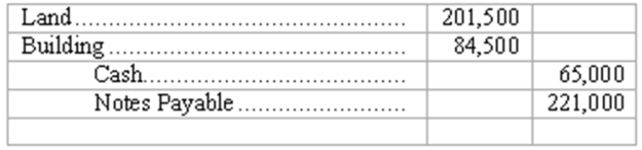

106. This transaction involves:
A. The sale of land and building for $286,000.
B. Payment of $221,000 on a note payable.
C. The receipt of $65,000 cash.
D. An increase in liabilities of $221,000.

107. Before the journal entry above, Wood had assets, liabilities, and owners' equity of $450,000, $100,000, and $350,000, respectively. What are total assets immediately after the above transaction occurs?
A. $221,000.
B. $671,000.
C. $735,500.
D. $450,000.

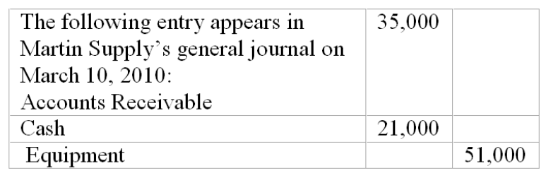

108. This transaction involves:
A. Martin's collection of $35,000 on an account receivable.
B. Payment of $21,000 cash by Martin.
C. A $21,000 overall increase in Martin's assets.
D. Sale of equipment by Martin for $51,000.

109. Before the journal entry above, Martin had assets of $900,000; liabilities of $460,000; and owners' equity of $440,000. Total assets immediately after the above transaction has been recorded amount to:
A. $905,000.
B. $921,000.
C. $956,000.
D. $794,000.

Montauk Oil Co. reports these account balances at December 31, 2010
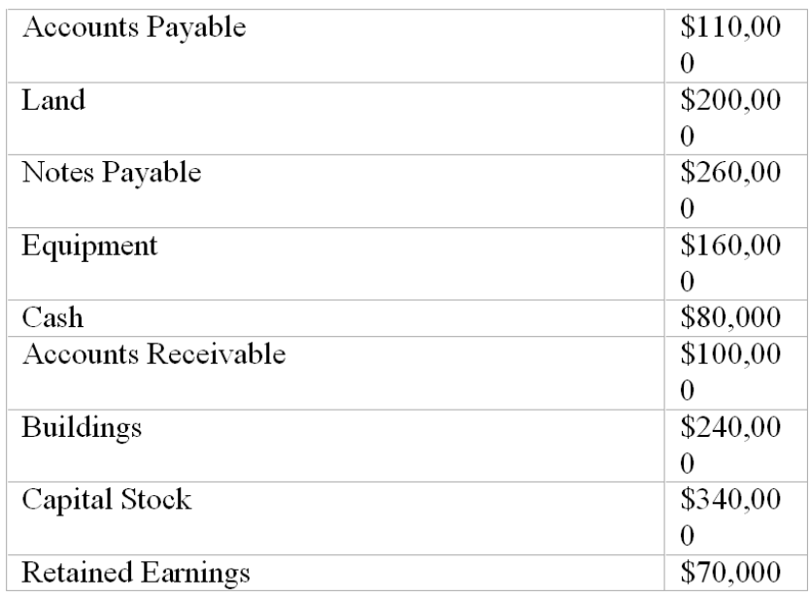
On January 2, 2011, Montauk Oil collected $50,000 of its accounts receivable and paid $20,000 of its accounts payable.

110. In a trial balance prepared at December 31, 2010 the total of the debit column is:
A. $1,540,000.
B. $780,000.
C. $1,020,000.
D. $700,000.

111. In a trial balance prepared at January 3, 2011, the total of the debit column is:
A. $760,000.
B. $1,570,000.
C. $740,000.
D. $370,000.

112. On January 3, 2011, total liabilities are:
A. $370,000.
B. $350,000.
C. $300,000.
D. $70,000.

Ceramic Products, Inc. reports these account balances at January 1, 2009 (shown in alphabetical order):
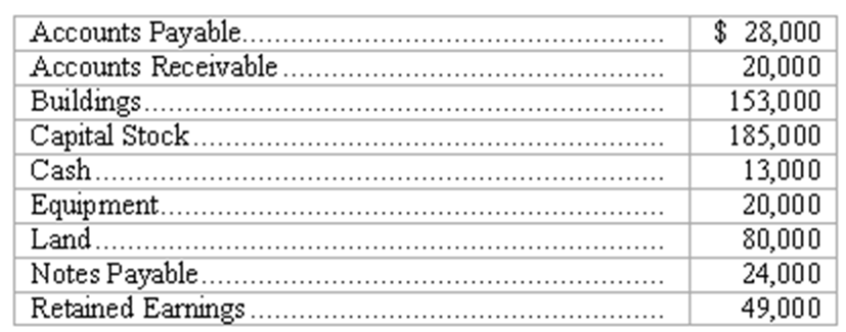
On January 5, Ceramic Products collected $12,000 of its accounts receivable and paid $11,000 on its note payable.

113. In a trial balance prepared for Ceramic Products on January 1, 2009, the total of the credit column is:
A. $182,000.
B. $196000.
C. $166,000.
D. $286,000.

114. In a trial balance prepared on January 5, 2009, the total of the credit column is:
A. $275,000.
B. $286,000.
C. $287,000.
D. $297,000.

115. On January 5, 2009, total liabilities are:
A. $0.
B. $30,000.
C. $56,000.
D. $41,000.

116. Ben Dryden, president of Jet Glass, Inc, noticed a $8,000 debit to Accounts Payable in the company's general ledger. This debit could correspond to:
A. A $8,000 sale to a customer.
B. A purchase of equipment costing $8,000 on credit.
C. A payment of $8,000 to a supplier to settle a balance due.
D. The failure to pay this month's $8,000 utility bill on time.

The following entry appears in Galloway Paints general journal on April 23, 2011:
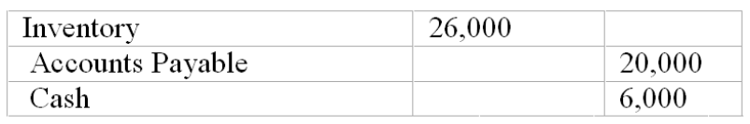

117. This transaction involves:
A. Galloway's collection of $20,000 on an account payable.
B. Payment of $6,000 cash by Galloway
C. A $26,000 overall increase in Galloway's assets.
D. Sale of inventory by Galloway for $26,000.

118. Before the journal entry above, Galloway had assets of $450,000; liabilities of $230,000; and owners' equity of $220,000. Total assets immediately after the above transaction has been recorded amount to:
A. $430,000.
B. $450,000.
C. $470,000.
D. $476,000.

Indirect Oil Co. reports these account balances at December 31, 2011
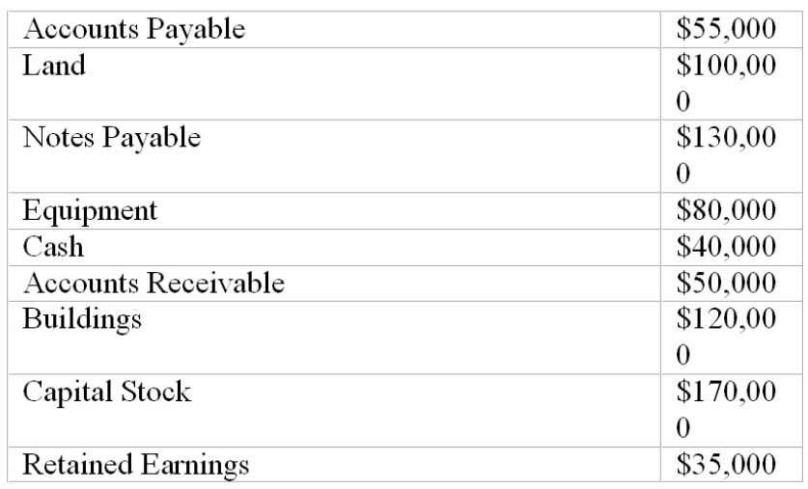
On January 2, 2012, Indirect Oil collected $25,000 of its accounts receivable and paid $20,000 of its accounts payable.

119. In a trial balance prepared at December 31, 2011 the total of the debit column is:
A. $805,000.
B. $780,000.
C. $415,000.
D. $390,000.

120. In a trial balance prepared at January 3, 2012, the total of the debit column is:
A. $760,000.
B. $825,000.
C. $740,000.
D. $370,000.

121. On January 3, 2012, total liabilities are:
A. $185,000.
B. $165,000.
C. $150,000.
D. $70,000.

Wilson Trucking, Inc. reports these account balances at January 1, 2012 (shown in alphabetical order):
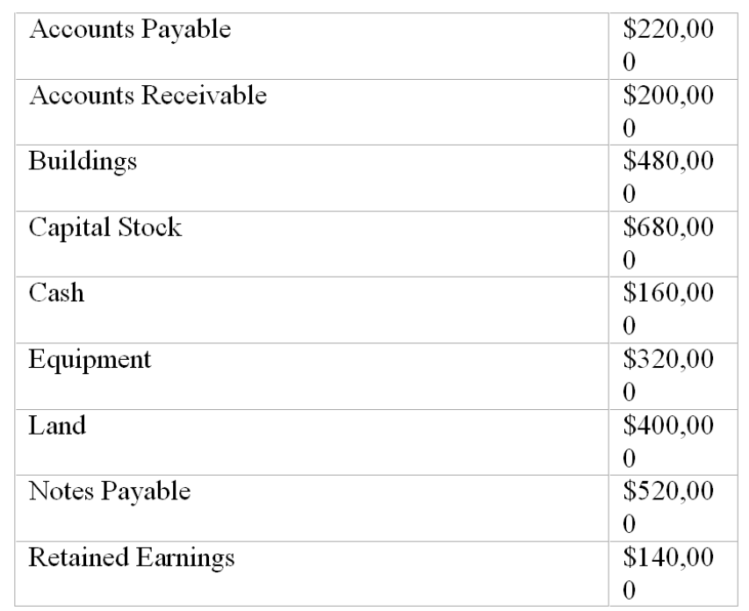
On January 5, Wilson Trucking collected $175,000 of its accounts receivable, paid $150,000 on its accounts payable, and paid $11,000 on its note payable.

122. In a trial balance prepared for Wilson Trucking on January 1, 2012, the total of the credit column is:
A. $1,580,000.
B. $1,560,000.
C. $1,620,000.
D. $3,120,000.

123. In a trial balance prepared for Wilson Trucking on January 5, 2012, the total of the debit column is:
A. $1,580,000.
B. $1,399,000.
C. $1,620,000.
D. $3,120,000.

124. In a trial balance prepared on January 5, 2012, the total of the credit column is:
A. $1,350,000.
B. $1,399,000.
C. $1,560,000.
D. $1,721,000.

125. On January 5, 2012, total liabilities are:
A. $0.
B. $579,000.
C. $1,399,000.
D. $1,721,000.

126. On January 5, 2012, total assets are:
A. $1,350,000.
B. $1,399,000.
C. $1,560,000.
D. $1,574,000.

Essay Questions
127. Accounting terminology
Listed below are nine technical accounting terms introduced in this chapter:
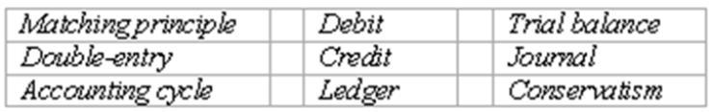
(A.) The accounting record in which transactions are initially recorded.
(B.) A concept designed to avoid overstatement of the financial strength of a company.
(C.) A schedule prepared to determine the equality of the debit and credit amounts in the ledger.
(D.) An amount entered in the right side of a ledger account.
(E.) The sequence of procedures involved in recording transactions, processing the information in the accounting system, and summarizing the information in the form of financial statements.
(F.) The accounting record that contains a separate account for each type of asset and liability, and for each element of owners' equity appearing in the balance sheet.
(G.) The system of accounting in which every business transaction is recorded by equal dollar amounts of debit and credit entries.

128. Recording transactions directly in T accounts; trial balance
On July 20, Mollie Rose began a new business called MR Printing, which provides typing, duplicating, and printing services. The following six transactions were completed by the business during July.
(A.) Issued to Rose 1,000 shares of capital stock in exchange for her investment of $200,000 cash.
(B.) Purchased land and a small building for $450,000, paying $165,000 cash and signing a note payable for the balance. The land was considered to be worth $240,000 and the building $210,000.
(C.) Purchased office equipment for $30,000 from Quality Interiors, Inc. Paid $17,000 cash and agreed to pay the balance within 60 days.
(D.) Purchased a motorcycle on credit for $3,400 to be used for making deliveries to customers. Mollie agreed to make payment to Spokes, Inc. within 10 days.
(E.) Paid in full the account payable to Spokes, Inc.
(F.) Borrowed $30,000 from a bank and signed a note payable due in six months.
Instructions
(A.) Record the above transactions directly in the T accounts below. Identify each entry in a T account with the letter shown for the transaction. This exercise does not call for the use of a journal.
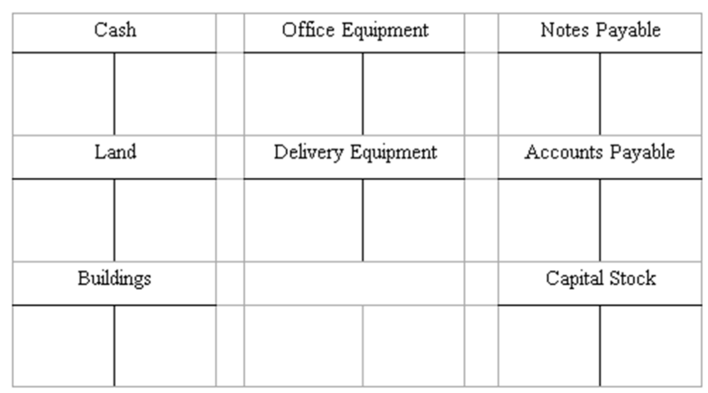
(B.) Prepare a trial balance at July 31 by completing the form provided.


129. Recording transactions in T accounts; trial balance
On May 15, George Manny began a new business, called Sounds, Inc., a recording studio to be rented out to artists on an hourly or daily basis. The following six transactions were completed by the business during May:
(A.) Issued to Manny 5,000 shares of capital stock in exchange for his investment of $200,000 cash.
(B.) Purchased land and a building for $410,000, paying $100,000 cash and signing a note payable for the balance. The land was considered to be worth $310,000 and the building $100,000.
(C.) Installed special insulation and soundproofing throughout most of the building at a cost of $120,000. Paid $32,000 cash and agreed to pay the balance in 60 days. Manny considers these items to be additional costs of the building.
(D.) Purchased office furnishings costing $18,000 and recording equipment costing $88,400 from Music Supplies. Sounds paid $28,000 cash with the balance due in 30 days.
(E.) Borrowed $180,000 from a bank by signing a note payable.
(F.) Paid the full amount of the liability to Music Supplies arising from the purchases in D above.
Instructions
(A.) Record the above transactions directly in the T accounts below. Identify each entry in a T account with the letter shown for the transaction. This exercise does not call for the use of a journal.
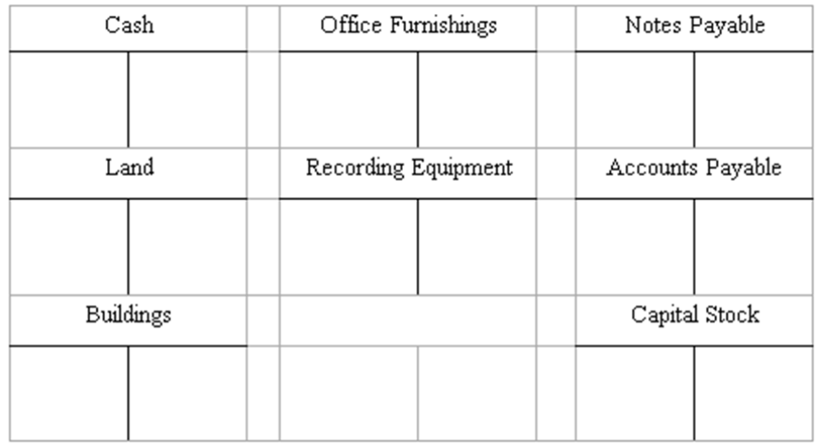
(B.) Prepare a trial balance at May 31 by completing the form provided.
SOUNDS, INC.
Trial Balance
May 31, 20__
Debit Credit

130. Recording transactions journal entry grid
A list of accounts for Harding Company is given below, followed by a series of transactions. Indicate the accounts that would be debited and credited in recording each transaction by placing the appropriate number (or numbers) in the space provided.
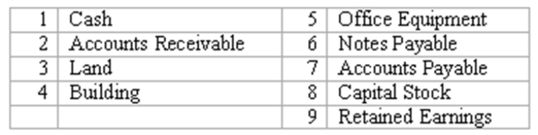
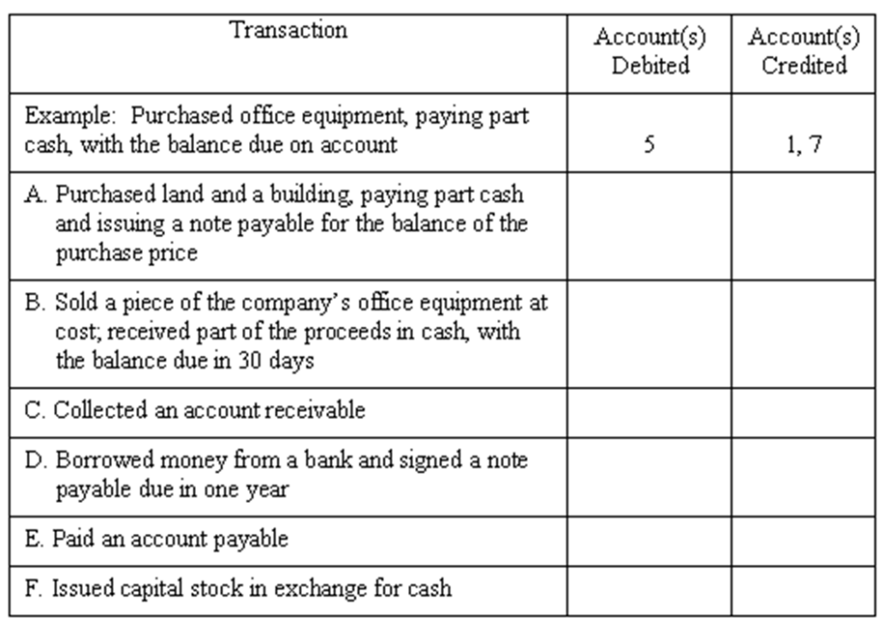

131. Listed below are accounts of Global Company, each identified by a number. Following this list of accounts is a series of transactions. You are to indicate for each transaction the accounts that should be debited and credited by inserting the proper account numbers in the space provided.
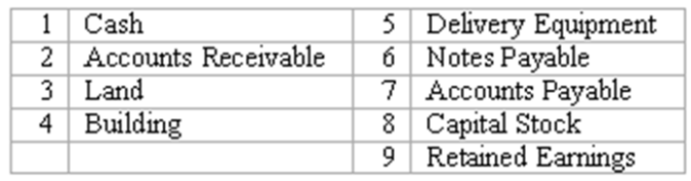
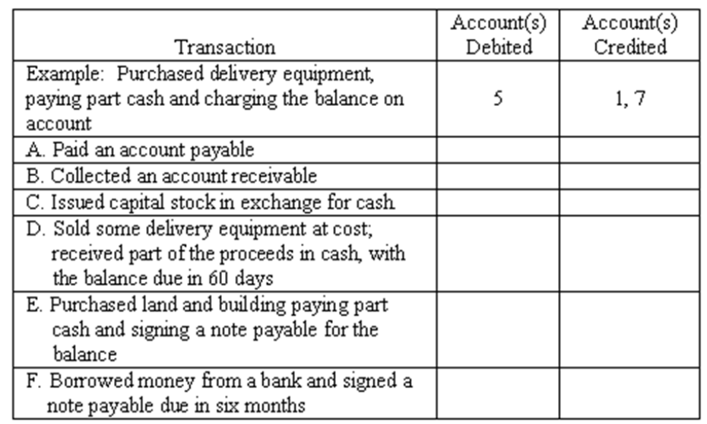

132. Recording transactions in general journal
Enter the following transactions in the two-column journal of Baumann Bathrooms. Include a brief explanation of the transaction as part of each journal entry.
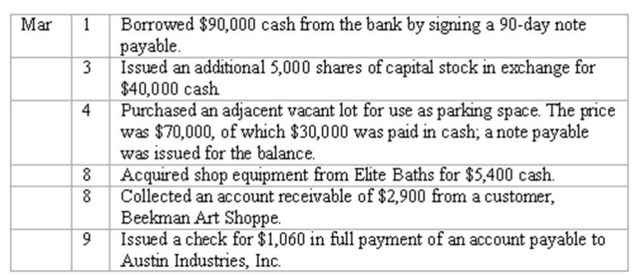
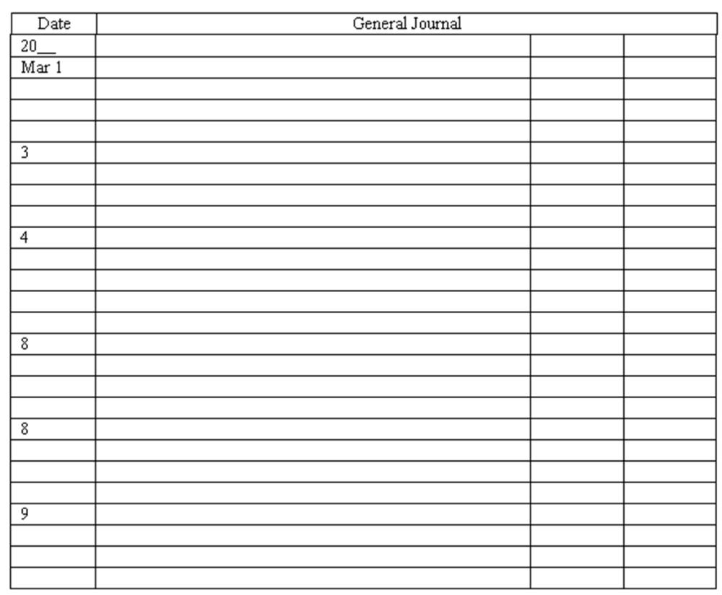
133. Recording transactions in general journal
Enter the following transactions in the two-column journal of Festive Parties, Inc. Include a brief explanation of the transaction as part of each journal entry.
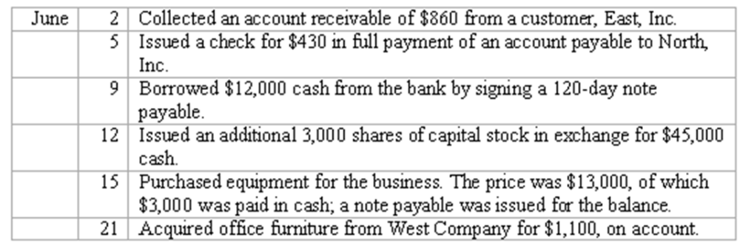
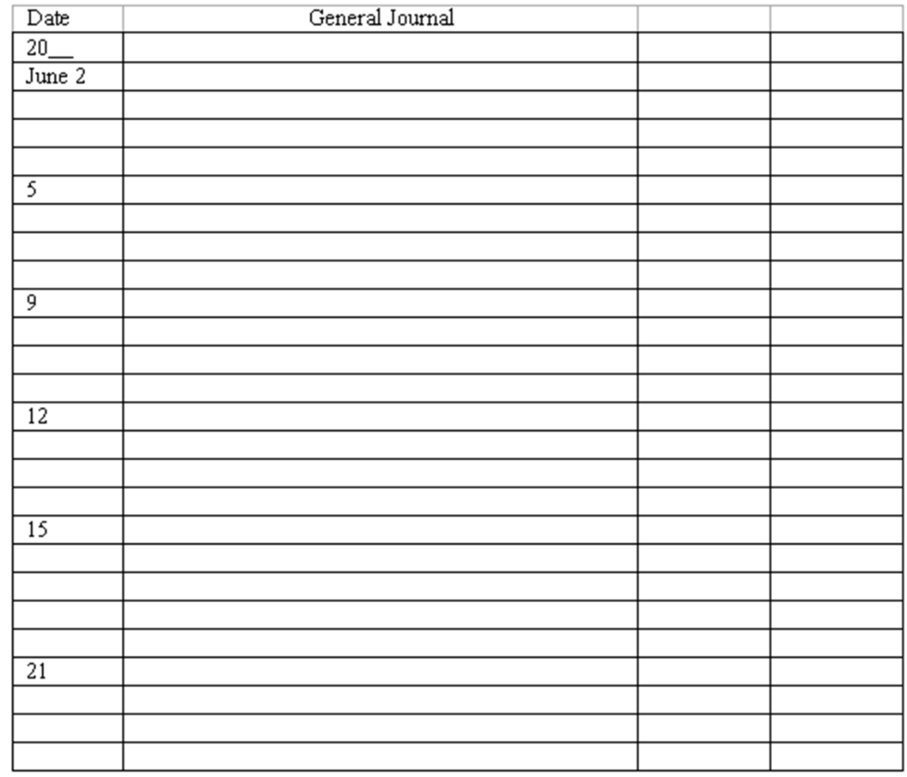

134. Journalize and post basic transactions
Precision Grading Co. was organized to grade construction sites.
* On June 1, owner Dave Precision deposited $90,000 in a new bank account opened in the name of the business in exchange for stock.
* On June 3, the company acquired grading equipment costing $89,000, paying $43,000 cash and signing a note payable for the balance.
* On June 10, the company paid $13,000 of the amount owed for equipment acquired on June 3.
Instructions: Journalize these three transactions and post to the ledger accounts.
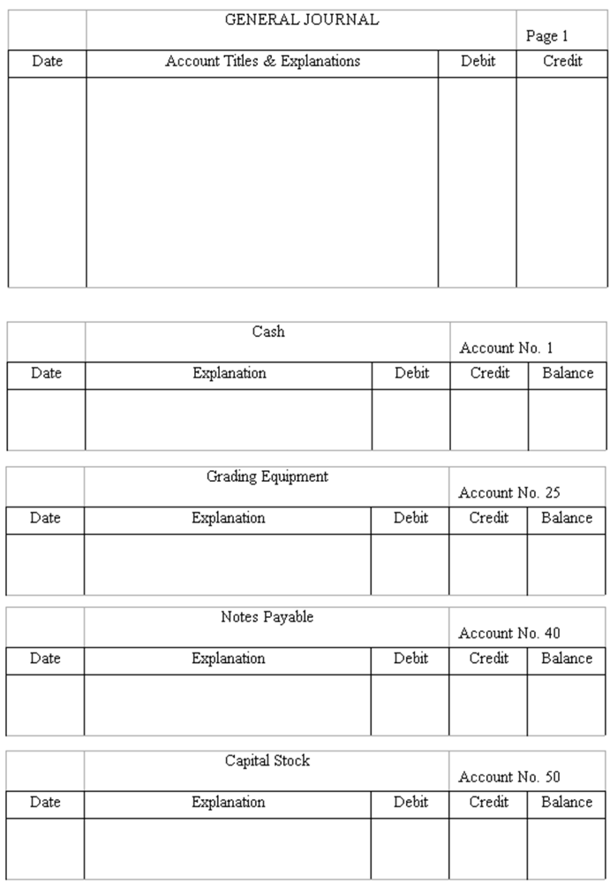
135. Journalize and post basic transactions
Geller Landscaping was organized on April 5 when the corporation issued 20,000 shares of capital stock to Larry Geller in exchange for $60,000 cash.
* On April 8, the business acquired gardening equipment by paying cash of $26,000 and signing a $20,000 note payable, due in four monthly installments of $5,000 each, beginning on April 15.
* On April 15, Larry Geller made the first payment on the note payable by writing a check from the business bank account.
Instructions: Journalize these three transactions and post to the ledger accounts.
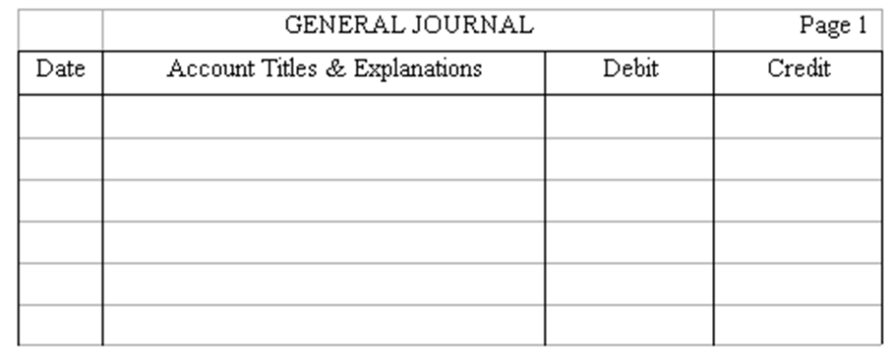
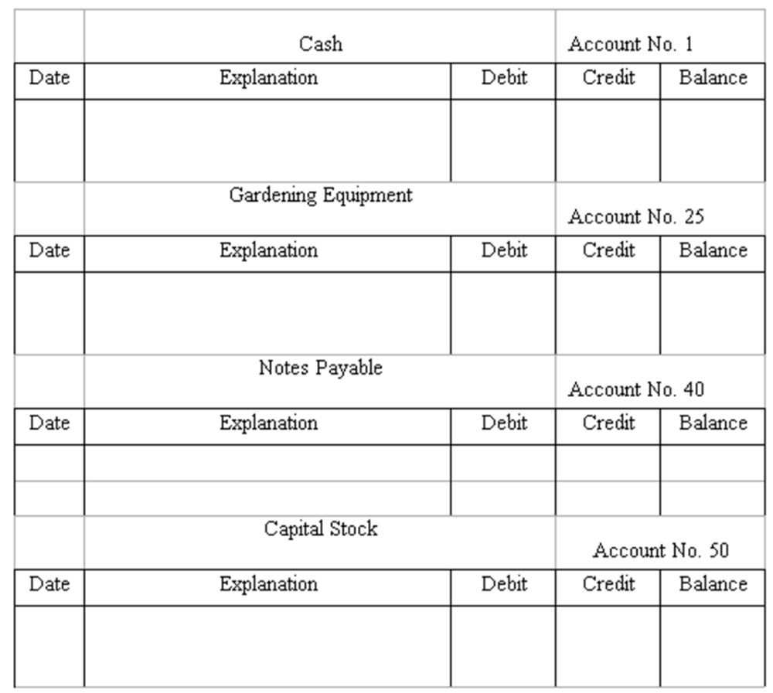

136. Effects of a series of transactions on balance sheet items
Fieldstone, Inc. had the following transactions during the month of March, the first month of operations for the business:
* The corporation issued 12,000 shares of capital stock to Sandy Fieldstone in exchange for $120,000 cash.
* Purchased $73,000 of equipment; made a $18,000 down payment and signed a note payable for the balance.
* Made payment of $9,000 on the amount owed for equipment.
(A.) Compute the balance in the Cash account at the end of March.
(B.) What are the total assets of Fieldstone, Inc. at the end of March?
(C.) Compute the balance in the Notes Payable account at the end of March.
(D.) What is the total amount of owners' equity at the end of March?

137. Effects of a series of transactions on balance sheet items
Clark Plumbing had the following transactions during the month of June, the first month of operations for the business:
* The corporation issued 12,000 shares of capital stock to Bill Clark in exchange for his investment of $72,000 cash.
* Purchased $36,000 of equipment; made an $8,000 down payment and signed a note payable for the balance.
* Made payment of $4,000 on the amount owed for equipment.
(A.) Compute the balance in the Cash account at the end of June.
(B.) What are the total assets of Clark Plumbing at the end of June?
(C.) Compute the balance in the Notes Payable account at the end of June.
(D.) What is the total amount of owners' equity at the end of June?

138. Double-entry accounting
The accounting system of most businesses, whether manual or computer-based, is some form of a double-entry system of accounting.
(A.) What is meant by the term "double-entry accounting"?
(B.) Explain how the double-entry system is applied in accounting for the following transaction:
Majestic Company purchases a piece of equipment costing $6,000, paying $3,000 cash with the balance of the purchase price to be paid within 60 days.

139. Rules of debit and credit as applied to balance sheet accounts
Items in the balance sheet are classified into three categories: assets, liabilities, and owners' equity.
(A.) Identify by name two ledger accounts in each of the first two categories above (assets and liabilities) and one owners' equity account. State whether each account would normally have a debit or credit balance.
(B.) Describe briefly the rules of debits and credits as applied to the three categories of balance sheet accounts: asset accounts, liability accounts, and owners' equity accounts.

140. Matching principle
In April, Grinnel Paving, Inc. acquired a large quantity of crushed stone on account with payment due in 90 days. The stone was used in May when Grinnel Paving, Inc. completed a large parking lot for a local shopping center. In early July, Grinnel Paving, Inc. paid the supplier from which the crushed stone had been purchased. In which month should Grinnel Paving, Inc. recognize the cost of the crushed stone as an expense? What accounting principle provides the justification for the answer?

141. Given the following list of accounts and their amounts for Hayden's Co. in alphabetical order, prepare a trial balance for December 31, 2009 as it should be presented.
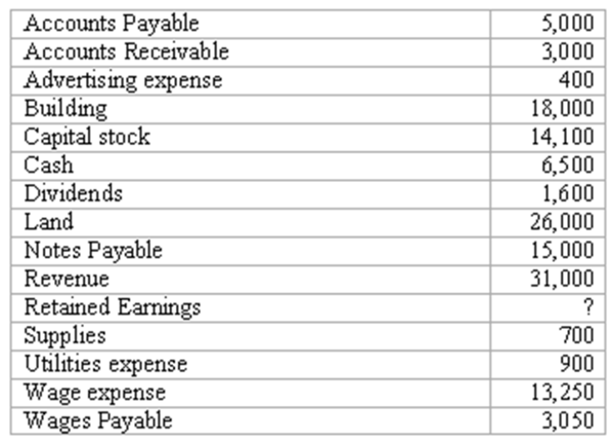

142. The following trial balance of Brian's Pickle Co for June 30, 2010 does not balance.
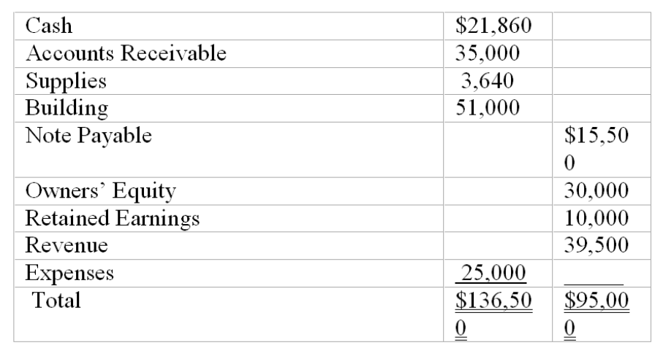
The following errors were discovered:
1. A purchase of supplies for cash was posted as $40 when it should have been $400.
2. The first two numbers of the amount for notes payable were transposed while being copied from the account balance to the trial balance. The correct amount of Notes Payable should be $51,500.
3. A collection of cash was debited to the cash account in the amount of $5,500 but was not credited to the revenue account.
4. A purchase of supplies for $725 on account was not recorded.
Instructions: Prepare a corrected trial balance

Multiple Choice Questions
The account balances for Creative Band, Inc. as of May 31, 2009, are listed below in alphabetical order:
Accounts Payable $12,000 Equipment $18,000
Accounts Receivable $14,000 Land $52,000
Building $42,000 Notes Payable $30,000
Cash $8,000 Capital Stock $92,000
On June 3, Creative Band, Inc collected $4,000 of its accounts receivable and paid $7,000 of its accounts payable. In addition, 2,000 of additional shares of capital stock are issued for $5,600.

143. In a trial balance prepared on May 31, 2009, the sum of the debit column is:
A. $120,000.
B. $156,000.
C. $134,000.
D. Some other amount.

144. On June 4, the balance in the Cash account is:
A. $17,600.
B. $5,000.
C. $10,600.
D. Some other amount.

145. On June 4, the balance in the Capital Stock account is:
A. $86,400.
B. $97,600.
C. $94,000.
D. Some other amount.

146. In a trial balance prepared on June 4, the sum of the credit column is:
A. $130,000.
B. $132,600.
C. $127,000
D. Some other amount.

147. On June 6, the bookkeeper for Creative Band, Inc makes this entry:
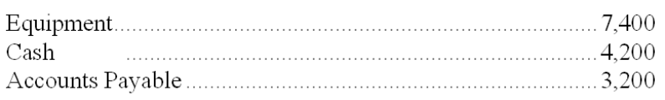
This transaction:
A. Decreases total assets.
B. Involves the sale of equipment for $7,400.
C. Increases total assets $7,400.
D. Increases liabilities.

Essay Questions
148. Enter the following transactions in the two-column journal provided for Charlie's Cabinetry. You may omit explanations.
Mar. 2 Purchased auto cleaning supplies from Robert Suppliers for $750 on account.
4 Collected an account receivable of $525 from a customer, Elegant Kitchens.
5 Paid $275 in partial payment of an account payable to Lucy Co for equipment purchased in February.
7 Issued capital stock in exchange for $5,600 cash.
9 Purchased office equipment from Diamond's Warehouse for $3,700; paid $1,700 cash and issued a note payable due in 90 days for the balance.
Date General Journal
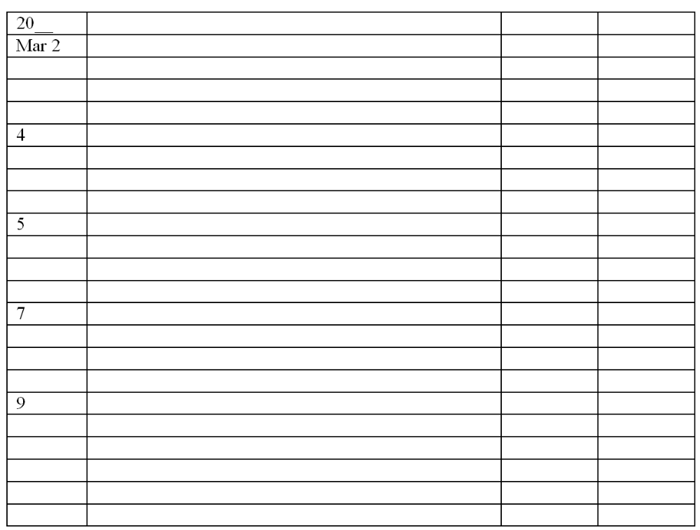

149. Capital Financial Advisors, Inc. had the following transactions during January, its first month of operations:
a. Issued to Marvin Tycoon 9,000 shares of capital stock in exchange for his investment of $45,000 cash.
b. Borrowed $30,000 from a bank and signed a note payable due in three months.
c. Purchased office furniture costing $19,750; paid $6,000 cash and charged the balance on account.
d. Paid $6,000 of the amount owed for office furniture.
e. Issued an additional 2,000 shares of capital stock to an individual who invests $10,000 in the business.
Instructions
Record the above transactions directly in the T accounts below. Identify each entry in a T account with the letter shown for the transaction.
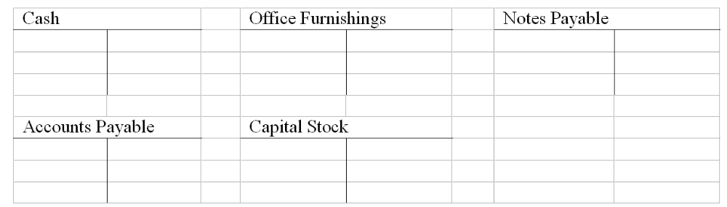

Multiple Choice Questions
The following transactions occurred during June, the first month of operations for Accurate Manufacturing.:
* Issued 60,000 shares of capital stock to the owners of the corporation in exchange for $600,000 cash.
* Purchased a piece of land for $250,000, making an $80,000 cash down payment and signing a note payable for the balance.
* Made a $100,000 cash payment on the note payable from the purchase of land.
* Purchased equipment on credit from National Supply for $40,000.

150. The balance in the Cash account at the end of June:
A. $52,000.
B. $350,000.
C. $420,000.
D. $380,000.

151. What are total assets of Precision Manufacturing at the end of June?
A. $710,000.
B. $890,000.
C. $630,000.
D. $460,000.

152. What is the total of Precision's liabilities at the end of June?
A. $70,000.
B. $110,000.
C. $200,000.
D. $240,000.

153. What is the total owners' equity at the end of June?
A. $60,000.
B. $110,000.
C. $240,000.
D. $600,000

154. According to the rules of debit and credit for balance sheet accounts:
A. Increases in asset, liability, and owners' equity accounts are recorded by debits.
B. Decreases in asset and liability accounts are recorded by credits.
C. Increases in asset and owners' equity accounts are recorded by debits.
D. Decreases in liability and owners' equity accounts are recorded by debits.

155. Sunset Tours has a $3,500 account receivable from the Del Mar Rotary. On January 20, the Rotary makes a partial payment of $2,100 to Sunset Tours. The journal entry made on January 20 by Sunset Tours to record this transaction includes:
A. A debit to the Cash Received account of $2,100.
B. A credit to the Accounts Receivable account of $2,100.
C. A debit to the Cash account of $1,400.
D. A debit to the Accounts Receivable account of $1,400.

156. Indicate all of the following statements that correctly describe net income. Net income:
A. Is equal to revenue minus expenses.
B. Is equal to revenue minus the sum of expenses and dividends.
C. Increases owners' equity.
D. Is reported by a company for a period of time.

157. Which of the following is provided by a trial balance in which total debits equal total credits?
A. Proof that no transaction was completely omitted from the ledger during the posting process.
B. Proof that the correct debit or credit balance has been computed for each account.
C. Proof that the ledger is in balance.
D. Proof that transactions have been correctly analyzed and recorded in the proper accounts.

158. Which of the following explains the debit and credit rules relating to the recording of revenue and expenses?
A. Expenses appear on the left side of the balance sheet and are recorded by debits; revenue appears on the right side of the balance sheet and is recorded by credits.
B. Expenses appear on the left side of the income statement and are recorded by debits; revenue appears on the right side of the income statement and is recorded by credits.
C. Revenue increases owners' equity and is recorded by a credit; expenses decrease owners' equity and are recorded as debits.
D. The realization principle and the matching principle.

159. Which of the following is not considered an analytical aspect of the accounting profession?
A. Evaluating an organization's operational efficiency.
B. Forecasting the probable results of future operations.
C. Designing systems that provide information to decision makers.
D. Journalizing and posting business transactions.

160. Indicate all correct answers. In the accounting cycle:
A. Transactions are posted before they are journalized.
B. A trial balance is prepared after journal entries have been posted.
C. The Retained Earnings account is not shown as an up-to-date figure in the trial balance.
D. Journal entries are posted to appropriate ledger accounts.

161. Indicate all correct answers. Dividends:
A. Decrease owners' equity.
B. Decrease net income.
C. Are recorded by debiting the Dividend account.
D. Are a business expense.

Chapter 03 The Accounting Cycle: Capturing Economic Events Answer Key

True / False Questions
1. The credit side of an account is the right side, while the debit side is the left side.
FALSE

AACSB: Reflective Thinking
AICPA BB: Critical Thinking
AICPA FN: Measurement
Bloom's: Remember
Difficulty: Easy
Learning Objective: 03-02 Describe a ledger account and a ledger.
Topic: The Ledger
2. In a computerized accounting system, posting may be done automatically but journalizing must be done by someone with an understanding of recording transactions.
TRUE

AACSB: Reflective Thinking
AICPA BB: Critical Thinking
AICPA FN: Measurement
Bloom's: Remember
Difficulty: Easy
Learning Objective: 03-05 Explain the purpose of a journal and its relationship to the ledger.
Topic: The Journal
3. The running balance form or the T account form is typically used in the trial balance to display the accounts and their amounts.
FALSE

AACSB: Reflective Thinking
AICPA BB: Critical Thinking
AICPA FN: Measurement
Bloom's: Remember
Difficulty: Easy
Learning Objective: 03-09 Prepare a trial balance and explain its uses and limitations.
Topic: The Trial Balance
4. Dividends are an expense of a corporation and reduce both total assets and liabilities.
FALSE

AACSB: Reflective Thinking
AICPA BB: Critical Thinking
AICPA FN: Measurement
Bloom's: Remember
Difficulty: Easy
Learning Objective: 03-03 Understand how balance sheet accounts are increased or decreased.
Topic: Debit and Credit Entries
5. Dividends increase owners' equity and therefore should be added to retained earnings.
FALSE

AACSB: Reflective Thinking
AICPA BB: Critical Thinking
AICPA FN: Measurement
Bloom's: Understand
Difficulty: Easy
Learning Objective: 03-03 Understand how balance sheet accounts are increased or decreased.
Topic: Debit and Credit Entries
6. Every business transaction is recorded by a debit to a balance sheet account and a credit to an income statement account.
FALSE

AACSB: Reflective Thinking
AICPA BB: Critical Thinking
AICPA FN: Measurement
Bloom's: Understand
Difficulty: Easy
Learning Objective: 03-04 Explain the double-entry system of accounting.
Topic: Debit and Credit Entries
7. Earning revenue increases owners' equity and expenses reduce owners' equity, therefore, revenues are recorded with debit entries and expenses are recorded with credit entries.
FALSE

AACSB: Reflective Thinking
AICPA BB: Critical Thinking
AICPA FN: Measurement
Bloom's: Understand
Difficulty: Medium
Learning Objective: 03-06 Explain the nature of net income; revenue; and expenses.
Topic: What is Net Income?
8. A trial balance cannot be distributed to stockholders in lieu of a balance sheet.
TRUE

AACSB: Reflective Thinking
AICPA BB: Critical Thinking
AICPA FN: Measurement
Bloom's: Understand
Difficulty: Easy
Learning Objective: 03-09 Prepare a trial balance and explain its uses and limitations.
Topic: The Trial Balance
9. Accounts are usually arranged in the ledger in financial statement order, that is, assets first, followed by liabilities, owners' equity, expenses, and revenues.
FALSE

AACSB: Reflective Thinking
AICPA BB: Critical Thinking
AICPA FN: Measurement
Bloom's: Remember
Difficulty: Easy
Learning Objective: 03-02 Describe a ledger account and a ledger.
Topic: The Ledger
10. A credit to a ledger account refers to the entry of an amount on the right side of an account.
TRUE

AACSB: Reflective Thinking
AICPA BB: Critical Thinking
AICPA FN: Measurement
Bloom's: Remember
Difficulty: Easy
Learning Objective: 03-02 Describe a ledger account and a ledger.
Topic: The Ledger
11. The left-hand side of an account is used for recording debits and the right-hand side for recording credits.
TRUE

AACSB: Reflective Thinking
AICPA BB: Critical Thinking
AICPA FN: Measurement
Bloom's: Remember
Difficulty: Easy
Learning Objective: 03-04 Explain the double-entry system of accounting.
Topic: Debit and Credit Entries
12. If the number of debit entries in an account is greater than the number of credit entries, the account will have a debit balance.
FALSE

AACSB: Reflective Thinking
AICPA BB: Critical Thinking
AICPA FN: Measurement
Bloom's: Understand
Difficulty: Medium
Learning Objective: 03-04 Explain the double-entry system of accounting.
Topic: Debit and Credit Entries
13. Liability accounts should only be debited and never credited.
FALSE

AACSB: Reflective Thinking
AICPA BB: Critical Thinking
AICPA FN: Measurement
Bloom's: Understand
Difficulty: Medium
Learning Objective: 03-03 Understand how balance sheet accounts are increased or decreased.
Topic: Debit and Credit Entries
14. Increases in owners' equity are recorded by credits; increases in assets and in liabilities are recorded by debits.
FALSE

AACSB: Reflective Thinking
AICPA BB: Critical Thinking
AICPA FN: Measurement
Bloom's: Remember
Difficulty: Medium
Learning Objective: 03-03 Understand how balance sheet accounts are increased or decreased.
Topic: Debit and Credit Entries
15. When making a general journal entry, there can only be one debit and one credit.
FALSE

AACSB: Reflective Thinking
AICPA BB: Critical Thinking
AICPA FN: Measurement
Bloom's: Understand
Difficulty: Easy
Learning Objective: 03-04 Explain the double-entry system of accounting.
Topic: Debit and Credit Entries
16. A business that is profitable and liquid will have more accounts with credit balances than with debit balances.
FALSE

AACSB: Reflective Thinking
AICPA BB: Critical Thinking
AICPA FN: Measurement
Bloom's: Understand
Difficulty: Medium
Learning Objective: 03-08 Understand how revenue and expense transactions are recorded in an accounting system.
Topic: Recording Income Statement Transactions: An Illustration
17. Every transaction affects equal numbers of ledger accounts and is recorded by equal dollar amounts of debits and credits.
FALSE

AACSB: Reflective Thinking
AICPA BB: Critical Thinking
AICPA FN: Measurement
Bloom's: Understand
Difficulty: Easy
Learning Objective: 03-02 Describe a ledger account and a ledger.
Topic: The Ledger
18. When a company uses the double-entry method, the total dollar amount of debits recorded must equal the total dollar amount of credits recorded, but the number of debit and credit entries may differ.
TRUE

AACSB: Reflective Thinking
AICPA BB: Critical Thinking
AICPA FN: Measurement
Bloom's: Understand
Difficulty: Medium
Learning Objective: 03-04 Explain the double-entry system of accounting.
Topic: Debit and Credit Entries
19. If ledger accounts are maintained in three-column, running balance form, the journal should be maintained in the same format.
FALSE

AACSB: Reflective Thinking
AICPA BB: Critical Thinking
AICPA FN: Measurement
Bloom's: Understand
Difficulty: Medium
Learning Objective: 03-05 Explain the purpose of a journal and its relationship to the ledger.
Topic: The Journal
20. The general ledger is sometimes called the book of original entry because it is the accounting record where transactions are first recorded.
FALSE

AACSB: Reflective Thinking
AICPA BB: Critical Thinking
AICPA FN: Measurement
Bloom's: Remember
Difficulty: Medium
Learning Objective: 03-05 Explain the purpose of a journal and its relationship to the ledger.
Topic: The Journal
21. Each business transaction is initially recorded in a journal and later transferred to the appropriate accounts in the general ledger.
TRUE

AACSB: Reflective Thinking
AICPA BB: Critical Thinking
AICPA FN: Measurement
Bloom's: Remember
Difficulty: Easy
Learning Objective: 03-05 Explain the purpose of a journal and its relationship to the ledger.
Topic: The Journal
22. The matching principle refers to the relationship between revenues and expenses.
TRUE

AACSB: Reflective Thinking
AICPA BB: Critical Thinking
AICPA FN: Measurement
Bloom's: Remember
Difficulty: Easy
Learning Objective: 03-07 Apply the realization and matching principles in recording revenue and expenses.
Topic: What is Net Income?
23. An increase in a liability is recorded by a credit; an increase in owners' equity by a debit.
FALSE

AACSB: Reflective Thinking
AICPA BB: Critical Thinking
AICPA FN: Measurement
Bloom's: Understand
Difficulty: Easy
Learning Objective: 03-03 Understand how balance sheet accounts are increased or decreased.
Topic: Debit and Credit Entries
24. Revenues increase owners' equity and are, therefore, recorded by crediting the revenues account.
TRUE

AACSB: Reflective Thinking
AICPA BB: Critical Thinking
AICPA FN: Measurement
Bloom's: Understand
Difficulty: Medium
Learning Objective: 03-08 Understand how revenue and expense transactions are recorded in an accounting system.
Topic: Recording Income Statement Transactions: An Illustration
25. The accrual basis of accounting recognizes expenses only when they are paid.
FALSE

AACSB: Reflective Thinking
AICPA BB: Critical Thinking
AICPA FN: Measurement
Bloom's: Remember
Difficulty: Easy
Learning Objective: 03-08 Understand how revenue and expense transactions are recorded in an accounting system.
Topic: Recording Income Statement Transactions: An Illustration
26. Every transaction which affects an income statement account also affects a balance sheet account.
TRUE

AACSB: Reflective Thinking
AICPA BB: Critical Thinking
AICPA FN: Measurement
Bloom's: Understand
Difficulty: Easy
Learning Objective: 03-08 Understand how revenue and expense transactions are recorded in an accounting system.
Topic: Recording Income Statement Transactions: An Illustration
27. A trial balance that balances provides proof that all transactions were correctly journalized and posted to the ledger.
FALSE

AACSB: Reflective Thinking
AICPA BB: Critical Thinking
AICPA FN: Measurement
Bloom's: Understand
Difficulty: Easy
Learning Objective: 03-09 Prepare a trial balance and explain its uses and limitations.
Topic: The Trial Balance
28. A trial balance proves that equal amounts of debits and credits were posted to the ledger.
TRUE

AACSB: Reflective Thinking
AICPA BB: Critical Thinking
AICPA FN: Measurement
Bloom's: Understand
Difficulty: Easy
Learning Objective: 03-09 Prepare a trial balance and explain its uses and limitations.
Topic: The Trial Balance
29. Dividends are an expense to a corporation and appear on the income statement.
FALSE

AACSB: Reflective Thinking
AICPA BB: Critical Thinking
AICPA FN: Measurement
Bloom's: Understand
Difficulty: Easy
Learning Objective: 03-06 Explain the nature of net income; revenue; and expenses.
Topic: Dividends
30. A CEO or CFO associated with fraudulent financial reporting could be fined but not imprisoned under the Sarbanes Oxley Act.
FALSE

AACSB: Ethics
AICPA BB: Legal
AICPA FN: Reporting
Bloom's: Understand
Difficulty: Easy
Learning Objective: 03-10 Distinguish between accounting cycle procedures and the knowledge of accounting.
Topic: Concluding Remarks
31. "I was just following orders" is an acceptable defense if you committed an unethical action during an audit.
FALSE

AACSB: Ethics
AICPA BB: Legal
AICPA FN: Reporting
Bloom's: Understand
Difficulty: Easy
Learning Objective: 03-10 Distinguish between accounting cycle procedures and the knowledge of accounting.
Topic: Concluding Remarks

Multiple Choice Questions
32. Sally Smith had expenses of $800 in June which she paid in July. She declared these expenses on her June income statement. By doing this, she is following the accounting principle of:
A. Revenue realization.
B. Adequate disclosure.
C. Matching.
D. Conservatism.

AACSB: Analytic
AICPA BB: Critical Thinking
AICPA FN: Measurement
Bloom's: Understand
Difficulty: Easy
Learning Objective: 03-07 Apply the realization and matching principles in recording revenue and expenses.
Topic: What is Net Income?
33. The price of the goods sold or services rendered during a given accounting period is called:
A. Net income.
B. Profit.
C. Revenue.
D. Equity.

AACSB: Reflective Thinking
AICPA BB: Critical Thinking
AICPA FN: Measurement
Bloom's: Remember
Difficulty: Easy
Learning Objective: 03-06 Explain the nature of net income; revenue; and expenses.
Topic: What is Net Income?
34. The principle that states revenue should be recognized at the time goods are sold or services rendered is called:
A. Adequate disclosure.
B. Conservatism.
C. Matching.
D. Revenue realization.

AACSB: Reflective Thinking
AICPA BB: Critical Thinking
AICPA FN: Measurement
Bloom's: Remember
Difficulty: Easy
Learning Objective: 03-07 Apply the realization and matching principles in recording revenue and expenses.
Topic: What is Net Income?
35. Recognizing revenue when it is earned and not when cash is received and recognizing expenses when the related goods or services are used rather than when they are paid for is called:
A. Revenue recognition.
B. Accrual accounting.
C. Conservatism.
D. Matching.

AACSB: Reflective Thinking
AICPA BB: Critical Thinking
AICPA FN: Measurement
Bloom's: Remember
Difficulty: Medium
Learning Objective: 03-07 Apply the realization and matching principles in recording revenue and expenses.
Topic: What is Net Income?
36. The agreement of the debit and credit totals of the trial balance gives assurance that:
A. All transactions were posted correctly.
B. No transactions were omitted.
C. The number of accounts with debit balances equals the number of accounts with credit balances.
D. The total debits equal the total credits.

AACSB: Reflective Thinking
AICPA BB: Critical Thinking
AICPA FN: Measurement
Bloom's: Understand
Difficulty: Medium
Learning Objective: 03-09 Prepare a trial balance and explain its uses and limitations.
Topic: The Trial Balance
37. The sequence of accounting procedures used to record, classify, and summarize accounting information is called the:
A. Accounting cycle.
B. Accounting period.
C. Accrual accounting.
D. Double-entry bookkeeping.

AACSB: Reflective Thinking
AICPA BB: Critical Thinking
AICPA FN: Measurement
Bloom's: Remember
Difficulty: Easy
Learning Objective: 03-01 Identify the steps in the accounting cycle and discuss the role of accounting records in an organization.
Topic: The Accounting Cycle
38. The purchase of equipment on credit is recorded by a:
A. Debit to Equipment and a credit to Accounts Payable.
B. Debit to Accounts Payable and a credit to Equipment.
C. Debit to Equipment and a debit to Accounts Payable.
D. Credit to Equipment and a credit to Accounts Payable.

AACSB: Reflective Thinking
AICPA BB: Critical Thinking
AICPA FN: Measurement
Bloom's: Understand
Difficulty: Medium
Learning Objective: 03-03 Understand how balance sheet accounts are increased or decreased.
Topic: Debit and Credit Entries
39. The collection of accounts receivable is recorded by a:
A. Debit to Cash and a debit to Accounts Receivable.
B. Credit to Cash and a credit to Accounts Receivable.
C. Debit to Cash and a credit to Accounts Receivable.
D. Credit to Cash and a debit to Accounts Receivable.

AACSB: Reflective Thinking
AICPA BB: Critical Thinking
AICPA FN: Measurement
Bloom's: Understand
Difficulty: Medium
Learning Objective: 03-03 Understand how balance sheet accounts are increased or decreased.
Topic: Debit and Credit Entries
40. Which of the following accounts normally has a debit balance?
A. Accounts payable.
B. Retained earnings.
C. Accounts receivable.
D. Service revenue.

AACSB: Reflective Thinking
AICPA BB: Critical Thinking
AICPA FN: Measurement
Bloom's: Understand
Difficulty: Easy
Learning Objective: 03-04 Explain the double-entry system of accounting.
Topic: Debit and Credit Entries
41. In the general ledger, a separate "account" is maintained for each:
A. Type of asset and liability and for each element of owners' equity.
B. Business transaction.
C. Business day.
D. Journal entry.

AACSB: Reflective Thinking
AICPA BB: Critical Thinking
AICPA FN: Measurement
Bloom's: Understand
Difficulty: Easy
Learning Objective: 03-02 Describe a ledger account and a ledger.
Topic: The Ledger
42. In accounting, the terms debit and credit indicate, respectively:
A. Increase and decrease.
B. Left and right.
C. Decrease and increase.
D. Right and left.

AACSB: Reflective Thinking
AICPA BB: Critical Thinking
AICPA FN: Measurement
Bloom's: Understand
Difficulty: Easy
Learning Objective: 03-03 Understand how balance sheet accounts are increased or decreased.
Topic: Debit and Credit Entries
43. In a ledger, debit entries cause:
A. Increases in owners' equity, decreases in liabilities, and increases in assets.
B. Decreases in liabilities, increases in assets, and decreases in owners' equity.
C. Decreases in assets, decreases in liabilities, and increases in owners' equity.
D. Decreases in assets, increases in liabilities, and increases in owners' equity.

AACSB: Reflective Thinking
AICPA BB: Critical Thinking
AICPA FN: Measurement
Bloom's: Understand
Difficulty: Medium
Learning Objective: 03-03 Understand how balance sheet accounts are increased or decreased.
Topic: Debit and Credit Entries
44. Which of the following accounts normally has a credit balance?
A. Cash.
B. Service revenue.
C. Accounts receivable.
D. Utilities expense.

AACSB: Reflective Thinking
AICPA BB: Critical Thinking
AICPA FN: Measurement
Bloom's: Understand
Difficulty: Easy
Learning Objective: 03-03 Understand how balance sheet accounts are increased or decreased.
Topic: Debit and Credit Entries
45. Which of the following is not true regarding the general ledger account for Cash?
A. The balance of the account indicates the amount of cash owned by the business on a particular date.
B. Each debit entry in the Cash account represents a cash receipt.
C. Debit entries are made before credit entries.
D. Credit entries in the Cash account represent cash payments.

AACSB: Reflective Thinking
AICPA BB: Critical Thinking
AICPA FN: Measurement
Bloom's: Understand
Difficulty: Medium
Learning Objective: 03-02 Describe a ledger account and a ledger.
Topic: The Ledger
46. The rules of debit and credit may be summarized as follows:
A. Accounts on the left side of the balance sheet are increased by debits, whereas, accounts on the right side of the balance sheet are increased by credits.
B. The balance of a ledger account is increased by debit entries and is decreased by credit entries.
C. Accounts on the left side of the balance sheet are increased by credits, whereas accounts on the right side of the balance sheet are increased by debits.
D. The balance of a ledger account is increased by credit entries and is decreased by debit entries.

AACSB: Reflective Thinking
AICPA BB: Critical Thinking
AICPA FN: Measurement
Bloom's: Understand
Difficulty: Medium
Learning Objective: 03-04 Explain the double-entry system of accounting.
Topic: Debit and Credit Entries
47. The essential point of a double-entry system of accounting is that every transaction:
A. Affects accounts on both sides of the balance sheet.
B. Is recorded in both the journal and the ledger.
C. Increases one ledger account and decreases another.
D. Affects two or more ledger accounts and is recorded by an equal dollar amount of debits and credits.

AACSB: Reflective Thinking
AICPA BB: Critical Thinking
AICPA FN: Measurement
Bloom's: Understand
Difficulty: Medium
Learning Objective: 03-04 Explain the double-entry system of accounting.
Topic: Debit and Credit Entries
48. Double-entry accounting is characterized by which of the following?
A. Every transaction affects both an asset account and either a liability account or an owners' equity account.
B. The number of general ledger accounts with debit balances is equal to the number with credit balances.
C. The total dollar amount of debit entries posted to the general ledger is equal to the dollar amount of the credit entries.
D. The number of debit entries posted to the general ledger equals the number of credit entries.

AACSB: Reflective Thinking
AICPA BB: Critical Thinking
AICPA FN: Measurement
Bloom's: Understand
Difficulty: Medium
Learning Objective: 03-04 Explain the double-entry system of accounting.
Topic: Debit and Credit Entries
49. The process of originally recording a business transaction in the accounting records is termed:
A. Journalizing.
B. Footing.
C. Posting.
D. Balancing.

AACSB: Reflective Thinking
AICPA BB: Critical Thinking
AICPA FN: Measurement
Bloom's: Remember
Difficulty: Easy
Learning Objective: 03-05 Explain the purpose of a journal and its relationship to the ledger.
Topic: The Journal
50. If the trial balance has a higher debit balance than credit balance, it signifies:
A. Assets are more than liabilities.
B. A profit.
C. A loss.
D. An error has been made.

AACSB: Reflective Thinking
AICPA BB: Critical Thinking
AICPA FN: Measurement
Bloom's: Understand
Difficulty: Medium
Learning Objective: 03-09 Prepare a trial balance and explain its uses and limitations.
Topic: The Trial Balance
51. Brett Tarek, a manager at D&J Landscaping, Inc. needs information regarding the amount of accounts payable currently owed by the company. This information would most easily be found in the:
A. General ledger.
B. General journal.
C. Income statement.
D. Notes to the financial statements.

AACSB: Reflective Thinking
AICPA BB: Critical Thinking
AICPA FN: Measurement
Bloom's: Understand
Difficulty: Easy
Learning Objective: 03-05 Explain the purpose of a journal and its relationship to the ledger.
Topic: The Journal
52. Which of the following accounting procedures requires the greatest knowledge of generally accepted accounting principles?
A. Journalizing business transactions.
B. Posting journal entries to ledger accounts.
C. Preparing a trial balance.
D. Locating errors in a trial balance.

AACSB: Reflective Thinking
AICPA BB: Critical Thinking
AICPA FN: Measurement
Bloom's: Understand
Difficulty: Medium
Learning Objective: 03-10 Distinguish between accounting cycle procedures and the knowledge of accounting.
Topic: Concluding Remarks
53. Transactions are recorded in the general journal in:
A. Numerical order.
B. Chronological order.
C. Account number order.
D. Financial statement order.

AACSB: Reflective Thinking
AICPA BB: Critical Thinking
AICPA FN: Measurement
Bloom's: Understand
Difficulty: Easy
Learning Objective: 03-05 Explain the purpose of a journal and its relationship to the ledger.
Topic: The Journal
54. A transaction is first recorded in which of the following accounting records?
A. Trial balance.
B. Ledger.
C. General journal.
D. Balance sheet.

AACSB: Reflective Thinking
AICPA BB: Critical Thinking
AICPA FN: Measurement
Bloom's: Remember
Difficulty: Easy
Learning Objective: 03-05 Explain the purpose of a journal and its relationship to the ledger.
Topic: The Journal
55. What type of account will normally contain a debit balance?
A. Asset.
B. Liability.
C. Owners' equity.
D. Revenue.

AACSB: Reflective Thinking
AICPA BB: Critical Thinking
AICPA FN: Measurement
Bloom's: Remember
Difficulty: Easy
Learning Objective: 03-03 Understand how balance sheet accounts are increased or decreased.
Topic: Debit and Credit Entries
56. If the trial balance has a smaller debit balance than credit balance, it signifies:
A. Assets are more than liabilities.
B. A profit.
C. A loss.
D. An error has been made.

AACSB: Reflective Thinking
AICPA BB: Critical Thinking
AICPA FN: Measurement
Bloom's: Understand
Difficulty: Medium
Learning Objective: 03-09 Prepare a trial balance and explain its uses and limitations.
Topic: The Trial Balance
57. The manager of Grande Home Improvements purchased several cash registers for the business on June 10 but does not remember whether he paid cash for the full price or still owes a balance to the vendor. Where is the best place for the manager to get the information about this transaction?
A. A trial balance prepared at the end of June.
B. The general journal.
C. A balance sheet prepared at the end of June.
D. The ledger account for equipment.

AACSB: Reflective Thinking
AICPA BB: Critical Thinking
AICPA FN: Measurement
Bloom's: Understand
Difficulty: Medium
Learning Objective: 03-02 Describe a ledger account and a ledger.
Topic: The Use of Accounts
58. Sue Costa, owner of A-1 Cleaning Services, invested an additional $75,000 in the company. Which of the following would be a part of the correct journal entry to record this transaction?
A. A debit to the Cash account.
B. A debit to the Equity account.
C. A debit to the Capital Stock account.
D. A debit to the Cash Received account.

AACSB: Reflective Thinking
AICPA BB: Critical Thinking
AICPA FN: Measurement
Bloom's: Understand
Difficulty: Medium
Learning Objective: 03-03 Understand how balance sheet accounts are increased or decreased.
Topic: Debit and Credit Entries
59. If a company purchases equipment on account:
A. Assets will increase and owners' equity will also increase.
B. Assets will increase and owners' equity will decrease.
C. Assets will increase and owners' equity will remain unchanged.
D. Assets will increase and liabilities will decrease.

AACSB: Reflective Thinking
AICPA BB: Critical Thinking
AICPA FN: Measurement
Bloom's: Understand
Difficulty: Medium
Learning Objective: 03-03 Understand how balance sheet accounts are increased or decreased.
Topic: Debit and Credit Entries
60. Preparing a journal entry in proper form involves all the following except:
A. Listing all accounts debited before any credits.
B. Computing the balances in accounts involved in the transaction.
C. Indicating the date of the transaction.
D. Providing a brief written explanation of the transaction.

AACSB: Reflective Thinking
AICPA BB: Critical Thinking
AICPA FN: Measurement
Bloom's: Understand
Difficulty: Medium
Learning Objective: 03-05 Explain the purpose of a journal and its relationship to the ledger.
Topic: The Journal
61. The journal entry to record a particular business transaction includes a credit to a liability account. This transaction is most likely also to include:
A. Issuance of new capital stock.
B. The purchase of an asset on account.
C. A cash payment.
D. A credit to Accounts Receivable.

AACSB: Reflective Thinking
AICPA BB: Critical Thinking
AICPA FN: Measurement
Bloom's: Understand
Difficulty: Medium
Learning Objective: 03-03 Understand how balance sheet accounts are increased or decreased.
Topic: Debit and Credit Entries
62. The journal entry to record a particular business transaction includes a credit to the Cash account. This transaction is most likely also to include:
A. Issuance of new capital stock.
B. The purchase of an asset on account.
C. Payment of an outstanding note payable.
D. A credit to Accounts Receivable.

AACSB: Reflective Thinking
AICPA BB: Critical Thinking
AICPA FN: Measurement
Bloom's: Understand
Difficulty: Medium
Learning Objective: 03-03 Understand how balance sheet accounts are increased or decreased.
Topic: Debit and Credit Entries
63. The collection of an account receivable is recorded by a debit to Cash and a credit to Accounts Payable. If this error is not corrected:
A. Total liabilities are understated.
B. Total assets are understated.
C. Total liabilities are overstated.
D. Owners' equity is overstated.

AACSB: Reflective Thinking
AICPA BB: Critical Thinking
AICPA FN: Measurement
Bloom's: Understand
Difficulty: Medium
Learning Objective: 03-03 Understand how balance sheet accounts are increased or decreased.
Topic: Debit and Credit Entries
64. Posting is the process of:
A. Transferring debit and credit entries from the journal into the appropriate ledger accounts.
B. Determining that the dollar amount of debit entries recorded in the ledger is equal to the dollar amount of credit entries.
C. Entering information into a computerized data base.
D. Preparing journal entries to describe each business transaction.

AACSB: Reflective Thinking
AICPA BB: Critical Thinking
AICPA FN: Measurement
Bloom's: Understand
Difficulty: Easy
Learning Objective: 03-05 Explain the purpose of a journal and its relationship to the ledger.
Topic: The Journal
65. If a company purchases equipment for cash:
A. Assets will increase and owners' equity will also increase.
B. Assets will increase and owners' equity will decrease.
C. Assets will increase and owners' equity will remain unchanged.
D. Total assets and owners' equity will remain unchanged.

AACSB: Reflective Thinking
AICPA BB: Critical Thinking
AICPA FN: Measurement
Bloom's: Understand
Difficulty: Medium
Learning Objective: 03-03 Understand how balance sheet accounts are increased or decreased.
Topic: Debit and Credit Entries
66. A trial balance that is out of balance indicates that:
A. The number of ledger accounts with debit balances is not equal to the number of accounts with credit balances.
B. A debit has been posted to the wrong account.
C. There is not an equality of debit and credit amounts in the ledger.
D. A journal entry has been completely omitted from the posting process.

AACSB: Reflective Thinking
AICPA BB: Critical Thinking
AICPA FN: Measurement
Bloom's: Understand
Difficulty: Medium
Learning Objective: 03-09 Prepare a trial balance and explain its uses and limitations.
Topic: The Trial Balance
67. A trial balance consists of:
A. A two-column schedule of all debit and credit entries posted to ledger accounts.
B. A two-column financial statement intended for distribution to interested parties outside the business.
C. A two-column schedule showing the totals of all debits and of all credits made in journal entries.
D. A two-column schedule listing names and balances of all ledger accounts.

AACSB: Reflective Thinking
AICPA BB: Critical Thinking
AICPA FN: Measurement
Bloom's: Understand
Difficulty: Easy
Learning Objective: 03-09 Prepare a trial balance and explain its uses and limitations.
Topic: The Trial Balance
68. Green Systems sold and delivered modems to Blue Computers for $660,000 to be paid by Blue in three equal installments over the next three months. The journal entry made by Blue Computers to record the last of the three installment payments will include:
A. A debit of $220,000 to Modem Expense.
B. A debit of $220,000 to Accounts Receivable.
C. A debit of $220,000 to Cash.
D. A debit of $220,000 to Accounts Payable.

AACSB: Analytic
AICPA BB: Critical Thinking
AICPA FN: Measurement
Bloom's: Apply
Difficulty: Medium
Learning Objective: 03-08 Understand how revenue and expense transactions are recorded in an accounting system.
Topic: What is Net Income?
69. Which of the following errors would be disclosed by preparation of a trial balance?
A. The collection of an account receivable was recorded by a debit to the Land account rather than to the Cash account.
B. The collection of an account receivable for $219 was recorded by a $291 debit to Cash and a $291 credit to Accounts Receivable.
C. The collection of a $365 account receivable was not recorded at all.
D. The collection of a $325 account receivable was recorded by a $325 debit to Cash and a $325 debit to Accounts Receivable.

AACSB: Analytic
AICPA BB: Critical Thinking
AICPA FN: Measurement
Bloom's: Understand
Difficulty: Hard
Learning Objective: 03-09 Prepare a trial balance and explain its uses and limitations.
Topic: The Trial Balance
70. Which of the following errors would not be disclosed by preparation of a trial balance?
A. An error was made in computing the balance of the Cash account.
B. A journal entry included a debit to the Equipment account for $3,200, but this amount was erroneously posted as $2,300.
C. During the posting process, a $1,700 debit to Cash was accidentally entered in the credit side of the Cash account.
D. The journal entries recorded on the last day of the year have never been posted to the ledger.

AACSB: Analytic
AICPA BB: Critical Thinking
AICPA FN: Measurement
Bloom's: Understand
Difficulty: Hard
Learning Objective: 03-09 Prepare a trial balance and explain its uses and limitations.
Topic: The Trial Balance
71. Black Systems sold and delivered modems to White Computers for $330,000 to be paid by White in three equal installments over the next three months. The journal entry made by Black Systems to record this transaction will include:
A. A debit to Sales Revenue for $330,000.
B. A debit to Accounts Receivable for $330,000.
C. A debit to Accounts Receivable for $110,000.
D. A debit to Cash Paid for $330,000.

AACSB: Analytic
AICPA BB: Critical Thinking
AICPA FN: Measurement
Bloom's: Apply
Difficulty: Medium
Learning Objective: 03-08 Understand how revenue and expense transactions are recorded in an accounting system.
Topic: What is Net Income?
72. The statement "This business produced net income of $520,000" is unclear because it failed to specify:
A. The accounting method, that is, accrual or cash basis.
B. Whether the amount earned is before or after expenses.
C. The time period.
D. The amount of cash withdrawn from the business by the owner.

AACSB: Analytic
AICPA BB: Critical Thinking
AICPA FN: Measurement
Bloom's: Understand
Difficulty: Hard
Learning Objective: 03-08 Understand how revenue and expense transactions are recorded in an accounting system.
Topic: Recording Income Statement Transactions: An Illustration
73. The term revenue can best be described as:
A. The selling price of goods and services rendered to customers during a given accounting period.
B. The cash received from selling goods and serving customers during a given accounting period.
C. The net increase in owners' equity during a given period.
D. The "bottom line" in the income statement.

AACSB: Reflective Thinking
AICPA BB: Critical Thinking
AICPA FN: Measurement
Bloom's: Understand
Difficulty: Medium
Learning Objective: 03-08 Understand how revenue and expense transactions are recorded in an accounting system.
Topic: Recording Income Statement Transactions: An Illustration
74. The realization principle indicates that revenue usually should be recognized and recorded in the accounting records:
A. When goods are sold or services are rendered to customers.
B. When cash is collected from customers.
C. At the end of the accounting period.
D. Only when the revenue can be matched by an equal dollar amount of expenses.

AACSB: Reflective Thinking
AICPA BB: Critical Thinking
AICPA FN: Measurement
Bloom's: Understand
Difficulty: Medium
Learning Objective: 03-07 Apply the realization and matching principles in recording revenue and expenses.
Topic: What is Net Income?
75. In February of each year, the Carlton Hotel holds a very popular wine tasting event. Tickets must be ordered and paid for in advance, and are typically sold out by November of the preceding year. The realization principle indicates that the revenue from these ticket sales should be recognized in the period in which the:
A. Order is placed.
B. Wine tasting event is held.
C. Payments are received.
D. Expenses associated with the wine tasting are paid in full.

AACSB: Reflective Thinking
AICPA BB: Critical Thinking
AICPA FN: Measurement
Bloom's: Understand
Difficulty: Medium
Learning Objective: 03-07 Apply the realization and matching principles in recording revenue and expenses.
Topic: What is Net Income?
76. Collection of an accounts receivable:
A. Increases the total assets of a company.
B. Decreases the total assets of a company.
C. Does not change the total assets of a company.
D. Reduces a company's total liabilities.

AACSB: Reflective Thinking
AICPA BB: Critical Thinking
AICPA FN: Measurement
Bloom's: Understand
Difficulty: Medium
Learning Objective: 03-03 Understand how balance sheet accounts are increased or decreased.
Topic: Debit and Credit Entries
77. The matching principle is best demonstrated by:
A. Using debits to record decreases in owners' equity and credits to record increases.
B. The equation Assets = Liabilities + Owners' Equity.
C. Allocating the cost of an asset to expense over the periods during which benefits are derived from the asset.
D. Offsetting the cash receipts of the period with the cash payments made during the period.

AACSB: Reflective Thinking
AICPA BB: Critical Thinking
AICPA FN: Measurement
Bloom's: Understand
Difficulty: Medium
Learning Objective: 03-07 Apply the realization and matching principles in recording revenue and expenses.
Topic: What is Net Income?
78. Net income is:
A. The excess of debits over credits.
B. The increase in owners' equity resulting from the profitable operations of the business.
C. The excess of credits over debits.
D. The increase in assets of a company during a year.

AACSB: Reflective Thinking
AICPA BB: Critical Thinking
AICPA FN: Measurement
Bloom's: Understand
Difficulty: Medium
Learning Objective: 03-08 Understand how revenue and expense transactions are recorded in an accounting system.
Topic: Recording Income Statement Transactions: An Illustration
79. Clinton prepares monthly financial statements. Which of the following violates the matching principle?
A. A portion of the salary payments made this month are not recognized as expense because some of the work was done by employees last month.
B. The premium on a six-month insurance policy is charged immediately to expense.
C. Expenses for the period exceed revenues.
D. The cost of advertising done during the month is charged to expense even though no payment is due for 60 days.

AACSB: Reflective Thinking
AICPA BB: Critical Thinking
AICPA FN: Measurement
Bloom's: Understand
Difficulty: Hard
Learning Objective: 03-07 Apply the realization and matching principles in recording revenue and expenses.
Topic: What is Net Income?
80. The matching principle:
A. Applies only to situations in which a cash payment occurs before an expense is recognized.
B. Applies only to situations in which a cash receipt occurs before revenue is recognized.
C. Is used in accrual accounting to determine the proper period in which to recognize revenue.
D. Is used in accrual accounting to determine the proper period for recognition of expenses.

AACSB: Reflective Thinking
AICPA BB: Critical Thinking
AICPA FN: Measurement
Bloom's: Understand
Difficulty: Medium
Learning Objective: 03-07 Apply the realization and matching principles in recording revenue and expenses.
Topic: What is Net Income?
81. The reason that revenue is recorded by a credit entry to a revenue account is:
A. That revenue always involves a debit to the Cash account.
B. Explained by the realization principle.
C. Explained by the matching principle.
D. That revenue increases owners' equity.

AACSB: Reflective Thinking
AICPA BB: Critical Thinking
AICPA FN: Measurement
Bloom's: Understand
Difficulty: Medium
Learning Objective: 03-08 Understand how revenue and expense transactions are recorded in an accounting system.
Topic: Recording Income Statement Transactions: An Illustration
82. Revenues increase owners' equity because:
A. Revenues increase net income which increases retained earnings.
B. Revenues are recorded by a credit.
C. Of the matching principle.
D. The realization principle requires revenues be recognized with an increase to owners' equity.

AACSB: Reflective Thinking
AICPA BB: Critical Thinking
AICPA FN: Measurement
Bloom's: Understand
Difficulty: Medium
Learning Objective: 03-08 Understand how revenue and expense transactions are recorded in an accounting system.
Topic: Recording Income Statement Transactions: An Illustration
83. The reason that both expenses and dividends are recorded by debit entries is that:
A. All dividend and expense transactions involve offsetting credit entries to the Cash account.
B. Both expenses and dividends are offset against revenues in the income statement.
C. Both expenses and dividends reduce owners' equity.
D. The statement is untrue-expenses are recorded by debits, but dividends are recorded by credits to the owners' equity account.

AACSB: Reflective Thinking
AICPA BB: Critical Thinking
AICPA FN: Measurement
Bloom's: Understand
Difficulty: Medium
Learning Objective: 03-08 Understand how revenue and expense transactions are recorded in an accounting system.
Topic: Recording Income Statement Transactions: An Illustration
84. A journal entry which records revenue must include:
A. A debit to Cash.
B. A credit to a revenue account.
C. A credit to the owners' equity account.
D. A debit to the owners' equity account.

AACSB: Reflective Thinking
AICPA BB: Critical Thinking
AICPA FN: Measurement
Bloom's: Understand
Difficulty: Medium
Learning Objective: 03-08 Understand how revenue and expense transactions are recorded in an accounting system.
Topic: Recording Income Statement Transactions: An Illustration
85. A journal entry to record revenue could include each of the following, except:
A. A credit to a revenue account.
B. A credit to the Capital Stock account.
C. A debit to Cash.
D. A debit to Accounts Receivable.

AACSB: Reflective Thinking
AICPA BB: Critical Thinking
AICPA FN: Measurement
Bloom's: Understand
Difficulty: Medium
Learning Objective: 03-08 Understand how revenue and expense transactions are recorded in an accounting system.
Topic: Recording Income Statement Transactions: An Illustration
86. A journal entry to recognize an expense must include:
A. A credit to Accounts Payable.
B. A credit to an expense account.
C. A credit to Cash.
D. A debit to an expense account.

AACSB: Reflective Thinking
AICPA BB: Critical Thinking
AICPA FN: Measurement
Bloom's: Understand
Difficulty: Medium
Learning Objective: 03-08 Understand how revenue and expense transactions are recorded in an accounting system.
Topic: Recording Income Statement Transactions: An Illustration
87. A journal entry to recognize an expense could include each of the following, except:
A. A debit to an expense account.
B. A credit to Accounts Payable.
C. A debit to a liability account.
D. A credit to Cash.

AACSB: Reflective Thinking
AICPA BB: Critical Thinking
AICPA FN: Measurement
Bloom's: Understand
Difficulty: Medium
Learning Objective: 03-08 Understand how revenue and expense transactions are recorded in an accounting system.
Topic: Recording Income Statement Transactions: An Illustration
88. Which of the following accounts normally does not have a debit balance?
A. Dividends.
B. Wage Expense.
C. Building.
D. Capital Stock.

AACSB: Reflective Thinking
AICPA BB: Critical Thinking
AICPA FN: Measurement
Bloom's: Understand
Difficulty: Medium
Learning Objective: 03-03 Understand how balance sheet accounts are increased or decreased.
Topic: Debit and Credit Entries
89. On June 18, Baltic Arena paid $6,600 to Marvin Maintenance, Inc. for cleaning the arena following a monster truck show held on June 9th. This transaction:
A. Is recorded by debiting the Retained Earnings account.
B. Is recorded by debiting Cash and crediting Cleaning Expense.
C. Causes a decrease in owners' equity by increasing expenses for June.
D. May not be recorded until all revenue generated from the monster truck show has been collected in cash.

AACSB: Analytic
AICPA BB: Critical Thinking
AICPA FN: Measurement
Bloom's: Understand
Difficulty: Medium
Learning Objective: 03-03 Understand how balance sheet accounts are increased or decreased.
Topic: Debit and Credit Entries
90. Davis, Inc., a music group, entertained at a black-tie dinner dance on April 26, and collected the fee in full at the end of the evening. This transaction:
A. Causes an increase in assets and revenue, as well as an increase in owners' equity.
B. Is recorded by debiting Cash and crediting the Retained Earnings account.
C. Causes an increase in assets and a decrease in owners' equity.
D. Violates the matching principle unless any expenses associated with this cash receipt are paid prior to recording the revenue.

AACSB: Reflective Thinking
AICPA BB: Critical Thinking
AICPA FN: Measurement
Bloom's: Apply
Difficulty: Hard
Learning Objective: 03-07 Apply the realization and matching principles in recording revenue and expenses.
Topic: What is Net Income?
91. At the end of October, Flagship Marina received a bill for fuel used in October. Payment is not due until November 30. This transaction:
A. Should not be recorded in the accounting records until November.
B. Causes a decrease in assets and in owners' equity in November, when the bill is paid.
C. Should be recorded as an expense of October, regardless of the payment date.
D. Is recorded as a liability in October, but is not considered an expense until paid.

AACSB: Reflective Thinking
AICPA BB: Critical Thinking
AICPA FN: Measurement
Bloom's: Apply
Difficulty: Hard
Learning Objective: 03-07 Apply the realization and matching principles in recording revenue and expenses.
Topic: What is Net Income?
92. On June 27, Healthy Life Services, Inc. performed extensive tests on lab specimens submitted by several customers and sent invoices totaling $5,200, due in 30 days.
A. No revenue from rendering these services should be recorded until payment is received.
B. This situation causes an increase in assets and in revenue in June, but has no effect on owners' equity until payment is received.
C. Revenue is earned in June, but assets are not increased until payment is received.
D. Assets, revenue, and owners' equity are increased in June, regardless of when payments are received for the services rendered.

AACSB: Reflective Thinking
AICPA BB: Critical Thinking
AICPA FN: Measurement
Bloom's: Apply
Difficulty: Hard
Learning Objective: 03-07 Apply the realization and matching principles in recording revenue and expenses.
Topic: What is Net Income?
The following transactions occurred during March, the first month of operations for Quality Galleries, Inc.
* Capital stock was issued in exchange for $360,000 cash.
* Purchased $180,000 of equipment by making a $60,000 cash down payment and signing a note payable for the balance.
* Made a $35,000 cash payment on the note payable from the purchase of equipment.
* Sold a piece of equipment for cash of $18,000. The equipment was sold at cost, so there is no gain or loss on the sale.

93. What is the balance in the Cash account at the end of March?
A. $283,000.
B. $343,000.
C. $318,000.
D. $378,000.
$360,000 - $60,000 - $35,000 + $18,000 = $283,000

AACSB: Analytic
AICPA BB: Critical Thinking
AICPA FN: Measurement
Bloom's: Apply
Difficulty: Medium
Learning Objective: 03-03 Understand how balance sheet accounts are increased or decreased.
Topic: Debit and Credit Entries
94. What are total assets of Quality Galleries at the end of March?
A. $283,000.
B. $162,000.
C. $445,000.
D. $480,000.
$283,000 + $180,000 - $18,000 = $445,000

AACSB: Analytic
AICPA BB: Critical Thinking
AICPA FN: Measurement
Bloom's: Apply
Difficulty: Medium
Learning Objective: 03-03 Understand how balance sheet accounts are increased or decreased.
Topic: Debit and Credit Entries
95. What is the balance in the Note Payable account at the end of March?
A. $120,000.
B. $85,000.
C. $35.000.
D. $155,000
$120,000 - $35,000 = $85,000

AACSB: Analytic
AICPA BB: Critical Thinking
AICPA FN: Measurement
Bloom's: Apply
Difficulty: Medium
Learning Objective: 03-03 Understand how balance sheet accounts are increased or decreased.
Topic: Debit and Credit Entries
96. What is the total owners' equity at the end of March?
A. $283,000.
B. $445,000.
C. $480,000.
D. $360,000.
Total owners' equity = $360,000 (capital stock issued)

AACSB: Analytic
AICPA BB: Critical Thinking
AICPA FN: Measurement
Bloom's: Apply
Difficulty: Medium
Learning Objective: 03-03 Understand how balance sheet accounts are increased or decreased.
Topic: Debit and Credit Entries
The following transactions occurred during May, the first month of operations for Hunter Products, Inc:
* Issued 50,000 shares of capital stock to the owners of the corporation in exchange for $600,000 cash.
* Purchased a piece of land for $400,000, making a $150,000 cash down payment and signing a note payable for the balance.
* Made a $60,000 cash payment on the note payable from the purchase of land.
* Purchased equipment on credit from BBW, Inc. for $63,000.

97. What is the balance in the Cash account at the end of May?
A. $210,000.
B. $390,000.
C. $600,000.
D. $810,000.
$600,000 - $150,000 - $60,000 = $390,000

AACSB: Analytic
AICPA BB: Critical Thinking
AICPA FN: Measurement
Bloom's: Apply
Difficulty: Medium
Learning Objective: 03-03 Understand how balance sheet accounts are increased or decreased.
Topic: Debit and Credit Entries
98. What are total assets of Hunter Products at the end of May?
A. $913,000.
B. $790,000.
C. $853,000.
D. $916,000.
$390,000 + $400,000 + $63,000 = $853,000

AACSB: Analytic
AICPA BB: Critical Thinking
AICPA FN: Measurement
Bloom's: Apply
Difficulty: Medium
Learning Objective: 03-03 Understand how balance sheet accounts are increased or decreased.
Topic: Debit and Credit Entries
99. What is the total of Hunter Products' liabilities at the end of May?
A. $253,000.
B. $190,000.
C. $63,000.
D. $313,000.
$250,000 - $60,000 + $63,000 = $253,000

AACSB: Analytic
AICPA BB: Critical Thinking
AICPA FN: Measurement
Bloom's: Apply
Difficulty: Medium
Learning Objective: 03-03 Understand how balance sheet accounts are increased or decreased.
Topic: Debit and Credit Entries
100. What is the total owners' equity at the end of May?
A. $810,000.
B. $600,000.
C. $790,000.
D. $660,000.
Total owners' equity = $600,000 (capital stock issued)

AACSB: Analytic
AICPA BB: Critical Thinking
AICPA FN: Measurement
Bloom's: Apply
Difficulty: Medium
Learning Objective: 03-03 Understand how balance sheet accounts are increased or decreased.
Topic: Debit and Credit Entries
101. Master Equipment has a $17,400 liability to Arrow Paint Co. When Master Equipment makes a partial payment of $7,600 on this liability, which of following is true about the journal entry made by Master to record this transaction?
A. The Cash Paid Out account is debited $7,600.
B. The liability account Accounts Payable is credited $9,800.
C. The Cash account is debited $7,600.
D. The Accounts Payable account is debited $7,600.

AACSB: Analytic
AICPA BB: Critical Thinking
AICPA FN: Measurement
Bloom's: Apply
Difficulty: Medium
Learning Objective: 03-03 Understand how balance sheet accounts are increased or decreased.
Topic: Debit and Credit Entries
102. Eagle News has a $6,000 account receivable from one of its advertisers, Allwood Floors. When Eagle receives $3,600 from Allwood as partial payment:
A. Eagle should debit Accounts Receivable for $3,600.
B. Eagle should credit Cash for $3,600.
C. Eagle should credit Accounts Receivable for $3,600.
D. Eagle makes no journal entry until the total of $6,000 is received from Allwood.

AACSB: Analytic
AICPA BB: Critical Thinking
AICPA FN: Measurement
Bloom's: Apply
Difficulty: Medium
Learning Objective: 03-03 Understand how balance sheet accounts are increased or decreased.
Topic: Debit and Credit Entries
103. Bruno's Pizza Restaurant makes full payment of $8,300 on an account payable to Stella's Cheese Co. Stella's would record this transaction with a:
A. Debit to Accounts Payable for $8,300.
B. Credit to Cash for $8,300.
C. Credit to Accounts Receivable for $8,300.
D. Credit to Accounts Payable for $8,300.

AACSB: Analytic
AICPA BB: Critical Thinking
AICPA FN: Measurement
Bloom's: Apply
Difficulty: Medium
Learning Objective: 03-03 Understand how balance sheet accounts are increased or decreased.
Topic: Debit and Credit Entries
104. The purchase of office equipment at a cost of $7,600 with an immediate payment of $4,200 and agreement to pay the balance within 60 days is recorded by:
A. A debit of $7,600 to Office Equipment, a debit of $4,200 to Accounts Receivable, and a credit of $3,400 to Accounts Payable.
B. A debit of $7,600 to Office Equipment, a credit of $4,200 to Cash, and a credit of $3,400 to Accounts Receivable.
C. A debit of $3,400 to Accounts Receivable, a debit of $4,200 to Cash, and a credit of $7,600 to Office Equipment.
D. A debit of $7,600 to Office Equipment, a credit of $4,200 to Cash, and a credit of $3,400 to Accounts Payable.

AACSB: Analytic
AICPA BB: Critical Thinking
AICPA FN: Measurement
Bloom's: Apply
Difficulty: Medium
Learning Objective: 03-03 Understand how balance sheet accounts are increased or decreased.
Topic: Debit and Credit Entries
105. Land is purchased by making a cash down payment of $40,000 and signing a note payable for the balance of $130,000. The journal entry to record this transaction in the accounting records of the purchaser includes:
A. A credit to Land for $40,000.
B. A debit to Cash for $40,000.
C. A debit to Land for $170,000.
D. A debit to Note Payable for $130,000.

AACSB: Analytic
AICPA BB: Critical Thinking
AICPA FN: Measurement
Bloom's: Apply
Difficulty: Medium
Learning Objective: 03-03 Understand how balance sheet accounts are increased or decreased.
Topic: Debit and Credit Entries
The bookkeeper for Wood Mfg. made the following journal entry on January 30, 2009:

106. This transaction involves:
A. The sale of land and building for $286,000.
B. Payment of $221,000 on a note payable.
C. The receipt of $65,000 cash.
D. An increase in liabilities of $221,000.

AACSB: Analytic
AICPA BB: Critical Thinking
AICPA FN: Measurement
Bloom's: Analyze
Difficulty: Medium
Learning Objective: 03-03 Understand how balance sheet accounts are increased or decreased.
Topic: Debit and Credit Entries
107. Before the journal entry above, Wood had assets, liabilities, and owners' equity of $450,000, $100,000, and $350,000, respectively. What are total assets immediately after the above transaction occurs?
A. $221,000.
B. $671,000.
C. $735,500.
D. $450,000.
$450,000 + $201,500 + $84,500 - $65,000 = $671,000

AACSB: Analytic
AICPA BB: Critical Thinking
AICPA FN: Measurement
Bloom's: Apply
Difficulty: Medium
Learning Objective: 03-03 Understand how balance sheet accounts are increased or decreased.
Topic: Debit and Credit Entries

108. This transaction involves:
A. Martin's collection of $35,000 on an account receivable.
B. Payment of $21,000 cash by Martin.
C. A $21,000 overall increase in Martin's assets.
D. Sale of equipment by Martin for $51,000.

AACSB: Analytic
AICPA BB: Critical Thinking
AICPA FN: Measurement
Bloom's: Analyze
Difficulty: Medium
Learning Objective: 03-03 Understand how balance sheet accounts are increased or decreased.
Topic: Debit and Credit Entries
109. Before the journal entry above, Martin had assets of $900,000; liabilities of $460,000; and owners' equity of $440,000. Total assets immediately after the above transaction has been recorded amount to:
A. $905,000.
B. $921,000.
C. $956,000.
D. $794,000.
$900,000 + $35,000 + $21,000 - $51,000 = $905,000

AACSB: Analytic
AICPA BB: Critical Thinking
AICPA FN: Measurement
Bloom's: Apply
Difficulty: Medium
Learning Objective: 03-03 Understand how balance sheet accounts are increased or decreased.
Topic: Debit and Credit Entries
Montauk Oil Co. reports these account balances at December 31, 2010
On January 2, 2011, Montauk Oil collected $50,000 of its accounts receivable and paid $20,000 of its accounts payable.

110. In a trial balance prepared at December 31, 2010 the total of the debit column is:
A. $1,540,000.
B. $780,000.
C. $1,020,000.
D. $700,000.
$80,000 + $100,000 + $200,000 + $160,000 + $240,000 = $780,000

AACSB: Analytic
AICPA BB: Critical Thinking
AICPA FN: Measurement
Bloom's: Apply
Difficulty: Medium
Learning Objective: 03-09 Prepare a trial balance and explain its uses and limitations.
Topic: The Trial Balance
111. In a trial balance prepared at January 3, 2011, the total of the debit column is:
A. $760,000.
B. $1,570,000.
C. $740,000.
D. $370,000.
$110,000 + $50,000 + $200,000 + $160,000 + $240,000 = $760,000 or
$780,000 (from above) - $20,000 payment of liability = $760,000

AACSB: Analytic
AICPA BB: Critical Thinking
AICPA FN: Measurement
Bloom's: Apply
Difficulty: Medium
Learning Objective: 03-09 Prepare a trial balance and explain its uses and limitations.
Topic: The Trial Balance
112. On January 3, 2011, total liabilities are:
A. $370,000.
B. $350,000.
C. $300,000.
D. $70,000.
$90,000 + $260,000 = $350,000

AACSB: Analytic
AICPA BB: Critical Thinking
AICPA FN: Measurement
Bloom's: Apply
Difficulty: Medium
Learning Objective: 03-03 Understand how balance sheet accounts are increased or decreased.
Topic: Debit and Credit Entries
Ceramic Products, Inc. reports these account balances at January 1, 2009 (shown in alphabetical order):
On January 5, Ceramic Products collected $12,000 of its accounts receivable and paid $11,000 on its note payable.

113. In a trial balance prepared for Ceramic Products on January 1, 2009, the total of the credit column is:
A. $182,000.
B. $196000.
C. $166,000.
D. $286,000.
$24,000 + $28,000 + $185,000 + $49,000 = $286,000

AACSB: Analytic
AICPA BB: Critical Thinking
AICPA FN: Measurement
Bloom's: Apply
Difficulty: Medium
Learning Objective: 03-09 Prepare a trial balance and explain its uses and limitations.
Topic: The Trial Balance
114. In a trial balance prepared on January 5, 2009, the total of the credit column is:
A. $275,000.
B. $286,000.
C. $287,000.
D. $297,000.
$28,000 + $13,000 + $185,000 + $49,000 = $275,000

AACSB: Analytic
AICPA BB: Critical Thinking
AICPA FN: Measurement
Bloom's: Apply
Difficulty: Medium
Learning Objective: 03-09 Prepare a trial balance and explain its uses and limitations.
Topic: The Trial Balance
115. On January 5, 2009, total liabilities are:
A. $0.
B. $30,000.
C. $56,000.
D. $41,000.
$28,000 + $13,000 = $41,000

AACSB: Analytic
AICPA BB: Critical Thinking
AICPA FN: Measurement
Bloom's: Apply
Difficulty: Medium
Learning Objective: 03-03 Understand how balance sheet accounts are increased or decreased.
Topic: Debit and Credit Entries
116. Ben Dryden, president of Jet Glass, Inc, noticed a $8,000 debit to Accounts Payable in the company's general ledger. This debit could correspond to:
A. A $8,000 sale to a customer.
B. A purchase of equipment costing $8,000 on credit.
C. A payment of $8,000 to a supplier to settle a balance due.
D. The failure to pay this month's $8,000 utility bill on time.

AACSB: Analytic
AICPA BB: Critical Thinking
AICPA FN: Measurement
Bloom's: Apply
Difficulty: Medium
Learning Objective: 03-03 Understand how balance sheet accounts are increased or decreased.
Topic: Debit and Credit Entries
The following entry appears in Galloway Paints general journal on April 23, 2011:

117. This transaction involves:
A. Galloway's collection of $20,000 on an account payable.
B. Payment of $6,000 cash by Galloway
C. A $26,000 overall increase in Galloway's assets.
D. Sale of inventory by Galloway for $26,000.

AACSB: Analytic
AICPA BB: Critical Thinking
AICPA FN: Measurement
Bloom's: Analyze
Difficulty: Medium
Learning Objective: 03-03 Understand how balance sheet accounts are increased or decreased.
Topic: Debit and Credit Entries
118. Before the journal entry above, Galloway had assets of $450,000; liabilities of $230,000; and owners' equity of $220,000. Total assets immediately after the above transaction has been recorded amount to:
A. $430,000.
B. $450,000.
C. $470,000.
D. $476,000.
$450,000 + $26,000 - $6,000 = $470,000

AACSB: Analytic
AICPA BB: Critical Thinking
AICPA FN: Measurement
Bloom's: Apply
Difficulty: Medium
Learning Objective: 03-03 Understand how balance sheet accounts are increased or decreased.
Topic: Debit and Credit Entries
Indirect Oil Co. reports these account balances at December 31, 2011
On January 2, 2012, Indirect Oil collected $25,000 of its accounts receivable and paid $20,000 of its accounts payable.

119. In a trial balance prepared at December 31, 2011 the total of the debit column is:
A. $805,000.
B. $780,000.
C. $415,000.
D. $390,000.
$100,000 + $80,000 + $40,000 + $50,000 + $120,000 = $390,000

AACSB: Analytic
AICPA BB: Critical Thinking
AICPA FN: Measurement
Bloom's: Apply
Difficulty: Medium
Learning Objective: 03-09 Prepare a trial balance and explain its uses and limitations.
Topic: The Trial Balance
120. In a trial balance prepared at January 3, 2012, the total of the debit column is:
A. $760,000.
B. $825,000.
C. $740,000.
D. $370,000.
$100,000 + $80,000 + $45,000 + $25,000 + $120,000 = $370,000 or $390,000 (from above) - $20,000 payment of liability = $370,000

AACSB: Analytic
AICPA BB: Critical Thinking
AICPA FN: Measurement
Bloom's: Apply
Difficulty: Medium
Learning Objective: 03-09 Prepare a trial balance and explain its uses and limitations.
Topic: The Trial Balance
121. On January 3, 2012, total liabilities are:
A. $185,000.
B. $165,000.
C. $150,000.
D. $70,000.
$35,000 + $130,000 = $165,000

AACSB: Analytic
AICPA BB: Critical Thinking
AICPA FN: Measurement
Bloom's: Apply
Difficulty: Medium
Learning Objective: 03-03 Understand how balance sheet accounts are increased or decreased.
Topic: Debit and Credit Entries
Wilson Trucking, Inc. reports these account balances at January 1, 2012 (shown in alphabetical order):
On January 5, Wilson Trucking collected $175,000 of its accounts receivable, paid $150,000 on its accounts payable, and paid $11,000 on its note payable.

122. In a trial balance prepared for Wilson Trucking on January 1, 2012, the total of the credit column is:
A. $1,580,000.
B. $1,560,000.
C. $1,620,000.
D. $3,120,000.
$220,000 + $680,000 + $520,000 + $140,000 = $1,560,000

AACSB: Analytic
AICPA BB: Critical Thinking
AICPA FN: Measurement
Bloom's: Apply
Difficulty: Medium
Learning Objective: 03-09 Prepare a trial balance and explain its uses and limitations.
Topic: The Trial Balance
123. In a trial balance prepared for Wilson Trucking on January 5, 2012, the total of the debit column is:
A. $1,580,000.
B. $1,399,000.
C. $1,620,000.
D. $3,120,000.
$25,000 + $480,000 + $174,000 + $320,000 + $400,000 = $1,399,000

AACSB: Analytic
AICPA BB: Critical Thinking
AICPA FN: Measurement
Bloom's: Apply
Difficulty: Medium
Learning Objective: 03-09 Prepare a trial balance and explain its uses and limitations.
Topic: The Trial Balance
124. In a trial balance prepared on January 5, 2012, the total of the credit column is:
A. $1,350,000.
B. $1,399,000.
C. $1,560,000.
D. $1,721,000.
($220,000 - $150,000 = $70,000) + $680,000 + ($520,000 - $11,000 = $509,000) + $140,000 = $1,399,000

AACSB: Analytic
AICPA BB: Critical Thinking
AICPA FN: Measurement
Bloom's: Apply
Difficulty: Medium
Learning Objective: 03-09 Prepare a trial balance and explain its uses and limitations.
Topic: The Trial Balance
125. On January 5, 2012, total liabilities are:
A. $0.
B. $579,000.
C. $1,399,000.
D. $1,721,000.
$70,000 + $509,000 = $579,000

AACSB: Analytic
AICPA BB: Critical Thinking
AICPA FN: Measurement
Bloom's: Apply
Difficulty: Medium
Learning Objective: 03-03 Understand how balance sheet accounts are increased or decreased.
Topic: Debit and Credit Entries
126. On January 5, 2012, total assets are:
A. $1,350,000.
B. $1,399,000.
C. $1,560,000.
D. $1,574,000.
($200,000 - $175,000 = $25,000) + $480,000 + ($160,000 + 175,000 - $150,000 - $11,000 = $174,000) + $320,000 + $400,000 = $1,399,000

AACSB: Analytic
AICPA BB: Critical Thinking
AICPA FN: Measurement
Bloom's: Apply
Difficulty: Medium
Learning Objective: 03-03 Understand how balance sheet accounts are increased or decreased.
Topic: Debit and Credit Entries

Essay Questions
127. Accounting terminology
Listed below are nine technical accounting terms introduced in this chapter:
(A.) The accounting record in which transactions are initially recorded.
(B.) A concept designed to avoid overstatement of the financial strength of a company.
(C.) A schedule prepared to determine the equality of the debit and credit amounts in the ledger.
(D.) An amount entered in the right side of a ledger account.
(E.) The sequence of procedures involved in recording transactions, processing the information in the accounting system, and summarizing the information in the form of financial statements.
(F.) The accounting record that contains a separate account for each type of asset and liability, and for each element of owners' equity appearing in the balance sheet.
(G.) The system of accounting in which every business transaction is recorded by equal dollar amounts of debit and credit entries.
(A.) Journal; (B.) Conservatism; (C.) Trial balance; (D.) Credit; (E.) Accounting cycle; (F.) Ledger; (G.) Double-entry

AACSB: Reflective Thinking
AICPA BB: Critical Thinking
AICPA FN: Measurement
Bloom's: Remember
Difficulty: Easy
Learning Objective: 03-01 Identify the steps in the accounting cycle and discuss the role of accounting records in an organization.
Learning Objective: 03-02 Describe a ledger account and a ledger.
Learning Objective: 03-04 Explain the double-entry system of accounting.
Learning Objective: 03-05 Explain the purpose of a journal and its relationship to the ledger.
Learning Objective: 03-07 Apply the realization and matching principles in recording revenue and expenses.
Learning Objective: 03-09 Prepare a trial balance and explain its uses and limitations.
Topic: Debit and Credit Entries
Topic: The Accounting Cycle
Topic: The Journal
Topic: The Ledger
Topic: The Trial Balance
Topic: What Journal
Topic: What is the Net Income
128. Recording transactions directly in T accounts; trial balance
On July 20, Mollie Rose began a new business called MR Printing, which provides typing, duplicating, and printing services. The following six transactions were completed by the business during July.
(A.) Issued to Rose 1,000 shares of capital stock in exchange for her investment of $200,000 cash.
(B.) Purchased land and a small building for $450,000, paying $165,000 cash and signing a note payable for the balance. The land was considered to be worth $240,000 and the building $210,000.
(C.) Purchased office equipment for $30,000 from Quality Interiors, Inc. Paid $17,000 cash and agreed to pay the balance within 60 days.
(D.) Purchased a motorcycle on credit for $3,400 to be used for making deliveries to customers. Mollie agreed to make payment to Spokes, Inc. within 10 days.
(E.) Paid in full the account payable to Spokes, Inc.
(F.) Borrowed $30,000 from a bank and signed a note payable due in six months.
Instructions
(A.) Record the above transactions directly in the T accounts below. Identify each entry in a T account with the letter shown for the transaction. This exercise does not call for the use of a journal.
(B.) Prepare a trial balance at July 31 by completing the form provided.
(A)
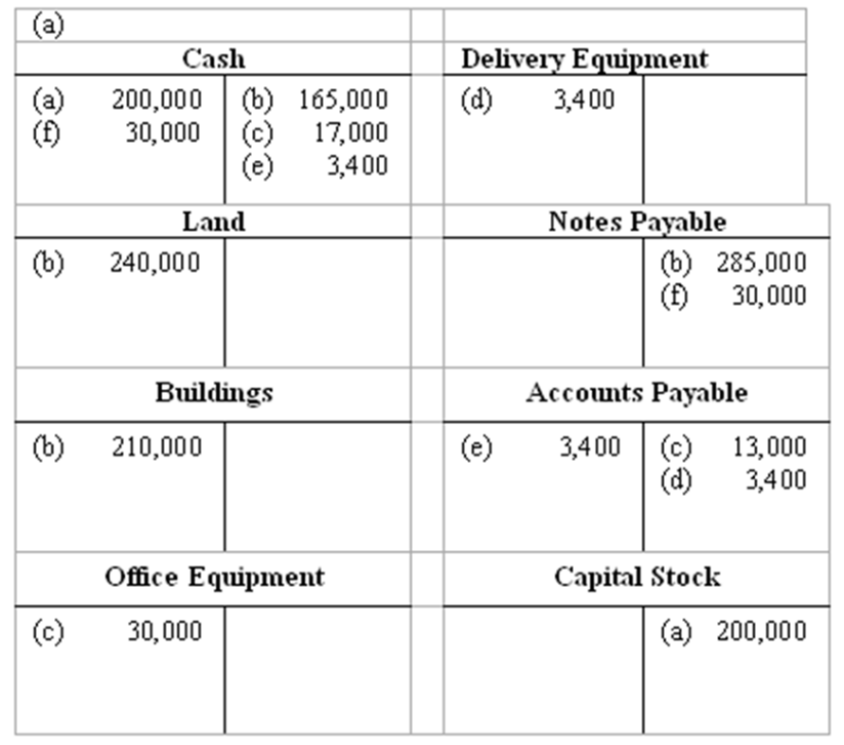
(B)
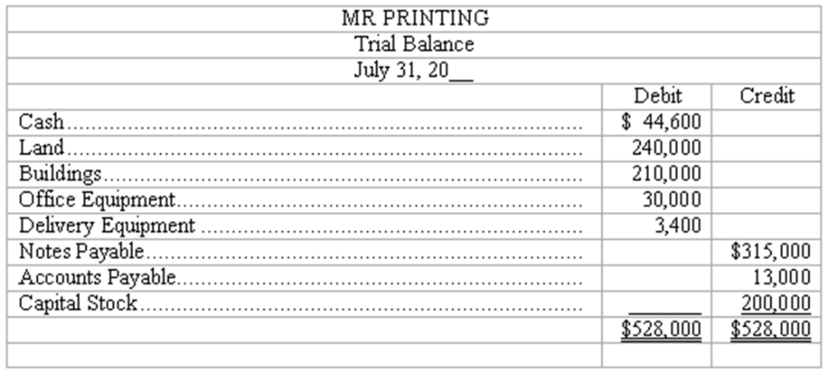

AACSB: Analytic
AICPA BB: Critical Thinking
AICPA FN: Measurement
Bloom's: Apply
Difficulty: Medium
Learning Objective: 03-03 Understand how balance sheet accounts are increased or decreased.
Topic: Debit and Credit Entries
129. Recording transactions in T accounts; trial balance
On May 15, George Manny began a new business, called Sounds, Inc., a recording studio to be rented out to artists on an hourly or daily basis. The following six transactions were completed by the business during May:
(A.) Issued to Manny 5,000 shares of capital stock in exchange for his investment of $200,000 cash.
(B.) Purchased land and a building for $410,000, paying $100,000 cash and signing a note payable for the balance. The land was considered to be worth $310,000 and the building $100,000.
(C.) Installed special insulation and soundproofing throughout most of the building at a cost of $120,000. Paid $32,000 cash and agreed to pay the balance in 60 days. Manny considers these items to be additional costs of the building.
(D.) Purchased office furnishings costing $18,000 and recording equipment costing $88,400 from Music Supplies. Sounds paid $28,000 cash with the balance due in 30 days.
(E.) Borrowed $180,000 from a bank by signing a note payable.
(F.) Paid the full amount of the liability to Music Supplies arising from the purchases in D above.
Instructions
(A.) Record the above transactions directly in the T accounts below. Identify each entry in a T account with the letter shown for the transaction. This exercise does not call for the use of a journal.
(B.) Prepare a trial balance at May 31 by completing the form provided.
SOUNDS, INC.
Trial Balance
May 31, 20__
Debit Credit
(A)
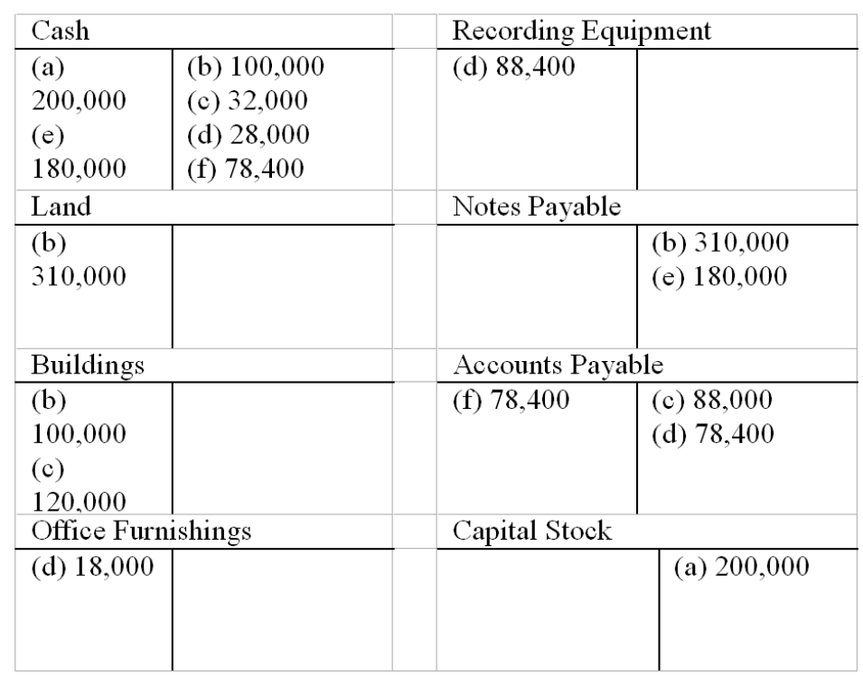
(B)
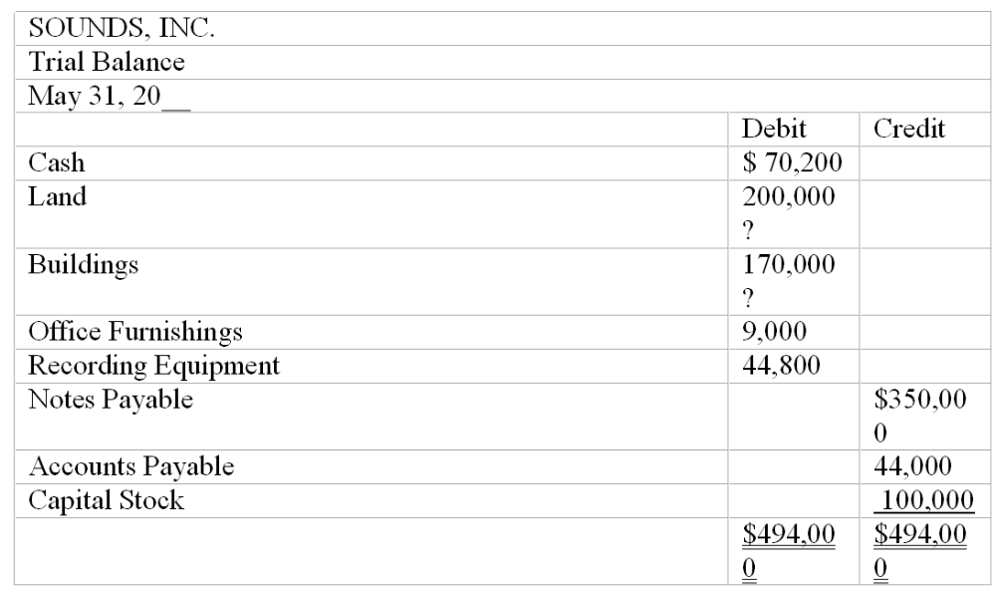

AACSB: Analytic
AICPA BB: Critical Thinking
AICPA FN: Measurement
Bloom's: Apply
Difficulty: Medium
Learning Objective: 03-03 Understand how balance sheet accounts are increased or decreased.
Topic: Debit and Credit Entries
130. Recording transactions journal entry grid
A list of accounts for Harding Company is given below, followed by a series of transactions. Indicate the accounts that would be debited and credited in recording each transaction by placing the appropriate number (or numbers) in the space provided.
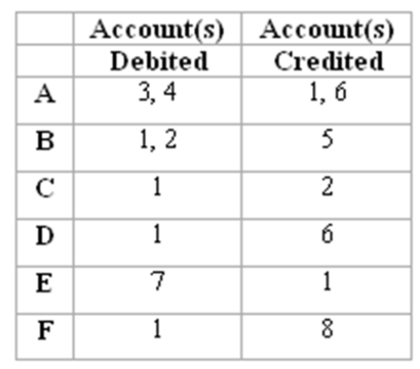

AACSB: Analytic
AICPA BB: Critical Thinking
AICPA FN: Measurement
Bloom's: Apply
Difficulty: Medium
Learning Objective: 03-03 Understand how balance sheet accounts are increased or decreased.
Topic: Debit and Credit Entries
131. Listed below are accounts of Global Company, each identified by a number. Following this list of accounts is a series of transactions. You are to indicate for each transaction the accounts that should be debited and credited by inserting the proper account numbers in the space provided.
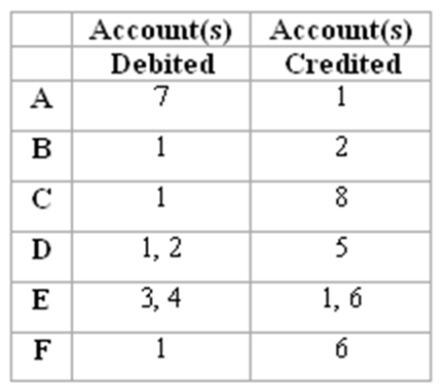

AACSB: Analytic
AICPA BB: Critical Thinking
AICPA FN: Measurement
Bloom's: Apply
Difficulty: Medium
Learning Objective: 03-03 Understand how balance sheet accounts are increased or decreased.
Topic: Debit and Credit Entries
132. Recording transactions in general journal
Enter the following transactions in the two-column journal of Baumann Bathrooms. Include a brief explanation of the transaction as part of each journal entry.
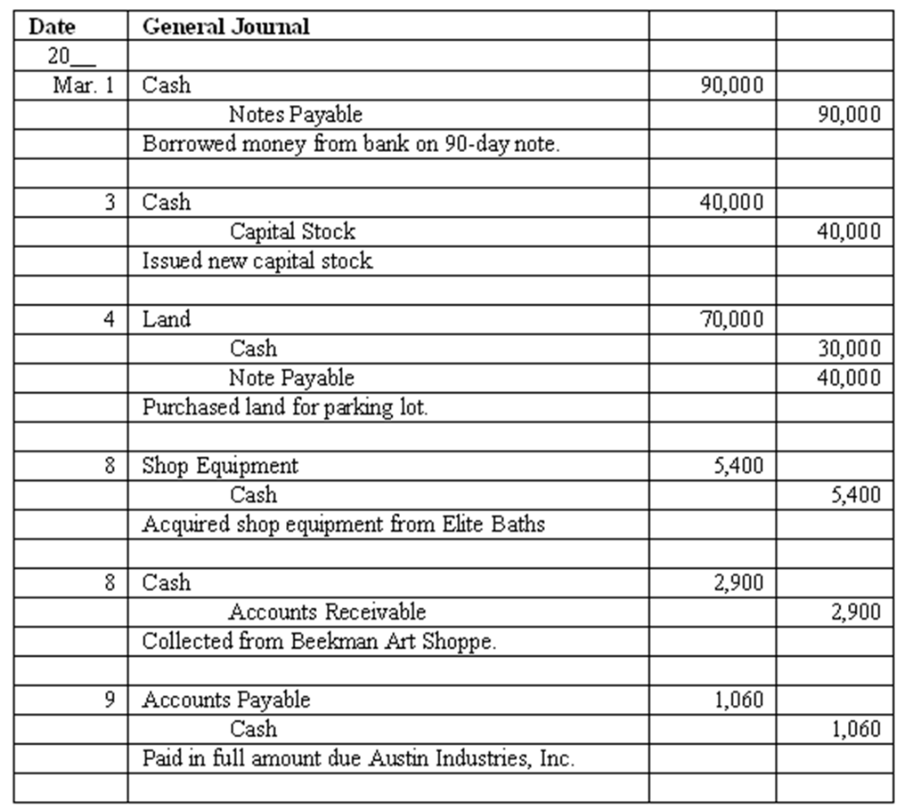

AACSB: Analytic
AICPA BB: Critical Thinking
AICPA FN: Measurement
Bloom's: Apply
Difficulty: Medium
Learning Objective: 03-05 Explain the purpose of a journal and its relationship to the ledger.
Topic: The Journal
133. Recording transactions in general journal
Enter the following transactions in the two-column journal of Festive Parties, Inc. Include a brief explanation of the transaction as part of each journal entry.
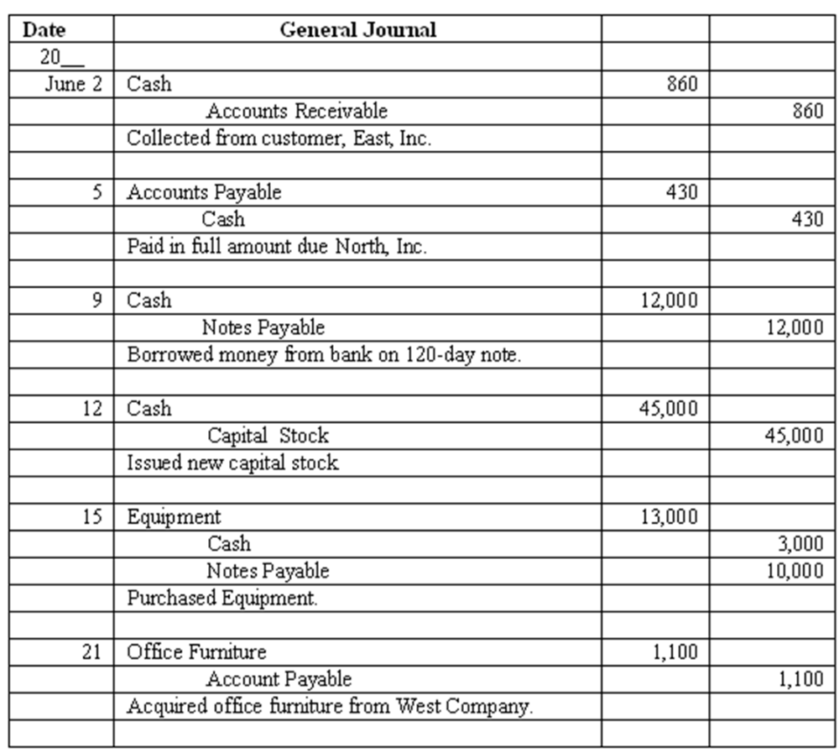

AACSB: Analytic
AICPA BB: Critical Thinking
AICPA FN: Measurement
Bloom's: Apply
Difficulty: Medium
Learning Objective: 03-05 Explain the purpose of a journal and its relationship to the ledger.
Topic: The Journal
134. Journalize and post basic transactions
Precision Grading Co. was organized to grade construction sites.
* On June 1, owner Dave Precision deposited $90,000 in a new bank account opened in the name of the business in exchange for stock.
* On June 3, the company acquired grading equipment costing $89,000, paying $43,000 cash and signing a note payable for the balance.
* On June 10, the company paid $13,000 of the amount owed for equipment acquired on June 3.
Instructions: Journalize these three transactions and post to the ledger accounts.
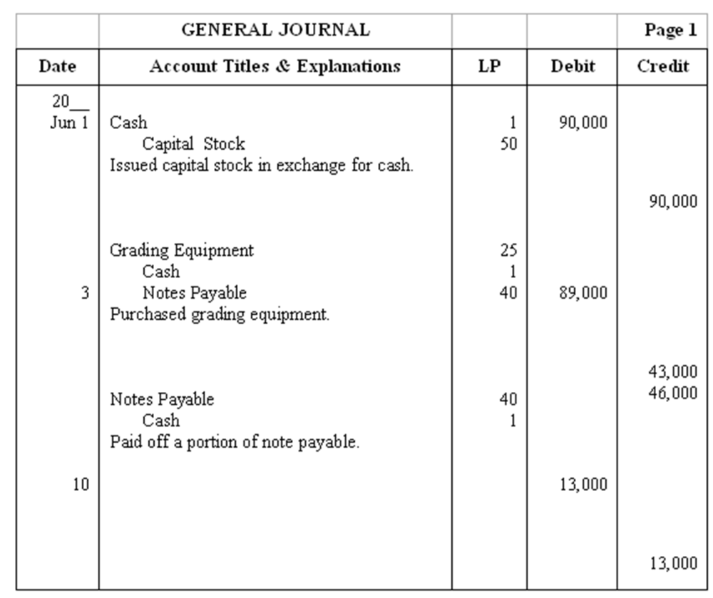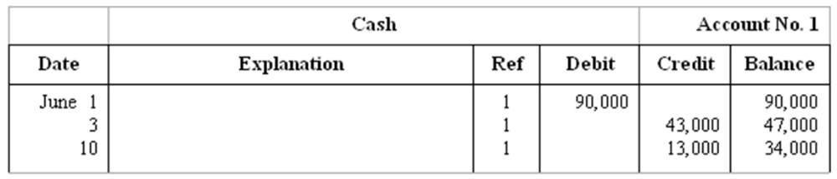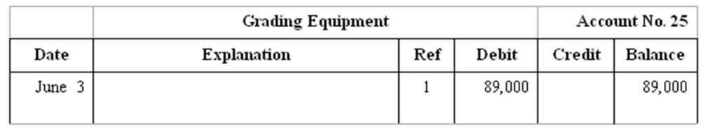
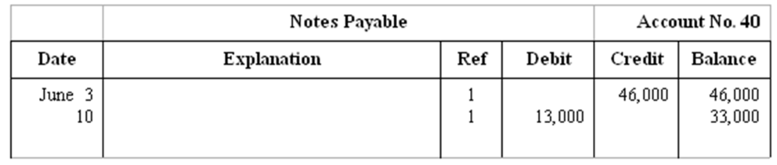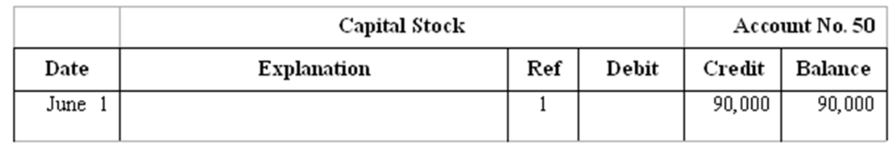

AACSB: Analytic
AICPA BB: Critical Thinking
AICPA FN: Measurement
Bloom's: Apply
Difficulty: Medium
Learning Objective: 03-05 Explain the purpose of a journal and its relationship to the ledger.
Topic: Ledger Accounts after Posting
135. Journalize and post basic transactions
Geller Landscaping was organized on April 5 when the corporation issued 20,000 shares of capital stock to Larry Geller in exchange for $60,000 cash.
* On April 8, the business acquired gardening equipment by paying cash of $26,000 and signing a $20,000 note payable, due in four monthly installments of $5,000 each, beginning on April 15.
* On April 15, Larry Geller made the first payment on the note payable by writing a check from the business bank account.
Instructions: Journalize these three transactions and post to the ledger accounts.
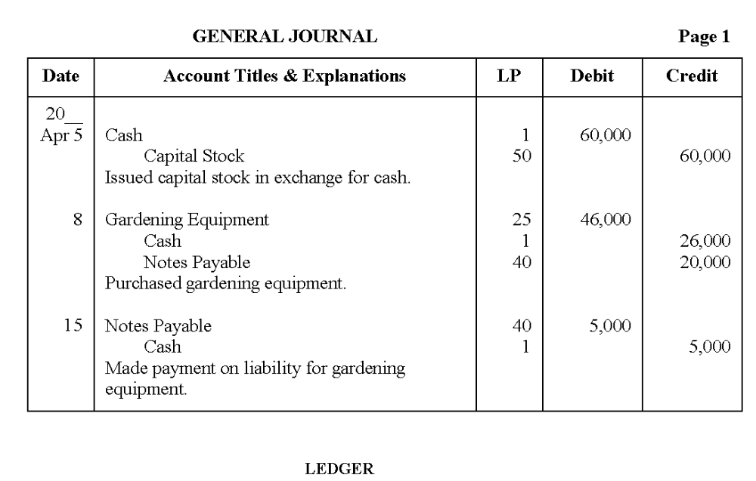
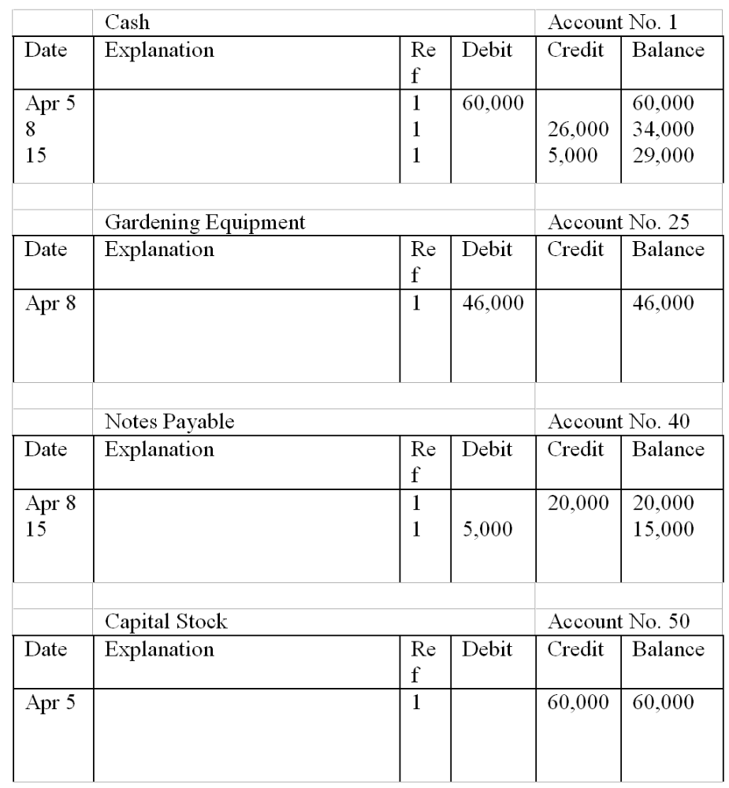

AACSB: Analytic
AICPA BB: Critical Thinking
AICPA FN: Measurement
Bloom's: Apply
Difficulty: Medium
Learning Objective: 03-05 Explain the purpose of a journal and its relationship to the ledger.
Topic: Ledger Accounts after Posting
136. Effects of a series of transactions on balance sheet items
Fieldstone, Inc. had the following transactions during the month of March, the first month of operations for the business:
* The corporation issued 12,000 shares of capital stock to Sandy Fieldstone in exchange for $120,000 cash.
* Purchased $73,000 of equipment; made a $18,000 down payment and signed a note payable for the balance.
* Made payment of $9,000 on the amount owed for equipment.
(A.) Compute the balance in the Cash account at the end of March.
(B.) What are the total assets of Fieldstone, Inc. at the end of March?
(C.) Compute the balance in the Notes Payable account at the end of March.
(D.) What is the total amount of owners' equity at the end of March?
(A.) $93,000
(B.) $166,000
(C.) $46,000
(D.) $120,000

AACSB: Analytic
AICPA BB: Critical Thinking
AICPA FN: Measurement
Bloom's: Analyze
Difficulty: Medium
Learning Objective: 03-03 Understand how balance sheet accounts are increased or decreased.
Topic: Debit and Credit Entries
137. Effects of a series of transactions on balance sheet items
Clark Plumbing had the following transactions during the month of June, the first month of operations for the business:
* The corporation issued 12,000 shares of capital stock to Bill Clark in exchange for his investment of $72,000 cash.
* Purchased $36,000 of equipment; made an $8,000 down payment and signed a note payable for the balance.
* Made payment of $4,000 on the amount owed for equipment.
(A.) Compute the balance in the Cash account at the end of June.
(B.) What are the total assets of Clark Plumbing at the end of June?
(C.) Compute the balance in the Notes Payable account at the end of June.
(D.) What is the total amount of owners' equity at the end of June?
(A.) $60,000
(B.) $96,000
(C.) $24,000
(D.) $72,000

AACSB: Analytic
AICPA BB: Critical Thinking
AICPA FN: Measurement
Bloom's: Analyze
Difficulty: Medium
Learning Objective: 03-03 Understand how balance sheet accounts are increased or decreased.
Topic: Debit and Credit Entries
138. Double-entry accounting
The accounting system of most businesses, whether manual or computer-based, is some form of a double-entry system of accounting.
(A.) What is meant by the term "double-entry accounting"?
(B.) Explain how the double-entry system is applied in accounting for the following transaction:
Majestic Company purchases a piece of equipment costing $6,000, paying $3,000 cash with the balance of the purchase price to be paid within 60 days.
(A.) The phrase "double-entry" refers to the need for both debit entries and credit entries, equal in dollar amount, to record every transaction. As a result of this double-entry system, the accounting equation always remains in balance.
(B.) (Students are asked to explain how the double-entry system is applied in accounting for purchase of equipment costing $6,000, paying $3,000 cash with balance to be paid within 60 days.) This transaction is recorded with a debit to the asset Equipment for $6,000, a credit to the asset Cash for $3,000, and a credit to a liability Accounts Payable for $3,000. This accounting demonstrates that the transaction is recorded by an equal dollar amount ($6,000) of debit entries and credit entries. The accounting equation remains in balance: total assets have increased by $3,000 and total liabilities have increased by $3,000 as a result of this transaction.

AACSB: Reflective Thinking
AICPA BB: Critical Thinking
AICPA FN: Measurement
Bloom's: Understand
Difficulty: Medium
Learning Objective: 03-04 Explain the double-entry system of accounting.
Topic: Debit and Credit Entries
139. Rules of debit and credit as applied to balance sheet accounts
Items in the balance sheet are classified into three categories: assets, liabilities, and owners' equity.
(A.) Identify by name two ledger accounts in each of the first two categories above (assets and liabilities) and one owners' equity account. State whether each account would normally have a debit or credit balance.
(B.) Describe briefly the rules of debits and credits as applied to the three categories of balance sheet accounts: asset accounts, liability accounts, and owners' equity accounts.
(A.) Student's answer should include two from asset and liability categories (other account titles are possible); they have been introduced to only two owner's equity accounts at this stage.
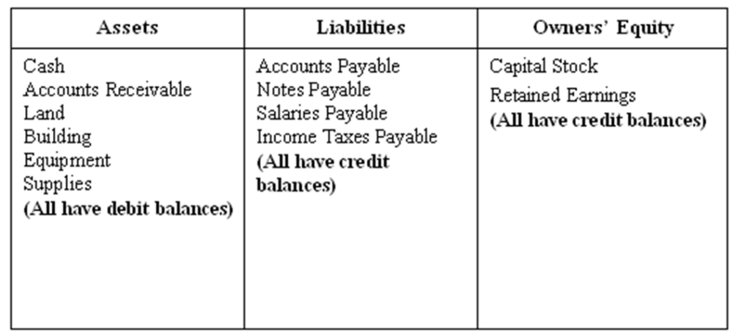
(B.) Debit and credit rules for:
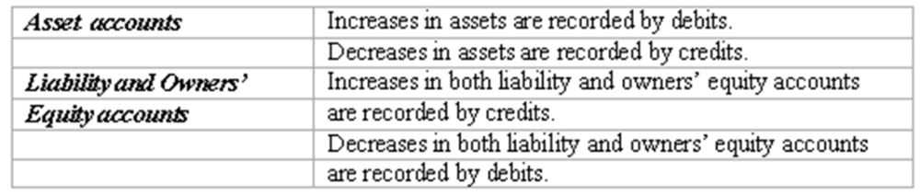

AACSB: Reflective Thinking
AICPA BB: Critical Thinking
AICPA FN: Measurement
Bloom's: Understand
Difficulty: Medium
Learning Objective: 03-03 Understand how balance sheet accounts are increased or decreased.
Topic: Debit and Credit Entries
140. Matching principle
In April, Grinnel Paving, Inc. acquired a large quantity of crushed stone on account with payment due in 90 days. The stone was used in May when Grinnel Paving, Inc. completed a large parking lot for a local shopping center. In early July, Grinnel Paving, Inc. paid the supplier from which the crushed stone had been purchased. In which month should Grinnel Paving, Inc. recognize the cost of the crushed stone as an expense? What accounting principle provides the justification for the answer?
Grinnel Paving, Inc. must recognize the expense in the month of May. This is the period in which the stone was used in earning revenue. The cost of the stone must be matched against the revenue earned in May. The matching principle requires and supports this accounting treatment.

AACSB: Reflective Thinking
AICPA BB: Critical Thinking
AICPA FN: Measurement
Bloom's: Understand
Difficulty: Medium
Learning Objective: 03-07 Apply the realization and matching principles in recording revenue and expenses.
Topic: What is Net Income?
141. Given the following list of accounts and their amounts for Hayden's Co. in alphabetical order, prepare a trial balance for December 31, 2009 as it should be presented.
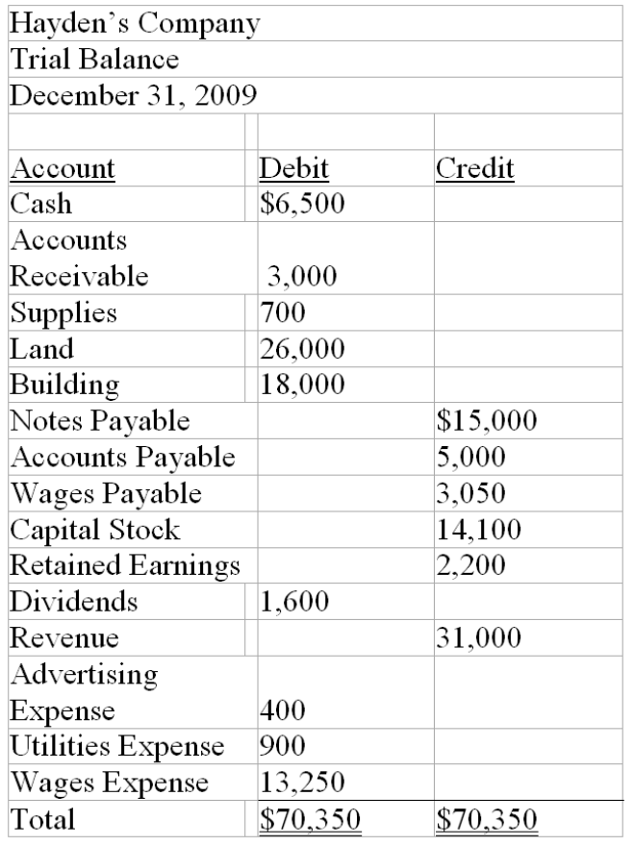

AACSB: Analytic
AICPA BB: Critical Thinking
AICPA FN: Measurement
Bloom's: Apply
Difficulty: Medium
Learning Objective: 03-09 Prepare a trial balance and explain its uses and limitations.
Topic: The Trial Balance
142. The following trial balance of Brian's Pickle Co for June 30, 2010 does not balance.
The following errors were discovered:
1. A purchase of supplies for cash was posted as $40 when it should have been $400.
2. The first two numbers of the amount for notes payable were transposed while being copied from the account balance to the trial balance. The correct amount of Notes Payable should be $51,500.
3. A collection of cash was debited to the cash account in the amount of $5,500 but was not credited to the revenue account.
4. A purchase of supplies for $725 on account was not recorded.
Instructions: Prepare a corrected trial balance
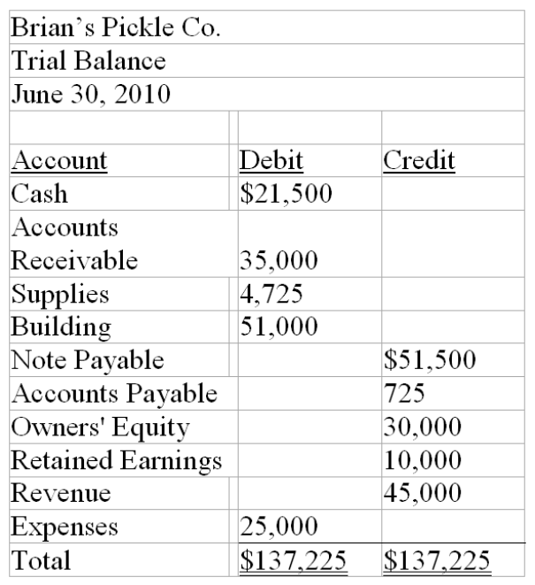

AACSB: Analytic
AICPA BB: Critical Thinking
AICPA FN: Measurement
Bloom's: Apply
Difficulty: Medium
Learning Objective: 03-09 Prepare a trial balance and explain its uses and limitations.
Topic: The Trial Balance

Multiple Choice Questions
The account balances for Creative Band, Inc. as of May 31, 2009, are listed below in alphabetical order:
Accounts Payable $12,000 Equipment $18,000
Accounts Receivable $14,000 Land $52,000
Building $42,000 Notes Payable $30,000
Cash $8,000 Capital Stock $92,000
On June 3, Creative Band, Inc collected $4,000 of its accounts receivable and paid $7,000 of its accounts payable. In addition, 2,000 of additional shares of capital stock are issued for $5,600.

143. In a trial balance prepared on May 31, 2009, the sum of the debit column is:
A. $120,000.
B. $156,000.
C. $134,000.
D. Some other amount.

Learning Objective: 03-02 Describe a ledger account and a ledger.
Learning Objective: 03-03 Understand how balance sheet accounts are increased or decreased.
Learning Objective: 03-04 Explain the double-entry system of accounting.
144. On June 4, the balance in the Cash account is:
A. $17,600.
B. $5,000.
C. $10,600.
D. Some other amount.

Learning Objective: 03-02 Describe a ledger account and a ledger.
Learning Objective: 03-03 Understand how balance sheet accounts are increased or decreased.
Learning Objective: 03-04 Explain the double-entry system of accounting.
145. On June 4, the balance in the Capital Stock account is:
A. $86,400.
B. $97,600.
C. $94,000.
D. Some other amount.

Learning Objective: 03-02 Describe a ledger account and a ledger.
Learning Objective: 03-03 Understand how balance sheet accounts are increased or decreased.
Learning Objective: 03-04 Explain the double-entry system of accounting.
146. In a trial balance prepared on June 4, the sum of the credit column is:
A. $130,000.
B. $132,600.
C. $127,000
D. Some other amount.

Learning Objective: 03-02 Describe a ledger account and a ledger.
Learning Objective: 03-03 Understand how balance sheet accounts are increased or decreased.
Learning Objective: 03-04 Explain the double-entry system of accounting.
147. On June 6, the bookkeeper for Creative Band, Inc makes this entry:
This transaction:
A. Decreases total assets.
B. Involves the sale of equipment for $7,400.
C. Increases total assets $7,400.
D. Increases liabilities.

Learning Objective: 03-02 Describe a ledger account and a ledger.
Learning Objective: 03-03 Understand how balance sheet accounts are increased or decreased.
Learning Objective: 03-04 Explain the double-entry system of accounting.

Essay Questions
148. Enter the following transactions in the two-column journal provided for Charlie's Cabinetry. You may omit explanations.
Mar. 2 Purchased auto cleaning supplies from Robert Suppliers for $750 on account.
4 Collected an account receivable of $525 from a customer, Elegant Kitchens.
5 Paid $275 in partial payment of an account payable to Lucy Co for equipment purchased in February.
7 Issued capital stock in exchange for $5,600 cash.
9 Purchased office equipment from Diamond's Warehouse for $3,700; paid $1,700 cash and issued a note payable due in 90 days for the balance.
Date General Journal
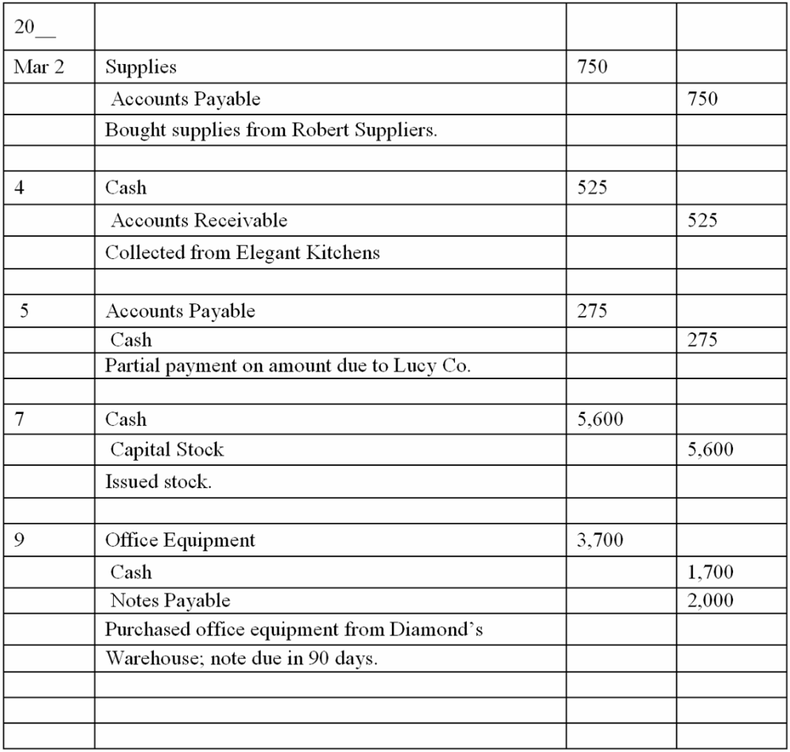

Learning Objective: 03-02 Describe a ledger account and a ledger.
Learning Objective: 03-03 Understand how balance sheet accounts are increased or decreased.
Learning Objective: 03-04 Explain the double-entry system of accounting.
149. Capital Financial Advisors, Inc. had the following transactions during January, its first month of operations:
a. Issued to Marvin Tycoon 9,000 shares of capital stock in exchange for his investment of $45,000 cash.
b. Borrowed $30,000 from a bank and signed a note payable due in three months.
c. Purchased office furniture costing $19,750; paid $6,000 cash and charged the balance on account.
d. Paid $6,000 of the amount owed for office furniture.
e. Issued an additional 2,000 shares of capital stock to an individual who invests $10,000 in the business.
Instructions
Record the above transactions directly in the T accounts below. Identify each entry in a T account with the letter shown for the transaction.
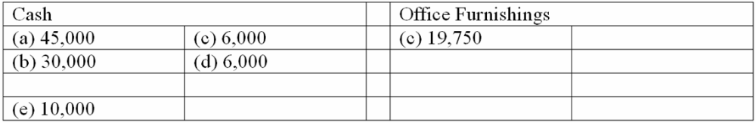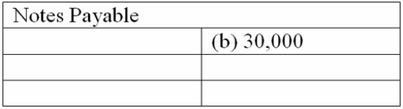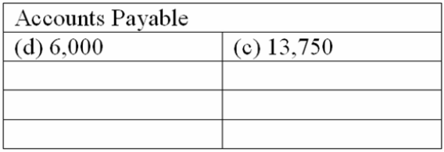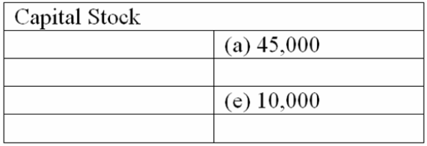

Learning Objective: 03-02 Describe a ledger account and a ledger.
Learning Objective: 03-03 Understand how balance sheet accounts are increased or decreased.
Learning Objective: 03-04 Explain the double-entry system of accounting.

Multiple Choice Questions
The following transactions occurred during June, the first month of operations for Accurate Manufacturing.:
* Issued 60,000 shares of capital stock to the owners of the corporation in exchange for $600,000 cash.
* Purchased a piece of land for $250,000, making an $80,000 cash down payment and signing a note payable for the balance.
* Made a $100,000 cash payment on the note payable from the purchase of land.
* Purchased equipment on credit from National Supply for $40,000.

150. The balance in the Cash account at the end of June:
A. $52,000.
B. $350,000.
C. $420,000.
D. $380,000.

Learning Objective: 03-02 Describe a ledger account and a ledger.
Learning Objective: 03-03 Understand how balance sheet accounts are increased or decreased.
Learning Objective: 03-04 Explain the double-entry system of accounting.
151. What are total assets of Precision Manufacturing at the end of June?
A. $710,000.
B. $890,000.
C. $630,000.
D. $460,000.

Learning Objective: 03-02 Describe a ledger account and a ledger.
Learning Objective: 03-03 Understand how balance sheet accounts are increased or decreased.
Learning Objective: 03-04 Explain the double-entry system of accounting.
152. What is the total of Precision's liabilities at the end of June?
A. $70,000.
B. $110,000.
C. $200,000.
D. $240,000.

Learning Objective: 03-02 Describe a ledger account and a ledger.
Learning Objective: 03-03 Understand how balance sheet accounts are increased or decreased.
Learning Objective: 03-04 Explain the double-entry system of accounting.
153. What is the total owners' equity at the end of June?
A. $60,000.
B. $110,000.
C. $240,000.
D. $600,000

Learning Objective: 03-02 Describe a ledger account and a ledger.
Learning Objective: 03-03 Understand how balance sheet accounts are increased or decreased.
Learning Objective: 03-04 Explain the double-entry system of accounting.
154. According to the rules of debit and credit for balance sheet accounts:
A. Increases in asset, liability, and owners' equity accounts are recorded by debits.
B. Decreases in asset and liability accounts are recorded by credits.
C. Increases in asset and owners' equity accounts are recorded by debits.
D. Decreases in liability and owners' equity accounts are recorded by debits.

155. Sunset Tours has a $3,500 account receivable from the Del Mar Rotary. On January 20, the Rotary makes a partial payment of $2,100 to Sunset Tours. The journal entry made on January 20 by Sunset Tours to record this transaction includes:
A. A debit to the Cash Received account of $2,100.
B. A credit to the Accounts Receivable account of $2,100.
C. A debit to the Cash account of $1,400.
D. A debit to the Accounts Receivable account of $1,400.

156. Indicate all of the following statements that correctly describe net income. Net income:
A. Is equal to revenue minus expenses.
B. Is equal to revenue minus the sum of expenses and dividends.
C. Increases owners' equity.
D. Is reported by a company for a period of time.

157. Which of the following is provided by a trial balance in which total debits equal total credits?
A. Proof that no transaction was completely omitted from the ledger during the posting process.
B. Proof that the correct debit or credit balance has been computed for each account.
C. Proof that the ledger is in balance.
D. Proof that transactions have been correctly analyzed and recorded in the proper accounts.

158. Which of the following explains the debit and credit rules relating to the recording of revenue and expenses?
A. Expenses appear on the left side of the balance sheet and are recorded by debits; revenue appears on the right side of the balance sheet and is recorded by credits.
B. Expenses appear on the left side of the income statement and are recorded by debits; revenue appears on the right side of the income statement and is recorded by credits.
C. Revenue increases owners' equity and is recorded by a credit; expenses decrease owners' equity and are recorded as debits.
D. The realization principle and the matching principle.

159. Which of the following is not considered an analytical aspect of the accounting profession?
A. Evaluating an organization's operational efficiency.
B. Forecasting the probable results of future operations.
C. Designing systems that provide information to decision makers.
D. Journalizing and posting business transactions.

160. Indicate all correct answers. In the accounting cycle:
A. Transactions are posted before they are journalized.
B. A trial balance is prepared after journal entries have been posted.
C. The Retained Earnings account is not shown as an up-to-date figure in the trial balance.
D. Journal entries are posted to appropriate ledger accounts.

161. Indicate all correct answers. Dividends:
A. Decrease owners' equity.
B. Decrease net income.
C. Are recorded by debiting the Dividend account.
D. Are a business expense.

