SURFING  Surface Water Sport | Abstract  Surfing is a surface water sport in which the wave rider, referred to as a surfer, rides on the forward or deep face of a moving wave, which is usually carrying the surfer toward the shore.  Malak Ghezzawi  CMPS 209

Table of Contents
Origins and History 2
Surf Waves 2
Wave Intensity 3
Artificial Reefs 3
Surfers and Surf Culture 4
Dangers 5
Drowning 5
Collisions 6
Marine life 6
Rip currents 6
Seabed 6

Waves suitable for surfing are primarily found in the ocean, but can also be found in lakes or in rivers in the form of a standing wave or tidal bore. However, surfers can also utilize artificial waves such as those from boat wakes and the waves created in artificial wave pools.

Origins and History
For centuries, surfing was a central part of ancient Polynesian culture. Surfing may have first been observed by Europeans at Tahiti in 1767 by Samuel Wallis and the crew members of the Dolphin who were the first Europeans to visit the island in June of that year. Another candidate is the botanist Joseph Banks being part of the first voyage of James Cook on the HMS Endeavour, who arrived on Tahiti on 10 April 1769. Lieutenant James King was the first person to write about the art of surfing on Hawaii when he was completing the journals of Captain James Cook upon Cook's death in 1779.
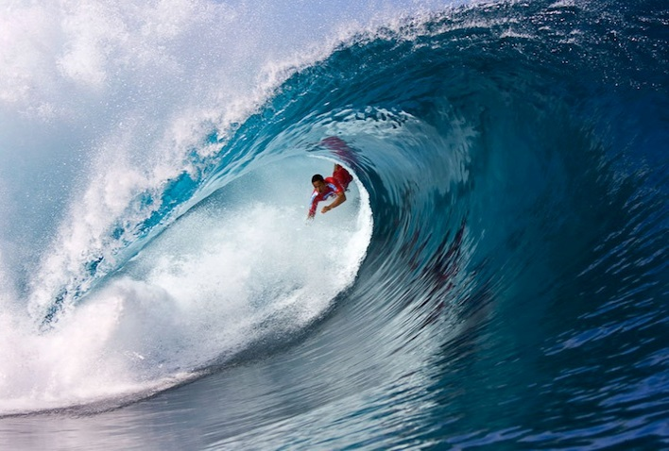
In July 1885, three teenage Hawaiian princes took a break from their boarding school, St. Mathew’s Hall in San Mateo, and came to cool off in Santa Cruz, California. There, David Kawananakoa, Edward Keliiahonui and Jonah Kuhio Kalaniana'ole surfed the mouth of the San Lorenzo River on custom-shaped redwood boards, according to surf historians Kim Stoner and Geoff Dunn.
George Freeth (8 November 1883 – 7 April 1919) is often credited as being the "Father of Modern Surfing". He is thought to have been the first modern surfer.
In 1975, professional contests started. That year Margo Oberg became the first female professional surfer.

Surf Waves
Swell is generated when wind blows consistently over a large area of open water, called the wind's fetch. The size of a swell is determined by the strength of the wind and the length of its fetch and duration. Because of this, surf tends to be larger and more prevalent on coastlines exposed to large expanses of ocean traversed by intense low pressure systems.
W
aves are generally recognized by the surfaces over which they break. For example, there are Beach breaks, Reef breaks and Point breaks. The most important influence on wave shape is the topography of the seabed directly behind and immediately beneath the breaking wave. The contours of the reef or bar front becomes stretched by diffraction. Each break is different, since each location's underwater topography is unique. At beach breaks, sandbanks change shape from week to week. Surf forecasting is aided by advances in information technology. Mathematical modeling graphically depicts the size and direction of swells around the globe. Surf travel and some surf camps offer surfers access to remote, tropical locations, where tradewinds ensure offshore conditions.

Wave Intensity
The Cobra: Square and Fast
Teahupoo: Square and Medium
Shark Island: Square and Slow
Speedies: Round and Fast
Banzai Pipeline: Round and Medium
Superbank: Almond and Fast
Bells Beach: Almond and Medium
Angourie Point: Almond and Slow

Artificial Reefs
The value of good surf in attracting surf tourism has prompted the construction of artificial reefs and sand bars. Artificial surfing reefs can be built with durable sandbags or concrete, and resemble a submerged breakwater. These artificial reefs not only provide a surfing location, but also dissipate wave energy and shelter the coastline from erosion. Ships such as Seli 1 that have accidentally stranded on sandy bottoms, can create sandbanks that give rise to good waves.
Even with artificial reefs in place, a tourist's vacation time may coincide with a "flat spell", when no waves are available. Completely artificial Wave pools aim to solve that problem by controlling all the elements that go into creating perfect surf, however there are only a handful of wave pools that can simulate good surfing waves, owing primarily to construction and operation costs and potential liability. Most wave pools generate waves that are too small and lack the power necessary to surf. The Seagaia Ocean Dome, located in Miyazaki, Japan, was an example of a surfable wave pool. Able to generate waves with up to 10-foot faces, the specialized pump held water in 20 vertical tanks positioned along the back edge of the pool. This allowed the waves to be directed as they approach the artificial sea floor. Lefts, Rights, and A-frames could be directed from this pump design providing for rippable surf and barrel rides. The Ocean Dome cost about $2 billion to build and was expensive to maintain. The Ocean Dome was closed in 2007. In England, construction is nearing completion on the Wave, situated near Bristol, which will enable people unable to get to the coast to enjoy the waves in a controlled environment, set in the heart of nature.

Surfers and Surf Culture
Surfers represent a diverse culture based on riding the waves. Some people practice surfing as a recreational activity while others make it the central focus of their lives. Within the United States, surfing culture is most dominant in Hawaii and California because these two states offer the best surfing conditions. However, waves can be found wherever there is coastline, and a tight-knit yet far-reaching subculture of surfers has emerged throughout America. Some historical markers of the culture included the woodie, the station wagon used to carry surfers' boards, as well as boardshorts, the long swim shorts typically worn while surfing. Surfers also wear wetsuits in colder regions.
The sport of surfing now represents a multi-billion dollar industry especially in clothing and fashion markets. The Association of Surfing Professionals (ASP) runs the world tour, hosting top competitors in some of the best surf spots around the globe. A small number of people make a career out of surfing by receiving corporate sponsorships and performing for photographers and videographers in far-flung destinations; they are typically referred to as freesurfers.
When the waves were flat, surfers persevered with sidewalk surfing, which is now called skateboarding. Sidewalk surfing has a similar feel to surfing and requires only a paved road or sidewalk. To create the feel of the wave, surfers even sneak into empty backyard swimming pools to ride in, known as pool skating. Eventually, surfing made its way to the slopes with the invention of the Snurfer, later credited as the first snowboard. Many other board sports have been invented over the years, but all can trace their heritage back to surfing.
Many surfers claim to have a spiritual connection with the ocean, describing surfing, the surfing experience, both in and out of the water, as a type of spiritual experience or a religion.

Dangers

Drowning
Surfing, like all water sports, carries the inherent danger of drowning. Anyone at any age can learn to surf, but should have at least intermediate swimming skills. Although the board assists a surfer in staying buoyant, it can become separated from the user. A leash, attached to the ankle or knee, can keep a board from being swept away, but does not keep a rider on the board or above water. In some cases, possibly including the drowning of professional surfer Mark Foo, a leash can even be a cause of drowning by snagging on a reef or other object and holding the surfer underwater. By keeping the surfboard close to the surfer during a wipeout, a leash also increases the chances that the board may strike the rider, which could knock him or her unconscious and lead to drowning. A fallen rider's board can become trapped in larger waves, and if the rider is attached by a leash, he or she can be dragged for long distances underwater.

Collisions
Under the wrong set of conditions, anything that a surfer's body can come in contact with is potentially a danger, including sand bars, rocks, small ice, reefs, surfboards, and other surfers. Collisions with these objects can sometimes cause injuries such as cuts and scrapes and in rare instances, death.

Marine life
Sea life can sometimes cause injuries and even fatalities. Animals such as sharks, stingrays, Weever fish, seals and jellyfish can sometimes present a danger. Warmer-water surfers often do the "stingray shuffle" as they walk out through the shallows, shuffling their feet in the sand to scare away stingrays that may be resting on the bottom.

Rip currents
Rip currents are water channels that flow away from the shore. Under the wrong circumstances these currents can endanger both experienced and inexperienced surfers. Since a rip current appears to be an area of flat water, tired or inexperienced swimmers or surfers may enter one and be carried out beyond the breaking waves. Although many rip currents are much smaller, the largest rip currents have a width of forty or fifty feet. However, by paddling parallel to the shore, a surfer can easily exit a rip current. Alternatively, some surfers actually ride on a rip current because it is a fast and effortless way to get out beyond the zone of breaking waves.

Seabed
The seabed can pose dangers for surfers. If a surfer falls while riding a wave, the wave tosses and tumbles the surfer around, often in a downwards direction. At reef breaks and beach breaks, surfers have been seriously injured and even killed because of a violent collision with the sea bed, the water above which can sometimes be very shallow, especially at beach breaks or reef breaks during low tide. Cyclops, Western Australia, for example is one of the biggest and thickest reef breaks in the world, with waves measuring up to 10 meters high, but the reef below is only about 2 meters (6.6 feet) below the surface of the water.

