EECE 320 – Digital Systems Design
Homework 4

Problem 1 [20 points] Solve Problem 6.20 Parts (a), (c), and (e) in the textbook.

Problem 2 [20 points] Solve Problem 6.21 in the textbook.

Problem 3 [20 points]: Write VHDL code to implement an 8-to-3 priority encoder. Provide printouts of your code including test bench file in addition to snapshots of the obtained simulation waveforms.

Problem 4 [20 points] Solve Problem 6.55 in the textbook. The MSI devices to be used are limited to 74x148 and 74x138.

Problem 5 [20 points] Solve Problem 6.57 in the textbook. Use VHDL and develop a suitable test bench file. Provide printouts of your code including test bench file in addition to snapshots of the obtained simulation waveforms.

Problem 1
6.20

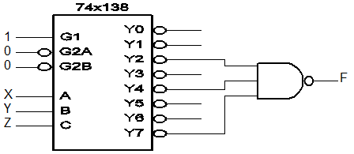

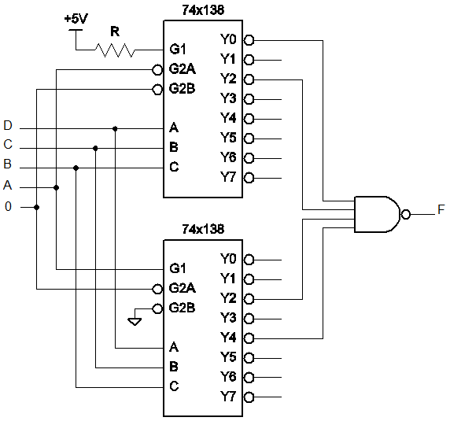

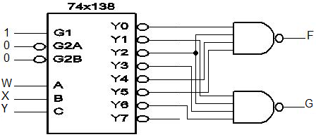

Problem 2
6.21
What is wrong with the circuit in Figure X6.21 is that the enable wire (EN_L) enables (or disables) both 2-to-4 decoders simultaneously, when EN_L gets 0, 2 of the 8 outputs to take the value 0 and two three-state buffers act like a normal buffer, and two 1-bit signals (out of P, Q, R, S, T, U, V and W) make their way to SDATA (the 1-bit party-line). But SDATA can only store 1-bit, therefore we can not predict how the circuit reacts.
To eliminate the terrible problem we can add an inverter between EN_L and one of the two G ports (1G or 2G). The new circuit is illustrated below:

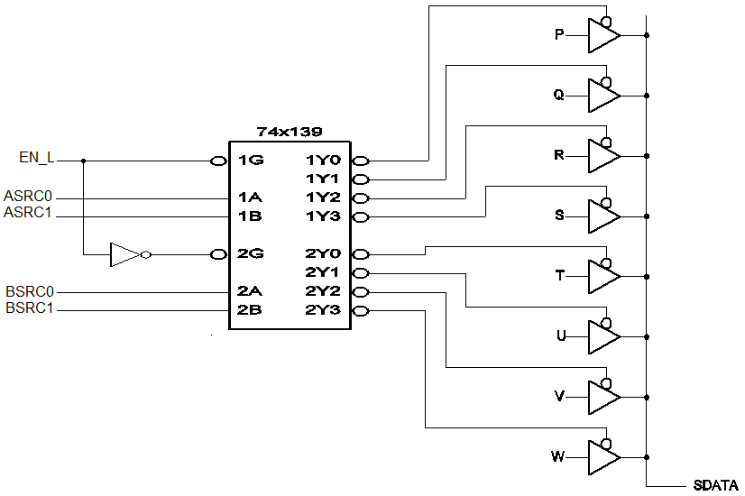

Problem 3
8-to-3 priority encoder:
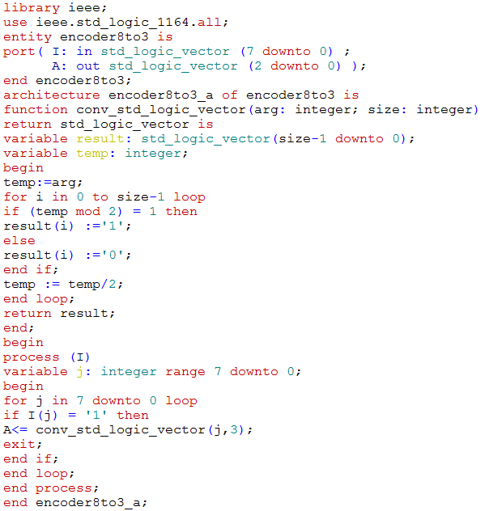

Test Bench:
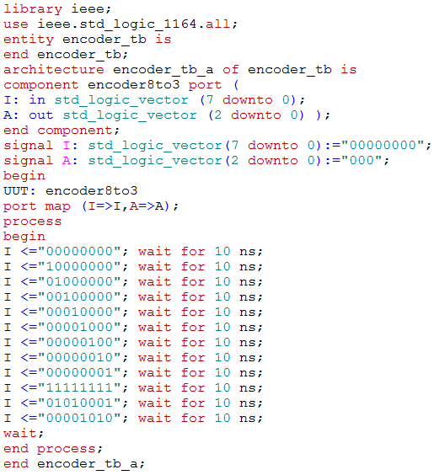

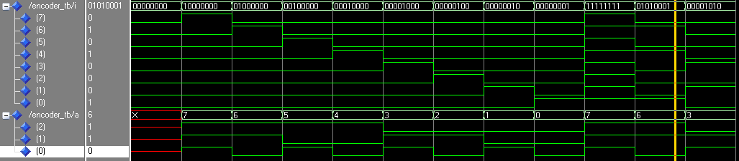
Simulation waveform:
Problem 4
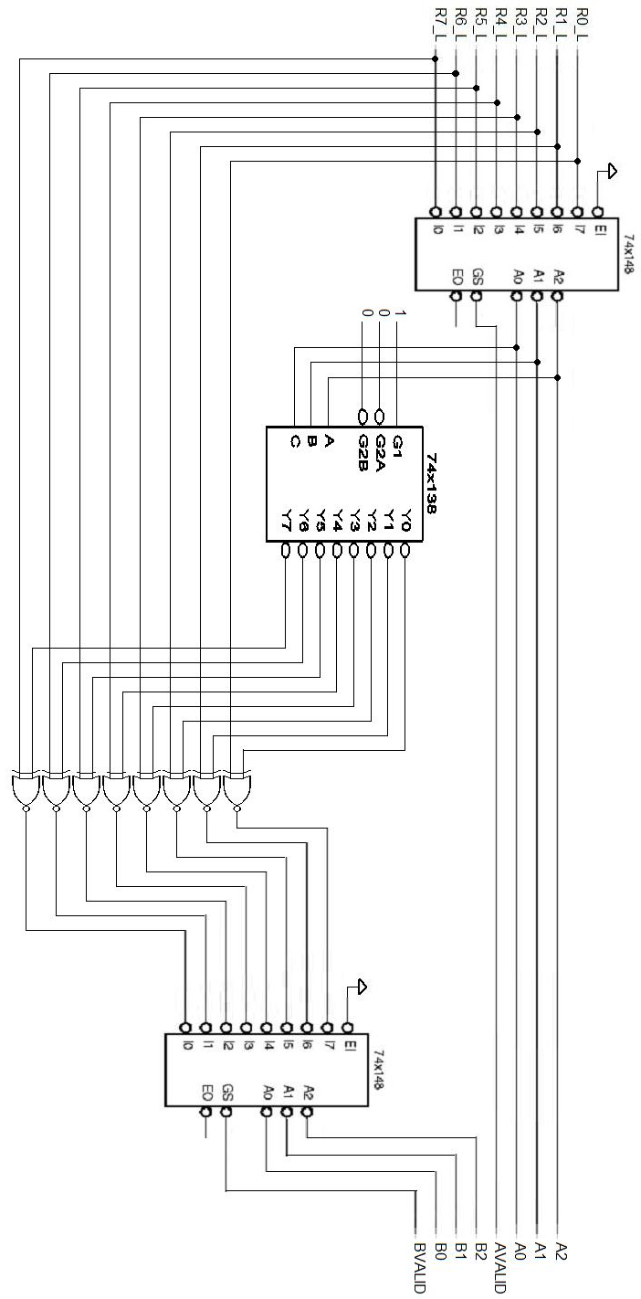

Problem 5
74x148 Priority Encoder:
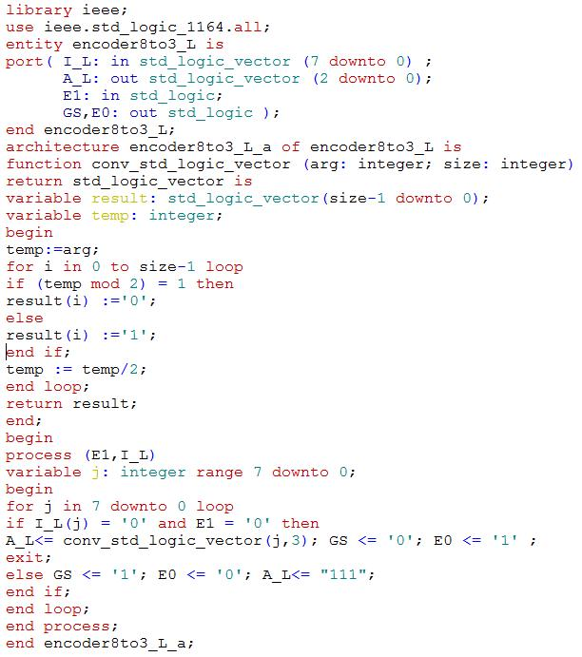

74x138 decoder:
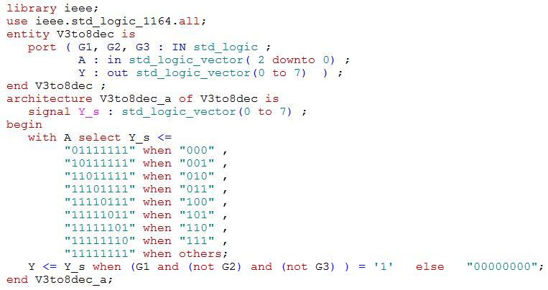

Circuit from 6.55:
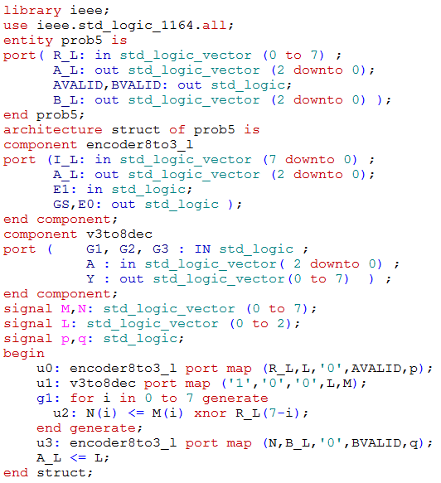
Test bench:
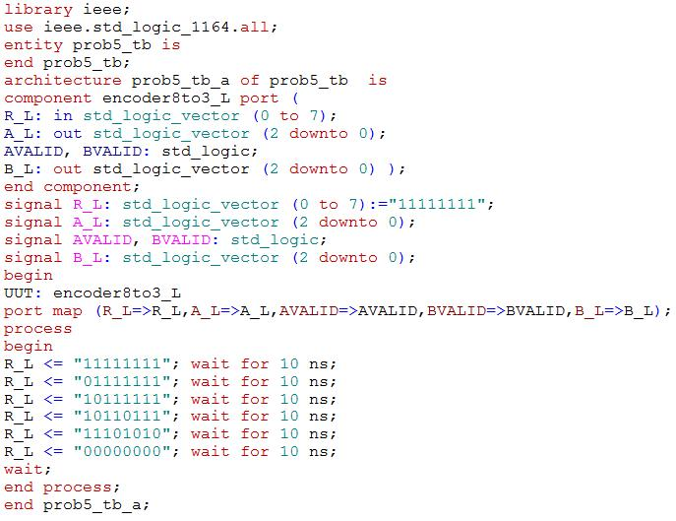

Simulation waveform:



