Quiz 2 – Sections 1, 2 and 3
Open Book – One and One-Half Hours

8%
1. A series RLC circuit is critically damped, i.e., 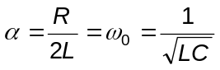. What is the Q of the circuit?
- 0.5
- 1
- 2
- 0
- None of the above
Solution: 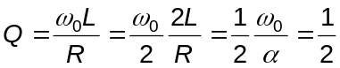.
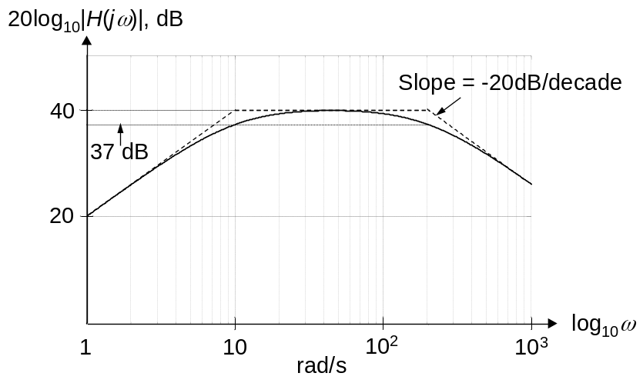
8%
- Determine the transfer
function whose Bode
magnitude plot is shown.
- 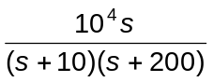
- 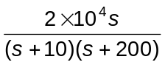
- 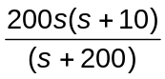
- 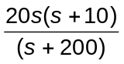
- None of the above
Solution: The low frequency asymptote is Ks. A pole must exist at 10 rad/s to reduce the slope to zero and another pole at 200 rad/s to give a slope of -20dB/decade. It follows that 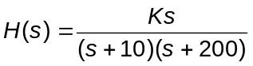. To determine K, we note that at very low frequencies, 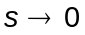 and 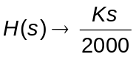, which must be the low-frequency asymptote. But this asymptote passes through the point (1 rad/s, 20dB). Hence, when s = jω = j, 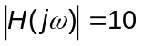. Substituting, gives 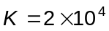.
8%
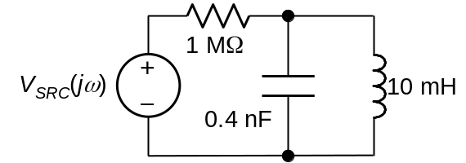
3. If a 4 MΩ resistor is connected in parallel with L and C, the bandwidth:
A. increases by 20%
B. decreases by 20%
C. increases by 25%
D. decreases by 25%
E. None of the above,
Solution: Before the 4 MΩ resistor is added, Q = ω₀CR = ω₀C×1, and BW = 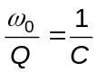. After the 4 MΩ resistor is added, R′ = 4||1 = 0.8 MΩ. Hence, Q′ = ω₀C×0.8, and BW′ = 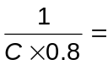 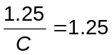BW.

8%
4. Given a bandpass transfer function of a series RLC circuit as 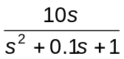, normalized to have ω₀ = 1 rad/s, C = 1 F, L = 1 H and R = 0.1 Ω. If the frequency is scaled so that ω₀ = 100 krad/s, and C = 100 nF, what would be the scaled value of Q?
A. 1
B. 0.1
C. 100
D. 10
E. None of the above.
Solution: In any type of bandpass filter, Q = 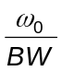. Both ω₀ and BW are scaled by the same factor, so that Q remains the same. For a series circuit, the coefficient of s in the denominator is 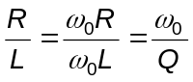. Hence, in the given transfer function, Q = 10 and remains 10 after scaling. This can be checked, for k_{f} = 10⁵ and 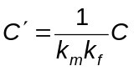, or 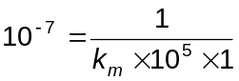, or k_{m} = 100, which gives R = 10 Ω and 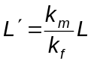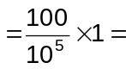1 mH. It It follows that 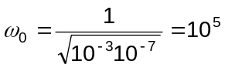 rad/s and 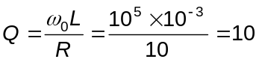.

8%
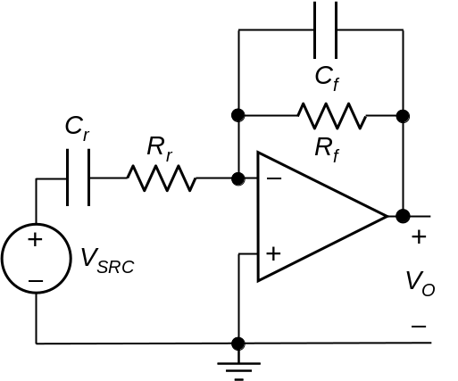
5. The circuit shown implements a filter of one of the following types:
A. Lowpass
B. Highpass
C. Bandpass
D. Bandstop
E. None of the above.
Solution: Qualitatively, the capacitors behave as open circuits at zero frequency. The input is isolated, and the output is connected to virtual ground, resulting in zero output. As ω → ∞, the capacitors behave as short circuits, again connecting the output to virtual ground and resulting in zero output. Maximum output occurs at an intermediate frequency, resulting in a bandpass response.
Quantitatively, 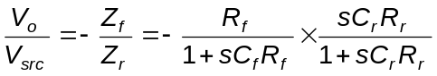, which is a bandpass type response.

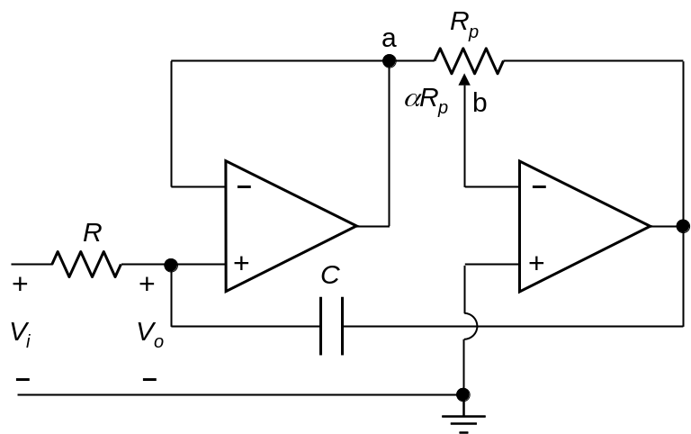
8%
- The circuit shown implements a first-order lowpass filter of variable cutoff frequency and a simulated large value of capacitance. The resistance between points a and b is αR_{p}, where 0 ≤ α ≤ 1. The 3-dB cutoff frequency is:
A. 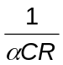
B. 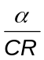
C. 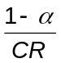
D. 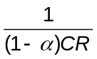
E. None of the above.
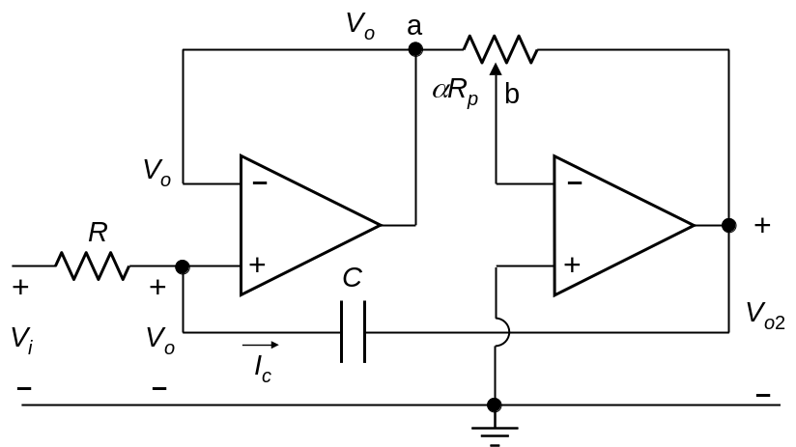
Solution: Because of the unity gain amplifier, the voltage of node a with respect to ground is V_{o}. The second op amp is an amplifier in the inverting configuration having R_{r} = αR_{p} and R_{f} = (1 – α)R_{p}. It follows that 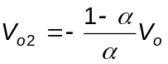. The current 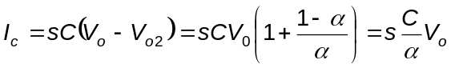. The effective capacitance at the noninverting input of the first op amp is C/α. The 3-dB cutoff frequency is therefore .
17%
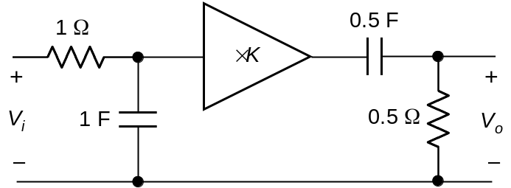
- The op amp in the figure is ideal and of gain K.
(6%) i) Determine the frequency of maximum response.
(5%) ii) Find K so that the maximum response is 20 dB.
(6%) iii) Calculate the bandwidth.
Solution: 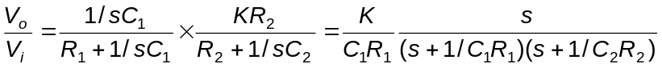, where C₁ = 1F, R₁ = 1 Ω, C₂ = 0.5 F, and R₂ = 0.5 Ω. This gives: 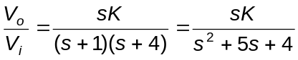.
- Substituting s = jω, 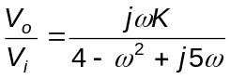. Maximum response occurs when ω = 2 rad/s.
- The maximum response is 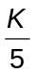. To have this equal to 10, that is 20 dB, K = 50.
- At the half-power frequencies: 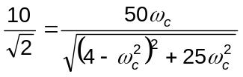. It follows that: 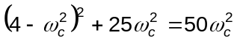; 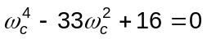; 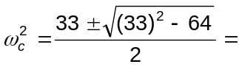32.508 and 0.49219; ω_{c} = 5.702 and 0.702. The bandwidth is 5 rad/s.
Alternatively, by equating the coefficient of s in the denominator, which is 5, to the coefficient of s in the standard form of the second-order response, which is 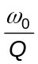, it follows that 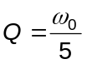. The bandwidth is 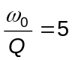rad/s.
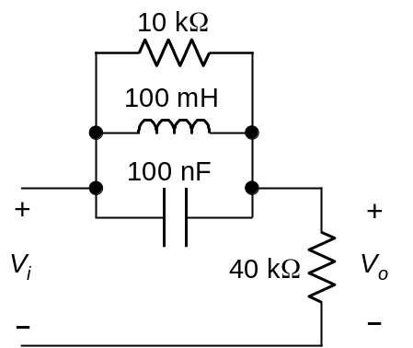
17%
8. For the filter shown,
(6%) i) Determine the resonant frequency.
(6%) ii) If V_{i} = 1 V, determine the output at resonance and sketch the frequency response.
(5%) iii) Find Q.
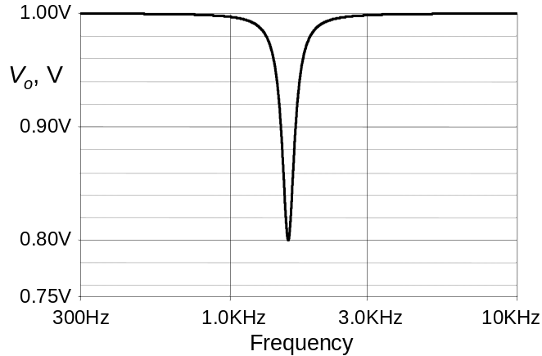
Solution:
i) 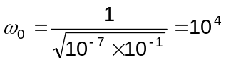rad/s.
ii) At resonance, 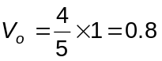V. The sketch of the response is as shown.
iii) 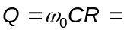 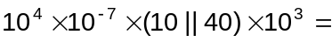
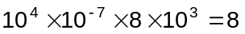.

18%
- Design a broadband bandpass filter consisting of a first-order lowpass active filter and a first-order highpass active filter to meet the following specification:
  - 3-dB cutoff frequencies of 10 Hz and 20 kHz.
  - A 1 nF capacitor is to be used in the lowpass filter and a 100 nF capacitor is to be used in the highpass filter.
  - Minimum input impedance of 10 kΩ resistive.
  - Overall gain of -10.
Assume ideal op amps. Draw the circuit diagram showing all component values.
Solution: Since the 3-dB cutoff frequencies are more than a decade apart, each filter can be designed separately. To have a cutoff frequency of 20 kHz for the lowpass filter requires R_{fl} = 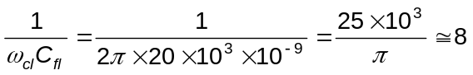kΩ. For the highpass filter, R_{rh} = 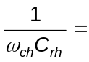
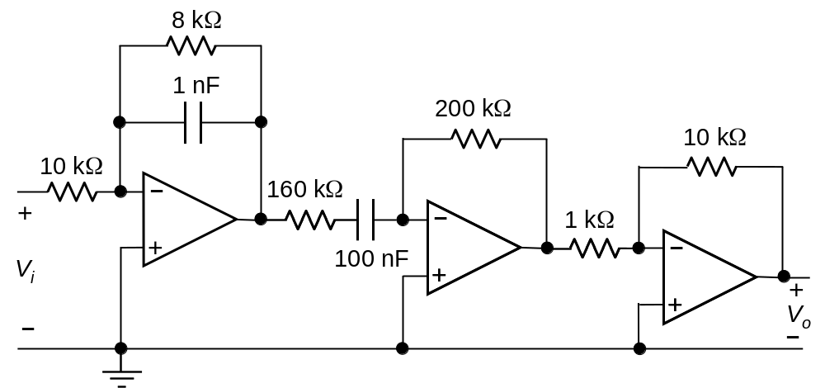
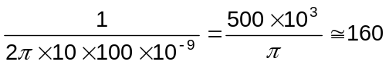kΩ. If R_{rl} = 10 kΩ, the gain of the two filters is 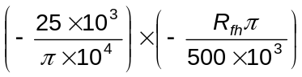= 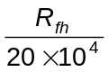. If R_{fh} = 200 kΩ, the overall gain is 1. To have a gain of 10, an inverting amplifier of gain -10 should be added. This can have R_{r} = 1 kΩ and R_{f} = 10 kΩ. The complete circuit is as shown.

