Example: Electric field of a ring of charge

A ring of charge of radius b is characterized by a uniform line charge density of positive polarity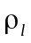. With the ring in free space and positioned in the x-y plane as shown in the figure below, determine the electric field intensity at the point P(0, 0, h) along the axis of the ring at a distance h from its center.
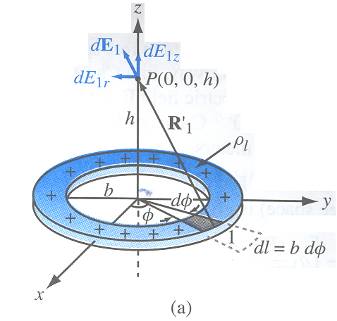
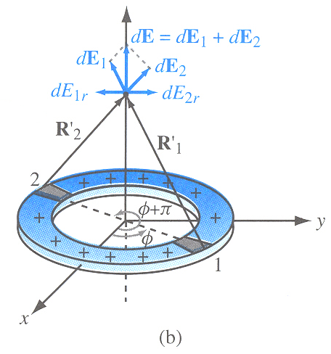

Solution:
The segment has a length 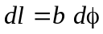 and contains charge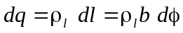.
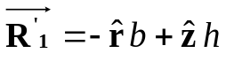
from which we have,
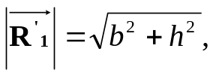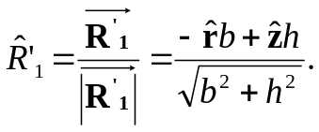
The electric field at P(0, 0, h) due to the charge of segment 1 is

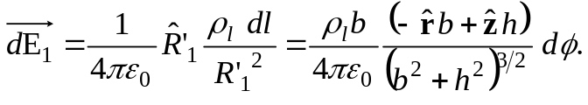
From symmetry considerations, the fields 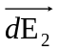 generated by segment 2 in the last figure which is located diametrically opposite the location of segment 1, is identical with 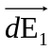 except that the - component of is opposite that of. Hence, the - component of the sum cancel and the -contributions add. The sum of the two contributions is

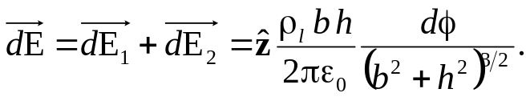

so,
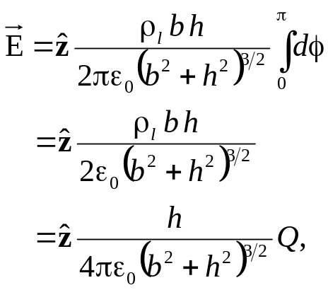
where 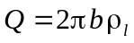.

Example: Electric field of a circular disk of charge

Find the electric field at a point P(0, 0, h) in free space at a height h on the z-axis due to a circular disk of charge in the x-y plane with uniform charge density 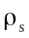, as shown in figure, and then evaluate for the infinite-sheet case by letting .
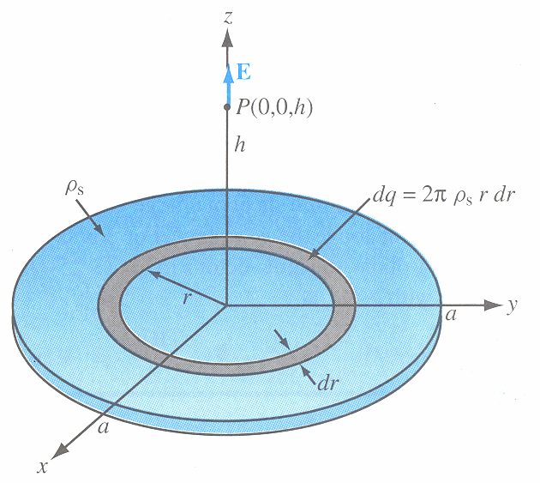

Solution:
A ring of radius r and width dr has an area 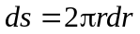and contains charge 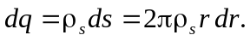
so,
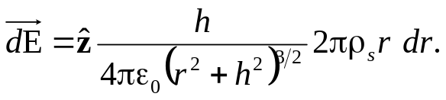

The total field at P is obtained by integrating the expression over the limits 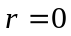 to :

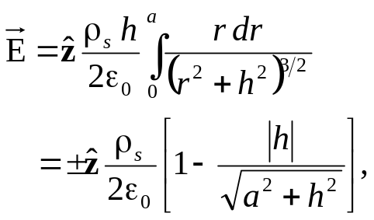

with the plus minus sign corresponding to when 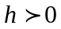and the minus sign to when 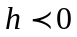(below the disk).
For an infinite sheet of charge with 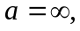
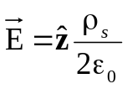 (Infinite sheet of charge).

Gauss’s Law:

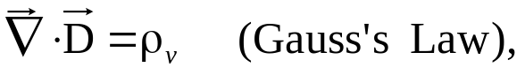

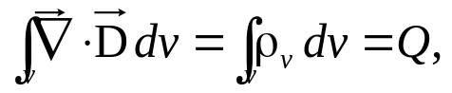

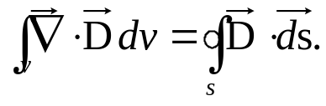

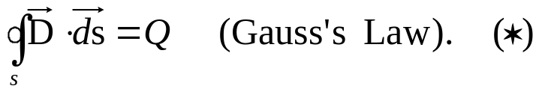

The integral form of Gauss’s law can be applied to determine 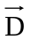 due to a single isolated charge q by constructing a closed, spherical, Gaussian surface S of an arbitrary radius R centered at q. Applying Gauss’s law gives

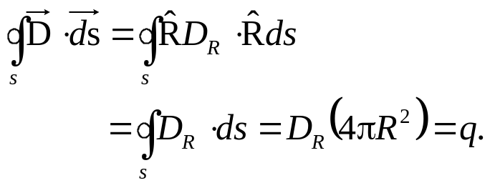
so,
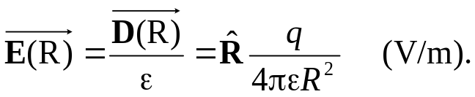

Gauss’s law, as given by equation (*), provide a convenient method for determining the electrostatic flux density when the charge distribution possesses symmetry properties that allow us to make valid assumptions about the variations of the magnitude and direction of as a function of spatial location. Because at every point on the surface, only the direction of 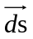is the outward normal to the surface, only the normal component of at the surface contribute to the integral in equation (*). To successfully apply Gauss’s law, the surface S should be chosen such that, from symmetry considerations, the magnitude of is constant and its direction is normal or tangential at every point of each subsurface of S (the surface of a cube, for example, has six subsurface).

Example: Electric field of an infinite line of charge

Use Gauss’s law to obtain an expression for in free space due to an infinitely long line of charge with uniform charge density along the z-axis.
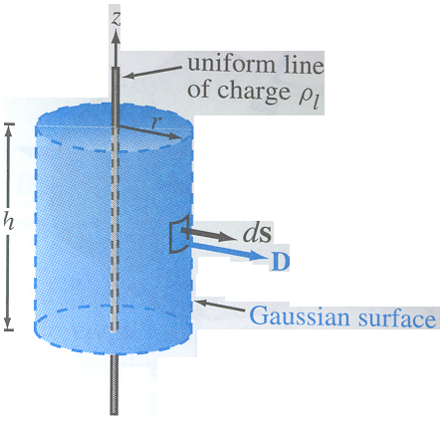

Solution:
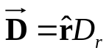
The total charge contained within the cylinder is 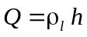, where h is the height of the cylinder. Since 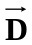 is along , the top and bottom surfaces of the cylinder do not contribute to the surface integral.

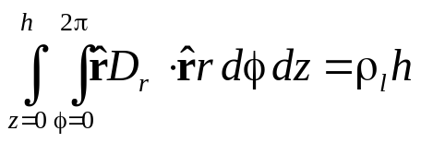

which gives the result,

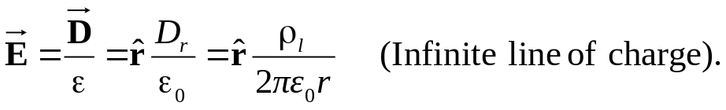

Electric potential as a function of electric field

We begin by considering the simple case of a positive charge q in a uniform electric field 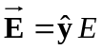, parallel to the (-y)-direction, as shown in figure. The presence of the field 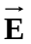 exerts a force 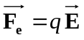on the charge in the negative y-direction. If we attempt to move the charge along the positive y-direction (against the force 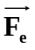), we will need to provide an external force 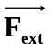 to counter-act 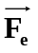, which requires the expenditure of energy. To move q without any acceleration (at a constant speed), it is necessary that the net force acting on the charge be zero, which means that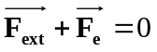, or
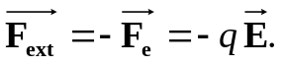
The work done, or energy expended, in moving any object a vector differential distance dl under the influence of a force 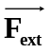 is

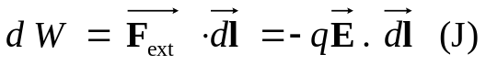

Work, or energy, is measured in joules (J). In the present case, if the charge is moved a distance dy along , then

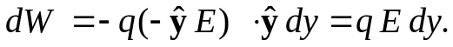

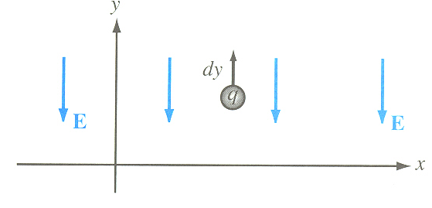

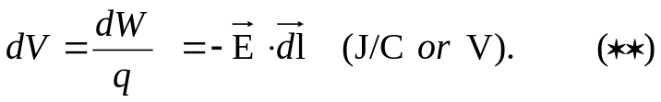

The potential difference between any two points P₂ and P₁ is obtained by integrating the equation (**) along any path between them. That is,

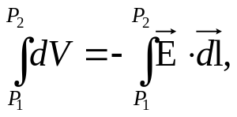

or,
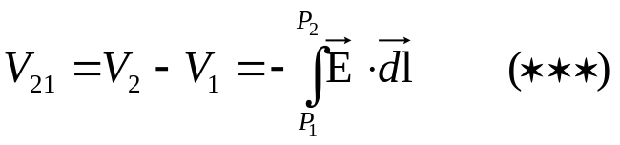
Usually, the reference-potential point is chosen to be at infinity. That is, in equation (***) we assume that 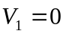 when P₁ is at infinity, and therefore the electric potential at any point P is given by
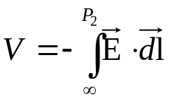

Electric potential due to point charges

For a point charge q located at the origin of a spherical coordinate system, the electric field at a distance R is given by
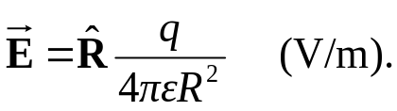

Hence, we will conveniently choose the path to be along the radial direction , in which case 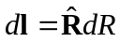 and
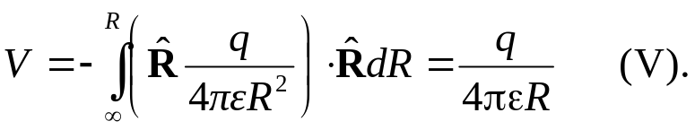

If the charge q is at a location other than the origin, specified by a source position vector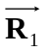, then V at observation position vector 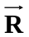 becomes
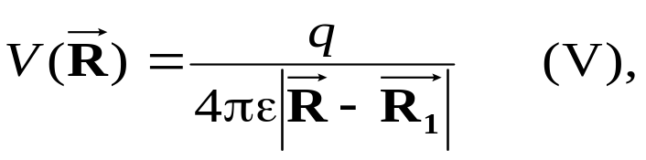
where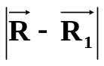is the distance between the observation point and the location of the charge q. The principle of superposition that we applied previously to the electric field also applies to the electric potential V. Hence, for N discrete point charges q₁, q₂,..., q_{N} having position vectors 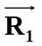, 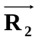, . . . , 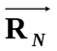, the electric potential is
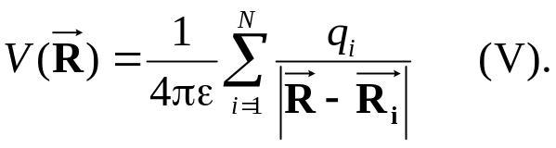
Electric potential due to continuous distributions

Based on previous analysis:

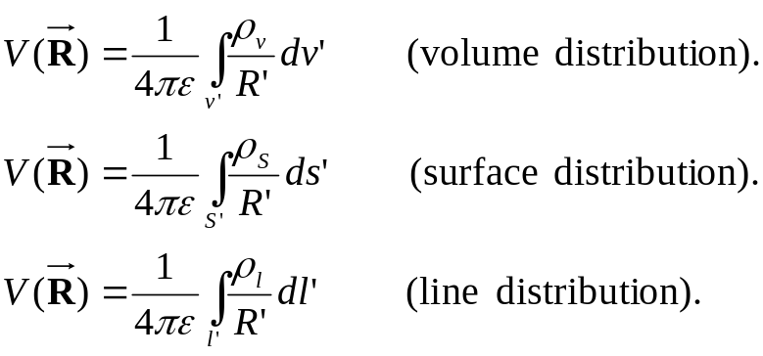

Electric field as a function of electric potential

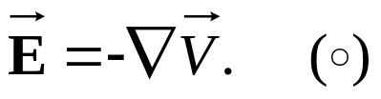

From mathematical reasoning any vector whose curl = 0 (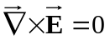) can be expressed as 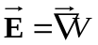. The minus sign is to indicate that the work done to move q is against the field .

Example: Electric field of an electric dipole

An electric dipole consists of two point charges of equal magnitude and opposite polarity, separated by a small distance as shown in figure. Determine V and at any point P in free space, given that P is at a distance 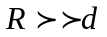, where d is the spacing between the two charges.
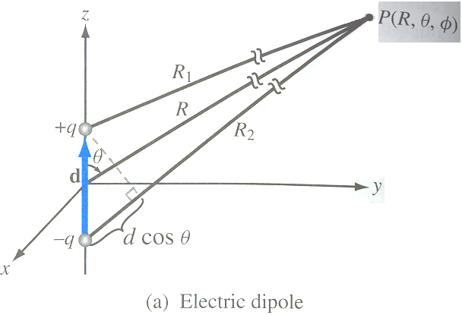
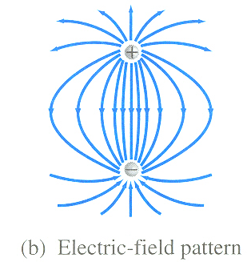

Solution:
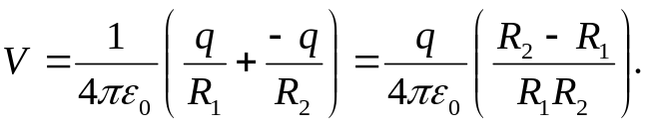

Since , the lines labeled R₁ and R₂ in the first figure are approximately parallel to each other, in which case the following approximations apply:
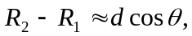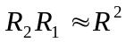
Hence,
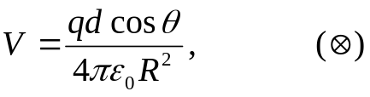
and

where p=qd is called the dipole moment of the electric dipole. Using the equation 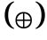 in equation 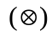then gives
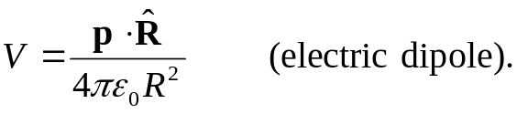

In spherical coordinates, equation 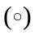 is given by
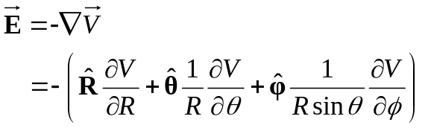
so,
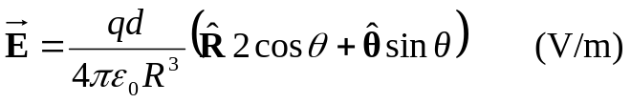

Poisson’s Equation

We have already seen that:

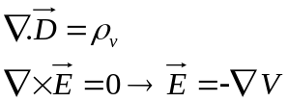

Also in a linear medium (and isotropic): 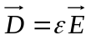 hence,

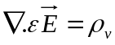 or 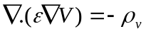
Where can be a function or position. For a simple medium (homogeneous) is a constant:
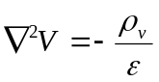

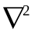(del square) is the Laplacian operator –‘it is the divergence of the gradient of-‘
is called Poisson’s equations.

For a volume v’ containing a volume density distribution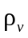, the solution for V derived previously and expressed as
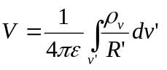
satisfies Poisson’s equation. If the medium under consideration contains no free charges, Poisson’s equation reduces to

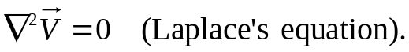

In Cartesian coordinates:

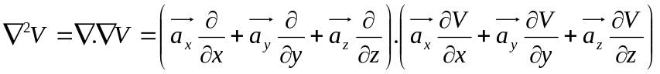

And this becomes:

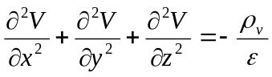 (V/m²)

In cylindrical coordinates:

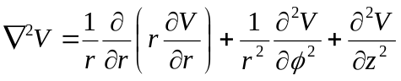

In spherical coordinates:

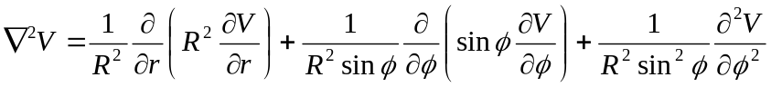
Remark: 3-D solution is a difficult task; normally 2-D and 1-D are sought.

In mediums where 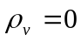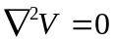

 Laplace’s equation 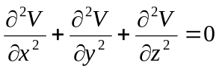

3.11.2 Boundary-Value Problems in Cartesian coordinates

Example 1:

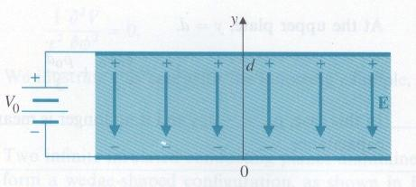
Two large // conducting plates are separated by a distance d and maintained at a potential 0 and V0, as shown.
The region between the plates is filled with a continuous distribution of electrons having a volume density of charges
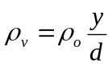 assuming negligible fringing effect at the edges, determine:
- The potential at any point between the plates.
- The surface charge densities on the plates.

Solution:
- Here the equation is: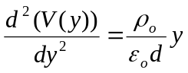

Integrating twice: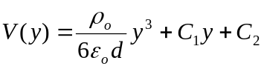
The boundary conditions on the two conducting plates:
At y = 0 we have V = 0 = C2
At y = d we have V = Vo = 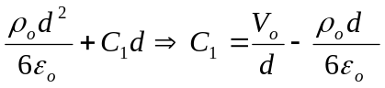

Substituting C1 and C2 in V(y): 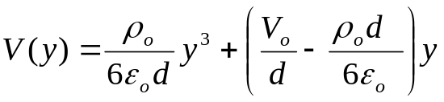

And 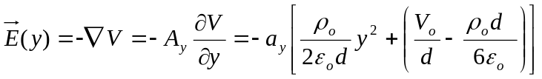
- At y = 0 (lower plate)
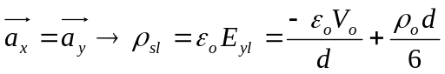

At the upper plate: y = d
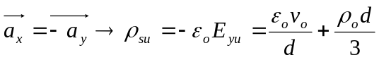

Here, 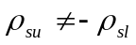 and it is no longer meaningful to compute the capacitance.

3.11.3 Boundary – value problems in cylindrical coordinates.

Here:
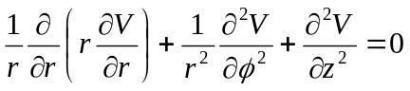

In situations where there is cylindrical symmetry: 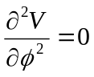 and “y” the lengthwise dimension is very large compared to the radius “r”
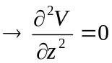 so what’s left is: 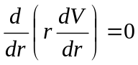

And “V” is a function of r only. The solution is:
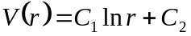
Where C₁ and C₂ are to be determined from boundary conditions;

If the problem is such that electric potential changes only in the circumferential direction and not in “r-” and “Z-” directions; we have:
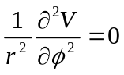

Example:
Two infinite insulation planes maintained at potentials 0 and V₀ from a wedge-shaped configuration. Determine the potential distributions for the regions:
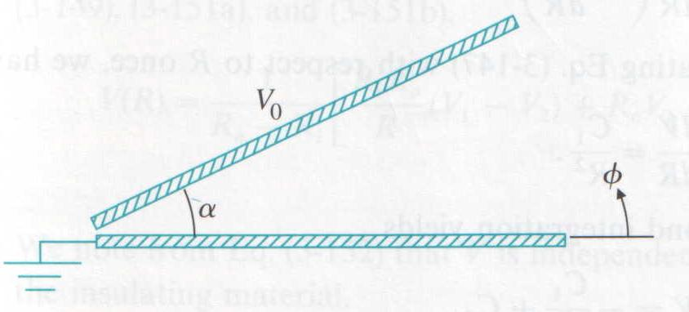
- 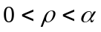
- 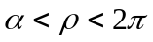

Here we have 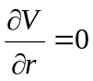 and 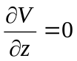 since the region at V = 0 is excluded: 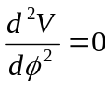 ; V depends only on  and can be found by double integrating.
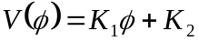
K₁ and K₂ are to be determined from boundary conditions.

- 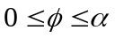
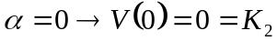
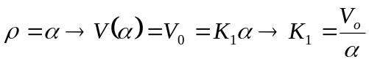
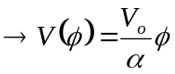

- 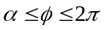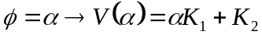
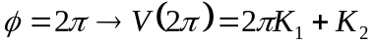

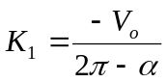

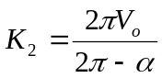

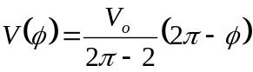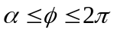

3.11.4 B.V.P in spherical coordinates.

See Example 3-23 (self-reading).

Conductors

The drift velocity 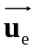 of electrons in a conducting material is related to the externally applied electric filed through
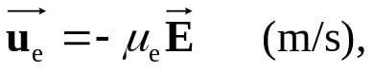
where 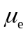 is a material property call the electron mobility with units of (m²/V.s). In a semiconductor, current flow is due to the movement of both electrons and holes, and since holes are positive-charge carriers, the hole drift velocity 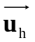is in the same direction as ,
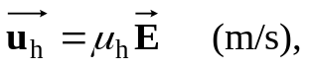
where 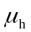 is the hole mobility.

The current density in a medium containing a volume density of charges moving with a velocity is 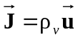. Thus, the total conduction current density is

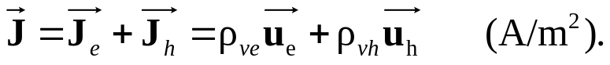
or
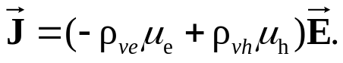

where 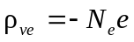 and 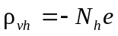, with N_{e} and N_{h} being the number of free electrons and the number of free holes per unit volume, and 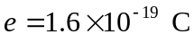 is the absolute charge of a single hole or electron. The quantity inside the parentheses is defined as the conductivity of the material, . Thus,
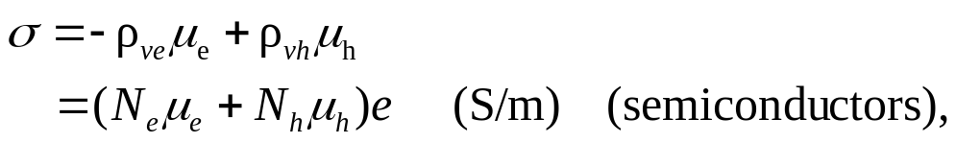

so,
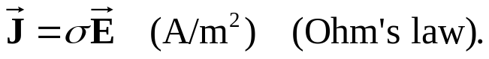

This equation is called the point form of Ohm’s law. Note that, in a perfect dielectric with 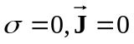 regardless of , and in a perfect conductor with 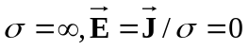 regardless of . That is,
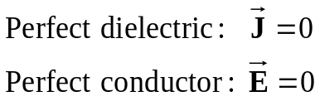

Resistance

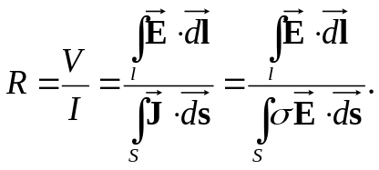

Example: Conductance of coaxial cable
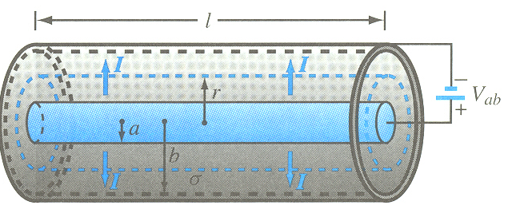
The radii of the inner and outer conductors of a coaxial cable of length l are a and b respectively. The insulation material has conductivity . Obtain an expression for G’, the conductance per unit length of the insulation layer.

Solution:
Let I be the total current flowing from the inner conductor to the outer conductor through the insulation material. At any radial distance r from the axis of the center conductor, the area through which the current flows is 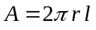. Hence,

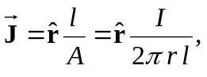
and from 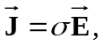
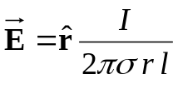

In a resistor, the current flows from higher electric potential to lower potential. Hence, if is the -direction, the inner conductor must be at a higher potential than the outer conductor. Accordingly, the voltage difference between the conductors is

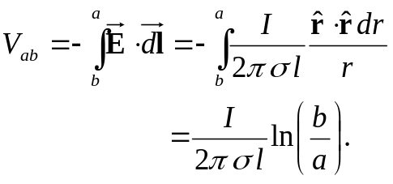
The conductance per unit length is then
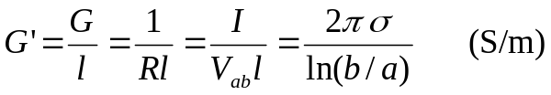

Dielectrics

In a dielectric, an externally applied field 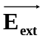 cannot effect mass migration of charges since none are able to move freely, but it can polarize the atoms or molecules in the material by distorting the center of the cloud and the location of the nucleus.

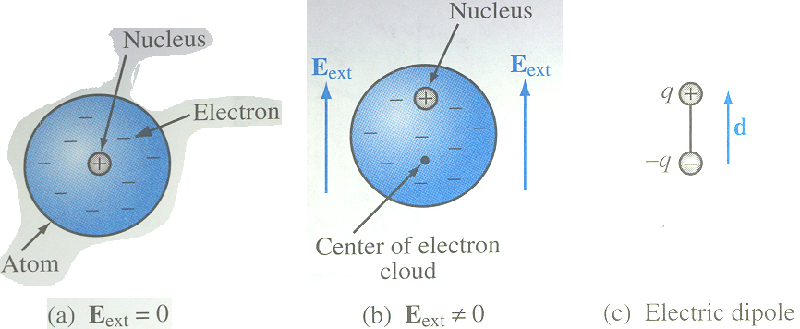
In the absence of an external electric field , the center of the electron cloud is co-located with the center of the nucleus, but when a field is applied, the two centers are separated by a distance d.
The induced electric field, called a polarization field, is weaker than and opposite in direction to. Consequently, the net electric field present in the dielectric material is smaller than .
Whereas and are related by 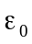 in free space, the presence of these microscopic dipoles in a dielectric material alters that relationship in that material to
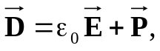
where , called the electric polarization field, accounts for the polarization properties of the material. A dielectric medium is said to be linear if the magnitude of the induced polarization field is directly proportional to the magnitude of , and it is said to be isotropic if the polarization field and are in the same direction.

A medium is said to be homogenous if its constitutive parameters (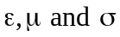) are constant throughout the medium.

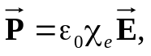
where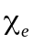 is called the electric susceptibility of the material. Thus we have
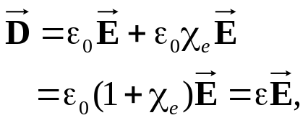

which defines the permittivity of the material as
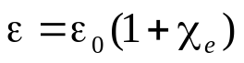

In reality, if exceeds a certain critical value, known as the dielectric strength of the material, it will free the electrons completely from the molecules and cause them to accelerate through the material in the form of a conducting current. When this happens, sparking can occur, and the dielectric material can sustain permanent damage due to electron collision with the molecular structure. This abrupt change in behavior is called dielectric breakdown.

