Assignment #5 – Solutions
(6.9,6.12)
6.9 A typical chart might look like the following:

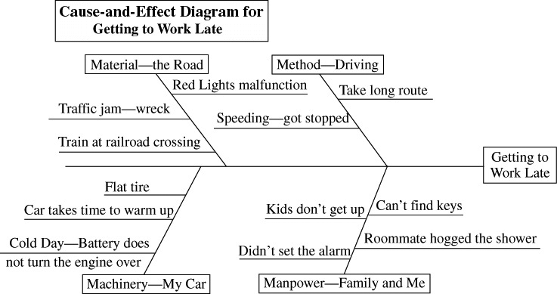

6.12

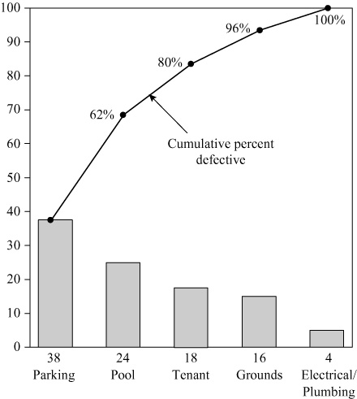

Recommendation: Start improvement by focusing on the high-frequency items (i.e. parking, pool, etc.)

