Freddy Vartabedian
#201203799
Assignment 3 Cad:

a)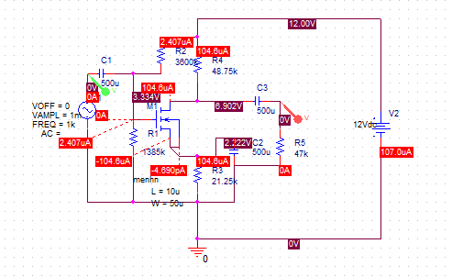
I_{G}= 0A
I_{B}=0A
I_{D}=I_{S}= 0.104mA
V_{D}=6.902V
V_{G}= 3.334V
V_{B}=V_{S}= 2.222V
V_{DS}=V_{D}-V_{S}= 4.68V

b)
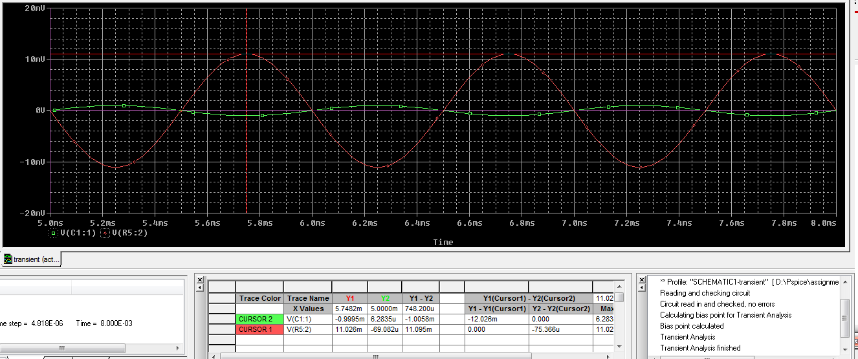

V_{0ut}/V_{in}= 22.052/2=11.026mV/mV

