HOMEWORK 3
NI MyDAQ-
Clipping Circuits

The objectives of this lab consist first of using MyDAQ acquisition board and LabVIEW instrument Launcher with its different pre-installed software including oscilloscope, function generator and DMM. Mainly, this experiment aims to make us learn how to build different variations of clipping circuits and measure their different characteristics.

Description of the hardware setup

Circuit connections

In this experiment we implemented five different clipping circuits with diodes and Zener diodes in order to explore how these electrical components behave to an input voltage signal. The five circuits implemented are shown in the below figures from 1 to 5.
Figure 1: One diode clipping circuit
Figure 2: One zener clipping circuit
Figure 3: Two diodes clipping circuit
Figure 4: Two Zener clipping circuit
Figure 5: Diode clipping with DC source

Connections between MyDAQ acquisition board and the circuit

In this experiment MyDAQ acquisition board was used to generate input sine functions to the circuits. We used it to operate the different measurements across resistances or diodes. One of the most important configurations we realized between MyDAQ board and our circuits is how to implement a voltage source in circuit 5. In fact, in order to do so I did a voltage regulator circuit. The latter is composed of a 5V DC source of MY-DAQ board and a breakdown voltage of 3 V for the zener diode. The voltage across the zener is the voltage source to be used in circuit 5.

Input and output lines used

The circuits I implemented in this experiment need only one input line and one output line:
- Channels AO 0 and AGND used as input to the circuits designed
- Channels AI 0 used to do the measurements since it measures the output waveforms characteristics.
- DMM banana jacks of the MyDAQ acquisition board

Photo depicting hardware setup and connections

Figure 7: Hardware setup for the one diode clipping circuit
Figure 8: Hardware setup for the on Zener clipping circuit
Figure 9: Hardware for two diode clipping circuit
Figure 10: Hardware setup for the two Zener clipping circuit
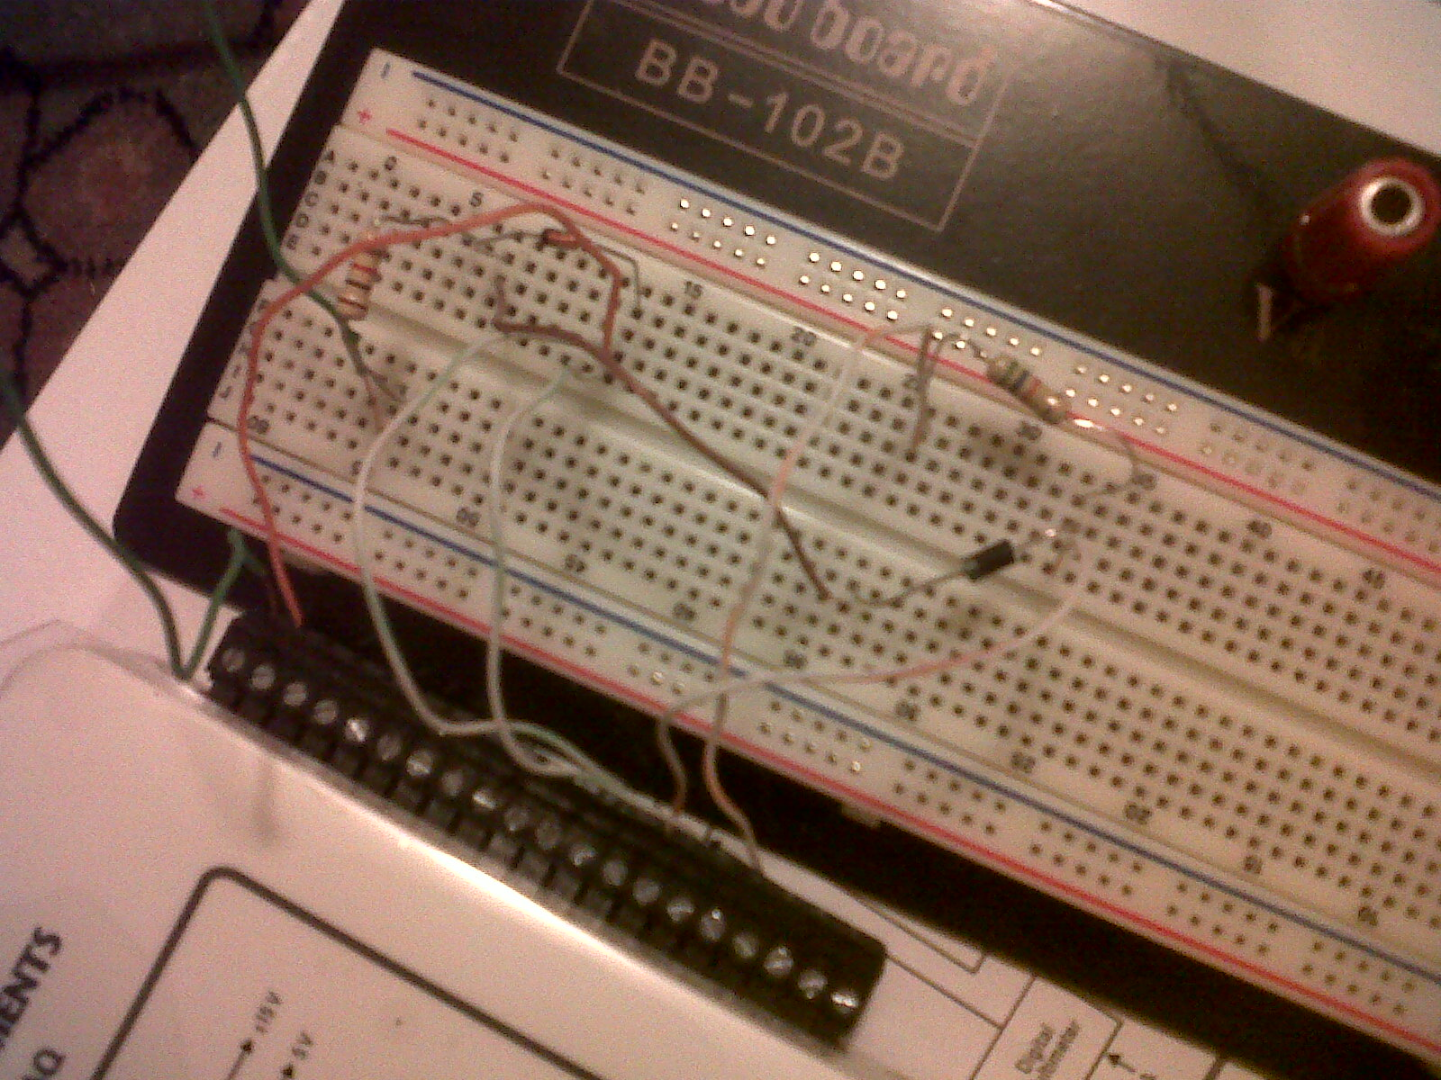
Figure 11: Hardware setup for the diode clipping with DC source

Description of the software setup

Modules used and Configurations

As in the previous experiment we use three modules installed in LabVIEW Launcher which are the FGEN, Scope and DMM to operate the different measurements required.
- The FGEN is used for waveforms generation specifying the type, amplitude and frequency.
- The Scope is used for voltage display and in order for us to do all the necessary measurements on the output waveforms including peak to peak voltage, minimum and maximum voltage. displays
- The DMM is used for voltage and resistance measurements required in this experiment.

Testing

- Resistance measurements
a. Measure the 1 Kohms resistor. Provide a snapshot showing the result.

Figure 12: 1KOhm Resistor
b. Measure the 5.6 Kohms resistor. Provide a snapshot showing the result.

Figure 13: 5.6 KOhms Resistor

One Diode Clipping Circuit

- Take a snapshot of the output (using Scope)

Figure 14: one diode clipping circuit output for 2Vpkpk input
- Measure pk-pk output voltage (using Scope)

Voltage peak to peak is 1.477 V.

- Measure the maximum output voltage

Figure 15: Maximum and minimum output voltage for 2Vpk-pk input

So maximum voltage is 478.8 mV.

- Measure the minimum output voltage

Minimum voltage is -1 V.

- Repeat i – iv for 3 volts pk-pk input wave

Figure 16: one diode clipping circuit output for 3Vpkpk input
Peak to peak voltage is 2.005 V
Figure 17: Maximum and minimum volatge output for 3Vpk-pk input
The maximum output voltage is 507.00 mV and the minimum output voltage is -1.50 V.

One Zener Clipping Circuit

- Take a snapshot of the output (using Scope)

Figure 18: one zener clipping circuit output for 3Vpkpk input

ii. Measure pk-pk output voltage (using Scope)

Peak to peak voltage is 2.201 V.

- Measure the maximum output voltage

Figure 19: Maximum and minimum output voltage for 3Vpk-pk input

The maximum output voltage is 1.48 V.

- Measure the minimum output voltage

The minimum voltage is -725.54 mV

- Repeat i – iv for 10 volts pk-pk input wave

Figure 20: one zener clipping circuit output for 10V pkpk input
Peak to peak voltage is 3.538V.
Figure 21: Maximum and minimum output voltage for 10Vpk-pk input
Maximum voltage is 2.80V and minimum voltage is -754.39 mV.

Two Diode Clipping Circuit

- Take a snapshot of the output (using Scope)

Figure 22: two diode clipping circuit output
- Measure pk-pk output voltage (using Scope)

Peak to peak voltage is 1.450.

- Measure the maximum output voltage

Figure 23: maximum and minimum output voltage for two diode clipping circuit
Maximum voltage is 450.59 mV.
- Measure the minimum output voltage

The minimum voltage is 1.00V.

Two Zener Clipping Circuit

i. Take a snapshot of the output (using Scope)

Figure 24: two zener clipping circuit output
ii. Measure pk-pk output voltage (using Scope)

The peak to peak voltage is 6.698 V.

iii. Measure the maximum output voltage

Figure 25: maximum and minimum output voltage for two zener clipping circuit

The maximum output voltage is 3.42 V.

iv. Measure the minimum output voltage

The minimum output voltage is -3.30 V.

Diode Clipping Circuit with DC Source

i. Take a snapshot of the output (using Scope)

Figure 26: Diode clipping circuit with DC source output
ii. Measure pk-pk output voltage (using Scope)

Peak to peak voltage is 7.656 V.

iii. Measure the maximum output voltage

Figure 27: maximum and minimum output voltage
The maximum voltage is 2.67 V.

iv. Measure the minimum output voltage

The minimum voltage is -5 V.

