**Homework # 1**

**NI MyDAQ-**

**Digital Design Circuit**

1. **Description of the hardware setup**
2. **Circuit connections**

We start by building the logic circuit on the breadboard using the internal gates of the chip. First, we relate two connecting wires to pins 1 and 2 as inputs A and B of the NAND gate A. Then, we connect another wire at pin 3 as the output of gate A, which we connect again to pin 4 to be the input of the NAND gate B. Subsequently, we connect another wire to pin 5 to be the third input C, which is the second input to NAND gate B. Then, we connect another wire to pin 6 to be the output of the logic circuit, which is also the output of NAND gate B.

At the end of this phase, we have the circuit built with 6 connecting wires emanating from the circuit which will be connected later to MyDAQ board, three of them constitute the inputs A, B and C at pins 1, 2 and 5 respectively, and one wire at pin 6 which is the output of the logic circuit, and the two wires to power the ship from pin 14 corresponding to the 5 V source needed and pin 7 corresponding to the ground.

1. **Connections between MyDAQ acquisition board and the circuit**

MyDAQ acquisition board has a total of 8 digital input and output lines and just next we have two lines called GROUND and 5V. I connected the wire emanating from pin 14 to line 5V which is at the end and the wire emanating from pin 7 to line called GND. At this stage we can assure that the chip will be powered. The inputs wires will be connected to the lines from 0-3. Then, the output is connected to any line chosen between 4-7.



The 8 digital input and output lines

1. **Input and output lines used**

For my personal testing experience of the digital design, I chose the lines to be related to the emanating wires as follows:

* Line 0 as input A, connection wire connected to pin 1.
* Line 1 as input B, connection wire connected to pin 2.
* Line 2 as input C, connection wire connected to pin 5.
* Line 4 as the output of the logic circuit, connection wire connected to pin 6.
* The wire from pin 7 was connected to GND line.
* The wire from pin 14 was connected to 5V line.

1. **Photo depicting hardware setup and connections**

Picture below shows the whole hardware setup and the circuit build which is now ready to be tested by LabVIEW instrument launcher.

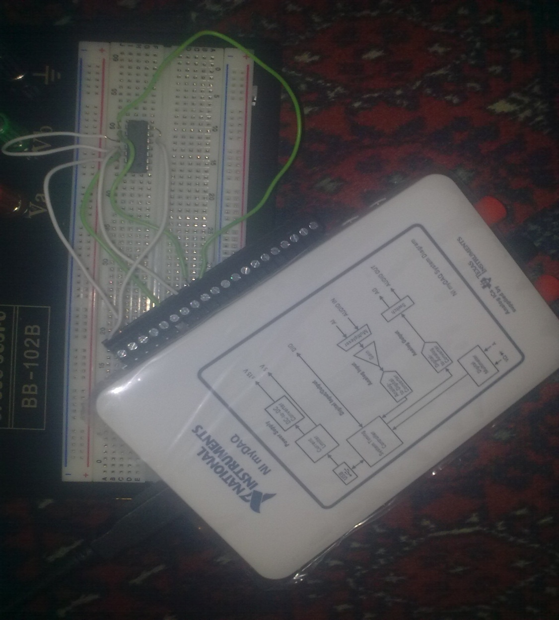

**Pictures 3:** Hardware setup and connections

1. **Description of the software setup**
2. **Modules used and configurations**

Now that I have executed the hardware setup and the connected to USB to the laptop, I then launched the software. First, the instrument launcher appeared on the screen.

I then pressed DigIn and DigOut, and it appeared on the screen the two modules, digital writer and digital reader of NI ELVIS.

 

**Figures 6 and 7:** Digital writer and Digital reader modules

The digital writer is related to the output lines of the acquisition board, which are used as inputs to the circuit design built on the breadboard. In the module of Digital writer I chose the configurations as showed in figure 6, in which the lines to write are (0-3). As a matter of fact, we change the values of indicators 0, 1 and 2 to the desired digital inputs in the circuit built. Once I chose the combination I want, I pressed Run.

The digital reader is related to the input lines of the acquisition board, which are used as outputs to the circuit design built on the breadboard. In the module of Digital reader I chose the configurations as showed in figure 7, which the lines to fead (4-7). The output will be shown on the LEDs numbered from any one between 4 to 7, in my case only line 4 will either be ON or OFF since it is related to the output of my circuit, showing the output of my logic circuit.

1. **Testing**
2. **Select two different testing vectors**

Since we have three inputs to the circuit built, A, B and C, we therefore have 8 possible testing vectors that can be chosen to test our circuit. Below in table 1, all the possible combinations of the three inputs to the circuit, and the two vectors I chose are highlighted.

|  |  |  |
| --- | --- | --- |
| A | B | C |
| 0 | 0 | 1 |
| 1 | 1 | 0 |

All possible combinations of testing vectors and the ones chosen (highlighted)

1. **Find the corresponding theoretical output of the chosen test vectors**

I chose the testing vectors 001 and 110. Theoretically, by logical analysis of the circuit in figure 1, we have respectively, 0 and 1, as shown in Table2.

|  |  |  |  |
| --- | --- | --- | --- |
| A | B | C | OUTPUT |
| 0 | 0 | 1 | 0 |
| 1 | 1 | 0 | 1 |

Theoretical results of the two chosen test vectors

1. **Include two snapshots showing the inputs and outputs for each test vector to validate the implementation of the designed circuit by running the digital reader and digital writer modules from the instrument launcher.**

**Test Vector 1: 001**

Picture 5 shows on the Digital writer LEDs 2 ON and LED 0 and 1 OFF, which corresponds to the input of 001. On the digital reader we can see LED 4 which corresponds to the output of the circuit turned OFF, which means that the output is 0. This proves the theoretical value in table 2.

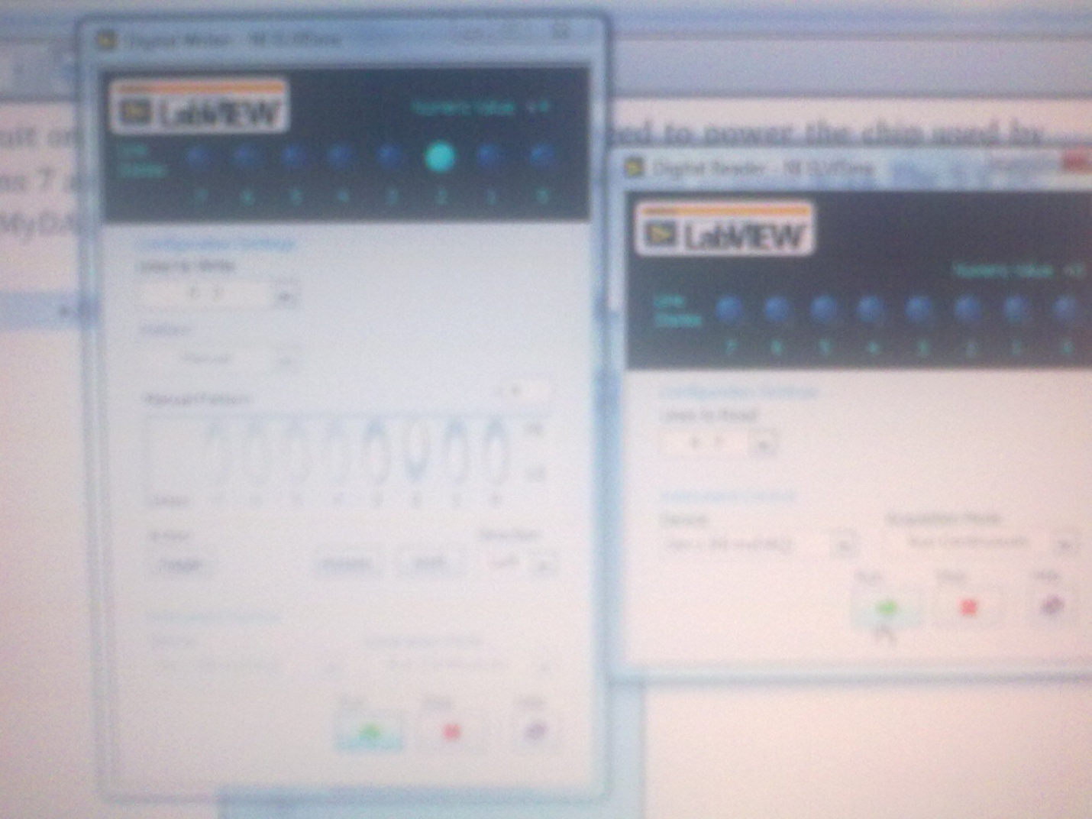

**Picture 5:** Testing of the vector 001

**Test Vector 2: 110**

Picture below shows on the Digital writer LEDs 0 and 1 ON and LED 2 OFF, which corresponds to the input of 110. On the digital reader we can see LED 4 which corresponds to the output of the circuit turned ON, which means that the output is 1. This proves the theoretical value in table 2.

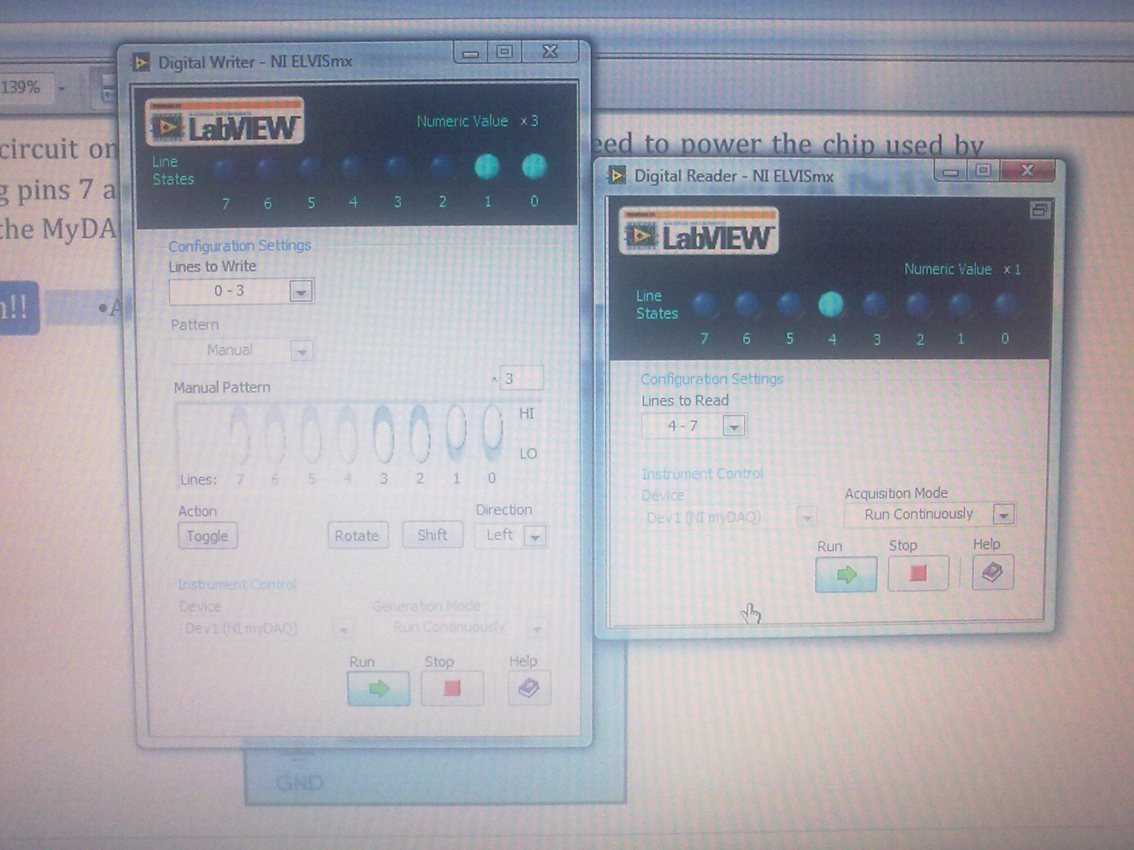

Testing of vector 110