Problem on De Broglie

Calculate the de Broglie wavelength for each of the following.
- an electron with a velocity 10% of the speed of light
- a tennis ball (55g) served at 35 m/s (~80 mi/h)

Solution:

(a) 10 % velocity of light = 0.10 x (3.00x10⁸ m/s) = 3.00 x 10⁷ m/s

λ = h/mv = 6.63x10⁻³⁴ J.s / [(9.11x10⁻³¹ kg) x )3 x 10⁷ m/s)] = 2.4286x10⁻¹¹ m = 24.28 pm

(b) λ = h/mv = 6.63x10⁻³⁴ J.s / (0.055 kg x 35 m/s) = 3.444 x10⁻³⁴ m

This value is so small that it is essentially zero and we can not detect a wavelength so small. This means we do not have to consider the wave properties of large objects.

Problem on Heisenberg Uncertainty Principle

Using Heisenberg uncertainty principle, calculate ∆x for each of the following.
- an electron with ∆ν = 0.100 m/s
- a baseball (mass = 145 g) with ∆ν = 0.100 m/s
- How does the answer in part a compare with the size of hydrogen atom?
- How does the answer in part b correspond to the size of a baseball?

Solution:

(a) ∆ν = 0.100 m/s, mass of electron = m_{e} = 9.11x10⁻³¹kg
∆x. ∆(mv) = h/4π,
Or, ∆x = h/(4πm∆ν) = (6.62x10⁻³⁴J.s)/{4 x 3.14 x 0.100 m/s x 9.11x10⁻³¹kg}= 5.79x10⁻⁴m

(b) ∆ν = 0.100 m/s, mass of the baseball = m = 0.145 kg
∆x. ∆(mv) = h/4π,
Or, ∆x = h/(4πm∆ν) = (6.62x10⁻³⁴J.s)/{4 x 3.14 x 0.100 m/s x 0.145 kg}= 3.64x10⁻³³m

(c) The diameter of H-atom is roughly 1.0x10⁻⁸ cm. The uncertainty in position is much longer than the size of the atom.

(d) The uncertainty is insignificant to the size pf the baseball.

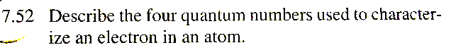

7.52
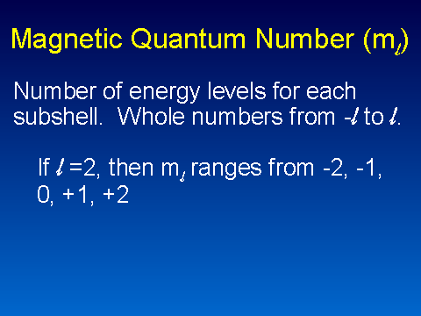
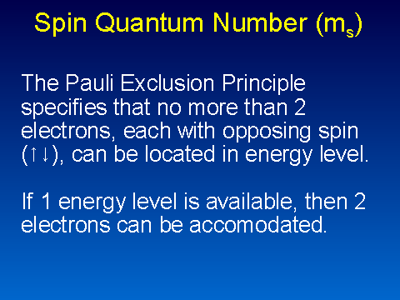
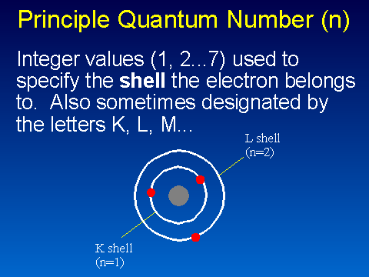
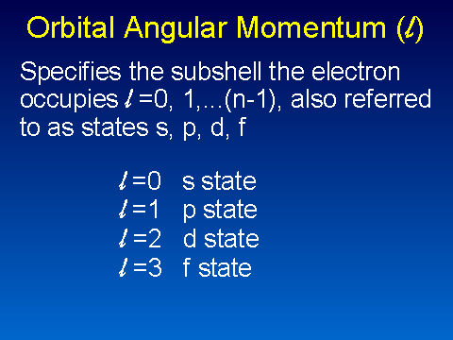

7.57 (a) 2p: n = 2, l = 1, m_{l} = 1, 0, or −1
(b) 3s: n = 3, l = 0, m_{l} = 0 (only allowed value)
(c) 5d: n = 5, l = 2, m_{l} = 2, 1, 0, −1, or −2

An orbital in a subshell can have any of the allowed values of the magnetic quantum number for that subshell. All the orbitals in a subshell have exactly the same energy.

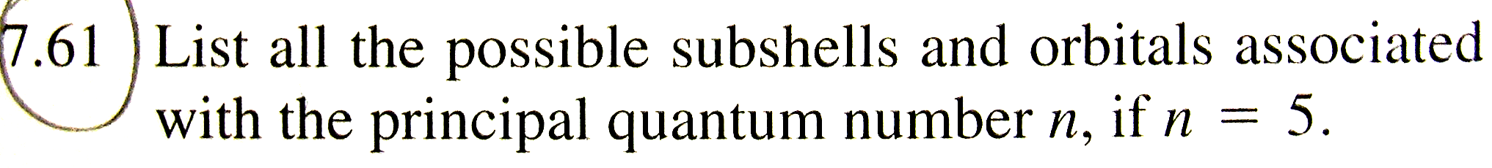
7.61 The allowed values of l are 0, 1, 2, 3, and 4. These correspond to the 5s, 5p, 5d, 5f, and 5g subshells. These subshells each have one, three, five, seven, and nine orbitals, respectively.

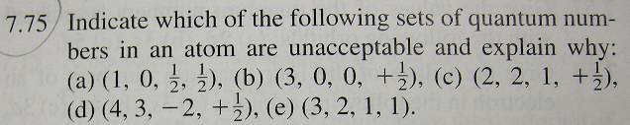

7.75 (a) is wrong because the magnetic quantum number m_{l} can have only whole number values.

(c) is wrong because the maximum value of the angular momentum quantum number l is n − 1.

(e) is wrong because the electron spin quantum number m_{s} can have only half-integral values.

