EECE 310L: Electric Circuits Laboratory
Experiment 9: MOS Transistor
By:
Group 12
Sunday, December 1st, 2013

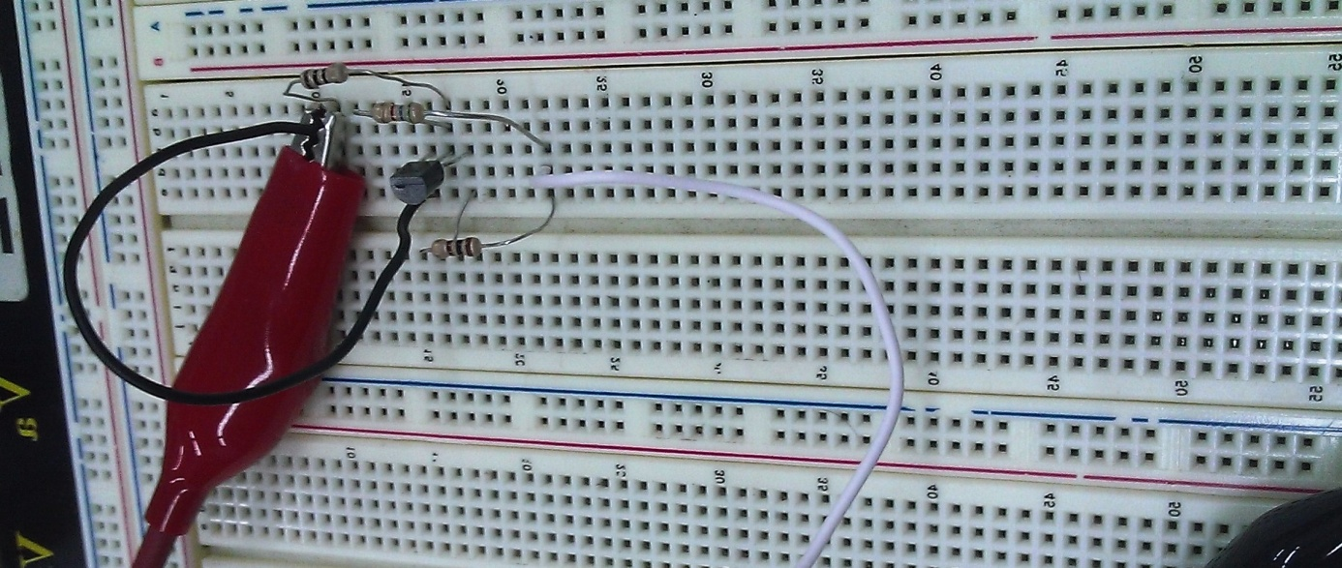

Table of Contents
- Objectives……………………………………………………………………….……..5
- Lab Equipment Used…………………………………………………………………..6
- Lab Tools Used …………………………………………………………………….....6
- Components Used……………………………………………………………………..6
- Experimental Procedure and Discussion ……………………………………………..7
- MOSFET Characteristics……………………………………………………...7
- Circuit Diagrams
- Experimental Procedure
- Measurements and Results
- Discussions

- MOSFET as a Voltage-Controlled Resistor …………………………………11
- Circuit Diagrams
- Experimental Procedure
- Measurements and Results
- Discussions

- MOSFET as Logic Gate …………………………………………………….17
- Circuit Diagrams
- Experimental Procedure
- Measurements and Results
- Discussions

- MOSFET as an Amplifier ………………………………………………...…21
- Circuit Diagrams
- Experimental Procedure
- Measurements and Results
- Discussions

- MOSFET as a current source …………………………………………….25
- Circuit Diagrams
- Experimental Procedure
- Measurements and Results
- Discussions
- Mistakes and Problems Faced during the Lab …………………………………...28
- References ………………………………………………………………………..28
- Signed Statement ………………………………………………………………..29

List of Figures and Tables

Type | Title | Page
Table | Resistors | 6
Figure | MOSFET circuit | 7
Figure | V_{DS} for different I_{D}s | 8
Figure | Values of k and V_{T} | 9
Figure | VGS calculated | 10
Figure | Voltage Controlled Resistor | 11
Figure | ID for VDS | 12
Figure | ID for VGS=VT+3 | 12
Figure | ID for VGS=VT+4 | 13
Figure | ID vs. VDS | 13
Figure | ID vs. VDS | 14
Figure | ID vs. VDS | 14
Figure | MOSFET as Logic Gate | 17
Figure | In lab results part C(1) | 18
Figure | In lab results part C(2) | 18,19
Figure | Vin vs. Vout | 21
Figure | MOSFET as an amplifier(1) | 21
Figure | MOSFET as an amplifier(2) | 21
Figure | MOSFET as an amplifier(3) | 22
Figure | MOSFET as a current source | 25
Figure | ID for RD | 26
Figure | VDS for RD | 27
Table | Values of R_{DS} measures | 15
Table | Values of R_{DS} calculated | 16
Table | In Lab report results part D(1) | 23
Table | In Lab report results part D(2) | 24

- Objectives:

The main purpose of this experiment was to get familiar with a MOSFET transistor which is a Metal Oxide Semiconductor Field Effect Transistor. We have began with studying its characteristics together with three regions of the MOSFET. Afterwards, we studied different applications of this type of transistor including applications such as: voltage controlled resistor, logic gate, amplifier, current source.

- Lab Equipment Used:

- Breadboard
- Oscilliscope (Tektronix TDS220)
- Function Generator (Agilent 33120A)
- DC Power Supply
- Digital Multimeter

- Lab Tools Used:
- We have used only a wire stripper and a wire cutter since all connections were made by only placing parts on the breadboard with help of wires.

- Components Used:
- MOSFET BS170 (N-Channel Enhancement Mode Field Effect Transistor)
- Three capacitors of value 10uF
- Wires
- Resistors:

Theoretical Value (Ω) | Measured Value (Ω) | Error (%)
100 | 101.2 | 1.2
10 | 10.2 | 2
1000 | 983 | 1.7
470 | 458 | 2.55
3300 | not measured | -
4700 | not measured | -
10000 | not measured | -
15000 | not measured | -
Table 1: Resistors

- Experimental Procedure & Discussion:

- MOSFET Characteristics
A1) Circuit Diagram

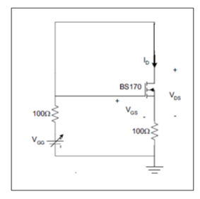
Figure 1: MOSFET circuit

A2) Detailed Experimental Procedure

In this part of the experiment, we connected the MOSFET in one circuit with two resistors of value 100 Ohms and V_{GG} voltage of 0.5V which was taken from the DC power supply. The main purpose, here, was to find two important characteristics of a MOSFET that is its trans conductance “k” and threshold voltage “V_{T}”. To find these two parameters we had to use the equation of a drain current in the MOSFET, in the saturation region, that is :
$I_{D}=\frac{k}{2}{\left({V }_{GS}– V_{T}\right)}^{2}$
with conditions that: V_{GS} > V_{T} and V_{DS} > V_{GS} – V_{T} .

To proceed with that equation we needed first to find V_{GS} for different values of I_{D}. We started with slowly increasing the voltage V_{GG} until we got a drain current of 15mA by watching the voltage across the sensing resistor. The sensing resistor is the resistor connected between the source and the ground. Also, for BS170 transistor V_{DS}=V_{GS} and V_{T}>0. We did not use here an ammeter because it could have a loading effect on the MOSFET and that would not give us accurate results. Then we have repeated the procedure for also getting a current of 30mA and 40mA. After getting all the values we ended up with two equations and two unknowns from which values “k” and “V_{T}” could be easily calculated when solving:
$I_{D1}=\frac{k}{2}{({V }_{GS1}– V_{T})}^{2}$ and $I_{D2}=\frac{k}{2}{({V }_{GS2}– V_{T})}^{2}$

Assumptions:
Our 100 Ohms resistor had actually a value of 101.2Ohms and so we had a 1.2% error coming from that fact already. Also, we did not account for the internal resistance in the wires. In addition, from the beginning of the experiment we assumed that our MOSFET is in saturation region. However, this was a true assumption and we can verify that using the formula : V_{GS}=V_{T}+ √(2I_{D}/k).

A3) Measurements & Results:
When increasing the V_{GG} and measuring the voltage across the sensing resistor, we obtained the values below:
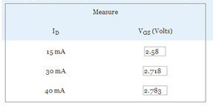
Figure 2: V_{DS} for different I_{D}s.

After getting the values of a drain current and V_{GS}, we solved for two equations to find the values of k and V_{T} using:
$$I_{D}=\frac{k}{2}{\left({V }_{GS}– V_{T}\right)}^{2}$$

- For I_{D}= 15 mA and V_{GS}=2.58V:
15*10^-3 = (k/2)(2.58-V_{T})²

- For I_{D}= 30 mA and V_{GS}=2.718V:
30*10^-3 = (k/2)(2.718-V_{T})²

=> 2= (2.718-V_{T})² / (2.58-V_{T})²
√2 = (2.718-V_{T}) / (2.58-V_{T})
V_{T}= 2.24 V
k=0.271 A/V²

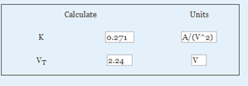
Figure 3: Values of k and Vt

To check our calculations with the measured values, we used:
V_{GS}=V_{T}+ √(2I_{D}/k) for I_{D}=40mA.

V_{GS} = 2.24 + √((2*40*10^-3)/0.271) = 2.783 V

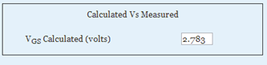
Figure 4: VGS calculated

A4) Discussion:
We got no error when comparing the calculated VGS with the measured VGS
=> (2.783-2.783)/2.783 *100=0%
That actually shows that all our measured values above are correct and the assumption that MOSFET is in the saturation region is also true.

B. MOSFET as a Voltage Controlled Resistor:
B1) Circuit Diagram

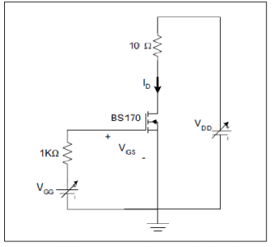
Figure 5: Voltage controlled resistor

B2) Detailed Experimental Procedure
In this part of the experiment we substituted one of the 100 Ohm resistors by 1kOhm resistor and the second one by 10 Ohms. Also, we added a DC voltage V_{DD}= 2V. As a result, we ended up using both master and slave connections from the power supply. For this application our transistor was working in the triode region where V_{GG} > V_{T} and V_{GG} > V_{DD} and our MOSFET acted like a resistor whose resistance could be calculated by the measured I_{D} and V_{DS}. Depending on V_{DD} we could control the region of operation of the MOSFET. After setting V_{GS}= 2+V_{T}, we started increasing V_{DD} as to get V_{DS} =0.1V. Then, we found the I_{D} using the voltmeter across the sensing resistor (in this case it is the 10 Ohm resistor). Afterwards, we repeated the procedure for finding the VGG=3+VT and VGG=VT+4.

Assumptions:
We assumed that for the voltage controlled resistor application of the MOSFET we should work in the triode region. However, our assumption was correct, we can easily check that by checking the conditions of the triode region: V_{GS}>V_{T} and V_{DS}< V_{GS}-V_{T.}

B3) Measurements & Results:
For V_{GS}=2+V_{T}= 2.24+2= 4.24 V:
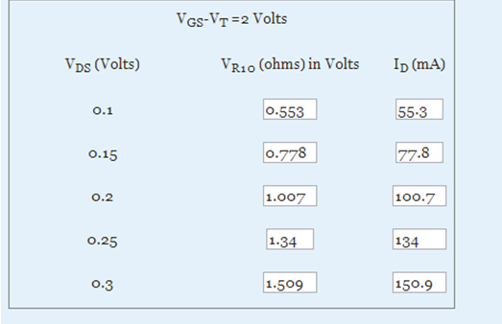
Figure 6: ID for VDS
For VGS= VT + 3=2.24+3=5.24 V
: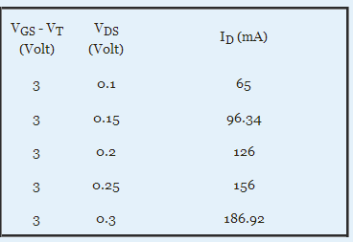
Figure 7: ID for VGS=VT+3

For VGS= VT + 4 =2.24+4=5.24 V :
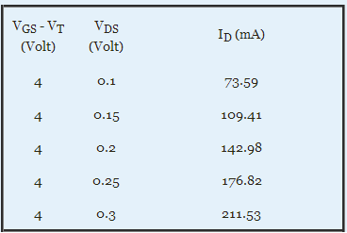
Figure 8: ID for VGS=VT+4

B4) Discussion:
- VGG=2+VT:

Figure 9: ID vs. VDS

- VGG=3+VT:

Figure 10: ID vs. VDS

- VGG=4+VT:

Figure 11: ID vs. VDS

- All the graphs are linear, also the first graph can be considered approximately linear the nonlinearity part at 0.25V of VDS might come from the errors in the measurements.
- Slope 1:
(150.9-55.3)/(0.3-0.1) = 478 mA/V
Slope 2:
(186.92-65)/(0.3-0.1)= 609.6 mA/V
Slope 3:
(211.53-73.59)/(0.3-0.1)= 689.7 mA/V
- Since R=1/slope :
R₁ =1/0.478= 2.09Ω
R₂ =1/0.6096= 1.64Ω
R₃ =1/0.6897= 1.45Ω

V_{GS}-V_{T} (V) | R_{DS} Measured (Ω)
2 | 2.09
3 | 1.64
4 | 1.45
Table 2: Values of RDS measured

- Since all of the three graphs are linear or approximately linear we can then conclude that MOSFET is working here in the linear/triode region. As another verification, we can also see that VGS > VT and VGS > VDS .

- The region in which the MOSFET is working is also called an ohmic region, for there is a linear relationship between V_{DS} and I_{D} => R_{DS}=V_{DS}/ I_{D.} So MOSFET acts like a voltage controlled resistor.

- The equation for the drain current in the triode region is:

I_{D} = (k/2)*2(V_{GS} – V_{T}) V_{DS} – V_{DS}²
In this case, V_{DS}² is small so we can ignore it.
=>Values for V_{DS} so the error in current values is less than 5% are :
(I_{D}- I_{Dx}) / I_{D} <5%
I_{Dx} :
= > (k/2)*2(V_{GS} – V_{T}) *V_{DS}

And for I_{Dx} => R_{DS}=1/k*(V_{GS}-V_{T})
=>(V_{GS}-V_{T})/((V_{GS}-V_{T})-0.5V_{DS}²)<1.05
Then when solving for VDS:
VDS=0.095*(VGS-VT)
=>R_{DS}=1/ k*(VGS-VT) where k=0.271

V_{GS}-V_{T} (V) | R_{DS} calculated (Ω) | Error%
2 | 1.845 | 11.7
3 | 1.230 | 25
4 | 0.923 | 36.3
Table 3:Values of RDS calculated

The error of R_{DS} , for any of the three cases ,between actual and calculated resistance is greater than 5% and so its inaccurate. Such huge error comes most probably from the resistance of wires and any probable errors coming from taking the results from the devices during the experiment.

MOSFET as a Voltage Controlled Resistor can be used in applications such as:
- Attenuator
- Analog filter
- In Modulation circuits
- Variable gain amplifiers controlled by VGS

C. MOSFET as Logic Gate
C1) Circuit Diagram

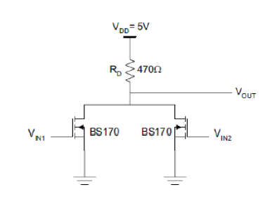
Figure 12: MOSFET as Logic Gate

C2) Detailed Experimental Procedure
The MOSFET figure above shows that both the input and output are connected to the same drain. MOSFETs here have the possibility of operating in either cut-off or triode region. Therefore, this will lead to operating as 2-Input NOR gate. However, in order to prove this we may apply 4 logic input combinations.
However, output values are obtained by varying V_{in1} after setting V_{in2} to 0V.Then, the corresponding regions of operations can be deduced.

C3) Measurement and Results

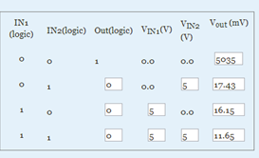
Figure 13: InLab Results of part C (1)
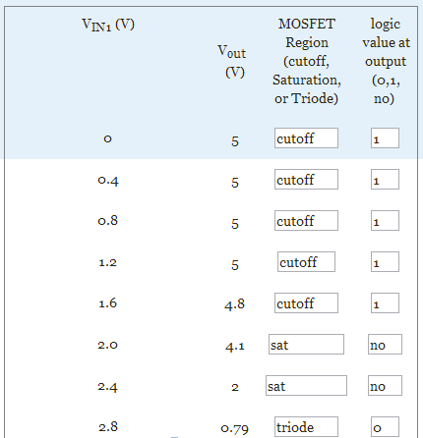
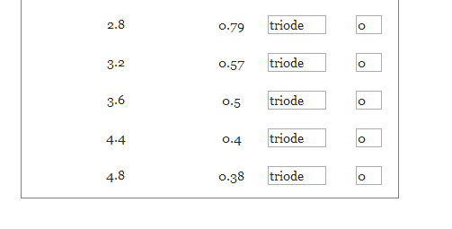
Figure 14: InLab Results of part C (2)

C4) Discussions
- The above results show that, the given MOSFET has V_{H}= 5.035V, and V_{L}= 17 approximately.

- The output is zero whenever we have at least one MOSFET operating in the triode region.
Then, MOSFET would be replaced by a resistor in this latter region, where its value is R_{DS} << R_{D}. Hence, a very low output voltage will be obtained due to logic zero caused by R_{D}, thus by voltage divider,
V₀₌ $\frac{RDS1||RDS2}{(RDS1|\left|RDS2\right)+RD}*VDD$if there are two MOSFETs in triode; or,
V₀₌ $\frac{RDS}{(RDS+RD)}*VDD$if there is only one MOSFET operating in triode.

Notice the following:
- When MOSFETs are in cut-off, RD has no effect on the output.
- R_{D} and V_{OL} are inversely proportional since when R_{D} increases, V_{OL} decreases (the denominator becomes large).

The graph below shows that at V_{in}= 0.4V approx., the MOSFET changes from cut-off to saturation. While it changes from saturation into triode region when V_{in}= 2V approx.

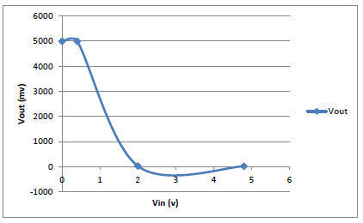
Figure 15: Vin vs Vout
D) MOSFET as an Amplifier
D1) Circuit Diagram

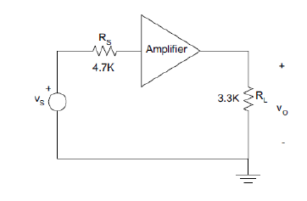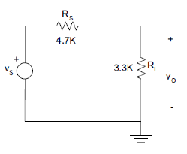
Figure 16: MOSFET as an Amplifier (1) Figure 17: MOSFET as an Amplifier (2)

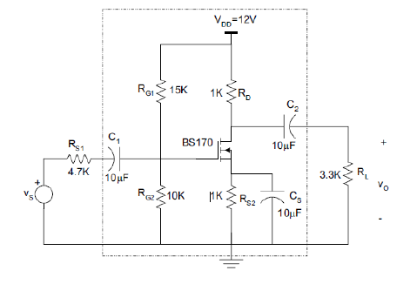
Figure 18: MOSFET as an Amplifier (3)

D2) Detailed Experimental Procedure
The following outputs should be obtained after applying the circuit with no amplifier:
- This circuit has an attenuator (a thing that makes it weaker) due to the fact that the voltage gain cannot exceed 1.
- The gain is not affected by the input signal frequency.

After that, the circuit is re-modeled to get rid of the DC and AC components of the input and output by connecting an amplifier along with some capacitors.
Then, to get high and low frequencies, with an amplitude= $\frac{1}{\sqrt{2}}$ its original value at saturation, by varying the frequency to relatively high and low.

D3)Measurement and Results
We used the following equations :
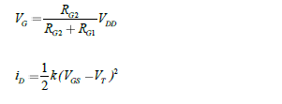
And, id= 0.5*0.244*(4.8-1000i_{d}-1.826)² i_{d1}= 2.8129 mA
Or, i_{d2}= 3.1342 mA which is rejected.
=>V_{GS}=4.8-2.8129= 1.978 which is greater than V_{T}.
Thus, this result is accepted.
Also, V_{DS}= 12-2*2.819= 6.3562V.
Now, apply the AC analysis calculations to get:
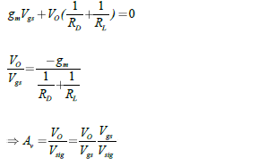
Then, Vo/V_{GS} = -28.5 V/V
Thus, A_{V} = -15.95 V/V
 | Value
I_{D} (DC) Ma | 2.655
V_{GS} (DC) Volts | 2.11
V_{DS} (DC) Volts | 6.774
Table 4: inLab Results of part D (1)
 | Value
V_{S} PK-PK (mV) | 106
V_{I} PK-PK (mV) | 64.8
V_{O} PK-PK (mV) | 820
Phase Shift (V_{I}, V_{O}) degrees | 180
Table 5: inLab Results of part D (2)

D4) Discussions
- It is shown that the amplification bandwidth is affected by the variation in the frequencies of the capacitors. This is revealed in the fact the capacitor in case of high frequency, where it becomes a short circuit. Hence, MOSFET’s biasing changes and moving it from the saturation region. However, in the case of low frequency, the signal source will disconnect in addition to a drop in the output to reach very low values as zero since the MOSFET will act as open circuit.

- If the MOSFET was connected while enlarging the amplitude of the signal, we will obtain a distortion in the signal due to the biasing in the MOSFET, thus there will be a change at the extremities of the signal at both cut-off and triode regions.
- Therefore to get rid of distortion both conditions should be satisfied:
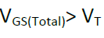 and 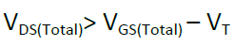

E) MOSFET as a Current Source
E1) Circuit Diagram

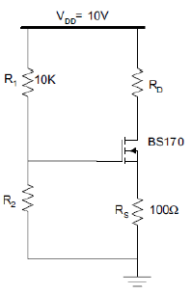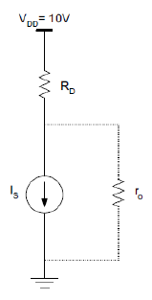
Figure 19: MOSFET as a Current Source (1) Figure 20: MOSFET as a Current Source (2)
E2) Detailed Experimental Procedure
Being biased to the saturation region is a must to ensure that the MOSFET is acting as a current source. Then, the i-v relationships will be revealed as the following:
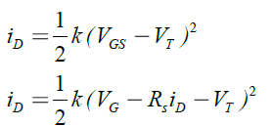 , by which we got V_{G} but, V_{G}= $\frac{R2}{R2+10K}$ .
Notice that the channel length modulation is being neglected.
The next step will be constructing the circuit with the value calculated of R₂ = 5.41Ω above while we vary R_{D} from 0 to 1000 K, meanwhile we record the drain to source and drain currents.

E3) Measurement and Results
R_{D} (ohms) | V_{S} (volts) | I_{D} (mA)= V_{S}/ R_{S} | V_{DS} (volts)
0 | 1.098 | 10.98 | 8.89
100 | 1.092 | 10.92 | 7.79
220 | 1.086 | 10.86 | 6.496
330 | 1.083 | 10.83 | 5.236
470 | 1.075 | 10.75 | 3.924
560 | 1.073 | 10.73 | 2.945
680 | 1.068 | 10.68 | 1.728
820 | 1.052 | 10.52 | 0.331
1000 | 0.909 | 9.09 | 0.067

E4) Discussions

Figure 21 ID for RD

It can be noticed that I_{D} is constant between 220 and 560. This region is approximated with part of the graph curve for the least derivative.

Figure 22 :VDS for RD

- The value of I_{D} is about 10.75 mA.
- Ro, the output resistance in saturation can be obtained using the following formula:
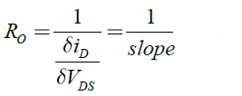
- I_{D} remains approximately constant between the interval 3.924 -8.89 V.
- Since I_{D} is independent of VDS, thus the aforementioned interval corresponds to the saturation region.
Note:
We have to take into consideration that the observed small variation is due to the channel length modulation.

- Mistakes faced in the lab

We have faced a real problem with the connections of wires, which resulted in the fact that we finished the required experiment very late. The oscilloscope seemed to not read well the output voltage as well as the input voltage that proved to us that there is a problem with wires. It also happened that the oscilloscope was reading noise and our measuring results were not correct. This was shown in this lab report where the error between the calculated and measured values was large.

- References

- Smith, S .Microelectronic Circuits 6th Edition.
- EECE 310Lab Lecture Notes

.

- Signed Statement

“I HAVE NEITHER GIVEN NOR RECEIVED AID ON THIS REPORT NOR HAVE I
CONCEALED ANY VIOLATION OF THE AUB STUDENT CODE OF CONDUCT.”

