EECE 310 L
Electric Circuits Laboratory
03/01/2012

Lab Report
Experiment #10
MOS Transistors

Michael Moufarrij
201101202
mrm19@aub.edu.lb
Section 2
Group 7

Table of Contents
Table of Contents 1
List of Figures and Tables 2
Objectives 3
Lab Equipment Used 3
Lab Tools Used 3
Components Used 3
Experimental Procedure and Discussion 4
MOSFET Characteristics 4
MOSFET as Voltage-Controlled Resistor 6
MOSFET as Logic Gate 10
MOSFET as Amplifier 12
MOSFET as a Current Source 15
References 17
Mistakes and Problems Face in the Lab 17
Statement 18

List of Tables and Figures
Figure A: Circuit Diagram (MOSFET Characteristics) 4
Figure B: Circuit Diagram (MOSFET as Voltage-Controlled Resistor) 6
Figure C: I_{D} vs V_{DS} (V_{OV}= 2) 8
Figure D: I_{D} vs V_{DS} (V_{OV}= 3) 8
Figure E: Circuit Diagram (MOSFET as a Logic Gate) 10
Figure F: V_{OUT} vs V_{IN} 11
Figure G: Circuit Diagram (MOSFET as an amplifier) 12
Figure H: Circuit Diagram (MOSFET as a current source) 15
Figure I: I_{D} as function of R_{D} 16
Figure J: I_{D} as function of V_{DS} 17

Objectives
The main objectives of this experiment are studying the characteristics of the MOSFET in the different regions of operation (cutoff, linear, saturation), and learning about its applications (voltage-controlled resistor, Logic inverter, NOR gate, Amplifier, Current Source).
- Lab Equipment Used
  - Tektronix PS280 Power Supply
  - Fluke 45 Digital Multi Meter
  - HP Agilent 33120A Function Generator
  - Tektronix TDS220 Oscilloscope
  - Breadboard
- Lab Tools Used
  - Wire stripper
  - Long nose pliers
- Components Used
Component | Theoretical Value | Measured Value | % error
Resistor | 100 Ω | 99.2 Ω | 0.8
Resistor | 470 Ω | 467.3 Ω | 0.57
Resistor | 1000 Ω | 991.8 Ω | 0.82
Resistor | 3300 Ω | 3238 Ω | 2.07
Resistor | 4700 Ω | 4610 Ω | 1.91
Resistor | 10000 Ω | 9850 Ω | 1.5
Resistor | 15000 Ω | 14902 Ω | 0.65
Capacitor | 10 µF | N/A | N/A
MOSFET (BS170) | N/A | N/A | N/A
Table 1: Component list

- Experimental Procedure and Discussion
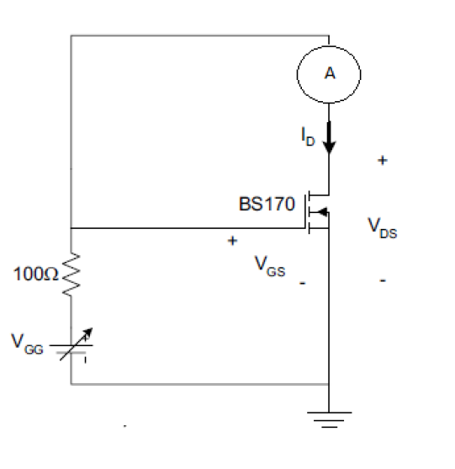
  - MOSFET Characteristics
    - Circuit Diagram:
Figure A: Circuit Diagram (MOSFET Characteristics)
    - Procedure:
      - In PART 1, our aim is to calculate k and V_{T} for the MOSFET. The above circuit biases the MOSFET in the saturation region, so ID = ½ k (VGS – VT)².
To calculate k and V_{T}, we measure I_{D} and V_{GS} at two different points and use the 2 obtained equations with 2 unknowns.
After connecting the circuit, we set to V_{GG} =0.5. We increase V_{GG} until I_{D} = 10 mA, and record V_{GS} at that point. We increase V_{GG} further until I_{D} = 25 mA and record V_{GS} again. The measurements are done using the DMM.
      - In PART 2, the characteristics are calculated using the 2 equations obtained in PART 1.
      - In PART 3, we wish to verify our obtained values. We measure V_{GS} at a known value of I_{D} (40 mA) and compare the measured quantity to the one obtained using the MOSFET equation V_{GS} = V_{T} + sqrt(2I_{D}/k) (where k and V_{T} are the values obtained above)

    - Results obtained:
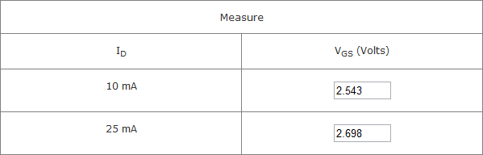
      - PART 1
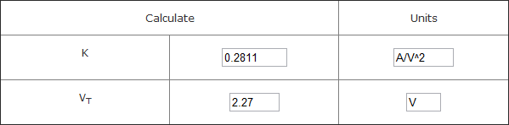
      - PART 2
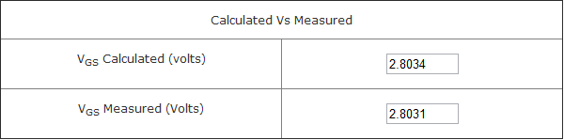
      - PART 3
Error = 0.01 %
The error between the two value of V_{GS} was very small, this indicates that the values obtained for k and V_{T} are accurate.

  - MOSFET as Voltage-Controlled Resistor
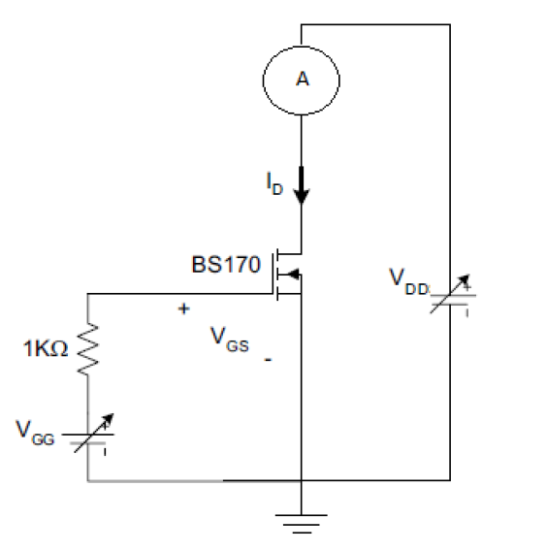
    - Circuit Diagram:
Figure B: Circuit Diagram (MOSFET as Voltage-Controlled Resistor)
    - Procedure:
      - In PART 1 of this experiment, we intend to bias the MOSFET in the linear region so as to use it as a voltage-controlled resistor. After constructing the circuit as shown, we fix the value of V_{GG} (and therefore V_{GS}) to V_{T} + 2V (V_{T}’s value is the one from the previous experiment), and we measure I_{D} for different values of V_{DD} (i.e. V_{DS}).
I_{D} is measured using an ammeter. V_{DS} and V_{GS} are measured using an oscilloscope while the ammeter is still connected. This is to negate the effect of the ammeter’s internal resistance.
      - In PART 2, we repeat the measurements of PART 1 but with V_{GS} – V_{T} = 3V.
      - In PART 3, we repeat the measurements of PART 1 but with V_{GS} – V_{T} = 4V.

    - Results Obtained:
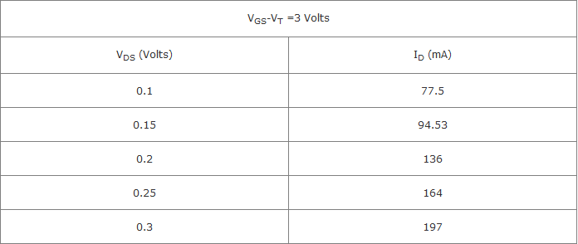
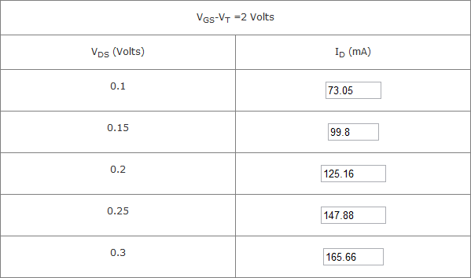
      - PART 1
      - PART 2
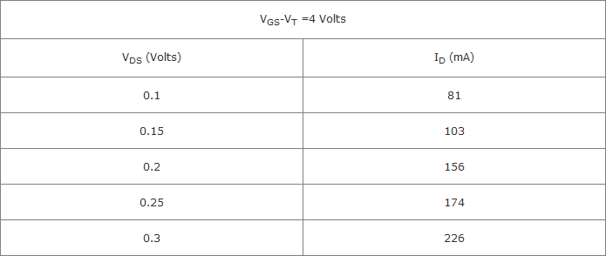
      - PART 3
    - Discussion:
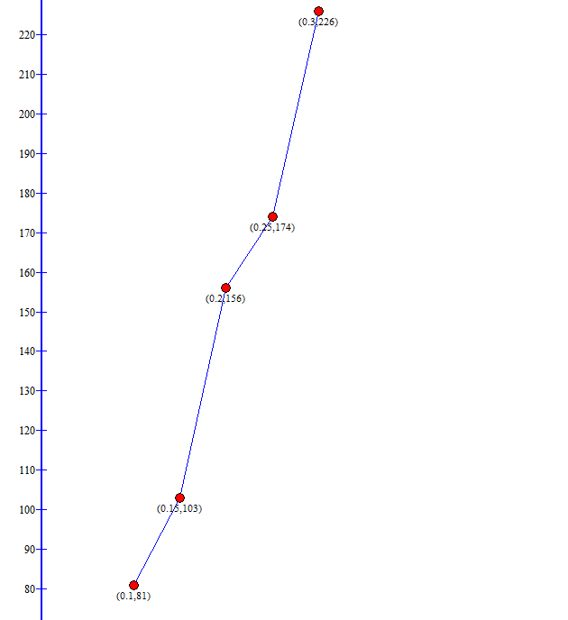
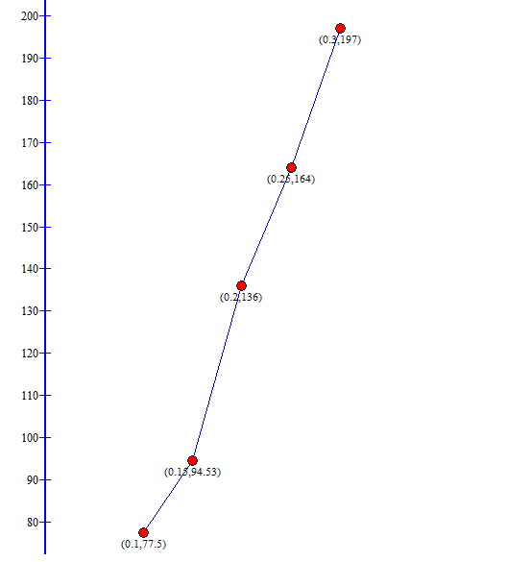
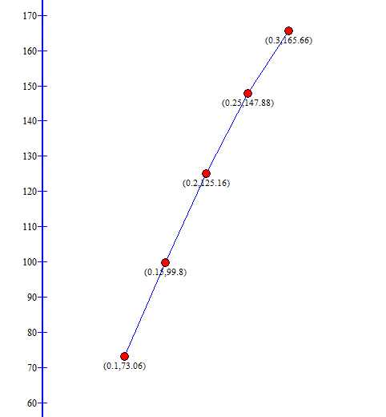
      - I_{D} vs. V_{DS} curves:
Figure 3: I_{D} vs V_{DS} (V_{OV} = 4)
Figure C: I_{D} vs V_{DS} (V_{OV}= 2)
Figure D: I_{D} vs V_{DS} (V_{OV}= 3)
      - We get a curve that’s almost linear.
      - Slope(V_{OV} = 2) = 0.463
Slope(V_{OV} = 3) = 0.5975
Slope(V_{OV} = 4) = 0.725
      - R_{DS} (V_{OV} = 2) = 1/0.463 = 2.16 Ω
R_{DS} (V_{OV} = 3) = 1/0.5975 = 1.67 Ω
R_{DS} (V_{OV} = 4) = 1/0.725 = 1.38 Ω
      - The MOSFET is in the linear region. It is called as such because for a constant overdrive voltage V_{OV}, the relationship between the voltage and current across the transistor is approximately linear. (i.e. it follows Ohm’s law)
      - When V_{DS} is small, V_{DS}² is very small and can be neglected, the equation becomes:
I_{D} = k. V_{OV}. V_{DS} and V_{OV} is constant, therefore V_{DS} = R_{DS}. I_{D} (where R_{DS} = 1/k. V_{OV})
      - This approximation is valid for small V_{DS}, namely V_{DS}
      - The value of R_{DS} = 1/k. V_{OV:} R_{DS} (V_{OV} = 2) = 1.78 Ω, R_{DS} (V_{OV} = 3) = 1.19 Ω, R_{DS} (V_{OV} = 4) = 0.89 Ω. The calculated values are smaller than the theoretical values. This is due to the additional internal resistance of the MOSFET.
      - We can use voltage-controlled resistors in attenuator circuits, Amplitude Modulation circuits, and for controlling devices (like the volume of an amplifier).

  - MOSFET as a Logic Gate
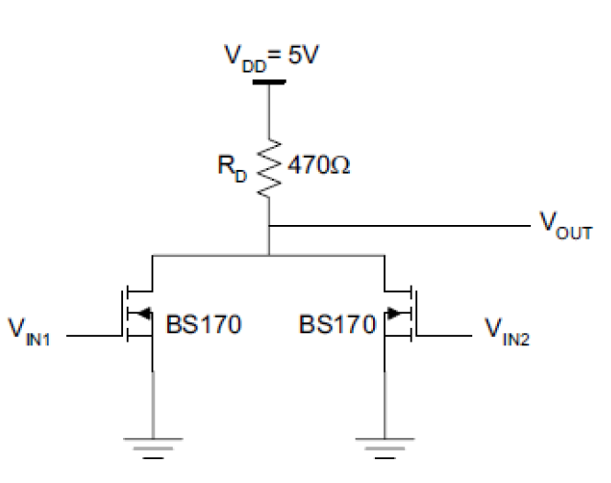
    - Circuit Diagram:
Figure E: Circuit Diagram (MOSFET as a Logic Gate)
    - Procedure:
      - In PART 1, the aim is to use the MOSFET as a logic gate. After connecting the circuit shown in the diagram, we need to know which logic function the circuit implements. For this, we apply combinations of logic 0’s (input connected to ground) and logic 1’s (input connected to relatively high voltage) and observe the output.
      - In PART 2, we cut the second MOSFET off by connecting V_{IN2} to ground. This turns the circuit into a different, unary logic gate. We try different values of voltage at the input and observe the output.
    - Results Obtained:
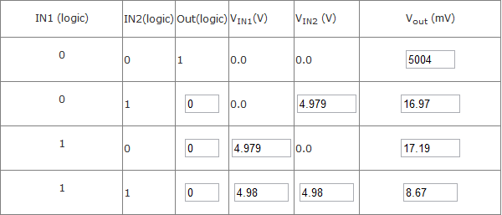
      - PART 1
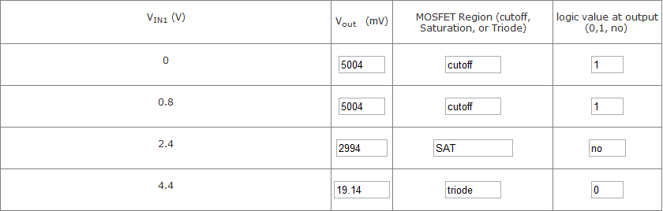
      - PART 2
    - Discussion:
      - From the truth tables, it’s apparent that the circuit in PART 1 represents a NOR gate while the circuit in PART 2 is a logic inverter.
      - High voltage = 5 V (approx)
Low Voltage = 19 mV (approx)
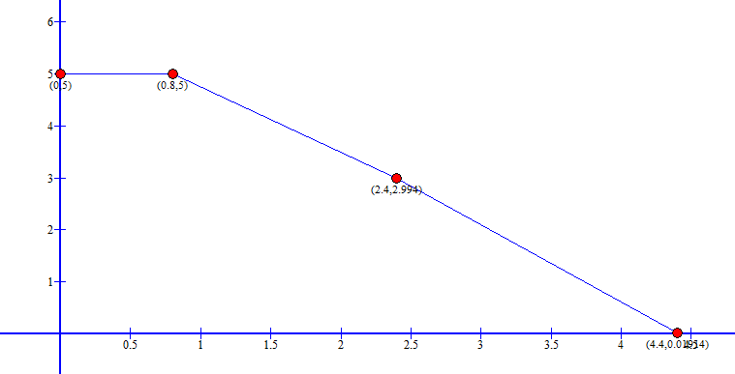
      - The low voltage value is inversely proportional to the resistor (assuming nothing else changes). Increasing it would make the output low value lower.
      - The output switches states when V_{IN} = V_{OH} or V_{IN} = V_{OL}
Figure F: V_{OUT} vs V_{IN}

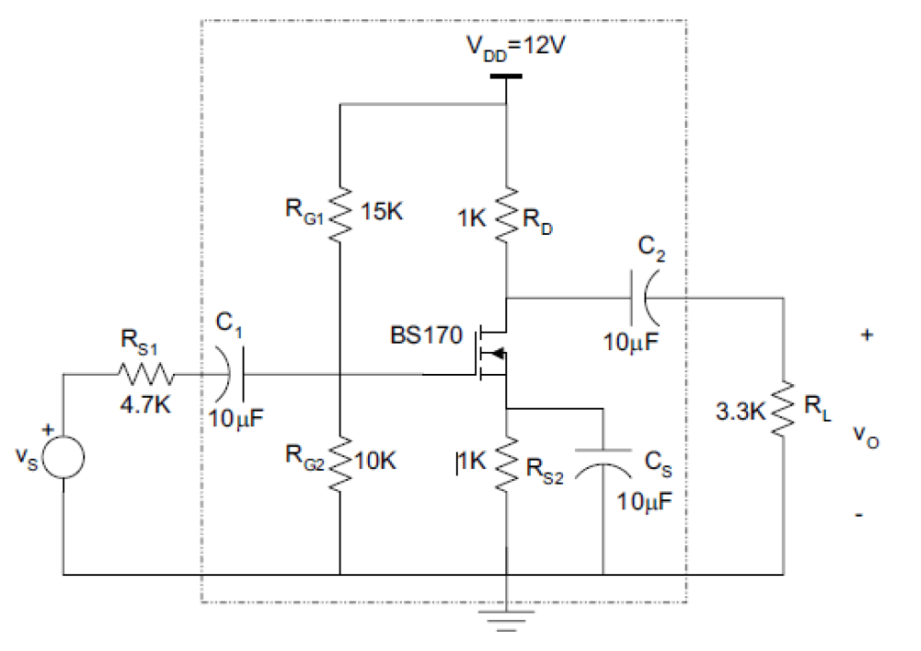
  - MOSFET as an amplifier
    - Circuit Diagram:
Figure G: Circuit Diagram (MOSFET as an amplifier)
    - Procedure:
In this experiment, we bias the MOSFET in saturation in order to use it as an amplifier and study its amplifying characteristics.
      - In PART 1, after connecting the circuit as shown, we measure the DC values of I_{D}, V_{GS}, and V_{DS}.
      - In PART 2, we apply a 100 mV signal input and we measure the voltage at the input, the voltage at the input of the amplifier, the voltage at the output, and the phase shift.
      - In PART 3, we determine the bandwidth of the amplifier by marking the frequencies at which the gain is divided by sqrt(2).

    - Results obtained:
      - PART 1
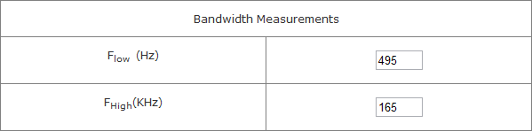
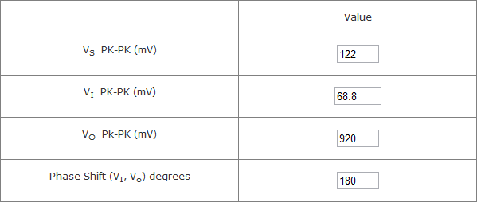
      - PART 2
      - PART 3

    - Discussion:
      - The gain drops at low frequencies due to the increased impedance of the capacitors on the input and output.
      - At high frequencies, the gain drops due to the parasitic capacitance C_{S}.
      - When the input voltage becomes large, the MOSFET will be outside the saturation region for part of the input signal, and that will cause distortion.
    - Theoretical values:
      - DC analysis:
The capacitors become open circuits.
V_{G} = 10/25 * 12V = 4.8 V (by voltage division)
now I_{D} = V_{S}/ 1kΩ = ½ k (V_{G} – V_{S} – V_{T})² (since MOSFET is in SAT)
=> V_{S} = 2.671 (rejected since V_{GS} < V_{T}) or V_{S} = 2.396 (accepted)
=> V_{GS} = 2.404,V_{DS} = , I_{D} = 2.396 mA, V_{OV} = 0.134 V
=> V_{D} = 12 – 1k (I_{D}) = 9.604 V => V_{DS} = 7.208
      - Comparison of DC values:
I_{D} error = 2.396 – 2.582/ 2.396 = 7.76 %
V_{GS} error = 2.404 – 2.2072 / 2.404 = 8.18 %
V_{DS} error = 7.208 – 6.886 / 7.208 = 4.47 %
      - Small signal analysis:
Capacitors have large capacitance => can be shorted
g_{m} = 35.76 mA/V
V_{S} = 100 mV
V_{I} = 6 / 10.7 * (100 mV) = 56.07 mA (by voltage division)
V_{O} = 1.53 V
      - Comparison of small signal values:
I will compare V_{S}/V_{I} instead of each one individually to eliminate the error coming from setting the function generator to exactly 100 mV.
V_{S}/V_{I} error = (100/56.07 – 122/68.8) / (100/56.07) = 0.57 %
V_{O} error = 1530 – 920 / 1530 = 39.8 %
MOSFET as a current source
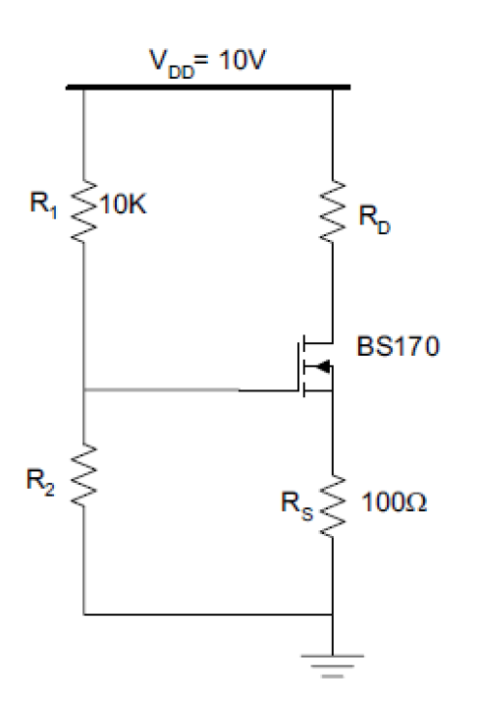
    - Circuit Diagram:
Figure H: Circuit Diagram (MOSFET as a current source)
    - Procedure:
The aim here is to use the MOSFET as a current source.
First, we need to calculate the value of R₂ needed to get a drain current of 10 mA.
R₂ = 5472 Ω (approx)
After connecting the circuit, we start with R_{D} as a short circuit and gradually increase it according to the shown values. At every point, we measure I_{D} and V_{DS}.

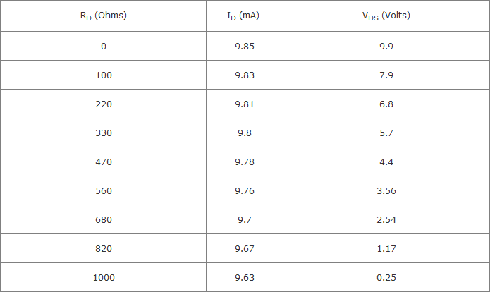
    - Results Obtained:
    - Discussion
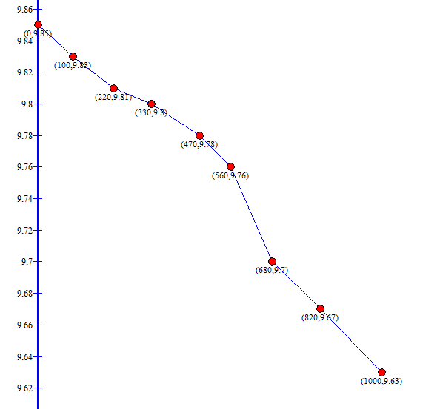
      - The current is almost constant when R_{D} is between 0 and 560 Ω
Figure I: I_{D} as function of R_{D}

      - The current source I_{s} is a 10mA source
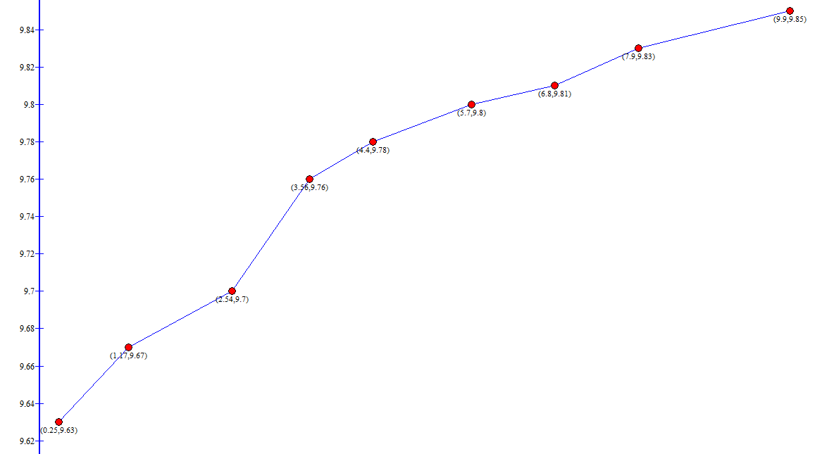
      - The current is almost constant for V_{DS} between 3.56 and 9.9 V
Figure J: I_{D} as function of V_{DS}
      - This range corresponds to SAT. Outside this range, the MOSFET is not in SAT.
      - r_{o} = 1/slope = 9.9-3.56 V/ (9.85-9.76) mA = 70.4 kΩ
- References
  - Lab Manual
  - "Using a MOSFET as a Switch". 090507 brunningsoftware.co.uk
- Mistakes and Problems faced in the Lab
  - Measurement errors
  - Inexact component values (i.e. 450 Ω resistor instead of 470 Ω)
  - Approximation errors

- Statement

“I HAVE NEITHER GIVEN NOR RECEIVED AID ON THIS REPORT NOR HAVE I CONCEALED ANY VIOLATION OF THE AUB STUDENT CODE OF CONDUCT.”

Signature:

