**Solution Chapter 9 exercises**

**(9.5,9.17)**

**9.5**

|  |  |  |  |  |
| --- | --- | --- | --- | --- |
| Interstation Distance Matrix—Original Layout | | | | |
|  | Pick Up |  | Pick Up | Verification |
|  | Paperwork | Advising | Class | of Status |
|  | and Forms | Station | Cards | and Payment |
|  | (A) | (B) | (C) | (D) |
| Paperwork/  Forms (A) | 0 | 30 | 60 | 90 |
| Advising (B) | 30 | 0 | 30 | 60 |
| Class Cards (C) | 60 | 30 | 0 | 30 |
| Verification/  Payment (D) | 90 | 60 | 30 | 0 |

|  |  |  |  |
| --- | --- | --- | --- |
| Load × Distance | | | |
| A → B: | 450 × 30 = | 13,500 | |
| A → C: | 550 × 60 = | 33,000 | |
| A → D: | 50 × 90 = | 4,500 | |
| B → A: | 350 × 30 = | 10,500 | |
| B → C: | 200 × 30 = | 6,000 | |
| C → D: | 750 × 30 = | 22,500 |  |
|  |  | 90,000 | |

Note: Work areas are “fixed” if using the software to reach this initial answer.

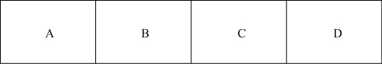(a) Initial layout:

|  |  |  |  |  |
| --- | --- | --- | --- | --- |
| Interstation Distance Matrix—Improved Layout | | | | |
|  | Pick Up |  | Pick Up | Verification |
|  | Paperwork | Advising | Class | of Status |
|  | and Forms | Station | Cards | and Payment |
|  | (A) | (B) | (C) | (D) |
| Paperwork/  Forms (A) | 0 | 30 | 30 | 60 |
| Advising (B) | 30 | 0 | 60 | 90 |
| Class Cards (C) | 30 | 60 | 0 | 30 |
| Verification/  Payment (D) | 60 | 90 | 30 | 0 |

|  |  |  |  |
| --- | --- | --- | --- |
| Load × Distance | | | |
| A → B: | 450 × 30 = | 13,500 | |
| A → C: | 550 × 30 = | 16,500 | |
| A → D: | 50 × 60 = | 3,000 | |
| B → A: | 350 × 30 = | 10,500 | |
| B → C: | 200 × 60 = | 12,000 | |
| C → D: | 750 × 30 = | 22,500 | |
|  |  | 78,000 |  |

(b) Improved layout:

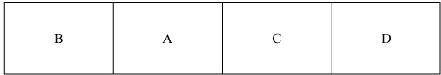

|  |  |  |  |  |  |
| --- | --- | --- | --- | --- | --- |
| 9.17 |  | Performance Time | | | Task Must Follow |
|  | Task | (in minutes) | | | This Task |
|  | A | 1 | | | — |
|  | B | 1 | | | A |
|  | C | 2 | | | A |
|  | D | 1 | | | C |
|  | E | 3 | | | C |
|  | F | 1 | | | C |
|  | G | 1 | | | D, E, F |
|  | H | 2 | | | B |
|  | I | 1 | | | G, H |
|  |  |  | 13 |  |  |



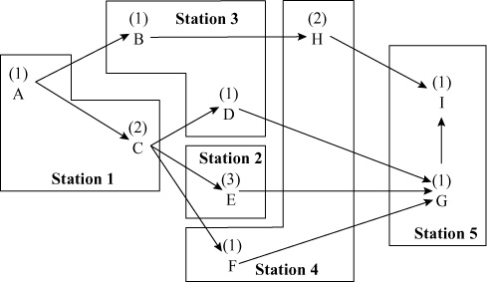 (a)

(b)



or Efficiency  78% with a cycle time of 3.33. Multiple layouts with this efficiency exist.





(d) Idle time = 1 + 1 = 2 min per cycle

= 60 cycles (boats) × 2 min

= 120 min; so it’s 2 hours per day