**Solutions - Chapter 6**

**(6.14,6.16)**

**FG06_014_01315855766.14**

**6.16** (a) The scatter diagram shows a strong positive relationship

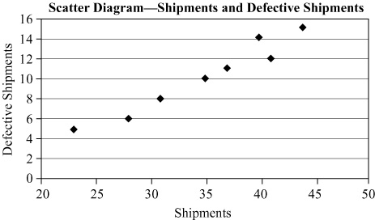

(b)The scatter diagram will resemble the chart below:

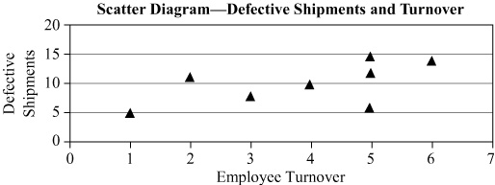There is an obvious relationship between turnover and quality as shown in this scatter diagram.

(c) The Pareto chart is:

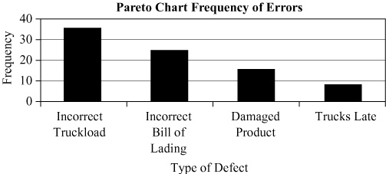(d)This is more appropriate for an in-class or group exercise where students may brainstorm for ideas. The possible causes should go on the four main bones. An example:

