**Assignment #3 – Solutions**

**(7.1©, 7.2,7.3,7.4,7.5,7.6,7.7,7.10)**

**7.1**

(c) Flow diagram for a shoe shine (customer perspective, a very different diagram would be prepared for the operator):

6829f7x01c

**7.2**

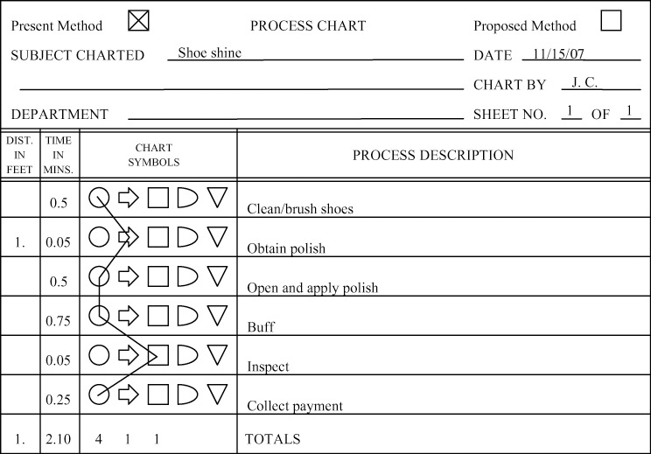

**7.3** Time function map of a shoe shine:

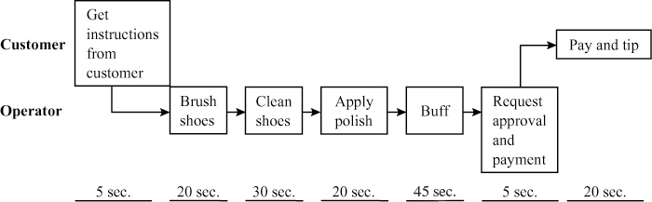

**7.4** A service blueprint for a shoe shine. (For a discussion of this  
particular application, see G.L. Shostack “Designing Services that  
Deliver,” *Harvard Business Review* 62, no. 1, (Jan.–Feb. 1984):  
133–139.)

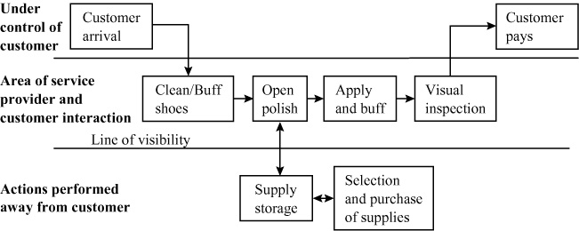

**7.5** GPE’s total cost = $3,100,000 = [($15 × 200,000)  
+ $100,000]

FMS’s total cost = $3,000,000 = [($14 × 200,000)  
+ $200,000]

DM’s total cost = $3,100,000 = [($13 × 200,000)  
+ $500,000]

The total cost for the flexible manufacturing system is lowest.

**7.6** 15*x* + 100,000 = 14*x* + 200,000. Therefore,

*x* = 100,000

14*x* + 200,000 = 13*x* + 500,000. Therefore,

*x* = 300,000

GPE is best below 100,000.

FMS is best between 100,000 and 300,000.

DM is best over 300,000.

**7.7** Based on the solution to Problem 7.6,

at 75,000 units, use GPE

at 275,000 units, use FMS

at 375,000 units, use DM

**7.10** (a)

|  |  |  |  |  |
| --- | --- | --- | --- | --- |
|  | Units | At 0 Units | At 4,000 units (arbitrary number) |  |
| (A) | *y* = 800 + 1.10*x* | 800 | $5200 | refurbish |
| (B) | *y* = 1100 + 0.70*x* | 1100 | $3900 | modify |
| (C) | *y* = 1800 + 0.4*x* | 1800 | $3400 | new |

FG07_010_0131585576

(b) At 3,000 boards, costs are:

Plan A: 800 + (1.10)(3,000) = $4,100.

Plan B: 1,100 + (.70)(3,000) = $3,200.

Plan C: 1,800 + (.40)(3,000) = $3,000.

So, at 3,000 board, plan C is the low-cost plan.

(c) Crossover points:

First, 800 + 1.10*x* = 1,100 + .70*x*

.40*x* = 300

*x* = 750

Second, 1,100 + .70*x* = 1,800 + .40*x*

.30*x* = 700

*x* = 2,333

So, between 1,000 and 2,000 boards, plan B is best.