3. The objectives are equivalent. For any values of X1 and X2, the absolute value of the objectives are the same. Thus, maximizing the value of the first objective is equivalent to minimizing the value of the second objective.

7. There is no guarantee that the optimal solution to an LP problem will occur at an integer-valued extreme point of the feasible region. (An exception to this general rule is discussed in Chapter 5 on networks).

13. X1 = number of desktop computers, X2 = number of laptop computers

MAX 600 X1 + 900 X2

ST 2 X1 + 3 X2 300

X1 80

X2 75

X1, X2 0



19. P = number of Presidential desks produced, S = number of Senator desks produced

MAX 103.75 P + 97.85 S

ST 30 P + 24 S 15,000

1 P + 1 S 600

5 P + 3 S 3000

P, S 0

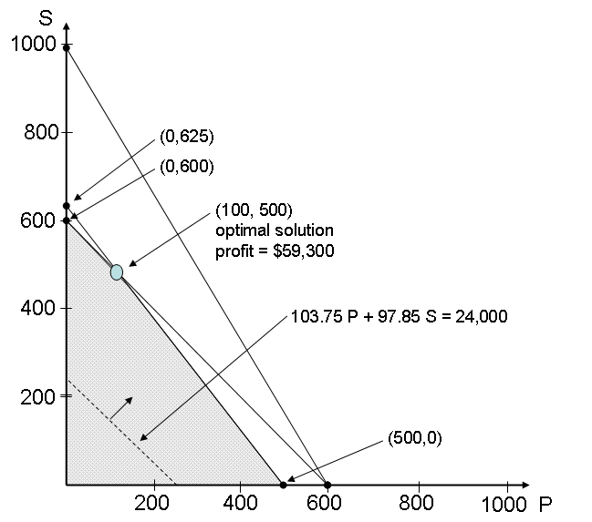

4.



18. X1 = number of generators, X2 = number of alternators

MAX 250 X1 + 150 X2

ST 2 X1 + 3 X2 260

1 X1 + 2 X2 140

X1, X2 0



20. X1 = number of generators, X2 = number of alternators

MAX 250 X1 + 150 X2

ST 2 X1 + 3 X2 260

1 X1 + 2 X2 140

X1 20

X2 20



d. No, the feasible region would not increase so the solution would not change -- you'd just have extra (unused) wiring capacity.

23. X1 = proportion of beef in the mix, X2 = proportion of pork in the mix

MIN .85 X1 + .65 X2

ST 1X1 + 1 X2 = 1

0.2 X1 + 0.3 X2 0.25

X1, X2 0



Extra Problem:

**Feasible Region:**

**5points for drawing the feasible region correctly**

**5 points for getting the optimal solution right: Optimal solution =( 96/5,46/5) and optimal cost=103.6.**



3. constraint is **binding**, so by relaxing the constraint, obj function value improves, i.e. it decreases for our problem. (2points).

**Note that in question 3, the key term here is “binding”.**