AMERICAN UNIVERSITY OF BEIRUT

**CIVE 310-MECHANICS OF MATERIALS**

**Spring term 2011- quiz I (grade from 100)**

**Student Name: ID:**

**----------------------------------------------------------------------------------------------------------**

**Problem 1. Strain (15 PTS).** A belt and a pulley system in a VCR (Video Casette recorder) has the dimensions shown in Figure 1. To ensure adequate but not excessive tension in the belts, the average normal strain in the belts must be min of 0.019 mm/mm and a maxi of 0.034 mm/mm.

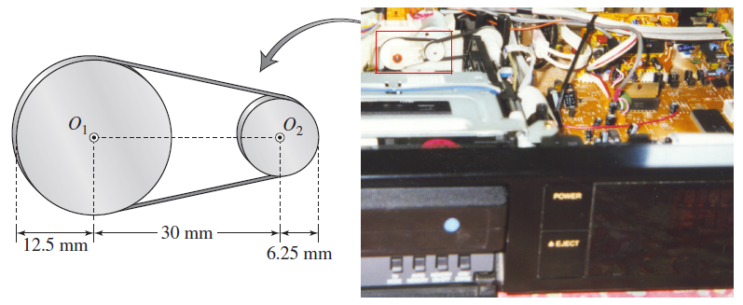

**Figure 1. Belt and pulley in a VCR**

What should be the minimum and maximum undeformed lengths of the belt to the nearest millimeter? (Formula: $ε=∆l/l_{0}$ + geometry/trigonometry are the only equations to be used).

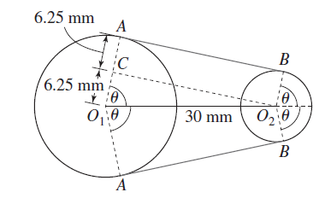**PLAN. *The belt must be tangent at the point where it comes in contact with the pulley. The deformed length of the belt is the length of belt between the tangent points on the pulleys, plus the length of belt wrapped around the pulleys. Once we calculate the deformed length of the belt using geometry, we can find the original length using the classic formula of strain and the given limits on normal strain***

**Problem 2.(35 PTS) Multi-axial loading (Part a-15pts)/Axial Loading (Part b-15 pts) -Parts a and b are independent**

a- A 60-mm cube is made from layers of graphite epoxy with fibers aligned in the *x* direction. The cube is subjected to a compressive load of 140 kN in the *x* direction. The properties of this hybrid material are: $E_{x}=155 GPa$, $E_{y}=12.10 GPa$, $E_{z}=12.10 GPa$, $v_{xy}=0.248$, , $v_{xz}=0.248$ and , $v_{yz}=0.458$

Determine the changes in the cube dimensions, if:

*\a)* the cube is free to expand in the y and *z* directions (Fig. 2);

*\b)* the cube is free to expand in the *z* direction, but is restrained from expanding in the *y* direction by two fixed frictionless plates (Fig. 3).

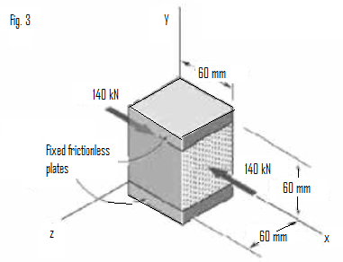c) Compare the results of parts a and b and conclude

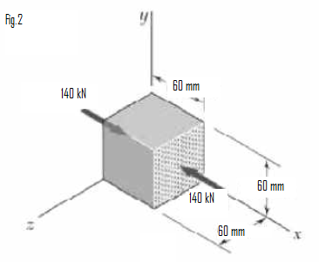

Formulas:

$v_{xy}=-\frac{ϵ_{y}}{ϵ_{x}}$ $ϵ_{x}=\frac{σ_{x}}{E_{x}}-\frac{v_{yx}σ_{y}}{E_{y}}-\frac{v_{zx}σ_{z}}{E_{z}}$

$δ_{x}=ϵ_{x}L$

$ϵ_{y}=\frac{σ_{y}}{E_{y}}-\frac{v_{xy}σ_{x}}{E_{x}}-\frac{v_{zy}σ_{z}}{E_{z}}v_{xz}=-\frac{ϵ_{z}}{ϵ_{x}}$ $ϵ_{z}=\frac{σ_{z}}{E_{z}}-\frac{v_{yz}σ_{y}}{E_{y}}-\frac{v_{xz}σ_{x}}{E_{x}}$

b-The rigid bar *CDE* is attached to a pin support at E and rests on the 30-mm diameter brass cylinder *BD.* A 22-mm-diameter steel rod *AC* passes through a hole in the bar and is secured by a nut which is snugly lilted when the temperature of the entire assembly is *20°C.* The temperature of the brass cylinder is then raised to 50°C while the steel rod remains at 20°C. Assuming that no stresses were present before the temperature change, determine the stress in the cylinder.

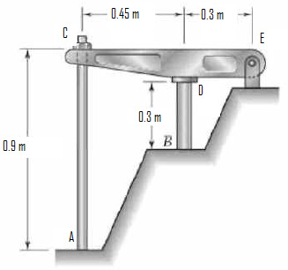

**Rod AC: Steel**

$E=200 GPa$ and $α=11.7 ×{10}^{-6}/°C$

**Cylinder BD: Brass**

$E=105 GPa$ and $α=20.9 ×{10}^{-6}/°C$

**Formulas: $δ_{T}=L\left(∆T\right)α$**

$$δ=\frac{PL}{AE}$$

**Problem 3. Bending (15 pts)**

Consider the general case of a prismatic beam subjected to bending-moment components $M_{x}$ and $M_{y}$ as shown, when the *x*, *y*, *z* axes pass through the centroid of the cross section.:



If the material is linear-elastic, the normal stress in the beam is a linear function of position such that: $σ=a+by+cz$. Using the equilibrium conditions:

$0=\int_{A}{σdA}$, $M_{y}=\int_{A}{zσdA}$ and $M_{z}=\int_{A}{-yσdA}$

Determine the constants *a*, *b*, and *c*, and show that the normal stress can be determined from the equation:

$$σ=\left[-\left(M_{z}I_{y}+M_{y}I_{yz}\right)y+\left(M_{y}I_{z}+M_{z}I_{yz}\right)z\right]/\left(I_{y}I_{z}-{I_{yz}}^{2}\right)$$

**Formulas: the moments and products of inertia are defined as following:*.***

$I_{y= }\int_{A}{z^{2}dA}$ $I_{z= }\int_{A}{y^{2}dA}$ $I_{xy= }\int_{A}{xydA}$**(Similar expression for any product of inertia of an area)**

**Problem 4- Bending and deflection (35 pts)**

When the diver stands at end *C* of the diving board, it deflects downward 3.5 in. Determine the weight of the diver. The board is made of material having a modulus of elasticity of $E=1.5 ×{10}^{3}ksi$. (Follow the Algorithm in next page to solve the problem)



**Algorithm:**

**Step 1: Find the support reactions**

**Step 2: Moment Functions.** Referring to the free-body diagrams of the diving board’s cut segments, find the moments $M(x_{1})$ and $M(x_{2})$ in terms of $(x_{1})$ and $(x_{2})$ respectively.



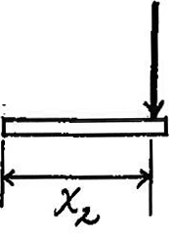

**Step 3: Apply the following equation at positions $(x_{1})$**  and $(x_{2})$ respectively



**And use the boundary conditions to find the constants. At the end of this step, you will have the exact value of constant C2, and the other constants in term of the weight W of the diver**

**Step 4: On the figure, at the two positions x=3 ft and x= 9 ft, we have:**



**Apply this condition of slope equality to the 2 positions and use the results of step 3 to find the values of the constants C1, C3 and C4 and finally the weight W.**