AMERICAN UNIVERSITY OF BEIRUT

*Department of Mechanical Engineering*

## MECH-341: Materials Laboratory

## Report 1

## Section-4

## Feb 25, 2009

### Instructor: Cherbel Seif

### Group members:

**Table of Contents**

1.Objective ..............................................................................................

2. Introduction .........................................................................................

3. Problem approach.................................................................................

4. Anaylsis and calculations......................................................................

5. Observations .........................................................................................

6. Conclusion.............................................................................................

7. References..............................................................................................

8. Appendix................................................................................................

1. Objectives

The purpose of this experiment is to obtain a number of experimental results that are used for the characterization of the mechanical properties and performance of materials. The experimental results are the values of ultimate tensile strength, yield strength, % elongation, fracture strain, and Young's Modulus of the selected metals when subjected to uniaxial tensile loading, etc... The experimental results obtained are then used for the design purposes by selecting the right material for a given design temperature.

1. Introduction

The engineering tension test is widely used to acquire basic properties of material being tested. The test provides us with basic design information of the strength of materials and as an acceptance test for the specification of materials to be selected for any application required. In tension test a standard specimen is prepared in a round along the gauge length as shown in figure 1. The inital gauge length is standardized and varies with the diameter . This is because if the gauge length is too long the % elongation might be undersestimated. Any heat treatment should be apploed on to the specimen prior to machinging to prodicce the final specimen to be used for testing. This is done in order to prevent the surface oxide scales that might act as stress concentraiton which might affect the final tensile propertiels due to premature failure. This specimen will be then subjected to a continually increasing uniaxial force, as result an engineering stress-strain curve is constructed from the load-elongation measurements.*(Dieter)*

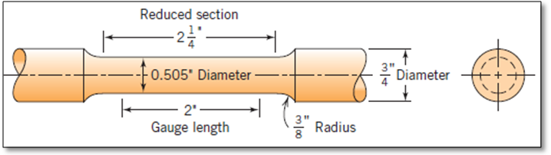

***Figure 2.1***: *Standard tensile specimens(Adapted from Calliester,7Ed.)*

As the specimen is subject to a tensile loading the metal will undergo elsastic and plastic deformation. Initially, the metal undegoes elastically deformation giving a linear reltationship of load and extension. These two parameter are then used for the calcuation of engineering stress and strain using following equations:

(1)



(2)



Where



During the elastic deformation, the engineering stress-strain relationship obeys the Hook’s law:



(3)

As the tensile loading continues the yielding occurs at the instant the plastic deformation is taking place. The yield stess can be obtain through the following relation:



(4)

Using the data obtained from the experiment and calculating the engineering stress and engineering strain using the formulas listed about, we obtain a relationship as illustrated in figure 2.*(Callister)*

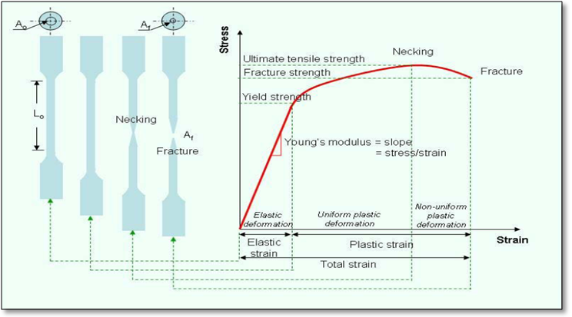

***Figure 2:*** *Stress strain relationship under tensil loading.*

The yield point can be determined directly from load-deflection cuve of the BCC metals such as steel and iron. This yield point phenomenon is associatied with a small amount of interstitial or substitutional atoms. For example, low-carbon steels which have small atoms of carbon and nitrogen as impurities. Pinning the dislocations by the solute atoms, the stress will be raised in order to overcome the breaing stess required for pulling of the dislocation line from the solute atmos, this is related the upper yield point as indicated in figure 3(a). If dislocation line is free from the solute atoms, the stress required to move the dislocations then suddenly drops which is associated with the lower yield point. Inaddition, the yield point effect is affected by the amounts of the solute atoms and is also influenced by the interaction energy between the solute atoms and the dislocations. *(Dieter)*

On the other hand, FCC crystal structure such as aluiminium does not show the definited yield point same as BCC structure, but it shows a smooth engineering stress-strain curve. Therefore, the yield strength is calculated from the load at 0.2% strain divided by the orginal cross section area as illustrated in figure 3(b).

As the load is continuously applied, the stress-strain (force-deflection) curve will reach the maxmum value which is the ultimate tensile strength. Ath this point, the specimen can withstand the highest stress before necking takes place. This can be observed by a reduction in the cross-sectional area of specimen.(Dieter)

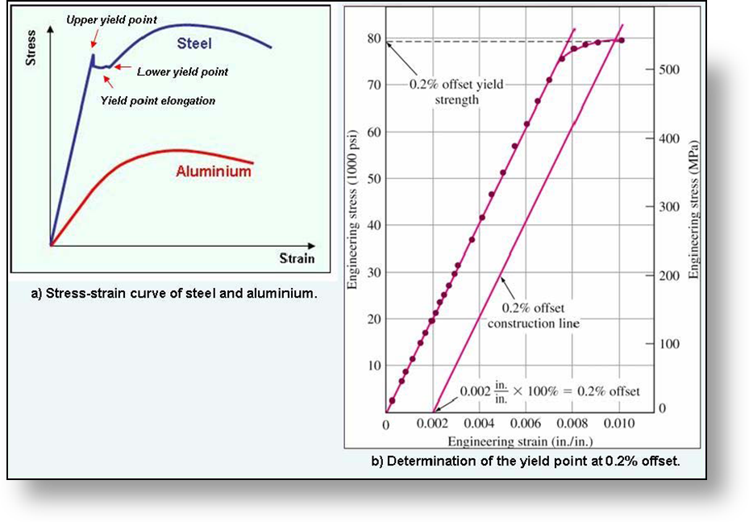

Metals with good ductility normally exhibit a cone fracture. Necking starts when the stress-strain (force-deflection) curve passed the maximum point where plastic deformation is no longer uniform. Across the necking area within the the specimen gage length microvoids are formed, this creates a crack having a plane perpendicular to the applied tensil stress. *(Dieter)*

For brittle metals, the fracture surfaces usually appear bright and consist of flat area *facets.* In some cases, clusters of thes brittle are visible when the grain size of the metal is large. The energy observations is small in this case which indicated relatively low tensile ductility due to limited amount of plastic deformation. *(Dieter)*

1. Problem Approach

In this experiment, our objective is to find out the mechanical properties of the material which are mainly the strength of the material. In scientific words, we want to find out the material’s behavior due to stress, how it deforms, its yield strength, its tensile strength, and its fracture point.

We need to measure the yield strength since it is the point in which the deformation changes from elastic to plastic, which means that there is no recovery from the deformation after the yield strength. Moreover, we must know the tensile strength so we could know what is the maximum stress that the material can bear. The fracture point must also be known so we could detect when the fracture will occur and the system will fail.

This helps us in engineering to specify which material we should use in our product design taking into consideration the product’s purpose. To manage the design of the product we must know the material’s properties mentioned above to calculate and predict the possibility of the system failure.

To proceed in this experiment, we should use a specific machine which is the Hounsfield UTM testing machine. This machine is specifically designed to undergo the stress- strain test. The Hounsfield UTM testing machine allows us to apply stress on a specimen of the material that we are testing by maintaining a certain strain rate (deformation rate) which we choose. Specifically in this experiment, the strain rate that we are using is 5 mm per minute. The machine is designed with a grip which ensures that the specimen stays straight while testing to prevent any loadings other than tensile load. The axis of the test specimen should coincide with center lines of the heads of the testing machine. We only need pure axial tensile stress on the gauge of the specimen. This machine uses forces in the range of the verified force application as per ASTM E4 standards. The Hounsfield UTM testing machine is supplied with an extensometer which will give the elongation corresponding to the yield stress and fracture.

The specimen has certain specifications of size and shape which are indicated in the figure below. This shape is of bigger radius on the edges to maintain a good grip and to ensure fracture in the gauge area.

The Hounsfield UTM testing machine supplies us with the data of load-strain curve.



1. Analysis and Calculations

***Note: Graphs are included in the appendix section.***

**A0** = (π D2 )/4 = π x (9 x10-3) 2/4 = 6.3617 x 10-5 m2

**L0** = 25mm

The data that we gathered from the experiment is the deformation of the bar and the force that was applied to form that deformation.

To get a stress-strain curve we need to plot stress vs. strain.

**Stress=** load/area = F/ AO = σ

So we find the value of stress for each corresponding force.

**Strain=** deformation/ gage length = δL/LO = ε

where δL is the extension of the bar (in mm) which is given to us

and LO is the gage length.

**Proportional limit stress σPl** =stress value at which the stress-strain curve goes nonlinear

σPl = 1068.11 MPa

**Yield Point Stress, σY**= stress value at which the stress-strain curve goes horizontal

σY = 1058.679 MPa

**0.2%-Offset Yield Stress, σ0.2%Y** = the stress value at which a line drawn with slope E starting at 0.002 strain intersects the stress-strain curve

σ0.2%Y = 1065.753 MPa

which is calculated graphically

**Ultimate Tensile Stress (σult ):** largest stress on the stress-strain curve

Therefore, from graph we can see that **σult = 1069.285 MPA.**

**Fracture Load =** final force applied when specimen fractures or breaks

So for our specimen, from Load-Deflection Graph, fracture load = 61000 N

**Engineering Fracture Stress**: It’s the stress at fracture point= fracture load/original area = 61000 N/ 6.3617 x10-5 m2 = 958.863 MPa.

**True Stress (σT)** = F/Ai = σ (1+ ε)

True stress values that were calculated from stress values are shown in the Tables (Appendix).

**To find the value of the new area we use the equality**

**Volume1 = Volume2**

**Area1 x L1 = Area2 x L2**

(6.3617 x10-5 m2)(25 mm) = area2(25 mm-1.24mm)

Therefore, area2 = 6.6937 x 10-5 m2 .

This is the uniform area.

**True Fracture Stress** = Ff / Ai : It's the true stress at fracture point= 989.361 MPA.

The true stress at fracture point= 589.853 MPA. (experiment 1)

**True Strain (εT)** = ln (Li/L0)= ln(1+ ε)

True strain values that were calculated from strain values are shown in The Table(Appendix).

From the true strain- true stress equations and using the strain and stress values, we form another curve (true stress-true strain curve).

**Modulus of Resilience** = UR : It represents the area under the elastic portion of the stress-strain curve. Numerically UR= σy2/ 2E = 1058.679 2 / 2 X (1512.4) = 370.54 MPA.

**Modulus of Toughness** =**UT** : It represents the area under the whole stress-strain curve.

**Energy at Yield =** area under the elastic portion of the load-deformation curve. We don’t have elastic portion due to MISSING DATA.

**Energy at Break =** area under the entire load-deformation curve.

In order to find this area, we used the iterative method known as the Rectangle rule.We divided the area under the stress-strain curve into small rectangles.

**Percent Elongation** = ( Lf-Lo)/Lo x 100% = [(22.6-25)/25 ] x (100)= - 9.6 % = (3.4)/25=13.6%.

**Percent Reduction in Area** = ( Af-Ai)/ Ai x100%=(6.3617 x10-5 -7.516 x 10-5)\ 6.3617 x10-5 x100=18.14 %.

1. Observations

We were able to notice that the rod had a small groove in it, and the groove is made to assure that the shear in the rod will happen in the middle where the groove is made and not in another location due to manufacturing errors or impurities.

We noticed was the sound of cracking we were hearing. For the first instance we thought it was coming from the machine, but when we began noticing the deformation (elongation) of the rod, and the changes in the load curve we realized that the noise of cracking was coming from the rod deformation and the slipping between it and the machine.

The rod deformed in a relatively small manner, the deformation was slightly noticed, and the necking phenomenon was noticed with careful observation of the whole process.

The rod upon fracture produced a loud sound that the instructor warned us from before it happens.

After the fracture occurred, the specimen at the surface of fracture shows a cup and con structure, a ductile material characteristic.

1. Conclusion

The material used in this experiment is very ductile. It has percent elongation of gage   
length approximately equal to *-9.6 %* and a small modulus of elasticity *E* equal to *1512.4* MPa.

The obtained values agree with what has been expected which is that ductile materials   
have large deformations for small applied stresses.

Moreover, we can mention that such materials are only suitable for low stress   
applications since a stress higher than the yielding stress can result in the failure of   
the material.

1. References

* Dieter, G.E., *Mechanical metallurgy*, 1988, SI metric edition, McGraw-Hill.
* W.D. Callister, *Fundamental of materials science and engineering, 7th edition*, 2007.

1. Appendix

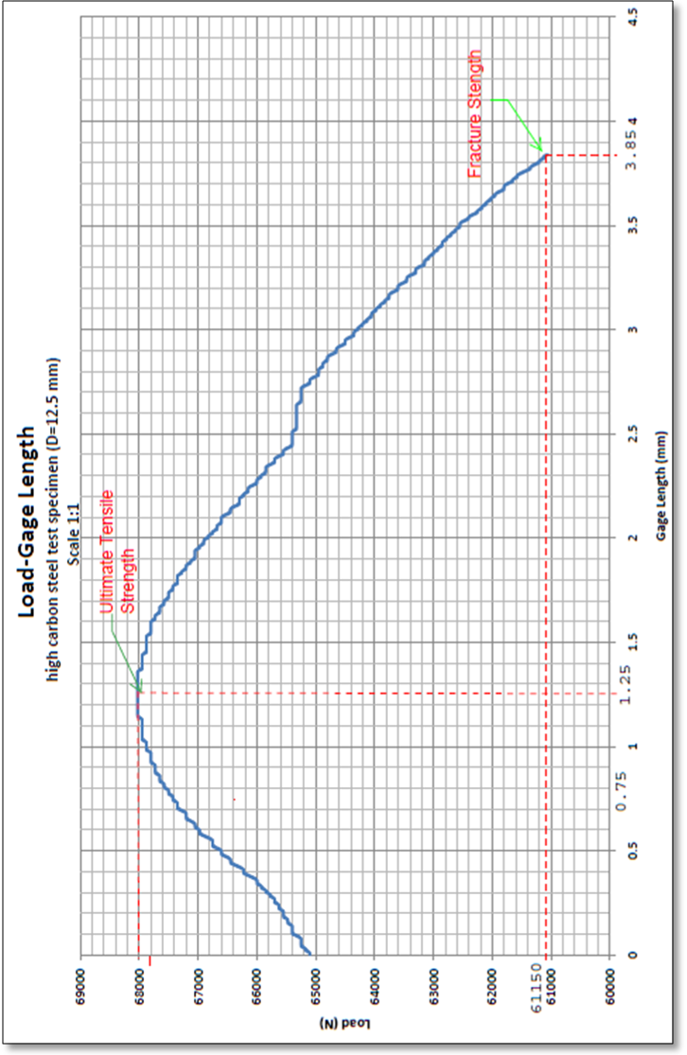

*Load-gage length realtionship under uniaxial tensile loading*

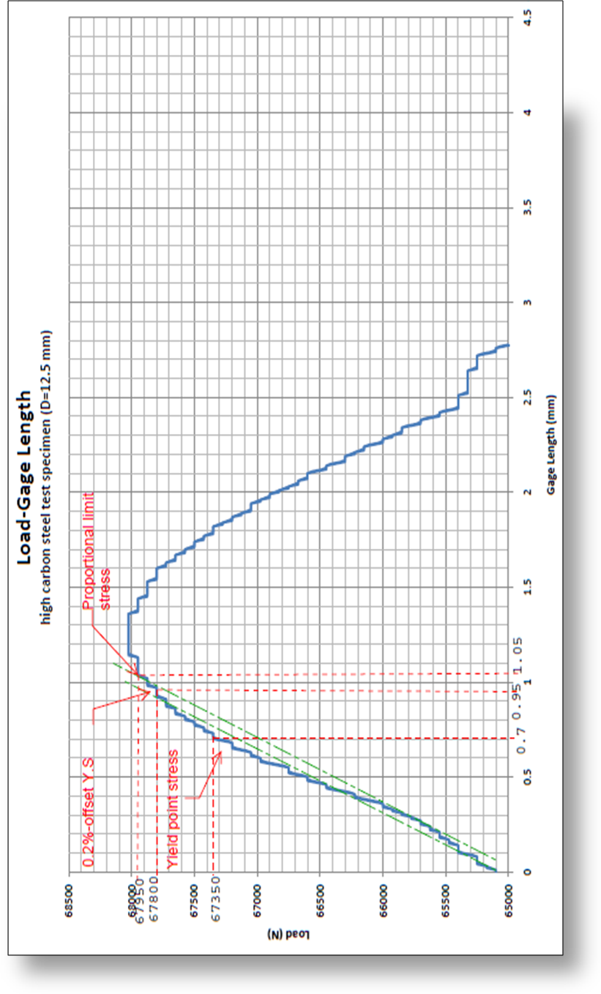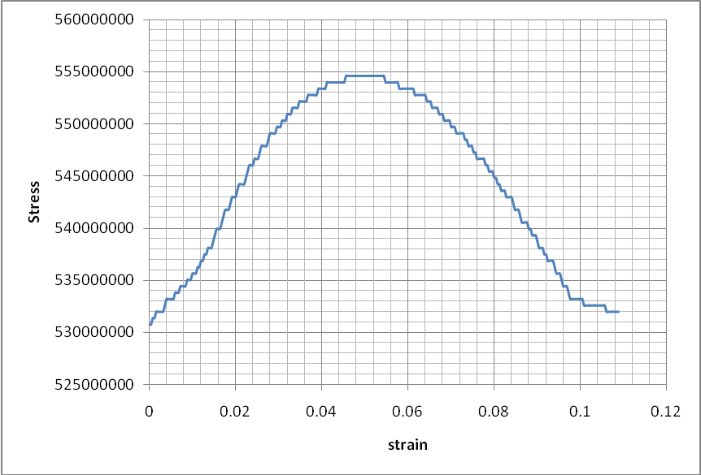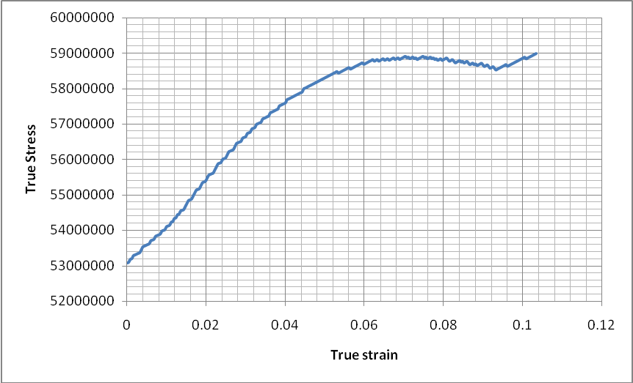

|  |  |  |  |  |  |
| --- | --- | --- | --- | --- | --- |
| Extension mm | Force N | Stress | Strain | True Stress | True Strain |
| 0 | 65100 | 530751592 | 0 | 530751592 | 0 |
| 0.01 | 65100 | 530751592 | 0.0004 | 530963892.6 | 0.0004 |
| 0.02 | 65175 | 531363057 | 0.0008 | 531788147.4 | 0.0008 |
| 0.03 | 65175 | 531363057 | 0.0012 | 532000692.7 | 0.001199 |
| 0.04 | 65250 | 531974522 | 0.0016 | 532825681.2 | 0.001599 |
| 0.05 | 65250 | 531974522 | 0.002 | 533038471 | 0.001998 |
| 0.06 | 65250 | 531974522 | 0.0024 | 533251260.9 | 0.002397 |
| 0.07 | 65250 | 531974522 | 0.0028 | 533464050.7 | 0.002796 |
| 0.08 | 65250 | 531974522 | 0.0032 | 533676840.5 | 0.003195 |
| 0.09 | 65325 | 532585987 | 0.0036 | 534503296.6 | 0.003594 |
| 0.1 | 65400 | 533197452 | 0.004 | 535330241.8 | 0.003992 |
| 0.11 | 65400 | 533197452 | 0.0044 | 535543520.8 | 0.00439 |
| 0.12 | 65400 | 533197452 | 0.0048 | 535756799.8 | 0.004789 |
| 0.13 | 65400 | 533197452 | 0.0052 | 535970078.8 | 0.005187 |
| 0.14 | 65400 | 533197452 | 0.0056 | 536183357.7 | 0.005584 |
| 0.15 | 65475 | 533808917 | 0.006 | 537011770.5 | 0.005982 |
| 0.16 | 65475 | 533808917 | 0.0064 | 537225294.1 | 0.00638 |
| 0.17 | 65475 | 533808917 | 0.0068 | 537438817.6 | 0.006777 |
| 0.18 | 65550 | 534420382 | 0.0072 | 538268208.8 | 0.007174 |
| 0.19 | 65550 | 534420382 | 0.0076 | 538481976.9 | 0.007571 |
| 0.2 | 65550 | 534420382 | 0.008 | 538695745.1 | 0.007968 |
| 0.21 | 65550 | 534420382 | 0.0084 | 538909513.2 | 0.008365 |
| 0.22 | 65625 | 535031847 | 0.0088 | 539740127.3 | 0.008762 |
| 0.23 | 65625 | 535031847 | 0.0092 | 539954140 | 0.009158 |
| 0.24 | 65625 | 535031847 | 0.0096 | 540168152.7 | 0.009554 |
| 0.25 | 65700 | 535643312 | 0.01 | 540999745.1 | 0.00995 |
| 0.26 | 65700 | 535643312 | 0.0104 | 541214002.4 | 0.010346 |
| 0.27 | 65700 | 535643312 | 0.0108 | 541428259.8 | 0.010742 |
| 0.28 | 65775 | 536254777 | 0.0112 | 542260830.5 | 0.011138 |
| 0.29 | 65775 | 536254777 | 0.0116 | 542475332.4 | 0.011533 |
| 0.3 | 65850 | 536866242 | 0.012 | 543308636.9 | 0.011929 |
| 0.31 | 65850 | 536866242 | 0.0124 | 543523383.4 | 0.012324 |
| 0.32 | 65925 | 537477707 | 0.0128 | 544357421.6 | 0.012719 |
| 0.33 | 65925 | 537477707 | 0.0132 | 544572412.7 | 0.013114 |
| 0.34 | 66000 | 538089171 | 0.0136 | 545407183.7 | 0.013508 |
| 0.35 | 66000 | 538089171 | 0.014 | 545622419.4 | 0.013903 |
| 0.36 | 66000 | 538089171 | 0.0144 | 545837655.1 | 0.014297 |
| 0.37 | 66075 | 538700636 | 0.0148 | 546673405.4 | 0.014692 |
| 0.38 | 66150 | 539312101 | 0.0152 | 547509644.9 | 0.015086 |
| 0.39 | 66225 | 539923566 | 0.0156 | 548346373.6 | 0.01548 |
| 0.4 | 66225 | 539923566 | 0.016 | 548562343.1 | 0.015873 |
| 0.41 | 66225 | 539923566 | 0.0164 | 548778312.5 | 0.016267 |
| 0.42 | 66300 | 540535031 | 0.0168 | 549616019.5 | 0.01666 |
| 0.43 | 66375 | 541146496 | 0.0172 | 550454215.7 | 0.017054 |
| 0.44 | 66450 | 541757961 | 0.0176 | 551292901.1 | 0.017447 |
| 0.45 | 66450 | 541757961 | 0.018 | 551509604.3 | 0.01784 |
| 0.46 | 66450 | 541757961 | 0.0184 | 551726307.5 | 0.018233 |
| 0.47 | 66525 | 542369426 | 0.0188 | 552565971.2 | 0.018625 |
| 0.48 | 66600 | 542980891 | 0.0192 | 553406124.1 | 0.019018 |
| 0.49 | 66600 | 542980891 | 0.0196 | 553623316.5 | 0.01941 |
| 0.5 | 66600 | 542980891 | 0.02 | 553840508.8 | 0.019803 |
| 0.51 | 66675 | 543592356 | 0.0204 | 554681640.1 | 0.020195 |
| 0.52 | 66750 | 544203821 | 0.0208 | 555523260.5 | 0.020587 |
| 0.53 | 66750 | 544203821 | 0.0212 | 555740942 | 0.020978 |
| 0.54 | 66750 | 544203821 | 0.0216 | 555958623.5 | 0.02137 |
| 0.55 | 66750 | 544203821 | 0.022 | 556176305.1 | 0.021761 |
| 0.56 | 66825 | 544815286 | 0.0224 | 557019148.4 | 0.022153 |
| 0.57 | 66900 | 545426751 | 0.0228 | 557862480.9 | 0.022544 |
| 0.58 | 66975 | 546038216 | 0.0232 | 558706302.6 | 0.022935 |
| 0.59 | 66975 | 546038216 | 0.0236 | 558924717.9 | 0.023326 |
| 0.6 | 66975 | 546038216 | 0.024 | 559143133.2 | 0.023717 |
| 0.61 | 67050 | 546649681 | 0.0244 | 559987933.2 | 0.024107 |
| 0.62 | 67050 | 546649681 | 0.0248 | 560206593.1 | 0.024497 |
| 0.63 | 67050 | 546649681 | 0.0252 | 560425253 | 0.024888 |
| 0.64 | 67125 | 547261146 | 0.0256 | 561271031.3 | 0.025278 |
| 0.65 | 67200 | 547872611 | 0.026 | 562117298.9 | 0.025668 |
| 0.66 | 67200 | 547872611 | 0.0264 | 562336447.9 | 0.026058 |
| 0.67 | 67200 | 547872611 | 0.0268 | 562555597 | 0.026447 |
| 0.68 | 67200 | 547872611 | 0.0272 | 562774746 | 0.026837 |
| 0.69 | 67275 | 548484076 | 0.0276 | 563622236.5 | 0.027226 |
| 0.7 | 67350 | 549095541 | 0.028 | 564470216.1 | 0.027615 |
| 0.71 | 67350 | 549095541 | 0.0284 | 564689854.4 | 0.028004 |
| 0.72 | 67350 | 549095541 | 0.0288 | 564909492.6 | 0.028393 |
| 0.73 | 67350 | 549095541 | 0.0292 | 565129130.8 | 0.028782 |
| 0.74 | 67425 | 549707006 | 0.0296 | 565978333.4 | 0.02917 |
| 0.75 | 67425 | 549707006 | 0.03 | 566198216.2 | 0.029559 |
| 0.76 | 67425 | 549707006 | 0.0304 | 566418099 | 0.029947 |
| 0.77 | 67500 | 550318471 | 0.0308 | 567268279.9 | 0.030335 |
| 0.78 | 67500 | 550318471 | 0.0312 | 567488407.3 | 0.030723 |
| 0.79 | 67500 | 550318471 | 0.0316 | 567708534.7 | 0.031111 |
| 0.8 | 67575 | 550929936 | 0.032 | 568559694 | 0.031499 |
| 0.81 | 67575 | 550929936 | 0.0324 | 568780065.9 | 0.031886 |
| 0.82 | 67575 | 550929936 | 0.0328 | 569000437.9 | 0.032274 |
| 0.83 | 67650 | 551541401 | 0.0332 | 569852575.5 | 0.032661 |
| 0.84 | 67650 | 551541401 | 0.0336 | 570073192.1 | 0.033048 |
| 0.85 | 67650 | 551541401 | 0.034 | 570293808.6 | 0.033435 |
| 0.86 | 67650 | 551541401 | 0.0344 | 570514425.2 | 0.033822 |
| 0.87 | 67725 | 552152866 | 0.0348 | 571367785.7 | 0.034208 |
| 0.88 | 67725 | 552152866 | 0.0352 | 571588646.9 | 0.034595 |
| 0.89 | 67725 | 552152866 | 0.0356 | 571809508 | 0.034981 |
| 0.9 | 67725 | 552152866 | 0.036 | 572030369.2 | 0.035367 |
| 0.91 | 67725 | 552152866 | 0.0364 | 572251230.3 | 0.035753 |
| 0.92 | 67800 | 552764331 | 0.0368 | 573106058.4 | 0.036139 |
| 0.93 | 67800 | 552764331 | 0.0372 | 573327164.1 | 0.036525 |
| 0.94 | 67800 | 552764331 | 0.0376 | 573548269.8 | 0.03691 |
| 0.95 | 67800 | 552764331 | 0.038 | 573769375.6 | 0.037296 |
| 0.96 | 67800 | 552764331 | 0.0384 | 573990481.3 | 0.037681 |
| 0.97 | 67800 | 552764331 | 0.0388 | 574211587 | 0.038066 |
| 0.98 | 67875 | 553375796 | 0.0392 | 575068127.2 | 0.038451 |
| 0.99 | 67875 | 553375796 | 0.0396 | 575289477.5 | 0.038836 |
| 1 | 67875 | 553375796 | 0.04 | 575510827.8 | 0.039221 |
| 1.01 | 67875 | 553375796 | 0.0404 | 575732178.2 | 0.039605 |
| 1.02 | 67875 | 553375796 | 0.0408 | 575953528.5 | 0.03999 |
| 1.03 | 67950 | 553987261 | 0.0412 | 576811536.2 | 0.040374 |
| 1.04 | 67950 | 553987261 | 0.0416 | 577033131.1 | 0.040758 |
| 1.05 | 67950 | 553987261 | 0.042 | 577254726 | 0.041142 |
| 1.06 | 67950 | 553987261 | 0.0424 | 577476320.9 | 0.041526 |
| 1.07 | 67950 | 553987261 | 0.0428 | 577697915.8 | 0.041909 |
| 1.08 | 67950 | 553987261 | 0.0432 | 577919510.7 | 0.042293 |
| 1.09 | 67950 | 553987261 | 0.0436 | 578141105.6 | 0.042676 |
| 1.1 | 67950 | 553987261 | 0.044 | 578362700.5 | 0.043059 |
| 1.11 | 67950 | 553987261 | 0.0444 | 578584295.4 | 0.043443 |
| 1.12 | 67950 | 553987261 | 0.0448 | 578805890.3 | 0.043825 |
| 1.13 | 67950 | 553987261 | 0.0452 | 579027485.2 | 0.044208 |
| 1.14 | 68025 | 554598726 | 0.0456 | 579888427.9 | 0.044591 |
| 1.15 | 68025 | 554598726 | 0.046 | 580110267.4 | 0.044973 |
| 1.16 | 68025 | 554598726 | 0.0464 | 580332106.9 | 0.045356 |
| 1.17 | 68025 | 554598726 | 0.0468 | 580553946.4 | 0.045738 |
| 1.18 | 68025 | 554598726 | 0.0472 | 580775785.9 | 0.04612 |
| 1.19 | 68025 | 554598726 | 0.0476 | 580997625.4 | 0.046502 |
| 1.2 | 68025 | 554598726 | 0.048 | 581219464.8 | 0.046884 |
| 1.21 | 68025 | 554598726 | 0.0484 | 581441304.3 | 0.047265 |
| 1.22 | 68025 | 554598726 | 0.0488 | 581663143.8 | 0.047647 |
| 1.23 | 68025 | 554598726 | 0.0492 | 581884983.3 | 0.048028 |
| 1.24 | 68025 | 554598726 | 0.0496 | 582106822.8 | 0.048409 |
| 1.25 | 68025 | 554598726 | 0.05 | 582328662.3 | 0.04879 |
| 1.26 | 68025 | 554598726 | 0.0504 | 582550501.8 | 0.049171 |
| 1.27 | 68025 | 554598726 | 0.0508 | 582772341.3 | 0.049552 |
| 1.28 | 68025 | 554598726 | 0.0512 | 582994180.8 | 0.049932 |
| 1.29 | 68025 | 554598726 | 0.0516 | 583216020.3 | 0.050313 |
| 1.3 | 68025 | 554598726 | 0.052 | 583437859.8 | 0.050693 |
| 1.31 | 68025 | 554598726 | 0.0524 | 583659699.2 | 0.051073 |
| 1.32 | 68025 | 554598726 | 0.0528 | 583881538.7 | 0.051453 |
| 1.33 | 68025 | 554598726 | 0.0532 | 584103378.2 | 0.051833 |
| 1.34 | 68025 | 554598726 | 0.0536 | 584325217.7 | 0.052213 |
| 1.35 | 68025 | 554598726 | 0.054 | 584547057.2 | 0.052592 |
| 1.36 | 68025 | 554598726 | 0.0544 | 584768896.7 | 0.052972 |
| 1.37 | 67950 | 553987261 | 0.0548 | 584345762.9 | 0.053351 |
| 1.38 | 67950 | 553987261 | 0.0552 | 584567357.8 | 0.05373 |
| 1.39 | 67950 | 553987261 | 0.0556 | 584788952.7 | 0.054109 |
| 1.4 | 67950 | 553987261 | 0.056 | 585010547.6 | 0.054488 |
| 1.41 | 67950 | 553987261 | 0.0564 | 585232142.5 | 0.054867 |
| 1.42 | 67950 | 553987261 | 0.0568 | 585453737.4 | 0.055245 |
| 1.43 | 67950 | 553987261 | 0.0572 | 585675332.3 | 0.055624 |
| 1.44 | 67950 | 553987261 | 0.0576 | 585896927.2 | 0.056002 |
| 1.45 | 67875 | 553375796 | 0.058 | 585471592.2 | 0.05638 |
| 1.46 | 67875 | 553375796 | 0.0584 | 585692942.5 | 0.056758 |
| 1.47 | 67875 | 553375796 | 0.0588 | 585914292.8 | 0.057136 |
| 1.48 | 67875 | 553375796 | 0.0592 | 586135643.1 | 0.057514 |
| 1.49 | 67875 | 553375796 | 0.0596 | 586356993.4 | 0.057891 |
| 1.5 | 67875 | 553375796 | 0.06 | 586578343.8 | 0.058269 |
| 1.51 | 67875 | 553375796 | 0.0604 | 586799694.1 | 0.058646 |
| 1.52 | 67875 | 553375796 | 0.0608 | 587021044.4 | 0.059023 |
| 1.53 | 67875 | 553375796 | 0.0612 | 587242394.7 | 0.0594 |
| 1.54 | 67800 | 552764331 | 0.0616 | 586814613.8 | 0.059777 |
| 1.55 | 67800 | 552764331 | 0.062 | 587035719.5 | 0.060154 |
| 1.56 | 67800 | 552764331 | 0.0624 | 587256825.3 | 0.06053 |
| 1.57 | 67800 | 552764331 | 0.0628 | 587477931 | 0.060907 |
| 1.58 | 67800 | 552764331 | 0.0632 | 587699036.7 | 0.061283 |
| 1.59 | 67800 | 552764331 | 0.0636 | 587920142.5 | 0.061659 |
| 1.6 | 67800 | 552764331 | 0.064 | 588141248.2 | 0.062035 |
| 1.61 | 67725 | 552152866 | 0.0644 | 587711510.6 | 0.062411 |
| 1.62 | 67725 | 552152866 | 0.0648 | 587932371.7 | 0.062787 |
| 1.63 | 67725 | 552152866 | 0.0652 | 588153232.9 | 0.063163 |
| 1.64 | 67650 | 551541401 | 0.0656 | 587722516.9 | 0.063538 |
| 1.65 | 67650 | 551541401 | 0.066 | 587943133.5 | 0.063913 |
| 1.66 | 67650 | 551541401 | 0.0664 | 588163750 | 0.064288 |
| 1.67 | 67650 | 551541401 | 0.0668 | 588384366.6 | 0.064664 |
| 1.68 | 67575 | 550929936 | 0.0672 | 587952427.7 | 0.065038 |
| 1.69 | 67575 | 550929936 | 0.0676 | 588172799.7 | 0.065413 |
| 1.7 | 67575 | 550929936 | 0.068 | 588393171.6 | 0.065788 |
| 1.71 | 67500 | 550318471 | 0.0684 | 587960254.4 | 0.066162 |
| 1.72 | 67500 | 550318471 | 0.0688 | 588180381.8 | 0.066537 |
| 1.73 | 67500 | 550318471 | 0.0692 | 588400509.2 | 0.066911 |
| 1.74 | 67500 | 550318471 | 0.0696 | 588620636.6 | 0.067285 |
| 1.75 | 67425 | 549707006 | 0.07 | 588186496.4 | 0.067659 |
| 1.76 | 67425 | 549707006 | 0.0704 | 588406379.2 | 0.068032 |
| 1.77 | 67425 | 549707006 | 0.0708 | 588626262 | 0.068406 |
| 1.78 | 67350 | 549095541 | 0.0712 | 588191143.5 | 0.06878 |
| 1.79 | 67350 | 549095541 | 0.0716 | 588410781.7 | 0.069153 |
| 1.8 | 67350 | 549095541 | 0.072 | 588630420 | 0.069526 |
| 1.81 | 67350 | 549095541 | 0.0724 | 588850058.2 | 0.069899 |
| 1.82 | 67350 | 549095541 | 0.0728 | 589069696.4 | 0.070272 |
| 1.83 | 67275 | 548484076 | 0.0732 | 588633110.4 | 0.070645 |
| 1.84 | 67275 | 548484076 | 0.0736 | 588852504 | 0.071017 |
| 1.85 | 67200 | 547872611 | 0.074 | 588415184.2 | 0.07139 |
| 1.86 | 67200 | 547872611 | 0.0744 | 588634333.3 | 0.071762 |
| 1.87 | 67200 | 547872611 | 0.0748 | 588853482.3 | 0.072135 |
| 1.88 | 67125 | 547261146 | 0.0752 | 588415184.2 | 0.072507 |
| 1.89 | 67125 | 547261146 | 0.0756 | 588634088.6 | 0.072879 |
| 1.9 | 67050 | 546649681 | 0.076 | 588195056.8 | 0.07325 |
| 1.91 | 67050 | 546649681 | 0.0764 | 588413716.6 | 0.073622 |
| 1.92 | 67050 | 546649681 | 0.0768 | 588632376.5 | 0.073994 |
| 1.93 | 67050 | 546649681 | 0.0772 | 588851036.4 | 0.074365 |
| 1.94 | 67050 | 546649681 | 0.0776 | 589069696.2 | 0.074736 |
| 1.95 | 66975 | 546038216 | 0.078 | 588629196.8 | 0.075107 |
| 1.96 | 66975 | 546038216 | 0.0784 | 588847612.1 | 0.075478 |
| 1.97 | 66900 | 545426751 | 0.0788 | 588406379 | 0.075849 |
| 1.98 | 66900 | 545426751 | 0.0792 | 588624549.7 | 0.07622 |
| 1.99 | 66900 | 545426751 | 0.0796 | 588842720.4 | 0.076591 |
| 2 | 66825 | 544815286 | 0.08 | 588400508.9 | 0.076961 |
| 2.01 | 66825 | 544815286 | 0.0804 | 588618435 | 0.077331 |
| 2.02 | 66750 | 544203821 | 0.0808 | 588175489.7 | 0.077702 |
| 2.03 | 66750 | 544203821 | 0.0812 | 588393171.3 | 0.078072 |
| 2.04 | 66675 | 543592356 | 0.0816 | 587949492.2 | 0.078441 |
| 2.05 | 66675 | 543592356 | 0.082 | 588166929.2 | 0.078811 |
| 2.06 | 66675 | 543592356 | 0.0824 | 588384366.1 | 0.079181 |
| 2.07 | 66600 | 542980891 | 0.0828 | 587939708.8 | 0.07955 |
| 2.08 | 66600 | 542980891 | 0.0832 | 588156901.1 | 0.07992 |
| 2.09 | 66600 | 542980891 | 0.0836 | 588374093.5 | 0.080289 |
| 2.1 | 66600 | 542980891 | 0.084 | 588591285.8 | 0.080658 |
| 2.11 | 66525 | 542369426 | 0.0844 | 588145405.6 | 0.081027 |
| 2.12 | 66450 | 541757961 | 0.0848 | 587699036.1 | 0.081396 |
| 2.13 | 66450 | 541757961 | 0.0852 | 587915739.3 | 0.081764 |
| 2.14 | 66450 | 541757961 | 0.0856 | 588132442.5 | 0.082133 |
| 2.15 | 66375 | 541146496 | 0.086 | 587685094.7 | 0.082501 |
| 2.16 | 66300 | 540535031 | 0.0864 | 587237257.7 | 0.082869 |
| 2.17 | 66300 | 540535031 | 0.0868 | 587453471.7 | 0.083238 |
| 2.18 | 66300 | 540535031 | 0.0872 | 587669685.7 | 0.083606 |
| 2.19 | 66300 | 540535031 | 0.0876 | 587885899.7 | 0.083973 |
| 2.2 | 66225 | 539923566 | 0.088 | 587436839.8 | 0.084341 |
| 2.21 | 66225 | 539923566 | 0.0884 | 587652809.2 | 0.084709 |
| 2.22 | 66150 | 539312101 | 0.0888 | 587203015.6 | 0.085076 |
| 2.23 | 66150 | 539312101 | 0.0892 | 587418740.4 | 0.085443 |
| 2.24 | 66150 | 539312101 | 0.0896 | 587634465.2 | 0.085811 |
| 2.25 | 66075 | 538700636 | 0.09 | 587183693.2 | 0.086178 |
| 2.26 | 66000 | 538089171 | 0.0904 | 586732432.1 | 0.086545 |
| 2.27 | 66000 | 538089171 | 0.0908 | 586947667.7 | 0.086911 |
| 2.28 | 66000 | 538089171 | 0.0912 | 587162903.4 | 0.087278 |
| 2.29 | 65925 | 537477707 | 0.0916 | 586710665 | 0.087645 |
| 2.3 | 65925 | 537477707 | 0.092 | 586925656 | 0.088011 |
| 2.31 | 65850 | 536866242 | 0.0924 | 586472682.8 | 0.088377 |
| 2.32 | 65850 | 536866242 | 0.0928 | 586687429.3 | 0.088743 |
| 2.33 | 65850 | 536866242 | 0.0932 | 586902175.8 | 0.089109 |
| 2.34 | 65850 | 536866242 | 0.0936 | 587116922.3 | 0.089475 |
| 2.35 | 65775 | 536254777 | 0.094 | 586662726 | 0.089841 |
| 2.36 | 65700 | 535643312 | 0.0944 | 586208040.7 | 0.090206 |
| 2.37 | 65700 | 535643312 | 0.0948 | 586422298 | 0.090572 |
| 2.38 | 65700 | 535643312 | 0.0952 | 586636555.3 | 0.090937 |
| 2.39 | 65625 | 535031847 | 0.0956 | 586180891.6 | 0.091302 |
| 2.4 | 65550 | 534420382 | 0.096 | 585724738.7 | 0.091667 |
| 2.41 | 65550 | 534420382 | 0.0964 | 585938506.8 | 0.092032 |
| 2.42 | 65550 | 534420382 | 0.0968 | 586152275 | 0.092397 |
| 2.43 | 65475 | 533808917 | 0.0972 | 585695143.7 | 0.092761 |
| 2.44 | 65400 | 533197452 | 0.0976 | 585237523.3 | 0.093126 |
| 2.45 | 65400 | 533197452 | 0.098 | 585450802.3 | 0.09349 |
| 2.46 | 65400 | 533197452 | 0.0984 | 585664081.3 | 0.093855 |
| 2.47 | 65400 | 533197452 | 0.0988 | 585877360.3 | 0.094219 |
| 2.48 | 65400 | 533197452 | 0.0992 | 586090639.2 | 0.094583 |
| 2.49 | 65400 | 533197452 | 0.0996 | 586303918.2 | 0.094946 |
| 2.5 | 65400 | 533197452 | 0.1 | 586517197.2 | 0.09531 |
| 2.51 | 65400 | 533197452 | 0.1004 | 586730476.2 | 0.095674 |
| 2.52 | 65325 | 532585987 | 0.1008 | 586270654.5 | 0.096037 |
| 2.53 | 65325 | 532585987 | 0.1012 | 586483688.9 | 0.0964 |
| 2.54 | 65325 | 532585987 | 0.1016 | 586696723.3 | 0.096764 |
| 2.55 | 65325 | 532585987 | 0.102 | 586909757.7 | 0.097127 |
| 2.56 | 65325 | 532585987 | 0.1024 | 587122792.1 | 0.09749 |
| 2.57 | 65325 | 532585987 | 0.1028 | 587335826.5 | 0.097852 |
| 2.58 | 65325 | 532585987 | 0.1032 | 587548860.9 | 0.098215 |
| 2.59 | 65325 | 532585987 | 0.1036 | 587761895.3 | 0.098578 |
| 2.6 | 65325 | 532585987 | 0.104 | 587974929.6 | 0.09894 |
| 2.61 | 65325 | 532585987 | 0.1044 | 588187964 | 0.099302 |
| 2.62 | 65325 | 532585987 | 0.1048 | 588400998.4 | 0.099664 |
| 2.63 | 65325 | 532585987 | 0.1052 | 588614032.8 | 0.100026 |
| 2.64 | 65325 | 532585987 | 0.1056 | 588827067.2 | 0.100388 |
| 2.65 | 65250 | 531974522 | 0.106 | 588363821.3 | 0.10075 |
| 2.66 | 65250 | 531974522 | 0.1064 | 588576611.1 | 0.101112 |
| 2.67 | 65250 | 531974522 | 0.1068 | 588789400.9 | 0.101473 |
| 2.68 | 65250 | 531974522 | 0.1072 | 589002190.8 | 0.101834 |
| 2.69 | 65250 | 531974522 | 0.1076 | 589214980.6 | 0.102196 |
| 2.7 | 65250 | 531974522 | 0.108 | 589427770.4 | 0.102557 |
| 2.71 | 65250 | 531974522 | 0.1084 | 589640560.2 | 0.102918 |
| 2.72 | 65250 | 531974522 | 0.1088 | 589853350 | 0.103278 |