American University of Beirut
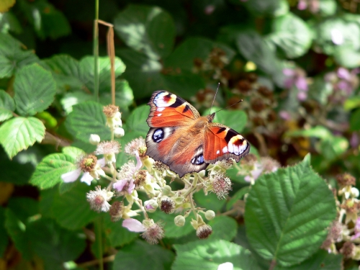
Faculty of Arts & Sciences
Department of Biology
Fall 2015-16

Biology 202: General Biology II
http://www.freedigitalphotos.net/details.php?gid=63&sgid=&pid=221

Course instructor:
Dr. Sawsan Kreydiyyeh
Biology bldg, Room 305
Email: sawkreyd@aub.edu.lb

Dates to Remember
Tuesday, Jan 26, 2016-Friday, Jan 29, 2016 Change of Schedule (Drop and Add)
Thursday, March 31, 2016 Last Day for WITHDRAWAL from Courses
Thursday, April 28, 2016 Last day of classes

Exams Schedule

First Exam: Mon Feb 29, 2016 at 6pm
Second Exam: Wed March 30 , 2016 at 6pm
Final Exam TBA

Course description:
The course gives an overview of plant's and animal's systems and emphasizes the correlation between structure function as well as the evolutionary relationships between different groups of organisms. Students will learn how multicellular organisms are organized, what the functions of the different tissues and systems are and how are their activities coordinated to maintain homeostasis. The lab component reinforces the biological concepts and principles and provides hands on experience in research and data interpretation.

Student learning outcomes  By the end of the course you should be able to | Assessment tool
Use biological terms in the proper context | Exams, lab reports
Explain mechanisms underlying plant and animal functions | Exams, discussion forums, class discussions
Analyze the functional relationship between different organs and systems in an organism | Exams, discussion forums, class discussions
Relate the complexity of form and function to the evolution of organisms | Exams, discussion forums, class discussions
Interpret experimental data | lab report, lab quizzes
Demonstrate skills in basic laboratory techniques | lab practicum
Demonstrate basic skills in using databases to retrieve biological information | Research assignment

Textbook: Biology by Raven and Johnson, 10th edition, McGraw Hill, 2014
Laboratory Manual: Biology Laboratory Manual, Vodopich & Moore, 9th Ed, 2011.

Course policies

Attendance and class etiquette
Satisfactory performance in this course requires regular attendance. Class attendance is highly recommended. Absence of a student does not exempt him/her from the responsibility of the work done or from any announcement made during the missed session. Students who miss classes or laboratory sessions excessively will be asked to drop from the course (AUB catalogue p 144).You are expected to be in class on time. Late comers will not be admitted.
Disruptive behavior in the class will not be tolerated. Excessive talking, use of cell phones are all examples of disruptive behavior.
Students who choose to disrupt the class will be asked to leave.

Participation in the class is expected of all students. Although this is a large class, you will be given many opportunities to contribute.
There is also an online component to your participation. Students who lack internet access from home can access the course from any of the computer labs available on campus.

Study Policies:
Students are encouraged to ask questions in lecture and lab sessions to clarify the information being presented. Because of class size, questions are best handled in Moodle forums where all the class may participate in answering your questions. The instructor will monitor the answers given and either approves them or correct them if they are wrong.
There are many new technical terms and concepts to be mastered during this course. Pay careful attention to word spellings and definitions. Scientific terms should be spelled properly in exams, lab assignments and lab reports.

The textbook is your source of detailed information and supplements the lecture material.

This course is a prerequisite to all other biology courses

Assessment and Grading
.

Percentage of final grade date
Lab 25

Lecture
Quiz I 20 Mon Feb 29, 2016 at 6pm
Quiz II 20 Wed March 30 , 2016 at 6pm
Final Exam 35

Outline

topic | chapter
Seedless Plants | 30
Seed Plants | 31
Plant form | 36
Transport in plants | 37
Sensory systems in plants | 40
Plant reproduction | 41
The animal body and principles of regulation | 42
Nervous system | 43
Sensory system | 44
Musculoskeletal system | 46
Digestive system | 47
Respiratory system | 48
Circulatory system | 49
Osmotic regulation and urinary system | 50

