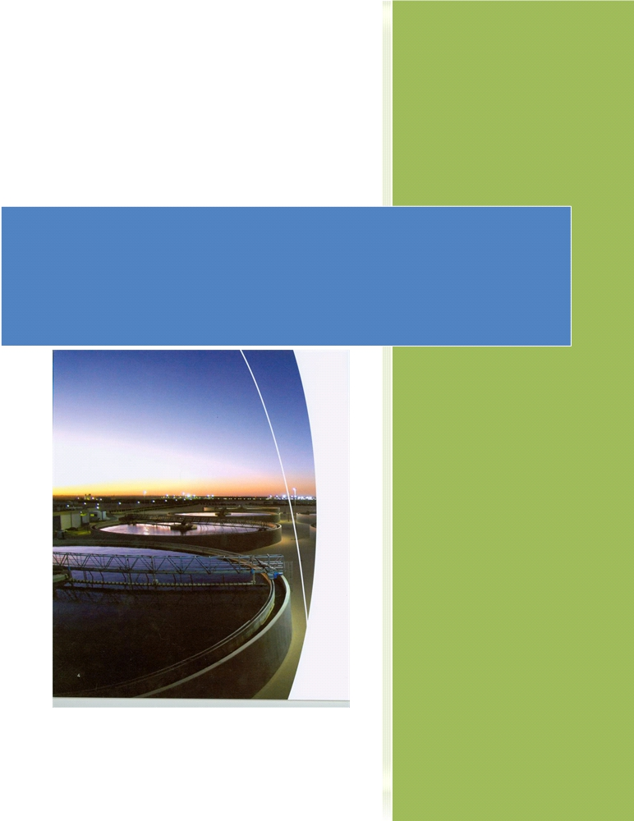

2012
Feasibility of Generating
Electricity from Methane-Based
Waste Water Plants

Table of Contents
Table of figures 4
Abstract 5
Introduction 6
Method Section 7
Overview of the process: How a waste water treatment plant works 8
Process of Waste water Treatment 8
1. First Phase: the Physical treatment 8
2. Second Phase: the Biological treatment 9
Description of the treatment stations 11
1. Machines and infrastructures 11
2. The working force 13
3. Geographical Location 13
Study on the possible implementation in Lebanon 14
Acting waste water treatment Plants (WWTP) in Lebanon 14
WWTP planned or under construction 14
Methane emission investigation 16
Methane emission from the process 16
Methane production 16
Methane Turbines and Efficiency 18
Methane Turbines 18
Advantages and disadvantages of the project 20
Benefits 20
1. Social benefits 20
2. Environmental benefits 22
Health and environmental hazards 23
Conclusion 25

2

References 26
Appendices 27
A. Interview with Dr. Rayan Slim 27
B. Figure 9 31
C. Figure 10 32
D. Figure 11 33

3

Table of figures

Figure 1: Overall process 10
Figure 2: Mechanical Equipments 12
Figure 3: Current Status of WWTP 14
Figure 4: Implementation state 15
Figure 5: Unemployment rate in Lebanon 21
Figure 7:methane emittion from Agriculture 22
Figure 6: methane emission from Energy 22
Figure 8: Toxicants Concentration 23
Figure 9: Land features needed for a WWTP site 31
Figure 10: Work Flow Chart 32
Figure 11: Percentage of buildings connected to a sewer network 33

4

Abstract

This Report studies the feasibility of producing electrical energy from methane gas
released from waste water treatment processes in Lebanon. It tackles the problem of the
treatment itself along with the efficiency of the transformation of the gas to electricity.
In addition, it compares generation from methane and generation from other steam
engines.
To do so, we used internet articles, AUB library resources, and interviewed Dr. Rayan
Slim.
It turns out that waste water treatment in Lebanon would be beneficial, but the lack of infrastructures and money inhibit it.

5

Introduction

In this report an examination of the feasibility of implementing methane engine to produce electricity, from waste treatment. Initially, an investigation on the WWT process is substantiated, followed by the status of the process in Lebanon. Afterwards, a brief chemical inquiry is necessary to scrutiny the efficiency of the procedure. Moreover, after studying methane turbines, a rigorous consideration of their efficiency is important, as to build on for the feasibility under question. In addition, knowing the advantages of such a step at different levels, economically, environmentally, and socially, triggers for a wider authentic research for its implementation.

6

Method Section

For our goals and ends in this report, we used different methods to scrutinize their feasibility and examine their possible implementation. The major steps and methods taken into consideration for the stated goals are:

1) Literature review on waste water treatment process in general.
2) Literature review on waste treatment plants in Lebanon.
3) Textual review on efficiency studies of methane and steam generations.
4) Textual evaluation of the advantages and disadvantages of the waste water
treatment and methane and steam engines.
5) Critical examination of an internship report done on WWTP in Sulaibiya.
6) Prolific interview with Dr. Rayan Slim, a Professor in Thermosciences and
Energy, at AUB.

7

Overview of the process: How a waste water treatment plant works

Process of Waste water Treatment

All water treatment plants have a similar general layout, yet they may differ in particular stations and moments. However, in this report, the description of the process shall be considered as an abstract for the process in general, as no particular plant's design is taken into consideration.

Accordingly, the process of Waste Water Treatment (WWT) is divided into two parts:
Physical Primary treatment (or first phase) and Biological Secondary treatment (or
second phase).
The first treatment is characterized by the removal of the solid hard materials. The secondary treatment is characterized by the removal of suspended toxics and microbacterial elements. (Sulaibiya Conventional Treatment Plant E-Book, 2004)

1. First Phase: the Physical treatment

After collecting the waste water from the different pumping stations, the removal of the suspended solids begins. The water is passed through large screens where the solids are caught and then transported to specific dumping areas. Afterwards, sand and grease are removed from the water by minute traps and classifiers [see Appendix A].
The sand is then disposed into containers for adequate removal and treatment. From this point, the secondary treatment handles the sewage to its first stage of Aeration.

8

2. Second Phase: the Biological treatment

Aeration tanks are the primary phase of the second treatment, which is defined by three processes: the Anaerobic, the Anoxic, and the Aerobic process [see Appendix B].
Anoxic is referred to the absence of oxygen. Anaerobic indicates the absence of a common electron acceptor. The combination of the aerobic and anoxic conditions results in nitrogen removal; whereas, the combination of the anaerobic and aerobic conditions results in phosphorous removal.

For catalyses, return activated sludge is required for this process.
Afterwards, sewage is then set into clarifiers in order to separate the sludge from water. This process rests upon gravitational forces that aim to settle the sludge onto the ground, while the water is pumped for further treatment.

The sludge is then pumped for thickening before the micro-bacterial digestion.
The latter is the final biological stage of the treatment, where the bacteria are allowed to
digest each other by the extensive diffusion of air bubbles. In some systems, Anaerobic
Digesters are used that allow the digestion of bacteria in the absence of air, producing
methane gas.

Finally, sludge is treated for further volume reduction and drying.
The figure below represents the overall process of the treatment stages in a particular plant, Sulaibiya Waste Water Treatment and Reclamation Plant in Kuwait. ( Technical and Training Internship Report, June 2011)

9

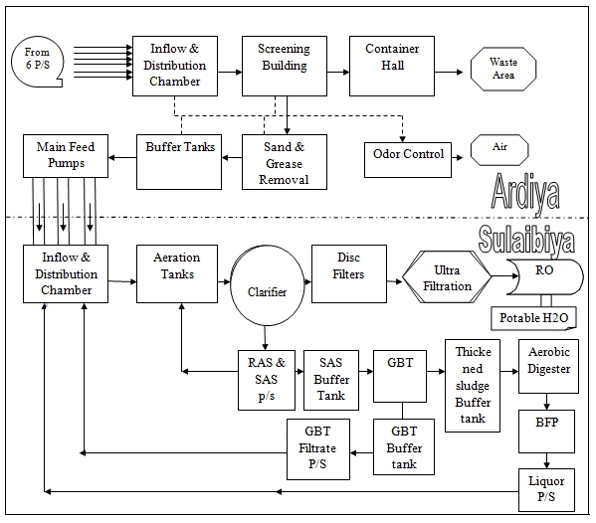

Figure 1: Overall process

10

Description of the treatment stations

1. Machines and infrastructures
The table below discusses the major mechanical equipments involved in the WWT process. It is true, as discussed above, that WWTP may differ in certain specifications and designs of the treatment and therefore a wide variance of mechanical equipments is involved, yet, a general scheme of equipments is necessary for every model and plays a crucial role in the process treatment.
To start with, screens are used to collect large suspended solids such as plastics,
cardboards, clothes, etc… Conveyors are used to convey and transmit wastes from a
stage to another of the treatment. Diffusers are intended perforated plates that emit air
with regulated pressure supplied by Blowers. Pumps are the most vital component, aims
to push waste water to the different stages of the process. Valves and Logs are important
to control the flow and to regulate the thresholds. In addition to multi crucial components,
starting from machinery requirements, rollers, fittings, blades, greasing, Bearings,
compressors, etc…

Treatment Stage Mechanical Parts

Screening Step Bar Screen
Screw conveyor
Compressor
Screen Discharge Converters Gates and Stop Logs
Sand and Grease Launder
Grease transfer Pump
Penstock Gates and Stop Logs
Aeration Tanks Mixers

11

Diffusers
Propeller Pumps
Flow Boosters
Gates, Valves, Stop Logs
Secondary Classifiers Scraper Bridge
Floating Screw Conveyor Scum pump submersible Gates and Valves
Thickening Treatment Bubble Diffusers
Pumps
Valves
Aerobic Digesters Bubble Diffuser Grid
Valves and Gates
Blowers
Sludge thickening system Progressive cavity pumps
Belt Press Machines

Figure 2: Mechanical Equipments

12

2. The working force
By understanding the nature of the system, process, and management required for
WWTP, it is then only feasible to underline working force culture. Starting with the
managerial administrative responsible, operators, maintenance team, moving to store
keepers, monitors, safety engineers, and guardians, are all essential to the activation of
the process. Mainly, the collaboration for the achieving the goals is held between the
operators, chemical engineers, mechanical and instrumentation engineers, and
maintenance team. An example of the flow work is given in the appendix. (Code of
practice for Small Sewage Treatment Plants, 40 City Road Southbank Victoria 3006,
2011)

3. Geographical Location
The choice of location of the plant is critical not only to the process itself, but also to the
engaging environment. The location of the waste treatment plant should be far from
residence, public places and any allotments which will possibly be built on during the life
time of the plant: the plant releases toxic gases that may get out of hand. It also smells
bad.
In addition, there should be sufficient land set aside the plant, as to account for a future expansion of the plant.
Moreover, every plant should be positioned in a way that protects it from any threat of flooding, earthquakes, tornadoes, and all harsh weather conditions. Furthermore, standards are substantiated to acquire the process's installment. Land capability is checked using a certain criteria (see Figure 9).
In addition, no waste water treatment is located within 15 m of a source of a water supply, or at such greater distance.

The size of a plant ranges between 500 and 1000 square meters.

13

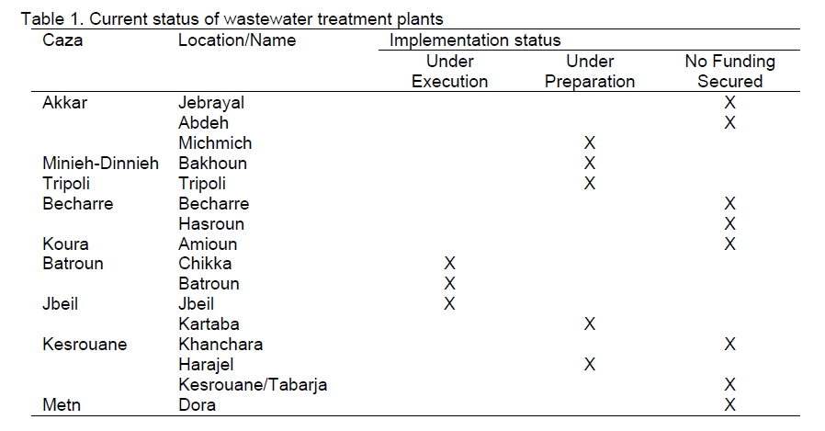

Study on the possible implementation in Lebanon

Acting waste water treatment Plants (WWTP) in Lebanon

There are, according to the “Daily Star” (2010), eight government-backed waste water
treatment plants in Lebanon. Sadly, only three are operational: Ghadir, Sidon, and
Baalbeck.

WWTP planned or under construction

According to “Geara Presentation 2010”, there are twelve waste water plants in Lebanon under execution, seventeen under preparation, and three with no funding secured.

Figure 3: Current Status of WWTP

14

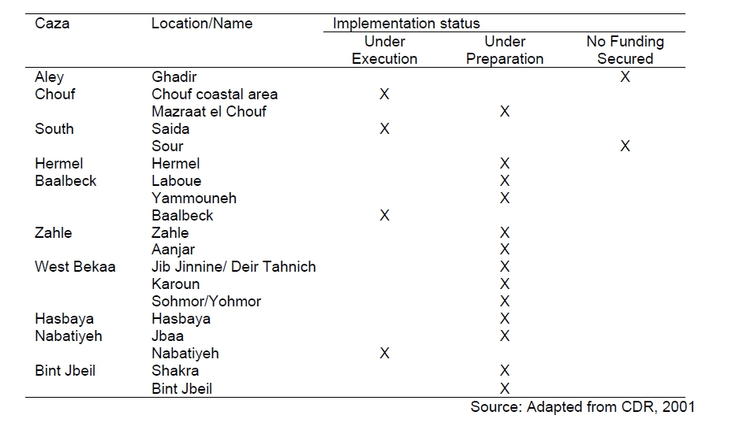

Figure 4: Implementation state

15

Methane emission investigation

Methane emission from the process

Methane production
Methane is produced abundantly in the process of waste water treatment. In particular,
during the process of the anaerobic digester, bacteria digest residual solids and create
methane gas as a byproduct. (Biomass and Alternative Methane Fuels, U.S. Department
of Energy)
This gas can be converted to significant amount of energy with low processing and can
be used as a substitute for natural gas. The gas produced by the anaerobic digester is
often more than 60 percent methane and can reach up to 95 percent in certain designed
digesters. Filtration occurs before the use of the gas, to remove contaminants, such as
Hydrogen Sulfide, Carbon Dioxide, and other processes, such as Dehydration. However,
the most important procedure to convert waste water treatment gas to electricity is using
internal-combustion engines; the latter functions by running a generator. However, a brief
illustration of the chemical process emitting methane fits the report's objectives. There
are four main biological and chemical stages of the anaerobic digester:
1) Hydrolysis: Breakdown of large organic polymers into smaller molecules and
solutions, such as sugar, fatty acids, and amino acids.
2) Acidogenesis: Further chemical breakdown of the molecules to attain simple
molecules.
3) Acitogenesis: The simple molecules produced are more simplified to carbon
dioxide, hydrogen, and acetic acid.
4) Methanogenesis: The production of methane occurs in this stage, by converting
the above products to methane, carbon dioxide, and water.

The equation governing the last stage is given as:

16

C₆H₁₂O₆ 3CO₂ + 3CH₄
As shown by the equation, methane is abundantly produced. Each molecule of sugar
is decomposed to three molecules of methane. Consequently, methane production is
efficient.

17

Methane Turbines and Efficiency

Methane Turbines
Methane Turbines are generators transforming methane into electrical energy. There are
different types of methane turbines, reciprocating engine generators, combustion turbines,
and Microbial Fuel Cells. (B. Logan and H. Liu, Production of Electricity during
Wastewater Treatment Using a Single Chamber Microbial Fuel Cell)
To start with, reciprocating engines are more efficient than combustion turbines; whereby
new low-Btu engine designs are able to operate at full rated horsepower with a dilute
mixture of only 40 percent methane and above. In addition, reciprocating engine
generator technology is significantly less expensive than combustion turbine technology. Furthermore, reciprocating engines require less complicated pressure systems relatively in comparison to other engines and systems; such as Stirling cycle engines, fuel cells and organic Rankin cycle. The latter are more costly than the former.
In a given system, if the concentration of methane is 45 percent or above, then the reciprocating engine is expected to work on full power output. Taking into consideration that methane emission is 60 percent of the total emitted gases from the digester; this would constitute an efficient factor for the turbine's activity.
The expected volume of gas required by a typical low-Btu engine generator is given by the following formula:

Indeed this formula is not precise, yet it allows a quick assessment of the gas volume needed for any given engine size. (K. Packham, The Case for Waste to Energy, Power Topic #6015)
However, the turbine works by burning methane inside a chamber, and the resulting
pressure yields a contraction in a piston (if the system is reciprocating) and that to its
18

rapid linear motion. The piston is connected to a crankshaft that transforms linear motion
into rotating motion. Afterwards, the circular motion is subjected to a coil of wires,
creating a magnetic field and allowing the passage of electrons in the wires, creating
electricity.
The efficiency of such turbines are 40 percent, we can find no higher percentage up till recent technologies.
However, knowing the energy produced by a methane molecule allow us to sense its efficiency. The equation of the combustion is given:

CH₄[g] + 2 O₂[g] -> CO₂[g] + 2 H₂O[l] + 891 kJ
Therefore, one methane molecule is sufficient to produce 891 KJ, which is relatively a good and efficient reaction.

19

Advantages and disadvantages of the project

Benefits

1. Social benefits

a. Energy
As it is known, Lebanon is suffering from an electrical crisis overall its territory. The
implementation of methane turbines and wiring electricity generated from them with
local electrical network may reinforce the system and revitalize the drastic situation. In
addition, Gas turbines produce a lot of power compared to their weight, which means that
the effort spent on building the machine are well accounted for in the power production.
Moreover, by applying waste water digester gas for energy, energy cost is saved from the
utilization of waste gas. Moreover, prices will be stable and protected from the volatility
of gas and fuel prices. In contrast to steam turbines and fuel, methane turbines do not
require a sparkle for ignition, and thus emissions are reduced from flaring.

b. Work opportunities
If it were feasible for execution, the process will evidently help in alleviating the pains of unemployment in Lebanon. As seen above, from the nature of the process, variety of labors are required for the continuity of the process. The plant will be providing jobs for mechanical, electrical, chemical, and instrumentation engineers, mechanical, electrical technicians, store keepers, guards, managerial and administrative positions starting from managers, consultants, risk managers and analysts, secretarial ranks, etc…

20

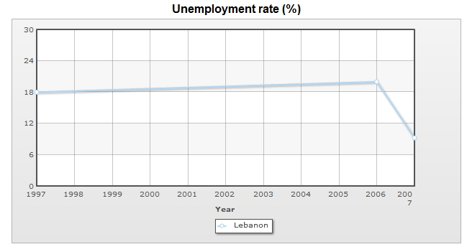

The graph below shows the rate of unemployment in Lebanon and evolution over the years. The appalling increase in the rate requires organizations that maintain low riskcosts and high profits, such as this project under research.
(http://www.indexmundi.com/g/g.aspx?c=le&v=74)

Figure 5: Unemployment rate in Lebanon

21

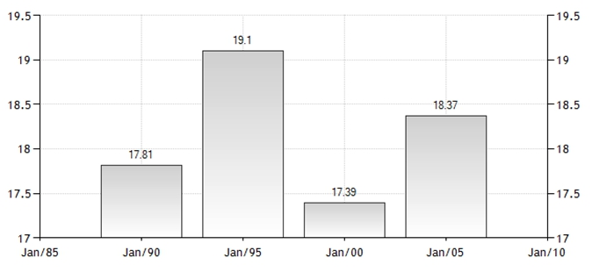
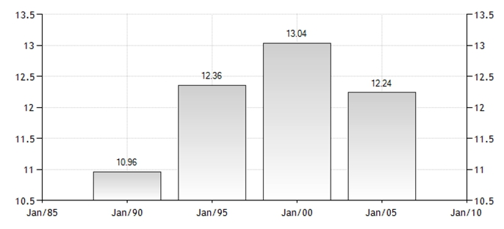

2. Environmental benefits
As it is widely known, methane is a major gas threatening life via global warming. Methane emission in Lebanon is particularly increasing over years, due to the expansion of burning fossil fuel, and agricultural ongoing-depositions. By executing methane turbines, these systems eliminate emissions of greenhouse gases that are at least 20 times more powerful than carbon dioxide in promoting global warming. (K. Packham, The Case for Waste to Energy, Power Topic #6015)

The graphs show, in Percentage (%), the amount of methane production both from

agriculture and energy production in Lebanon, over the past 20 years.

Figure 7:methane emittion from Agriculture

Figure 6: methane emission from Energy

22

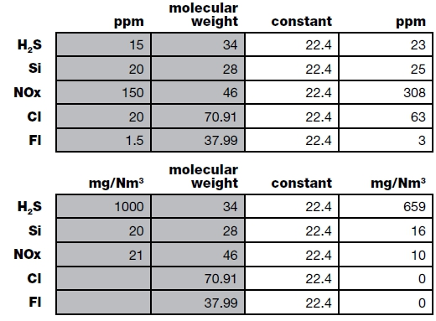

As the graphs shows the percentage of methane emissions from energy and agriculture with respect to the total production of methane. These percentages may grow higher upon the upcoming expansion and implementations of WWTP illustrated above. For this reason, the possibility of using methane turbines for electricity production, seems to be plausible and worth more investigation by authorities. This would prevent, pre-maturely, global warming and solve the drastic electric status in Lebanon.

Health and environmental hazards
However, WWTP is characterized by some toxic gases that are lethal if exceeded a
threshold. Studies have shown that waste treatment process may generate aerosols
containing micro-bacterial and chemical constituents. These may be lethal as to cause
cancer, and some may cause conditions of nausea, vomiting, indigestion, diarrhea, and
flu-like complaints. Workers may be exposed to direct contact through inhalation or skin.
Sludge analyses report included the existence of chlorine, polycyclic aromatics,
petroleum hydrocarbons, flame retardants, heavy metals, asbestos, and radioactive
materials. In addition, Hydrogen Sulfide is an abundant gas, produced by WWTPs, that
may cause severe toxicities and suffocating upon high exposure. Therefore, workers in
WWTP may be at an increased risk of infections. A table of some of the pollutants
developed by WWTP is given below. (N. Brown, Health Hazard Manual: Waste Water
Treatment Plant and Sewer Workers, Cornell University, 1997)

Consequently, workers are
obliged to follow a safety
formula that best reduces the
risk of infection; such as: safety
shoes, goggles, uniforms,
masks, and gloves. In addition,
there are certain considerations
in dealing with confined spaces

23

Figure 8: Toxicants Concentration

and hazardous zones that require the certain intricate procedures before habilitation; for instance, measuring the amount of gases existing in these zones, types, concentrations, and possible chemical reactions. In addition, certain systems are imposed on the design to lessen the malicious effects of the process. (N. Brown, Health Hazard Manual: Waste Water Treatment Plant and Sewer Workers, Cornell University, 1997)

Some of these are:

1) Enforce pre-treatment regulations to reduce air-chemicals at the surface.
2) Plant trees around the area to capture particles.
3) Reduce the amount of air-stripping and aerosol formation by using finer bubbles
for aeration.
4) Reduce air-stripping and aerosols by using diffused aeration rather than
mechanical aeration.
5) Avoid handling screens by hand, etc…

24

Conclusion

In conclusion, after examining the process of the Waste Water Treatment (WWT), and
after detecting the stages of methane emissions from the process, the feasibility takes its
shape and then lays its foundations on the efficiency of methane turbines. Consequently,
after acknowledging the methane engines briefly, and examining its efficiency, the report
draws its closure by its importance and vital characterizations. Moreover, after studying
the status of waste treatment in Lebanon, and realizing the upcoming projects, it is vital
for the local authorities to take into consideration the accomplishment of such systems
within their agenda. Add to that, by doing so, several problems will be solved;
environmental, social, and economical.

25

References
1) Operation manual for Sulaibiya waste treatment plant, Kharafi National, Kuwait.

2) , internship report, "technical and training report", June 2011

3) Code of practice for Small Sewage Treatment Plants, 40 City Road Southbank
Victoria 3006,

4) Biomass and Alternative Methane Fuels, U.S. Department of Energy
5) N. Brown, Health Hazard Manual: Waste Water Treatment Plant and Sewer
Workers, Cornell University, 1997

6) K. Packham, The Case for Waste to Energy, Power Topic #6015

7) B. Logan and H. Liu, Production of Electricity during Wastewater Treatment
Using a Single Chamber Microbial Fuel Cell

26

Appendices

A. Interview with Dr. Rayan Slim

Question: Could you give me your full name?
Answer : I'm Dr Rayan Slim. I'm basically a
Mechanical engineer with a PHD in thermosciences and energy. My thesis was about
drying the sewage sludge that comes from waste water plants.
Q: The feasibility of using methane from waste water to produce energy. In how
many ways can we do that? We can either use the methane as fuel , or in a gas
turbine. Which one would be better.

A: In both of them you have a combustion for methane. In a gas turbine you're
saying that the gas is the one that is compressed in a compressor and then sent to a
turbine.

The plant is made of a compressor, your gas is being compressed to a high temperature, then you have here your gas with some air, here you have heat addition, then you have in the turbine it's going to expand, producing the amount of work, then it's released to the atmosphere to make an open cycle or if you want to close the cycle you can use a heat exchanger to reject your energy.
This is called a gas turbine cycle and it's called a gas turbine because the fluid isn't a fluid
that's going to undergo a phase change like water. You don't have evaporation then
condensation, it's always gas, it's like air entering in all the components with ideal gas
behavior. This is the difference between a power plant operating under a vapor power
cycle (evaporation, expansion, condensation, compression and the gas turbine.

Until now, I haven't seen one that uses the expansion for methane, so they're most
probably using the methane in a gas turbine is as fuel to ignite the combustion in the boiler, and it's not in the initial
Initially you have air, compressed with high pressure high temperature, then mixed with methane and spark ignition you obtain a combustion, and the heat of your combustion is used again , or the expansion gases are expanded in your turbine, but it's not pure
methane, it's used a fuel to your combustion.

27

Q: What are the downsides of a waste water plant? I've heard you shouldn't work in
them because of...

A: Ammonium, or H2S. You can't even get near it.
In my project, I had direct contact with sludge. You're not allowed to be exposed to a given amount per minute. You have to be equipped to get near the sludge.
During the methanisation, you can't get in contact with the sludge without proper
equipment. If you're well equipped, you're not exposed, so it's ok.
It's a dangerous environment and, if you're not equipped, you can be easily hurt by the H2S. The minute you feel that you've inhaled, you're dead.

Q: Through the methanisation, we're producing a lethal gas. Where should the waste
water plants be built then?
A: You can implement wherever you want as long as you're abiding by some
regulations. If there are no leaks, there are no problems. In France, they have them in each region.

You should increase the number of WWTP to treat all the waste water. The problem in
Lebanon isn't the plants or smell. There is no infrastructure to have this waste water.It
operates well in other countries because they have a circuit of waste water infrastructure.
Usually all the waste water comes from the buildings and goes to an place where it
accumulates or directly to a waste water plant. In Lebanon, you don't have this.
We're not ready to collect our waste water.

Q: Assuming you have the infrastructure?
A: They're working on having an infrastructure. Then you can have a waste water
treatment plant. We should have 10-20 in lebanon. Now we have two that are being
maintained and updated but aren't operating, one that is.
The thing is, you need to have money to operate them. This is it.

Q: How big is a plant?
A: The one thing that is a drawback from having a waste water treatment plant.
A power plant normally is a chain : you get the waste water, then you have a first
screening period where you get all the suspended solids out, then a second one where
smaller solids are being suspended, then you have some aerobic digestion where you give
some O2 to get out some bacteria, then you have the mechanical drying, where here you
are compressing the sludge to take out all the free water from it. It's called mechanical
dewatering.

28

From here you have a choice : either you dry the sludge, and you can use it as fuel or for agriculture, mix it with cement...

All this chain takes between 500m^2 and 1000m^2.
It will also depend on the amount of sludge that is being treated. Q: Should we have multiple plants, or just one big one?
A:We should have in at least each region one, to avoid transportation costs.

Q: Let's say we have the plants, and we're producing energy. Should this energy be
transferred to electrical plants and then redistributed, or directly distribute it from there?
A: Since we have a problem of electricity in Lebanon, it would be better to send it to
EDL but the problem is that to be able to sell the electricity. An investor would be
interested in selling the electricity to EDL or the government, not giving it for free.

If he wants to invest, he'll need financial incentives. It's a bit complicated when it comes to the government : incentives , plus reduction on taxes...

Any renewable energy project isn't well promoted in Lebanon if it isn't accompanied by financial incentives. So if there are financial incentives, then yeah sure, why not sell to the government and enhance the provision of electricity of your country, but if not you can work in closed systems and have each region produce it's own electricity.

Q: A region could potentially power itself through using it's waste water.?
A: It depends on the amount or the efficiency of the production of methane. Maybe
coupled with another form of renewable energy it will, for example covering the waste
water plant with photovoltaic solar cells. But all of that is incremental costs.
Q: In which phase does the methanisation happen?
A: The last one.
The aerobic stage is made to take out some of the bacteria in the sludge if you want to use it in agriculture, compost or whatever.
The methanisation is anaerobic. I'm not sure if you skip the aerobic digestion part.

Usually you have the aerobic digestion stage, where you give O2 or air in order to free some bacteria that are harmful in the sludge. If your objective is to produce methane, which is an anaerobic process, I'm not sure if you have the aerobic phase.

29

Q: What types of workers would a waste water plant need?
A: For the construction of the plant, you'll need all kind of engineers : mechanical
engineers, computer engineers.
Once the plant is operational, you need either a chemical or a mechanical engineer, a crew of technicians for maintenance, and a technician to take care of the automation of the plant, and a mechanical engineer always on board.
I'm assuming the quality of the sludge is being tested in a separate laboratory, if it's tested. If you want a WWTP with a laboratory for a continuous checking of the sludge, then in this lab you have a chemical engineer, two or three interns that are working on a project or two technicians that follow up the sampling system. It becomes more complicated.
To run a WWTP isn't a big issue. It can work on its own.

30

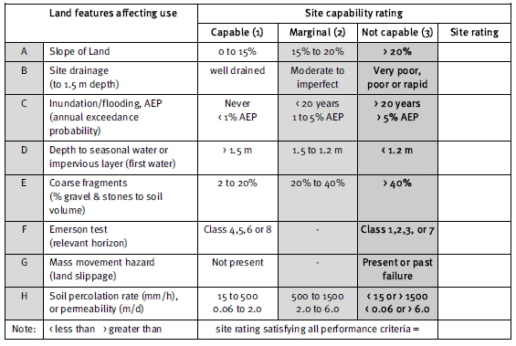

B. Figure 9

TaFigure 9: Land features needed for a WWTP site

31

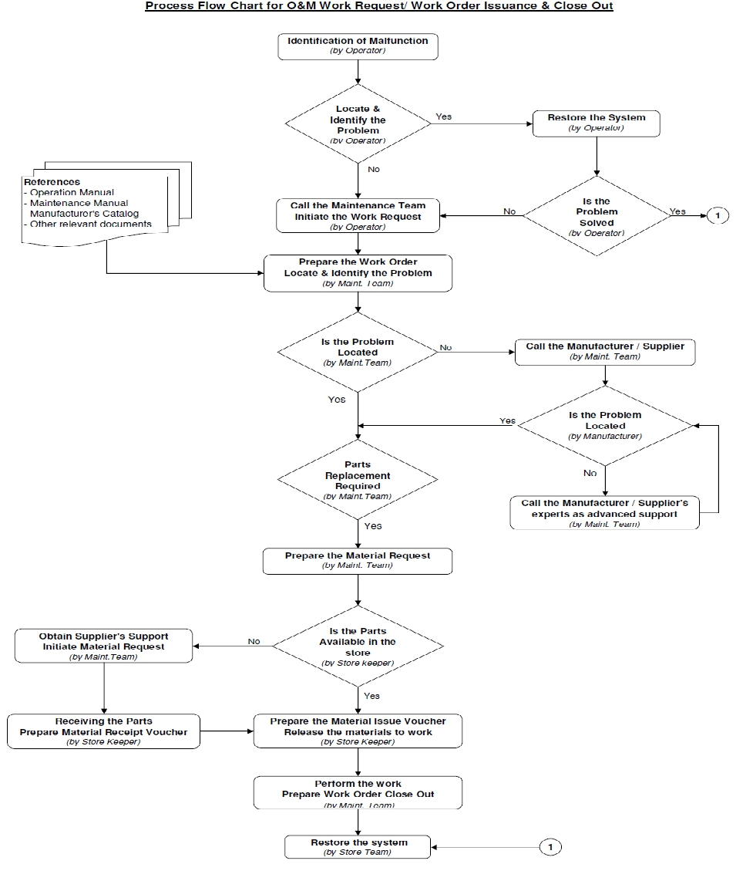

C. Figure 10

32
Figure 10: Work Flow Chart

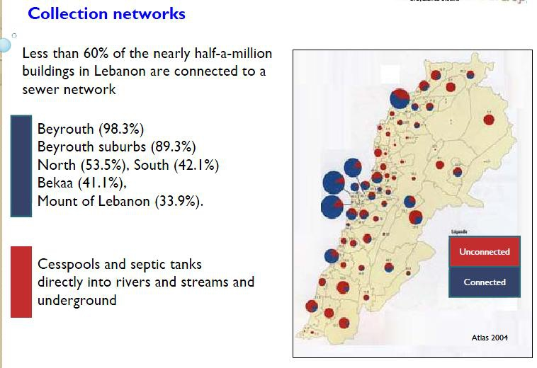

D. Figure 11

Figure 11: Percentage of buildings connected to a sewer network

33

