American University of Beirut

Faculty of Engineering and Architecture

Department of Electrical and Computer Engineering

Electric Machines Lab_EECE 470L
Experiment 9
Three Phase Induction Motor

Objectives:
The objectives of this experiment are to obtain load characteristics of a squirred-cage induction motor by a direct load test, to determine the starting current and the starting torque, and to derive the equivalent circuit parameters from no-load and blocked-rotor tests.

Procedure and Circuit Diagram:
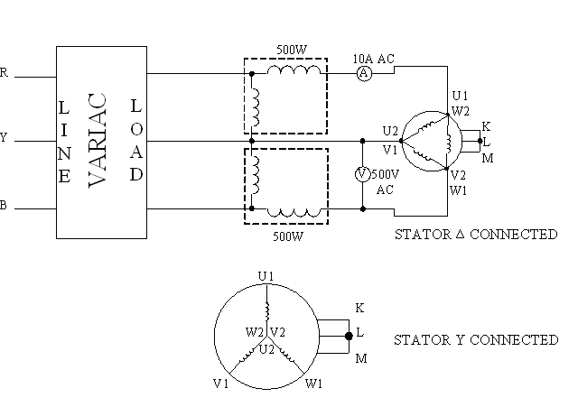
Figure 1: Induction motor
Concerning the procedure, we had two test to perform which are the no load test at Y-connection and the locked rotor test at Y and delta connections. The detailed procedure is shown below:
- The starter winding is connected in ‘delta’. Using a 3-phase VARIAC, apply a reduced voltage at the instant of switching on, and then increase the supply voltage as the motor speeds up. Perform a load test with loads up to 15% over the rated value. Measure the voltage, current, torque, speed and power using the relevant meters. Power is measured using the 2 W-meters method.
- Perform the blocked-rotor test by increasing the supply voltage so that the current increases in steps of 1A up to the rated value. For each step take readings of the meters.
- Connect the stator winding into ‘Y’ and repeat the procedure of II.
- Measure the DC resistance of the stator winding.

Apparatus:
1. 3 Phase induction motor
2. DC shunt generator for loading purposes
3. Voltmeter
4. 2 Ammeters
5. 2 Watt-meters
6. Connection wires
7. Three phase power supply
8. Resistive load
9. Variable resistor

Measured Data Tabulation:
For the no-load test we have the following data:
No-load Voltage (V) | 190
Terminal Voltage (V) | 220
No-load Current (A) | 4.3
Power (W) | 800
Speed (RPM) | 1520
Torque (N.m) | 0.5

For the loading of the Motor we have the following measurements:
Load-Current (A) | 0.81 | 2 | 3 | 4 | 5
Field Current (A) | 0.408 | 0.403 | 0.527 | 0.576 | 0.569
Terminal Voltage (V) | 220 | 220 | 220 | 220 | 220
Speed (RPM) | 1514 | 1496 | 1484 | 1471 | 1458
Torque (N.m) | 2.04 | 4.15 | 5.9 | 7.38 | 9.02
Armature Current (A) | 4.5 | 4.78 | 5.3 | 5.9 | 6.6
Input Power (W) | 820 | 810 | 1060 | 1350 | 1570

For the Blocked-rotor test in Y-connection:
Current (A) | Voltage (V) | Power (W)
1 | 5 | 5.5
2 | 10.4 | 21
3 | 15.8 | 48
4 | 20.7 | 80
5 | 26.3 | 118
6 | 31.3 | 169
7.8 | 40 | 268

For the Blocked-rotor in Delta-Connection:
Current (A) | Voltage (V) | Power (W)
1 | 16.4 | 1.4
2 | 30.2 | 54
3 | 46.8 | 123
4 | 62 | 218
4.5 | 69.3 | 271

Report
- Explain the starting behaviour of the motor.
To start the 3-phase induction motor a VARIAC is used. The usage of the VARIAC at this stage has a very good purpose. The motor could not be turned on directly at rated voltage because in some cases a short circuit may occur and the current will be very high. The voltage should be zero initially and then increased while monitoring the current until arriving to the rated voltage. We can notice that the speed of the motor is low and then increases when increasing gradually the voltage.
- Calculate and tabulate power factor, output power (in hp), and efficiency from the data. Plot graphs of torque, speed, current, power factor and efficiency as a function of the output power using available spreadsheets or MATLAB. Comment on the results.
Load-Current (A) | 0.81 | 2 | 3 | 4 | 5
Terminal Voltage (V) | 220 | 220 | 220 | 220 | 220
Speed (RPM) | 1514 | 1496 | 1484 | 1471 | 1458
Torque (N.m) | 2.04 | 4.15 | 5.9 | 7.38 | 9.02
Input Power (W) | 820 | 810 | 1060 | 1350 | 1570
Output Power (A) | 3.23.3 | 649.8 | 916.4 | 1136.3 | 1376.5
Power Factor | 27 | 1.1 | 0.9 | 0.9 | 0.8
Efficiency (%) | 39.4 | 80.2 | 86.5 | 84.2 | 87.7
The formulas used to calculate the PF and the output Power are respectively:
$$PF=\frac{P_{in}}{\sqrt{3}V_{T}I_{L}}, P_{OUT}=w x torque=RPMx \left(\frac{2pi}{60}\right)x torque$$
The graphs needed are below:
- Torque versus Output Power

As expected the characteristic is a straight line since when increasing the output power the torque will increase as shown in the relation above.

- Speed Versus Output Power

As expected also, when the load on the motor increase the speed will decrease.

- Current Versus Output Power

When increasing the load current the output power will increase as shown since the output power is the product of the terminal voltage (constant) and the load current.

- Power Factor Versus Output Power

Since the output power increase with the load current and the PF decreases when the load current increase then the PF will decrease when the output power decrease.

- Efficiency Versus Output Power

The characteristic is a variable characteristic as shown but in general the efficiency increase when the output power increase.

- From the no-load and blocked-rotor tests and stator resistance measurement, determine the parameters of the equivalent circuit. To account for skin effect, take the effective stator resistance as 15% above the DC value.
The parameters of the equivalent induction motor circuit can be calculated using the no-load test and the blocked rotor test.
The no load data:
No-load Voltage (V) | 190
Terminal Voltage (V) | 220
No-load Current (A) | 4.3
Power (W) | 800
Speed (RPM) | 1520
Torque (N.m) | 0.5

We have:
$$Z_{eff}=\frac{V}{I}=X_{1}+X_{m}=\left(\frac{\frac{190}{\sqrt{3}}}{4.3}\right)=25.51$$
The Stator resistance is as measured in the lab 1.2 Ohms and accounting for the skin effect we have an additional 15% so $R_{s}=1.38 Ohms.$
The data for the blocked-rotor (Y and delta connections) is:
Current (A) | Voltage (V) | Power (W)
1 | 5 | 5.5
2 | 10.4 | 21
3 | 15.8 | 48
4 | 20.7 | 80
5 | 26.3 | 118
6 | 31.3 | 169
7.8 | 40 | 268

Current (A) | Voltage (V) | Power (W)
1 | 16.4 | 1.4
2 | 30.2 | 54
3 | 46.8 | 123
4 | 62 | 218
4.5 | 69.3 | 271

For I =4 A we have V=20.7V and P=80W so the PF= 0.558
$$\left|Z\right|=\frac{\frac{20.7}{\sqrt{3}}}{4}=3=>Re\left(Z\right)= R_{S}+R_{2}=3x0.558=1.674$$
$$R_{2}=1.674-1.38=0.294 ohms$$
$$Im\left(Z\right)=3x\sqrt{1-{0.558}^{2}}=2.489= X_{1}+X_{2}.$$
In Class A of induction motors we have:
$$X_{1}=X_{2}=\frac{2.489}{2}=1.245 and hence X_{m}=25.51-1.244=24.26$$
$$\frac{1}{R_{C}}=\frac{P_{no-load}-P_{losses}}{V_{T}^{2}}=\frac{20}{{220}^{2}}=>R_{C}=\frac{{220}^{2}}{20}=2420 ohms.$$
The Equivalent circuit is:
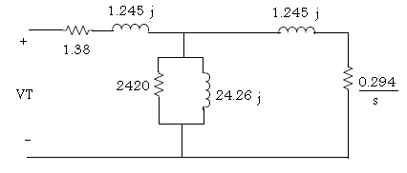
- From the load test, obtain the slip corresponding to rated current, and use it in the equivalent circuit derived above to computer torque, hp output, efficiency, and power factor at rated current. Compare with corresponding values obtained from the load test. Comment on the results.
To obtain the slip we apply the following formula:
$$slip=\frac{n_{sync}-n_{m}}{n_{sync}}=\frac{1800-1514}{1800}=0.19$$
The terminal voltage is 110 V and the load current is 7.8 A so the power factor is 0.995
The equivalent resistance of the circuit is $1.38+j1.245+[2420\left|\left|j24.26\right|\right|\left(\frac{0.294}{0.19}\right)+j1.245)]=2.77+2.5j$

QUESTIONS:
- A squirrel-cage motor consists essentially of two units, namely
- Rotor
- Stator
In a squirrel-cage motor, the secondary winding takes the place of the field winding in a synchronous motor. As in a synchronous motor, the currents in the stator set up a rotating magnetic field. This field is produced by the increasing and decreasing currents in the windings. When the current increases in the first phase, only the first winding produces a magnetic field. As the current decreases in this winding and increases in the second, the magnetic field shifts slightly, until it is all produced by the second winding.
When the third winding has maximum current flowing in it, the field is shifted a little more. The windings are so distributed that this shifting is uniform and continuous. It is this action that produces a rotating magnetic field. As this field rotates, it cuts the squirrel-cage conductors, and voltages are set up in these just as though the conductors were cutting the field in a DC generator. These voltages cause currents to flow in the squirrel-cage circuit – through the bars under the adjacent south poles into the other end ring, and back to the original bars under the north poles to complete the circuit.
The current flowing in the squirrel-cage, down one group of bars and back in the adjacent group, makes a loop that establishes magnetic fields in the rotor core with north and south poles. This loop consists of one turn, but there are several conductors in parallel and the currents may be large. The poles in the rotor are attracted by the poles of the rotating field set up by the currents in the armature winding and follow them around in a manner similar to the way in which the field poles follow the armature poles in a synchronous motor.
Reference: http://www.electrical-design-tutor.com/squirrelcagemotors.html

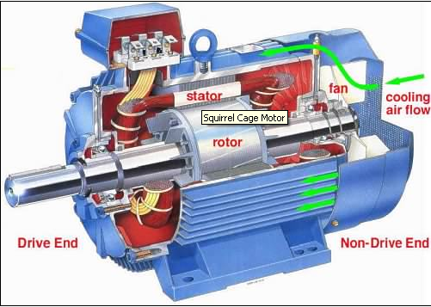

- Different methods exist for the starting process of an induction motor we can mention for example:
1- Starter resistance
2- Variable speed drive
3- Step-down transformer
4- AC power controller
5- Cyclo converter
6- Inverter

The inverter type has solid-state drives so we will discuss it with a diagram:
The inverter-three-phase squirrel-cage induction motor drive system provides mechanical characteristics with constant maximum torque or increased maximum torque and reduced slip speed at frequencies below the nominal frequency. The control algorithm is based on the constant volts per hertz principle using two improvement techniques: keeping maximum torque constant or keeping magnetic flux constant. The basic control action involved in adjustable speed control of induction motors is to apply a variable frequency variable magnitude AC voltage to the motor to achieve the aims of variable speed operation. The most common AC drives today are based on sinusoidal pulse-width modulation SPWM. Both voltage source inverters and current source inverters are used in adjustable speed AC drives. However, voltage source inverters with constant Volts/Hertz (V/f) are more popular, especially for applications without position control requirements, or where the need for high accuracy of speed control is not crucial.

Reference: Improving mechanical characteristics of inverter-induction motor drive system

American Journal of Applied Sciences, August, 2006 by Hussein Sarhan, Rateb Issa

III- When increasing the load the power factor increases which makes the effect of the resistive elements more important and the effect of the reactive elements decreases. So as the load increases the power factor should approach 1.
IV- If the speed of the rotor is equal to the speed of the stator, then there will be no induced voltage and no current. This leads to zero magneto motive force in the rotor and therefore it will stop rotating. Then the rotor goes back to the original place and follows the field of the stator again. The speed of the rotor is prevented from arriving to the speed of the stator through friction that will not allow such thing to happen.
V- In order to decrease the losses and the flux leakage the air gap is decreased.
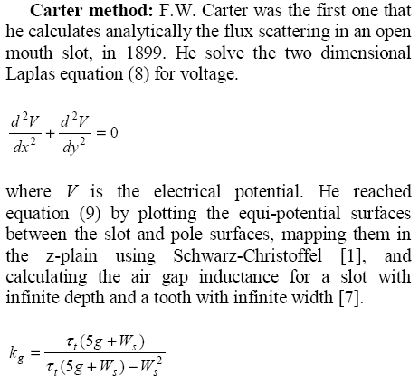
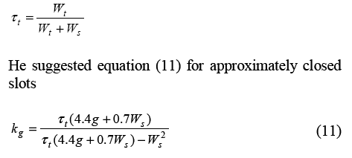

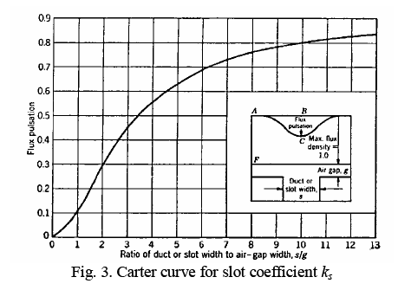
Reference: SLOT FRINGING EFFECT ON THE MAGNETIC CHARACTERISTICS OF THE ELECTRICAL MACHINES, by K. Shaarbafi , J. Faiz , MBB Sharifian and MR Feizi from the Department of Electrical Engineering, Faculty of Engineering, University of Tabriz, Tabriz, Iran.
In simple words, the Carter coefficient is used for the compensation of the slots effect. It depends on the slot dimension and the air gap length.

