American University of Beirut

Faculty of Engineering and Architecture

Department of Electrical and Computer Engineering

Electric Machines Lab EECE 470L
Experiment 8
Synchronous Motor “V” Curves

Objectives:
The objectives of this experiment are to synchronize the three phase AC generator /synchronous motor set to the laboratory 3-phase supply and to obtain the ‘V’ curves of the machine when operating as a synchronous motor, and to determine the open-circuit and short-circuit characteristic of an alternator and to determine the regulation.

Procedure and Circuit Diagram:
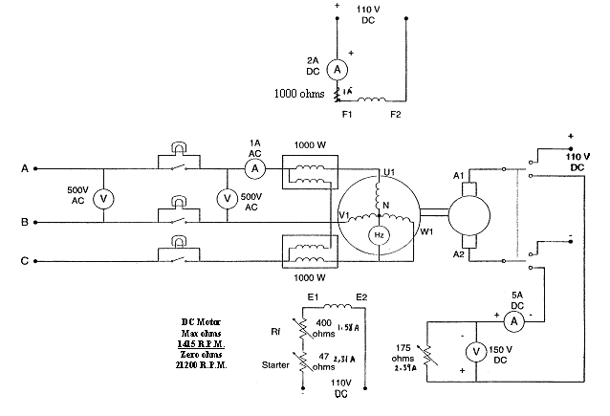
Figure 1: Synchronization Process
- The synchronous motor is mechanically coupled to a DC machine which is used as a DC motor to drive the set up to synchronous speed and also as a generator to mechanically load the synchronous motor. Use the DC motor to drive the synchronous machine as a generator at rated speed. Adjust the excitation to obtain rated voltage and check frequency, voltage, and phase sequence before synchronizing on to the mains with the aid of the synchroscope and the 3-lamps board.

- After synchronization, disconnect the DC machine from its supply and connect it to a resistive load by the change-over switch. The AC machine is now running as a synchronous motor under no-load condition. To obtain the ‘V’ curve for this condition vary the field current of the AC machine and record the variation of the armature current. Also record the power. Avoid any instability and excessive armature currents with low excitations, making note, if possible, of the point where instability starts.

- Repeat part II with the DC machine being loaded with a load current of 0.6A and 1A.

- With the alternator driven at rated speed, measure the open-circuit generated emf as the field current is varied up to a maximum value of 0.7A. Use the stroboscope to measure the speed.

- With the armature winding being short-circuited, drive the alternator at rated speed. Carefully increase excitation, starting from zero up to 20% over rated armature current. Make sure that the short-circuit is 3-phase symmetrical. Keep a check on constant speed, and watch the armature current.

- Measure the DC resistance of the armature winding per phase. Check that it is the same for all 3 phases.

Apparatus:
1. Three light bulbs
2. Change over switch
3. Two wattmeters
4. 110 V DC supply
5. Three phase power supply 380V
6. Frequency meter
7. Three Ammeters
8. DC Generator and a synchronous motor

Measured Data Tabulation:
I- Plot the ‘V’ curves that correspond to the 3 loading conditions of the DC motor using MATLAB. Why does the field current that correspond to unity power factor increase with the load? Calculate the power factor for different portions of the curve. Sketch the region of instability, if any.
II- Plot the constant unity power factor curve on the above graph. Indicate regions of lagging and leading power factor.
At no load:
Ia (A) | If (A) | Power (W)
0.358 | 0.117 | 205
0.288 | 0.2 | 180
0.214 | 0.3 | 170
0.147 | 0.4 | 180
0.087 | 0.7 | 190
0.196 | 0.9 | 190
0.247 | 1 | 180
At Iloal= 0.6 A
Ia (A) | If (A) | Power (W)
0.379 | 0.2 | 200
0.282 | 0.3 | 180
0.215 | 0.4 | 175
0.161 | 0.6 | 150
0.214 | 0.8 | 175
0.303 | 1 | 190
At Iload=1 A
Ia (A) | If (A) | Power (W)
0.373 | 0.3 | 225
0.291 | 0.4 | 235
0.252 | 0.5 | 230
0.246 | 0.7 | 225
0.276 | 0.8 | 225
0.333 | 1 | 225

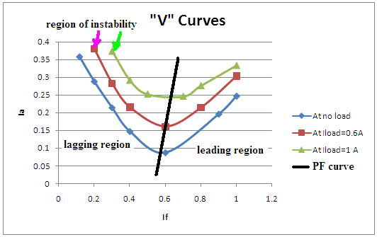
The “V” curve of a synchronous motor corresponds to the variation of the armature current as a function of the field current. As noticed in the figure the armature current decrease with the field current until it arrives to a minimum and then it increase with the field current. In the region of decrease the power factor is lagging, at the minimum point the power factor is 1 and in the in the increase region the power factor is leading.
At the unity power factor the power supplied for or to the motor is a real power and the reactive power is zero. In the lagging region the motor is consuming reactive power and in the leading the motor is delivering reactive power. So by controlling the field current of a synchronous motor we can control whether the motor is behaving as an inductor or as a capacitor.
The increase in the field current increase the internal voltage and with the increase of the internal voltage the armature current increases. At unity power factor the power delivered is real power so the motor is behaving like a resistance.

III-What conditions have to be met in order to achieve a smooth synchronization procedure? Explain the theory behind the 3-lamp method.
The main conditions for synchronization are:
a- Same voltage
b- Same phase sequence
c- Same frequency
The theory behind the 3-lamp method: Three light bulbs are stretched across the open terminals of the switch connecting the generator to the system. As the phase changes between the two systems, the light bulbs first get bright (large phase difference) and then get dim (small phase difference). If all three bulbs get bright and dark together then the systems have the same phase sequence. If the bulbs brighten in succession, then the systems have the opposite phase sequence.
IV- Do the powers on the AC and DC sides agree? If not, explain why.
The powers on the AC and the DC sides do not agree due to:
a- Friction and mechanical losses
b- Copper and Core losses
V-What does the minimum armature current with no load on the DC machine represent?
The minimum armature current with no load at the DC machine represents the no load losses due to friction and mechanical losses, copper and core losses.
VI-Could the synchronous machine be started as a motor by switching directly on to the mains? What could be the result of such switching?
The synchronous machine could be started as a motor by switching directly to the main. But there is some consequences for such an action and can be summarized by:
a- Unstable region in the motor behavior due to low field current
b- A high field current could also cause a high starting current
c- The absence of a starting torque in the motor since the motor starts from zero speed in this case.
VII-Sketch the phasor diagrams for conditions of under-excitation and over-excitation, both diagrams to be related to the same output.

The under-excitation reflects the lagging region where the motor corresponds to an R-L load. The phasor diagram is as follows:
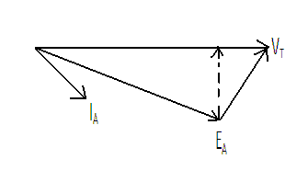

The over-excitation corresponds to the leading region where the motor behaves as an R-C load. The phasor diagram is as follows:
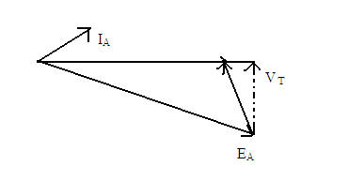

VIII-Plot on the OC characteristic and draw the air-gap line. On the same sheet, plot the SC characteristic; determine the short circuit ratio (SCR).
The data measured:
For the Open-Circuit test:
Ifield (A) | VT (V)
0.116 | 142
0.2 | 222
0.3 | 294
0.4 | 339
0.5 | 371
0.6 | 390
0.7 | 403

For the Short-Circuit Test:
Ifield (A) | Iarmature (A)
0.116 | 0.110
0.2 | 0.185
0.3 | 0.281
0.4 | 0.373
0.5 | 0.469
0.6 | 0.556
0.7 | 0.645
0.8 | 0.743
0.9 | 0.837
1 | 0.952

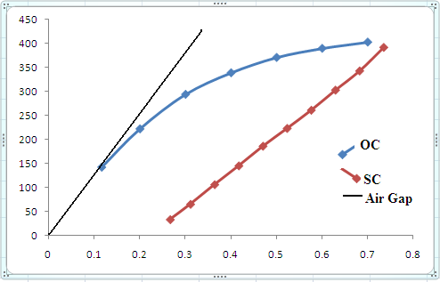
The SCR is:
$$SCR=\frac{If at rated VT (OC)}{If at rated Ia (SC)}=\frac{If at 380 V}{If at 0.7A}=\frac{0.6}{0.645}=0.93$$

IX- Calculate the approximate saturated synchronous reactance per phase (in Ω and p.u.). Calculate the effective armature resistance also, assuming it to be 10% above the DC value. Hence, obtain the voltage regulation for rated armature current at 0.8 power factor lagging.
The approximate saturation reactance is 1/SCR=1/0.93=1.075 p.u
The impedance base is :$Z_{base}=\frac{380}{0.7}=543$
The real value of the reactance is: 1.075*543=584 ohms=jwL => L=1.86 H
The armature resistance is R_{A}=32*1.1=35.2 ohms.
E_{A}=V_{T}+(jX_{S}+R_{A})I_{A}=380+(584j+35.2)0.7<cos⁻¹(0.8)=575<33degrees.
The voltage regulation is :
$$V_{R}=\frac{575-(\frac{380}{\sqrt{3}})}{575}x100\%=61\%$$
X-Comment on the following:
A_The degree of saturation evident from the open-circuit characteristics.
B_The degree of saturation evident under short-circuit characteristics.

A- At high voltages we have saturation in the motor’s core due to the high magnetic field at the OC test. That’s why the characteristic reach a steady state.

B- In contrast with the OC test , the voltage is low that why the magnetic field in the motor is small that’s why the motor does not enter in saturation.

