American University of Beirut

Faculty of Engineering and Architecture

Department of Electrical and Computer Engineering

Electric Machines Lab_EECE 470L
Experiment 7
DC Compound Generator

Objectives:
The objectives of this experiment are to investigate the load voltage characteristics of a DC generator when connected in cumulative compound, differential compound and shunt connection.

Procedure and Circuit Diagram:

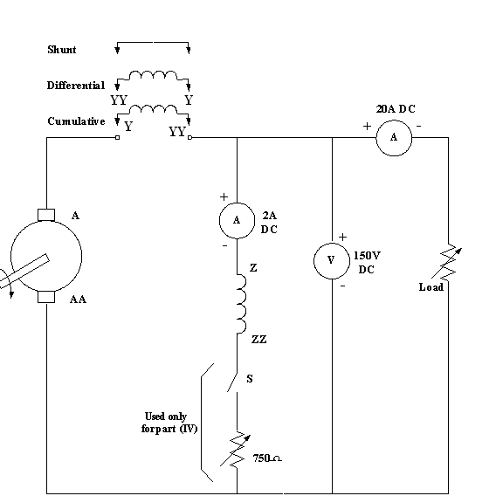
Figure 1: DC compound generator
Concerning the procedure, we had three connections to investigate; the cumulative compound connection, the differential compound connection and the shunt connection. Below the detailed procedure in the lab:
  - Connect the generator in the cumulative compound connection as shown in Fig.1. Switch “S” should be closed, and the field rheostat shorted. Perform a load test (at both low and high speeds) starting from no load up to 10% overload. Take readings of the terminal voltage, armature current, and field current.

  - Repeat part I with the generator connected in the differential compound connection. Perform the load test (at high speed only) up to the point of short circuiting the load.

  - Repeat part I with the generator connected in the shunt connection (No series field). Perform a load test at both high and low speeds.

  - With the generator connected in the shunt connection and run at no load, change the field current from zero up to a value that gives a 20% over-rated terminal voltage. Take readings of field current and terminal voltage.

  - Measure the resistance of both the armature and the series windings by the voltage drop method. (Figs. 2 and 3).

Apparatus:
1. DC compound generator
2. 2 Ammeters
3. Voltmeter
4. Variable resistor
5. Induction Motor
6. Connection wires
7. Three phase power supply

Measured Data Tabulation:
At high speeds, we have the following data:
Cumulative Compound:

Vterminal (V) | Ifield (A) | Iload (A)
132 | 0.668 | 0
130 | 0.656 | 2
129 | 0.649 | 5.6
128.5 | 0.64 | 8
126.4 | 0.631 | 10.4
124.6 | 0.616 | 13.3
122 | 0.1 | 16

Differential Compound

Vterminal (V) | Ifield (A) | Iload (A)
126.4 | 0.624 | 0
122 | 0.596 | 1
118.2 | 0.58 | 2
109.7 | 0.534 | 3.2
100 | 0.497 | 4.3
93 | 0.455 | 4.7
64 | 0.498 | 5.2
61 | 0.297 | 5
30.9 | 0.155 | 3.6
17.4 | 0.085 | 2.2
11 | 0.054 | 1.7
0.13 | 0 | 0.7

Shunt Connection:

Vterminal (V) | Ifield (A) | Iload (A)
126.8 | 0.615 | 0
123 | 0.594 | 2
116 | 0.565 | 5
111.6 | 0.541 | 7
107 | 0.516 | 8.8
100 | 0.48 | 10.7
94 | 0.454 | 12.3
86.5 | 0.415 | 14

To get the magnetization curve we changed the field current from zero up to a value that gives 20% over-rated terminal voltage. The following Data was measured in the lab:
Field Current (A) | Terminal Voltage (V)
0.007 | 7
0.034 | 12.36
0.073 | 22
0.183 | 58
0.234 | 67
0.345 | 90
0.411 | 102
0.612 | 126.8

QUESTIONS:
I- Plot on the same sheet, the graphs showing the variation of the terminal voltage as a function of the load current for shunt, cumulative and differential compound connections. Comment on the results.

The results are what are expected to be. For the cumulative compound connection we have that: When the load current increases, the armature current increases and knowing that $V_{T}=E_{A}-I_{A}R_{A}$so the terminal voltage will decrease since E_{A} is a constant. For the differential compound when the load current increases the armature current also increases. The EMF voltage is proportional to the flux and thus proportional to the field current that is decreasing and thus the flux is decreasing until a point where the flux is zero and thus the terminal voltage will start decreasing until reaching zero. For the shunt connection, the shape of the characteristic is similar to the cumulative compound characteristic however it is less than the cumulative compound due to the absence of the series field responsible of increasing the terminal voltage.

II- Plot on the same sheet, the graphs showing the variation of output power with the load current for shunt, cumulative and differential compound connections. Comment on the results.
To obtain the output power we can apply the following formula:
$P_{OUT}=V_{T}I_{L}$ so we obtain the following data:
For the cumulative compound:
Vterminal (V) | Iload (A) | Pout
132 | 0 | 0
130 | 2 | 262
129 | 5.6 | 722.4
128.5 | 8 | 1024
126.4 | 10.4 | 1314.56
124.6 | 13.3 | 1657.18
122 | 16 | 1952

For the differential compound:
Vterminal (V) | Iload (A) | Pout
126.4 | 0 | 0
122 | 1 | 122
118.2 | 2 | 236.4
109.7 | 3.2 | 351.04
100 | 4.3 | 430
93 | 4.7 | 437.1
64 | 5.2 | 332.8
61 | 5 | 305
30.9 | 3.6 | 111.24
17.4 | 2.2 | 38.28
11 | 1.7 | 18.7
0.13 | 0.7 | 0.091

For the shunt:
Vterminal (V) | Iload (A) | Pout
126.8 | 0 | 0
123 | 2 | 246
116 | 5 | 580
111.6 | 7 | 781.2
107 | 8.8 | 941.6
100 | 10.7 | 1070
94 | 12.3 | 1156.2
86.5 | 14 | 1211

We obtain the following graph:

Since the differential compound graph is not clear we will plot it in another sheet. This is due to the scale difference between the plots.

These shapes for the three connections are expected. In fact because we have the relation that $P_{OUT}=V_{T}I_{L}$, it is expected that we have the same form. With the terminal voltage constant the power will increase with the increase of the load current.
III-Calculate the values of the induced emf corresponding to the terminal voltage readings taken for the cumulative compound connection at both speeds. Plot the internal and external characteristics.
We will calculate the data for the high speed.
We have that the $E_{A}=V_{T}+(I_{L}+I_{F})R_{A}$. The armature resistance is measured to be 3.2 ohms. So we have the following data:
Vterminal (V) | Ifield (A) | Iload (A) | Emf
132 | 0.668 | 0 | 134.138
130 | 0.656 | 2 | 138.5
129 | 0.649 | 5.6 | 148.997
128.5 | 0.64 | 8 | 156.148
126.4 | 0.631 | 10.4 | 161.699
124.6 | 0.616 | 13.3 | 169.141
122 | 0.1 | 16 | 173.52
We will plot the EMF versus the load current and the terminal voltage versus the load current.

IV-Plot the magnetization curve from the data obtained in part V.

V- For the shunt connection, estimate from the magnetization curve the critical resistance, being the slope of the linear part of the curve, and compare it to the measured shunt field resistance. What is the effect of having the shunt resistance greater than the critical value?
The slope using excel curve fitting is obtained to : 208 Ohms. The value measured in the lab is 203 ohms. It is very close and the percentage of error is approximately: 2.5%.
The effect of having the shunt resistance greater than the critical value is that the field current will decrease and thus the terminal voltage will decrease since we know that in a DC compound generator the terminal voltage is proportional to the filed current.

