American University of Beirut

Faculty of Engineering and Architecture

Department of Electrical and Computer Engineering

Electric Machines Lab_EECE 470L
Experiment 6
Torque-Speed and Efficiency Characteristics of a DC Compound Motor at Different Field Currents

Objectives:
The objectives of this experiment are to investigate the torque speed and efficiency characteristics of a DC compound motor with both cumulative and differential connections and to study the effect of changing the shunt field current on the torque speed characteristic of a DC compound motor and compare these characteristics to those of a shunt DC motor.

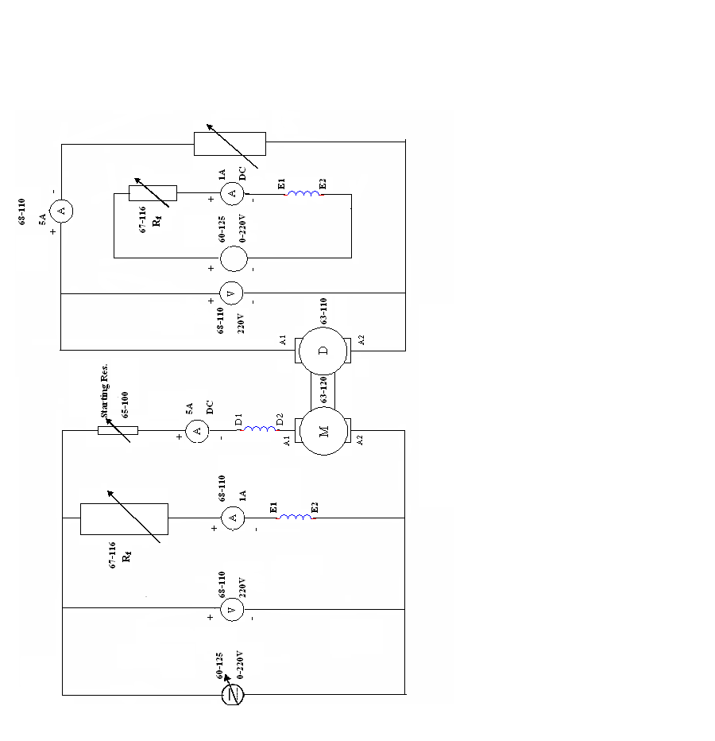
Procedure and Circuit Diagram:
Figure 1: DC Compound motor connected to the automatic starter

- Connect the circuit diagram as shown in the figure.
- Turn on the DC supply by:
  - Switching on the single and 3- phase power on the 60-100 panel.
  - Switching on the circuit breaker on the 60-125.
  - Switching the supply select switch on the 60-125 to position '2' selecting the dc output.
- Slowly increase the voltage read on the 68-110 voltmeter to 220V using the variable output control on the dc supply. This voltage should remain constant throughout the experiment.
- Adjust the Variable Resistance to set the field current (I_{f}) to 0.16A read on the 68-110 ammeter. Ensure I_{f} remains 0.16A throughout the test.
- Apply a range of loads in increments of 0.2A to the motor by adjusting the load resistance.
- Record measurements of all meters for loads up to 1.2A. Ensure that the terminal voltage remains constant at 220V throughout the test.
- Return the load resistance to its maximum position.
- Repeat parts 5 and 6 for I_{f} = 0.14A and 0.12A.
- Switch the motor off by returning the starter (65-100) to position 'OFF' and the supply select switch on the 60-125 panel to position '0'.
- Connect the motor in the differential connection.
- Repeat parts 5 and 6 ONLY for I_{f} = 0.16A.
- Return the load resistance to its maximum position.
- Return the starter (65-100) to position 'OFF' and the supply select switch on the 60-125 panel to position '0'.

Apparatus:
1. DC Compound Motor
2. Two Ammeters
3. Voltmeter
4. Single and three phase power supply

Measured Data Tabulation:
I- Calculate the input power, output power and efficiency for different loads at If=0.16A.

Load Current(A) | Field current(generator  (A) | Speed (RPM) | Armature Current(A) | Pout  (W) | Pin  (W) | Efficiency  (%)
0.05 | 0.215 | 3026 | 0.45 | 11 | 146.3 | 8
0.15 | 0.215 | 2988 | 0.5 | 33 | 157.3 | 21
0.295 | 0.213 | 2955 | 0.65 | 64.9 | 190 | 34
0.395 | 0.244 | 2919 | 0.75 | 86.9 | 219 | 40
0.525 | 0.263 | 2875 | 0.9 | 116 | 256 | 45
0.75 | 0.257 | 2864 | 1.1 | 165 | 299 | 56

The Formulas used are: $P_{in}=V_{in}\left(I_{a}+I_{f}\right) and P_{out}=I_{L}V_{T}, with V_{T}=220V.$

II-Plot the torque against the speed, armature current, efficiency for I=0.16A on the same graph and comment.
The formulas used are: $w_{m}=\frac{RPM}{60}×2π, and Torque=\frac{P_{out}}{w_{m}}$
RPM | Wm(rad/s) | Torque (N.m)
3026 | 317 | 0.034
2988 | 313 | 0.1
2955 | 309 | 0.2
2919 | 306 | 0.284
2875 | 301 | 0.384
2824 | 296 | 0.558

Graph:

With the torque increasing the efficiency and the armature current are increasing. However, when the torque increases the speed decreases since the torque is proportional to the flux and the speed is inversely proportional to the flux. This is quite logical; since we have that the torque is proportional to the armature current in the relation $τ=KφI_{a}.$

III-Plot the torque against the speed for all field current on the same graph and comment.
The below table summarizes all the values needed for the graph:
Field Current :0.16A |  |  | Field Current: 0.14A |  |  | Field Current 0.12A
RPM | w | Torque | RPM | w | Torque | RPM | w | Torque
3026 | 317 | 0.034 | 3195 | 334 | 0.032 | 3255 | 341 | 0.032
2988 | 313 | 0.1 | 3124 | 327 | 0.1 | 3216 | 337 | 0.098
2955 | 309 | 0.2 | 3076 | 322 | 0.2 | 3170 | 332 | 0.195
2919 | 306 | 0.284 | 2987 | 313 | 0.277 | 3118 | 327 | 0.266
2875 | 301 | 0.384 | 2947 | 308 | 0.375 | 3063 | 321 | 0.36
2824 | 296 | 0.558 | 2912 | 305 | 0.541 | 2983 | 312 | 0.528
Graph:

We know that when the armature current increases the field current decreases so that there sum remains constant. For the previous question we know that the torque is proportional to armature current. So we can conclude that the torque is inversely proportional to the field current and this is why the graphs shows decreasing characteristics. Furthermore, when the field current increases the torque increases and this is also shown in the graphs because for the same value of the torque the speed is less for 0.16 A than for 0.12 A for example. It is similar to the DC shunt graph which is logical.
IV-Plot the torque against speed for the three connections at I_{f} = 0.16A.
We will gather the data for this question from experiment 5 and this experiment. The below tables shows the data for If=0.16A for the shunt connection, the differential connection and the compound connection.

Shunt connection:
RPM | Wm(rad/s) | Torque (N.m)
3135 | 328.2 | 0
3120 | 326.7 | 0.067
3098 | 324.4 | 0.15
3087 | 324 | 0.217
3058 | 320 | 0.331

Compound connection:
RPM | Wm(rad/s) | Torque (N.m)
3026 | 317 | 0.034
2988 | 313 | 0.1
2955 | 309 | 0.2
2919 | 306 | 0.284
2875 | 301 | 0.384
2824 | 296 | 0.558

Differential connection:
If | ILoal | Iarmature | RPM | Wm(rad/s) | Torque (N.m)
0.171 | 0.055 | 0.4 | 3112 | 326 | 0.033
0.180 | 0.15 | 0.5 | 3099 | 324 | 0.1
0.185 | 0.29 | 0.6 | 3102 | 324 | 0.199
0.192 | 0.48 | 0.8 | 3105 | 324 | 0.267
0.191 | 0.52 | 0.9 | 3437 | 360 | 0.356

The Graph:

We did not complete the measurements in the lab for the differential connection to get a better characteristic because the motor became unstable.

V-Comment on the reason of the unstable behavior of the motor in the differential mode.
When we connect the motor in a differential mode the series field and the shunt field are subtracted from each other. The speed will be inversely proportional to the difference of the two fields. When this difference tends to zero ($∅_{1}-∅_{2})=0$ the speed will increase very much and the motor tends to become unstable. This instability limits the application of the differential connection since the motor will rotate suddenly at a high speed in the reverse direction.

