American University of Beirut

Faculty of Engineering and Architecture

Department of Electrical and Computer Engineering

Electric Machines Lab_EECE 470L
Experiment 5
Starting Current, Torque-Speed and Efficiency Characteristic of a Shunt DC Motor

Objectives:
The objectives of this experiment are to investigate the starting Current of a DC shunt motor, to investigate also the torque speed and efficiency characteristic of a DC shunt motor at different field currents and finally to separate the mechanical and iron losses in a DC shunt motor at no load.

Procedure:

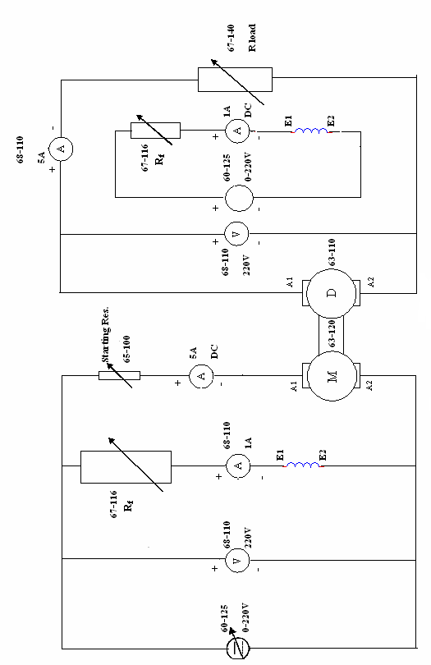
Figure 1: DC series motor connected to the automatic starter
Concerning the procedure, we had four tests to do. The determination of the starting current, the no load test, the load test and the retardation test. The detailed procedure for each test is given below:
- Starting Current
  - Connect the circuit diagram as shown in the figure.
  - Switch on the single and three phase power on the 60-100 panel.
  - Switch on the circuit breaker on the 60-125 panel.
  - Switch the supply select switch on the 60-125 to position '2' selecting the dc output.
  - Adjust the variable output control to 220V DC.
  - To start the motor, the switch on the switched resistance starter (65-100) is moved from the off- position to position “1”. Measure the starting current.
  - Repeat for positions 2 and 3.
  - Switch the starter to the off position and wait until the motor shaft is stationary.

- No load Test
  - Connect the dynamometer to the circuit.
  - Run the motor at no load and measure the input and output powers.
  - Switch off the motor.

- Load Test
  - Slowly increase the terminal voltage read on the left hand 68-110 voltmeter to 220V using the variable resistance 67-116. This voltage should remain constant throughout this part.
  - Adjust the variable resistance to set the field current (I_{f}) to 0.16A read on the right hand 68-110 Ammeter. Maintain If constant, vary the resistive load 67-140 and measure all meters.
  - Repeat part 13 for I_{f} = 0.14A and 0.12A.
  - Switch the motor off.

- Retardation Test
  - Run the machine at no load with the switched resistance starter at position1.
  - Perform a retardation test on the machine by disconnecting the supply from the armature (switch off the breaker on 65-100). Measure the time taken by the motor to stop completely. Repeat for positions 2,3, and 4.
C. Repeat the set of retardation tests in part 1, but this time opening both the armature and field supplies (switch off the breaker on the DC supply 60-125).

Apparatus:
1. DC shunt Motor
2. Two Ammeters
3. Voltmeter
4. Dynamometer or generator acting as a load for the motor
5. Single and three phase power supply
6. Chronomoter

Measured Data Tabulation:
I- Calculate the input power, output power and efficiency at no load at If=0.16A.
At no load the current is zero. So obviously the output power is zero. Concerning the input power we have:
The armature current $I_{a}=0.4 A and I_{f}=0.16 A so P_{in}=V_{in}\left(I_{a}+I_{f}\right)=220\left(0.4+0.16\right)=220\left(0.56\right)=123.2 watts.$
The efficiency is then concluded as: $efficiency=\frac{P_{out}}{P_{in}}=0\%.$
II-Calculate the input power, output power, and efficiency for different loads at If=0.16 A.
Load Current(A) | Field current(generator  (A) | Speed (RPM) | Armature Current(A) | Pout  (W) | Pin  (W) | Efficiency  (%)
0.05 | 0.180 | 3135 | 0.4 | 0 | 123 | 0
0.1 | 0.179 | 3120 | 0.45 | 22 | 134.2 | 17
0.22 | 0.188 | 3098 | 0.6 | 48.4 | 167.2 | 29
0.32 | 0.196 | 3087 | 0.7 | 70.4 | 189.2 | 37.2
0.48 | 0.206 | 3058 | 0.8 | 106 | 211.2 | 51

The Formulas used are: $P_{in}=V_{in}\left(I_{a}+I_{f}\right) and P_{out}=I_{L}V_{T}, with V_{T}=220V.$

III-Plot the torque against the speed, armature current, efficiency on the same graph and comment.
The formulas used are: $w_{m}=\frac{RPM}{60}×2π, and Torque=\frac{P_{out}}{w_{m}}$
RPM | Wm(rad/s) | Torque (N.m)
3135 | 328.2 | 0
3120 | 326.7 | 0.067
3098 | 324.4 | 0.15
3087 | 324 | 0.217
3058 | 320 | 0.331

Graph:

Please note that the values of I armature were multiplied by 10 just to be near the range of the speed (else the line will not appear).
With the torque increasing the efficiency and the armature current are increasing. However, when the torque increases the speed decreases. This is quite logical; since we have that the torque is proportional to the armature current in the relation $τ=KφI_{a},$and we have that the voltage E_{A} decreases with the armature current. So because the voltage E_{A} is proportional to the speed in the relation $E=Kφw$, then the torque will be inversely proportional to the torque as shown in the graph.

IV-Plot the torque against the speed for all field current on the same graph and comment.
The below table summarizes all the values needed for the graph:
Field Current :0.16A |  |  | Field Current: 0.14A |  |  | Field Current 0.12A
RPM | w | Torque | RPM | w | Torque | RPM | w | Torque
3135 | 328.2 | 0 | 3200 | 335 | 0.03 | 3350 | 351 | 0.03
3120 | 326.7 | 0.067 | 3180 | 333 | 0.12 | 3300 | 346 | 0.25
3098 | 324.4 | 0.15 | 3150 | 329 | 0.328 | 3280 | 343 | 0.333
3087 | 324 | 0.217 | 3139 | 328 | 0.35 | 3277 | 342 | 0.4

Graph:

We know that when the armature current increases the field current decreases so that there sum remains constant. For the previous question we know that the torque is proportional to armature current. So we can conclude that the torque is inversely proportional to the field current and this is why the graphs shows decreasing characteristics. Furthermore, when the field current increases the torque increases and this is also shown in the graphs because for the same value of the torque the speed is less for 0.16 A than for 0.12 A for example.

V-Plot the retardation curve and comment.
The data for this plot is shown in the table below:
Disconnecting the armature we have for the field current of 0.12 A
R₁+R₂+R₃ | 3.6s
R₁+R₂ | 4s
R₁ | 4.1s
Armature only | 4.2s

Decreasing the starter resistance makes the voltage increase which increases the speed and thus the motor needs more time to stop.
Disconnecting the armature and the field current:
R₁+R₂+R₃ | 4.3s
R₁+R₂ | 4.5s
R₁ | 4.7s
Armature only | 5s

As noticed when the armature and the field current are off the motor needs more time to stop.

QUESTIONS:
1- What do we use the series starting resistance for and why do we use switched resistors?
The main use for starting resistors is the reduction of the starting current and thus for the motor protection. The usage of switched resistors is beneficial to reduce the losses when the motor stabilizes and thus the starting current stabilizes. At this point the switched resistor is set off.
2- State the main losses in a dc shunt motor and specify which of them are constant and which of them are not?
The losses are: (taken from Electric Machinery Fundamentals by Chapman)
a. Electrical and copper losses (I²R): these losses occur in the armature and field winding of the machine, not constant since it depends on If and Ia.
b. Core losses: the hysteresis and eddy current losses, occurring in the metal of the motor. Not constant since they vary with the square of the flux density and the 1.5th power of the speed of rotation.
c. Mechanical losses: Two types: friction and windage. Not constant since they vary with the cube of the speed of rotation of the motor.
d. Stray losses: these losses are non-categorized losses. Constant as 1% of full load
e. Brush losses: it is the power lost across the contact potential at the brushes, not constant because they are proportional to the brush voltage drop and the armature current.
3- What is the main application of the shunt motor?
Since in a dc shunt motor the speed is inversely proportional to the field current the main application of dc shunt motor is speed control. So we can have different speeds by changing only the field current.

4- What is the field weakening method?
This method rests on the fact that we can reduce the field current by increasing the field resistance. According to Chapman:
- Rf is increased
- If decreased
- Flux is decreased
- Decrease in the internal generation voltage (E_{A})
- The armature current increases
- So the torque increases
- The speed increases since the induced torque will be greater than the load torque
- So E_{A} increases again
- The armature current decreases
- The induced torque decreases until it is equal to the load torque but at a higher speed.

