American University of Beirut

Faculty of Engineering and Architecture

Department of Electrical and Computer Engineering

Electric Machines Lab_EECE 470L
Experiment 3
Parallel operation of Three Phase Transformers

Objectives:
The objectives of this experiment are to study the effect of various connections and the parallel operation of three phase transformers.

Procedure:
Parallel operation:
The figure of the parallel operation connection is showed in Figure 1.
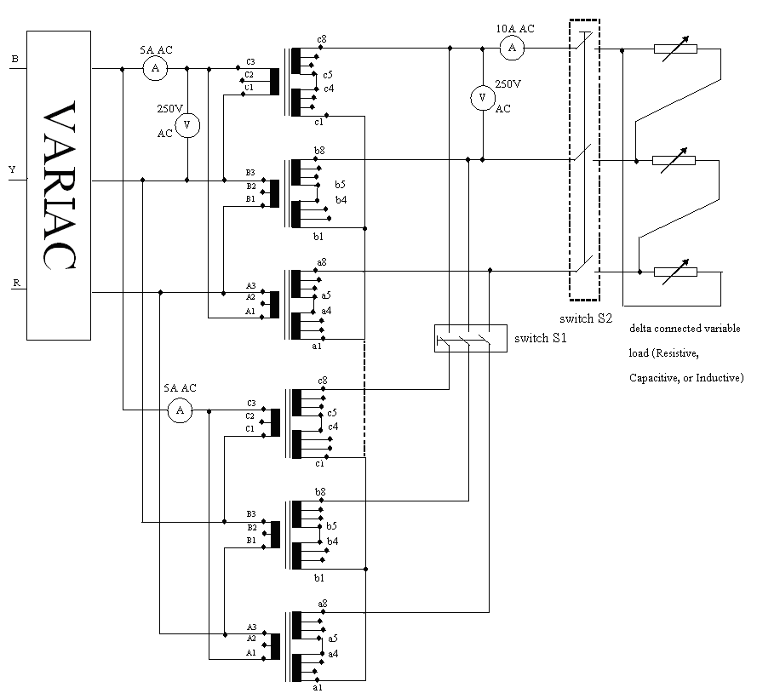
Figure 1: Parallel operation of three phase transformer.

The circuit was connected as shown in Figure1. We measured the no load secondary voltage when the two switches are off. Then we made sure that the voltage across the switches is zero so we can close the circuit. After closing the circuit, we connected at the secondary three types of loads connected in delta; resistive, capacitive and inductive. The primary side of the two transformers is connected at Delta and the secondary side is connected as Wye.

Apparatus:
1. Two 3-phase transformer
2. Multi-meters
3. 3-phase AC power supply (190V)
4. Switches
5. Connecting electric wires
6. Variable load, capacitive, resistive and inductive
7. VARIAC

Measured Data Tabulation:

R_load
$$V_{1}$$ | $$I_{1}$$ | $$I_{1}^{'}$$ | $$V_{2}$$ | $$I_{2}$$
217.8 | 0.87 | 0.912 | 221.7 | 1.39
216.4 | 1.689 | 1.745 | 218.8 | 3
215.5 | 2.208 | 2.27 | 217.1 | 4
214.6 | 2.84 | 2.9 | 215 | 5.25

L_load
$$V_{1}$$ | $$I_{1}$$ | $$I_{1}^{'}$$ | $$V_{2}$$ | $$I_{2}$$
220.4 | 0.849 | 0.875 | 223.2 | 1.245
220 | 1.44 | 1.48 | 220.6 | 2.36
219.8 | 2.05 | 2.11 | 218 | 3.66
219.4 | 2.65 | 2.71 | 215.1 | 4.9

C_Load
$$V_{1}$$ | $$I_{1}$$ | $$I_{1}^{'}$$ | $$V_{2}$$ | $$I_{2}$$
221.1 | 0.456 | 0.471 | 228.5 | 1.26
221.4 | 1.128 | 1.153 | 231.4 | 2.6
221.9 | 1.776 | 1.82 | 234.3 | 4

The no_load voltage measured at the secondary is $V_{nl}=225.6 V.$

Graphs:
In the graph below we represent the variation of $V_{2 } versus I_{2}$ for the resistive, capacitive and inductive load.
The second graph presents the variation of the primary current versus the secondary current. $I_{1} versus I_{2}$ for each of the loads.

Resistive load:

Inductive Load:

Capacitive Load:

Comments on the Graphs:
For the first graph, $V_{2} versus I_{2}$ we notice that all the graphs start from the no load voltage measured at the secondary side which is equal to 225.6 Volts.
As we noticed in the first experiment, we have that the resistive load is a straight line between the capacitive load which is and increasing straight line and the inductive load which is a decreasing straight line. The capacitor is providing more current which cause the voltage to rise. On the contrary the current is lost as a magnetizing current which cause the voltage to decrease.
As for the other series of graphs that reflect the current variation we notice that $I_{1} and I_{1}^{'}$ are approximately equal in the three loads. It is in addition obvious the ratio of the current variation is double so we have: $\frac{I_{2}}{I_{1}} and \frac{I_{2}}{I_{1}^{'}}=2.$We can also notice that the currents do not start from zero which means that we have a no load current${ I}_{nl}$.

Parallel operation of three phase transformers:
The Parallel operation of three transformers necessitates the existence of some conditions:
- The same phase sequence
- The same type of connections
- The same neutral since we still have a three phase system.
- The voltage across the switch must be equal to zero to parallel the two transformers.

