American University of Beirut

Faculty of Engineering and Architecture

Department of Electrical and Computer Engineering

Electric Machines Lab_EECE 470L
Experiment 1
Three Phase Transformers

Objectives:
The objectives of this experiment are to measure the efficiency and the short circuit impedance of a 3-phase transformer using multiple tests. These tests are the no-load test, the short circuit test and the load test. Before performing the tests, the winding resistance was measured using an ohmmeter. The short circuit test helps us determine the series resistance and reactance while the no load test helps us determine the core resistance and the magnetizing reactance. On the other hand, we also performed a balanced loading of the 3-phase transformer with resistive, inductive and capacitive loads. With the obtained results we plotted the I-V characteristic showing the effect of the three types of loading.

Procedure:
Measuring the winding resistance:

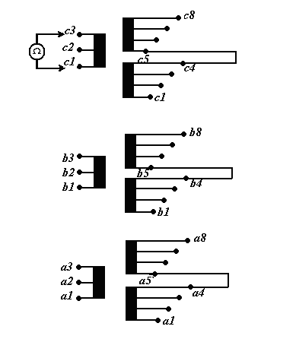
Figure 1: Connection for the winding resistance
The winding resistance was measured using an Ohmmeter after connecting the phases as shown in the figure (c5->c4, b5->b4, a5->a4)
No-Load test
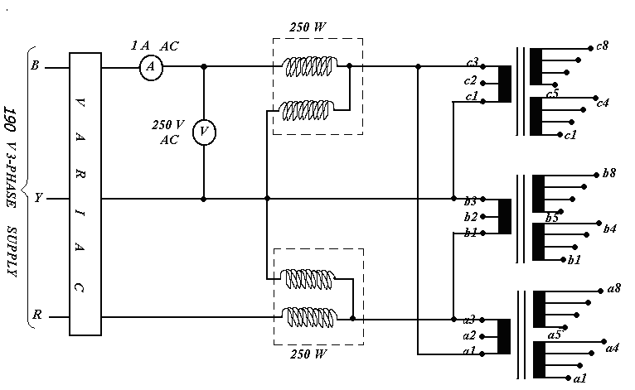
Figure 2: The no-load test

As shown in the figure, the connections on the primary of the transformer are Delta. The circuit is open on the secondary side. In addition we have 2 wattmeters (2-wattmeters method), the one for the current is in series and the one for voltage is in parallel. The potential coil of the wattmeter needs to be switched in case of negative reading. The VARIAC is used to avoid any short circuit. Switch on the 3-phase supply; adjust the VARIAC so that the input voltage to the transformer becomes 220V (line to line). Take readings of current and power values.

Short-circuit test
As we can remark, the primary side is similar to the no-load test. The secondary side is Wye connected as shown in Fig3 below with an Ammeter to measure the short-circuit current. We Switch on the 3-phase supply and, starting from zero, increase the primary voltage slowly until the rated current (5.25 A) flows in the primary winding. We take readings of the secondary current, primary voltage and the power using the two wattmeters.

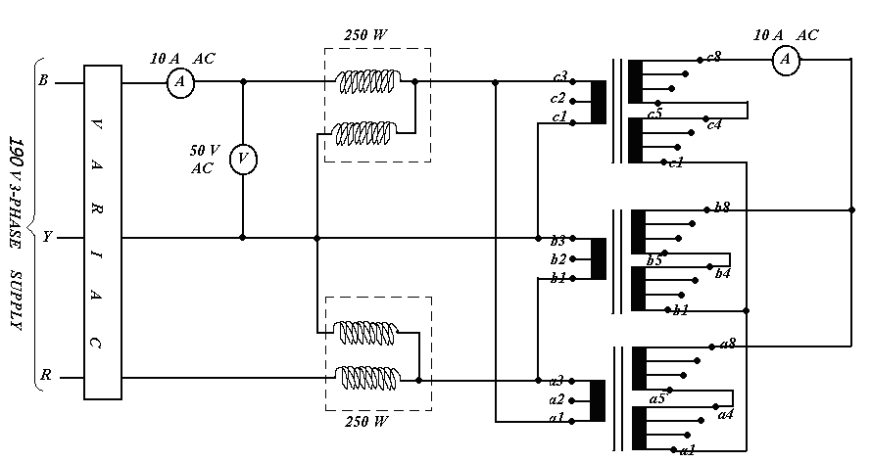
Figure 3: Short-circuit test

Load test:
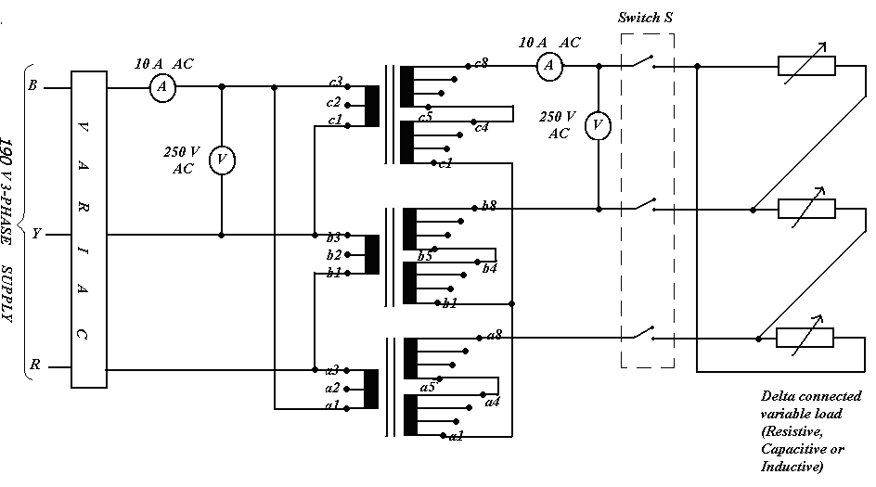
Figure 4: Load Test
The circuit on the primary side is the same and the loads are connected on the secondary side using a three-phase switch. The switch “S” must be open. Switch on the 3-phase supply, and adjust the VARIAC so that the supply voltage to the transformer becomes 220V (Line). We set the load to the position that gives minimum current. We close the switch and Vary the load so that the secondary current rises up to the rated value (5.25 A). Take readings for all currents and voltages.

Apparatus:
- Three Phase transformer
- Electric Wires
- VARIAC
- 3 Multi-meter
- 2 watt-meters
- AC power supply of 190 V
- 3 phase resistive load
- 3 phase capacitive load
- 3 phase inductive load

Circuit Diagram:
The circuit model of a three-phase transformer is shown below in Fig.5 . The circuit referred to the primary side is shown in Fig.6.
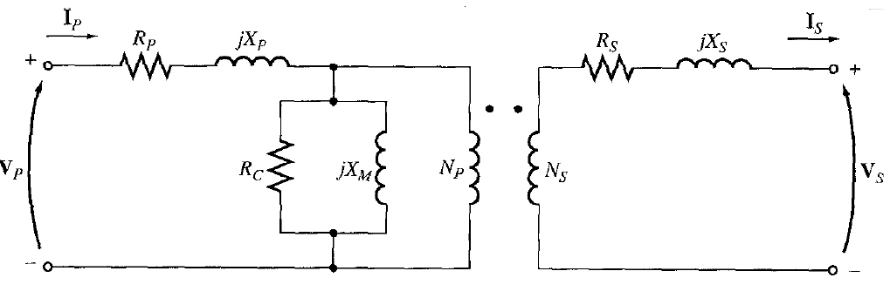
Figure5: Complete model of the transformer
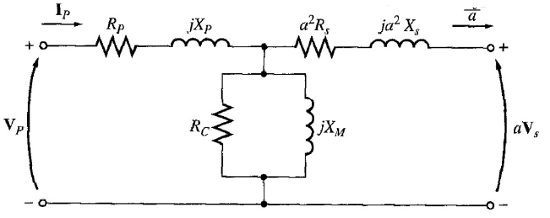 Figure6: Parameters referred to the primary side

Measured Data Tabulation:
The winding resistance was measured and its value is 1.1 ohms/Phase.
At no-load test the line to line voltage $V_{OC}=220 V, I_{OC}=0.24 A and P_{OC}=60 W.$
At short circuit test the line to line voltage $V_{SC}=17 V, I_{SC}=4.66 A and P_{SC}=100 W.$
At load test the following data was measured:
Resistive load:
V1 | 217 V
I1 | 1.58 A
V2 | 220 V
I2 | 1.38
V2 | 215 V
I2 | 3 A

Capacitive load
V1 | 221.6 V
I1 | 1.182 a
V2 | 232.7 V
I2 | 1.285 A
V1 | 222.22 V
I1 | 2.52 A
V2 | 238.5 V
I2 | 2.666 A
V1 | 222 V
I1 | 3.85 A
V2 | 244 V
I2 | 3.96 A
V1 | 223 V
I1 | 5.34 A
V2 | 249.7 V
I2 | 5.44 A

Inductive load
V1 | 221 V
I1 | 1.86 A
V2 | 221.4 V
I2 | 1.36 A
V1 | 219 V
I1 | 3.4 A
V2 | 216 V
I2 | 2.65 A
V1 | 218 V
I1 | 4.94 A
V2 | 211 V
I2 | 3.87 A
V1 | 217 V
I1 | 5.63 A
V2 | 209.2 V
I2 | 4.51 A

Graphs:

Comments on Graphs:
- The no-load secondary voltage is the same for the three types of loads
- The R-load line has a small slope
- The C-load l_V characteristic is an increasing straight line since $i=c\frac{dV}{dt}$, so as i increases dV increases, and the current leads the voltage.
- The L-load I_V characteristic is a decreasing straight line and the current lags the voltage.

Answers to relevant questions:
1_ Circuit parameters:
The parameters of the transformer are calculated using current, voltage and power of the no-load and the short-circuit tests.

We have:
$$Y_{E}=\frac{I_{l}}{V_{ln}}∠\cos^{-1}{\frac{P_{OC}}{\sqrt{3}xV_{ll}xI_{l}}=0.24/(\frac{220}{\sqrt{3}})∠\cos^{-1}{\begin{aligned}\frac{60}{\sqrt{3}x220x0.24}=1.88x{10}^{-3}∠-49=\frac{1}{R_{C}}-\frac{j}{X_{M}} \\ \\ \end{aligned}}}$$
$$R_{C}=813 ohms and X_{M}=709 Ohms.$$
$$Z_{eq}=\frac{V_{ln}}{I_{l}}∠\cos^{-1}{\frac{P_{SC}}{\sqrt{3}xV_{ll}xI_{l}}=\frac{17}{\sqrt{3}}/(4.66)∠\cos^{-1}{\begin{aligned}\frac{1000}{\sqrt{3}x17x4.66}=2.11∠43.21=1.53+1.47j \\ \\ \end{aligned}}}$$
$$R_{L}=1.53 ohms and X_{L}=1.47 Ohms.$$

2- Efficiency:
$$efficiency=\frac{P_{out}}{P_{OUT}+P_{losses}}x100$$
pF=1 | Pout=100W | Plosses=60W | Efficiency=62.5 %
pF=0.8 | Pout=80W | Plosses=60W | Efficiency=57.15%

3-Reactive losses of the transformer:
Reactive losses in the transformer are due to the primary and secondary leakage reactances and the leakage due to the magnetizing reactance $X_{M}.$
Reactive losses to the series leakage reactances:
$$Q_{L1}=Q_{L2}=3I_{1}^{2}X=3{\left(5.25\right)}^{2}x1.47=121.5VAR$$

For pF=0.8 we have:
$$V_{M}=V_{P}+\left(R_{L}+jX_{M}\right)xI_{P}=127+\left(1.53+j1.47\right)\left(5.25∠-38.88\right)=138.1 V$$
Where $V_{M} is the voltage across the magentizing reactance, V_{P } is the primary voltage.$
So: $Q_{M}=\frac{3V_{M}^{2}}{X_{M}}$=80.68 VAR
So: Total reactive power: $Q_{TOT}=Q_{M}+2Q_{L}=80.68+2\left(121.5\right)=324 VAR$
For pF=1we have:
$$V_{M}=V_{P}+\left(R_{L}+jX_{M}\right)xI_{P}=127+\left(1.53+j1.47\right)\left(5.25\right)=135 V$$
Where $V_{M} is the voltage across the magentizing reactance, V_{P } is the primary voltage.$
So: $Q_{M}=\frac{3V_{M}^{2}}{X_{M}}$=77.4 VAR
So: Total reactive power: $Q_{TOT}=Q_{M}+2Q_{L}=77.4+2\left(121.5\right)=320 VAR$
4-Graph

Comments on the graph can be found in section 5 of this report
5-Comparison of results:
For resistive load:
V1 | I1 | V2 | I2
217 V | 1.58 A | 213 V | 3A

The calculated value:
$$V_{2}=217-\left(1.58-0.24\right)\left(1.53x2+1.47jx2\right)=212.94 V$$
The error is approximately 0.5%
6-For the inductive load:
V1 | I1 | V2 | I2
219 V | 3.4 A | 216 V | 2.65

The calculated value:
$$V_{2}=219-\left(3.4-0.24\right)\left(1.53x2+1.47jx2\right)=210 V$$
The error is approximately 2.78 %

