Nutrition

- Nutrients
- Carbohydrates
- Categories
Simple: also called sugars
e.g. glucose, fructose, sucrose, lactose
Complex: digestible: starch: hundreds of glucose units
indigestible: fibers: e.g. pectin, cellulose

- Major functions
Energy: provide 4 kcal/g
glucose: basic fuel for all cells, only fuel for NS cells
→ spare protein for tissue building
Fibers: do not provide energy
important for normal functioning of digestive system

- Daily need: starch & sugars: 55-60% of total energy intake
fibers: about 30g

- Food sources
Glucose & fructose: fruits & honey
Sucrose: table sugar (sugar canes & beets), honey, maple syrup
Lactose: milk, some dairy products
Starch: cereals (wheat, rice... & products), legumes (beans, peas, lentils),
potatoes, bananas
Fibers: fruits, vegetables, grain covers
- Lipids

- Categories
Fats (fatty acids)
.SFA (solid at room t°, unhealthy): saturated in H
.UFA (generally liquid at room t°, healthy fats):
MUFA
PUFA: include 2 essential FA: ω-3 & ω-6
.Trans FA (very unhealthy fats):
UFA but abnormal distribution of H: worse than SFA
obtained during hydrogenation of vegetable oils (margarine)
Cholesterol

- Major functions
Fats (stored in adipose tissue as triglycerides)
provide energy (9 kcal/g)
insulate body & protect internal organs
Cholesterol
does not provide energy
used to form vitamin D
used to form steroid hormones (e.g. sex hormones)

- Daily need
Fats: less than 30% of total energy intake
(SFA: less than 10% of total energy intake)
Cholesterol: made by liver from SFA (= major source of body ch^{l})
upper limit: 300 mg
- Food sources
SFA: animal fats (except fish fat)
meat, poultry (esp. skin), egg yolks, milk & products
plant fats rich in SFA: palm oil & coconut oil
MUFA: oleic acid: olive oil, peanuts, almonds, avocados
PUFA: vegetable seeds & their oils (soybean, sunflower, corn)
fish
Ch^{l}: only animal products
best: organ meat (e.g. liver) & egg yolk

- Proteins
- Categories
.Complete (high-quality protein)
contain all essential AA
all animal protein (except gelatin)
.Incomplete (low-quality proteins)
lack at least 1 essential AA
plant protein (except soy proteins)

- Major functions: Tissue synthesis
Can also provide energy (4 kcal/g)

- Daily need: 0.9g / kg of body weight for adults
(~ 15% of total energy intake)

- Food sources:
Animal: meat, poultry, fish, milk & products, eggs (yolk & white)
Plant: richest are legumes, also in cereals & potatoes

- Vitamins

- Categories:

.Fat-soluble: A, D, E, K
Generally stored in the body (except K), not excreted in urine =>
⊕ symptoms of deficiency develop relatively late (months)
Θ can accumulate & become toxic (hypervitaminosis A & D)

.Water-soluble: B, C
Generally not stored in body (except B12), excreted in urine =>
Θ symptoms of deficiency develop within days
⊕ lower risk of toxicity

- Major functions
Do not provide energy
Necessary for various body functions

- Daily need: very small amounts (µg to mg)

Vitamin | Major Sources | Major Functions | Deficiency
A | .Vit A: liver, milk fat  .Provit A (carotene):  dark green leafy vegetables  orange fruits & vegetables | .Vision  .Antioxidant (carotene) | Night blindness
D | .Fortified foods (milk, cereals)  .Body synthesis (sunlight) | Blood Ca maintenance  => bone & teeth mineralization | Bone problems:  .Children: rickets  .Adults:osteoporosis
E | Vegetable seed oils, nuts | Antioxidant | Anemia
K | .Green leafy vegetables  .Intestinal bacteria | Blood clotting | Hemorrhage

Vitamin | Major Sources | Major Functions | Deficiency
B family | .Meat, poultry, eggs, yeast  .Bran & germ of cereals  (except B12: only animal foods) | Many biochemical reactions  (e.g. energy-production reactions) | .Impaired growth  .Anemia
C | Fresh fruits & vegetables  (esp. if acidic, e.g. citrus fruits) | .Immune response  .Antioxidant  .Iron absorption | Scurvy

- Minerals

- Categories (based on amounts needed for adults)
Macrominerals: e.g. Ca, Mg, Na, K
Microminerals (trace minerals): e.g. Fe, I, F

- Daily need for adults
Macrominerals: ≥ 100 mg
Microminerals: less than 1 to a few mg

- Major functions
Do not provide energy
Necessary for various body functions

Mineral | Major Sources | Major Functions | Deficiency
Calcium | .Milk & products  .Green leafy vegetables  .Legumes | .Bone & teeth formation  .Nerve & muscle function | .Bone problems  (rickets & osteoporosis)  .Muscle cramps
Magnesium | .Green leafy vegetables  .Unrefined grains | .Bone structure  .Muscle contraction | Muscle cramps
Sodium | .Table salt  .Processed foods | .Body water distribution  .Nerve & muscle function | Muscle problems
Potassium | .Wide distribution | .Body water distribution  .Nerve & muscle function | Muscle problems
Iron | .Meat, poultry, fish, eggs  .Legumes, green leafy vegetables | .O2 transport (hemoglobin)  .Normal brain functioning | .Anemia  .Fatigue
Iodine | .Seafood & iodized salt | Part of thyroid hormones | Goiter
Fluoride | .Seafood  .Tea  .Fluoridated water & foods | Teeth resistance to caries | Frequent caries

Water

- Represents about 70 % of body weight

- Major functions
Medium for chemical reactions
Transport (blood)
Temperature regulation (sweat)
Lubrication (mucus, tears…)
Waste removal (urine)

- Daily need
About 2.5 liters (1 to 1.5 l from drinks, preferably mineral water)
Need increased by
illness
exercise
high temperatures
high altitude, airplane
high coffee & alcohol intake (↑ urination)

- Food sources
Beverages (water, juices, sodas…)
Foods (variable amounts)

2. Healthy Nutrition
- Dietary Guidelines
- Eating a variety of foods for adequate intake of all nutrients
- Maintenance of a healthy body weight
- Eating plenty of plant products (starch, fibers, vitamins, minerals)
- Keeping fat, SFA and cholesterol intake low
- Moderate consumption of
Sodium (salt): increases risk of hypertension
Sugars: “empty calories” + dental caries
Alcohol: dependence & health (e.g. liver) problems

- Food Guide Pyramid
- Includes 5 food categories that cannot substitute for each other
Grains
Vegetables
Fruits
Milk
Meats and beans
- Daily consumption of foods from all 5 groups, in different amounts
- Limited fat (preferably from fish or plant sources), sugars & salt intake
- Balance between food and physical activity

New Pyramid

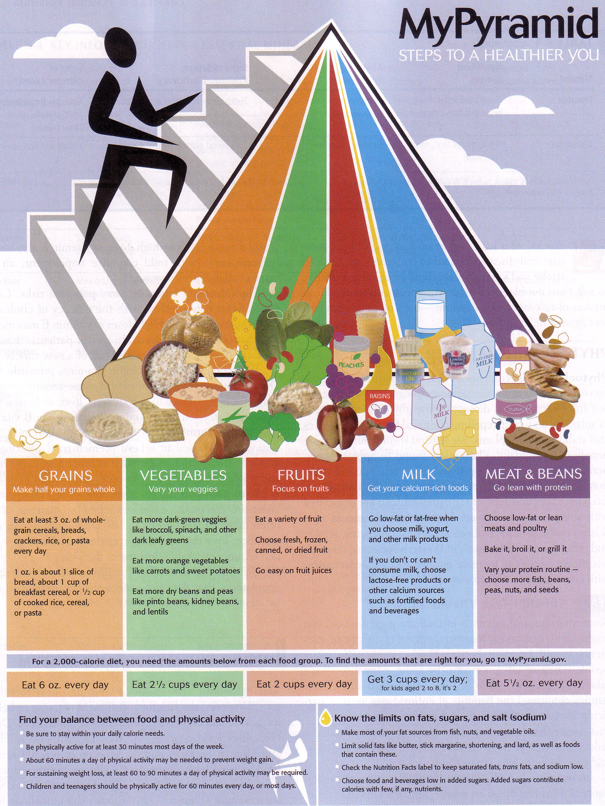

Old Pyramid

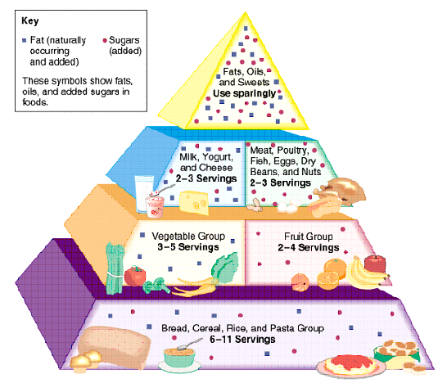

• Ways to decrease fat intake
- Remembering relative fat content of animals: fish < poultry < meat
- Choosing fish & legumes as an alternative protein-source to meat
- Grilling, boiling, steaming instead of frying
- Replacing butter & mayo with mustard & ketchup
- Adding flavor to foods by using herbs, spices, lemon, marinades
- Reducing high-fat snacks & appetizers (chips, salamis, hod dogs…)
- Removing visible fat before cooking & excess fat during or after
- Mixing 1 egg + egg whites to make omelets
- Choosing low-fat/fat-free products (milk, cream, mayo, butter,dressing)
- Choosing water-packed canned fish & meat (instead of oil-packed)
- Choosing low-fat frozen yogurts & sherbets instead of ice cream

- Vegetarian Diets
- Types
.strict vegetarians (“vegans”): only plant products
.lacto: plant products + milk & products
.lacto-ovo: plant products + milk & products + eggs
.lacto-ovo-pesco: plant products + milk & products + eggs + seafood
.lacto-ovo-pesco-pollo: plant products + milk & products
+ eggs + seafood + poultry
- Benefits
.high in fibers, starch, vitamins, minerals and phytochemicals
.low in fat, SFA, no cholesterol

- Health status of vegetarians: lower incidence of
.cardiovascular diseases (lower cholesterol levels)
.overweight
.cancer
.hypertension
.osteoporosis

- Cautions for strict vegetarians
.iron: adequate vitamin C intake increases plant Fe absorption
.vitamin B12: supplements or B12-fortified foods are necessary
.complementary proteins for adequate intake of all essential AA
(e.g. cereals & legumes)
3. Reading Food Labels
- Labels focus on following nutrients
Total fat & saturated fat
Cholesterol
Sodium
Carbohydrates: fibers & sugars (starch = the rest)
Proteins

- Amounts given per serving

- Daily Values (DV)
- Total amount of a nutrient an average adult should get/not exceed
- Sodium, cholesterol, vitamins and minerals: same amounts for all
- Fats, proteins & carbohydrates: amounts based on a 2000 kcal diet

- Labels in expanded version, bottom includes general nutrition info
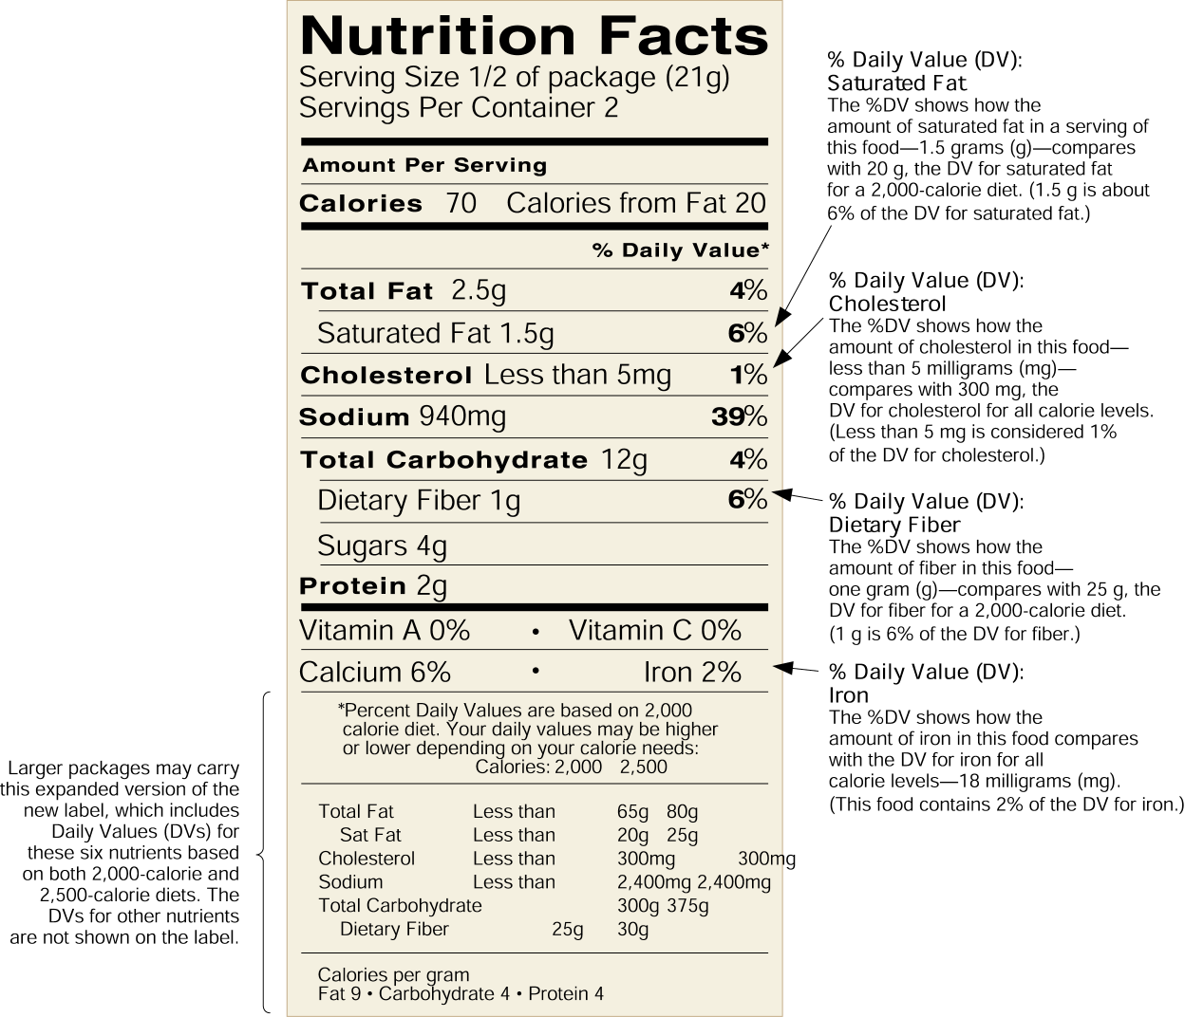
Criteria for choosing
- Calories: the lower the better if one is watching weight

- Total fat: no more than 3g / 100 kcal

- Saturated fat: no more than 1g / 100 kcal

- Cholesterol:
- Avoiding very high amounts
- Careful about plant products w/o ch^{l} but cooked with SFA/trans FA
(e.g. chips)

- Sugars: trying to keep low

- Sodium: keep low

- Fibers, Ca & other vitamin & minerals
- Good = 10%DV
- High = 20%DV

4. Antioxidants and Phytochemicals

- Antioxidants

- Prevent damage by O-containing free radicals that can
damage membrane → cell dies
damage DNA → risk of cancer
oxidize LDL → stick better to artery walls

- Include
β-carotene (provitamin A)
vitamin E
vitamin C
selenium

- Phytochemicals

- Chemicals naturally occurring in plants

- Prevent cancers

- Examples of phytochemical-rich foods
Hot peppers
Citrus fruits, tomatoes
Broccoli, cabbage, cauliflower

5. Supplements
- Mostly vitamins & minerals, individually or combined

- People consume them to
-Protect themselves from diseases (cancer, heart…)
- Have more energy
- Lengthen their life
- Make sure they have adequate amounts if diet supply not enough

- Safety concerns
- A and D: risk of hypervitaminosis (D: overcalcification)
- Water-soluble vitamins & minerals
some toxic in large doses (Ca: overcalcification, Na: hypertension)
others excreted anyway → useless

=> Best is to get vitamins & minerals from diversified diet

- Situations where supplements might be recommended/needed
- Pregnant & breastfeeding women
Iron for RBC
Folate for normal nervous system development & RBC
Calcium for bones
- Post-menopausal women: calcium for osteoporosis
- Strict vegetarians: vitamin B12
- Elderly
- People with illnesses/medications that interfere with appetite/digestion

6. Food Safety
I. Biological Hazards: bacteria, viruses & parasites

- Do not generally alter smell, taste or appearance of food

- Symptoms of disease classically include
vomiting, abdominal pain, diarrhea
nausea, fever, dehydration

- Severity of disease depends on
agent (type and amount ingested)
general condition of individual (health, age…)
immune system status

1. Bacteria
- Are destroyed by proper heating, survive when frozen

- Some can turn into spores to survive harsh conditions (heat, acid…)

- Can multiply on food (PHFs: potentially hazardous foods) that are
moist / rich in protein / ≈ neutral pH / at 5 - 60°C

- E.g.¹ Salmonella: food sources: mostly poultry & eggs

- E.g.² Staphylococcus
causes disease through production of heat-stable toxin
food sources: ready-to-eat foods prepared with human contact
found in/on nose, hair & skin (load ↓ by antiseptic lotions & soaps)

- E.g.³ Bacterium that causes botulism
causes disease through production of heat-sensitive neurotoxin
can be fatal
food sources: improperly canned foods, esp. if low acid
2.Viruses
- Generally transferred to food from infected persons,
- Do not multiply in food
- Are destroyed by proper heating, survive when frozen
- E.g. Hepatitis A virus
disease duration: weeks (if mild) to months (if severe)
symptoms: classical then swelling of liver & jaundice

3. Parasites
- Are generally present in flesh of infected animals
- Do not multiply in food
- Are killed by heat and appropriate freezing
- E.g. Taenia
segmented flat worm, few m long
causes classical symptoms and weight loss
food sources: raw or undercooked pork & beef

- Protecting oneself from biological hazards includes
- Not eating raw/undercooked animal products (flesh, eggs, milk)
- Not leaving PHFs between 5 & 60°C for more than 2 consecutive h
- Avoiding cross contamination (from raw meat to ready-to-eat foods)
can occur through hands, utensils, food contact surfaces…

II. Chemical Hazards

1. Naturally Occurring
- E.g. Mycotoxins produced by molds (food spoilage organisms)
ingestion of small doses over time can cause cancer, liver damage, death

2. Man-Added

- Food additives: majority are safe, some are not
- Coloring agents
- Taste enhancers: e.g. MSG can cause Chinese Restaurant Syndrome
(headaches & chest tightness)

- Preservatives
e.g.¹ sulfites (prevents discoloration of foods): can cause allergies
e.g.² nitrites (used in meat curing): can cause digestive tract cancers

- Pesticides (chemicals to control insects, weeds, fungi)
- Leave residues on fruits & vegetables
- Ways to decrease exposure to pesticides
buying organically grown products whenever possible
washing carefully
removing outer leaves from leafy vegetables (e.g. lettuce)
peeling removes surface pesticides, but not pesticides inside

- Cleaning or sanitizing chemicals

- Chemicals from containers
- E.g.¹ metals from cans & containers (tin, copper, iron, lead, zinc)
- E.g.² chemicals from plastic that migrate into food when μwaving

III. Food Allergies

- When IS reacts to a food component as if it was a potential threat

- Exaggerated immune reaction is what causes the symptoms

- Symptoms include
headache
vomiting, diarrhea
itching, puffy, teary eyes
runny nose
rash

- Commonly allergenic foods
eggs
nuts
wheat
seafood
cow's milk

