NOTRE DAME UNIVERSITY
FACULTY OF ENGINEERING

CEN 204
SECTION "D"
EXPERIMENT#4

INDETERMINATE BEAM
CASE 1: BENDING AT CANTALIVER BEAM
INTRODUCTION:
This experiment will enable to compare theoretical and experimental values for the bending of a cantilever beam under the effect of a weight once placed at its middle and once placed at 200mm from the free end.

LIST OF EQUIPMENTS USED:
A fixed support
A steel beam of cross section 20*6mm
A dial gage
A weight of 10N
A slider

THEORETICAL ANLYSIS:
for the calculated values the equations involved are those from the appendix "c" from the mechanics of materials book under the title cantilevered beam slopes and deflections.

For the force F=10N located at mid-span of the cantilever beam,
the deflection will be given by the following formula:
v = -Px²/6EI (1.5L-x) , 0≤x≤L/2
v = -PL²/24EI (3x-0.5L) ,L/2≤x≤L
P(N)= | 10
E= | 210000
I(mm⁴)= | 360
L(mm)= | 600
x(mm) from fixed support= | 500
 | 400
 | 300
 | 200
 | 100

For the force F=10N located at 200mm from the free-end of the cantilever beam,
the deflection will be:
v = -Px2/6EI (3L-x) , 0≤x≤400mm |  |  | θ_{max}= -PL²/2EI
where in this case, the span L is considered to be 400mm.
for x>400, the deflection will be computed by trigonometry of the elastic curve
in relation to the deflection at x=400mm; since beyond the location of force P,
the elasic curve shall be a straight line.
Elastic curve as a function of F (200mm from the free-end):

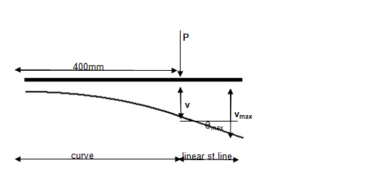
DISCUSSION OF THE WORK DONE:
From the chart of the values calculated the experimental values are a bit bigger than the theoretical ones which make the values of the error somehow high values for the load at 300mm from the free end the average error is 25% and for the load at 200mm from the free end is 21%. From the results the value of the deflection increases since the formula of the deflection is proportional to the value of the distance from the fixed support as for the modulus of elasticity as this value increases the deflection decreases since the deflection formula is disproportional to the modulus of elasticity same for the moment of inertia as the cross section increases the deflection decreases also the graphs shows an approximately linear increase in the values of the deflection .

PROCEDURES FOLLOWED:
Here is the apparatus of the experiment done:
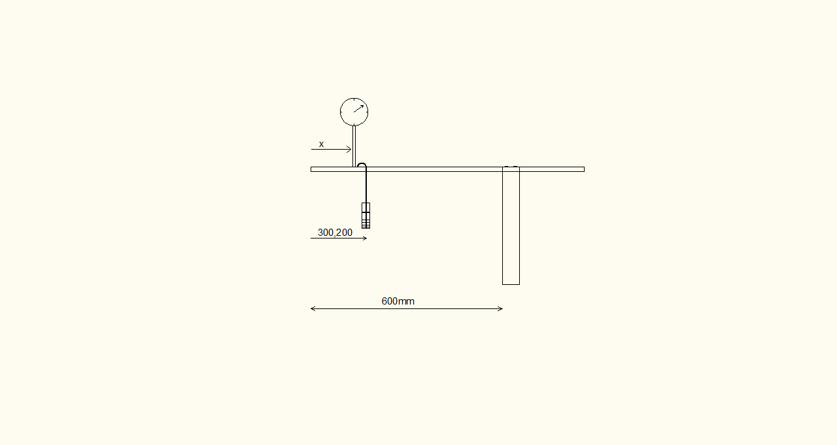
The beam is clamped at a distance of 600mm from the fixed support a slider is fixed at 300mm from the free end to hang the load a dial gage is fixed each time a 100mm span from the support and the deflection is measured the experiment is repeated for the load at 200 from the free end.

CONCLUSION AND RESULTS:
For a cantilever beam:
As the load is far from the support the deflection increase
The modulus of elasticity and cross section are disproportional to the deflection

Here are the data sheet and graph for this experiment:

Experiment #4, Case 1:Bending at Cantilever Beam
 | Material: Steel, Section: 20x6mm², L=600mm
x (mm) from the free end | 10N at 300mm from the free end |  | % error | 10N at 200mm from the free end |  | % error
 | Deflection(mm) Exp | Deflection(mm) theo |  | Deflection(mm) Exp | Deflection(mm) theo
500 | 0.27 | 0.176 | 34.81481 | 0.36 | 0.24 | 33.33333
400 | 0.81 | 0.617 | 23.82716 | 1.155 | 0.88 | 23.80952
300 | 1.335 | 1.19 | 10.86142 | 2.195 | 1.786 | 18.63326
200 | 2.17 | 1.78 | 17.97235 | 3.22 | 2.82 | 12.42236
100 | 2.88 | 2.38 | 17.36111 | 4.5 | 3.82 | 15.11111
0 | 4.3 | 2.97 | 44.78114 | 6.185 | 4.82 | 22.06952
 |  | avg %error | 24.93633 |  | avg %error | 20.89652

References

R.C Hibbler Mechanics of Materials 2nd edition section 12.2 and 12.4
Appendix "C" from R.C Hibbler Mechanics of Materials 2nd edition

Abstract

The topic under testing in this experiment is the case of the deflection of a cantilever beam where the beam will be under two positions of the loading at the middle of the beam and at 2/3 from the fixed support the values of the deflection the influence of the cross section and the moment of inertia and position of the load the discussion will be associated with graphs and data sheet.

