NOTRE DAME UNIVERSITY
FACULTY OF ENGINEERING

CEN 204
SECTION "D"
EXPERIMENT#9

STRAIN GAGE TRAINING SYSTEM
CASE1: TENSILE EXPERIMENT
CASE2: BENDING TEST
CASE3: TORSION TEST
Abstract
In this experiment stress and strain will be simulated electrically using the training system where stress and strain will be evaluated through the change in the electrical resistance of the training system the tests that will be done are the tensile, torsion and bending. For these three tests stress and strain will be calculated theoretically and experimentally compared, tabulated and graphed. In addition the procedures followed and the sample calculations will be showed and finally appropriate conclusions will be declared
Introduction
The training system offers a comprehensive introduction to the fundamentals of the strain gage technology, permitting investigation of simple mechanical situations as tension, bending and torsion. When the specimen is placed in the frame and connected once strained it induces a change in the electrical resistance the sensitivity of this apparatus is insured by the use of strain gauges and the occurring voltage is read on an amplifier. The tests that can be simulated on that system are torsion, tensile and bending tests which will be in question in that report.
Apparatus and list of equipments
For the tensile test:
Steel, brass, copper and aluminum bars of cross section 10*2mm
Weights of: 5, 7, 10, 15, 20, 25, 30, 35, 40, 45 and 50N
This is the apparatus of this experiment:
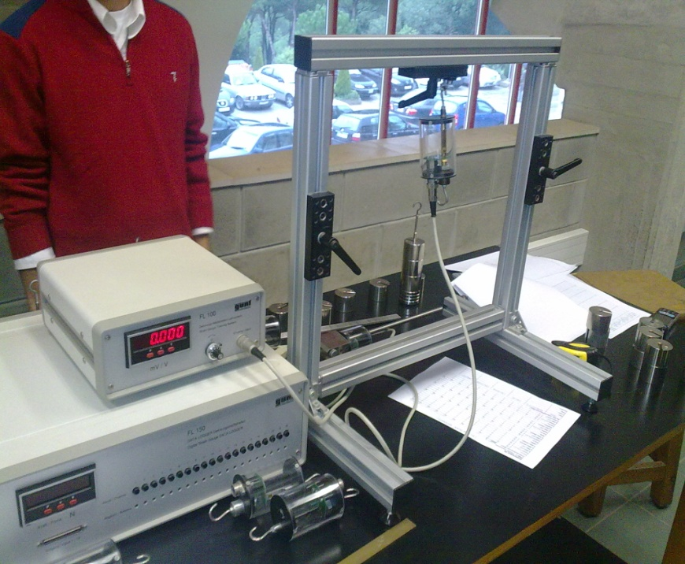
For the bending test:
A steel rod of cross section 20*5mm
Weights of 10, 20, 20N
The apparatus of the experiment:
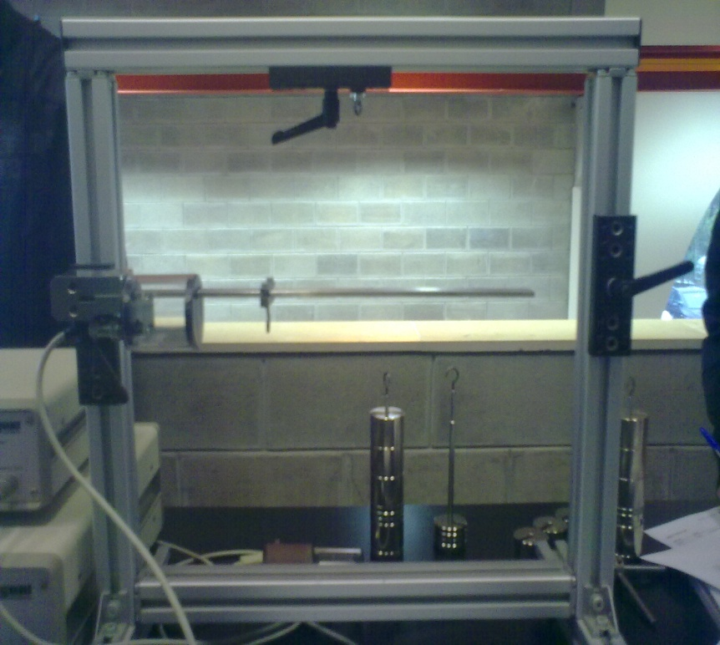
For the torsion test:
A steel rod with circular cross section of 10 mm
Weights of 5, 10, 15, 20, 25, 30, 35, 40, 45and 50 N
The apparatus of the experiment is:
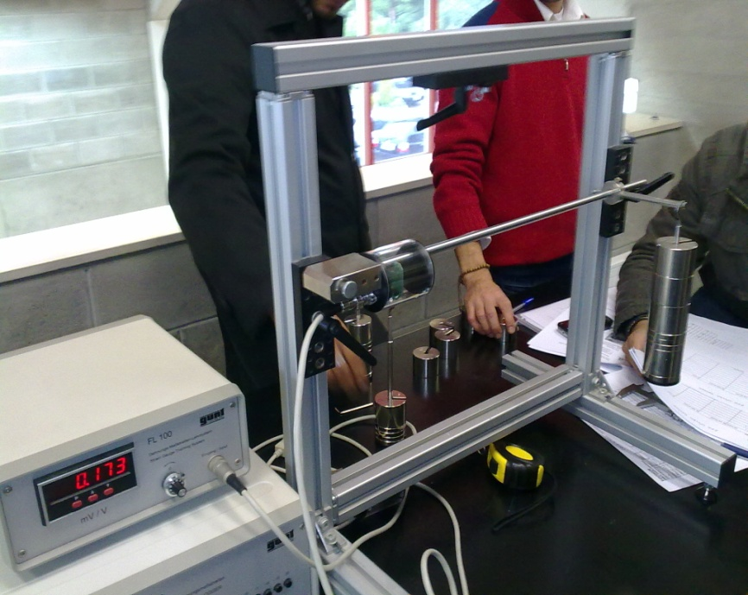
Procedure followed:
For the three tests the same electrical apparatus is used but what differs is the type of material used and the aim of the test
First the tensile test: first the steel bar already in a special frame is connected to the apparatus and hanged from one end the apparatus is calibrated to zero then the weight is hanged from the other end and the value of the voltage is read on the monitor. This same procedure is repeated for each load an each type of material. In this test all bars have a unique cross section of 10*2mm.
For the bending test: a steel bar of cross section 20*5mm is placed in a special frame this frame is connected to the electrical apparatus the load is placed at different distances and several loads are applied and before each measurement the apparatus is calibrated to zero.
For the torsion test: a steel rod of diameter 10mm is placed in a special frame connected to the electrical apparatus several loads are used and before each load the apparatus is calibrated to zero .
In all the three tests the voltage difference is read on the screen this value will lead to the calculation of the experimental stress and strain and will enable to compare these values with the theoretical ones.
Theoretical analysis:
For the first case: the material in question is steel with cross section 10*2mm and the applied load is 10N
Theoretical stress = F/A→ 𝛅= 10/10*2= 0.5N/mm^2 where F is the applied force and A is the area of the bar
Theoretical strain 𝛆=𝛅/E →𝛆= 0.5/210000=23.8*10^-5 where E is the modulus of elasticity of steel
Experimentally:
Experimental strain 𝛆=(4*(ua/ue))/(2*k*(1+v))→𝛆=(4*0.005)/2*2.05*(1+0.28)*10^-3*10^5=0.381N/mm^2
Experimental stress 𝛅=𝛆exp/210000*10^5=0.8N/mm^2

For the second case: the bending test, the tested material is steel and the load is 10N and at a distance of 100mm
Theoretically: stress = MC/I→𝛅=10*100*2.5/(2500/12)=12N/mm^2
Where M is the moment due to the load
C is the furthest distance from the neutral axis
I is the least moment of inertia is equal to B*H^3/12 = 20*5^3/12=2500/12
Strain is equal 𝛅/E*10^5→𝛆=12/210000*10^5=5.714
Experimentally:
Strain is equal (1/K)*Ua/Ue→𝛆=1/2.05*(0.147*10^-3)*10^5=7.170
Stress is equal E*𝛆→𝛅=210000*7.170*10^5=15.058
These same equations are used for various loads and various distances

For the third case the torsion test:
The tested material is steel and the load applied is 10N
Theoretically moment M=F*arm length →M=10*100=1000
Experimentally moment M=G*(2/K)*Ua/Ue*Wp
M=80850*2/2.05*0.069*10^-3*10^3*∏/16=1068.6491N/mm
Where G is the modulus of rigidity of steel
K is the sensitivity of the strain gage
Wp is the section modulus of torsion and equal to D^3*∏/16

Discussion of the work done:
For the tensile test:
The experimental results were obtained by the aid of the Poisson’s ratio. This is derived by the property of material which states that any beam under a tensile or a compressive stress would lead to the lateral and longitudinal deformation. Hence, the Poisson’s ratio (υ) is just the strain due to lateral deformation over the strain due to the longitudinal deformation. Since the lateral deformation is opposite to the longitudinal deformation, the Poisson’s ratio should be preceded by a negative sign. As a conclusion, the Poisson’s ratio is unique for a particular material that is both isentropic and homogeneous.
Concerning the graphs including experimental stress versus strain for four different materials, it has been shown that the curves are increasing straight lines passing by the origin but having different slopes. The reason behind this is the relation between stress and strain which is: σ =Eε
Therefore it is obvious that the slopes are just referring to the modulus of elasticity (E).
As larger as the modulus of elasticity as higher are the slopes. As a consequence deformation will occur less as the stress or the load increases.
It should be noticed that the preceding formula is identification to Hook’s law, since the stress is directly proportional to the load and the strain is directly proportional to the deformation.
Referring to graph 1 and 3, an essential point should be mentioned about the stress and strain for different materials conditioned to the same load. The stress is only dependent on the load however the strain is dependant on the combination of the load and the material. Graph 3 proves the preceding statement since the stress for different loads is approximately equal however the strain demonstrates a variation.
For the second case the bending test
The moment of inertia (I) is relative to the dimensions of the beam and its centroid. Since it is a simple beam of width (b) and thickness (h), I=1/12xbxh.
The strain gauges are connected at the surface of the beam; therefore, c would be the maximum distance from the neutral axis till the surface of the beam. Since thickness h=5mm and the centroid is at its midpoint (homogeneous and isotropic beam), c_{max}=c=2.5mm.
It has been shown by graph 4 that as the position of the load is farther from the strain detector as the bending stress is larger. Hence farther positions of the loads results in larger moments which in turn induces larger bending stress. This is proved by the formula: σ =Mc/I
The maximum strain at the surface was revealed by the gauge strain experimentally to result in the maximum experimental bending stress by hooks law. However the bending stress could be simply calculated theoretically by the preceding formula. The experimental values were higher than the theoretical ones especially at farther load positions due to the malleability of the steel beam and the repetitive critical actions on the beam. Moreover Hook’s law could not be considered experimentally at high inelastic loads.
It should be noticed that the bending stress is not relative to the beam’s material; however it is relative to the beam’s dimensions.

For the third case the torsion test:
The graph demonstrates that the torsional moment increases proportionally as the load increases. This is valid for the theoretical and the experimental yield. Both values are quite near to each other, and have an average differential error of 7.245%.
The theoretical curve was a straight line due to the fact that: M=LxF
Hence L is a multiple constant of 100mm, inducing a direct proportional straight line.
Experimentally, the torsional moment has been calculated by finding the strain at the surface of the rod at different loads F. Hence the deformation induces a shear strain and a shear stress which in turn can be a tool for finding the torsional moment by the following formula: M_{t} = τ x W_{p}

The experimental values were greater than the theoretical values at all loads F due to the fact that repetitive experimenting of the rod used induces a change in rigidity and elasticity; hence, the rod will tend to deform more easily than its initial use under the effect of crucial time and loads.

Data sheet and graphs:
Case 1:
Cross-sectional area 20mm²
Steel
load (N) | 0 | 5 | 7 | 10 | 15 | 20 | 25 | 30 | 35 | 40 | 45 | 50
Reading (mV/V.10⁻³) | 0 | 0.002 | 0.003 | 0.005 | 0.006 | 0.007 | 0.007 | 0.01 | 0.012 | 0.013 | 0.015 | 0.017
ε (theo.) x10⁻⁵ | 0 | 0.119 | 0.167 | 0.238 | 0.357 | 0.476 | 0.595 | 0.714 | 0.833 | 0.952 | 1.071 | 1.19
ε (exp.) x10⁻⁵ | 0 | 0.152 | 0.229 | 0.381 | 0.457 | 0.534 | 0.534 | 0.762 | 0.915 | 0.991 | 1.143 | 1.296
σ (theo.) (N/mm²) | 0 | 0.25 | 0.35 | 0.5 | 0.75 | 1 | 1.25 | 1.5 | 1.75 | 2 | 2.25 | 2.5
σ (exp.) (N/mm²) | 0 | 0.32 | 0.48 | 0.8 | 0.96 | 1.12 | 1.12 | 1.601 | 1.921 | 2.081 | 2.401 | 2.721
Copper
load (N) | 0 | 5 | 7 | 10 | 15 | 20 | 25 | 30 | 35 | 40 | 45 | 50
Reading (mV/V.10⁻³) | 0 | 0.002 | 0.003 | 0.005 | 0.008 | 0.011 | 0.015 | 0.018 | 0.02 | 0.024 | 0.027 | 0.03
ε (exp.) x10⁻⁵ | 0 | 0.147 | 0.22 | 0.367 | 0.587 | 0.807 | 1.1 | 1.32 | 1.467 | 1.76 | 1.981 | 2.201
σ (exp.) (N/mm²) | 0 | 0.18 | 0.271 | 0.451 | 0.722 | 0.992 | 1.353 | 1.624 | 1.805 | 2.165 | 2.436 | 2.707
Brass
load (N) | 0 | 5 | 7 | 10 | 15 | 20 | 25 | 30 | 35 | 40 | 45 | 50
Reading (mV/V.10⁻³) | 0 | 0.002 | 0.003 | 0.005 | 0.007 | 0.01 | 0.011 | 0.014 | 0.017 | 0.019 | 0.022 | 0.024
ε (exp.) x10⁻⁵ | 0 | 0.147 | 0.22 | 0.367 | 0.513 | 0.734 | 0.807 | 1.027 | 1.247 | 1.394 | 1.614 | 1.76
σ (exp.) (N/mm²) | 0 | 0.129 | 0.194 | 0.323 | 0.452 | 0.646 | 0.71 | 0.904 | 1.097 | 1.226 | 1.42 | 1.549
Aluminum
load (N) | 0 | 5 | 7 | 10 | 15 | 20 | 25 | 30 | 35 | 40 | 45 | 50
Reading (mV/V.10⁻³) | 0 | 0.005 | 0.007 | 0.01 | 0.015 | 0.02 | 0.025 | 0.031 | 0.035 | 0.042 | 0.047 | 0.052
ε (exp.) x10⁻⁵ | 0 | 0.374 | 0.523 | 0.748 | 1.121 | 1.495 | 1.869 | 2.318 | 2.617 | 3.14 | 3.514 | 3.887
σ (exp.) (N/mm²) | 0 | 0.262 | 0.366 | 0.523 | 0.785 | 1.047 | 1.308 | 1.622 | 1.832 | 2.198 | 2.46 | 2.721
For 50N, Cross-sectional area 20mm²
Material | Reading (mV/V.10^-3) |  |  | ε (exp.) x10⁻⁵ |  | σ (exp.) (N/mm2) |  | σ (theo.) (N/mm2) |  | ε (theo.) x10⁻⁵
steel | 0.017 |  |  | 1.2957 |  | 2.7210 |  | 2.5 |  | 1.1905
Copper | 0.03 |  |  | 2.2010 |  | 2.7070 |  | 2.5 |  | 2.0325
Brass | 0.024 |  |  | 1.7600 |  | 1.5490 |  | 2.5 |  | 2.8409
Aluminum | 0.052 |  |  | 3.8875 |  | 2.7212 |  | 2.5 |  | 3.5714

For case 2 the bending test
 | U_{a}/U_{e} (10⁻³ mV/V)
X (mm) : | 100 | 170 | 200 | 270 | 300 | 340
Load (N)
10 | 0.147 | 0.251 | 0.301 | 0.4 | 0.437 | 0.503
ε(theo.) x10⁻⁵ | 5.714285714 | 9.7142857 | 11.428571 | 15.428571 | 17.142857 | 19.428571
|σ(theo)| | 12 | 20.4 | 24 | 32.4 | 36 | 40.8
ε(exp.) x10⁻⁵ | 7.170731707 | 12.243902 | 14.682927 | 19.512195 | 21.317073 | 24.536585
|σ(exp.)| | 15.05853659 | 25.712195 | 30.834146 | 40.97561 | 44.765854 | 51.526829
20 | 0.296 | 0.5 | 0.604 | 0.799 | 0.873 | 1.007
ε(theo.) x10⁻⁵ | 11.42857143 | 19.428571 | 22.857143 | 30.857143 | 34.285714 | 38.857143
|σ(theo)| | 24 | 40.8 | 48 | 64.8 | 72 | 81.6
ε(exp.) x10⁻⁵ | 14.43902439 | 24.390244 | 29.463415 | 38.97561 | 42.585366 | 49.121951
|σ(exp.)| | 30.32195122 | 51.219512 | 61.873171 | 81.84878 | 89.429268 | 103.1561
30 | 0.445 | 0.752 | 0.906 | 1.187 | 1.31 | 1.512
ε(theo.) x10⁻⁵ | 17.14285714 | 29.142857 | 34.285714 | 46.285714 | 51.428571 | 58.285714
|σ(theo)| | 36 | 61.2 | 72 | 97.2 | 108 | 122.4
ε(exp.) x10⁻⁵ | 21.70731707 | 36.682927 | 44.195122 | 57.902439 | 63.902439 | 73.756098
|σ(exp.)| | 45.58536585 | 77.034146 | 92.809756 | 121.59512 | 134.19512 | 154.8878

For case 3 the torsion test:
Lever Arm: | 100mm
Load (N) | U_{a}/U_{e} (10⁻³mV/V) | M_{t}, exp (N.mm) | M_{t}, theo (N.mm) | % error
5 | 0.035 | 542.0684 | 500 | 8.413681
10 | 0.069 | 1068.6491 | 1000 | 6.864914
15 | 0.104 | 1610.7175 | 1500 | 7.381169
20 | 0.138 | 2137.2983 | 2000 | 6.864914
25 | 0.173 | 2679.3667 | 2500 | 7.174667
30 | 0.207 | 3205.9474 | 3000 | 6.864914
35 | 0.242 | 3748.0158 | 3500 | 7.086166
40 | 0.277 | 4290.0842 | 4000 | 7.252105
45 | 0.312 | 4832.1526 | 4500 | 7.381169
50 | 0.346 | 5358.7334 | 5000 | 7.174667
 |  |  | Avg.%error: | 7.245837

Conclusion
From this experiment we can say that we cannot have stress without a strain they appear together and we can say that one is the cause of the other.
Stress is independent of the material but dependent on the cross section while the strain is dependent on the material and the cross section.

