Chem 200: Very Easy Test 1; Tuesday Feb 26th, 2019

The Chemical Elements, Stoichiometry, and

Atomic Electronic Structure

Family Name as used in the AUB record:

First Name as used in the AUB record:

ID-number:

Section number:

Class list number:

Useful Energy Expressions

**1.** Schrodinger’s formula for the energy of a single electron bound to a nucleus having charge Z is:

 (in J).   
For polyelectron atoms we use Zeff in place of Z

**2.** The energy and wavelength of a photon are related by Planck’s formula:



1 Fundamentals

1A (5 pts) Describe the experiment that demonstrates electrons have wave character. Give a drawing and few words that explain what is observed and how the observation confirms a wave character.

1B (5 pts) It is now accepted that in addition to the wave character, light also has particle character. What is the experiment that proves that light has particle character? Use an illustrated drawing and key words.

1C (10 pts) What experiment would you do to determine if the spin of a given particle is S = ½ or S = 1? Utilize drawings and few words on the reasoning behind the observation that will determine the answer.

1D (5 pts) The helium nucleus has two protons confined to a very tiny space. Based on the electrostatic repulsion between the two protons, one would expect the protons to simply fly apart. What is it that keeps the protons confined within the helium nucleus?

1E (5 pts) Energy is the ability to do work. Suggest a simple demonstration that clarifies what this means. You must be convincing.

1F (5 pts) What is the difference between natural uranium and enriched uranium? Keep it simple and brief.

2 From the readings

2A (5 pts) What is ammonia and how it is synthesized industrially and what are its two major uses? Give a balanced chemical equation for the synthesis.

2B (10 pts) What are the typical stages that are used to extract gold in artisanal mining? Which stage contaminates the aquatic life with mercury (lakes and rivers) and which stage contaminates the atmosphere with mercury? Quality matters. Be concise. Use a diagram or a flow chart if this can improve the quality of your presentation.

2C (5 pts) In your judgment, what could be a reasonable solution to curb the growing threats of artisanal mining? Give your reasoning briefly.

3 Emission from the hydrogen atom

3A-(10 pts) When beaten, hydrogen atoms emit a number of photons with discrete energies including a red photon.

Draw an up to scale labeled energy level diagram for the hydrogen atom. Specify on your diagram what happens when hydrogen atoms are beaten and what causes of the red photon.

Calculate the exact wave length of this red photon (show your work).

4 Electronic structure of a polyelectron atom

4A-(5 pts) Draw a simplified generic energy level diagram for the ground state of the nitrogen atom, and give the matching electron configuration and Lewis dot structure.

4B-(5 pts) Give a quantitative estimate of the ionization energy of the 2s AO of the nitrogen atom, show your work

4C-(5 pts). According to your energy diagram, what is the total spin of the nitrogen atom? Give your reasoning

5 Chemical reactions

5A (10 pts) How many grams of calcium bromide (CaBr2) would you obtain if you mix one gram of calcium metal and one gram of bromine.

Show your work. Start with a balanced chemical equation

5B (10 pts) What is the energy change associated with the given electron transfer reaction? Show your work

H + He+2 🡺 H+1 + He+1 E = ??

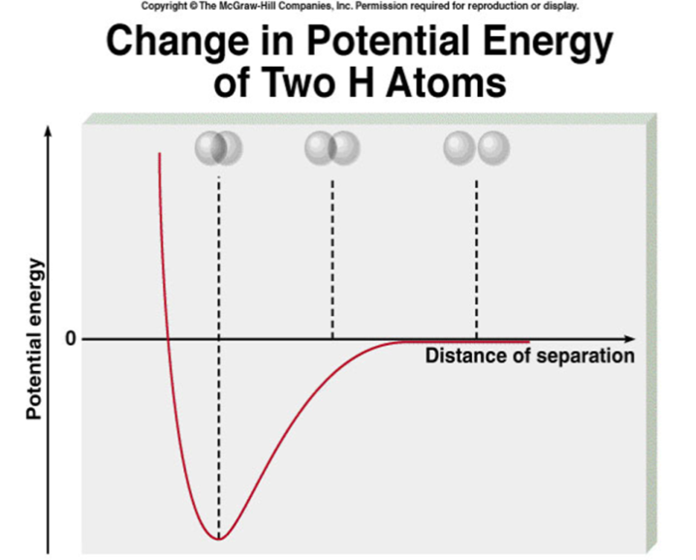

5C (bonus 5 pts) Given is the potential energy change as a function of the distance of two hydrogen atoms. Add to the same figure the potential energy curve as a function of two helium atoms.