To be delivered Tuesday and Wednesday 10 and 11 April , print and fill in hand written.

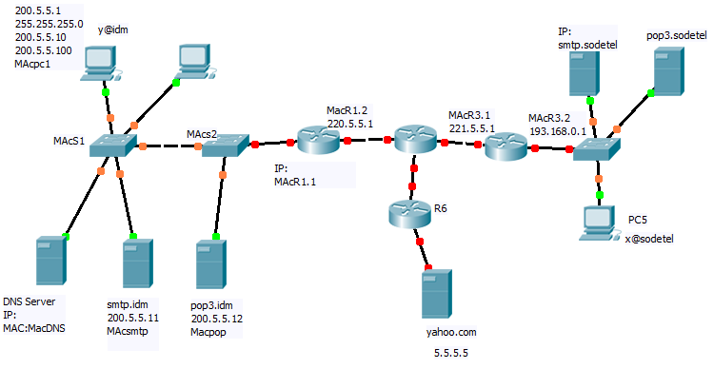

Fill in the ip addresses where there is IP:

1-Y@idm sends an email to x@sodetel :

- SMTP packet goes from Y@idm PC to SMTP.IDM

Source Mac | Dest Mac | Source IP | Dest IP | Source Port | Dest Port

- Then from SMTP.idm to SMTP.Sodetel : fill in the following: (note that you must organize them by numbering them .

SMTP packet

Source Mac | Dest Mac | Source IP | Dest IP | Source Port | Dest Port

Arp request Packet

Source Mac | Dest Mac | Who has IP

Arp reply Packet

Source Mac | Dest Mac | Who has IP

Arp request packet

Source Mac | Dest Mac | Who has IP

Arp reply packet

Source Mac | Dest Mac | Who has IP

DNS Packet

Source Mac | Dest Mac | Source IP | Dest IP | Source Port | Dest Port

DNS reply packet

Source Mac | Dest Mac | Source IP | Dest IP | Source Port | Dest Port

Smtp reply packet

Source Mac | Dest Mac | Source IP | Dest IP | Source Port | Dest Port

- The email now arrived at SMTP.sodetel , and them to POP.sodetel , what happens now ?

- Assign an IP , SM , DG and an external DNS for PC5, also a real mac address.

- PC5 sent a request to ftp://5.5.5.5

What will be the second packet coming out of PC5 :
1-an ARP packet
2-a DNS packet
3-an http packet
4-an ftp packet

Justify below:

- Yahoo is replying fill in the below FTP reply packet

Source Mac | Dest Mac | Source IP | Dest IP | Source Port | Dest Port

- The ftp reply packet is on R3 now :

Source Mac | Dest Mac | Source IP | Dest IP | Source Port | Dest Port

- How many collision domains exist in the first network (IDM), how many broadcast domains ?

