American University of Science & Technology

Department of Computer Science

CSI 311L – Java Programming Lab

Spring 2011/2012

Lab Work 13

Problem1:
Write a java Applet that generate a random number (1-50) and ask the user to guess the secret number. The user will insert the number and the applet will notify if the number entered is larger than or smaller than the secret number.
When the user inserts the right guess, the applet will show the user score (which is the number of trials made to guess the secret number).
The user can try to guess a new number by clicking on the "Play again" button.

Note: The user is not allowed to put a negative number.

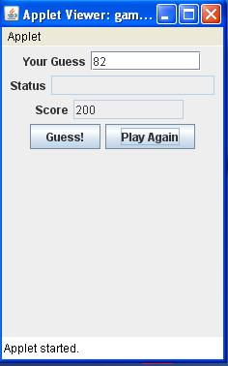

Problem2:

Write the implementation of the following classes used in a backup system:
A Document is defined as follows:
- num: a number to identify each document.
- Date: to register the issue date of a document.
- Subject: to define the category of the document.
Provide a constructor, set and get methods for all attributes, and toString method to return the values stored in an object.
Certain document are classified to be billable in the system by implementing the methods in the class Billable, which is defined as follows:
- getAmount(): that returns the money value of a document.
- getCurr(): that returns the currency of a billable document.

An Invoice is a billable document that is defined as follows:
- amount: the prices of items on an invoice.(can’t be alterd after is initialized to a value)
- Currency: to define the amount currency.
- Payed: the amount settled of an invoice.
Provide a constructor, set and get methods for all attributes, and toString method to return the values stored in an object.
Provide toPay() method to return the value of the unsettled amount of an invoice.

III- Write a java application that uses a well-designed graphical interface to create a new invoice or to settle a payment on an invoice (use different Jbuttons and JPanels).
Your program should handle any error on the data. The data should be kept in an array the n saved on a file

