American University of Science & Technology

Department of Computer Science

CSI 311L – Java Programming Lab

Spring 2011/2012

Lab Work 12

Problem1:
Write a java application to enable a user to choose his pizza using the following GUI. The program should display the pizza price when the user clicks the compute button.

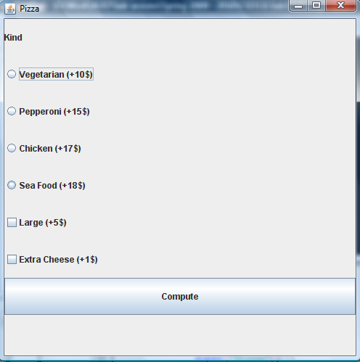

Problem2:

Use polymorphism to maintain a course roster whose enrolled students include both Undergraduate and Graduate students.

For a student we record his/her name and the three test scores.
Provide an abstract method get_course_grade() .
Provide a constructor.
Provide set and get methods for the name and the three tests attribute.

For an Undergraduate the get_course_grade() returns
“Pass” if (0.25*test1+0.25*test2+0.5*test3)>=70, “fail” otherwise.

For an Graduate the get_course_grade() returns
“Pass” if (0.25*test1+0.25*test2+0.5*test3)>=80, “fail” otherwise.

I- Provide the implementation of the classes Student, Undergraduate and Graduate.

II- Write a java application to allow the user to create a student object and compute his course grade. The user is allowed to enter only 1 or 2 for the student type; other values should not be acceptable.

