American University of Science & Technology

Department of Computer Science

CSI 311L – Java Programming Lab

Spring 2011/2012

Lab Work 7

Problem1:
Trace the following java applications:
a-
//Suppose that the generated numbers are: 14 25 46 45 39

public class Lab
{
public static void main ( String a [] )
{
int x[] = new int [5];

for( int i = 0; i < 5; i++ )
x[i] = 1 + (int)(Math.random() * 51);

for( int i = 0; i < 5; i++ )
System.out.println( x[i] );

int c = 0;

for( int i = 0; i < 5; i++ )
if( x[i] % 2 == 0 )
c++;

System.out.println(
"Percentage of Even Numbers: " + c * 100 / x.length + "%" );

System.out.println( "Percentage of Odd Numbers: " +
( x.length - c ) * 100 / x.length + "%" );
}
}

b-

class q8
{
public static void main(String[] args)
{
int N = 1000 + 1;

// Create Array
Boolean p [] = new Boolean [ N ];

// Initialize to TRUE
for (int i=0;i<p.length ; i++)
p[i] = true;

for (int i=2;i<N ;i++)
{
// skip all FALSE elements
if (p[i] == false)
continue;

// I removed all multiples of 'i'
for (int j=i;j*i<N ;j++)
p[i*j] = false;
}

// Print all prime numbers
for (int i=1;i<N;i++)
{
if (p[i] == false)
continue;// not prime
System.out.println(i + " is prime!");
}
}
}

Problem 2:

write a java application to output the following shape:

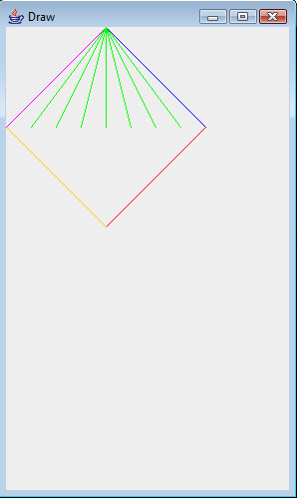

Problem 3:
Write the class definitions and implementations for the following class specifications.

Instructor
Attributes | - id: an integer to identify the id of the instructor  - name: a String to identify the name of the instructor  - highestDegree: a String to identify the highest degree achieved by the instructor  - rate: a floating-point value to identify the rate per hour of the instructor
Methods | - Default constructor  - Constructor  - set methods  - get methods  - toString: to return information about an instructor

Course
Attributes | - code: a String to identify the code of the course  - name: a String to identify the name of the course  - instructor: an object of class Instructor to identify the instructor of the course  - hours: an integer to identify the number of hours to be taught for this course
Methods | - Default constructor  - Constructor  - set methods  - get methods  - toString: to return information about a course  - compute: to compute the cost of the course

- Write a java application to do the following (Use JOptionPane methods):
- Create N objects of class Instructor and let the user initialize them
- Create N objects of class Course and let the user initialize them
- Compute and display the total cost of all courses
- Display information about courses taught by a specific instructor

